RESP
AHAD WEEK 7: RESPIRATORY

Required Readings- Links:
COVID 19
- Ontario Health(rapid antigen testing; diagnostic PCR testing)
  - These two topics also still have a ton other links underneath them…
- Covid-19: a remote assessment in primary care.
Asthma
- Canadian Thoracic Society guidelines (Asthma).
  - This is just a link to the guidelines website and there are a bunch
  - The first one in the table seems most relevant and is 15 pages
- Asthma Canadian Thoracic Society Guidelines
- 2021 Canadian Thoracic Society Guideline – A focused update on the management of very mild and mild asthma(NEW)
COPD
- COPD Health Quality Ontario
- Canadian Thoracic Society guidelines (COPD)
  - The link “addressing therapeutic questions…” under the domain COPD is the only non-thera COPD guideline that is current on this link
Smoking cessation:
- Best Practices for Clinical Smoking Cessation in Canada
Spirometry testing and Interpretation
Obstructive Sleep Apnea: Assessment and Management in Adults
Obstructive sleep apnea and driving: A Canadian Thoracic Society and Canadian Sleep Society position paper
TB Canadian Tuberculosis Standards 8th 2022
Canadian Immunization Guide Chapter on Influenza and Statement on Seasonal Influenza Vaccine for 2022–2023

Breath sounds
Expiratory wheeze: asthma, COPD
Monophonic wheeze: obstruction (asthma/copd)
Crackles: pneumonia, CHF, fibrosis, COPD
Coarse crackles: pneumonia, CHF, fibrosis
Bronchial: normal in central, abnormal in peripheral; pneumonia, fibrosis, lung abscess, collapse due to pleural effusion
Inspiratory stridor: children, blockage of airways due to croup foreign body aspiration
Rhonchi: bronchitis and pneumonia
Pleural friction rub: pleurisy, pleural tumor

Mining/Occupational Risks
Coal workers' pneumoconiosis (CWP), commonly known as "black lung disease," is a type of pneumoconiosis caused by long-term exposure to coal dust. When coal dust is inhaled, it can accumulate in the lungs, leading to inflammation, fibrosis, and eventually permanent lung damage. CWP is primarily seen in coal miners and workers in industries where coal dust is prevalent.

Types of Coal Workers' Pneumoconiosis
- Simple CWP:
  - Characterized by small nodular opacities in the lungs, usually detected on chest X-rays.
  - Typically presents with mild or no symptoms but can progress over time.
- Complicated CWP (Progressive Massive Fibrosis - PMF):
  - Involves larger masses of fibrosis in the lungs and is often associated with more severe symptoms.
  - Can lead to respiratory failure and other serious complications.

Symptoms
- Early stages: May have minimal symptoms.
- Advanced stages:
  - Chronic cough
  - Shortness of breath (dyspnea)
  - Sputum production
  - In severe cases, may lead to respiratory failure and increased susceptibility to infections.

Diagnosis
- Occupational history: Essential to determine exposure to coal dust.
- Spirometry
- CBC if S/S infection
- Imaging: Chest X-ray or high-resolution CT scans to identify characteristic nodules or fibrosis.
- Pulmonary function tests (PFTs): To assess the extent of lung impairment.

Prevention and Management
- Prevention: Primary focus on reducing exposure to coal dust through adequate ventilation, respiratory protective equipment, and regular health screenings for workers.
- Management: No cure for CWP, so treatment is mainly supportive, including:
  - Bronchodilators for symptom relief
  - Oxygen therapy if necessary
  - Pulmonary rehabilitation
  - Monitoring for complications, such as COPD and lung infections

Prognosis
The progression and severity depend on the level and duration of exposure, with PMF being the more severe form that can significantly impact quality of life and overall health.
Preventing coal dust exposure remains the most effective strategy to reduce the risk of CWP among coal workers.

Obstructive Sleep Apnea (OSA)
Def’n | Periodic reduction or cessation of breathing d/t narrowing or occlusion of upper airway during sleep.  Dx: Either  - Presence of >15 apneas, hypopneas, or resp effort related arousals per hour of sleep in an asymptomatic client OR  - Presence of >5 apneas, obstructive hypopneas or resp effort related arousals per hour of sleep in a client with S/S of disturbed sleep
Pathology/Cause | - Increased tissue thickness of the structures of the tongue and soft tissues of the pharynx decreases passageway for air to the trachea. `  - At night, oropharyngeal muscles relax > results in relative obstruction of airway  - Obesity and hypertrophy of tonsils and/or adenoids account for most cases of OSA in children  - Children: OSA in kids aged 2-10 is usually d/t adenotonsillar lymphatic tissue growth (surgical removal of enlarged tonsils/adenoids usually cures it completely)
Risk Factors/Epidemiology | - Obesity is #1 risk factor (obesity adds 4 fold risk of disordered breathing)  - Older age (up to 65, then it plateaus)  - Males>females  - ETOH  - Hypothyroid, tonsillar hypertrophy, craniofacial abnormalities, certain meds, allergic rhinitis, genetic conditions, diabetes, HTN  - Ethnicity (black, asian, hispanic)  - Family hx
Clinical Presentation | Common findings:  - Daytime sleepiness/increased general fatigue  - Loud snoring, gasping, or snorting during sleep  Other: dry mouth, sore throat, headaches, decreased libido, cognitive deficits, feeling fatigue
Hx/Key Questions | -Frequent naps/sleepiness? Snoring/gasping?  DAYTIME SLEEPINESS IS A KEY FEATURE  Epworth Sleepiness Scale:  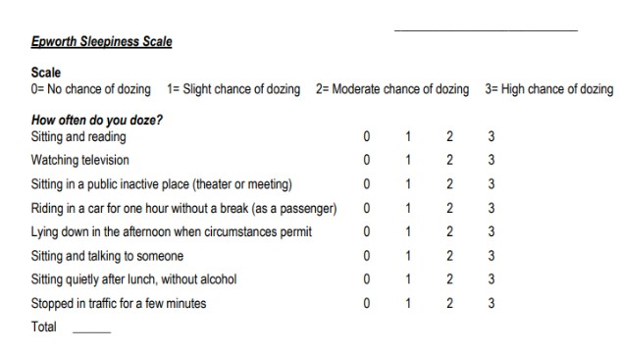  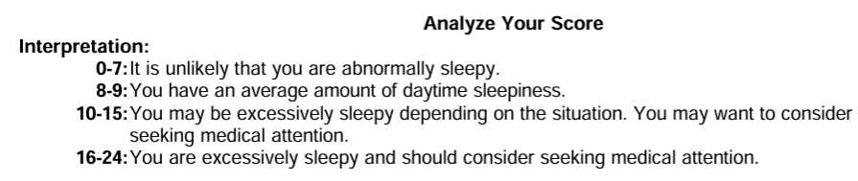
Physical Exam | VS, Ht/wt/BMI  Inspect:  - HEENT Oropharynx for peritonsillar narrowing or hypertrophy, enlarged tongue or uvula  - Nose for septal deviation and nasal polyps  - Signs of pulm HTN (JV distention, peripheral edema)  Palpate: Thyroid gland  Auscultate: heart and lungs  Assess mental status  Meausre around collar (>40cm?)
Diagnostics/Labs | Polysomnography (PSG) is the standard method of diagnosis  Labwork not recommended
Red flags | OSA has been linked to traffic accidents, cardiac diseases, stroke, diabetes, obesity, nocturnal cardiac arrhythmias, chronic and acute cardiac events, and poor neurocognitive performance
Differential Diagnoses | Primary snoring, arrhythmia, narcolepsy, restless leg syndrome, swallowing disorder, nocturnal seizures, GERD, tonsillar hypertrophy
Treatment/Management | Treatment:  - CPAP or BiPAP is the main treatment for moderate-severe OSA  - Can also try oral appliances (OA) or mandibular repositioning appliances (MRA) (requires dental referral)  - Surgical treatment considered after using an OA or positive airway pressure for 3 months - good for tonsillar or adenoid hypertrophy or craniofacial deformities  Counseling/Education: educate re: modifiable risk factors (diabetes, HTN control, diet, exercise, smoking cessation)  Non-pharm therapies:
Referrals | Dentist - for OA  ENT if If the patient has significant nasal or upper airway obstruction (e.g., enlarged tonsils/adenoids, nasal polyps, deviated septum, or nasal obstruction) contributing to OSA.  Pulmonologist - for mgmt of therapy and/or surgical treatment  Smoking cessaion?  Dietician for weight loss
Follow-up | See OSA guideline below
Additional Reading: OSA and MVCs
https://www.ncbi.nlm.nih.gov/pmc/articles/PMC4128516/
Increased risk of MVCs: untreated OSA significantly increase risk of MVCs d/t daytime sleepiness and impaired vigilance (2-10 fold higher risk of collisions)

Recommendations for non-commercial drivers:
- Severity of OSA alone is not a reliable predictor of driving risk; holistic approach needed to consider factors like sleepiness, comorbidities, and driving hx
- Physicians should assess fitness to drive and provide recommendations to licensing authorities but final decisions on driving restrictions are made by authorities
- Pts on CPAP: compliance should be documented to ensure treatment efficacy

Recommendations for commercial drivers:
- More stringent/rigorous evaluations recommended for commercial drivers d/t increased time on the road; more sleep studies and objective assessment of compliance with CPAP tx needed
Additional Reading: OSA Guideline on Assessment and Management in Adults
https://www2.gov.bc.ca/gov/content/health/practitioner-professional-resources/bc-guidelines/sleep-apnea
Key recommendations include:
- History: if OSA suspected, take detailed history and physical exam, focused on the upper airway
- Assessment:
  - STOP-Bang questionnaire can be used to help determine risk of moderate-severe OSA
  - Epworth sleepiness scale is also recommended (see Hx/Key questions section above)
- Testing:
- Home sleep apnea test (HSAT) should only be used in symptomatic patients for diagnosis of OSA who are determined to be at an increased risk of moderate-severe OSA (not for asymptomatic screening)
- A negative HSAT doesn’t exclude OSA. If OSA still suspected, polysomnography is recommended
- Management and follow-up:
- OSA is a serious chronic disease that warrants regular follow-up: short-term to ensure initial compliance and response to tx and long-term to confirm continued effectiveness
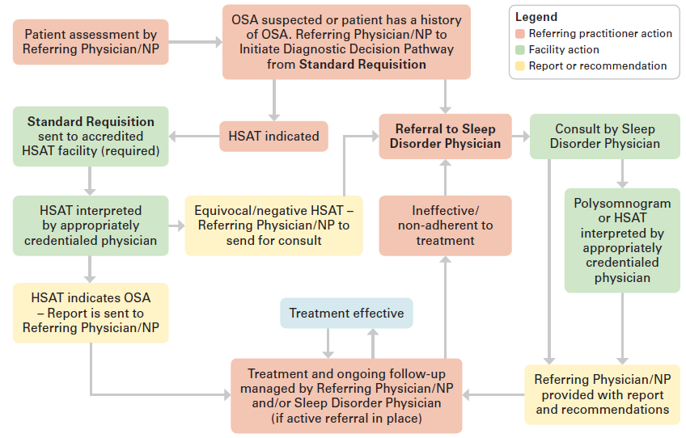
STOP-BANG questionnaire:
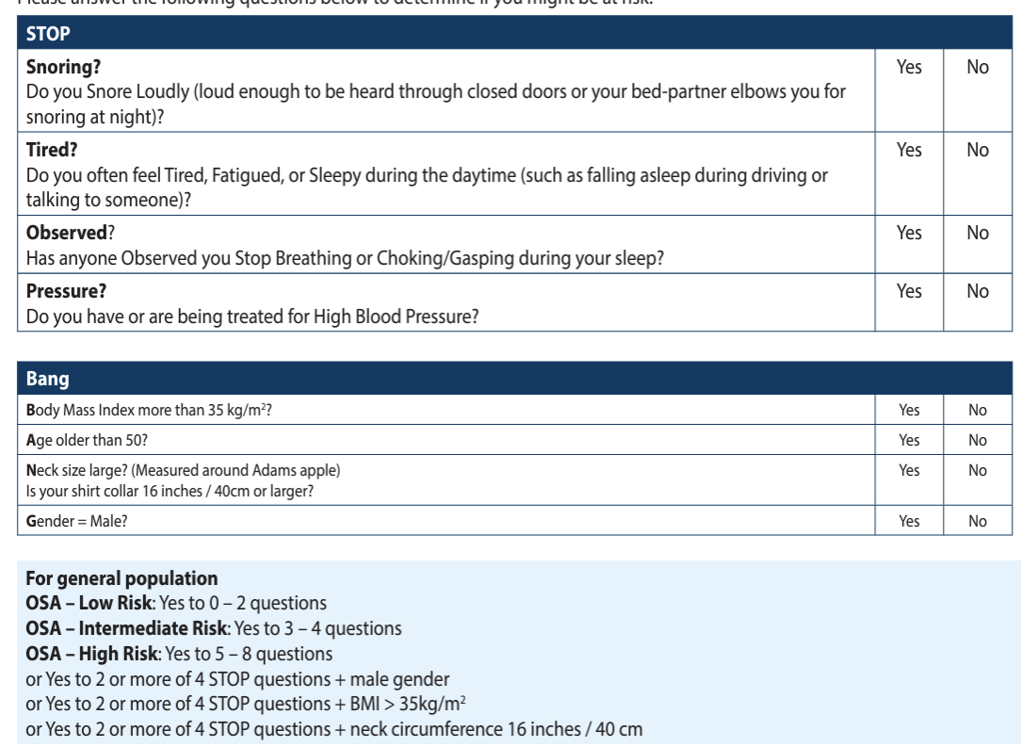

Smoking Cessation
From MUMS Respiratory Guidelines:
- Smoking is the #1 cause of COPD. Greater the exposure, greater the risk of developing airway limitation
- After quitting smoking, the rate of decline in FEV1 returns towards that of a non-smoker. Quitting also produces symptomatic relief of chronic cough, sputum, SOB, and wheezing
- Nearly 50% of smokers attempt to quit but only 7% are still abstinent 1 year later

Strategies:
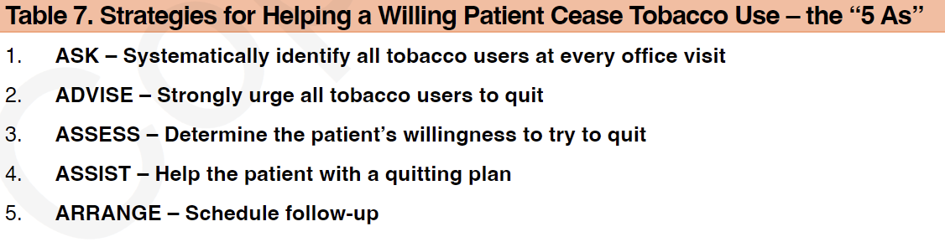
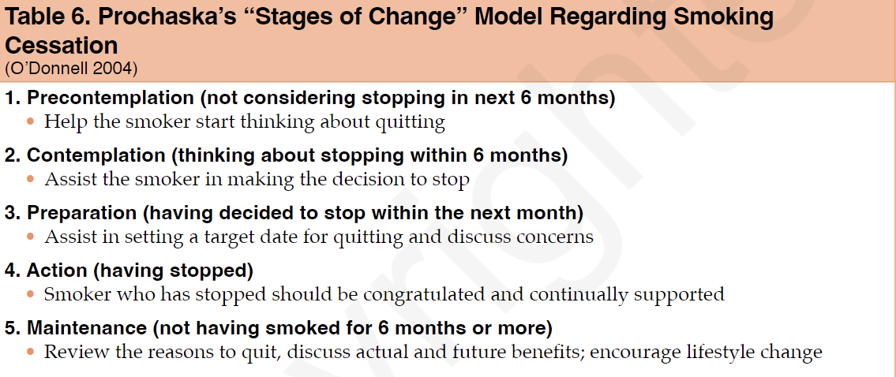

Factors that increase smoking cessation rates:
- Self help strategies alone are unlikely to be effective. Combined pharmacotherapies and counseling either alone or together can significant increase cessation rates
- Individual and group counseling sessions
- Greater number and length of sessions correlate with successful quitting; however even 3 min session that urges a smoker to quit can be effective and should be included at each visit and patients reminded that more intensive therapy increases the likelihood of sustained quitting
- Encourage patients to be persistent despite failures; long-term cessation typically takes 3-4 attempts
- Abrupt quitting is more effective but cutting back strategy is still considered appropriate counseling option
- Pharmacotherapy is an adjuvant to counseling and should be offered early in the process

Influenza
Description | A common, acute viral infection that is a self-limiting (typically between 7-10 days), febrile illness of the respiratory tract. Spread from person to person through sneezing, coughing, talking, or self-inoculation of secretions through direct contact routes
Pathology/cause | Influenza A and B can undergo periodic changes in their glycoprotein envelopes  - More extensive outbreaks seen for influenza A  Hemophilus influenzae is a bacteria that can cause meningitis, otitis media, sinusitis, epiglottitis, septic arthritis, febrile bacteremia, cellulitis, pneumonia, and empyema (can also cause neonatal meningitis)
Epidemiology | Epidemics occur yearly in the winter months in both hemispheres. Mortality rates are highest in geriatric populations above age 65 BUT during pandemics, can have 50% of deaths in individuals under 65. Affects patients of all ages
Risk Factors | Based on risk of exposure to the viral strain in respiratory droplets and contaminated surfaces.  Adults…  - Age 65+, pregnancy, high risk jobs (teachers, HCW, police, firefighters)  - Recent illness or lowered resistance immunity state (stress, fatigue, poor nutrition)  - Immunosuppression from drugs, illness, chronic disease  - Crowded living conditions, travel to endemic areas, avian flu risk with exposure to dead or ill poultry  Children…  - Chronic pulmonary disease like asthma, cystic fibrosis, BPD  - Congenital heart disease or abnormalities  - Age under 5
Clinical Presentation  (Subjective Symptoms & Objective Signs) | HALLMARK: respiratory symptoms may be less prominent at time of illness onset. Rapid onset respiratory illness. Sudden, severe onset. Patients often describe a “hit-by-a-truck” feeling, with intense symptoms appearing within hours.  Common findings:  - Abrupt onset of fever, chills, severe throat pain  - Joint pain, headache, conjunctivitis in avian flu  Other signs and symptoms:  - Upper congestion, malaise, fatigue, anorexia, swollen lymph nodes, nonproductive cough persisting for weeks, muscle aches, GI symptoms (more n/v/appetite changes in children), febrile seizures, otitis media  - May cause photophobia
Hx/Key Questions | OPQRST of symptoms, especially myalgia and malaise  - When was the last flu vaccination  - Symptoms from family members, coworkers, and close contacts  - Immunization status  - Recent travel, to what locations (exposure to cruise ships or planes)  - Living conditions (can help rule out TB***)  - Smoking history, medication use  - Asthma or COPD?  - Immunity status, other comorbidities
Physical Exam | VITALS: temperature, pulse, respirations, BP  INSPECT: overall appearance for pallor, and respiratory distress  - Assess hydration status, ENT exam, observe for seizure activity in children and note their level of activity  AUSCULTATE: lung fields and observe for crackles/wheezing; heart  PALPATE: neck and lymph nodes (all 10)  NEUROLOGIC: assess LOC, and assess for nuchal rigidity and meningitis signs  - Brudzinski’s sign  - Kernig’s sign  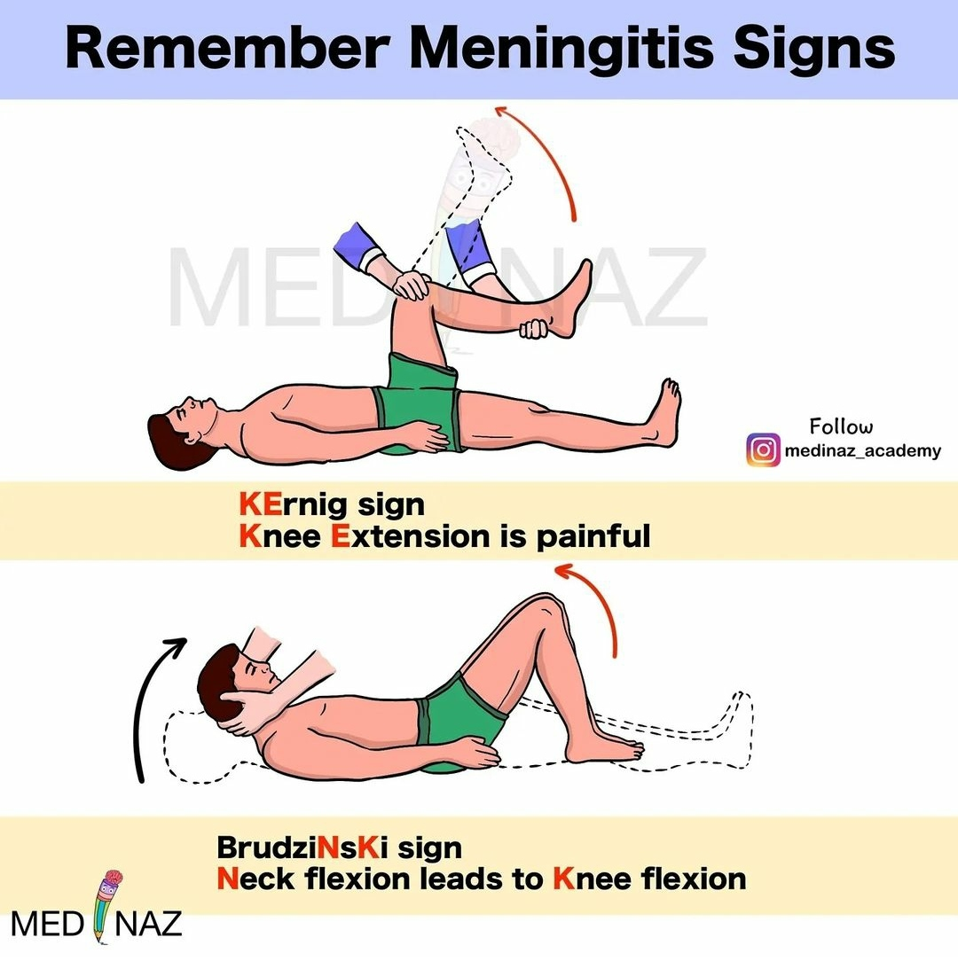
Red Flags | Signs of meningitis and pneumonia! Desaturations, decreased fluid intake, lower LOC, etc.
Differential Diagnosis | Types of influenza (A vs B vs avian flu vs H1N1), pneumonia, bronchitis, mononucleosis, RSV, early HIV, SARS, meningitis
Diagnostics:  Labs & Imaging | Laboratory tests (usually not required)  - CBC: elevated WBC  - Viral RNA cultures (in first 72 hours of illness due to rapid decrease in viral shedding after then)  - NP swabs  - Can do monospot test if considering mononucleosis as a diagnosis  Diagnostic tests and/or Imaging  - Typically, none are required  - CXR if pneumonia is a differential  - Rapid influenza testing best done in first 48h of symptom onset
Treatment/ Management | Counseling/Education  - Cough suppressants are not recommended for young children  Complementary Therapies (non-pharmacological)  - Typically, treat the symptoms  - Rest, increased fluid intake, non-prescription analgesics
Referrals | To a neurologist if complications arise
Follow-up | Inn 7-10 days if symptoms have not improved
Common Complications | Monitor for pulmonary and neurologic complications  - Increased risk of pneumonia development if pregnant  - In pediatrics, the most common complication is otitis media  - Risk of Reye’s syndrome with influenza B mostly, can occur with A
1° and 2° Prevention | Primary prevention: get the flu vaccine before the season starts (in September if possible)! (safe in pregnancy at any stage), handwashing
References | MUMS, Cash & Glass, Dains et al, Canada vaccine regimen required reading

Pneumonia
 | Viral | Bacterial
Etiology | Caused by viruses such as influenza, respiratory syncytial virus (RSV), adenovirus, coronaviruses (including SARS-CoV-2), and parainfluenza. | Caused by bacteria including Streptococcus pneumoniae, Haemophilus influenzae, Staphylococcus aureus, Mycoplasma pneumoniae, and Chlamydia pneumoniae.
Epidemiology/  Pathology | More prevalent in children and can occur in outbreaks, particularly during winter months. Increased incidence in immunocompromised individuals.  Viruses invade and damage respiratory epithelium, leading to inflammation, mucus production, and impaired gas exchange. Immune response can further contribute to symptoms. | Common across all age groups; incidence increases with age, smoking, chronic lung disease, and immunocompromised states. Higher rates in crowded living conditions.  Bacteria invade alveoli, leading to inflammation, alveolar filling with exudate, and impaired gas exchange. This process can also lead to local or systemic complications (abscess, empyema).
Incubation period | Generally 1 to 4 days, depending on the specific virus. | Usually 1 to 3 days, can vary based on bacterial species and patient’s immune status.
Symptoms | -Gradual onset  -Cough (dry or with minimal sputum)  - Shortness of breath  - Fatigue  - Muscle aches  - Sore throat  - Headache  - Sometimes gastrointestinal symptoms (nausea, vomiting, diarrhea) | - USUALLY LUNG/ SPECIFIC S/S NOT OTHER CONSTITUTIONAL S/S  -Fast onset  -Chest pain with inhalation  - high Fever  -new cough (with purulent sputum)  - Fever and chills  - Shortness of breath  - Fatigue  - Muscle aches  - Sore throat  - Headache  - Sometimes gastrointestinal symptoms (nausea, vomiting, diarrhea)  -RR > 20/min, tachycardia, crackles, consolidation, hypotension  ***Absence of VS abnormalities and chest auscultation abnormalities substantially lessen likelihood of pneumonia
Physical exam | General Assessment  - Observe the patient's overall appearance, including signs of respiratory distress (tachypnea, use of accessory muscles, nasal flaring, cyanosis).  - Assess the patient’s level of consciousness and responsiveness.  Vital Signs  Respiratory Examination  - Inspection:  - Observe chest movement for symmetry.  - Look for signs of labored breathing or retractions (indrawing of the chest wall).  - Assess for cyanosis  - Palpation:  - Palpate the chest for tenderness or abnormal masses.  - Assess tactile fremitus. Increased fremitus suggests consolidation (bacterial pneumonia), decreased fremitus may indicate pleural effusion or obstructive processes (viral pneumonia).  - Percussion:  - Percuss the chest to evaluate for dullness (indicative of fluid or consolidation) or hyper-resonance (indicating a pneumothorax).  - Auscultation:  - Listen to breath sounds over all lung fields.  - Note the presence of:  - Adventitious sounds:  - Crackles (rales) may indicate fluid in the alveoli (common in both types of pneumonia).  - Wheezing may suggest bronchospasm or inflammation (often more associated with viral pneumonia).  Cardiovascular Examination  - Assess heart sounds for any murmurs or abnormal rhythms.  - Check peripheral pulses for strength and symmetry.  Additional Examination  - If indicated, perform a focused abdominal examination to assess for tenderness or organomegaly, which may suggest associated complications.  - Lymphnodes  - Inspect the skin for rashes or other signs of systemic infection.  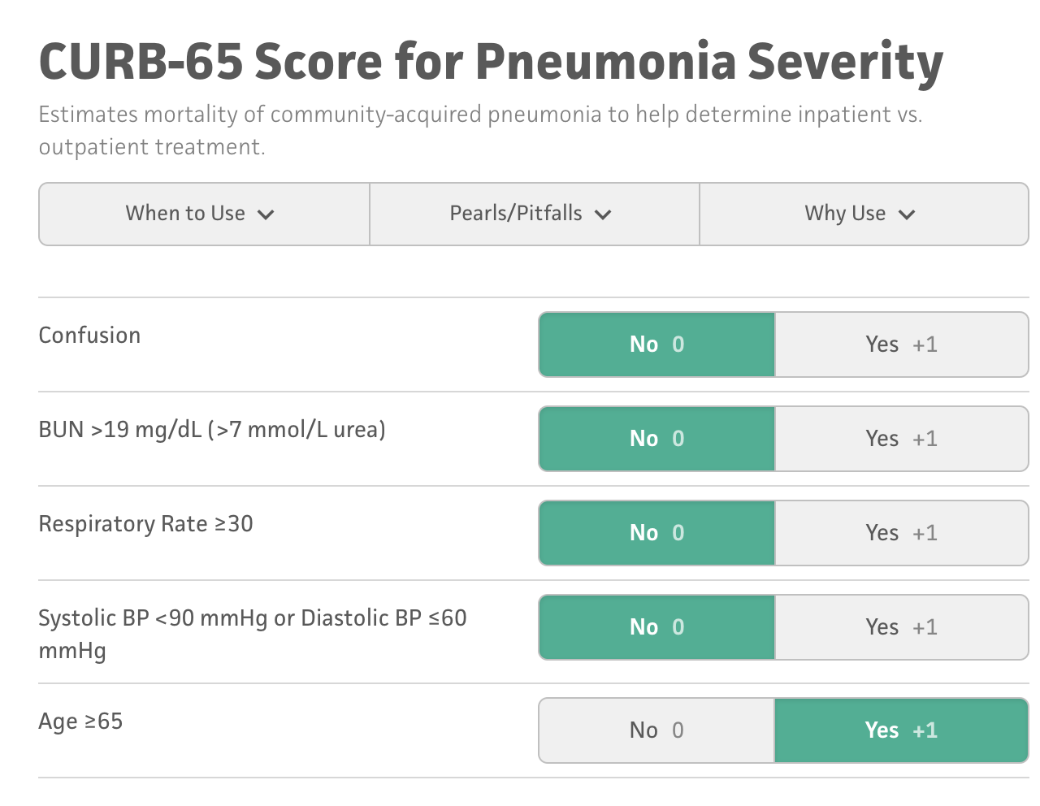  CURB-65 is a scoring system used to assess the severity of community-acquired pneumonia and guide decisions regarding hospitalization or intensive care.  CURB-65 Criteria:  - C: Confusion (new disorientation in person, place, or time)  - U: Urea > 7 mmol/L (20 mg/dL)  - R: Respiratory rate ≥ 30 breaths/min  - B: Blood pressure (systolic < 90 mmHg or diastolic ≤ 60 mmHg)  - 65: Age ≥ 65 years  Scoring and Management:  - 0–1 points: Low risk, outpatient treatment.  - 2 points: Moderate risk, consider hospitalization.  - 3–5 points: High risk, consider ICU admission or aggressive treatment.
Physical Exam Findings | - Respiratory rate often increased  - Wheezing or crackles on auscultation  - Hypoxia may be present  - Possible lymphadenopathy  - Signs of respiratory distress (use of accessory muscles) | - Respiratory rate often increased  - Dullness to percussion (if pleural effusion is present)  - Bronchial breath sounds  - Crackles or rales on auscultation  - Possible decreased breath sounds in affected areas
Diagnostic | - Chest X-ray (may show bilateral interstitial infiltrates or a "ground-glass" appearance)  -spirometry  - PCR testing for viral pathogens  - Nasopharyngeal swab for rapid viral testing  - Serology for specific viruses if necessary | 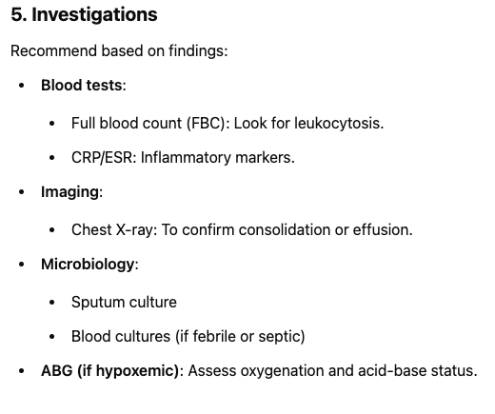- Chest X-ray (may show lobar consolidation or cavitary lesions)  -spirometry  - Sputum culture and sensitivity  - Blood cultures (especially in severe cases)  - Complete blood count (CBC) showing leukocytosis, often with a left shift  - Urinary antigen tests for Streptococcus pneumoniae and Legionella pneumophila  If deciding re: hospitalization:  BUN, CBC, glucose, lytes, LFTS, ABGs, CREA (esp if >65 or coexisting illness)  Consider PRN:  -Rapid antigen test: influenza A/B -Blood cultures Sputum C&S if resistance  -Nucleic Acid Amplification (NAA)  -TB Procalcitonin (biomarker for acute infection) to indicate illness severity, direct tx.
Differential | - Other viral infections (bronchitis, influenza)  - Bacterial pneumonia  - Allergic bronchitis  - Asthma exacerbation  - Pulmonary embolism | - Viral pneumonia  - Lung abscess  - Pulmonary embolism  - Lung cancer  - Tuberculosis  - Interstitial lung disease
Red Flags | -Severe respiratory distress  - High fever > 38.5°C  - Rapidly worsening symptoms  - Signs of dehydration  - Persistent vomiting | - Severe chest pain  - High fever with rigors  - Severe dyspnea or respiratory failure  - Altered mental status or confusion  - High risk of sepsis (immunocompromised, elderly)
Treatment | - Supportive care (hydration, analgesics, antipyretics)  - Antiviral medications ( oseltamivir for influenza) if initiated early  - Corticosteroids in severe cases to reduce inflammation | - Antibiotic therapy based on culture results and clinical guidelines  - Supportive care (oxygen therapy, fluids)  - Corticosteroids may be indicated in severe cases to reduce inflammatory response
Follow up | Monitor for improvement within 48-72 hours, reevaluate if no improvement or worsening symptoms. If respiratory distress or hypoxia persists, consider hospitalization. | -Repeat chest x ray (usually in 4 weeks) IF NOT RESPONDING TO TREATMENT  -Follow up to assess treatment response, re-evaluate if symptoms persist or worsen. Repeat imaging may be necessary if initial treatment fails.
Referral? | Referral to a specialist may be needed for severe cases, immunocompromised patients, or if complications develop (secondary bacterial infection). | Referral to a pulmonologist or infectious disease specialist for complicated pneumonia, empyema, or failure to respond to outpatient treatment. Consider hospitalization for severe cases.

Tuberculosis
Def’n | Infectious disease most often of the lungs  But can involve multiple organs such as lungs, liver, spleen, lymph nodes, kidney, brain, eyes, bone
Pathology/Cause | Caused by air-borne Mycobacterium tuberculosis, mycobacterium bovis  -TB bacilli travels to pulmonary lymphatic and vascular system and spreads  -incubation period from infection to positive skin test is 2-10 weeks  Infection progressive primary TB: when immune system is not capable  of containing the bacilli with pulmonary macrophages  Post Primary (reactivation) TB: when initial infection is contained by pulmonary macrophages but infection results due to compromised T-cells.
Risk Factors/Epidemiology | -close contact with recently diagnosed  -immigrants and travellers from countries with high incidence  -homeless  -indigenous  -occupational exposure (shelters, correctional facilities, long term care)  -drug users  -AIDS, HIV,transplant organ, CKD dialysis, carcinoma on head or neck,  -treatment with glucocorticoids, TNF-a, DM, underweight, smoker, alcohol
Clinical Presentation | -Cough for >3 weeks and can be productive or bloody  -Unexaplined weight loss/night sweats  -fever  -fatigue  -chest pain  -SOB  unknown fever, malaise, significant weight loss, cough, night sweats, chills, haemoptysis, fatigue,  -CXR- adults there is usually radiographic presentation in apices of lung
Hx/Key Questions | -when did the symptom onset, duration, course of illness  -were you exposed to someone with TB?  -recent weight loss?  -what is your living situation and socioeconomic location? Where have you travelled to?
Physical Exam | Record: temperature, RR, pulse, O2, BP, weight  Inspect: overall appearance, skin pallor,  Auscultate: lungs and heart  Percuss chest  Palpate- lymphadenopathy the posterior cervical and supraclavicular nodes  Check for splenomegaly and nuchal rigidity  Meninigits!!!!! To r/u milliary TB  -weakness and malaise, weight loss, fever and night sweats  -Harsh dry “brassy” cough caused by airways compression  -At first minimally productive of yellow or green mucus  -later on mucus turned purulent, blood-streaked  As disease progresses the cough becomes more productive  Infiltrates can be found in any part of the lung, with pleural effusion often
Diagnostics/Labs | 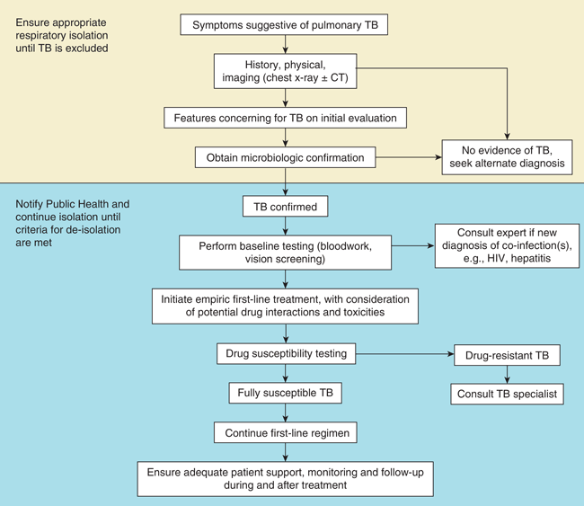  Initial Screening Tests  - Chest X-ray: First imaging study to look for evidence of TB infection, including cavitary lesions, nodules, or infiltrates in the upper lobes. In people with HIV, the presentation may be atypical, or imaging may appear normal even if TB is present.  Microbiologic Testing  - Sputum Sample Collection:  - Sputum for Acid-Fast Bacilli (AFB) Smear: Obtain at least three sputum samples, ideally one collected early in the morning. A positive AFB smear suggests TB, though smear-negative cases can still have active TB.  - Sputum Culture: Culture remains the gold standard for TB diagnosis, allowing detection of Mtb and drug susceptibility testing (DST). It typically takes 2–6 weeks to yield results.  - Nucleic Acid Amplification Test (NAAT): Rapid test performed on sputum or other respiratory samples. Positive NAAT confirms TB, and it is highly sensitive in smear-positive cases but less so in smear-negative cases. Negative NAAT doesn’t rule out TB.  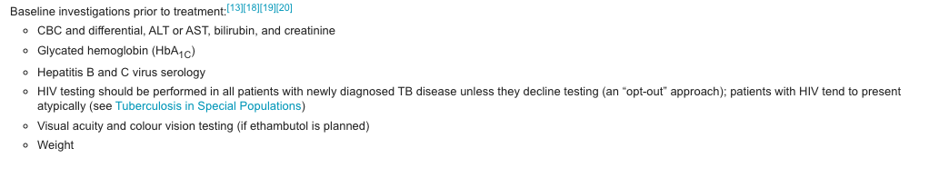  Skin test, IGRA, sputum if bloody/fever/night sweats/weight loss, xray  2 tests to identify TB infection: *Looking at redness and induration*  -Tuberculin skin test (TST)-injection of purified protein derivative (PPD).  -if previously infected a delayed hypersensitivity reaction will occur in 48-72 hours and cause localized swelling and induration, check for antibodies. Can't detect between active or latent. You should be palpating TB test to feel the induration as it's not always visible (doesn’t matter about redness or a mild skin reaction, it is specifically the induration only)  Positive test:  - Greater than 10mm;  - If child/hx HIV: 5mm  We do a 2 step due to high potential for false negatives  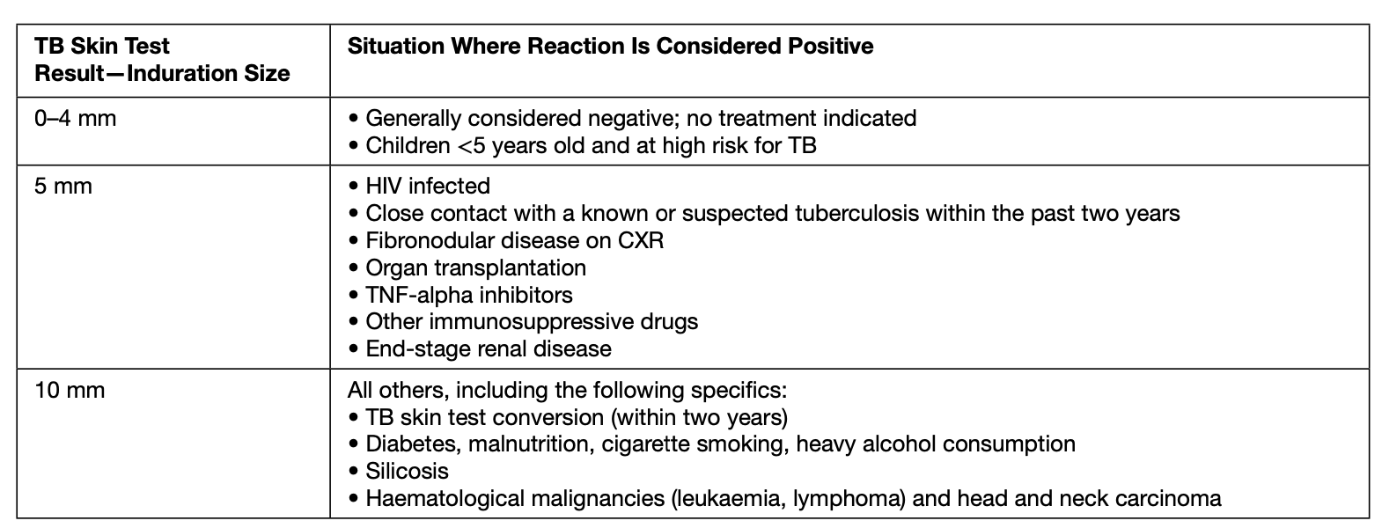  -Interferon-gamma release assay (IGRA)  - detect interferon gamma released by a persons T cells following stimulation by exogenous antigens. Cant detect between active and latent.  - Preferred in children who have already had a BCG vaccine or if someone is unlikely to return for reading  (Quantiferon-TB gold) this is the IGRA test available in Canada  NAAT (nucleic acid amplification test)- shouldnt be used for monitoring treatment or determining contagiousness.  Sputum culture-acid- fast bacilli (M tuberculosis) are seen in sputum (definitive diagnosis can only be made by a culture)-three samples  Sputum smear microscopy and culture test  Bronchoscopy  CXR-used for everyone that is high risk, not specific  Monitor renal and hepatic labs  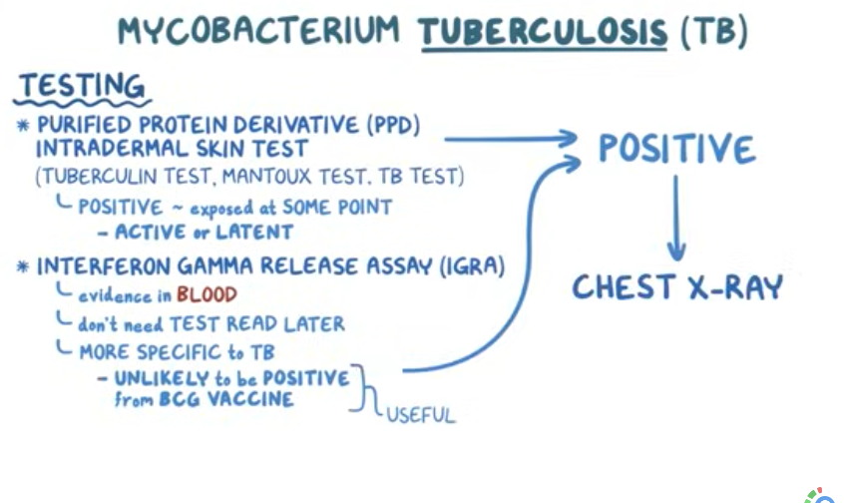
Red flags | Pnuemothorax, resp failure, meningitis, military systemic TB
Differential Diagnoses | -bronchiectasis, asthma, COPD,histoplasmosis, coccidioidomycosis, blastomycosis, malignancies, pulmonary infections, aspiration pneumonia
Treatment/Management | Treatment: isoniazid, vitamin B6  Counselling/Education: educate clients regarding compliance to therapy, adverse effects of medications  Breastfeeding is safe during treatment  Non-pharm therapies:
Referrals | Mandatory to report all TB cases to public health***  Consult TB or Infectious Disease Specialist  Pregnant clients must go to TB specialists
Follow-up | -Regular follow up q 4-8 weeks to ensure compliance and to monitor the adverse effects and response to medication.  -repeat CXR after 2-3 months to observe the response to treatment

ACUTE BRONCHITIS/TRACHEOBRONCHITIS
Description | Inflammation of the large airways (tracheobronchial tree); nearly always self-limiting in otherwise healthy patients
Pathology | In adults: 90% viral  In children: almost ALL cases are viral  Can be caused by infectious, allergens, or irritants
Epidemiology | More common in the fall and winter  - Seen more in children < 5 and men > women
Risk Factors | Infection with adenovirus, influenza, parainfluenza viruses, and RSV  - Viral infection, URI, smoking, cigarette smoke exposure, other irritants, allergens, and GERD/chronic aspiration
Screening
Clinical Presentation  (Subjective Symptoms & Objective Signs) | HALLMARK: clinical course 10-14 days. A dry, hacking or raspy-sounding cough that is first dry then loosens and becomes productive. Can last >3 weeks in viral cases  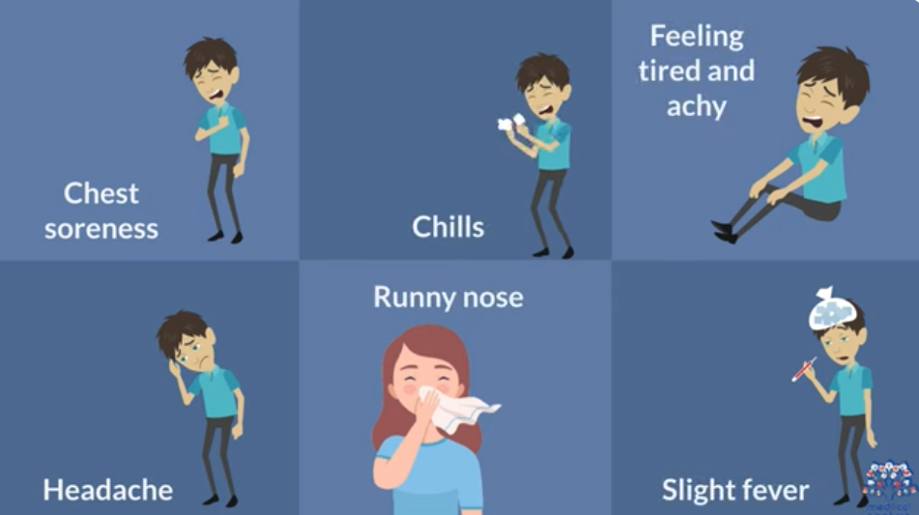  Caused by virus!!!!  Common findings:  - A cough that lasts 1-3 weeks and can present with or without phlegm  - Purulent sputum is NOT an indicator of bacterial cause  - Sore throat, rhinorrhea/congestion, low-grade fever, malaise, retrosternal pain during deep breathing and coughing, decreased or lack of appetite  - Absence of High Fever: Patients rarely have a high fever. A mild fever is possible, but a high, persistent fever might suggest pneumonia.  - NO CRACKLES, instead may see wheeze the clears with coughing  Other signs and symptoms:  - IN CHILDREN: Fever is expected as part of viral or bacterial illness  - Consider pneumonia in children if they are breathless, tachypneic
Hx/Key Questions | OPQRST?  - Is it productive, is there substernal discomfort? Is there malaise/fever?  - Is there a history of smoking or exposure to smoke?  - Review occupational history and review for GERD symptoms
Physical Exam | VITALS: temp, pulse, BP  INSPECT: overall appearance, eyes/ears/nose/throat (pharynx)  - Transilluminate the sinuses  PALPATE: lymph nodes & maxillary/frontal sinuses  AUSCULTATE: lung fields for adventitious sounds *crackles and wheezes  - Likely to hear diffuse rhonchi with expiration  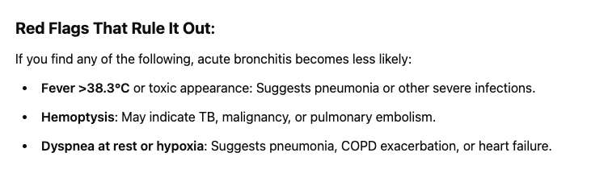  MILD WHEEZE THAT CLESRS WITH COUGHING
Red Flags | Need to rule out pneumonia (higher risk in the elderly)  - HR >100, RR >24, oral temp >38  - Chest examination: focal consolidation like rales or egophony or fremitus
Differential Diagnosis | Pneumonia, URI, asthma, sinusitis, cystic fibrosis, aspiration, resp tract abnormalities, foreign-body aspiration, COPD and emphysema, pertussis in pediatric patients  Chronic bronchitis in adults= excess mucus secretion with chronic recurrent or productive cough 3 successive months/year food 2 consecutive years
Diagnostics:  Labs & Imaging | Laboratory tests  - If done would see WBC elevation, but not required  Diagnostic tests and/or Imaging  - Consider chest x-ray to rule out pneumonia depending on presentation  - If bronchitis, would be negative  - May potentially culture sputum
Treatment/ Management | Counseling/Education  - Children may have repeated episodes that last 4+ weeks and may be considered chronic with no consensus on specific diagnostic criteria  - Evaluate these children for asthma, cystic fibrosis, dyskinetic cilia, foreign-body aspiration, and irritant exposure  - Children can continue to go to school unless they develop a fever  Complementary Therapies (non-pharmacological)  - Increased hydration and humidity to manage the cough
Medical management | - Antibiotics are not useful in acute bronchitis, especially in smokers  - Antitussive over expectorant (no cough/cold meds in pediatric patients)  - Generally, use supportive measures and ensure oxygenation is maintained
RTC or call for help… | Cyanosis, shortness of breath at rest, signs of inadequate oxygenation
Referrals | If they are in respiratory distress or if you suspect pneumonia
Follow-up | They should come back if they don’t improve in 48 hours
1° and 2° Prevention | Primary prevention: reduction of risk factors (smoking cessation, avoid second-hand smoke)  - Encourage annual vaccinations
References | MUMS, Cash & Glass, Myrick & Karosas, Dains et al

ASTHMA
Description | Airway inflammation, intermittent airflow obstruction secondary to increased smooth muscle tone, and bronchial hyperresponsiveness. Episodes associated with widespread, variable, and often reversible obstructions when exposed to stimuli or triggers  4 Categories…  - Mild intermittent→ </= 2 symptom events per week (<2/month at night)  - Normal PEFR between attacks  - PEFR >80% with variability <20%  - Mild persistent→ symptoms less than 1/day but more than 2x/week  - May affect activity  - Nighttime symptoms occur more than twice per month  - PEFR 80+, and variability 20-30%  - Moderate persistent→ daily symptoms requiring a beta-2 agonist  - Attacks affect activity  - 2+ exacerbations per week with nighttime symptoms more than once per week  - PEFR 60-80% with >30% variability  - Severe persistent→ continuous symptoms limiting physical activity  - Frequent exacerbations, frequent nighttime symptoms  - PEFR 60% or less with over 30% variability  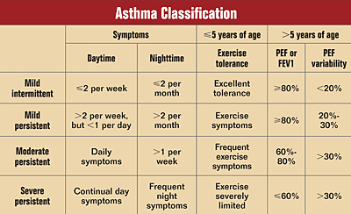
Pathology | Airway inflammation from irritants that progresses to hyperresponsiveness, bronchoconstriction, airway wall edema, chronic mucus plug formation, and chronic airway remodeling
Epidemiology | Affects 3.8 million Canadians, the most common chronic disease of childhood  - Associated with persistent rhinitis, GERD, and obesity  - Can present at any age but typically before 40 with symptoms first appearing in childhood; consider between age 1-5 if key symptoms
Risk Factors | CHILDREN  - Allergy or family history of it, male, atopy  ADULTS  - Family history, co-existing sinusitis, nasal polyps, sensitivity to ASA and other NSAIDs  - Workplace exposure to wood, dust, metals, animal products  - Premenstrual asthma, female, comorbidities in older adults  ALL AGES  - Inhalation of irritants like tobaccos; viral resp infection, GERD, obesity  TRIGGERS  - Allergen exposure, viral URI, exercise, foods, hormones, reflux, stress  - Medications  - Beta blockers, ACE, ASA, COX inhibitors  - Situational  - Cold air, laughter, strong odors, air pollution, smoke, pregnancy
Screening/  Diagnostic Protocol | When diagnosing children under 6, use clinical judgment and symptom assessment along with history and physical examination…  - Severe wheezing or dyspnea, occuring after 1 year of age  - 3+ episodes of wheezing or history of recurrent respiratory symptoms  - Chronic, non-productive cough at night or with exercise  - Clinical benefit from SABA or ICS medications  - Family history of atopy and asthma; personal hx of atopy
Clinical Presentation  (Subjective Symptoms & Objective Signs) | HALLMARK: a recurrent cough that is worse at night and in early morning, recurrent wheezing/SOB, dyspnea. Airflow limitation is usually episodic and completely reversible with therapy. FEV1 is normal between exacerbations in well-controlled asthma.  Common findings:  - Wheezing, chest tightness, dyspnea, cough, infrequent sputum production  - Recurrent cough worse early AM and night, with cold air, and exercise  Other signs and symptoms:  - Nocturnal awakening from symptoms  - Variation of symptoms across seasons or environments  - Chest discomfort, tightness, with moderate activity  - Hypoxemia is rare and unusual, may occur with severe exacerbations  - 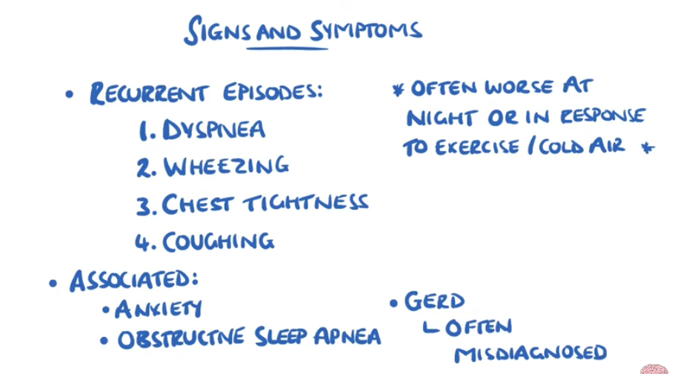
Hx/Key Questions | OPQRST? Full medication history  - Sudden, severe episodes of coughing, wheezing, and SOB and if triggers/precipitating factors were identified  - Do chest colds take longer than 10 days to resolve?  - Smoking history  - Seasonal or irritant exposures to common allergens  - Are they awoken in the night (important question for peds), does it affect physical activity  - Are they pregnant? Do they have any other medical problems?  - Have they ever been tested for allergies? Have they ever gone to ED for an asthma attack?  Administer the asthma self or parent-reported control check
Physical Exam | VITALS: temperature, BP, pulse, respirations, oxygen  - Measure height and weight for BMI due to association with obesity  INSPECT: for hyperexpansion of the chest, signs of accessory muscle use, deformities (hunched shoulders, chest deformity), inspect nose for foreign body  - ENT, tonsils, adenoids, nasal polyps  - Skin for eczema, dermatitis, or other signs of allergies  - Observe for allergic shiners and pebbled conjunctiva  - Look for digital clubbing  AUSCULTATE: lung sounds for wheezing during expiration (normal and prolonged) that is common with asthma  - Listen for an asymmetric wheeze  - Auscultate the heart as well  PERCUSS: lung fields
Special Tests | GOLD STANDARD= Spirometry  - If not available or under 6, can use peak flow meter measurements  - Evaluate FVC and FEV1 before and after inhalation of a short-acting bronchodilator  - Diagnose if the FEV1 is improved by 12+ % post-inhaler  - If using Peak expiratory flow rate (PEFR) diagnosis is confirmed if  - 20% increase after 15-20 minutes from SABA use  - PEFR varies >20% between arising and 12h post in clients taking bronchodilators  - If there is a >10-15% decrease in FEV1 post exercise  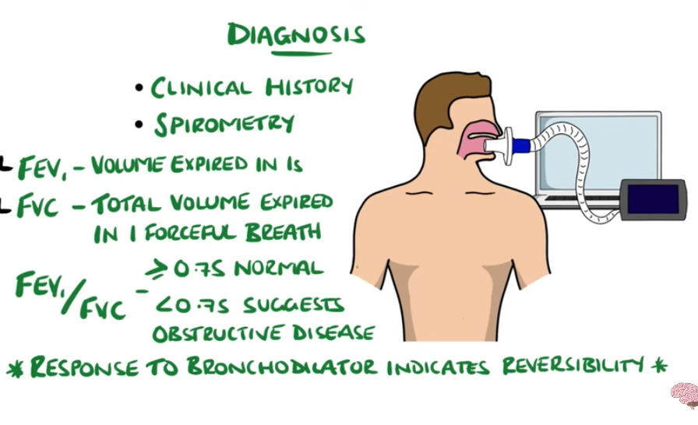  Allergy testing suggested for peds if persistent asthma  Peak flow; same time every day when well to monitor asthma control  - 80-100% is the target and is considered good control  - 50-80% is a caution to slow down  - <50% is considered a medical emergency
Red Flags | Effect on QOL, silent chest to auscultation, tripod position breathing  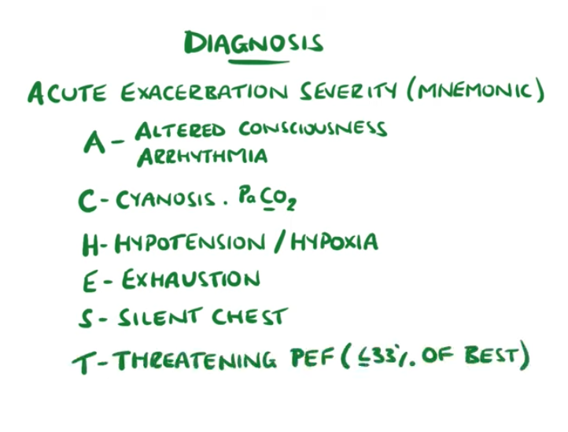
Differential Diagnosis | In infants and children→ pulmonary infection (pneumonia, RSV, viral bronchitis, TB), allergic rhinitis/sinusitis, foreign body, GERD, cystic fibrosis, pulmonary dysplasia, vocal cord dysfunction, enlarged lymph nodes/tumors  - The younger the patient, the more likely a diagnosis BESIDES asthma will explain the wheezing  In adults→ COPD, GERD, CHF, secondary to ACE-i or beta blockers, pneumonia, PE, laryngeal dysfunction, tumors, vocal cord dysfunction
Diagnostics:  Labs & Imaging | Laboratory tests  - Spirometry!  - CBC can be used to rule out other diagnoses/infection  Diagnostic tests and/or Imaging  - CXR can be used to rule out other diagnoses/infection  - Usually not required, normal unless experiencing acute exacerbation  - Recommend allergy testing in children with persistent asthma  - If spirometry is non-diagnostic, then can consider doing a bronchial provocation test with histamine or metacholine
Treatment/ Management | Counseling/Education  - Demonstrate correct use of inhalers  - Stress importance of PEF monitoring at home to monitor disease progression  - Inhaled flu vaccines should not be used in asthmatic children  Complementary Therapies (non-pharmacological)  - Identify allergens and triggers and develop avoidance plans  - Smoking cessation or avoid passive exposure to smoke  - Develop an asthma action plan  - Educate about symptom recognition and evaluation  - Review inhaler techniques  - Benefits of influenza and pneumococcal vaccinations
Medical management | This is all thera… not making notes on this right now
Advise clients when to RTC or call for help | Hospitalization if not completely responsive to treatment for acute episodes within 1-2 hours
Referrals | To a specialist if severe asthma, inadequate response to standard care, or for add-no therapy. Consult specialists with pregnant clients (risk of uncontrolled disease). Other times to consider…  - Atypical presentation, uncertain or asthma/COPD overlap, recent ED visits, not meeting goals after 3-6 months of treatment, high-dose corticosteroid inhalers required, comorbidities, suspected anaphylaxis or food allergies, requiring extensive education or counseling, candidates for biologic therapy  - Refer children with an unclear diagnosis, symptoms from birth or from perinatal lung problems, excessive vomiting, persistent wet or productive cough, family history of atypical chest disease, failure to thrive, unexpected clinical findings, and requiring high-dose steroids or frequent hospitalizations
Follow-up | - After acute episodes, follow up next day or sooner to monitor improvement until stable  - If clients have mild intermittent or mild persistent asthma  - Once under control for at least 3 months, follow up q 6 months for education and reinforcement
1° and 2° Prevention | Primary prevention: avoidance of triggers
References | MUMS, Cash & Glass

Spirometry
The recommended method of measuring airflow limitation and reversibility to establish an asthma diagnosis. Uses FEV1
- 12+% (preferably 15%) and 200+mL improvement in FEV1 from baseline 15 minutes after using a SABA inhaler
- Asthma/COPD overlap syndrome diagnosis uses 12% and >400mL on top of fixed obstruction to diagnose
Most patients with not exhibit reversibility at each assessment, especially if on treatment…
- Test lacks sensitivity
- Repeat at different visits for optimal measurements
Peak Expiratory Flow
Not preferred for establishing the asthma diagnosis (not a substitute for FEV measures)
- Can underestimate the degree of limitation especially when the condition is worsening
If spirometry is not available, diagnose asthma when…
- 20% or more from prebronchodilator PEF improvement after use of the SABA inhaler
- OR, diurnal PEF variability >20% (with twice daily readings, more than 10%)
- Take measures first thing in the morning for monitoring asthma
Airway Hyperresponsiveness Methacholine Challenge Test
Useful to measure airway hyperresponsiveness when the diagnosis of asthma is in doubt (e.g., history suggests but spirometry is normal)
- Effective at ruling out asthma if negative when symptomatic (positive can be caused by several other diseases)
- Performed in a specialty pulmonary function lab
Measurement of Allergic Status
Using allergy skin testing to consider when there is a suspected association between asthma occurrences and allergies
Severe Asthma
Common to refer these individuals to an asthma specialist
- Consider inhaler technique, compliance, comorbidities, occupational/home environment
Use biomarkers like sputum, blood eosinophil count, and fractional exhaled nitric oxide to aide in diagnosis and treatment
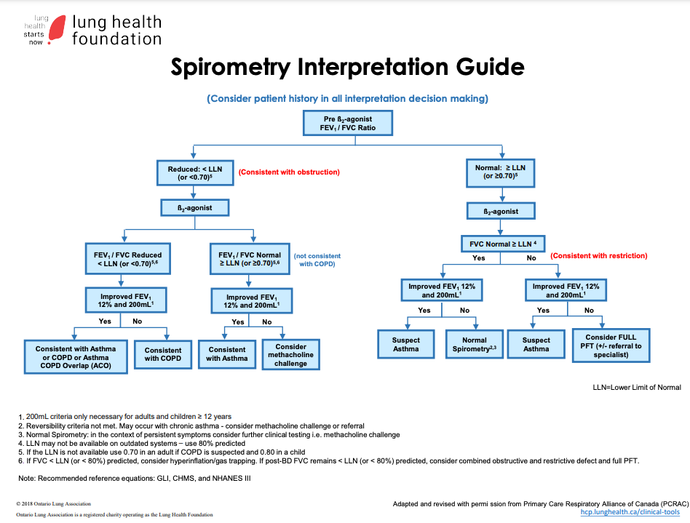
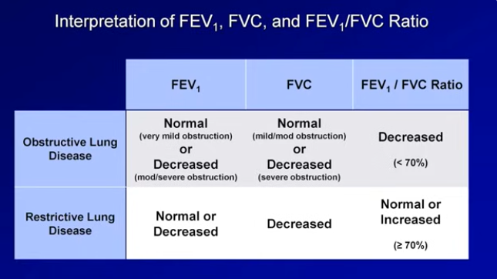
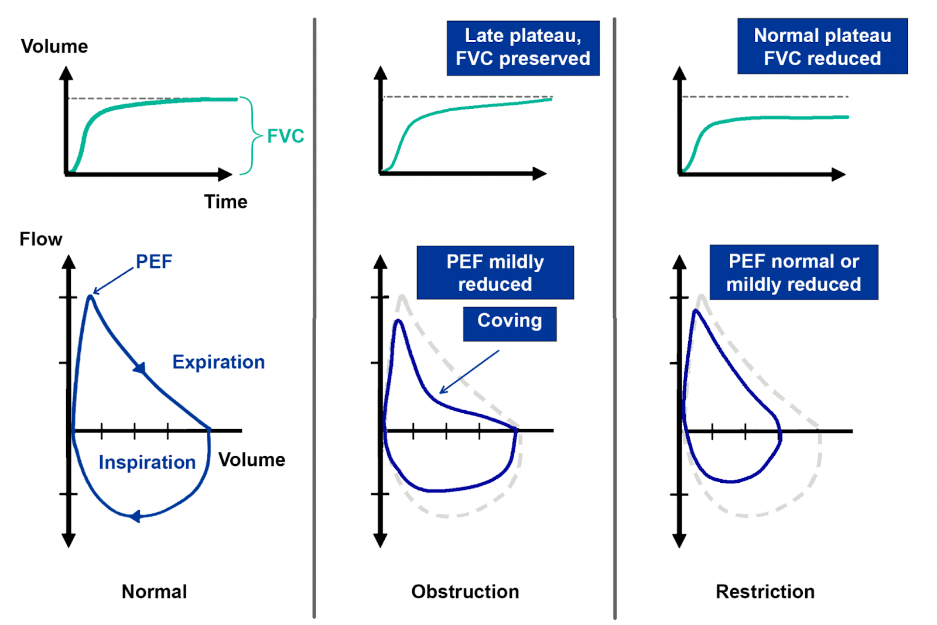
If values are abnormal with spirometry, consider…
- Gender (lung volumes are larger in males)
- Non-caucasians can have smaller lung volumes and lower predicted values
- Age (lung volume decreases with age; caution with interpretation from patients <20 and >70)
- Extremes of height patients may have abnormal readings (Use measured heights as opposed to patient reported heights)
- Volume measurements may be lower when supine (have patients in an upright posture)
Spirometry interpretation algorithms (SIAs): there may be differences in suggested interpretations and treatments between versions

COPD
Description | Progressive, chronic, expiratory airway obstruction. Some degree of reversibility to the bronchoconstriction from inflammation. Can be in smokers or those with a1 antriptan deficiency  Chronic bronchitis= A chronic productive cough lasting 3+ months during 2 consecutive years after all other causes of cough have been eliminated.  Emphysema= abnormal, permanent enlargement and destruction of the alveolar air sacs and e lastic recoil of the lungs  Asthmatic patients with complete reversibility do NOT have COPD; when there is not complete reversal of airflow obstruction in asthma patients, consider Asthma/COPD overlap
Pathology/cause | 90% of COPD cases are the result of prolonged tobacco smoking.  Chronic bronchitis→ airway narrowing and increased resistance. Mucus gland enlargement is the hallmark  Emphysema→ loss of the air sac elastic recoil causes air trapping and barrel chest.  Mild COPD= SOB when hurring on a constant level or walking up a slight hill  - FEV1 80% predicted  Moderate COPD= SOB causing clients to stop after walking about 100m on a constant level  - FEV1 50% up to <80%  Severe/very severe COPD= results in the client being too breathless to leave the house, breathless when getting dressed, or chronic respiratory failure or signs of right heart failure  - FEV1 30-50% predicted (FEV1/FVC of less than 0.7)
Epidemiology | 4.4% of the population in Canada age 35+ has been diagnosed with COPD. Third leading cause of death in Canada, #1 cause of hospitalizations. Prevalence is higher in women before age 75, then it is higher in men.  - Onset usually after age 40
Risk Factors | - Cigarette smoking (especially if >10 pack years), occupational/ environmental/atmospheric pollutants  - Dust, chemical fumes, second-hand smoke, air pollution  Genetics→ alpha-1 antitrypsin deficiency causes emphysema-type COPD
Screening | Suspect COPD in individuals over 35 who are current or past smokers, with the following…  - Persistent cough and sputum production  - Frequent or persistent respiratory tract infections  - Progressive, activity-related shortness of breath  - Significant occupational exposure to respiratory irritants  - Initially thought to have asthma but not responding optimally to therapy
Clinical Presentation  (Subjective Symptoms & Objective Signs) | Cardinal triad: dyspnea, chronic cough, and sputum production.  HALLMARK: dyspnea with exertion that progresses to dyspnea at rest. A slow, cumulative, progressive disease associated with frequent exacerbations. KEY= shortness of breath and activity limitations  3 CORE clinical findings: worsening dyspnea, increase in sputum purulence and sputum volume  CB: mucus for at least 3 months of the year for 2+ years  Common findings:  - Chronic cough and sputum that is worse in the morning  - Wheezing, difficult speaking or performing tasks  - Weight loss or a decrease in fat-free mass  Other signs and symptoms:  - Pursed lip breathing to induce auto-peeping  - Use of accessory muscles, tripod position, barrel chest, cyanosis  - Tachypnea, tachycardia, distended neck veins  - Abnormal, diminished, or absent lung sounds  - Mental status changes, anxiety and depression  - Pulmonary hypertension, cor pulmonale (right heart failure), or left HF
Hx/Key Questions | - DO YOU SMOKE, family hx, envio erritants  - Genetic disorders? Alpha 1 antitipan!  - Past respiratory problems or infections (fever, chills or other systemic signs)  - OPQRST of situation and sputum  - Determine smoking history, occupational and environmental irritants  - How far can they walk before becoming breathless? When do the symptoms occur?  - Innsomnia, anxiety, restlessness, edema, weight changes  - How many pillows at night- do they have to sleep sitting upright?  - Assess ability to perform ADLs  - Alcohol use, medications  Determine a pattern of symptom development; history of exacerbations, hospitalizations for respiratory complaints, social and family supports, review possibilities for reducing risk factors  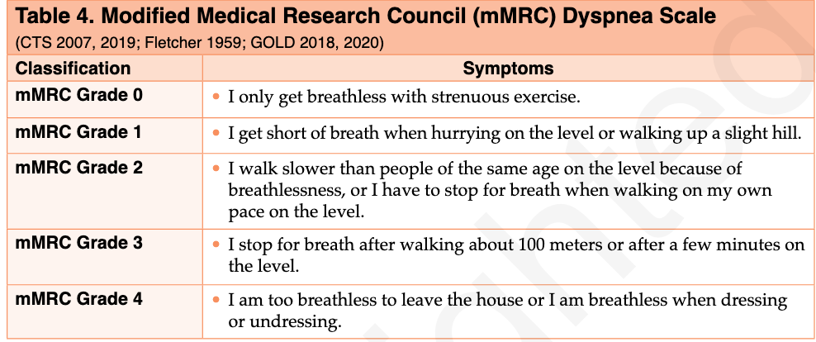  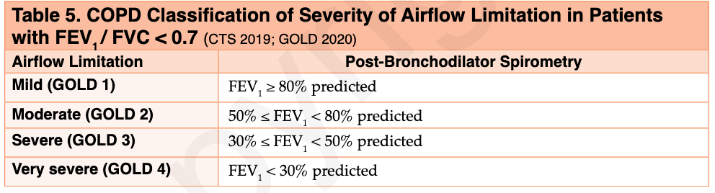
Physical Exam | VITALS: temperature, BP, pulse, respirations, oxygen (RR will increase proportionally to disease severity)  - Take height and weight to calculate BMI  - Early in disease, examination may be mostly normal  INSPECT: general appearance, skin colour (may see grayed mucous membranes), posture, gait, respiratory effort with walking, anteroposterior chest diameter (barrel chest)  - Sputum (frothy pink= pulmonary edema)  - Lips/fingers/nose for cyanosis (finger clubbing is not seen with COPD)  - Neck for distended veins and peripheral edema in advanced disease  - Look for pursed-lip breathing and use of accessory muscles  - Inhalation vs exhalation time→ in COPD, exhalation may be up to 4x longer, rather than the usual 2x  AUSCULTATE: heart, lungs, vocal fremitus (vibration) and egophony (increased resonance and high-pitched bleating quality), carotid arteries  - Air trapping causes pockets that don’t transmit sound well  - COPD= absent ventricular lung sounds or decreased breath sounds overall  - May also hear early inspiratory crackles  - 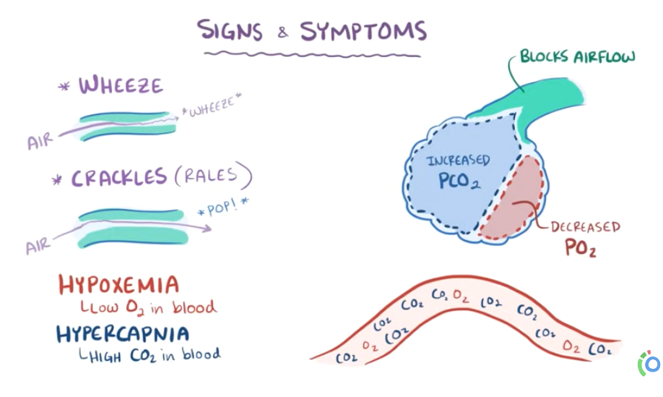  - 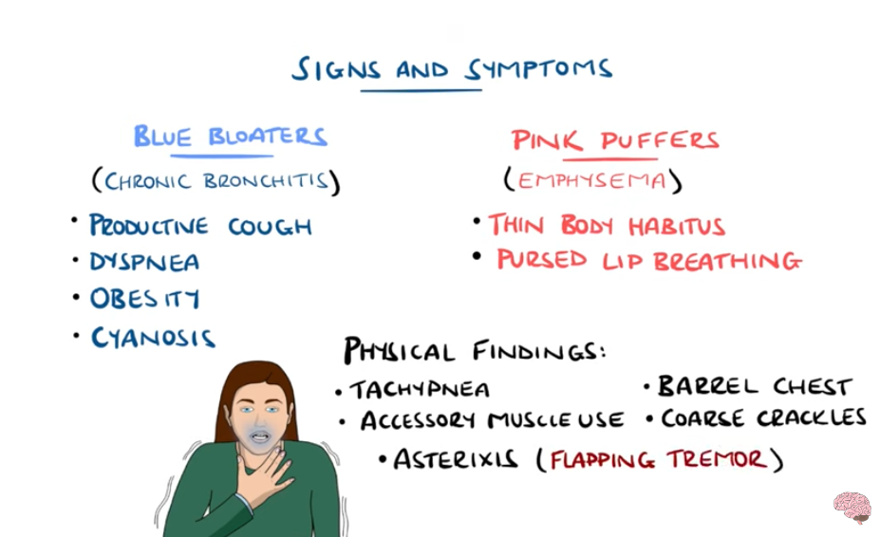  PERCUSS: chest for hyperresonance and signs of consolidation  PALPATE: neck for lymphadenopathy, chest, abdomen for organomegaly, pedal edema, tactile fremitus (decreased)  MENTAL STATUS: decreased level of consciousness  6-minute walking distance test to evaluate for oxygen desaturations  *Further examinations depending on comorbidities
Diagnostic/  Special Tests | GOLD STANDARD= spirometry (FEV1 and FEV1/FVC ratio)  - Therapy rarely causes improvements in spirometry results  - 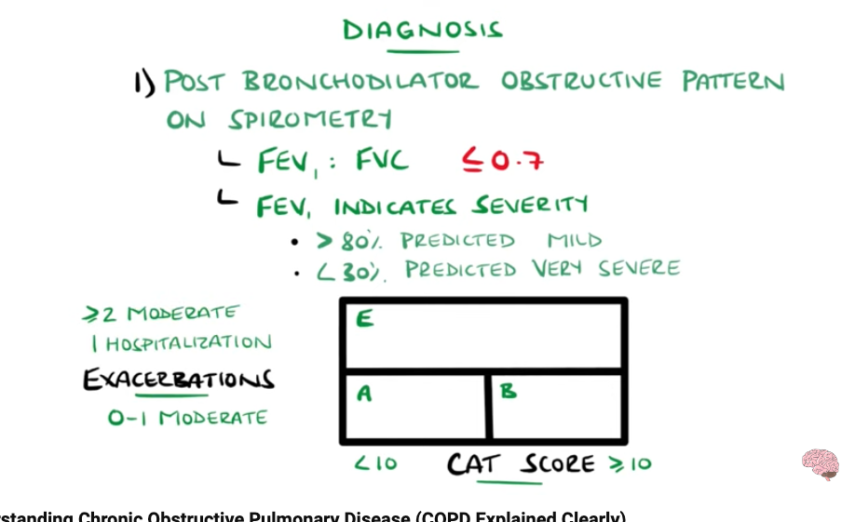  Pulmonary function tests→ used to diagnose, determine severity, and follow disease progression of COPD  - Perform spirometry before and after using a SABA to determine degree of restriction reversibility  - FEV1 is used to determine prognosis in emphysema  - A fixed FEV1/FVC ratio less than 0.7 or less than the Lower Limit of Normal (LLN) aka below the lower 5th percentile from the reference value for a healthy population, indicates COPD  If you think infection consider xray  CAT (COPD Assessment Test)--> measures impact of COPD on pts health status  - 0-10: Low impact of symptoms (mild COPD)  - 11-20: Medium impact (moderate COPD)  - 21-30: High impact (severe COPD)  - 31-40: Very high impact (very severe COPD)  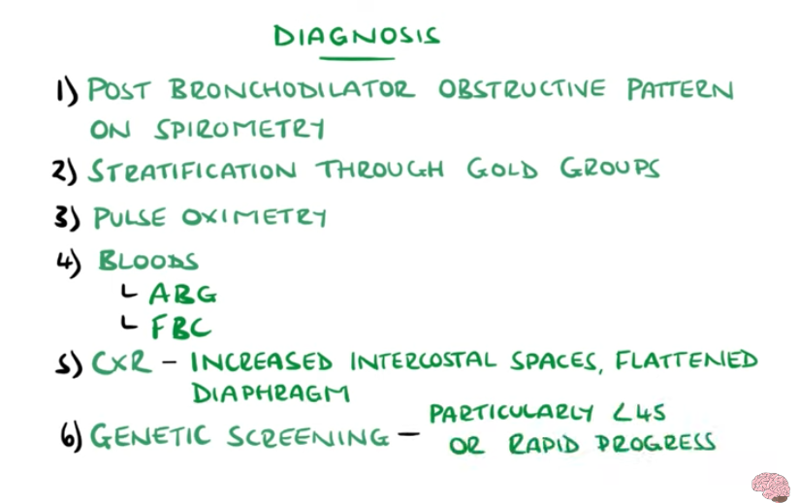  - 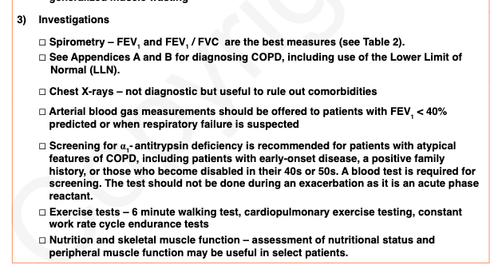
Differential Diagnosis | Asthma, CHF, PE, TB, bronchiectasis, pulmonary edema, AAT deficiency, pneumonia, cystic fibrosis, cancer
Diagnostics:  Labs & Imaging | Laboratory tests  - CBC to assess for polycythemia from chronic hypoxia  - Sputum culture is generally not required  - AAT levels: if client is under 40 or has a family history of early onset emphysema (risk of early lung damage due to proteolytic enzyme action)  - ABG (offer if FEV1 <40% predicted or if resp failure is suspected)  - BNP if HF is suspected  Diagnostic tests and/or Imaging  - CXR can rule out other diagnoses but is not required to diagnose COPD  - Would see a low, flat diaphragm and potentially horizontal or flattened ribs  - ECG to assess for tachycardia and atrial arrhythmias  - Echocardiogram to evaluate for secondary pulmonary hypertension
Treatment/ Management | Counseling/Education  - Encourage client involvement in plan of care; emphasize importance of treatment adherence  - Assess for malnourishment and suggest a low-carbohydrate diet  - High carbohydrate associated with increased CO2 production, worsens respiratory work  Complementary Therapies (non-pharmacological)  - Smoking cessation plan  - Regular physical activity and strength training as tolerated  - Influenza and pneumococcal vaccinations to decrease resp infections  - Pulmonary rehabilitation, psychosocial supports, nutrition  - 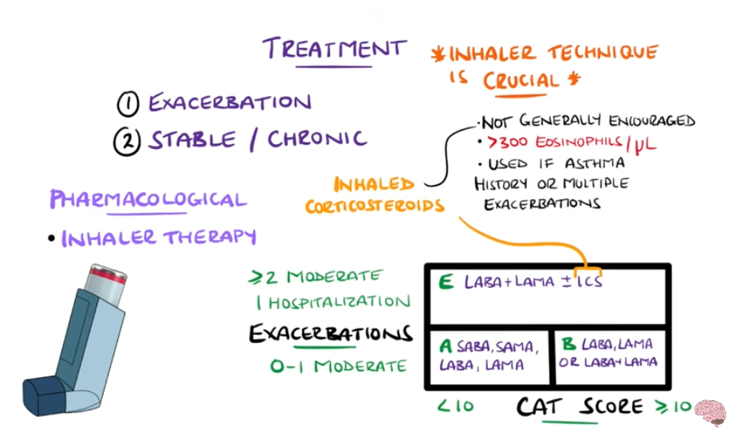
Referrals | All COPD patients should be referred to pulmonary rehabilitation  Dietician for nutritional planning  Respirologist for consultation and management of severe disease  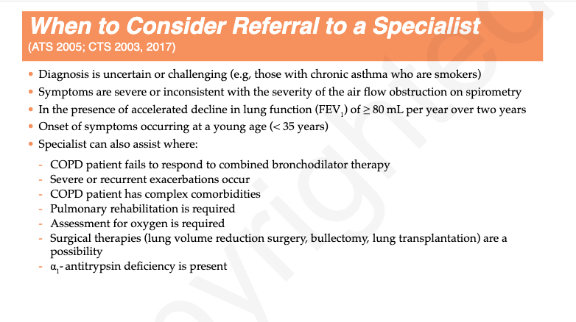
Follow-up | Same day or following day for acute exacerbations  For stable, chronic COPD→ 1-3 months depending on client needs  Re-evaluate oxygen therapy 1-3 months after starting
Common Complications | Commonly seen with other comorbidities like hypertension, cardiac disorders (Atrial fibrillation, heart failure), diabetes, GI disorders, lung cancer, depression, and osteoporosis  - Re-evaluate bone mineral density and body weight regularly  In later stages, can affect nutritional status, depression, right-sided heart failure, polycythemia, and skeletal muscle dysfunction
1° and 2° Prevention | Primary prevention: smoking cessation and immunizations to prevent exacerbations
References | MUMS, Cash & Glass

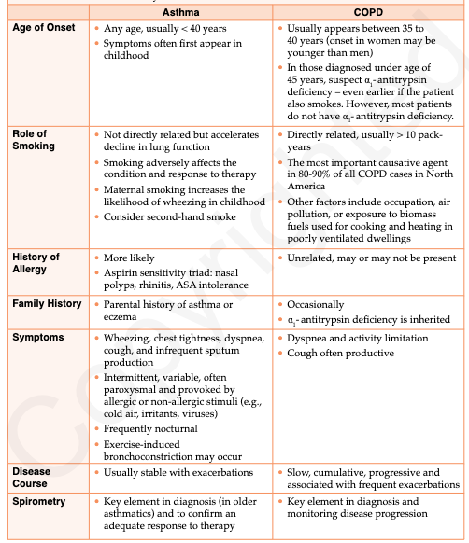
 | Asthma | COPD
Onset age | Any; usually <40 | Between 35 and 40 (if <45, suspect AAT deficiency)
Smoking | Not directly related but accelerates decline in lung function, decreases success of therapy | Directly related, especially if >10 pack year history  Most important causative agent
Allergy | More likely  Associated with the aspirin sensitivity triad (nasal polyps, rhinitis, and ASA intolerance) | Unrelated, may or may not be present
Family hx | Parental history of asthma or eczema | Occasionally; consider AAT deficiency (inherited)
Symptoms | Typically appear first in childhood  Wheezing, chest tightness, dyspnea, cough, infrequent sputum production  - Intermittent, variable, reversible  - Provoked by allergic or non-allergic stimuli  - Frequently nocturnal  - Exercise-induced bronchoconstriction | Dyspnea and activity limitations  Cough is often productive
Disease course | Stable with exacerbations | Slow, cumulative and progressive with frequent exacerbations
Spirometry | Key element in diagnosis and to confirm response to treatments | Key element in diagnosis and monitoring of disease progression
Reversibility | Usually episodic limitations that are completely reversible with therapy  - FEV1 should return to normal with treatment and between attacks  - May not return to normal with longstanding or poorly controlled asthma | Chronic, progressive airway limitation that may be partially reversible  - FEV1 reduction is significant  - Poorly responsive (assess treatment response using symptoms, not FEV1)
Hypoxemia | Unusual; episodic with severe attacks only | Chronic in advanced stages
Chest x-ray | Normal unless taken during acute attacks | Normal in early disease  May see chronic hyperinflation, increased bronchial markings  NOT diagnostic for COPD

COVID-19
Description | An urgent, rapidly spreading threat. A respiratory viral infection
Pathology/cause | Incubation period= 2-14 days (average 5-6)
Epidemiology | ●
Risk Factors | Elderly patients, immunocompromised (atypical presentation)  - Healthcare workers, transport workers  - Travel to a recent hotspot is not as relevant as early on in the pandemic
Screening
Clinical Presentation  (Subjective Symptoms & Objective Signs) | HALLMARK: difficult to pinpoint due to amount of emerging evidence as disease evolves  Common findings:  - Fever >38 (not always) that persists beyond 5 days  - Cough that is dry, but may have sputum production that persists for >5 days  - Systemic symptoms like fatigue, muscle pain  Other signs and symptoms:  - Shortness of breath, dyspnea (indicates more serious disease)  - Emerging evidence of GI symptoms being common with COVID  - Early symptoms= Loss of appetite, anosmia  Indicative of another condition NOT COVID-19…  - Nasal congestion, conjunctival congestion, and other allergic symptoms like itchy eyes  - Body aches is more indicative of influenza  Signs and symptoms in order or frequency: cough, fatigue, sputum, comorbidity pre-existing, elevated temp >37.5-38, shortness of breath, muscle aches, sore throat, headache, chills, nasal congestion, nausea and vomiting, diarrhea
Hx/Key Questions | - Incidence of key symptoms and signs  - Personal medical history  - Date of first symptom, peak of fever temperature reading, how long the fever lasted  - History of asthma or other respiratory comorbidities and if use of puffers has increased recently  - Assess breathlessness  - Ask patient to rank breathing ability  - Are they able to speak without getting breathless  - Can they still perform ADLs  - Are they breathless at rest  - Are they breathing faster  - Have their abilities changed?  - History of contact with known COVID-19 cases
Physical Exam | General assessment→ demeanor, flushing, pallor, cyanosis  Inspection→ tonsillar swelling, use of accessory muscles  Vitals→ BP, temp, pulse, respirations, oxygenation  Assess mental health→ upset or distressed?  Full respiratory and cardiac examination if able to in person
Red Flags | Breathlessness, pain or pressure in the chest, cyanosis, signs or symptoms suggesting shock (cold, clammy, mottled skin, new onset infusion, difficult to rouse, significantly reduced urine output)  Hemoptysis is a poor prognostic symptom  If pneumonia is suspected, consider sending to hospital if…  - HR >100, RR >20, temperature >38  - New-onset confusion, low urine output
Differential Diagnosis | Severe illness→ bacterial pneumonia, meningitis, sepsis  Mild illness→ influenza, mononucleosis, sinusitis, acute bronchitis, common cold
Diagnostics:  Labs & Imaging | Laboratory tests  ● PCR  Diagnostic tests and/or Imaging  ●
Treatment/ Management | Counseling/Education  - 80% of patients have mild illness, and can be managed like the flu  - Counsel on self-swabbing if indicated for the patient  - Create a “safety net” plan due to potential for significant deterioration around week 2 despite initial mild illness  Complementary Therapies (non-pharmacological)  - Rest, increase fluid intake, take OTC pain medications as needed but try to avoid NSAIDs
Medical management | Most patients can be managed remotely with advice for symptom management and self-isolation
Referrals | Respirologist if respiratory comorbidities exist
Follow-up | Required if you cannot confidently conclude that the patient has only mild illness  - Comorbidities like asthma or COPD
Common Complications | Deterioration round week 2 with development of pneumonia
1° and 2° Prevention | Primary prevention: regular hand washing with soap and water, self-isolation/limit contacts
References | Required Reading: Covid-19: a remote assessment in primary care.

COPD Health Quality Ontario

Key Quality Statements and Guidelines

1. Diagnosis Confirmed With Spirometry

Objective:

Ensure accurate diagnosis of COPD using spirometry, a lung function test that confirms airflow obstruction.

Guideline:

Patients suspected of having COPD based on symptoms and risk factors (smoking) should have spirometry testing within 3 months of the onset of symptoms.

Why It's Important:

Many people with COPD remain undiagnosed or misdiagnosed due to a lack of spirometry testing. Proper diagnosis can prevent over- or under-treatment and unnecessary anxiety.

2. Comprehensive Assessment

Objective:

Conduct a thorough assessment to understand the severity of COPD, the risk of exacerbations, and the presence of other medical conditions (comorbidities).

Guideline:

Comprehensive assessments should be done at diagnosis and repeated annually or when the patient’s condition changes. These assessments should guide care planning and treatment adjustments.

Why It's Important:

A comprehensive assessment, beyond spirometry alone, helps personalize the management of COPD and can improve quality of life by addressing broader health issues.

3. Goals of Care and Individualized Care Planning

Objective:

Align care with the patient's personal goals, including discussions about disease progression, quality of life, and advanced care planning.

Guideline:

Patients should engage in regular discussions about their goals of care with healthcare providers and their chosen caregivers. This informs an individualized care plan that is updated regularly.

Why It's Important:

Engaging patients in setting care goals leads to more personalized treatment, better patient satisfaction, and ensures that care aligns with their values and preferences.

4. Education and Self-Management

Objective:

Empower patients and caregivers to manage COPD effectively with the right education and tools.

Guideline:

Provide both verbal and written information about COPD, including symptom management, proper use of medications, and self-management plans that guide patients in handling acute exacerbations.

Why It's Important:

COPD is a long-term condition, and educating patients about their role in managing their disease can lead to better outcomes, reduced exacerbations, and improved quality of life.

5. Promoting Smoking Cessation

Objective:

Support patients in quitting smoking, as it is the primary risk factor for developing and worsening COPD.

Guideline:

Healthcare providers should ask patients about smoking at every opportunity and offer both pharmacological (nicotine replacement therapy) and non-pharmacological (counseling) cessation interventions.

Why It's Important:

Smoking cessation is the most effective intervention to slow the progression of COPD and reduce the frequency and severity of symptoms and exacerbations.

6. Pharmacological Management of Stable COPD

Objective:

Provide individualized medication plans that control symptoms and prevent exacerbations.

Guideline:

Prescribe medications based on the patient’s COPD severity and review them annually. Ensure that patients understand how to use inhalers correctly and check their inhaler technique regularly.

Why It's Important:

Proper medication management reduces symptoms and exacerbations, leading to improved patient outcomes. Incorrect inhaler use is common and can reduce treatment effectiveness.

7. Vaccinations

Objective:

Protect patients with COPD from respiratory infections that can trigger exacerbations.

Guideline:

Offer annual influenza vaccines and appropriate pneumococcal vaccinations, as these reduce the risk of respiratory infections and hospitalizations.

Why It's Important:

COPD patients are more vulnerable to infections like flu and pneumonia, which can lead to life-threatening exacerbations.

8. Specialized Respiratory Care

Objective:

Ensure patients are referred to specialized care when necessary.

Guideline:

Patients should be referred to respiratory specialists for further assessment and management when their condition requires more complex or specialized care. This should follow a comprehensive primary care assessment.

Why It's Important:

Timely referral to a specialist ensures that patients receive the appropriate level of care when needed, preventing deterioration and improving outcomes.

9. Pulmonary Rehabilitation

Objective:

Improve the physical and emotional well-being of patients with moderate to severe COPD through structured rehabilitation programs.

Guideline:

Refer patients to pulmonary rehabilitation programs if they experience activity limitations or breathlessness despite optimal pharmacological treatment.

Why It's Important:

Pulmonary rehabilitation is one of the most effective interventions for improving exercise capacity, quality of life, and reducing exacerbations in COPD patients.

10. Management of Acute Exacerbations of COPD

Objective:

Provide timely access to care when patients experience exacerbations (sudden worsening of symptoms).

Guideline:

Patients should have access to a healthcare professional within 24 hours of the onset of an exacerbation. Follow-up assessments should occur within 7 days of hospital discharge for acute exacerbations.

Why It's Important:

Early management of exacerbations can prevent hospitalization, reduce the severity of flare-ups, and improve recovery times.

11. Pulmonary Rehabilitation After Hospitalization for an Acute Exacerbation

Objective:

Improve recovery after a hospital stay due to a COPD exacerbation.

Guideline:

Refer patients to pulmonary rehabilitation programs within 1 month of hospital discharge.

Why It's Important:

Early rehabilitation post-hospitalization helps patients regain strength and reduces the likelihood of re-hospitalization.

12. Palliative Care

Objective:

Ensure that patients and their caregivers have access to palliative care when needed.

Guideline:

Offer palliative care services to meet the emotional, physical, and psychological needs of patients with advanced COPD.

Why It's Important:

Palliative care helps manage the complex needs of patients with severe COPD and improves their quality of life as the disease progresses.

13. Long-Term Oxygen Therapy

Objective:

Provide long-term oxygen therapy for patients with hypoxemia (low oxygen levels).

Guideline:

Assess patients for long-term oxygen therapy if they exhibit signs of chronic low oxygen levels.

Why It's Important:

Oxygen therapy can improve survival, quality of life, and exercise capacity in patients with severe COPD and chronic hypoxemia.

COVID 19- Ontario Health (rapid antigen testing; diagnostic PCR testing)
Molecular Tests:
- Nucleic acid-based testing
- Nucleic acid amplification tests that sense the genetic RNA fragments of the COVID virus
  - Based on detection technology called polymerase chain reaction (PCR)
- PCR tests require extensive validation for laboratory professional use only
- Done for diagnostic purposes
- Positive molecular testing is a CONFIRMED CASE
- Negative= confidence that it is a true negative
- Rapid molecular tests :
- Moderate to low complexity tests authorized by Health Canada for point of care testing
  - Good for completion by non-lab professionals
Rapid antigen tests:
- Detect virus proteins, not DNA
- High false negative rates
  - Low sensitivity for people who are asymptomatic
- Potential for false positives
- Most settings do not require confirmatory testing if a RAT is +
- Useful for asymptomatic individuals at regular intervals (serial testing 2-3x over 36 hours)
Specimen collection
- NPS or lower respiratory specimens (e.g., tracheal aspirates) in hospitalized patients
- For non hospitalized patients, combined oral/nasal swabbing or saliva collection
  - Can be self-collected
Priority groups for molecular testing…
Symptomatic…
- Age 60+
- Age 18+ with one or more comorbidities that put them at increased risk of severe disease
  - Cancer, CKD, liver disease, lung disease, CF, diabetes, disabilities, heart conditions, HIV, mental health disorders (mood, schizophrenia, depression), obesity, pregnancy, recent pregnancy, smoking, organ or stem cell transplant, TB, corticosteroid/immunosuppressive use
- Age 18+ and unvaccinated or an incomplete primary vaccine series
- 18+ with most recent vaccine >6 mos ago and no COVID infection in the last 6 mos
- Immunocompromised
- Pregnant individuals
- Patients seeking emergency medical care or outpatients who a diagnostic test may change clinical management
- Patient-facing HCWs
- Staff/volunteers/respidents/inpatients/care providers/visitors in highest risk areas
  - Hospitals, congregate living settings
  - Include household members of these people as well
- Home and community care workers
- International agriculture workers living in congregate settings
- Underhoused or homeless individuals
- First responders
Symptomatic or asymptomatic…
- First Nations/Inuit/Metis individuals or those traveling to these communities for work
- Admission or transfer to hospital/LTC
- Outbreaks
- Scheduled surgery patients
- Newborn to confirmed COVID+ parents
- 24-48h prior to cancer treatment or hemodialysis
- Staff with close contacts in the last 10 days
Who is eligible for government funded PCR testing?
- Ages 65+
- 18+ with at least one high risk condition (see above)
- Immunocompromised
- Residents and patients in hospital and congregate living settings with medically or socially vulnerable individuals
- People in the context of a suspected or confirmed outbreak as determined by public health units

Canadian Immunization Guide Chapter on Influenza and Statement on Seasonal Influenza Vaccine for 2022–2023
- COVID vaccines can be given at the same time as, before, or after the flu vaccine
  - In ages 5+
- Wait at least 14 days between if 6 months to 5 years of age between COVID and non-COVID vaccines
- All influenza vaccines are egg-based other than the quadrivalent recombinant influenza vaccine
- Trivalent influenza vaccines= H1N1 influenza A + H3N2 influenza A + one influenza B
  - Quadrivalent vaccines include an additional influenza B strain
- Influenza vaccine is preferentially given before the start of the season, but can be given at any point up until the end of the season
- Types of vaccines
  - Inactivated influenza vaccines (IIV)
  - Recombinant influenza vaccines (RIV)
  - Live attenuated influenza vaccines (LAIV)
- IIV and RIV have no capacity to cause influenza illness
Who should get the influenza vaccine?
- Anyone 6 months or older with no contraindications to the vaccine
- Who are the focus groups for receiving it/
  - People at high-risk for complications or hospitalizations
  - People capable of transmitting the flu to those at high risk
    - HCWs, household contacts, child care providers, service workers in crowded settings (e.g., ship crewmembers)
  - People who provide essential community services
  - People in direct contact with poultry infected with avian flu
- In infants less than 6 months of age
  - Less immunogenic; does not provide sufficient protection to make it useful in this group
  - Can offer to pregnant mothers, or household members of these patients to decrease risk of disease
Who is at high risk of complications and hospitalizations?
- Children ages 6-59 months (under 5)
- Adults and children with the following health conditions
  - Cardiac or pulmonary disorders
  - Diabetes
  - Cancer
  - Renal disease
  - Anemia or hemoglobinopathies
  - Neurologic or neurodevelopmental conditions
  - Morbid obesity
  - Children 6-18 months receiving long-period treatment with ASA due to the risk for Reye’s syndrome
  - All pregnant individuals
  - People of any age who are residents of nursing homes or other chronic care facilities
  - Adults age 65+
  - Indigenous individuals
Dosing…
- Adults and children age 9+ should receive one dose each year
- Children between 6 months and 9 years should get 2 doses if they have never had the vaccine before
  - Give at least 4 weeks apart
*I stopped here because literally everything else in the document is all thera, like dosing of the vaccines and what type to give etc.

Spirometry testing and Interpretation
Spirometry Testing= diagnosis of COPD and asthma
PRETEST PROCEDURES
- Spirometer calibration verification
  - Verify daily with a 3L calibration syringe and whenever the flow sensor is changed
  - Should see slow, intermediate, and fast flows in recorded values of 3L +/- 3.5%
  - Calibration should be verified regardless of manufacturer report
- Testing personnel performance
  - Primary cause of low-quality results is poor training
  - Most patients can produce acceptable and repeatable results with the right coaching and instructions
  - Bring in a tech from an accredited organization to do regular training
- Gathering accurate demographics
  - Compare patient data with biologic peers who are non-smokers and have disease-free lungs
  - Dependent on 4 things
    - Age
    - Sex
    - Height
    - Race
  - Important to use exact birth date, not a rounded age especially in children
  - Greatest difference in lung size between the sexes occurs after childhood
    - Males have larger lungs
  - Height is used as an estimate of chest size
    - Measure without shoes, standing straight, with the ear canal and lower orbital socket inline on a horizontal plane
  - Can use arm span as an estimate if patient has spinal deformities or is unable to stand
  - Self-reported heights are unreliable and should NOT be used
  - African and southeast Asian patients smaller lung capacity
- Selecting a reference equation
  - Being above the clinical reference is of no significance
    - Be suspicious of inaccurate testing technique if substantially higher out of range
  - Ideal to use a single reference equation for a patient’s entire lifespan
    - Include one with representation from multiple ethnic groups
    - E.g., Global Lung Function Initiative from 2012
  - Not ideal to choose narrow age-range equations, because the software will stitch multiple equations, and cause false impressions of lung function changes
- Testing quality and common errors
  - Tongue and laryngeal structures cannot obstruct airflow from the chest during the test
  - Continue forced exhalation for 6 seconds in adults, and 3 seconds in children
  - Full loop is achieved with inhalation to max, exhalation as fast as possible, and another maximum inhalation
  - Acceptability criteria= exclude erroneous efforts and data
  - Repeatability criteria= increase confidence that reported data is accurate
    - Submaximal efforts are less likely to be repeatable
  - The flow volume loop: flow is vertical on the y-axis, and volume is horizontal on the x-axis
  - Flow above x-axis= expiration, flow below it= inhalation
  - Normal
    - 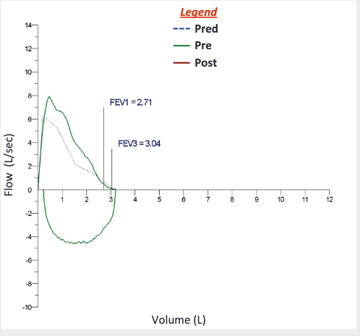
BASIC SPIROMETRY INTERPRETATION
- Which values are important?
  - Forced vital capacity (FVC)
  - Forced expiratory volume in the first second (FEV1)
  - FEV1/fVc ratio
- What are normal values?
  - The predicted value is the median of the bell curve for that group of similar nonsmoking, disease-free subjects
  - Spirometry uses a one-tailed approach in terms of statistics, because we are only concerned with low values
  - Testing the 5th percentile of all normal values= the lower limit of normal (LLN)
  - Greater change of disease if scoring in the LLN with additional elevated pre-test probability of disease (e.g., smoking history)
- Spirometry reports
  - Include only the clinically meaningful indices in the reports (FVC, FEV1, ratio)
  - List recorded values followed by the normal range
  - Provide notes on the test quality, and other pertinent information for interpretation
BASIC SPIROMETRY PATTERNS
- Normal pattern
  - All 3 values within the normal range
  - This cannot completely rule out lung disease, particularly if the pretest probability of disease is elevated and the recorded values are near the LLN
  - Spirometry normal reading cannot rule out asthma because most asthmatics spend most of their time with normal lung function
- Obstructive pattern
  - FEV1/FVC < LLN (shows a scooped appearance)
  - Without airflow obstruction, most of the FVC should be exhaled in the first second anyways
  - Obstructive disease is also often accompanied by an FEV1 <LLN
  - 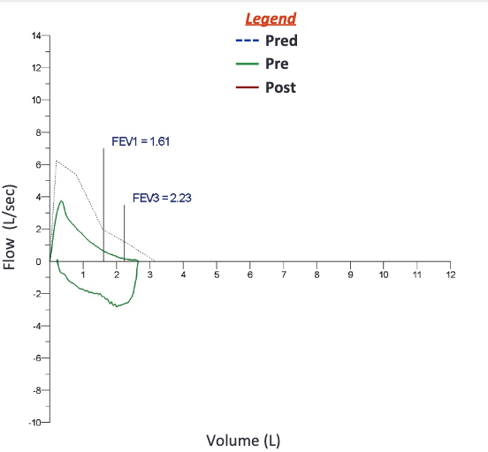
- Restrictive pattern
  - FVC and FEV1 <LLN with FEV1/FVC ratio >LLN
  - Confirm restrictive disease by measuring lung volumes and documenting total lung capacity
  - A thin loop due to small volumes
  - 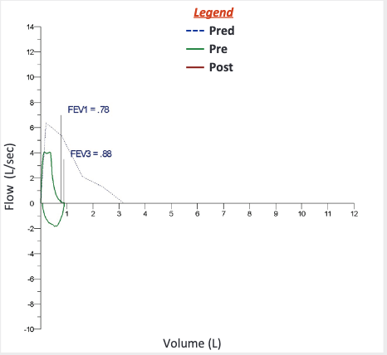
- Post-bronchodilator testing
  - Tests are often repeated after administering a SABA
  - A minimum 12% or 200mL increase in FVC and/or FEV1 is significant
    - Indicates benefit from SABA therapy
  - Normalization of a previously abnormal value may indicate asthma
  - Functional improvements may occur in the absence of significant changes to the spirometry results (common in COPD; aka the symptoms improve but the spirometry results don’t really look like they are changing much)
  - Allow a minimum of 10 minutes in between drug delivery and post-inhaler spirometry measurements
  - 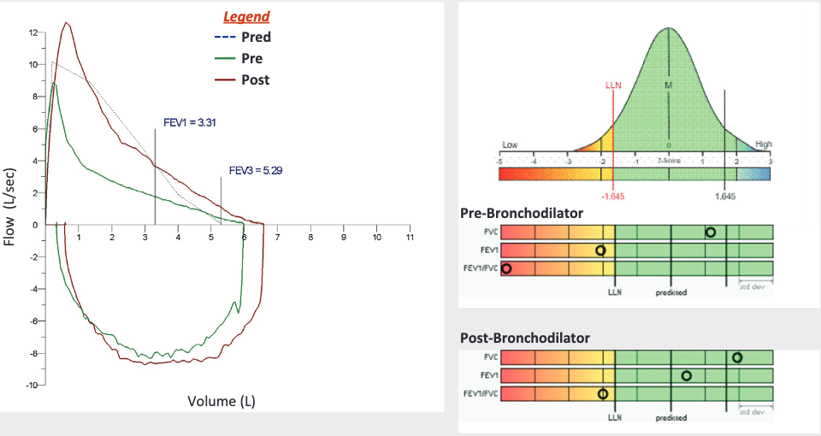
- Longitudinal testing
  - Follow-up once a diagnosis has been made to assess asthma control and COPD progression
  - Low FEV1 may indicate greater risk for asthma exacerbations, lung function decline, and poor perception of uncontrolled asthma
  - Normal FEV1 in a symptomatic asthma patient may indicate a comorbidity
    - FEV1 can be preserved in the presence of increased airway resistance
  - Repeated observations of responsiveness to bronchodilators in asthmatics with asthma controlling medications may indicate non-compliance, improper technique when using the inhaler, need for additional medication, or ongoing trigger exposures
  - Identify accelerated loss of function through yearly spirometry testing
    - Yearly changes should not exceed 15% difference
  - FVC in decline can indicate disease progression in neuromuscular disorders like ALS as well

Acceptability Criteria | Repeatability Criteria
Free of artifacts  - Cough, glottis closure, early termination, submaximal effort, leaks, obstructed mouthpieces | Minimum of 3 acceptable tests should be obtained
Back extrapolated volume <5% of FVC or 0.15L (whichever is greater) | 2 largest FVC measurements should be within 0.15L of each other
Expiratory time 6+ seconds in adults or 3+ seconds in children  OR  Plateau in volume-time curve or when the patient cannot or should not continue to exhale | 2 largest FEV1 measurements should be within 0.15L of each other

Smoking Cessation: Best Practices for Clinical Smoking Cessation in Canada
Tobacco smoking= the leading cause of preventable disease, disability and death in Canada
Benefits of smoking cessation…
- Reduced cardiovascular and cancer risks, improved lung function and capacity
- Fewer admission to hospital and shorter lengths of stay
- Increased life expectancy
- Improved quality of life
- Lower healthcare costs
- Reduction in the consequences and amount of exposure to secondhand smoke

The QSP: The Quit Smoking plan
- An intensive, outpatient smoking cessation program
- Referral
  - Age 18+
  - Can be done by a HCP or self
- Information session
- First clinic visit
  - Involves creating and individually tailored quit plan
- Follow-up visits
  - At 2, 5, and 10 weeks
  - A 26-week phone call follow-up
  - Target relapse prevention, medication review, and titration

There are 3 simple steps to approaching smoking cessation…
- Ask
  - Can be done by a triage nurse in 30 seconds
- Advise
  - Can be done by the doctor or NP in 2 minutes
- Act
  - Involves active creation of a quit plan with a nurse, NP, or pharmacist
  - Done in 20-30 minutes
- This can be used as a guide to operationalize the program into busy practitioner offices

Ottawa Model of Smoking Cessation: Evidence-Based Clinical Components
- Identification and documentation
  - Ascertain smoking status of every patient at every visit
  - Record smoking status on intake and history forms
- Treatment
  - Pharmacotherapy: offer first-line smoking cessation medications
  - Strategic advice: brief counseling for all patients
- Follow-up
  - Automated follow-up support for 1-6 months
  - Link to primary care
  - Referral to community cessation programs
Phases of the Ottawa Model’s Implementation Plan
- Program introduction and buy-in
- Pre-implementation evaluation
- Institutional tobacco control protocol development
- Physician, nurse, and other HCP training
- Program launch
- Post-implementation evaluation and quality improvement

Asthma Canadian Thoracic Society Guidelines
Uncontrolled vs severe asthma:
- Severe asthma requires treatment with high-dose ICS and a second controller for the last year, or systemic corticosteroids for 50% of the previous year to prevent it rom being uncontrolled, or if it remains uncontrolled despite this therapy
- Uncontrolled= at least one of the following
  - Poor symptom control using a standardized tool to evaluate
  - Frequent or severe exacerbations
    - Two or more courses of systemic corticosteroids lasting 3+ days in the previous year
  - Serious exacerbations
    - At least one hospitalization, ICU stay, or mechanical ventilation in the previous year
  - Airflow limitation
    - After appropriate bronchodilator, FEV1 <80% of personal best or <LLN with reduced FEV1/FVC ratio <LLN
- Explore all other possible reasons before providing a patient with a diagnosis of severe asthma
- Consider the complication of comorbidities if patients are not responding to treatments
- GERD occurs in almost 80% of asthma patients
  - PPI treatment is not effective at decreasing asthma exacerbations
- How to screen and differentiate between uncontrolled vs severe asthma
  - Confirm the diagnosis of asthma with history, spirometry
  - Educate on self-management strategies and refer to an asthma specialist
  - Review domestic and occupational environmental exposures, comorbidities, and adherence to treatment as well as techniques for puffer use
  - Address adherence and techniques multiple times before officially diagnosing patients with severe asthma and before considering adding additional therapies
Is there a way to predict response to biologic agents or macrolides?
- Severe asthma is mediated by type 2 cytokines (the TH2 pathway)
- Sputum differential cell count
  - A sputum neutrophil count >65% is considered neutrophilic inflammation
  - There is no clear link between sputum cell count and response to treatment
  - May indicate increased chance of success with biologics, but inconclusive for macrolides
- Fractional exhaled nitric oxide
  - Nitric oxide is generated by airway epithelium in response to interleukin 3
  - Also no studies that make conclusions about this
- Blood eosinophil counts
  - Able to identify who will experience fewer exacerbation with biologic therapies
- Serum IgE
  - Does not predict response to therapy or the benefit achieved with biologics

Covid-19: a remote assessment in primary care
Most COVID-19 patients can be managed remotely through guidance on symptom management and self-isolation, with consultations done via telephone or video.

Choosing Video vs. Telephone Consultations
- Video Consultations: Recommended for sicker patients, those with comorbidities, social challenges impacting illness, and highly anxious individuals. Video allows for visual assessment, providing diagnostic clues and therapeutic presence.
- Telephone Consultations: Suitable for patients with mild symptoms, administrative inquiries, or general information. Patients can also use online symptom checkers or prerecorded telephone messages.

Key Points for History Taking
- Symptom Onset: Record the date symptoms began.
- Temperature: Document current, peak, and duration of fever (often >38°C, lasting beyond five days in COVID-19 cases).
- Cough: Common in COVID-19, typically dry and persisting beyond five days.
- Shortness of Breath: Less common but indicates a more severe illness when present.
- Systemic Symptoms: Fatigue and muscle pain (may be absent).
- Exposure History: Record any contact with confirmed/suspected COVID-19 cases, particularly close, prolonged contact.

Recognizing Red Flags
- Urgent symptoms needing immediate assessment include severe breathlessness, chest pain or pressure, blue lips/face, and signs of shock (e.g., clammy skin, confusion, low urine output).

Remote Physical Examination
While full physical exams are limited remotely, video consultations allow for some observations:
- Demeanor, positioning (bed-bound or active), skin color (e.g., pallor, cyanosis).
- Visual cues of breathlessness
- Chronic conditions like asthma and cardiovascular disease
- Mental health impacts, such as stress or family issues that may complicate recovery

Home-Based Readings and Monitoring
When possible, have the patient take readings with available home devices:
- Temperature, pulse, blood pressure, peak expiratory flow, and oxygen saturation.
- Guide patients on proper device usage and document confidence in the readings’ accuracy.

Reporting
COVID-19 is a REPORTABLE disease; report laboratory-confirmed and clinically suspected cases as per local guidelines.
Obstructive Sleep Apnea: Assessment and Management in Adults
History and physical examination for Obstructive Sleep Apnea (OSA should focus on:
- Nocturnal Breathing Abnormalities
- Daytime Sleepiness
- Family and Personal Medical History
The STOP-Bang questionnaire is an effective tool to assess risk, addressing Snoring, Tiredness, Observed apnea, Pressure (high blood pressure), Body mass index, Age, Neck size, and Gender.
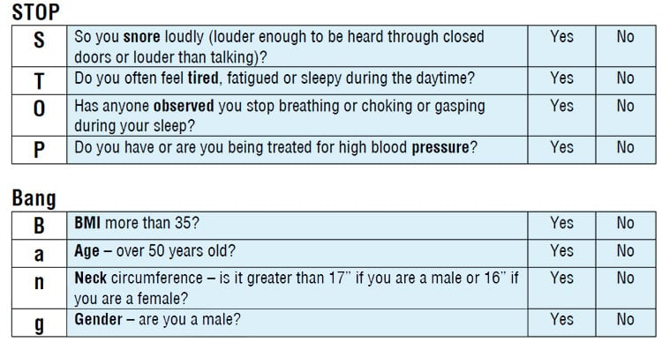
The primary symptom of OSA is excessive daytime sleepiness, though symptoms can vary. Assess how sleepiness impacts the patient’s daily life and consider using the Epworth Sleepiness Scale:
- Score >10: Significant daytime sleepiness.
- Score ≤10: Does not rule out OSA.
Other common OSA symptoms:
- Fatigue
- Loud snoring
- Choking, gasping, or breathing pauses during sleep
- Morning headaches
- Frequent nighttime awakenings
- Non-refreshing or restless sleep
- Impaired concentration
- Nocturia
- FYI: Ask about occupational risks, especially if the patient operates heavy equipment or has a safety-critical job. Document any history of drowsy driving or near-miss incidents within the last five years.
Physical Examination:
- Head and neck assessment
- Measure neck circumference
- Examine the upper airway
- Assess the Mallampati score, as higher classifications may indicate increased OSA risk.

Determining Diagnostic Testing
For patients with increased risk of moderate-to-severe OSA (daytime sleepiness/fatigue with at least two of the following: observed apneas, loud snoring, hypertension):
- Home Sleep Apnea Test (HSAT) is appropriate unless exclusions are present→concerns for non-respiratory sleep disorders, significant cardiopulmonary disease, BMI ≥40, age <16, inability to perform self-assessment).
- For higher-risk patients with exclusion criteria, refer to a sleep disorder physician for a possible polysomnography (PSG).
- If HSAT results are negative or inconclusive, the facility should advise the referring clinician to consider consultation or a polysomnography study. (DUMB ASF…WHY EVEN DO THE HOME ONE THEN FML)

Diagnostics Suspected OSA
- Patient assessment by NP.
- If indicated, refer to a sleep disorder physician.
- The sleep disorder physician consults and arranges for HSAT or PSG.
- HSAT results are interpreted by a credentialed physician and reported to the referring clinician.
- If HSAT is negative/inconclusive, further consultation is recommended.
- A final report with recommendations is provided for the referring clinician, who manages treatment and follow-up.

Apnea-Hypopnea Index (AHI) Interpretation
- The number of apnea and hypopnea per hour of measured sleep.Normal: <5 events/hr, and is one of the criteria used to determine the severity of sleep apnea
- Mild OSA: 5-14 events/hr
- Moderate OSA: 15-29 events/hr
- Severe OSA: ≥30 events/hr
- 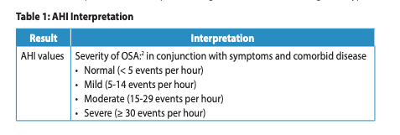

Treatment Considerations
When evaluating treatment necessity, consider:
- Symptom severity
- Presence and severity of comorbidities
- Safety-critical occupations
- All abnormalities in sleep monitoring data
Untreated OSA is associated with increased perioperative risks. Consider pre-surgical screening for OSA in at-risk patients (e.g., using the STOP-Bang Questionnaire).
OSA and Driving
When assessing a patient's fitness to drive, the severity of OSA alone should not be the sole determining factor/ A sleep medicine physician is the best person to advise driving authorities on fitness to drive. BUT, the licensing authority ultimately makes the final decision on driving restrictions…and they should consider the physician's recommendations and follow provincial guidelines.
Several factors should be taken into account:
- Comorbidities
- Meds
- Sleep/wake schedule
- Sleep deprivation
- Subjective and objective sleepiness
- Hx of motor vehicle collisions
***Physicians should educate patients on the connection between sleep disorders and the risk of MVCs
Assessing Fitness to Drive Post-Treatment
For patients who have undergone treatment for OSA, the following factors should be considered:
- Clinical response to therapy: sleepiness, fatigue, and frequency of microsleeps.
- Objective CPAP compliance: Ensure the patient uses CPAP for at least 4 hours on more than 70% of nights.
- Efficacy of therapy: Use data from CPAP downloads, Apnea Hypopnea Index (< 20 events/hour), oximetry, PSG to verify the effectiveness of treatment.
- Surgical and oral appliance treatments: Confirm that the patient’s AHI is < 20 events/hour and that they use the oral appliance for at least 4 hours per night on more than 70% of nights.
Commercial drivers should be held to a higher standard due to increased time spent on the road and abnormal sleep/wake schedules
Commercial drivers should be screened for OSA through a two-stage process:
- Stage 1: Screening using symptoms, questionnaires, and measures like BMI and neck circumference to identify high-risk drivers. Drivers with a BMI >35, regardless of symptoms, should be considered high-risk.
- Stage 2: Testing using PSG or a level 3 study.

Best Practices for Treatment and Follow-Up
- Ideally, drivers should consult a qualified sleep medicine physician before initiating treatment. However, in regions with limited access to sleep specialists, a physician experienced in managing OSA is a reasonable alternative.

TB Canadian Tuberculosis Standards 8th 2022 (I only did the article on assessment/diagnosis since theyre like 10 different articles)
Assessment and diagnosis of TB infection focuses on identifying individuals who are at increased risk of developing TB disease and who would benefit from tuberculosis preventive treatment (TPT).
*The tuberculin skin test (TST) and interferon-gamma release assays are the primary tools for diagnosing TB infection.*
- The primary goal of TB testing is to identify individuals who are at increased risk of developing TB disease and would benefit from preventive treatment.
- Neither TST nor IGRA can distinguish between TB infection (latent TB) and TB disease. Both tests measure the host's immune response to M. tuberculosis. Further diagnostic testing is required to rule out TB disease in individuals with positive test results, such as an xray.
- Low-risk individuals: Testing is not recommended for individuals with a low risk of TB infection or progression to TB disease.
- Diagnosing TB disease: Neither TST nor IGRA should be used to diagnose active TB disease in adults and adolescents over 12 years of age.
- Routine mass screening: Routine screening outside of contact investigations or occupational screening programs is not recommended.
- Monitoring TB treatment response: TST and IGRA are not useful for monitoring the effectiveness of TB disease treatment.

Tuberculin Skin Test (TST)
- Injects a small amount of purified protein derivative (PPD) from M. tuberculosis into the skin. A delayed hypersensitivity reaction indicates prior infection with M. tuberculosis.
- The induration is measured 48–72 hours after. A positive result depends on the size of the induration, which varies based on the individual’s risk factors (>10mm if low risk, >5mm if high risk such as HIV of immunocompromised)
- TST is affected by hx of BCG vaccination or non-tuberculous mycobacteria (NTM) infections and can lead to false positives. BCG vaccination in infancy can be disregarded in individuals aged 10 years and older.

Interferon-Gamma Release Assays (IGRAs)
- IGRAs are blood tests that detect interferon-gamma released by T cells when stimulated by M. tuberculosis-specific antigens. They do not require a return visit for interpretation.
- Are not affected by prior BCG vaccination
- Sensitivity is reduced in immunocompromised individuals, but IGRAs have higher specificity and are unaffected by BCG vaccination.

Choosing Between TST and IGRA
- Previous BCG vaccination? IGRA is preferred for individuals who have received the BCG vaccine, particularly:
  - Children over 2 years old and under 10 years old.
  - Individuals over 10 years old who received BCG after infancy or multiple times.
- Test availability? Availability of trained personnel and facilities may influence the choice of test.
- Likelihood of return for test reading? IGRAs may be preferred in settings where patients are unlikely to return for TST interpretation.

Follow-up for Positive Test Results
Individuals with a positive TST or IGRA should undergo further evaluation for active TB disease which includes a chest x-ray, before initiating TB preventive treatment.

Pulmonary Anatomy - imaging video

- White=more dense
- Black=hallow/less dense
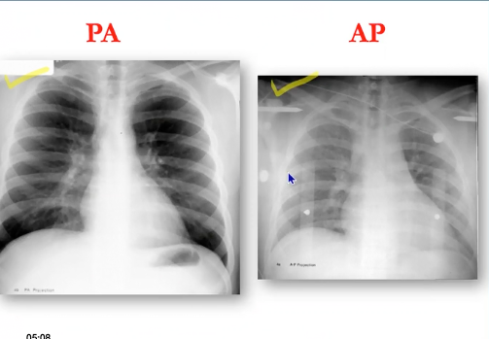
- PA xray is the best xray as it reduced radiation. This MUST be done in radiology department
- If you cannot sent pt to get xray in radiology AP xray is done. This is portable, done from a short distance thus its magifitied and less sharp. Pt may be supine or sitting and lung markings may appear more crowded.
- Heart size on xray should be no bigger than ½ the thorax. A larger heart can indicate HF. FYI AP Xray will make heart look larger so be aware!
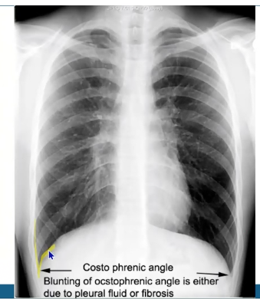
- Start looking a density, look for white and dark areas and if there is under or over penetration
- Look at bones/joints, observe fir factures
- Number of ribs helps you know how much lungs are inflated
  - 9 ribs=good inflation
  - >10 ribs…hyperinflation? And could mean COPD
- Look at spine, scapula and clavicals and ensure its aligned
- Look at Costo pherntic angle…are the crisp or blunted by fluid? (see photo)
- Diapharm should be higher on right because liver is under it.
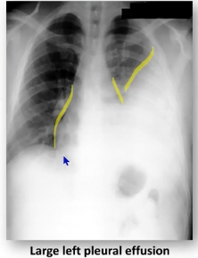
Silhouette sign:
- Loss of silhouette! You see this with a consolidation or a mass, and it obscures the normal borders of adjacent structures like the heart or diaphragm. It helps localize the lesion: for example, loss of the right heart border suggests right middle lobe pneumonia, while loss of the left heart border may indicate left lower lobe pneumonia. This sign is useful in diagnosing and pinpointing the location of lung pathology. (see photo)

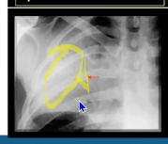
Air Broncahrogram
- You usually cannot see bronchi/broncioles because theyre filled with air, however if you have fluid in your lungs, such as in pneumonia, pulmondary edema, hemmorage, cancer then you get increased opacity in that area when it usually shouldnd be (see photo)

4 Patterns on a X Ray
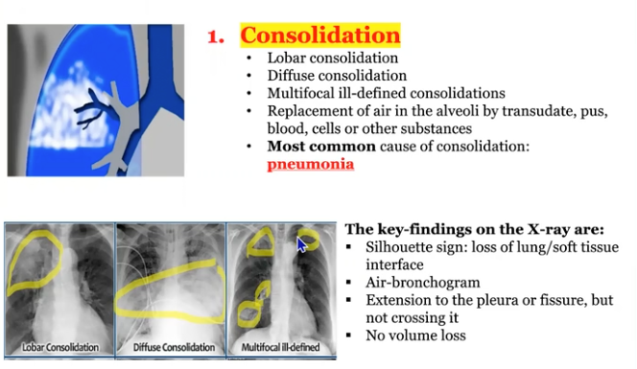
- Consolidation: pathological process that fills alveloili with fluid, puss, blood, cells (tumor), resulting in lobar/difuse/multifocal white opacities

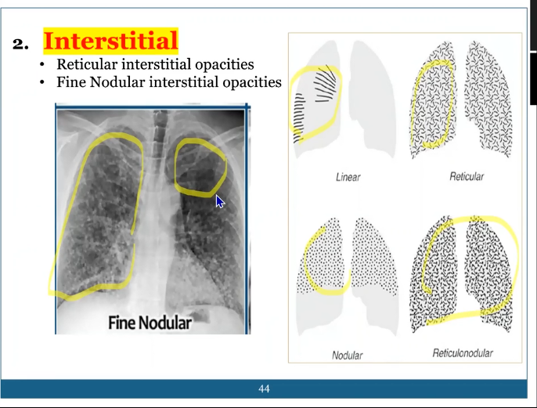
- Interstitial: Involemvent of support tissue of lung resulting in fine/coerse retifuclar opacitiies. Usually due to scarring from pulmonary fibrosis, TB, sarcoidosis.

- Nodule or mass: any space occupying leusion, if very well defined borders and less than 3cm in diamer its unlikely a malignancy. If >3cm is malinant until proven otherwise
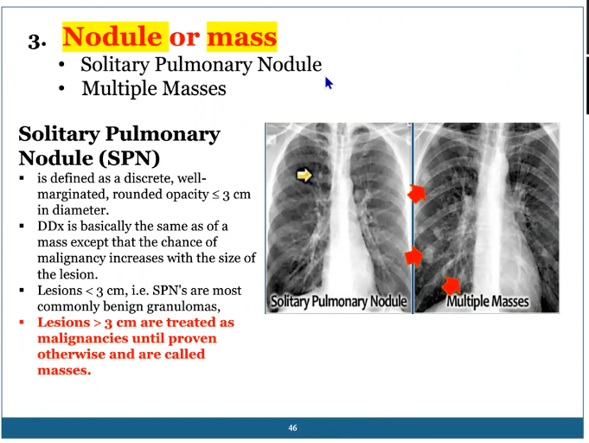

- Ateletcsaisis: collapse of lung/loss of volume. It is usually the first sign of lung cancer
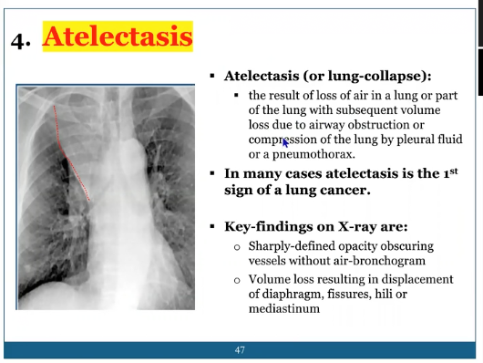

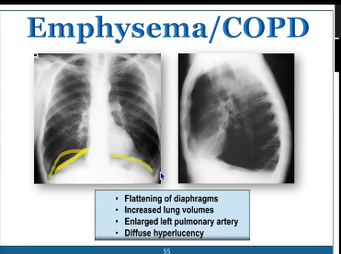
Flat diaphragm, hyperinflated lungs especially on lateral film, +++ dark bevcause over inflated and gas trapping and large space btween ribs

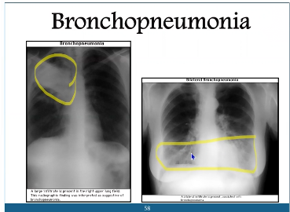
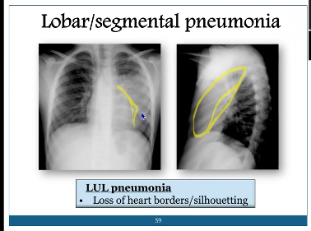
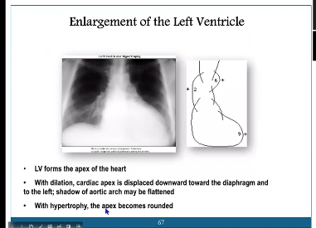
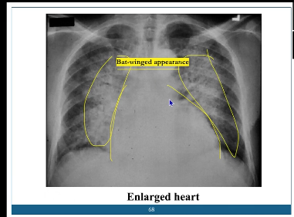
2021 Canadian Thoracic Society Guideline – A focused update on the management of very mild and mild asthma

Assessment and Diagnosis of Asthma
“Asthma is marked by intermittent symptoms that can range in severity. The severity of asthma is determined by the intensity of treatment required to achieve and maintain control. Therefore, asthma severity is typically assessed only after treatment has been initiated, based on whether or not the patient achieves control of their symptoms.”
Key elements in the assessment and diagnosis process:
- Spirometry is a critical tool for diagnosing asthma, as it objectively measures lung function and helps identify airflow limitation, which is a hallmark of the condition.
- Reversibility of airflow limitation is another key feature of asthma, meaning that lung function should improve following the use of a bronchodilator, such as a SABA.
- Medical history plays a crucial role in diagnosis, as detailed information about the frequency, severity, and potential triggers of symptoms can help differentiate asthma from other respiratory disorders.

Assessing Asthma Control
- Important to formally assess asthma control at every visit using structured assessments or questionnaires.
- Relying solely on a patient's subjective perception of their asthma control can lead to overestimation, as studies show that many patients tend to overrate their condition.
- Pharmacy records can provide valuable, objective data, particularly the number of SABA inhalers dispensed, which can signal inadequate control. If a patient fills more than two SABA inhalers within a year, further discussion about their asthma management is warranted.
- The threshold for symptom frequency and SABA use has been reduced from fewer than 4 days per week to 2 or fewer days per week.
Asthma is considered poorly controlled if any of the well-controlled asthma criteria are unmet:

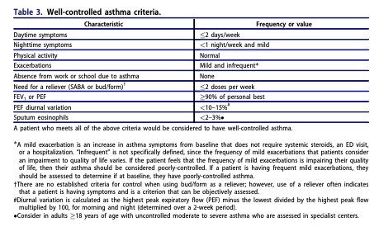

- Important to evaluate the risk of future asthma exacerbations, even in patients whose asthma appears well-controlled.
- Exacerbations can occur in mild cases and may be life-threatening, account for 30-50% of asthma-related deaths.
- THERA BUT HELPFUL: DO NOT USE PRN SABA as the sole treatment for anyone over the age of 12 for asthma…must add second med such as ICS.
Risks of asthma exacerbation:
- Hx of severe exacerbations (requiring prednisone, ED visits, or hospitalization)
- Poorly controlled asthma, as per CTS guidelines
- Overuse of SABA (defined as filling more than two SABA inhalers per year)
- Current smoking status
- Comorbid atopic/allergic disease
- Elevated blood eosinophils (>300/µL)
- Young age
- Low SES
- Male
- Underweight

Canadian Thoracic Society guidelines (COPD)

Canadian Thoracic Society guidelines (Asthma)

GI
AHAD Week 10: GI
Learning Objectives
- Evaluate the clinical findings associated with the acute abdomen
- Examine the relationship between psychosocial factors and selected GI conditions
- Discriminate between clinical presentations, which are benign versus emergent

Required Readings by Condition:
- Abdominal aortic aneurysm ✅
- Anorectal pain ✅
- Appendicitis ✅
- Bowel obstruction
- Cholelithiasis & cholecystitis NEED TO DO IM SORRY I GOT CAUGHT UP WITH MY PAPER
- Constipation ✅
- Diarrhea ✅
- Diverticulosis and diverticulitis ✅
- Dyspepsia ✅
- Gastric and duodenal ulcer ✅
- Gastritis (basically the same as ulcers, i’ll add to this later)
- GERD ✅
- Hemorrhoids ✅
- Hernia ✅
- Inflammatory bowel disease (Crohn’s disease, ulcerative colitis) ✅
- Irritable bowel syndrome (IBS) ✅
- Non-alcoholic fatty liver disease (NAFLD) ✅
- Pancreatitis ✅
Readings: For each condition, refer to the appropriate chapter in your textbooks
Glass & Cash (2020)
Myrick & Karosas (2022)
Daines, Baumann & Scheibel (2024)
Bates’ Visual Guide to Physical Examination Video.
Abdominal-Pain-1.pdf ✅
Dyspepsia.pdf ✅
Fatty Liver Disease (Julia) ✅

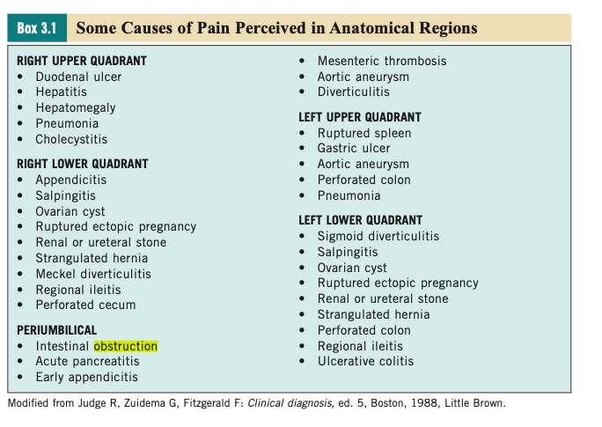

Abdominal Aortic Aneurysm

WE DID THIS IN WEEK 5 BUT HERE IS SOME EXTRA STUFF
Def’n | Outbulging of an artery
Risk Factors/Epidemiology | Age 65+, male, smoking, family history, other vascular aneurysms, taller height, CAD, cerebrovascular disease, atherosclerosis, HTN, hyperlipidemia
Clinical Presentation  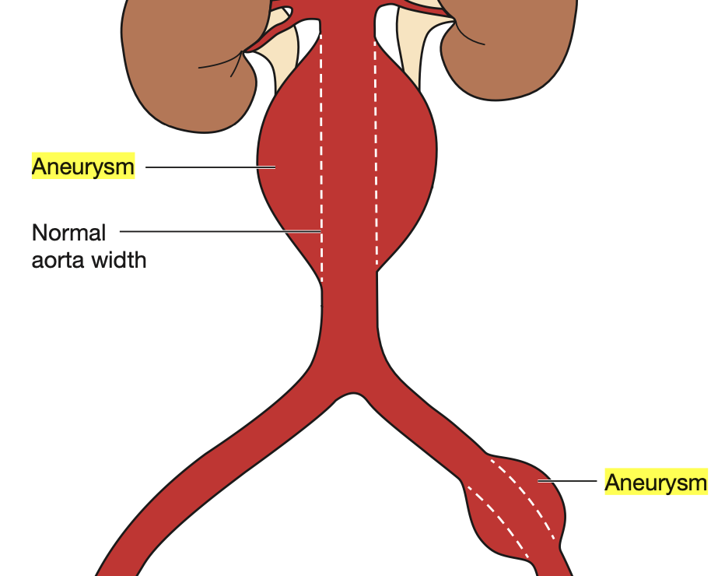 | TRIAD: hypotension, flank/back pain, and pulsatile mass.  Lateral pulsations at midline abdomen, sudden pain abdomen and radiating to back and genitalia; ripping/tearing chest pain  Tachycardia, hypotension, BP differential bilateral arms, diminished femoral pulses  Cullen Sign: Grey Turner: 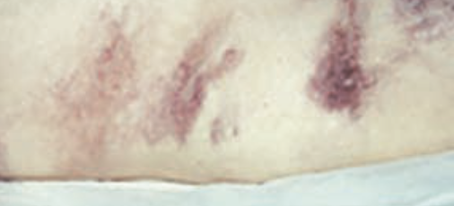  Grey Turner: Clinical sign that refers to bruising or discoloration of the flanks (the sides of the abdomen, just below the ribs and above the hips). This is a sign of retroperitoneal hemorrhage→bleeding behind the peritoneal cavity (the lining of the abdomen), often associated with conditions like pancreatitis or abdominal trauma.  - The discoloration is caused by blood tracking through tissues and appearing on the skin as bruises. This sign is typically seen in severe cases of acute pancreatitis, but it can also occur in other conditions like ruptured abdominal aortic aneurysms or severe trauma.  Cullen Sign: Bluish or purple discoloration around the umbilicus (belly button).This indicates the presence of internal bleeding or hemorrhage. It is often associated with acute pancreatitis, but it can also occur in conditions like ruptured ectopic pregnancy, peritonitis, or trauma.  - The discoloration occurs as blood leaks into the abdominal wall and travels through tissues to the area around the umbilicus.
Hx/Key Questions | Refer to week 5
Physical Exam | VItals: BP bilateral arms  Pulse check  Do not percuss abdomen if AAA suspected
Diagnostics/Labs | U/S???  CT/MRI  ECG  CBC  lipids  Cardiac enzymes  One Time US assessment between 65-80 who have smoked more than 100 cigarettes in their lifetime for screening
Red flags | SURGICAL EMERGENCY, hypovlemic chock
Differential Diagnoses | Refer to week 5
Treatment/Management | Treatment:  Counseling/Education:  Non-pharm therapies:
Referrals | If symptmatic need surgery!!!!!
Follow-up | Refer to week 5

Anorectal Pain
https://www.youtube.com/watch?v=MzHL66rr9kw&ab_channel=Medskl.com
Def’n | Anorectal pain refers to discomfort or pain in the region around the anus and rectum. It can result from various causes, including anal fissures, hemorrhoids, abscesses, inflammatory bowel diseases, or sexually transmitted infections.
Pathology/Cause | - Hemorrhoids: see hemorrhoids condition sheet.  - Fissure: small cut or split in the anoderm that may be induced by a hard bowel movement or straining.  - Rectal cancer: cancer of the rectum.  - Abscess: an infection of the anal gland. The suppurative process then tracks through the various planes in the anorectal region.  - Perineal sepsis: the most common cause is advanced cryptoglandular infection resulting in a necrotizing perineal infection.  - Proctalgia fugax: unknown. May be related to IBS.  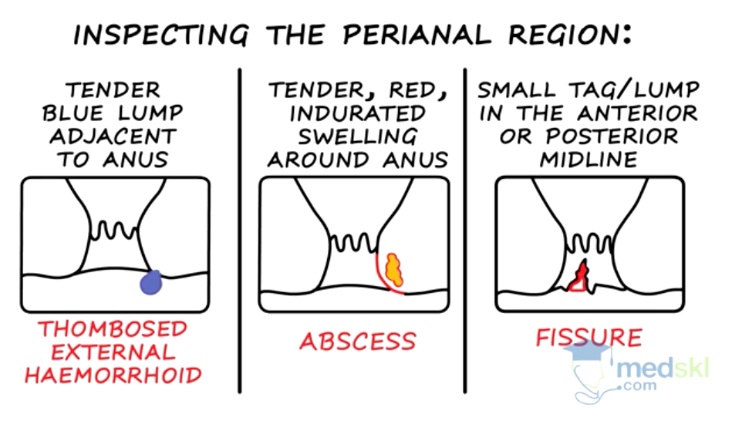
Risk Factors/Epidemiology | Anorectal pain can affect individuals of all ages and is common in both men and women. Certain conditions, such as hemorrhoids, become more prevalent with age.  Constipation, diarrhea, straining during bowel movements, obesity, a sedentary lifestyle, poor hygiene, and certain medical conditions, such as Crohn's disease or ulcerative colitis.
Clinical Presentation  *Insert picture here* | HALMARK: Pain or discomfort during bowel movements, itching, bleeding, swelling around the anus, or a lump felt during self-examination.  The severity and specific symptoms depend on the underlying cause of anorectal pain.
Hx/Key Questions | Inquire about bowel habits, dietary habits, recent changes in lifestyle, the nature of pain or discomfort, associated symptoms (bleeding, discharge), and any history of previous anorectal conditions or surgeries.
Physical Exam | Inspection of the perianal area for signs of swelling, redness, or lumps. Digital rectal examination may be performed to assess for tenderness, masses, or other abnormalities in the rectum.
Diagnostics/Labs | Depends on the cause.  Anoscopy, sigmoidoscopy, or colonoscopy to visualize the anal and rectal tissues. Imaging studies, such as MRI or CT scans, may be ordered in certain cases. Laboratory tests for infection or inflammation may be performed.
Red flags | Severe, persistent pain, rectal bleeding, changes in bowel habits, or symptoms not improving with conservative measures warrant prompt medical evaluation to rule out serious underlying conditions such as perianal sepsis
Differential Diagnoses | Rule out conditions such as anal fissures, hemorrhoids, abscesses, proctitis, or colorectal tumors. Diagnostic tests, such as anoscopy, sigmoidoscopy, or imaging studies, may be necessary for definitive diagnosis.
Treatment/Management | Provide education on dietary habits, proper hygiene, and lifestyle modifications to prevent or manage anorectal pain. Discuss the importance of seeking medical attention for persistent or severe symptoms.  FIRST LINE: Topical treatments for pain relief, such as over-the-counter creams or ointments containing analgesics or corticosteroids. Fiber supplements or stool softeners may be recommended for certain conditions.  Warm baths, sitz baths, dietary modifications (increased fiber intake), and lifestyle changes (avoiding straining during bowel movements) may complement medical treatments.
Referrals | Depends on the cause. Hemorrhoids and fissures can be treated in clinic. Abscesses need GI, require drainage. Suspicion of rectal cancer needs referral to GI. Suspicion of perineal sepsis requires ER.
Follow-up | Regular follow-up to assess symptom improvement, adjust treatment as needed, and monitor for any complications. Surgical interventions may require ongoing postoperative care and follow-up.
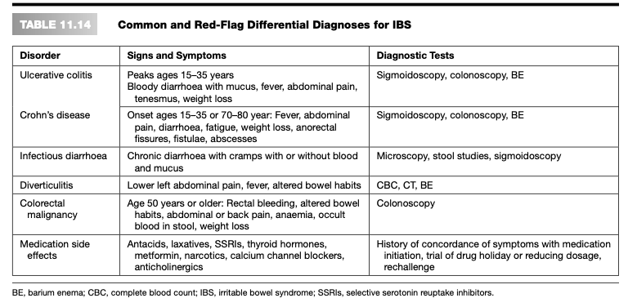

Diverticulosis
Def’n | Diverticulosis is a condition characterized by the presence of small pouches (diverticula) that can form in the walls of the colon, particularly in the sigmoid colon. These pouches may or may not become inflamed, leading to diverticulitis.
Pathology/Cause | Diverticulosis is primarily caused by increased pressure on the walls of the colon, leading to the formation of diverticula. Factors such as age, low-fiber diet, constipation, and genetics may contribute to the development of diverticulosis.
Risk Factors/Epidemiology | Diverticulosis is more common in older adults, with prevalence increasing with age. It is more prevalent in Western societies, possibly due to dietary factors. Most individuals with diverticulosis remain asymptomatic.  Age, a diet low in fiber, obesity, lack of physical activity, smoking, certain medications, and genetics.  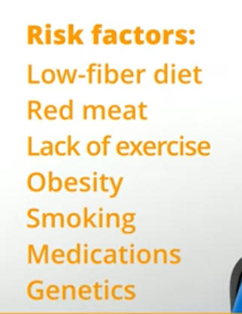
Clinical Presentation | Most individuals with diverticulosis are asymptomatic.  Symptoms, when present, may include abdominal pain, bloating, and changes in bowel habits, painless rectal bleedinh. Diverticulosis itself does not cause inflammation unless it progresses to diverticulitis. 95% involve the sigmoid colon (site of highest pressure)  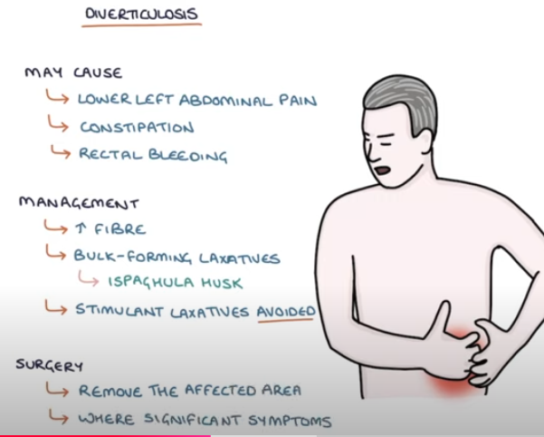
Hx/Key Questions | Inquire about bowel habits, abdominal pain, and any associated symptoms. Obtain information on dietary habits, lifestyle factors, and the presence of any comorbidities.
Physical Exam | Normal physical exam typically  May have LLQ abdominal pain, bloating, flatulence, constipation, or diarrhea
Diagnostics/Labs | Colonoscopy is the gold standard for diagnosing diverticulosis and excluding other conditions. Imaging studies, such as CT scans or barium enemas, may also be used to visualize the colon and diverticula.
Red flags | Severe abdominal pain, fever, and signs of systemic illness may suggest diverticulitis rather than uncomplicated diverticulosis and require medical attention.
Differential Diagnoses | Rule out other causes of abdominal pain and changes in bowel habits, such as irritable bowel syndrome (IBS) or colorectal malignancies. Colonoscopy or imaging studies may be performed for confirmation.
Treatment/Management | Treatment: High-fiber diet and bulk-forming agents, such as psyllium or methylcellulose, are often recommended to promote regular bowel movements and prevent constipation. Pain management with analgesics may be considered.  Counseling/Education: Provide education on a high-fiber diet, maintaining regular bowel habits, and the importance of staying hydrated. Educate on potential symptoms of diverticulitis and when to seek medical attention.  Non-pharm therapies: Complementary therapies may include probiotics to support gut health and alleviate symptoms. Yoga or relaxation techniques may help manage stress, which can impact symptoms.
Referrals | RD for diet recommendations
Follow-up | Regular monitoring for symptom improvement, dietary adherence, and prevention of complications. Follow-up may involve repeat colonoscopies or imaging studies as recommended by healthcare providers.

Diverticulitis

C-reactive protein (CRP; >50 in the client with LLQ pain and no vomiting is highly suggestive of diverticulitis)
Def’n | Occurs when the diverticula become plugged and inflamed
Pathology/Cause | Exact etiology unknown  Present theory fiber is a protective agent against the development of diverticula and subsequent diverticulitis holds that insoluble fiber causes the formation of bulkier stool, which leads to decreased effectiveness in colonic segmentation
Epidemiology | Diverticulosis is very common and increases with age.  - Prevalence by age:  - Age 40 years: 5%.  - Age 60 years: 30%.  - Age 80 years: 65% to 80%.  - No significant difference in prevalence by gender: Diverticulosis is symptomatic in 70% of cases. It leads to diverticulitis in 5% to 25%; and is associated with bleeding in 5% to 15%. The sigmoid colon is commonly affected. There are two types of diverticular disease and diverticulitis:  - Simple, with no complications; responds to treatment such as dietary changes without the need for surgery.  - Complicated, with abscesses, fistula, obstruction, perforation, and peritonitis leading to sepsis; usually requires surgery.
Risk Factors | Advanced age  Obesity  Low-res diet  Complicated diverticular disease is exacerbated by the following:  1. Smoking  2. NSAIDs  3. Tylenol use (esp paracetamol)  4. Opioids  5. Steroids  Indication that genetics is predisposing factor:  1. LT-sided diverticula is most common  2. Right-sided (caecal) diverticula is predominant in Asia
Clinical Presentation  *Insert picture here* | - Severe pain in LLQ  - Fever chills  - Blood in stool  - Diarrhea  - N/V  - Painless rectal bleeding is the hallmark of diverticular bleeding, w/ intermittent passage of maroon on bright red blood  - Common symptoms: LLQ pain, constipation  Other S/S:  Back pain, flatulence, periodic abdominal distension, borborygmi (or loud, prolonged gurgles caused by hyperactive intestinal peristalsis, diarrhea, N/V, dysuria, tenderness on palpation, possible guarding, fever/low-grade
Hx/Key Questions | Review the onset, duration and course of symptoms, including size, colour, consistency, and frequency of stools  Ask the client whether constipation is chronic or acute problem and whether it alternates with diarrhea, ever had an obstruction?  Review daily diet and fluid intake  Ask client about med use, including iron supps, NSAIDs and Tylenol  Inquire about the colour, amount, and frequency of rectal bleeding. Does the strain when having a BM?  Review of hx of pain with defecation  Review the client’s hx of kidney stones, as it mimics diverticulitis
Physical Exam | FYI: The constellation of LLQ tenderness with or without peritoneal findings, fever, and leukocytosis is suggestive of sigmoid diverticulitis:  Check VS, PE may be relatively unremarkable but most commonly reveals abdo tenderness or a mass  Assess abdo for distension/guarding  Auscultate abdo, BS may be decreased or normal in early diverticulitis  Percuss the abdomen  Palpate the abdomen for rebound tenderness or masses signaling possible abscess and tenderness  Palpate beneath the right costal arch, checking for Murphy’s sign or pain on deep inspiration  Consider a pelvic exam to r/o gyne sources of abdo pain  Rectal exam: eval for hemorrhoids, masses, fissures, fistula, inflammation, and stool in the ampulla  *May present with fullness/tenderness in the LLQ or a tender palpable loop of the sigmoid colon appreciates as a mass on exam
Diagnostics/Labs | Focused History and Exam: A thorough history and physical examination are essential in assessing recurrent diverticulitis.  Colonscopy: The diagnosis of diverticular colitis is confirmed through endoscopic examination and histological analysis. Endoscopy should be avoided in suspected acute diverticulitis due to an increased risk of perforation. It is recommended that a colonoscopy is performed approximately six to eight weeks after symptoms have resolved to rule out malignancy, inflammatory bowel disease, or possibly colitis if the patient has not had a recent colonoscopy.  CT Scan: A CT scan of the abdomen and pelvis is the optimal investigation for suspected acute diverticulitis.  CBC with Differential:  - White blood cell (WBC) count may show leukocytosis with a left shift.  - Hemoglobin (hgb) and hematocrit (Hct) may be low in cases of chronic or acute bleeding.C-Reactive Protein (CRP): A CRP level greater than 50 in a client with left lower quadrant (LLQ) pain and no vomiting is highly suggestive of diverticulitis.  Cbc, esr, crp, CT with contrast (or U/S or barium and xray if cant)  Radiography:  - Flat plate and upright films of the abdomen can be used to evaluate for ileus, obstruction, free air, and perforation.  Abdominal Ultrasound: This may be employed to assess for masses or abscesses.  WBC Count Variability: It's important to note that the WBC count may be normal in up to 45% of patients with acute diverticulitis.
Red flags | Obstrcution, colon performation, perintonitsis, fistula , abcess
Differential Diagnoses | - Hernia  - Renal colic  - Acute appendicitis  - Bowel obstruction  - Ischemic colitis  - Colon cancer (Colon Ca)  - Hemorrhoids  - Constipation or impaction  - Inflammatory bowel disease (IBD)  - Urologic disorder: pyelonephritis  - Tubo-ovarian abscess / Pelvic inflammatory disease (PID)  - Torsion (testicular/ovarian)  - Ectopic pregnancy  - Cholecystitis  - Urinary tract infection (UTI)
Treatment/Management | FIBRE!!!!!!  Clear liquid die to resit colon  Oral abx if needed  Asymptomatic diverticulosis:  ● Generally discovered incidentally on colonoscopy; there is no indication for therapy​  Acute diverticulitis:  ● Improvement in symptoms within 3 days of therapy and complete resolution of symptoms within 7–10 days of therapy  Chronic diverticulitis and SUDD:  ● Decrease frequency of patient-reported symptoms and thereby improve quality of life  ● Prevent recurrence of symptoms  Prevent development of diverticulitis or its complications, including abscess, obstruction and sepsis  Education:  -Surgery is often the first line tx for young symptomatic clients.  -Exercise: reg, vigorous exercise/maintain healthy BMI  -Smoking cessation-tobacco is associated with an increased incidence  Dietary:  -Fibre: low dietary fiber intake is a risk factor for the development of diverticulosis, standard practice to encourage high fibre  -Vegetarian diet has a decreased risk of diverticular disease  -Corn, nuts and seeds: AVOID (don’t have to avoid small fruit with seeds now)
Referrals | Arrange for prompt hospitalization and surgical consultation if the client’s temperature rises above 38.3°C, his or her pain worsens, peritoneal signs develop, or WBC continues to rise. Surgery consultation is required for abscess, peritonitis, obstruction, fistula, or failure to improve after several days of medical management.
Follow-up | Stress the importance of strict adherence to diet.  Dietary management:  ○ Nothing by mouth (NPO) status for acute treatment.  ○ Full-liquid diet or low-fiber diet if not on bowel rest.  Long-term dietary management:  ■ High-fiber diet including bran, beans, fruits, and vegetables.  ■ Bulk agents if unable to tolerate bran.  ■ Note foods to avoid, such as nuts.  ■ Medical and surgical management: Acute treatment has not been well defined in diverticular disease:  Acute treatment may include the following:  ■ Nasogastric (NG) tube placement.  ■ Intravenous (IV) fluids.  ○ Surgical intervention is required for abscess, peritonitis, obstruction, fistula, or failure to improve after several days of medical management, or recurrence after successful medical management.  Follow-up:  Follow up in two to three days. Continue conservative management if the client has no signs of complications.  A colonoscopy should be performed from six to eight weeks after recovery to evaluate the extent of the diverticulosis/rule out other manifestations.

Diverticulosis
Referral is not typically required for uncomplicated diverticulosis, but it may be necessary if:
- Diagnostic Clarification:
  - Unexplained gastrointestinal bleeding or persistent anemia (refer for colonoscopy or gastroenterology assessment).
  - Concern for overlapping conditions (e.g., colorectal cancer or inflammatory bowel disease).
- Symptomatic Diverticulosis:
  - Chronic or severe abdominal pain unresponsive to dietary and lifestyle modifications.
  - Frequent episodes affecting quality of life, possibly warranting advanced imaging or specialized dietary guidance.

Diverticulitis
Referral is often more likely for diverticulitis due to its potential complications:
- Complicated Diverticulitis:
  - Suspected abscess, perforation, fistula, or peritonitis (urgent referral to the emergency department or surgeon).
  - Persistent fever, severe abdominal pain, or clinical deterioration despite appropriate treatment in the community.
- Recurrent Episodes:
  - Multiple episodes of diverticulitis, especially if quality of life is significantly impacted. A surgical consult may be considered for elective resection.
- Uncertainty in Diagnosis:
  - Atypical symptoms or presentation that may mimic other conditions, such as appendicitis, malignancy, or ischemic colitis.
- Immunocompromised Patients:
  - These individuals are at higher risk for severe complications and may require closer monitoring by a gastroenterologist or surgeon.

General Principles for Referral
- Urgent Referral:
  - Acute complications (e.g., abscess, sepsis, or perforation).
- Routine Referral:
  - Persistent or recurrent symptoms.
  - Follow-up colonoscopy (after diverticulitis resolution) to exclude malignancy, especially in patients over 50 or those with alarming symptoms (e.g., weight loss, rectal bleeding).

Dyspepsia
Def’n | Dyspepsia is a common presentation and is often described as chronic or recurrent discomfort centered in the upper abdomen. It can include symptoms of upper abdominal discomfort, nausea, bloating, fullness and early satiety.
Pathology/Cause | It can be caused by a variety of conditions, and symptoms of possible causes often overlap, which can make initial diagnosis difficult. For many patients, a definite cause is never established. For every patient, it is important to consider H.pylori status and rule out alarm features (>55, melena, dysphagia, weight loss, anemia, hematemesis) and use of NSAIDS.
Risk Factors/Epidemiology | Functional dyspepsia prevalence varies worldwide, with higher rates of 10% to 40% in Western countries, including the United States (US). The global prevalence ranges from 5% to 11%.  In Asian countries, the prevalence is 5% to 30%.  Risks:  Women>Men  Anxiety  Depression  Childhood abuse  Inflammation, allergen exposure
Clinical Presentation  *Insert picture here* | 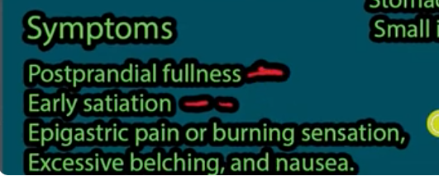  UPPER ABDO PAIN  Functional dyspepsia in adults with no evidence of structural disease is diagnosed with at least one of the following symptoms present for 3 or more months with onset at least 6 months before diagnosis:  - Postprandial fullness  - Epigastric pain  - Epigastric burning  - Early satiation  MUST EXCLUSE GERD AND GASTRIC ULCER!!!!!!!!! AND HPYLORI  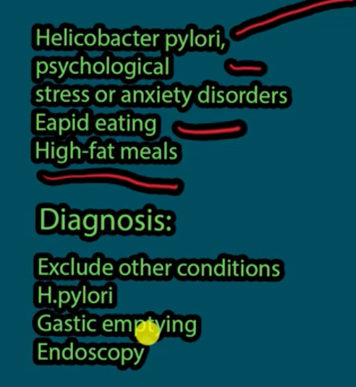
Hx/Key Questions | 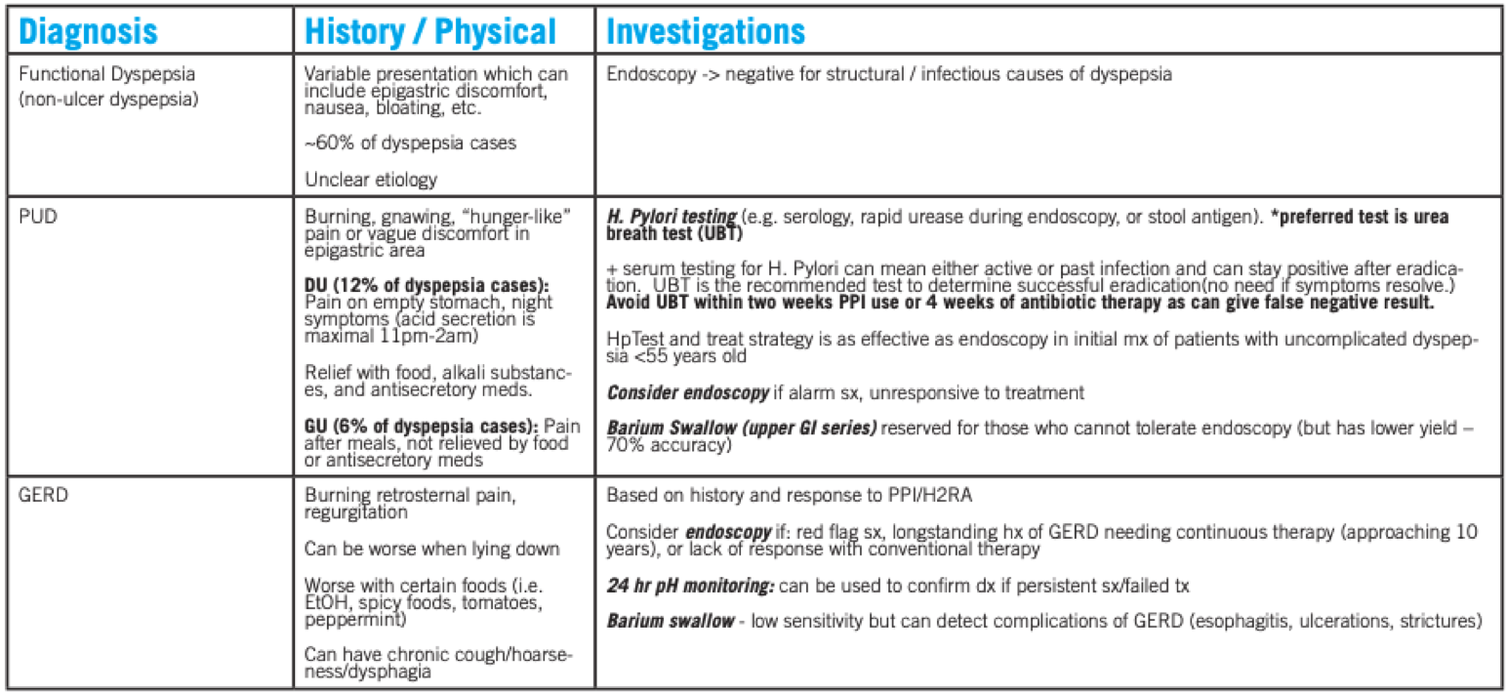
Physical Exam | Review of vital signs should note presence of tachycardia or irregular pulse.  General examination should note presence of pallor or diaphoresis, cachexia, or jaundice. Abdomen is palpated for tenderness, masses, and organomegaly.  Rectal examination is done to detect gross or occult  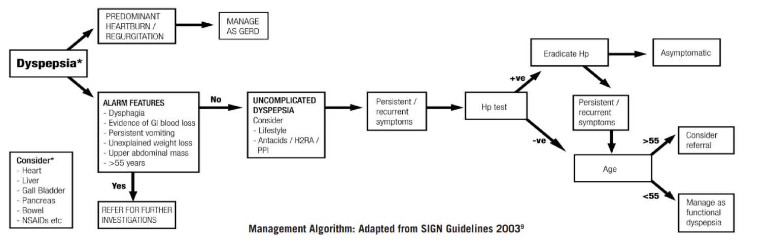
Differentials | - IBS: Rome Criteria – at least 2/3 criteria for at least 3/12 in last year (1. Pain relieved by defecation 2. Pain related to change in frequency of stool, 3. Pain related to change in consistency of stool)  - Medication related 1,4,8: NSAIDs,(including ASA and COX-2 inhibitors – 20% of patients using these meds >12 weeks have endoscopic evidence of ulceration), calcium channel blockers, bisphosphonates, iron and potassium supplements, steroids, antibiotics (esp. erythromycin, metronidazole), amiodarone, acarbose, metformin, orlistat, opiates, theophylline  - Biliary: RUQ/epigastric pain following meals (esp. fatty). Asymptomatic weeks-months in between. Can be associated with bloating, sweating, N/V -Pancreatitis: Acute onset, usually max. intensity within 10-20 min, constant, ++severe, radiates to back. RFs: EtOH (esp. if pain onset 1-3 d post binge), gallstones  - Metabolic disorder/dysmotility: hx of diabetes (gastroparesis nausea/bloating/anorexia), hyper/hypothyroidism, hyperparathyroidism, scleroderma Cancer: Symptoms ass. w/ alarm sx: Age >55, weight loss, progressive dysphagia, long hx of GERD (Barrett’s), anemia, hematemesis, melena, persistent vomiting, jaundice, FHx GI malignancy  - Cardiac: if pain occurs with exertion – assess cardiac RFs and do cardiac evaluation  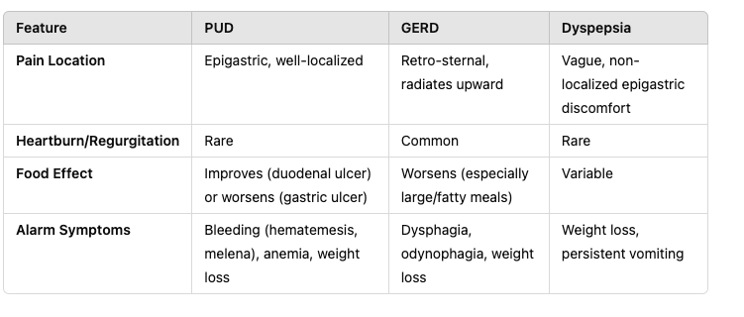
Red flags | The following findings are of particular concern:  ● Acute episode with dyspnea, diaphoresis, or tachycardia  ● Anorexia  ● Nausea or vomiting  ● Weight loss  ● Blood in the stool  ● Dysphagia or odynophagia  Failure to respond to therapy with H2 blockers or proton pump inhibitors (PPIs)
Diagnostics | H. Pylori Testing  Endoscopy if over 50 or alarm s/s  scope if concerning symptoms or unresponsive to tx  Barium swallow (upper Gi series) for those who cannot tolerate endoscopy  - Blood Tests: Complete blood count (CBC) ro r/u anemia if bleeding, liver function tests, amylase/lipase if pancreatitis is suspected.  - H. pylori Test: Urea breath test or stool antigen test for Helicobacter pylori.  - Endoscopy: If symptoms persist or red flags are present, to evaluate for ulcers or malignancy.
Treatment/Management | Treatment: For functional dyspepsia, most practitioners begin with lifestyle modifications and can consider step up therapy with H2agonists or step down with PPIs for 4 week trial. Medication is not necessary for all patients with functional dyspepsia, but when given –short term or intermittent treatment is more appropriate than long term continuous therapy.  Lifestyle modifications: recommended despite limited evidence because of low cost and relative safety:  1. Dietary: smaller, more frequent meals, decrease offending foods (e.g. EtOH, spicy/greasy foods, coffee, peppermint, tomatoes)  2. Avoid lying down for > 2 hr after eating  3. Avoid tight fitting clothing  4. Weight loss if obese  5. Limit alcohol intake  6. Stop smoking  7. Elevate legs under head of bed (10-15 cm blocks)
Referrals | Consider referral for assessment for patients with red flags or those who have uncomplicated dyspepsia whose symptoms persist after initial management strategies.
Follow-up | Follow up after medication trials.

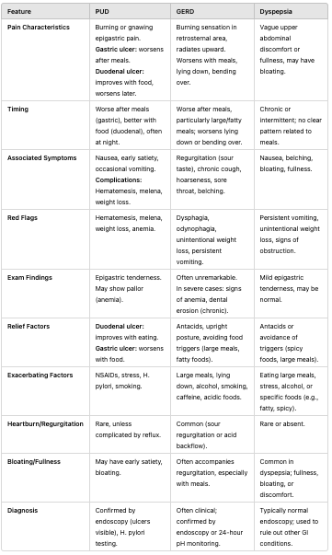

Cholelithiasis & cholecystitis
Tell-tale sign is hx of alcohol use or appendicictis***
Definition | Cholelithiasis | Cholecystitis
Definition | The presence of stones (gallstones) in the gallbladder. | Inflammation of the gallbladder, typically caused by obstruction of the cystic duct due to gallstones.
Pathology/Cause | Cholesterol stone/crystals form when there is too much cholesterol in bile, typically in conditions like cirrhosis or hemolysis. | - Acute: Usually caused by a blockage in the cystic duct by gallstones, leading to inflammation and infection.  - Chronic: Long-standing inflammation often from recurrent episodes of acute cholecystitis.
Risk Factors/Epidemiology | - Age >40  - Hx. Gout  - Female sex (especially in multiparous women)  - Obesity  - Rapid weight loss  - Pregnancy  - Diabetes  - Family history/genetics  - Native American and Hispanic. | - Obesity  - Age >40  - Hx. Gout  - Female sex (especially in women over 40)  - Male gender is a risk factor in older age.  - Diabetes  - Pregnancy  - Rapid weight loss  - Chronic gallstones
 | 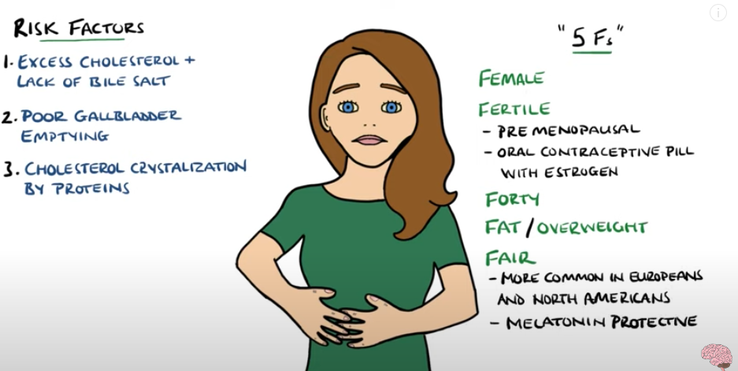
Clinical Presentation | Many are asymptomatic and unaware of the stones.  Intermittent RUQ pain (may radiate to the right shoulder), often after fatty meals.  Nausea/Vomiting  Bloating or sensation of fullness after eating.  Jaundice→rare unless stones obstruct the bile duct. | Sudden and severe RUQ pain, often lasting hours, triggered by fatty foods.  Often associated with fever/chills.  Nausea/Vomiting.  Jaundice may occur if there is bile duct obstruction.  Murphy’s sign→Positive in acute cases (pain on palpation of the RUQ).
Hx/Key Questions | - History of intermittent RUQ pain, particularly after meals.  - Duration and frequency of pain episodes.  - Any history of nausea, vomiting, bloating, or indigestion.  - History of rapid weight loss or dietary changes. | - Onset, severity, and duration of RUQ pain.  - Fever or chills?  - History of similar episodes or gallstones.  - Associated symptoms like nausea, vomiting, or jaundice.
Physical Exam | Vitals (usually WNL)  Height/Weight/BMI  Full Abdo exam…look for→  RUQ Tenderness (no rebound tenderness.)  Murphy’s sign is usually NEGATIVE.  *Consider auscultating heart if complainaing of epigastric pain to r/u any cardiac origin | Vitals (Fever/Tachycardia)  Height/Weight/BMI  Full Abdo exam…look for→  RUQ Tenderness over the gallbladder, often with guarding or rebound.  Epigastirc pain with palpation  Murphy’s Sign is usually POSITIVE  CVA tenderness  Skin and eyes for jaundice  *Consider auscultating heart if complainaing of epigastric pain to r/u any cardiac origin
Diagnostics/Labs | - Ultrasound (U/S): Primary diagnostic tool for detecting gallstones in the gallbladder.  - CBC: Mild leukocytosis may be seen in cases of biliary colic.  - Amylase/Lipase: To rule out pancreatitis.  - Electrolytes: To check for dehydration if vomiting is present.  - Liver Function Tests (AST/ALT/Bilirubin): To check for liver involvement or bile duct obstruction. | - Ultrasound (U/S): Shows gallstones and signs of gallbladder wall thickening or fluid around the gallbladder.  - CBC: Elevated white blood cell count (leukocytosis) indicating infection.  - LFT: elevated AST, ALT, bilirubin if bile duct is obstructed.  - Amylase/Lipase: To rule out pancreatitis if there is concern for biliary obstruction.  - Urinalysis: To rule out pyelonephritis if fever and flank pain are present.
Red Flags | Fever or chills, constant pain unrelieved by position changes, Jaundice, signs of acute pancreatitis (severe epigastric pain, elevated amylase/lipase). | Severe RUQ pain not relieved by medications, high fever with shaking chills, jaundice, tachycardia or hypotension, S/S of sepsis.
Differential Diagnoses | Gastritis (xommon cause of epigastric pain but no associated RUQ tenderness or jaundice)  Peptic Ulcer Disease (typically epigastric and related to meals)  Pancreatitis (Severe epigastric pain with nausea and vomiting.)  Hepatitis | Acute Pancreatitis (RUQ pain, but with elevated amylase/lipase and epigastric tenderness.  Peptic Ulcer Disease (but typically lacks fever or significant tenderness)  Hepatitis  Pyelonephritis
Treatment/Management | low-fat diet, surgical cholecystectomy if symptomatic or complications occur.  Avoid fatty foods and large meals.  In asymptomatic cases, monitor for any new symptoms. | May need hospitalization for IV fluids, antibiotics and pain control (NSAIDs or opioids), surgical cholecystectomy  Discuss the importance of cholecystectomy to prevent recurrent episodes or complications.  Avoiding fatty foods post-surgery.
Referrals | Gastroenterology for medical management of asymptomatic cases or complicated cases.  Surgery for cholecystectomy. | Surgical referral for cholecystectomy, especially if acute.  Gastro if concerns about complicated biliary disease.
Follow-up | Periodic follow-up if asymptomatic. | Post-operative follow-up after cholecystectomy within 1-2 weeks to monitor recovery and complications.
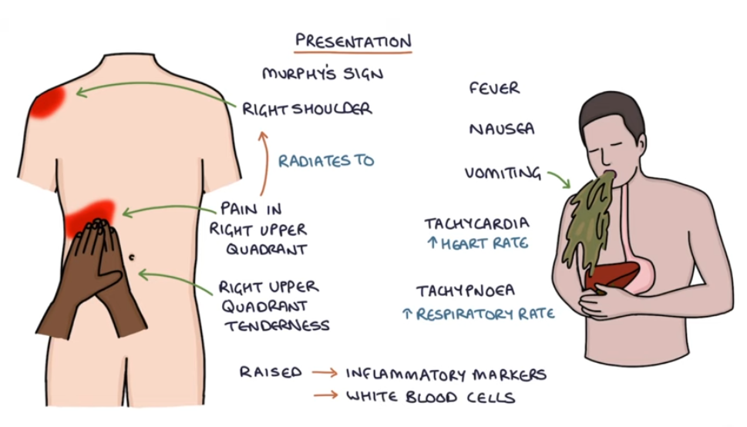

Bowel Obstrcuction
Definition | A mechanical or functional blockage of the intestines, preventing normal passage of contents through the digestive tract.
Pathology/Causes | Mechanical→Adhesions, hernias, tumors, volvulus, intussusception.  Functional→ Paralytic ileus, ischemic bowel, post-surgical complications.  Other→ options, lack of mobility, family hx
Risk Factors/Epidemiology | Newborns, older adults, recent GI surgery patients.  Other Risks: Abdominal surgeries (adhesions), hernias, inflammatory bowel diseases.
Clinical Presentation | HALLMARK: Sudden crampy pain (umbilical/epigastric region) with vomiting, constipation or diarrhea (partial obstruction).  Other symptoms:  Nausea/vomiting, abdominal distention, high-pitched bowel sounds, visible peristaltic waves (thin patients), palpable mass (lower obstruction), absence of flatus.  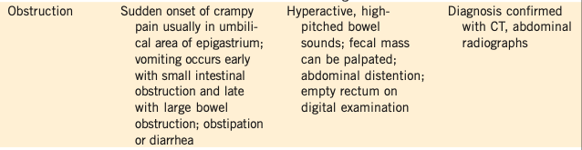
History/Key Questions | -Do you have any GI symptoms (gas, diarrhea, constipation, vomiting, heartburn)?  -Have you had changes in bowel habits, stool, or eating patterns?  -Is the pain relieved by defecation or burping?  -Baseline BM’s frequency and appearance  -Use bristol dypp; chart to assess other BMs theyve had recently  -Family hx of constipation  -Medications (opiods)  -Urinary symptoms (dysuria, hematuria, hesitancy, or frequency)?
Physical Exam | Vitals  Inspect: abdominal distention, may see visible peristaltic waves in thin patients.  Auscultate look for hyperactive, high-pitched bowel sounds (early) or absent bowel sounds after 5 full minutes of auscultation (late). RLQ if often chosen for aucultation for 5 mins.  Palpate: masses or impacted stool, pain (usually in LQ)  Percuss: may hear dull sounds over onstruction  DRE→ Empty anus on digital exam, palpable mass in some cases.  Mental status  May complete tests (ie. Rebound tenderness to r/u differentials)
Red Flags | Fever, tachycardia, peritoneal signs, acidosis (suggestive of strangulation/perforation), absence of flatulence for several days, vomiting*****, diarrhea
Diagnostics/Labs | First line: Abdominal X-rays (supine and sitting), CT abdomen/pelvis (preferred), MRI.  CBC, electrolytes, lactate (ischemia marker), blood culture if concerned about dehydration or infection that may be suggestive of sepsis or perforation
Differential Diagnoses | -Ileus  -AAA  -Gastroenteritis.  -Diverticulitis.  -Ureterolithiasis  -Appendicitis.  -Ischemic bowel disease.  To differentiate from ruptured abdominal aortic aneurysm pain does not radiate to the back as in AAA.  For ureterolithiasis pain radiates to the groin.  If they complain of flank pain its likely renal calculi/pyelonephritis.
Treatment/Management | Have pt become NPO, IV fluids, NG tube decompression.  May need surgery (if complete or strangulated obstruction) or conservative management (partial obstruction).  Education on importance of follow-up, diet modifications post-treatment,r est, bowel rest, and fluids
Refferal | General surgeon if serve obstrcution and surgery needed. Often in PHC you would send the pt to ED for this as it is a medical emergency.
Follow-Up | - Monitor for resolution or worsening symptoms.  - Regular imaging if conservative management.

Constipation
Def’n | A condition characterized by infrequent bowel movements or difficulty passing stool, typically defined as having fewer than three bowel movements per week.
Pathology/Cause | Can be caused by a variety of factors, including slow colonic transit, pelvic floor dysfunction, dietary factors (low fiber intake), dehydration, medications (opioids), and underlying medical conditions (hypothyroidism, diabetes).
Risk Factors/Epidemiology | -Older age, female gender, sedentary lifestyle, low fiber diet, dehydration, certain medications, and underlying health issues.  -Affects up to 20% of the population at some point.  -Meds can worse it: NSAIDS, anticonvulsants, MAOIs, dietetics, antipsychotics, iron, antidepressants, opioids, chemo meds, antacids, antiemetics, antihistamines, anticholinergics
Clinical Presentation  *Insert picture here* | HALLMARK: infrequent stools, hard or lumpy stools, straining during bowel movements, a sense of incomplete evacuation, abdominal discomfort, and bloating.  Less than 3 poops per week
Hx/Key Questions | How often do you have bowel movements? What is the consistency of your stools? Do you experience straining or discomfort? Any dietary changes or recent medication use? Do you have a history of gastrointestinal disorders?
Physical Exam | Check vitals  Inspection: Assess overall nutritional status, skin (especially rectum) for pallor/dehydration/hypothyroidism, check for hernias, inspect anus (position, anal wink, prolapse, excoriation, perianal erythema, hemorrhoids, fissures, skin tags), examine lower back for spinal lesions (hairy/hyperpigmented patches, gluteal fold asymmetry, cutaneous dimples, sinus tracts, lipomas), skin turgor if you think dehydrated  Auscultation: Listen to all abdominal quadrants for bowel sounds (high-pitched or absent).  Percussion: Percuss the abdomen.  Palpation: Check abdomen for masses, tenderness, distension, fecal mass; palpate liver and spleen.  DRE--> Assess rectum for anorectal mass, stricture, hemorrhoids, fissures, fistula, prolapse, inflammation, anal warts; evaluate impaction, anal reflex, sphincter tone (resting/squeezing/expulsion force), and use Valsalva maneuver for rectocele, prolapse, pelvic floor descent, puborectalis dysfunction.  Neurologic Exam: Assess tone, strength, reflexes, focal deficits, and delayed ankle jerk relaxation (hypothyroidism).  Pelvic Exam: Evaluate for prolapse/rectocele at rest and with straining.  Screen for depression and somatization.  - Abdominal examination for distention or tenderness  - digital rectal examination to assess for fecal impaction, rectal tone, and any abnormalities.  --Palpate for abdo masses
Diagnostics/Labs | - CBC to check for anemia  - Lytes and renal if dehydrated  - Thyroid function tests if hypothyroidism is suspected  - Colonoscopy if there are concerning symptoms (unexplained weight loss, rectal bleeding).  - FOBT/FIT if blood in stool and r/u hemroids  - U/S or xray if you think an obstruction
Red flags | - Unexplained weight loss, rectal bleeding, severe abdominal pain, new onset after age 50, family history of colorectal cancer or inflammatory bowel disease.  NO BOWEL SOUNDS AND S/S OF SEPSIS= R/U OBSTRUCTION or PERFORATION  –Diarrhea with constipation is a red flag as it could indicate an obstruction
Differential Diagnoses | - Irritable bowel syndrome (IBS)  - Fecal impaction  - Colorectal cancer  - Hypothyroidism  - Diabetes mellitus  - Neurological disorders affecting bowel function.
Treatment/Management | Treatment: Increase dietary fiber intake (20-35 grams/day), ensure adequate hydration, laxatives (polyethylene glycol, stool softeners), treat underlying conditions.  Counseling/Education: Educate on the importance of dietary changes, hydration, and regular exercise. discuss normal bowel habits and encourage a bowel routine.  Non-pharm therapies: Behavioral pelvic floor exercises or bowel training.
Referrals | gastroenterologist for chronic cases or when red flags are present.
Follow-up | Schedule follow-up in 4-6 weeks to assess the effectiveness of interventions and adjust treatment as needed. Encourage ongoing monitoring of bowel habits and symptoms.

Diarrhea
Def’n | Frequent, loose, or watery stools, typically defined as having three or more loose stools per day.
Pathology/Cause | Diarrhea can be caused by infections (viral, bacterial, or parasitic), food intolerances, medications, inflammatory bowel disease (IBD), irritable bowel syndrome (IBS), and malabsorption syndromes.  Common pathogens:  - Salmonella (cramping is common and blood in stool)  - E.coli (can or cannot have blood in stool)  - Travelers Diarrhea  - Paratie infection (Giardiasis)  - Entamoeba Bistoylyia (amebiasis)  - CDiff
Risk Factors/Epidemiology | Recent travel, poor hygiene, consumption of contaminated food or water, weakened immune system, and use of antibiotics.  Epidemiologically, acute diarrhea is common, with infectious causes accounting for many cases.
Clinical Presentation | Symptoms may include frequent loose stools, abdominal cramps, urgency, nausea, vomiting, fever, and dehydration.
Hx/Key Questions | How many times per day do you have diarrhea? What is the consistency and appearance of your stools (mucus, blood)? Are there any accompanying symptoms (e.g., fever, vomiting, abdominal pain)? Any recent travel or exposure to sick individuals? Are you taking any medications? Any recent new foods, meds, contaminated water intake? Hx of IBS?
Physical Exam | - Abdominal examination for tenderness or distention  - Vital signs to check for signs of dehydration ( low blood pressure, high heart rate)  - Assessment of hydration status (skin turgor, mucous membranes).
Diagnostics/Labs | - Stool tests to identify infectious agents →cultures (cdiff)  - Consider imaging or endoscopy if chronic or red flags are present.  -Ova and parasite tests  Labs:  - CBC to check for signs of infection (leukocytosis)  - Electrolyte panel to assess for dehydration  - CRP  - Renal (dehydration)  - Liver enzymes to r/u differentials
Red flags | - Severe abdominal pain  - High fever (≥ 101°F or 38.3°C)  - Blood or mucus in the stool  - Symptoms lasting longer than 48 hours  - Signs of dehydration  - Recent antibiotic use or travel history.
Differential Diagnoses | - Infectious gastroenteritis (viral or bacterial)  - Food poisoning  - IBD (Crohn's disease, ulcerative colitis)  - IBS  - Malabsorption syndromes (e.g., celiac disease)  - Medication-induced diarrhea.
Treatment/Management   | Treatment: Rehydration (oral rehydration solutions for mild cases, IV fluids for severe dehydration) and antidiarrheal medications (loperamide) may be used cautiously.  Counseling/Education: Educate on the importance of hydration and dietary modifications and advise on when to seek medical attention (persistent symptoms, dehydration)  Non-pharm therapies: Dietary adjustments (BRAT diet: bananas, rice, applesauce, toast). Probiotics may help in some cases.
Referrals | Gastroenterologist for chronic diarrhea or when red flags are present.
Follow-up | Follow up in 2-3 days for acute cases or sooner if symptoms worsen. For chronic cases, reassess in 4-6 weeks to evaluate treatment effectiveness and consider further testing if necessary.

Appendicitis
Def’n | Acute inflammation of appendix d/t obstruction of appendiceal lumen.  There’s no single S/S or test that confirms dx of inflammation.
Pathology/Cause | Foreign bodies, fecal material, tissue hypertrophy, strictures or a bend or twist in the organ may cause obstruction of the appendix. Bacterial invasion causes inflammation and leads to gangrene and perforation.  Common bacteria: E Coli, pseudomonas, Bacterioides fragilis
Risk Factors/Epidemiology | - Most common condition requiring abdo surgery in children and pregnancy  - Pregnancy  - Torsion  - Abdo trauma  - Male  - 10-30 yo
Clinical Presentation | STARTS AS UMBILICAL PAIN THEN GOES TO RLQ  50% of cases - Anorexia and periumbilical pain followed by RLQ pain and N/V  Adults:  - Generalized or localized abdo pain in epigastric or periumbilical area > within 2-12 h, pain localizes in RLQ at McBurney’s point and intensity increases  - Pain typically develops before N/V  - Elderly may present with confusion  Pediatrics:  - <2 yo: abdo distension, irritability, lethargy, fever  - >2yo: vomiting (usually the first symptom), RLQ pain, fever  Other S/S: rigid abdo, tachycardia, tachypnea, involuntary guarding, rebound tenderness
Hx/Key Questions | OPQRST, has this pan ever occurred before and if so what was the dx? What was the previous tx? Pain pattern? Pain scale? LMP? Any hx of dysparaeunia or dysmenorrhea that suggests pelvic pathology? Review meds nd drug hx. R/O abdo trauma, MVS, assaults, falls. Discuss bowel habits. Urinary symptoms?  Murphy's triad consists of "pain in the abdomen followed by nausea or vomiting, and general abdominal sensitiveness on the right side, followed by an elevated body temperature."  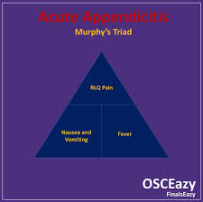  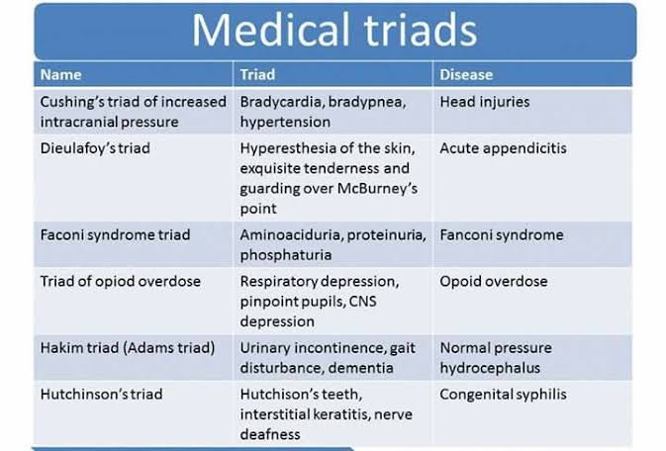
Physical Exam | Evaluate for a “surgical abdomen” - defined as a rapidly worsening prognosis in the absence of surgical intervention  - Pts should be NPO while a dx of surgical abdomen remains under consideration  VS (including ortho BP)  INSPECT:  - General appearance, acute distress/pain, skin colour, LOC  - Abdomen: any surgical scars?  - Any bruising or other signs of domestic violence in “bathing suit areas” - breasts, abdo, back  AUSCULTATE:  - Abdo- bowel sounds  - Heart/lungs  PALPATE:  - CVA tenderness  - Rebound tenderness  - McBurneys Point: a point midway between the umbilicus and the right anterior-superior iliac spine. Rebound pain on palpation is a + sign  - Obturator sign: abdo pain in response to passive internal rotation of RT hip from 90 degree angle hip-knee flexion position  - + sign indicates pain secondary to irritation of obturator muscle with inflamed appendix  - Psoas sign: increased abdo pain occurring when pt attempts to raise his/her RT thigh against the pressure of your hand placed over their RT knee  - + sign indicates inflammation of psoas muscle in acute appendicitis  - Apley rule: the farther the pain from the navel, the more likely it is organic in origin (as in related to an organ)  - Rovsing’s sign: pain in RLQ on palpation of LT side  - PALPATE ABDO: at the end of the exam because positive response produces pain and muscle spasm that can interfere with subsequent exam:  - Have pt bend knees to help relax abdo muscles  - Murphy’s sign: inspiratory arrest in response to RUQ palpation - seen in cholecystitis  - Rebound tenderness  - Jar tenderness  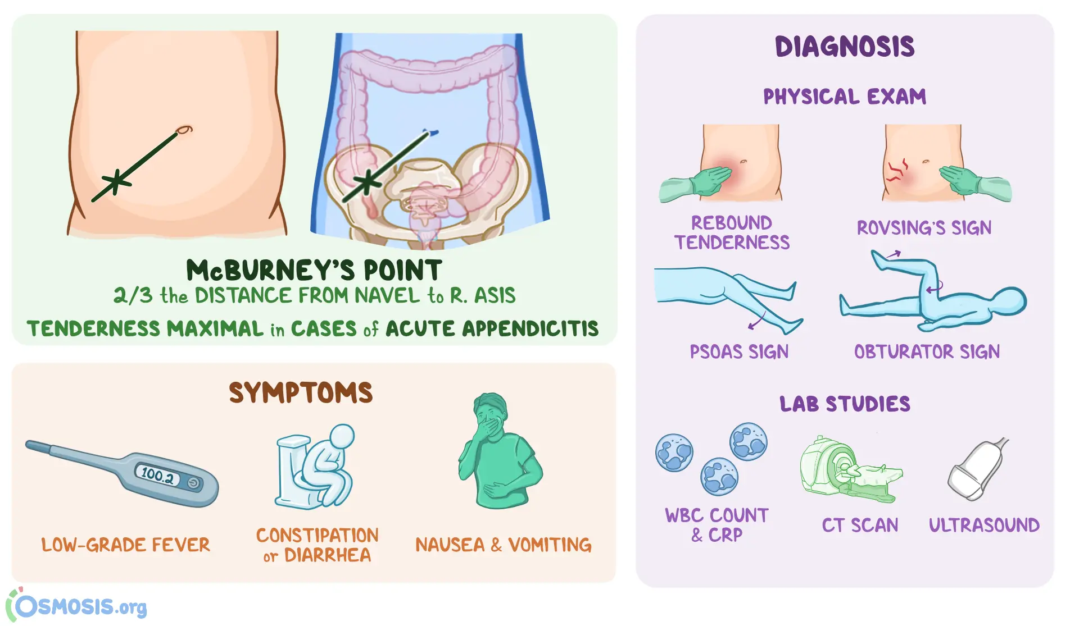  **NOTE on pregnancy: location of appendix alters during pregnancy so location of pain will be different  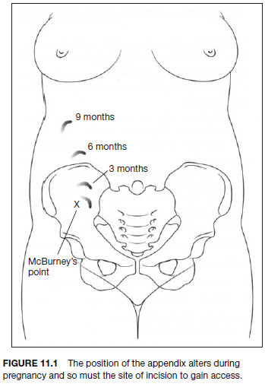
From DAINS: | Abdominal examination to assess for localized tenderness, rebound tenderness, and guarding.  Markle sign: Have the patient stand up on his or her toes, and then drop down to a regular standing position. If peritonitis is present, the patient will experience abdominal pain when his or her heels hit the floor.  McBurney’s point (IF NEGATIVE NOT APPENDICITIS…IF POSITIVE CAN BE OTHER DIFFERENTIALS SO USE ANOTHER TEST TO CONFIRM→ OBTURATOR/PSOAS): Tenderness at a point located at one-third of the distance between the umbilicus and the anterior superior iliac spine. This distance is approximately 2 inches.  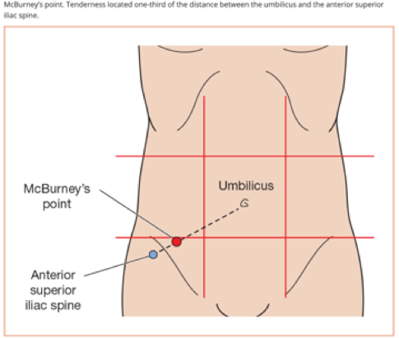  Rovsing’s sign: Patient experiences pain in the RLQ when the LLQ is palpated. This occurs because displacing the abdominal contents on the left side causes vibrations that migrate to the right and irritate the peritoneum surrounding the inflamed appendix.  Obturator sign: The patient experiences suprapubic pain when the examiner flexes the thigh and rotates the femur internally and externally. This occurs because the inflamed appendix is rubbing against the obturator muscle. This test is used to detect a pelvic appendix.  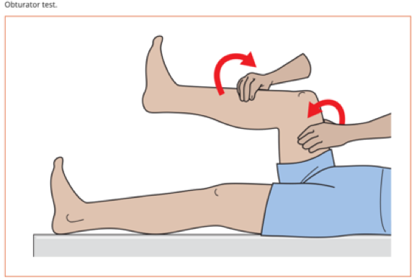  Psoas sign: The patient experiences pain when the right hip is passively extended. The patient flexes the hip in response to the pain. This occurs because the inflamed appendix is rubbing against the iliopsoas muscle.  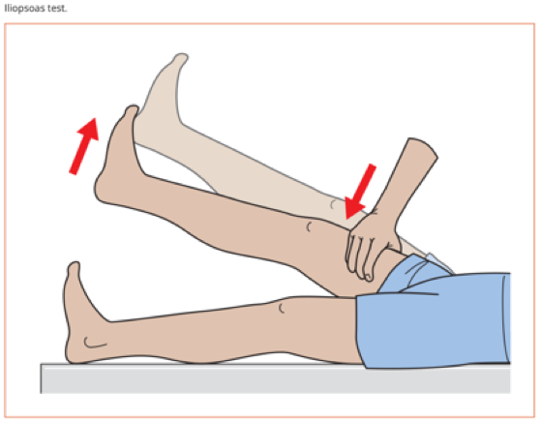
Diagnostics/Labs | Labs:  - Complete blood count (CBC): Elevated white blood cells.  - C-reactive protein (CRP): Elevated in inflammation.  - Beta-hCG (if applicable): Rule out pregnancy.  - Urinalysis: Rule out urinary tract infection or stones.  Imaging:  - Ultrasound: First-line in children and pregnant patients.  - CT Scan: Preferred in adults for higher accuracy if available.  - ULTRASOUND  - BHCG: pregnancy should be excluded in all women of childbearing age  - CBC  - CRP  - Urinalysis to R/O urinary disorders  - Abdo U/S; if they have abdo trauma  - CT with or without contrast  - Stool guaiac test for occult blood  - Alvarado score  - 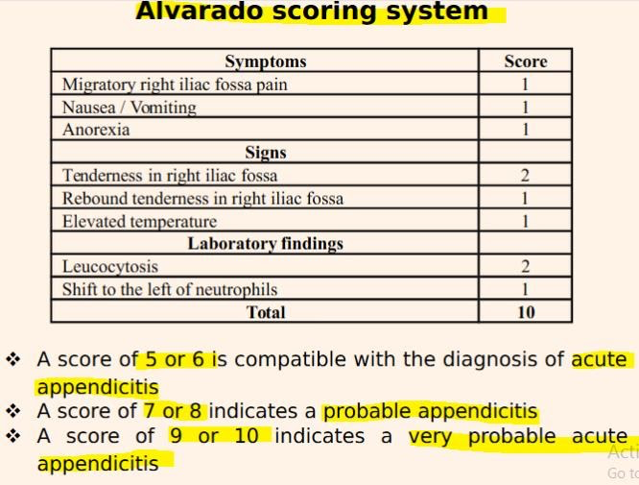
Red flags | Perforation- risk of perf increases after 72h, making early diagnosis of appendicitis and intervention a goal of treatment
Differential Diagnoses | Ovarian cyst, ovarian torsion, pelvic inflammatory disease, endometriosis, ureteral calculi, incarcerated hernia, bowel obstruction, intussusception, testicular torsion, IBD/Crohns, constipation,
Treatment/Management | Treatment: Surgery (appendectomy)  Counseling/Education:  Non-pharm therapies:
Referrals | Surgical consultation and possible emergency transport and hospitalized are often required
Follow-up | Post-op F/U with surgeon

Abdo Pain
ABDO PAIN BY LOCATION
ARIC TIP FOR OSCE: ALWAYS ASK PT IN ALL ABDO EXAMS TO POINT TO THE PAIN! ALWAYS R/L PREGNANCY, FLANK PAIN, CARDIAC

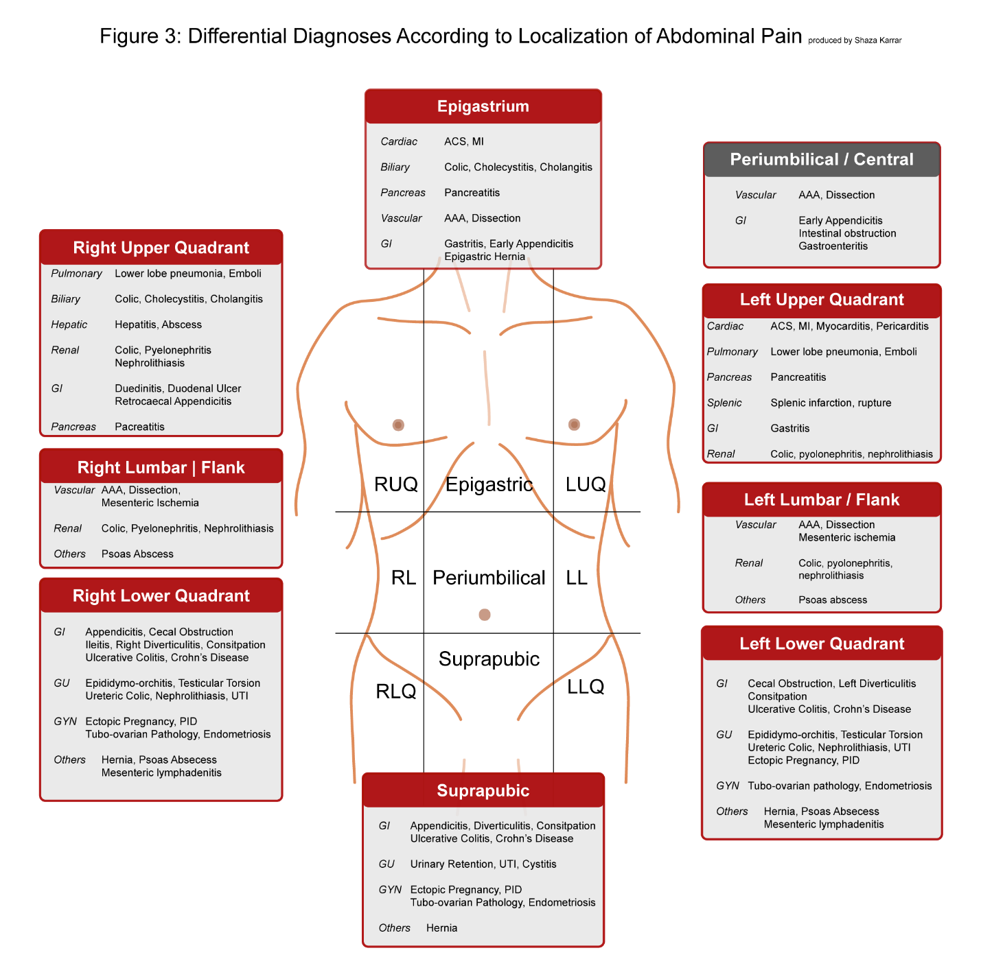
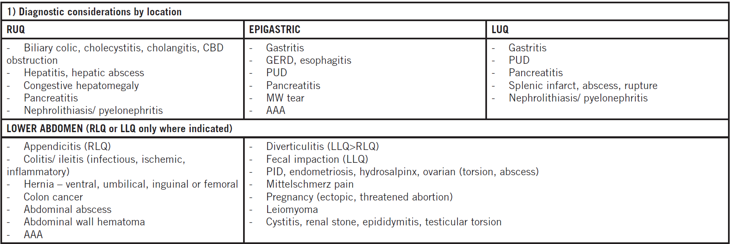
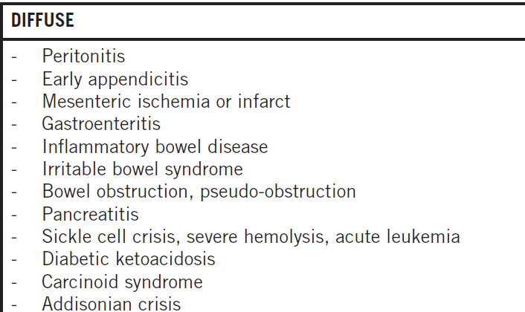

ABDO PAIN BY SYSTEM
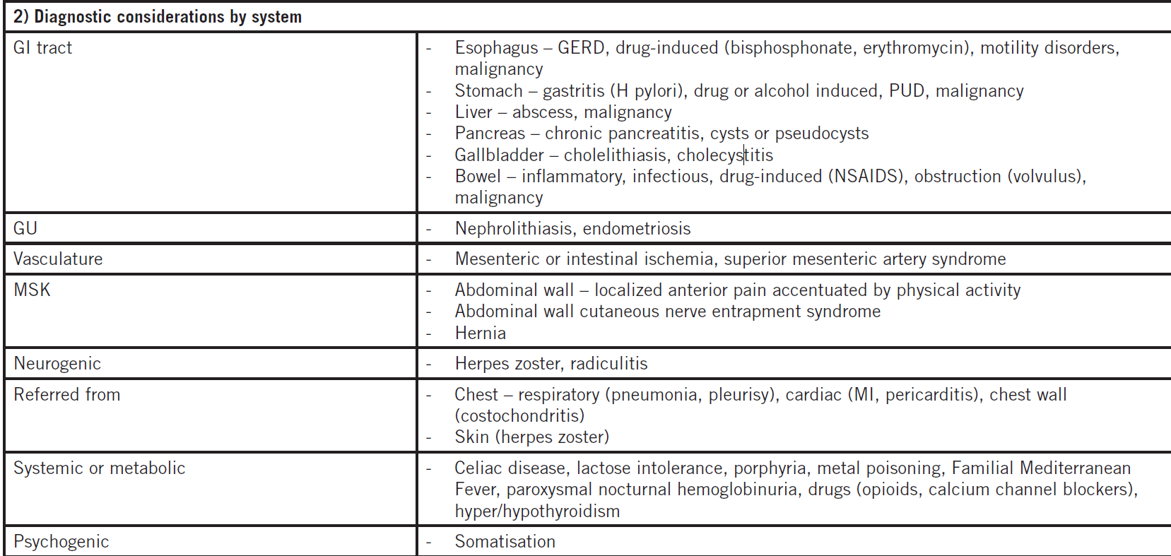

Chronic Abdo Pain (>3months)
Usually more benign. Potential causes:
- Organic (as in above tables)
- Functional - majority of chronic AP is IBS or functional dyspepsia
Hx/Key Questions | - OPQRST  - Assoc symptoms- N/V/D, weight change, GI bleed, jaundice  - Pregnancy?  - Stool (r/u blood in stool)  - What quadrant?
Physical Exam | - Inspect: colour, pulstation >3cm, contour, bruising→internal bleeding (cullen, grey turner, fox sign is upper thigh brusing, briant signs is bruising at testicles)  - Auscultate: bowel sounds, vascular bruits  - Palpation and percussion: degree and location of tenderness, guarding or rigidity over abdo wall (suggests “surgical abdomen”), masses (firm, fluctuating pulsating), enlarged organs.  - Deep palpation for liver: go inch by inch from umbilicu to RUQ, some smoothness is expected over liver border which is about 1cm away from rib cage on right side (in RUQ)  - Deep palpation for spleen starting in RLQ and deeply palpate up towards LUQ  - Should be hearing typmaic/resonacne sounds on percussion (except liver is dull)  - DRE: for anorectal masses, frank bleeding, black stools  - Vaginal exam: bleeding, discharge  - Inguinal canal and groin for protuberances +/- cough and enlarged lymph nodes
Tests to do based on quadrant of concern | RLQ (think appendicitis)  - McBurneys (land mark umbiicus, feel for illiac crest on right side and go to lower 3rd, and press down then release…pain on rebound! + means perirontits, appendicitis, or pancreaititis)  - If McBurnys is - then definitely not appendicitis, if its + then probably appendicitis but r/u other differentials too  - Rovsing sign  - Psoasis Sign  - Obturator Sign  RUQ (think Cholesistsits)  - Murphys sign (inhale, place hand papellel to ground, deep breath in and deeply palpate under ribcage, if painful then its + and gallbladder issues)  Back pain (think pyleonephritis)  - CVA tenderness  Eppigastric pain (apply pressure to right middle area, if nausea, metallic taste, etc think GERD, pancreatitis, dyspepsia , ulcerrrr  Umbilical (tink hernia)  - Inspect and palpate  LUQ (think spleen, peptic ulcer)  - No specific test, apply pressure to spleen/assess pain  - Percuss spleen  LLQ (tenderness is normal because of poop, if acute tenderness or rebound tenderness think diverticulitis or ovarian cysts but assess RLQ is orairan)  - Palpate  Subrapubic pain (think bladder, uterine issues, or hernia
Diagnostics/Labs | First line: Abdo U/S  Tailor diagnostics based on hx and physical exam findings  - Labs: CBC (infection), Hgb (bleeding), Lytes, glucose, Cr, LFTs, liver enzymes, lipase, amylase, ESR, CRP (inflammation), urinalysis, urine culture, TSH, preg test  - Imaging: Abdo XR, US, CT, MRI, barium studies  - Endoscopy/colonoscopy  - Stool for C&S, O&P (bowel infection), H pylori (dyspepsia), celiac testing, STI testing/vag swabs
Red flags | Unstable VS, progressive symptoms, syncope, fever, uncontrolled vomiting or diarrhea, weight loss, obstipation, concomitant chest or back pain, awakening pain, resp distress, acute vag or GI bleeding, signs of peritonitis (guarding, rigidity, diminished bowel sounds)
Treatment/Management | Treatment:  Counseling/Education:  Non-pharm therapies:
Referrals | Emerg if unstable, surgery/GI
Follow-up | N/A

GASTRIC AND DUODENAL ULCERS
Short definition/ description | Peptic ulcer disease is circumscribed ulceration of the GI mucosa in areas that are exposed to pepsin and acid.
Pathology/cause | An interplay between acid production, pepsin secretion, and H. pylori bacterial infection  - Duodenal ulcers= excess acid
Epidemiology | High recurrence rate of 50-80% in the first 6-12 months after healing, but recurrence is not always symptomatic  - 16-30% caused by NSAIDs (associated with higher risks of peptic ulcers and death)  - NSAIDs can inhibit prostaglandin synthesis and cause direct erosion
Risk Factors | - Prior history of ulcers  - Cigarette smoking  - NSAID use  - H. pylori infection  - Family history of ulcer disease  - Age (25 to 75 for duodenal but most common in ages 45-54; 55-65 for gastric)  - Gender: PUD occurs more in males than females at a 2:1 ratio  - Alcohol consumption  - Medication use  - Corticosteroid use potentiates ulcer risk in NSAID users  - Anticoagulants, bisphosphonates, spironolactone, SSRIs  - Diet, irregular or skipped meals  - Physiologic stress (burns, CNS trauma, surgery, medical illness)  - Other→ radiation induced, chemo induced, vascular insufficiency, obstruction  - Bile reflux, cocaine use
Screening | 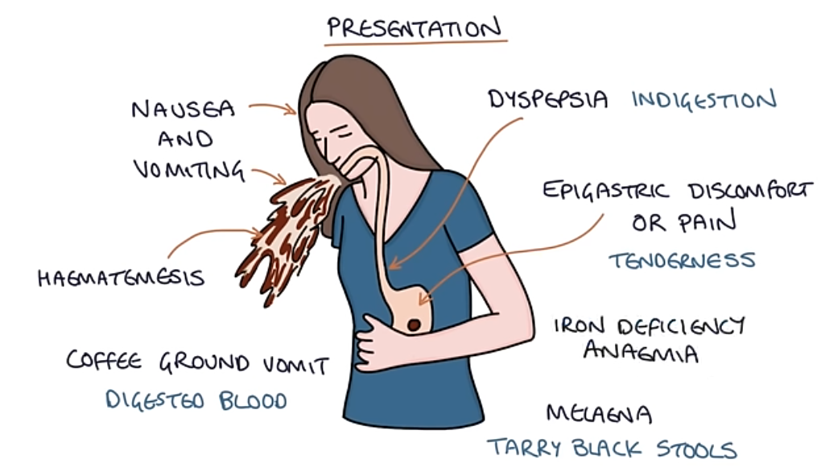  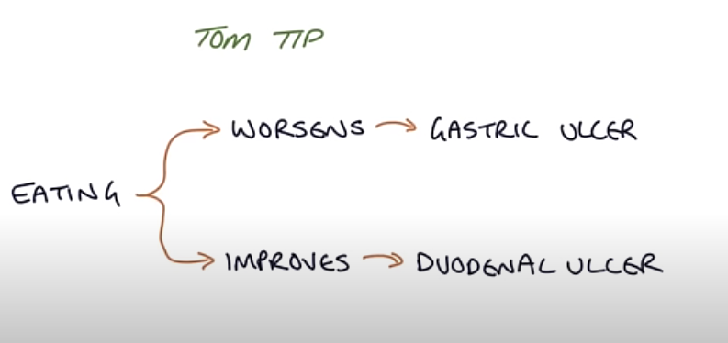
Clinical Presentation  (Subjective Symptoms & Objective Signs) | HALLMARK: an aching, boring, gnawing or burning feeling in the upper quadrants or just below the breast  Common findings:  - Pain that awakens the person late at night or early in the morning  - Perforated peptic ulcers present with the sudden onset of severe, sharp abdominal pain  Other signs and symptoms:  - Typically no correlation between symptoms and presence of an ulcer; there can be an absence of symptoms, but an ulcer can still be present  - Pain may be relieved by food, antacids, or vomiting  - Hematemesis, chest discomfort, blood in stools (maroon coloured), loss of appetite or weight, weight gain with DU as eating relieves the pain  - Anemia due to blood loss
Hx/Key Questions | OPQRST  - History of peptic ulcer disease, treatment, and was it completed  - Use of NSAIDs  - Relatives with the same condition  - Smoking history, alcohol use  - Eating habits  - Bowel patterns, blood in the stool, abdominal symptoms, ingestion of red foods  KEY QUESTION TO ASK:  Gastric Ulcers (Peptic Ulcer in the Stomach)  - Pain typically occurs during or shortly after eating.  - Eating triggers the stomach to produce acid, which can irritate the ulcer and cause pain. The stomach lining is already damaged by the ulcer, and the food causes more acid secretion, worsening discomfort.  - Pain usually starts within 30 minutes to 1 hour after eating, and it may get worse as the stomach continues to produce acid during digestion.  Duodenal Ulcers (Peptic Ulcer in the Duodenum)  - Pain typically occurs before eating or a few hours after eating, often when the stomach is empty.  - When the stomach is empty, there is less food to buffer stomach acid, and the acid can irritate the duodenum (the first part of the small intestine), where the ulcer is located. The pain is often relieved temporarily by eating, because food helps neutralize the acid and soothes the ulcer.  - Pain often occurs 2 to 3 hours after eating or in the middle of the night (when the stomach is empty). It improves after eating and comes back once the stomach empties again.
Physical Exam | VITALS: temp, pulse, respirations, BP, weight  PALPATE: for tenderness, guarding, rigidity, masses in the abdomen  PERCUSS: for hepatosplenomegaly  AUSCULTATE: for bowel sounds  RECTAL EXAM: check for tenderness and masses, take stool sample
Red Flags | Signs of bleeding→ hematemesis, melena, hypotension, weakness and dizziness, paleness, shortness of breath  Anemia is often the only symptom of gastric cancer  performation  Steanosis
Differential Diagnosis | GERD; Zollinger-Ellison disease; cancers; pancreatitis; MI; abdominal aneurysm, diverticulitis; drug-induced dyspepsia; gastric infection; cholelithiasis
Diagnostics:  Labs & Imaging | EGD scope, Complete blood work, liver function, and levels of amylase and lipase, urea breath test. Barrium swallow if cant have scope  Laboratory tests  - CBC  - Stool sample for occult blood test  - Coagulation studies  - H. pylori testing→ Endoscopy with biopsy is the most accurate  - Rapid urease breath test is the preferred method  - Can be falsely negative if there is active bleeding in the stomach  - Serum test for H. pylori antibodies, or stool testing (more accurate than antibody, and less expensive)  Diagnostic tests and/or Imaging  - Radiography with barium meal  - Mucosal biopsy to rule out cancer  - Fasting gastrin level for Zollinger-Ellison syndrome screening  - If over 40, high risk of gastric cancer→ should do an upper GI series or endoscopy to document nature and location of lesions  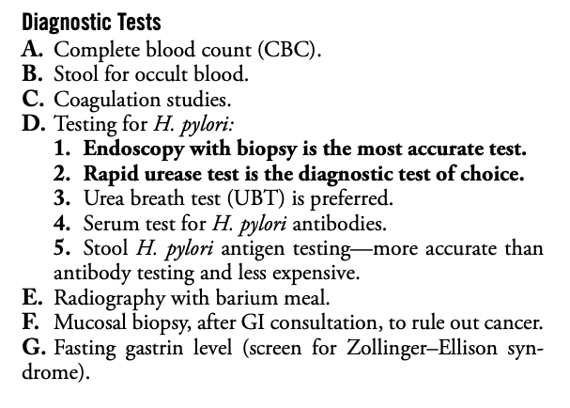  - Initial Testing in Primary Care:  - H. pylori Testing:  - Urea breath test or stool antigen test (non-invasive).  - CBC:  - Assess for anemia (microcytic anemia suggests chronic blood loss).  - Occult Blood in Stool:  - To check for gastrointestinal bleeding.  - Referral for Upper Endoscopy EGD or barium swallow+xray:  - Indicated for:  - Alarm symptoms (e.g., weight loss, bleeding, anemia, persistent vomiting).  - Patients >60 years with new-onset dyspepsia.  - Refractory symptoms despite treatment.  - Endoscopy: Gold standard for diagnosing and evaluating ulcers.  - Helicobacter pylori testing: Via breath test, stool antigen test, or biopsy during endoscopy.  - CBC: To assess for anemia due to bleeding.  - Urea breath test: To detect active H. pylori infection.  - Stool antigen test: For H. pylori detection.  - Barium swallow (if endoscopy is not available): Can show ulcers but is less sensitive.
Treatment/ Management | Counseling/Education  - Stop taking NSAIDs or use the lowest possible effective dose  - Smoking cessation  - Avoid alcohol, coffee  - Complementary Therapies (non-pharmacological)
Medical management | Surgery for cases of refractory disease and complications  - Benign ulcers should heal within 15 weeks, otherwise sx may be indicated  - Other indications→ loss of 6-8 units of blood in 24 hours, recurrent bleeding, perforation, obstruction
Advise clients when to RTC or call for help
Referrals | Consult a surgeon and a gastroenterologist, and admit to hospital when there are symptoms of hemorrhage, perforation, or obstruction
Follow-up | A trial of lifestyle changes plus a H2RA, sucralfate, or omeprazole for 1-2 weeks should provide relief  - Re-evaluate after 2 weeks and if there is symptom improvement, prescribe a full course of 6-8 weeks  - Re-evaluate again after 8 weeks when the course has been completed  Consider re-testing to confirm eradication of H. pylori
Common Complications | - Bleeding ulcer  - Perforation  - Obstruction  - With long-term PPI use, increased risk of osteoporotic fractures
1° and 2° Prevention | Primary prevention: dietary changes (lower acidic intake like alcohol and caffeine), smoking cessation.
References | Cash & Glass

GASTRITIS
Short definition/ description
Pathology/cause
Epidemiology
Risk Factors
Screening
Clinical Presentation  (Subjective Symptoms & Objective Signs) | - HALLMARK:  - Common findings:  - Other signs and symptoms:
Hx/Key Questions
Physical Exam | - Equal concurrence between the sexes
Diagnostic/
Special Tests
Red Flags
Differential Diagnosis
Diagnostics:  Labs & Imaging | Laboratory tests  Diagnostic tests and/or Imaging
Treatment/ Management | - Counseling/Education  - Complementary Therapies (non-pharmacological)
Medical management
Advise clients when to RTC or call for help
Referrals
Follow-up
Common Complications
1° and 2° Prevention | Primary prevention
References

GERD: Gastro-Esophageal Reflux Disease
Short definition/ description | 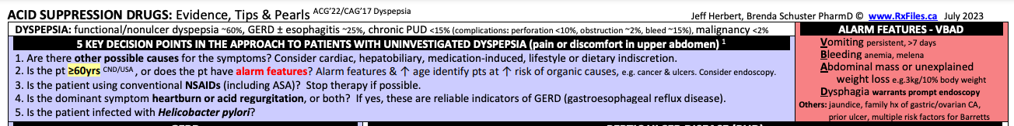Symptoms or complications from reflux of the gastric contents into the esophagus or beyond (possibly into the oral cavity, larynx, or lungs)  GER= gastroesophageal reflux  - Considered a normal physiologic process in healthy infants, children, and adults  - Most episodes last under 3 minutes, and occur 30-60 minutes after a meal with reclining position  GERD= symptoms that happen more than twice per week
Pathology/cause | Relaxation or incompetence of the lower esophagus persisting beyond the newborn period  - Relaxation of the LES allows reflux of gastric acid and pepsin into the distal esophagus  - Heartburn occurs when reverse peristaltic waves lead to regurgitation of acidic stomach contents into the esophagus  GERD is a trigger for asthma due to vagal reflexes or microaspiration  - Asthma can also promote GERD, and GERD can provoke asthma  - Asthma medications can reduce LES tone, and GERD can cause pulmonary disease due to acidic exposure in the lungs
Epidemiology | Very common! 17-65% of the population are affected by postprandial heartburn  - Affects 30-80% of women during pregnancy  - 30-90% of adults have GERD
Risk Factors | - Obesity  - Smoking  - Hital hernia  - Consuming large meals  - Pregnancy  - Emotional stress  - Food: spicy, caffine, fatty, chocolate, soda  - Immature, weak sphincters in newborns  - Increased abdominal pressure from tight clothes, straining to lift or defecate, and swallowing air  - Ingesting drugs that promote relaxation of the LES  - NSAIDs, benzodiazepines, CCBs, theophylline, nitrates, anticholinergics, alcohol, chocolate, peppermint  - Smoking (increases stomach acid and LES pressure)  - Ingesting caustic agents like lye  - Infectious agents like candida, HSV, or CMV directly attack the esophageal mucosa  - Compromised immunity from AIDS, diabetes, or chemotherapy  - Asthma  - Improper diet and nervous tension may precipitate an episode  - Anatomical abnormalities  - Hiatal hernia (more common in the elderly)
Clinical Presentation  (Subjective Symptoms & Objective Signs) | HALLMARK: heartburn, regurgitation of fluid or food, and chest pain. Worse when laying down better when sitting up. Mettalic taste. Chronic cough. Indigestion. Pain with swallowing  PAIN AFTER EATING, WORSE WHEN LAY FLAT***  Other signs and symptoms:  - Retrosternal aching or burning  - Nocturnal aspiration, water or acid brash  - Harsh taste in the mouth when waking up  - Chronic cough, particularly at bedtime  - Hoarseness, globus sensation, nausea, dental erosions  - In infants→ failure to thrive and vomiting  In infants, differentiate between regurgitation and vomiting  Regurgitation= within the first hour of feeding, with burping  - May see irritability or arching of the back during or after feeding  Vomiting= projectile often, any time regardless of feeding, and results in significant loss of body fluid and electrolytes
Hx/Key Questions | OPQRST  - Medication use, herbals and OTC included  - How long have OTC antacids been taken for?  - Are there drugs being taken that induce esophagitis  - Antibiotics, alendronate, NSAIDs, ascorbic acid, potassium chloride, iron, quinidine  - Review smoking and alcohol habits  - Ask about weight loss, blood loss, regurgitation, diarrhea  - Establish usual weight to determine severity of the problem  - Ask about asthma and Crohn’s disease  - Rule out cause fromm caustic agents (important in pediatric cases)  - Review history for risk of bulimia
Physical Exam | VITALS: pule, respirations, BP, weight  INSPECT: for stridor, resp distress  - Examine the throat and mouth for dental erosions  - Assess swallowing  AUSCULTATE: for wheezing in the lungs  - Auscultate the heart  - Listen to bowel sounds  PALPATE: for hepatosplenomegaly, and masses, tenderness  RECTAL EXAM:  - Perform exam if indicated, based on history of melena or hematemesis  R/U cardiac stuff so may want to assess JVP, peripheral legs, skin.
Diagnostic/  Special Tests | Clinical examination and history is usually sufficient to confirm the diagnosis of GERD  - Important to rule out other causes of chest pain before starting therapy
Red Flags | Dysphagia  Unintentional weight loss  Predominant upper abdominal pain  Hematemesis  Melena  Odynophagia (pain with swallowing)  Severe symptoms  In pregnancy→ sudden onset discomfort with no relief from antacids may indicate HELLP syndrome
Differential Diagnosis | Cancer (gastric, esophageal), MI or angina, esophageal spasm, gallbladder disease, pyloric stenosis, infections with CMV, HSV, or candida, peptic ulcer, ingestion of a caustic substance, food allergy, self-induced, eosinophilic esophagitis, and autoimmune disorders affecting the esophagus  Vomiting in infants…  - Overfeeding, sepsis, metabolic disorders (galactosemia), increased intracranial pressure
Diagnostics:  Labs & Imaging | Laboratory tests  - Ambulatory 24-hour pH monitoring for GERD in asthmatics  - Expensive and not universally available  - Consider H. pylori testing  Diagnostic tests and/or Imaging  - Endoscopy i not required for GERD symptoms, but may be required if there are red flags in clients at high risk for complications  - Upper GI or barium contrast radiograph is typically NOT used to diagnose GERD  - Can rule out anatomical abnormalities of the upper digestive tract if suspected
Treatment/ Management | Counseling/Education  - No evidence to support specific dietary eliminations, but may be helpful in identifying own triggers  Complementary Therapies (non-pharmacological)  - Weight loss if client is overweight or obese
Medical management | Tailor to the frequency, severity, and duration of symptoms  - Surgery is not recommended for clients who do not respond to PPI therapy  - Surgery is as effective as medication
Referrals | Refer to endoscopy for clients who are on NSAIDs and experiencing upper gastric pain  Referral is required if client fails after 2 different medication trials, dysphagia, recent weight loss, or blood loss  Also refer patients having frequent relapses  In infants…  - A full evaluation should be done with referral to a pediatric gastroenterologist
Follow-up | Should have a diagnosis for non-cardiac chest pain due to GERD prior to starting therapy
Common Complications | - Erosive esophagitis  - Esophageal strictures  - Barrett’s esophagus (<1% of the population)  Acid suppression drugs are associated with→ CAP, c. diff, GI infections
1° and 2° Prevention | Primary prevention
References | Cash & Glass

HEMORRHOIDS
Short definition/ description | Clusters of vascular tissues, smooth muscle, and connective tissue of the anal canal  - Internal= above the anorectal canal  - Covered by rectal mucosa and found in any position in the rectum  - Graded by severity  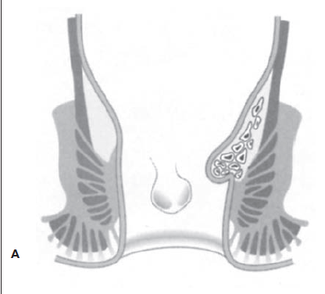  - External= below the anorectal canal, covered by anal skin  - Painless, flaccid skin tags  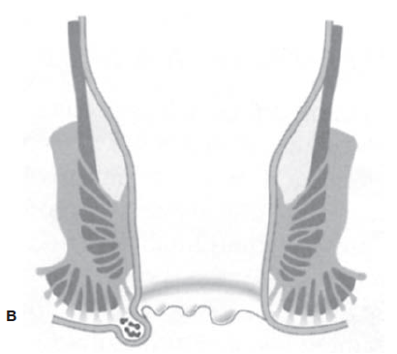  Thrombosed hemorrhoids→ blood within the hemorrhoid becomes clotted due to obstruction  - These appear as shiny blue masses  Rectal bleeding can still be a symptom of another disease process, and should be examined further  - Colorectal cancer, IBD, diverticular disease, angiodysplasia  - 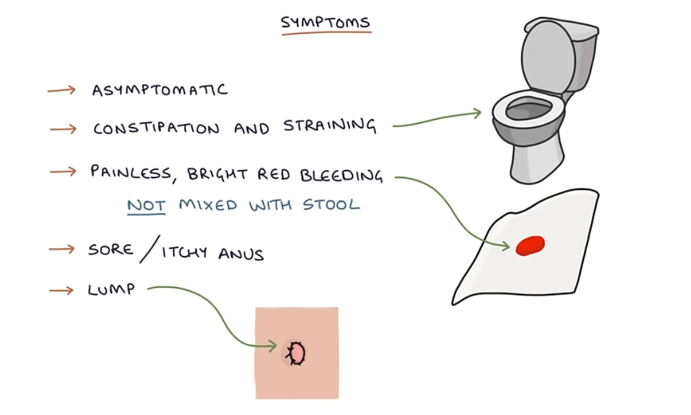
Pathology/cause | May be due to shearing forces from passing large, firm stools, increased venous pressure from heart failure or pregnancy, or by straining from lifting or defecation  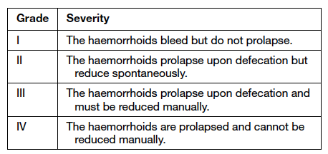
Epidemiology | Hard to know incidence, as clients typically present after using OTC treatments and failing to control their hemorrhoids  - Common in people over age 20 (uncommon in patients under 20 unless secondary to pregnancy)
Risk Factors | - Increased abdominal pressure from constipation, pelvic congestion, pregnancy, portal hypertension, and cirrhosis  - Altered bowel function (either constipation or diarrhea)  - Low-fiber diet  - Sedentary jobs like driving, piloting planes  - Loss of muscle tone due to advanced age  - Anal intercoure  - Colon malignancy  - Obesity  - Rectal surgery  - IBD  In children, rectal prolapse is associated with cystic fibrosis  - Rectal prolapse in general is more common in the elderly
Screening
Clinical Presentation  (Subjective Symptoms & Objective Signs) | HALLMARK: bleeding that is bright red and painless with defecation (internal)  Common findings:  - Anal pruritus, prolapse, and pain due to thrombosis  Other signs and symptoms:  - Visible prolapsed mass  - Incomplete defecation  - Leakage of feces (due to internal hemorrhoids)  - Excessive moisture  - Weakness or fatigue with anemia  - External hemorrhoids→ protruding from the rectum
Hx/Key Questions | OPQRST  - Hygiene practices, history of rectal bleeding  - History of hemorrhoids and treatments tried (surgery?)  - Pregnancy, liver disease, and constipation  - Job and level of daily activity  - Sexua practices  - Diet history for fluid and fiber intake  - Bowel habits, ease of evacuation  - Family history, focusing on intestinal disease
Physical Exam | VITALS: temp, BP, HR, resp rate, weight  INSPECT: observe anal area for skin tags, prolapse, irritation, fissures, and condyloma  - Internal hemorrhoids are usually not visible unless prolapsed  - External will protrude with straining or standing  PALPATE: the abdomen for masses  - Internal hemorrhoids are usually not palpable unless thrombosed  - Perform digital rectal exam
Red Flags | Signs of acute blood loss, anemia, significant weight loss
Differential Diagnosis | Condyloma acuminata, rectal prolapse  Rectal bleeding due to…  - Colorectal cancer, polyps, anal fissure, fistula, perianal abscess, IBD, diverticulitis, pelvic tumor
Diagnostics:  Labs & Imaging | Laboratory tests  - Hematocrit and hemoglobin if bleeding is present  - Stool for occult blood testing (guaiac)  Diagnostic tests and/or Imaging  - Anoscopy, as DRE cannot alone diagnose or exclude internal hemorrhoids  - Sigmoidoscopy or colonoscopy in the geriatric population is recommended to exclude underlying malignancy  - Air contrast barium enema for atypical bleeding
Treatment/ Management | Counseling/Education  Complementary Therapies (non-pharmacological)  - High fiber diet with adequate fluid intake to maintain soft, bulky stools  - Allows for defecation without straining  - Warm sitz baths up to TID for irritation and pruritus  - Lie prone and apply ice pack to the area if there are thrombosed hemorrhoids
Medical management | No treatment required if the client is asymptomatic except for maintaining regular bowel habits and performing comfort measures as needed  - Surgical treatment is contraindicated in pregnancy due to risk of inducing labor
Advise clients when to RTC or call for help
Referrals | Onset of urinary retention and fever immediately after office-based procedure may be a sign of perianal sepsis; requires emergency evaluation  Refer if bleeding is repeated, if prolapse occurs, if there is intractable pain, or thrombosis  - Or if 3-5 consecutive days of treatment does not provide relief
Follow-up | None required if the client symptoms resolve  - If symptoms persist, re-evaluate in 2 weeks  - If providing interventions, evaluate in 7-10 days
Common Complications | Of hemorrhoidectomy…  - Urinary retention, UTI  - Fecal impaction, pain, hemorrhage, non-healing wound, anal leakage, fistula formation
1° and 2° Prevention | Primary prevention
References | Cash & Glass

HERNIA (PELVIC)
Short definition/ description | A protrusion of a peritoneum-lined sac through a defect from one anatomical space to another  Three types of inguinal hernias:  - Direct inguinal  - Protrudes through the external inguinal ring  - Can remain in the canal, exit the external ring, or pass into the scrotum  - Can be unilateral or bilateral  - Indirect inguinal  - Protrudes through the internal inguinal ring  - Located in the region of Hesselbach’s triangle  - Rarely enters the scrotum  - Femoral  - Protrudes through the femoral ring, femoral canal, and fossa ovalis
Pathology/cause | Pelvic hernias occur due to a potential space for protrusion  - Commonly the bowel, but may also be the omentum  - Indirect and direct hernias arise along the course that the testicle travels as it exits the abdomen and enters the scrotum during intrauterine life  - Indirect hernias may be due to congenital defects in the processus vaginalis, where it remains patent  - Femoral hernias occur at the fossa ovalis, where the femoral artery exits the abdomen
Epidemiology | Most common= indirect inguinal hernias  - Affect both sexes, often seen in children and young males  - 7:1 ratio of males to females  - Incidence increases with age  Direct inguinal hernias  - Occur more often in males, more common in age 40+  - 1-5% of infants, and 9-10% of those born prematurely  Least common= femoral hernias  - Rare in children, more common in females (1.8:1 ratio of females to males)  - More common to have right-sided presentation  3% have a sliding component  - Overwhelmingly left sided (4.5:1)  - Sliding hernias are more common in men than women, and predominance increases with age  - Female infants  - High incidence of sliding tube/ovary/broad ligament hernias  Primary perineal hernias→ most often occur in elderly, multiparous women
Risk Factors | - Pregnancy  - Straining  - Age  - Obesity  - Gender  - Repetitive stress or hard physical labor  - Congenital defects  - Premature birth (occurrence is inversely related to weight)  - Chronic cough  - Chronic constipation  - Family history of hernia  - History of abdominal aortic aneurysm
Clinical Presentation  (Subjective Symptoms & Objective Signs) | HALLMARK: a bulging or swelling localized to the groin or scrotum  Common findings:  - A dull ache in the lower abdomen to groin area  - Swelling of the labia majora in women  - Children may have minimal symptoms and present with a history of intermittent mass noted when straining or crying  - Bowel obstruction  Other signs and symptoms:  - Ability to reduce the hernia  - Exacerbation on standing, straining, or coughing  - Strangulation→ colicky abdominal pain, nausea, voting, hyperperistalsis, fever, edema, discolouration, tenderness  - Infants→ distress, vomiting, poor feeding, irritable, crying  *outright pain is unusual
Hx/Key Questions | OPQRST  - History of straining, trama, physical labor, pregnancy  - Red flag symptoms of strangulation  - Reducibility  - Bowel habits and occurrence of constipation  - COPD and cough history
Physical Exam | For all types of hernia, the purpose is to determine the type, reducibility, and risk of incarceration or strangulation. Palpation is best done when the client is standing  VITALS: pulse, respirations, BP, temp, weight  INSPECT: for discoloration and edema of the area  - Inspect for a visible hernia  - Ask the client to perform valsalva maneuver to increase intra-abdominal pressure  - Transilluminate the scrotum to evaluate for bowel contents  AUSCULTATE: for bowel sounds  PALPATE: the groin for lymphadenopathy, masses, and tenderness  - Remember that it is more common for the right side to be affected, overall  In males…  - Invaginate the scrotal skin with and without cough/strain  - A true heria→ a silky impulse tapping against the finger  - Scrotal lump is either soft or unusually firm  In females…  - Visually examine for a bulge, and then place 2-3 fingers across the inguinal canal and ask the client to cough or bear down to elicit the bulge or impulse  - Palpate the labia for swelling (will be either soft or unusually firm)  - Groin hernias may be exacerbated by pregnancy; know the difference between this and general round ligament pain
Red Flags | Outright pain→ strangulation or incarceration  Signs of strangulation= nonreducible, compromised blood supply
Differential Diagnosis | Acute conditions  - Testicular torsion, epididymitis  Non-acute conditions  - Testicular tumor, hip arthritis, undescended testes, hydrocele, varicocele, spermatocele  Bowel obstruction
Diagnostics:  Labs & Imaging | *Best method for diagnosis is history and physical exam  Laboratory tests  - Karyotyping in females if testicle is palpable in the inguinal canal  - Routine lab work is not recommended  Diagnostic tests and/or Imaging  - Ultrasound for abdominal masses and strangulation  - MRI can differentiate inguinal and femoral hernias  - Limited evidence→ x-rays  - Not recommended→ sigmoidoscopy
Treatment/ Management | Counseling/Education  - Avoid heavy lifting  - Know the signs of strangulation  Complementary Therapies (non-pharmacological)  - Use of a truss
Medical management | Surgery is the only effective treatment (contraindicated in pregnancy; defer until 4 weeks postpartum)  - Open or laparoscopic repair (herniorrhaphy)  - Watchful waiting can be done in asymptomatic clients as long as they are aware of the risk, and understand the need for attention if complications arise
Advise clients when to RTC or call for help | If they feel a lump or swelling in the scrotum; even if small or painless
Referrals | Refer femoral hernia clients to a surgeon  - Require immediate repair due to risk of incarceration and strangulation  Watchful waiting is not recommended in females; refer immediately  Refer males with moderate to severe symptoms from inguinal hernias, recurrent hernias, or scrotal hernias
Follow-up | Return to office if there is fever, severe pain, or strangulation  Continue to monitor for recurrence after surgery for up to 5 years and beyond
Common Complications | Strangulation, incarceration
References | Cash & Glass

IBD- CROHN’S DISEASE
Short definition/ description | Chronic inflammatory bowel disease of the GI tract that produces ulceration, fibrosis, and malabsorption  - Can involve any segment of the GI tract from mouth to anus  - Terminal ileum and colon are the most common sites  - In pediatrics, more common to present with disease to the small intestine only  - Elderly clients may have long standing IBD, or late onset IBD  A chronic, relapsing, incurable disease characterized by remissions and exacerbations
Pathology/cause | Inflammation of the mucosal lining of the intestinal tract, causing ulceration, edema, and bleeding and fluid/electrolyte loss  Etiology is unclear (potentially immunologic, pathogenic organisms but unknown, autoimmune, or genetic)
Epidemiology | Affects 13-30% of Canadians  - Peak incidence in late adolescence to the third decade of life  - Most have small bowel involvement (80%)  - Least likely to have mouth or gastroduodenal or esophagus involvement  - 33% have perianal disease  - 15-20% have arthralgias
Risk Factors | - Age 15-35  - Genetic predisposition and family history of Crohn’s  - First degree relative= 5-20x increased risk  - Children of a parent with IBD= 5% risk  - 70% incidence with identical twins  - Jewish populations  - Smoking increases risk for Crohn’s
Screening | 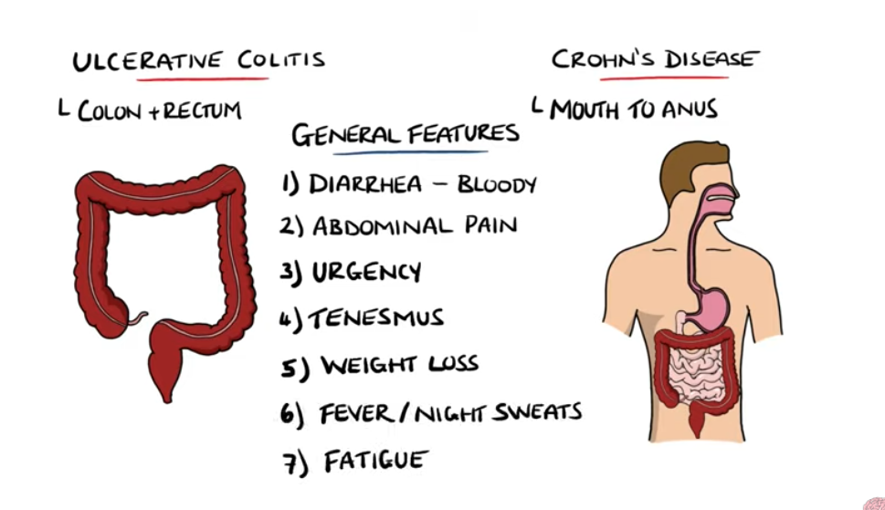  Heavy bloody diahhrea is usually UC  History Taking  - Presenting Symptoms:  - Abdominal Pain:  - Crohn’s Disease: Crampy, typically in the right lower quadrant.  - UC: Diffuse or left-sided pain.  - Diarrhea:  - Crohn’s Disease: Watery, may be large volume.  - UC: Bloody, smaller volume with urgency and tenesmus.  - Weight Loss:  - Common in both, more significant in Crohn’s disease.  - Fatigue and Malaise:  - Often due to anemia or systemic inflammation.  - Associated Symptoms:  - Fever (suggesting active inflammation).  - Extraintestinal symptoms:  - Joint pain (arthritis), erythema nodosum, pyoderma gangrenosum, uveitis, or primary sclerosing cholangitis.  - Symptoms of complications:  - Fistula (Crohn’s): Unusual discharge, perianal pain.  - Toxic megacolon (UC): Severe abdominal distension, high fever, shock.
Clinical Presentation  (Subjective Symptoms & Objective Signs) | HALLMARK: about 80% of clients have chronic or nocturnal diarrhea, with abdominal pain in the RLQ, fatigue related to pain, inflammation and anemia and other vitamin defncic ys like D, B12, calcium  Common findings:  - Symptoms typically correspond well with the degree of inflammation  Other signs and symptoms:  - Constipation is an early sign  - Weight loss, abdominal mass, cramping with bowel movements, urgency to defecate, rectal bleeding, perianal discomfort or soft/semi liquid irritating rectal discharge, vomiting, low-grade fever, folate deficiency, anorexia  - Fissures and fistulas, abscesses extending to skin  - Weight loss, diarrhea, growth restriction  - Extraintestinal symptoms→ erythema nodosum, inflammation of the eyes and skin  - In pediatrics→ failure to grow, delayed development of secondary sex characteristics  - Loss of normal menstrual cycle  In the elderly, unexplained diarrhea, weight loss, and perianal disease should arouse suspicion for Crohn’s
Hx/Key Questions | OPQRST of pain and bowel habits  - Any signs that there may have been flares in the past that went undiagnosed?  - Stool pattern history  - Recent travel to foreign countries  - Previous GI surgery?  - Weight loss?  - Family history, medication use, drug and tobacco use  - Effect on quality of life?
Physical Exam | VITALS: temp, pulse, resps, BP, weight  - Plot pediatric weight on growth chart to follow for trends  INSPECT: for pallor, wasting, ecchymosis, skin ulcerations, jaundice, and signs of Kaposi’s sarcoma  - Head and neck for aphthous stomatitis, glossitis, stomatitis, poor dentition  - Eye exam: screen for uveitis  - Joints: warmth, tenderness  AUSCULTATE: abdomen in all quadrants, screen for obstruction  PALPATE  - Neck for goiter and lymphadenopathy  - Abdomen for distention, ascites, tenderness, rebound, guarding, masses  - Palpate for hepatomegaly in the RLQ  RECTAL EXAM  - Check for tags, control, and discharge around the anal sphincter  - Palpate for masses, fistulas, tags, and inflammation  - DRE to assess for anal strictures and rectal masses  NEURO EXAM  - Assess for signs of B12 deficiency including tingling sensation and numbness the hands or feet  - 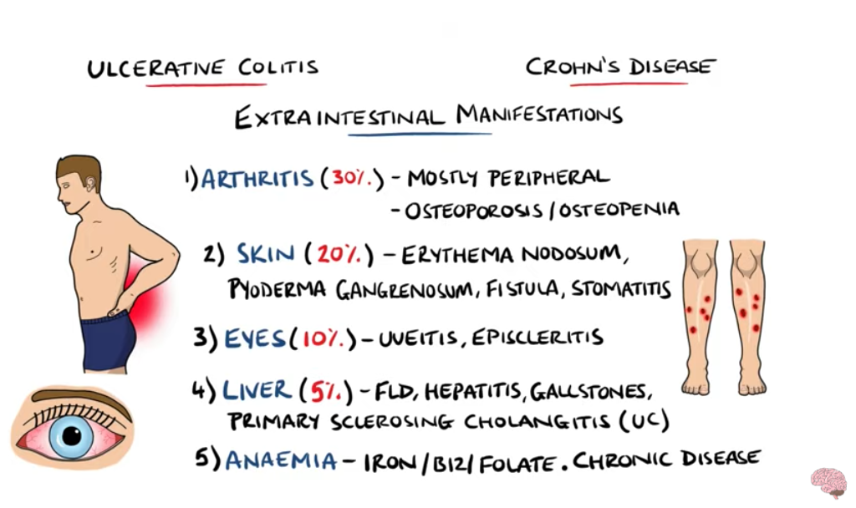
Diagnostic/  Special Tests | Initial Steps  - Clinical History & Physical Exam:  - Key first step: A detailed history and physical exam is critical to guide your next steps. This helps assess the likelihood of IBD and rule out other potential causes.  Laboratory Tests  - Basic Blood Tests:  - CBC (Complete Blood Count): To assess for anemia, infection, or inflammation.  - CRP/ESR: Inflammatory markers to assess for active inflammation.  - Electrolytes: To assess for dehydration if the patient has diarrhea or vomiting.  - LFT  - b12  - Stool Studies:  - Stool culture and Ova/Parasite exam: Only if there's concern for an infectious etiology (diarrhea, recent travel, or high risk for infections).  - Fecal Calprotectin: This can be a non-invasive first-line test to suggest inflammation in the intestines, helping differentiate IBD from other conditions like IBS.  - Note: H. pylori testing (urea breath test or stool antigen test) would be ordered if the patient has dyspeptic symptoms (e.g., heartburn, epigastric pain), but not routinely for IBD diagnosis.  Imaging (When Indicated)  - Abdominal X-ray or Ultrasound:  - Only if there are concerns about acute complications, such as perforation, obstruction, or abscess (more urgent scenarios, or if you suspect Crohn's disease with complications).  Referral to Gastroenterology  - Referral for Endoscopy (Colonoscopy):  - Colonoscopy is essential for diagnosing IBD and differentiating between Crohn's and Ulcerative Colitis. However, this is typically ordered by a gastroenterologist, though a primary care provider can initiate the referral.  - CT/MRI Enterography would generally not be ordered by primary care unless Crohn’s disease is highly suspected with complications (like abscesses or fistulas) that require further imaging.  Lab Work:  - CBC: Look for anemia or leukocytosis.  - B12  - CRP/ESR: Markers of inflammation.  - Albumin: May be low due to chronic inflammation.  - Fecal calprotectin: Elevated in active IBD.  - Stool studies: Rule out infection (C. difficile, culture, ova/parasites).  Imaging:  - Abdominal X-ray: Rule out obstruction, perforation, or toxic megacolon.  - CT or MRI Enterography: Assess small bowel involvement in Crohn’s.  Endoscopy:  - Colonoscopy with biopsy:  - Crohn’s: Skip lesions, cobblestone mucosa, transmural inflammation.  - UC: Continuous involvement, limited to colon, mucosal/submucosal inflammation.
Red Flags | Signs of dehydration, significant blood loss, toxic megacolon, blood loss
Differential Diagnosis | Ulcerative colitis  Ischemic or medication-induced colitis  Appendicitis, colon cancer, IBS, anorexia, perianal abscess, intestinal protozoan or bacterial causes, food poisoning, CMV, intestinal tuberculosis
Diagnostics:  Labs & Imaging | Usually done with endoscopic finding in a client with a compatible clinical history  Laboratory tests  1. Complete blood count (CBC) with differential.  2. Electrolytes and albumin.  3. ESR  4. vitamin B12  5. Serum iron.  6. Folate.  7. Liver enzymes and functioning tests (IRN, bilirubin)  8. HIV.  9. Celiac antibody testing should be considered.  10. Cstool culture, CDiff toxin assay  Barium enema (string sign differentiates CD from UC)  Colonoscopy (copplestone and skip is UC)  - CBCD, electrolytes, albumin, ESR, B12, iron studies, folate, liver enzymes, LFTs (INR, bilirubin)  - HIV, celiac antibody testing  - If considering AZA or MP medication, do thiopurine methyltransferase activity  Diagnostic tests and/or Imaging  Stool studies  - Guaiac, stool culture, C. diff assay, ova and parasites  Imaging  - Abdominal flat plate  - Barium enema→ look for the string sign (narrow band of barium flowing through an inflamed or scarred area in the terminal ileum; this is how to differentiate Crohn’s from ulcerative colitis)  - Rectal sparing suggests Crohn’s in the presence of other inflammatory changes elsewhere in the colon  - Thumbprinting indicates mucosal inflammation (can be seen on a flat plate of the abdomen)  - Skip lesions are areas of inflammation with normal-appearing areas in between  - A small bowel follow-through GI series  - Fistulogram to guide surgical correction  - CT of the abdomen and pelvis to look or fistula  - Indicated as the investigation of choice  Procedures  - Colonoscopy→ look for cobblestone appearance  - Flexible sigmoidoscopy with biopsy→ reveals skip lesions in the colon, significant small bowel involvement, fistulas, and granulomas  - Upper endoscopy→ can assess for aphthous ulcers in the stomach and duodenum (occurs in 5-10% of cases)  - Capsule enteroscopy→ major risk is potential for camera to be lodged in a stricture and require operative removal  - Skin biopsy  Tuberculin purified protein derivative skin test
Treatment/ Management | Counseling/Education  - Ensure sufficient protein and calorie intake to limit stress o the bowel  - High fiber, low fat diet  - If there is steatorrhea, consider <80 grams per day of fat)  - Empiric trial of restricting milk products may terminate diarrhea due to a lactase deficiency  - If there is severe diarrhea, partial bowel rest maybe required  Complementary Therapies (non-pharmacological)
Medical management | More than 70% of clients will undergo surgery within 20 years of the diagnosis  Indications→ strictures, intractable/fulminant disease, anorectal disease, intra-abdominal abscesses
Advise clients when to RTC or call for help | If fever develops, diarrhea worsens, bleeding occurs, or abdo pain becomes more marked
Referrals | Joint management should be done with a gastroenterologist, colorectal surgeon, rheumatologist, nutritionist, and other specialties as needed  *Annual ophthalmology exams if on lagoon-term corticosteroids  Psychosocial counselling in children
Follow-up | Record daily weights to monitor changes  Assess stool patterns to evaluate effectiveness of therapy  Bloodwork follow-up depending on pharmacologic agents being used  Begin colonoscopy screening in children 8-10 years after diagnosis of Crohn’s disease
Common Complications | Joints: Arthritis  Urinary: renal calculi  Sclerosing cholangitis (fatigue and jaundice)  Skin diseases  - Erythema nodosum (painful, tendere, raised, purple lesion on the tibia)  - Pyoderma gangrenosum (inflamed patch of skin that progresses to ulceration)  - Herpetic lesions related to immune suppression  Ocular inflammation  Hypercoagulability  Worse outcomes in the elderly due to delayed presentation and comorbid conditions
1° and 2° Prevention | Primary prevention
References | Cash & Glass

IRRITABLE BOWEL SYNDROME (IBS)
Short definition/ description | The most common GI motility disorder. A relapsing, functional disturbance of intestinal motility marked by a common symptom complex. A symptom-based diagnosis in the absence of detectable organic cause.  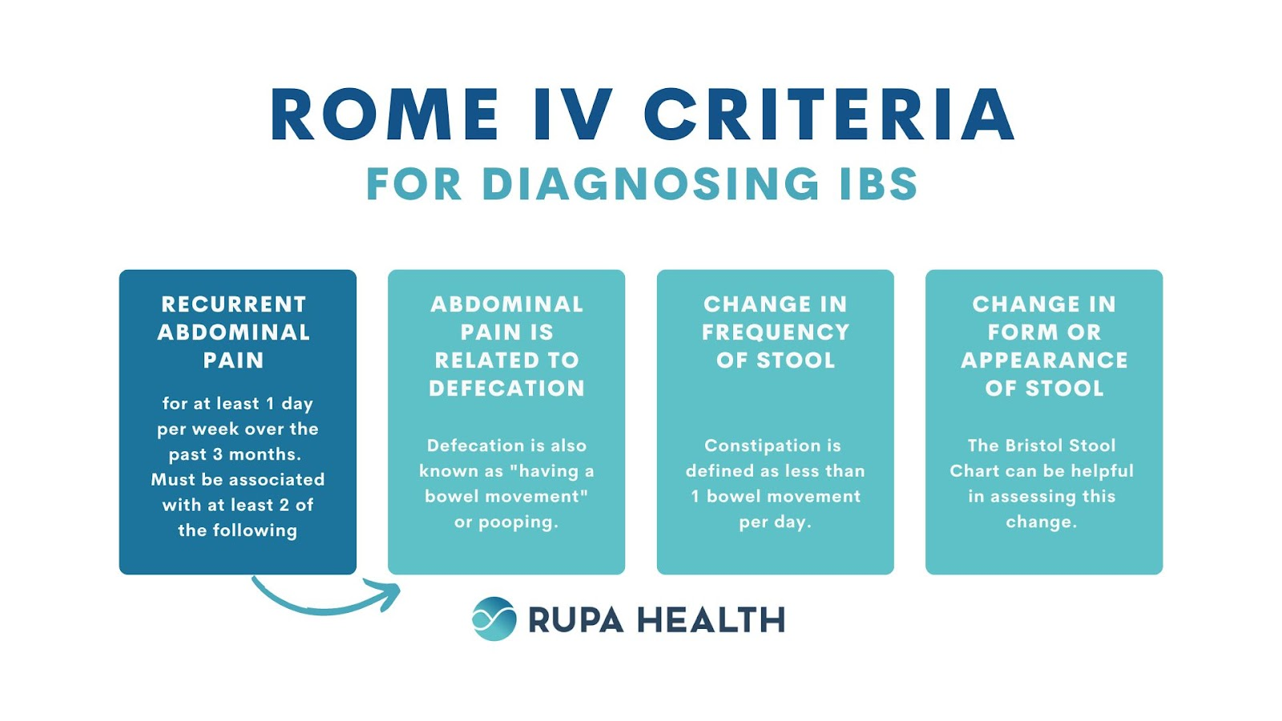  To qualify under a subtype, the person must have that predominant stool type >25% of the time, and the opposite stool type <25% of the time. The client can also have mixed or cyclic pattern (both hard and soft stools >25% of the time)
Pathology/cause | An absence of detectable pathology and lab tests are unrevealing  - Evolves from a disturbance in bowel motor activity to a more integrated understanding of visceral hypersensitivity ad brain-gut reaction  - Can be a normal response to severe stress and a learned visceral response to stres
Epidemiology | Common; 40% of GI complaints seen by HCPs  - Has been seen in both adults and children aged 11-17  Constipation type is more common in women; diarrhea type is more common in men
Risk Factors | - Age (mainly between age 15 and 65)  - 50% of cases occur before age 35, 40% between age 35-50  - Gender (adult women are 2-3x more likely to have IBS)  - Emotional factors and situational stress  - Prior GI infection-induced IBS  - Genetics  - Carbohydrate intolerance can produce significant symptoms
Tyes | 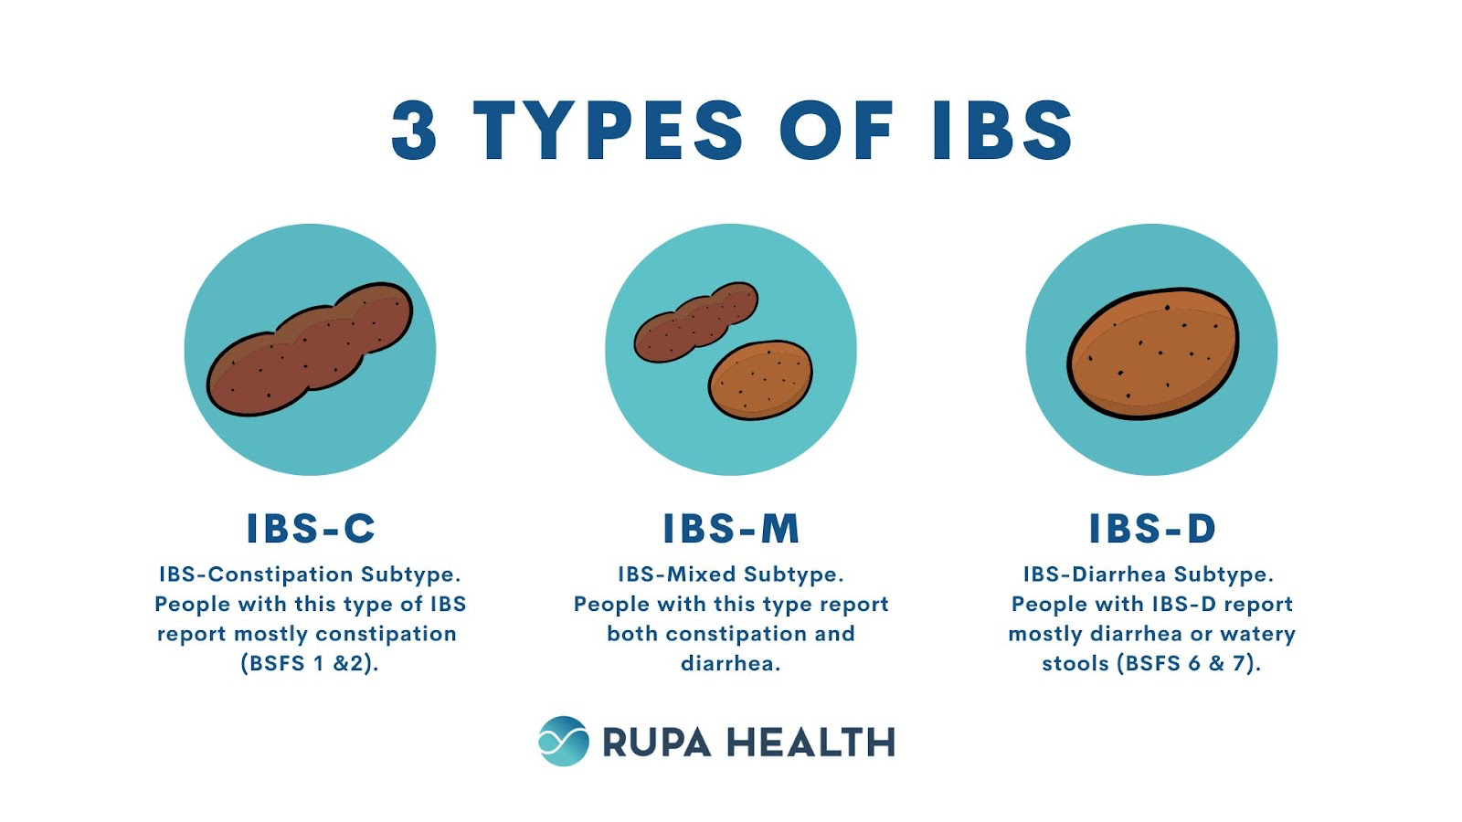
Clinical Presentation  (Subjective Symptoms & Objective Signs) | HALLMARK: bloating, abdominal pain or discomfort associated with defecation, flips between diarrhea and constipation and sometimes relieved with BM  IBD is the same S/S but involves inflmataion, ulcers  Common findings:  - 50% have associated bladder dysfunction  - Chronic, relapsing stool pattern of diarrhea (>3 loose stools per day), alternating diarrhea with constipation, or constipation (<3 BMs per week)  - Feeling of incomplete evacuation, abdominal distention and bloating, straining with bowel movements, aching or cramping in the periumbilical or lower abdominal region, and pain relief with bowel movements  Other signs and symptoms:  - Changes in bowel function  - Clear, mucous stool  - Pain precipitated by meals  - Pain radiating to the left chest or arm from gas in the splenic flexure  - Flatulence, nausea, anxiety, depression, preoccupation with bowel symptoms  - Extraintestinal symptoms→ dysmenorrhea, urinary frequency, urgency or incomplete bladder emptying, impaired sexual function and dyspareunia, fibromyalgia  - Menses can exacerbate IBS symptoms  *IBS SYMPTOMS DISAPPEAR DURING SLEEP but with IDB they don’t
Hx/Key Questions | OPQRST  - Determine history for stress factors, ask whether symptoms relate to them  - Establish normal weight history, determine amount of loss if any, and over what time period  - Ask about laxative use  - Ask about family history of GI diseases or malignancies  - Review travel and food history if diarrhea is predominant  - Review association with menses  Review diet for the following…  - Response to milk or lactose products  - Artificial sweeteners, alcohol  - Irregular or inadequate meals  - Insufficient fluid intake  - Excessive fiber intake  - Obsession with dietary hygiene  - Response to gluten ingestion (wheat, barley, rye)
Physical Exam | - HALLMARK: one of the following→night time incontinence, blood or mucus in stool, or and urgency  VITALS: temperature, pulse, resps, BP, weight  INSPECT: for general appearance for signs of depression and anxiety  - Assess abdominal contour for masses and bulges  AUSCULTATE: all quadrants of the abdomen for bowel sounds, note normalcy vs hyperactivity  PERCUSS: for dullness or tympany  PALPATE: evaluate for rigidity, tenderness, guarding, and masses  - Evaluate for hepatosplenomegaly or lymphadenopathy  Rectal exam…  - Check for masses and tenderness  - Obtain stool for diagnostic testing  - Rectal exam in patients with IBS will be normal
Red Flags | Nocturnal pain; bleeding, weight loss, nocturnal diarrhea  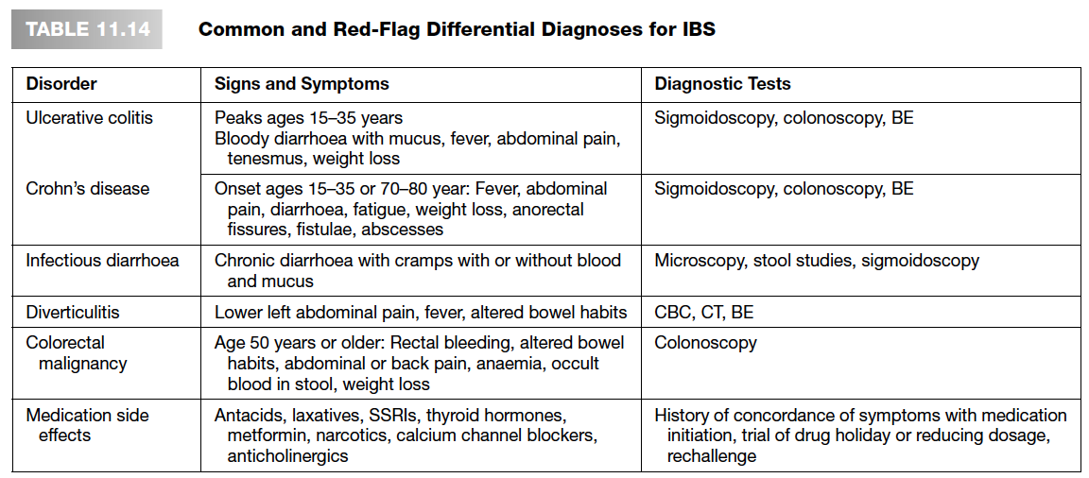
Differential Diagnosis | IBD, viral or bacterial gastroenteritis, GI neoplasm, acute diarrhea from protozoa or bacteria, lactose insufficiency or deficiency, laxative misuse, drug side effects, diabetes, celiac spruce/gluten etiology, diverticulitis, failure to thrive in children, endometriosis or PID, Zollinger-Ellison syndrome
Zollinger- Ellison syndrome | 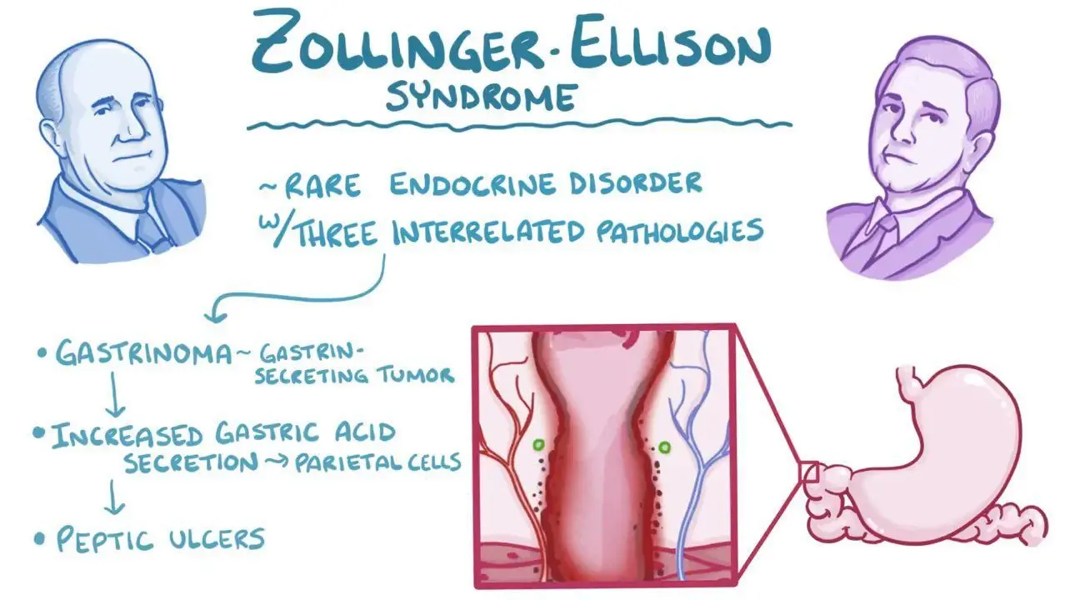
Diagnostics:  Labs & Imaging | - IBS is a clinical diagnosis, but exclude organic causes as needed:  - Blood Work:  - CBC (to rule out anemia or infection)  - Lytes  - CRP or ESR (to rule out IBD).  - THRYOID  - Stool cultures (if infectious diarrhea is suspected).  - scope, Clients under 50 with no alarm features do not need to have routine colonic imaging. Clients with IBS symptoms WITH alarm features like anemia, weight loss, or age over 60 should have colonic imaging to exclude organic disease.  History and physical is typically sufficient for diagnosing IBS  Laboratory tests  - If you are suspecting organic disease, laboratory tests can be done to rule this out  - CBC, ESR, CRP, K+, blood glucose if diarrhea is predominant to rule out diabetes  - Thyroid function  - Stool specimen to culture for leukocytes, fat, oval/parasites, occult blood  - IBS= leukocyte-free mucous  - C. diff cultures  Diagnostic tests and/or Imaging  - Barium enema or proctosigmoidoscopy if sever S&S after consulting or referring to a specialist  - Celiac serology  - Mucosal biopsy if colonoscopy or sigmoidoscopy is performed  - Esophagogastroduodenoscopy (EGD) and distal duodenal biopsy in clients with diarrhea to rule out celiac disease, tropical sprue, giardiasis, and if abdominal pain.discomfort is more in the upper abdomen  - Hydrogen breath test to evaluate lactose intolerance and small-intestinal bowel overgrowth (SIBO)
Treatment/ Management | Counseling/Education  - Keep a diary of events of bowel movements and precipitating factors  - Quit smoking; nicotine can aggravate symptoms  Complementary Therapies (non-pharmacological)  - Daily exercise and stress reduction  - High fiber diet, avoid aggravating foods  - Broccoli, garlic, onions, beans, etc.  - Assess diet for clues of lactose and sorbitol intolerance
Medical management | Stop all non-essential medications that may affect bowel function
Referrals | To a gastroenterologist if there are red flag symptoms  Consider psychiatric consultation for anxiety, depression, somatization, and symptom-related fears
Follow-up | Re-evaluate any treatment or lifestyle factors within 2 weeks  - If symptoms persist without relief, clients should return  - Return if diarrhea or constipation lasts more than 2 weeks on medication therapy
Common Complications | If constipation predominates, rule out malignancy in clients over age 40 with weight loss or family history of colon cancer
1° and 2° Prevention | Primary prevention: recommended fiber intake in children is age plus 4  After age 50, annual rectal examination and sigmoidoscopy may be recommended in adults
References | Cash & Glass

NON-ALCOHOLIC FATTY LIVER DISEASE (NAFLD)
Short definition/ description | Fat in the liver develops when a person consumes more fat and sugars than tolerable by the body  Too much fat stored in the liver cells  NAFLD has no associated hepatocellular injury or fibrosis
Pathology/cause | Occurs if fat builds up to >5% of the liver  The disease that occurs in people who drink little to no alcohol
Epidemiology | Affects about 20% of Canadians  Aside from obesity, other causes include…  - Starvation and protein malnutrition  - Long-term TPN use  - Intestinal bypass for obesity treatment  - Rapid weight loss  As childhood obesity is on the rise, so is NAFLD in children  - Occurs in ⅕ overweight or obese children in Canada  - Has been seen in children as young as 2 years old  - More common in boys than girls  - Increased in caucasian and south Asian children  - Associated with family history of T2DM  - May be linked to Wilson Disease, viral hepatitis, or autoimmune disease
Risk Factors | Established risk factors…  - Obese or overweight  - Metabolic syndrome  - Diabetes mellitus  Other risk factors (emerging evidence)  - Abdominal obesity, increased waist circumference (>88cm in women, >102cm in men)  - Diet high in sugary and fatty foods  - Genetic factors  - Some drugs and chemicals  - HIV infection  - Obstructive sleep apnea  - PCOS  Often accompanied by hyperlipidemia, and insulin resistance and hypertension
Screening | Routine screening is not recommended, even for high-risk adults
Clinical Presentation  (Subjective Symptoms & Objective Signs) | HALLMARK: no symptoms but elevated liver enzymes or evidence of steatosis incidentally found on testing performed for another reason  Common findings:  - Discomfort in the abdomen at the level of the liver  - Fatigue, generally feeling unwell  - Vague discomfort or pruritus
Hx/Key Questions | Questions related to alcohol intake, diabetes, sugar and fat content in diet, family history, weight management strategies and recent changes in weight.
Physical Exam | Abdominal exam to assess for hepatosplenomegaly  - Assess for hypertension  Weight, abdominal circumference, auscultate the bowels, inspect for masses  Assess for other diabetes-related conditions? (feet for ulcers, eyes for retinal involvement)
Red Flags | More serious form= Nonalcoholic steatohepatitis (NASH)  - Causes scarring, fibrosis, and cirrhosis  - Increased risk for liver cancer, liver failure, and requiring transplant
Differential Diagnosis | Drug-induced hepatic steatosis, alcoholic fatty liver disease, NAFL vs NASH, autoimmune hepatitis, Wilson disease, hereditary hemochromatosis, alpha-1 antitrypsin deficiency
Diagnostics:  Labs & Imaging | Laboratory tests  - Hypercholesterolemia (cholesterol panel)  - Insulin resistance (fasting glucose, HbA1C)  - Liver enzymes and liver function tests (ALT, AST)  - Alcohol-induced liver damage causes an AST:ALT ratio over 1.5, but NAFLD is usually under 0.8  Diagnostic tests and/or Imaging  - Ultrasound of the liver (method of choice)  - Liver biopsy (consider if at high risk for fibrosis)  Only provide a diagnosis of NAFLD in children after all other potential causes of a fatty liver have been ruled out  - For waist circumference in children, if you divided WC/height in CM, the ratio should not be greater than 0.5 (indicates potentially too much fat deposit in the abdomen)
Treatment/ Management | Counseling/Education  - Those with NASH should avoid drinking alcohol  - Reduce intake of added sugar  Complementary Therapies (non-pharmacological)  - Address risk factors  - Improve blood sugar control, monitor diabetes  - Achieve gradual, sustained weight loss
Medical management | Treat the cause! No proven treatment with medication for this condition  Primary “treatment” is weight loss through proper diet and exercise  - 7-10% body weight loss  Statins can be used to manage concurrent dyslipidemia
Referrals | Consider bariatric surgery in obese individuals; refer to a surgeon (not considered a specific treatment for NAFLD; consider in conjunction with other obesity related diseases)
Follow-up | Repeat LFTs in 6 to 12 months; and PRN based on risk of fibrosis
Common Complications | Makes the liver more vulnerable to inflammation and scarring  NASH is more associated with cardiovascular disease, cancer, and end-stage liver disease  NAFLD is mostly associated with a benign, nonprogressive disease course  - 20% develop to NASH, and only 20% who have NASH develop cirrhosis
1° and 2° Prevention | Primary prevention: healthy diet low in fat and added sugars, exercise regularly, maintain a healthy weight and abdominal circumference
References | Liver.ca  https://www.aafp.org/pubs/afp/issues/2020/1115/p603.html

PANCREATITIS
Short definition/ description | Acute pancreatitis is the sudden onset of reversible inflammation  Chronic pancreatitis is a progressive disorder characterized by ongoing inflammation and destruction (can occur insidiously)
Pathology/cause | Caused by gallstones or chronic alcohol use  Exocrine pancreas→ releases digestive enzymes into the duodenum via the pancreatic and bile ducts  - Premature activation of the enzymes causes inflammation
Epidemiology | Most common causes are gallstones and alcohol abuse
Risk Factors | - Cholelithiasis  - History of alcohol abuse  - Medication use  - Abdominal trauma  - Pancreatic abnormalities  - Hereditary factors  - Infections  - Hypertriglyceridemia  - Surgical procedures  - Tumors  - Vascular abnormalities  ACUTE:  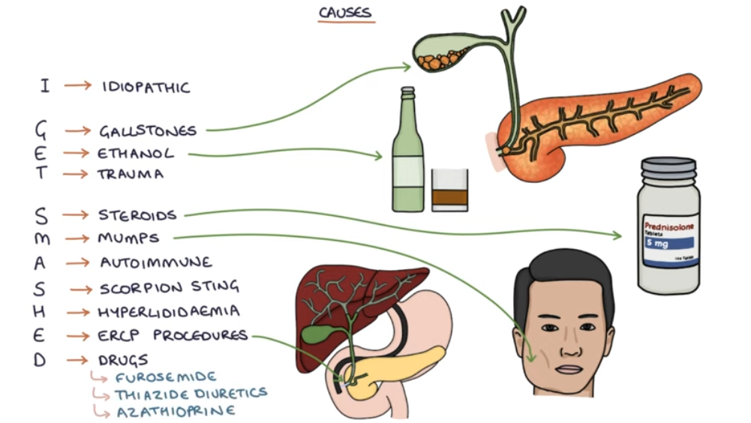  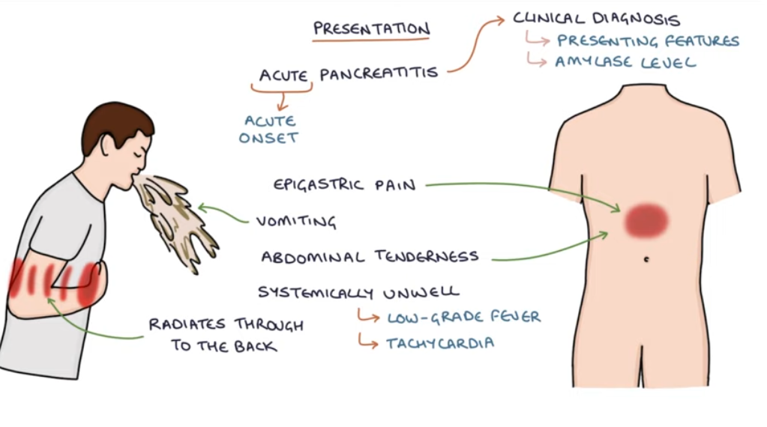
Screening | Guidelines for diagnosing acute pancreatitis (at least 2 of the following…)  - Abdominal pain suggestive of pancreatitis  - Serum amylase and/or lipase at least 3x the normal level  - Imaging findings suggestive of pancreatitis
Clinical Presentation  (Subjective Symptoms & Objective Signs) | HALLMARK: a steady, boring pain that is relieved by changing position  Common findings:  - Periumbilical pain; a sudden onset of pain with acute pancreatitis  - Pain radiates to the back from the LUQ and is worse in the supine position  - May be associated with recurrent exacerbations of pain  - Hypotension  *CHRONIC PANCREATITIS CAN BE PAINLESS OR PAINFUL  - LOOK FOR WEIGHT LOSS, STEATORRHEA  Other signs and symptoms:  - Ecchymosis around the umbilicus (Cullen’s sign) or the flank (Grey Turner sign)  - Nausea, vomiting, diaphoresis  - Appears acutely ill  - Abdominal distention, decreased bowel sounds, diffuse rebound tenderness  - Muscle rigidity in the upper abdomen  - Limited diaphragmatic excursion of the lungs on examination
Hx/Key Questions | OPQRST of symptoms  - Ask questions that will rule out cardiac etiology of chest pain  - Social history to assess alcohol use  - Medications being used  - Family history of pancreatic disorders
Physical Exam | Vitals: temp, pulse, BP, resp rate  - Use to assess hydration status  Inspect  - May see jaundice (biliary tree obstruction)  - Patients may present with altered mental state in severe cases  Examine the abdomen  - Auscultate for bowel sounds (usually decreased)  - Palpate for tenderness and passes  - Epigastric pain with pancreatitis  - See guarding, peritoneal irritation, distention, rigidity  Vitals→ assess for tachycardia, tachypnea, diaphoresis, fever  - Murphy's sign – to rule out gallbladder pathology (positive in cholecystitis).  - Look for Grey Turner and Cullens sign to r/u performation
Red Flags | Pain characteristics suggesting cardiac etiology
Differential Diagnosis | Chest pain of a cardiac etiology  - Consider pancreatitis if pain is severe, constant, reported inn the epigastric area of the abdomen, radiating to the chest, shoulder or arm, and associated with hypotension  Cholecystitis, peptic ulcer disease, gastritis, biliary disease  If acute pancreatitis, consider peptic ulcer disease, cholecystitis, perforated viscus, acute mesenteric ischemia, intestinal obstruction  If chronic pancreatitis, consider malignancy, recurrent acute pancreatitis, and mesenteric ischemia
Diagnostics:  Labs & Imaging | Laboratory tests  - CBCD  - Amylase and lipase serum levels (amylase rises 2-12 hours after symptom onset)  - Lipase level rise is slower (useful for diagnosis late in disease course)  - Renal and hepatic panel  - Urinalysis  - Calcium, lactate dehydrogenase  - Triglyceride levels if there is no evidence of significant alcohol use or gallstones  - If alcohol abuse is suspected, add magnesium and phosphorus levels  Diagnostic tests and/or Imaging  - Abdominal ultrasound (offer to all patients with suspected acute pancreatitis)  - CT (best at assessing severity and prognosis)  - Not needed for routine, mild acute pancreatitis cases  - Use if there is severe abdominal pain, iff necrotic pancreatitis or other complication sare suspected  - Can do MRI instead if CT is contraindicated  - Safe for unclear clinical diagnosis or if no improvement after 2-3 days in hospital  - X-ray  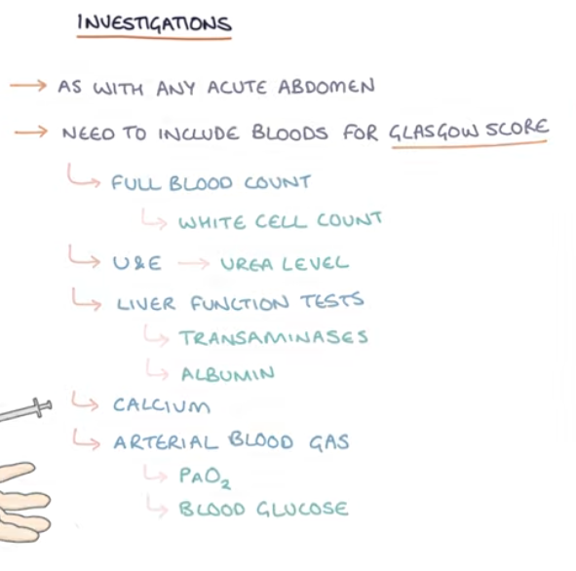  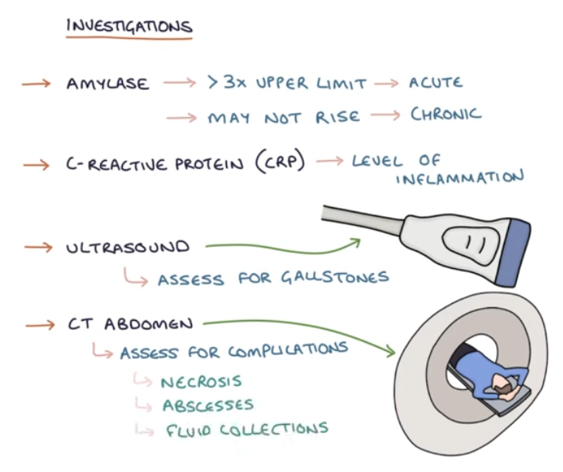  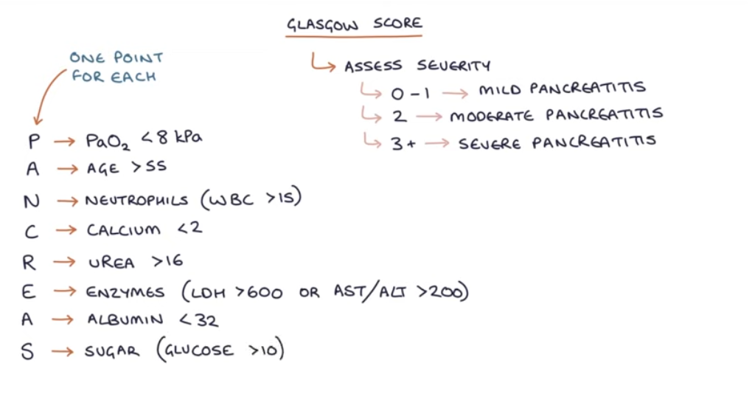  Laboratory Tests:  - Serum amylase and lipase (lipase is more specific and sensitive).  - Liver function tests (LFTs): To check for gallstone involvement.  - Complete blood count (CBC): To look for leukocytosis (suggestive of infection or inflammation).  - Blood glucose: Hyperglycemia may occur.  - Urea and electrolytes (U&Es): To assess for dehydration and renal function.  - Calcium levels: Hypocalcemia can be a complication of severe pancreatitis.  b. Imaging:  - Abdominal ultrasound: First-line to rule out gallstones or biliary obstruction.  - CT scan (contrast-enhanced): For confirmation and to assess the severity of pancreatitis, complications (e.g., pancreatic necrosis), and potential pancreatic pseudocysts or abscesses.
Treatment/ Management | Counseling/Education  - Patients should moderate their alcohol intake and stop smoking  Complementary Therapies (non-pharmacological)  - Weight reduction, low-fat diet, regular exercise
Medical management | Pain control, early and aggressive hydration, bowel rest  Cholecystectomy may be required if it is gallstone-associated pancreatitis
Referrals | Patients need to go to the hospital for the first 48-72 hours of treatment to monitor for worsening of disease
Follow-up | Dietician for management of lifestyle factors
Common Complications | Severe disease has a 30% mortality rate  - Abdominal compartment syndrome, acidosis, acute renal failure, ascites, ARDS, bowel infarction, chronic progression, DIC, ileus, gastric varices, abscess formation, necrosis, pseudocyst formation
References | Dains et al, Myrick and Karosas  https://www.aafp.org/pubs/afp/issues/2014/1101/p632.html#afp20141101p632-t3  https://www.ncbi.nlm.nih.gov/books/NBK538337/

IBD- ULCERATIVE COLITIS
Short definition/ description | An inflammatory bowel disease that is limited to the colon and extends proximally from the anal verge in an uninterrupted pattern to a part of or the entire colon  - Intermittent exacerbations and remissions  - Pan Ulcerative colitis  - Total colitis  - Extensive disease with evidence of colitis proximal to the splenic flexure  - Massive dilation of the colon (toxic megacolon)  - Risk of perforation  - Left-sided disease  - Continuous colitis, present from the rectum and the descending colon up to, but not proximal to the splenic flexure  - Proctosigmoiditis  - Disease limited to the rectum and sigmoid colon  - Ulcerative proctitis  - Disease limited to the rectum, usually less than the full rectum
Pathology/cause | Complete remission= symptom remission and endoscopic healing (normal mucosa, vascular blurring, chronic changes without friability)  Symptomatic remission= normal stool frequency and no blood in the stool  Symptomatic response= meaningful improvement in symptoms as judged by both the client and provider in the absence of remission response  - Not the desirable final outcome but useful to assess early response to treatment  *Etiology is unknown; may be considered an autoimmune disease
Epidemiology | Smoking is protective of developing ulcerative colitis  Ulcerative colitis is 3x more common than Crohn’s  Very uncommon to see ulcerative colitis in children under age 10
Risk Factors | - Caucasian, jewish descent  - 30% more in females than males  - Genetic susceptibility (linked to chromosomes 12 and 16)
Clinical Presentation  (Subjective Symptoms & Objective Signs) | HALLMARK: frequent, small volume diarrhea with blood (with or without mucous)  Common findings:  - Severe bowel urgency  - Abdominal cramps and pain with bowel movements  - Constipation, anorexia, anemia, nocturnal BMs  Other signs and symptoms:  - Tenesmus→ rectal urgency or a constant feeling of needing to pass stool  - Abdominal tenderness, arthralgias, fatigue due to anemia, failure to thrive in children  Signs of severe ulcerative colitis= fever, tachycardia, significant abdominal tenderness, signs of volume depletion  - Extracolonic manifestations→ uveitis, pyoderma gangrenosum, pluritis, erythema nodosum, ankylosing spondylitis, and spondyloarthropathies  Pediatric presentation→ systemic complaints of fatigue, arthritis, failure to gain weight, and delayed puberty
Hx/Key Questions | OPQRST  - Review travel history or camping history to screen for parasitic infections  - Medication history, focus o NSAIDs (linked to ⅓ of exacerbations with ulcerative colitis)  - Review smoking history, TB history, family history of GI diseases  - Evaluate for visual symptoms of uveitis (floaters, light sensitivity, blurry vision, pain to touch)
Physical Exam | VITALS: TEMP, PULSE, BP, WEIGHT  INSPECT; observe general appearance for nutritional status, cachexia, pallor  - Observe perianal area for tags, fissures, fistulas, abscesses  - Observe abdomen for distention, presence of surgical scars  - Evaluate the eyes for redness, irritation, ocular complaints  - Evaluate dermatological system for erythema nodosum, and pyoderma gangrenosum  AUSCULTATE: heart and lungs, all 4 quadrants of the abdomen  PALPATE;  - Abdomen for tenderness, rebound, guarding  - Assess for hepatosplenomegaly  - DRE to assess for anal strictures and rectal masses  - Joints for warmth, tenderness, and ROM
Diagnostics | Ideal→ endoscopy and biopsy
Red Flags | Severe ulcerative colitis= fever, tachycardia, significant abdominal tenderness, signs of volume depletion
Differential Diagnosis | ISchemic colitis, toxic megacolon, colon cancer, adenocarcinoma, rectal cancer, radiation colitis, intestinal infections, intestinal lymphoma, chronic diverticulitis, amoebiasis
Diagnostics:  Labs & Imaging | Laboratory tests  - CBC, platelets, ESR, CRP, CMV, HIV  - Stool testing  - Bacterial, viral, or parasitic causes of diarrhea  - Occult blood  - Fecal leukocytes  Diagnostic tests and/or Imaging  - Plain radiograph, CT scan, MRI, US  - Barium enema  - Celiac antibody testing and intestinal TB testing should be considered  - Women have higher rates of abnormal paps (monitor closely and adhere to screening guidelines)
Treatment/ Management | Counseling/Education  - Adequate nutrition is critical (protein and calories)  - Assess for lactose intolerance; this is common with ulcerative colitis patients  - Decrease dietary fiber when disease activity is increased (during flares)  Complementary Therapies (non-pharmacological)  - Stress reduction can improve some symptoms  - Immunizations should be rigorously maintained as up to date during treatment (inactivated vaccines only); administer live vaccines prior to starting treatment
Management | May be cured with surgery
Referrals | Manage severe cases jointly with a gastroenterologist and a colorectal surgeon  Consult gastroenterologist for colonoscopy confirmatory diagnosis
Follow-up | Provide a screening colonoscopy within 8-10 years from diagnosis/onset of symptoms  - Increased risk of colonic neoplasms  Increased risk of anxiety and depression in these patients (screen at each visit)
Common Complications | Toxic megacolon→ most common cause of death  Fulminant disease is more common in children  Adenocarcinoma (increased risk with duration of disease)  Major extraintestinal manifestations (uveitis**, sclerosing cholangitis, ankylosing spondylitis, erythema nodosum, pyoderma gangrenosum)
References | Cash & Glass
Visual References | Erythema Nodosum:  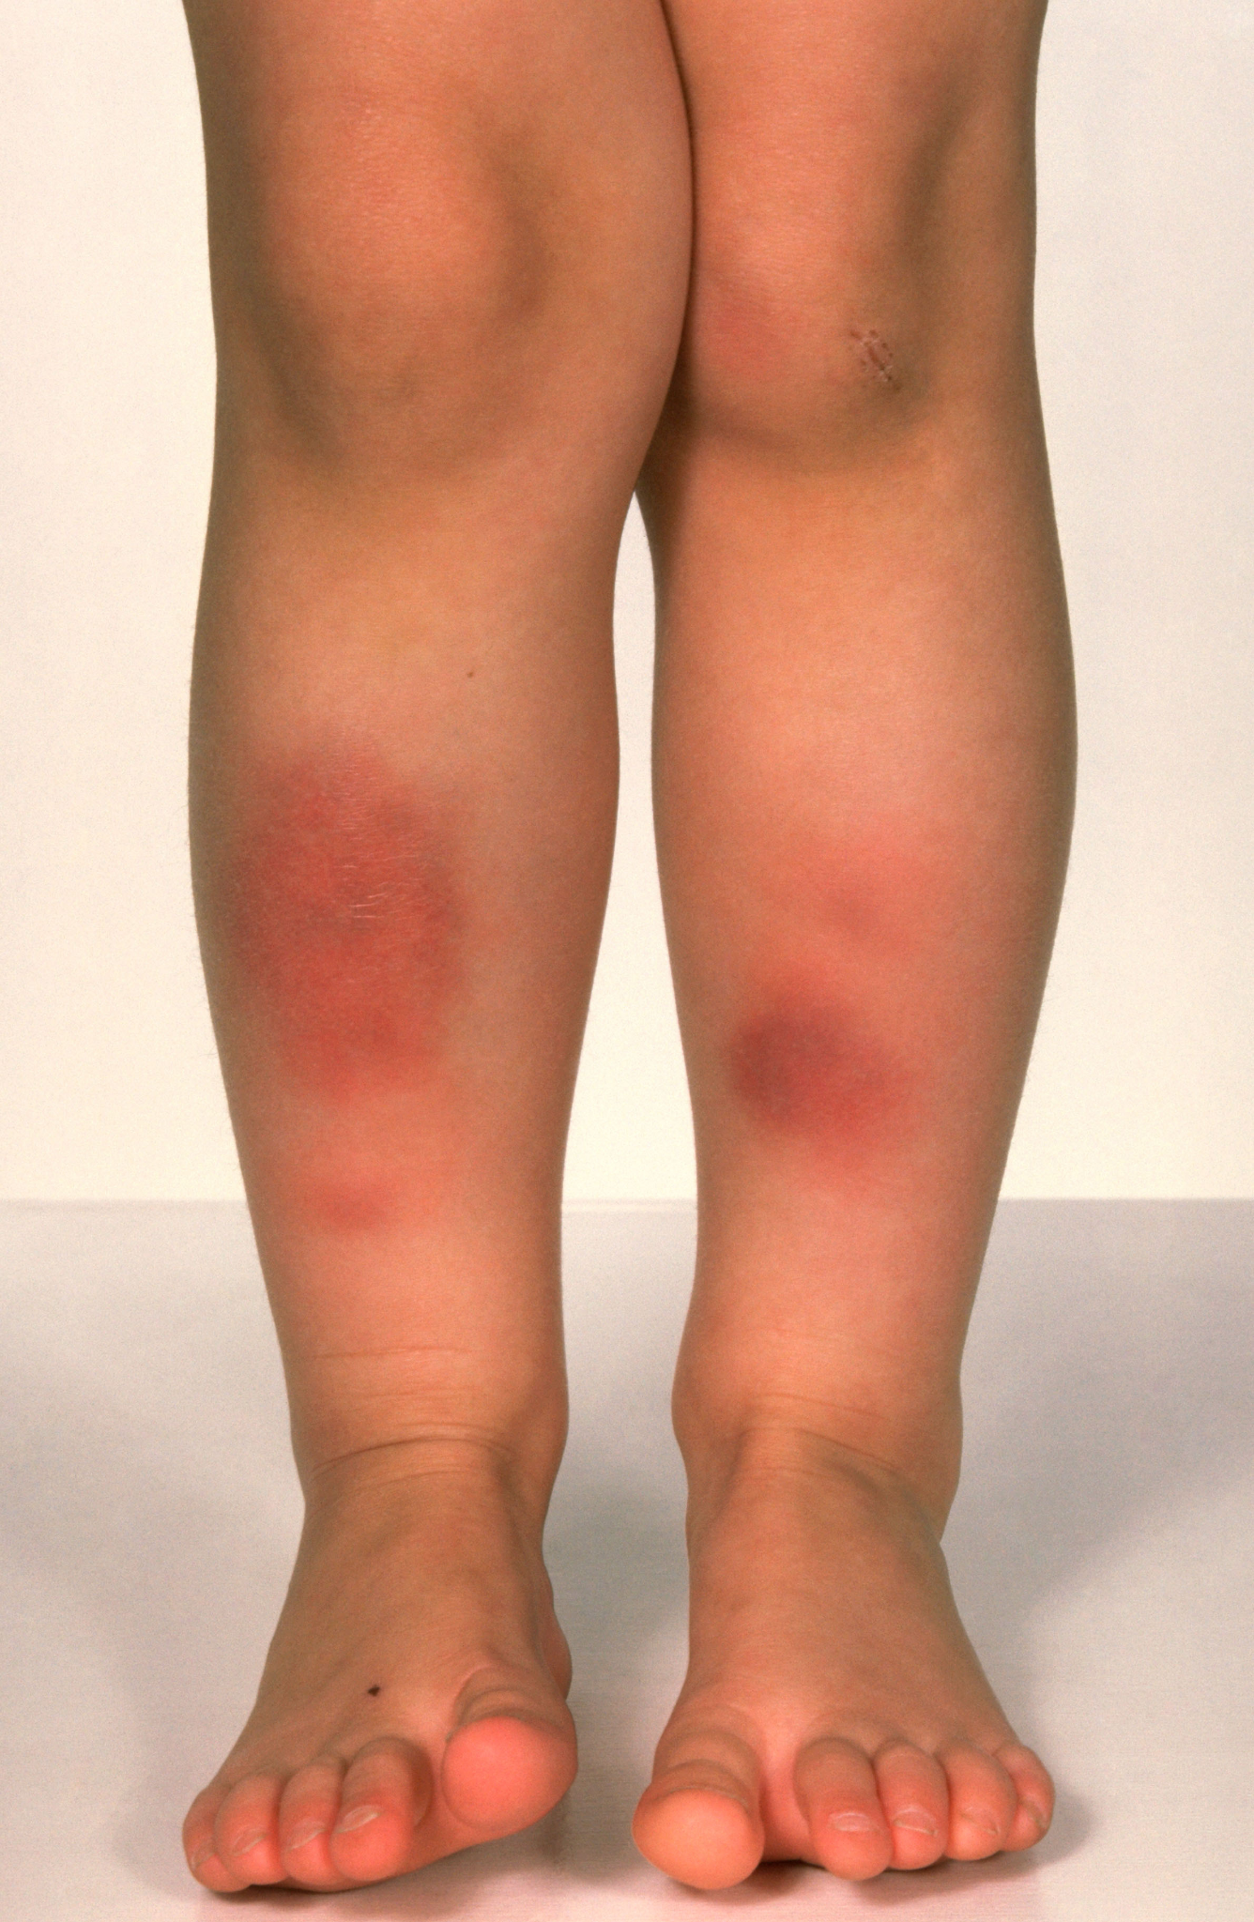  Pyoderma Gangrenosum  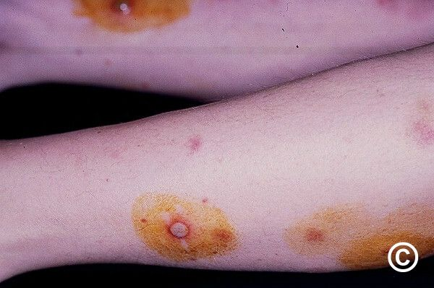

History Taking
Remember that the health history is paramount to making an accurate diagnosis.
- Always explore the OPQRST of the presenting chief complaint. This should assist in developing your list of differential diagnoses to guide the health history.
- Consider all the key questions, which would either rule in/rule out these differential diagnoses.
As an example, when a client presents with abdominal pain, specific questions will assist the NP-PHC in supporting or eliminating specific differential diagnoses.
- Location of the pain assists in consideration of abdominal structures that could be precipitating the pain. For example, RUQ pain can be related to the gallbladder, (cholelithiasis/cholecystitis), hepatitis, etc.
- Relationship of the pain to meals? Food can relieve symptoms of a peptic ulcer. In contrast, pain after a fatty meal suggests cholelithiasis.
- Fever and RLQ pain are positive physical exam findings that suggest appendicitis.
- Watery diarrhea with bleeding indicates more serious concerns such as ulcerative colitis.
- Add a history of travelling and one might consider infectious diarrhea (E. coli, parasitic infection).
- Grouping of symptoms including generalized abdominal pain, alternating patterns of diarrhea and constipation and history of anxiety might indicate irritable bowel syndrome.
Many patients have difficulty differentiating and articulating their abdominal symptoms and will need careful coaxing. Your knowledge of the causation of symptoms and common conditions will help you to ask the right questions in eliciting a careful history.
- Always consider other systems, for example for a lower abdominal pain in a female you have to evaluate the possibility of a gynecologic etiology or urinary.
  - And for an upper abdominal pain you have to consider cardiac etiology.
- These are only a few of the possible examples of questions that one might ask.
- The answers to the health history questions will now lead you to focus your physical examination to further rule in/rule out the differentials that still exist for the presenting chief complaint.

Examples of GI tests which the NP-PHC can order include:
- Bilirubin (total, direct)
- Amylase
- Lipase (more sensitive for pancreatitis diagnosis than amylase)
- Albumin
- ALT (Alanine aminotransferase)
- GGT
- ALP (alkaline phosphatase)
- CBC
- INR
- Hepatitis Associated Antigen or Antibody Immunoassay for Hepatitis A B & C
- Helicobacter Pylori
- Fecal Occult Blood
- Stool culture for bacteria, including for C. difficile
- Stool for Ova and Parasites
- Pinworm (scotch tape prep)
- Urinalysis and culture
- Abdominal ultrasound
- Abdominal imaging other than U/S
- Upper GI series
- Barium enema
- Endoscopy
- Colonoscopy
- Sigmoidoscopy
- CT scan – abdomen

Tools and Resources:
Investigations Module for this system - GI
Interpretation of liver enzymes (nice to know stuff)
https://www.cmaj.ca/content/cmaj/172/3/367.full.pdf

Red Flags and Pearls:
- Obstruction
- Appendicitis
- Bleeding
- Aortic Aneurysm
- Non voluntary weight loss
- Ectopic pregnancy
***When you perform the abdominal exam, remember to start with inspection then auscultation and finish with percussion and palpation.
Choosing Wisely Canada : Gastroenterology
Don’t maintain long-term PPI therapy for GI symptoms without an attempt to stop or reduce the PPI at least once per year (in most patients)
Avoid using an upper GI series to investigate dyspepsia
Avoid performing an endoscopy for dyspepsia without alarm symptoms for patients under age 60
Avoid performing a colonoscopy for constipation in patients under age 50 without a family history of colon cancer or alarm features
Don’t routinely perform colonoscopy in IBS patients under 50 without alarm features
Don’t prescribe oral corticosteroids in adults with Crohn’s disease of any severity in order to maintain complete remission
Don't prescribe oral corticosteroids in children with crohn’s of any severity in order to maintain clinical remission
Don’t use opioids long-term to manage abdominal pain in IBD
Don’t unnecessarily prolong the course of IV corticosteroids in patients with severe ulcerative colitis in the absence of a clinical response to treatment
Don’t initiate or escalate long-term medical therapies for the treatment of IBD based only on symptoms
Don't use abdominal CT scan to assess IBD in the acute setting unless there is suspicion of a complication like obstruction, perforation, or abscess or a non-IBD etiology for abdominal symptoms.
Don't consult in-person visits for GI care when a virtual visit can be performed and is clinically appropriate and preferred by the patient. Health care delivery in digestive health telemedicine has proven to be safe and effective.

Skills:
The following is a list of additional advanced examination techniques that you will need to incorporate in your physical exam, when indicated.

Illiopsoas sign  This does the same thing and way easier to do! Put pressure on upper of thigh and assess RLQ pain!!!!  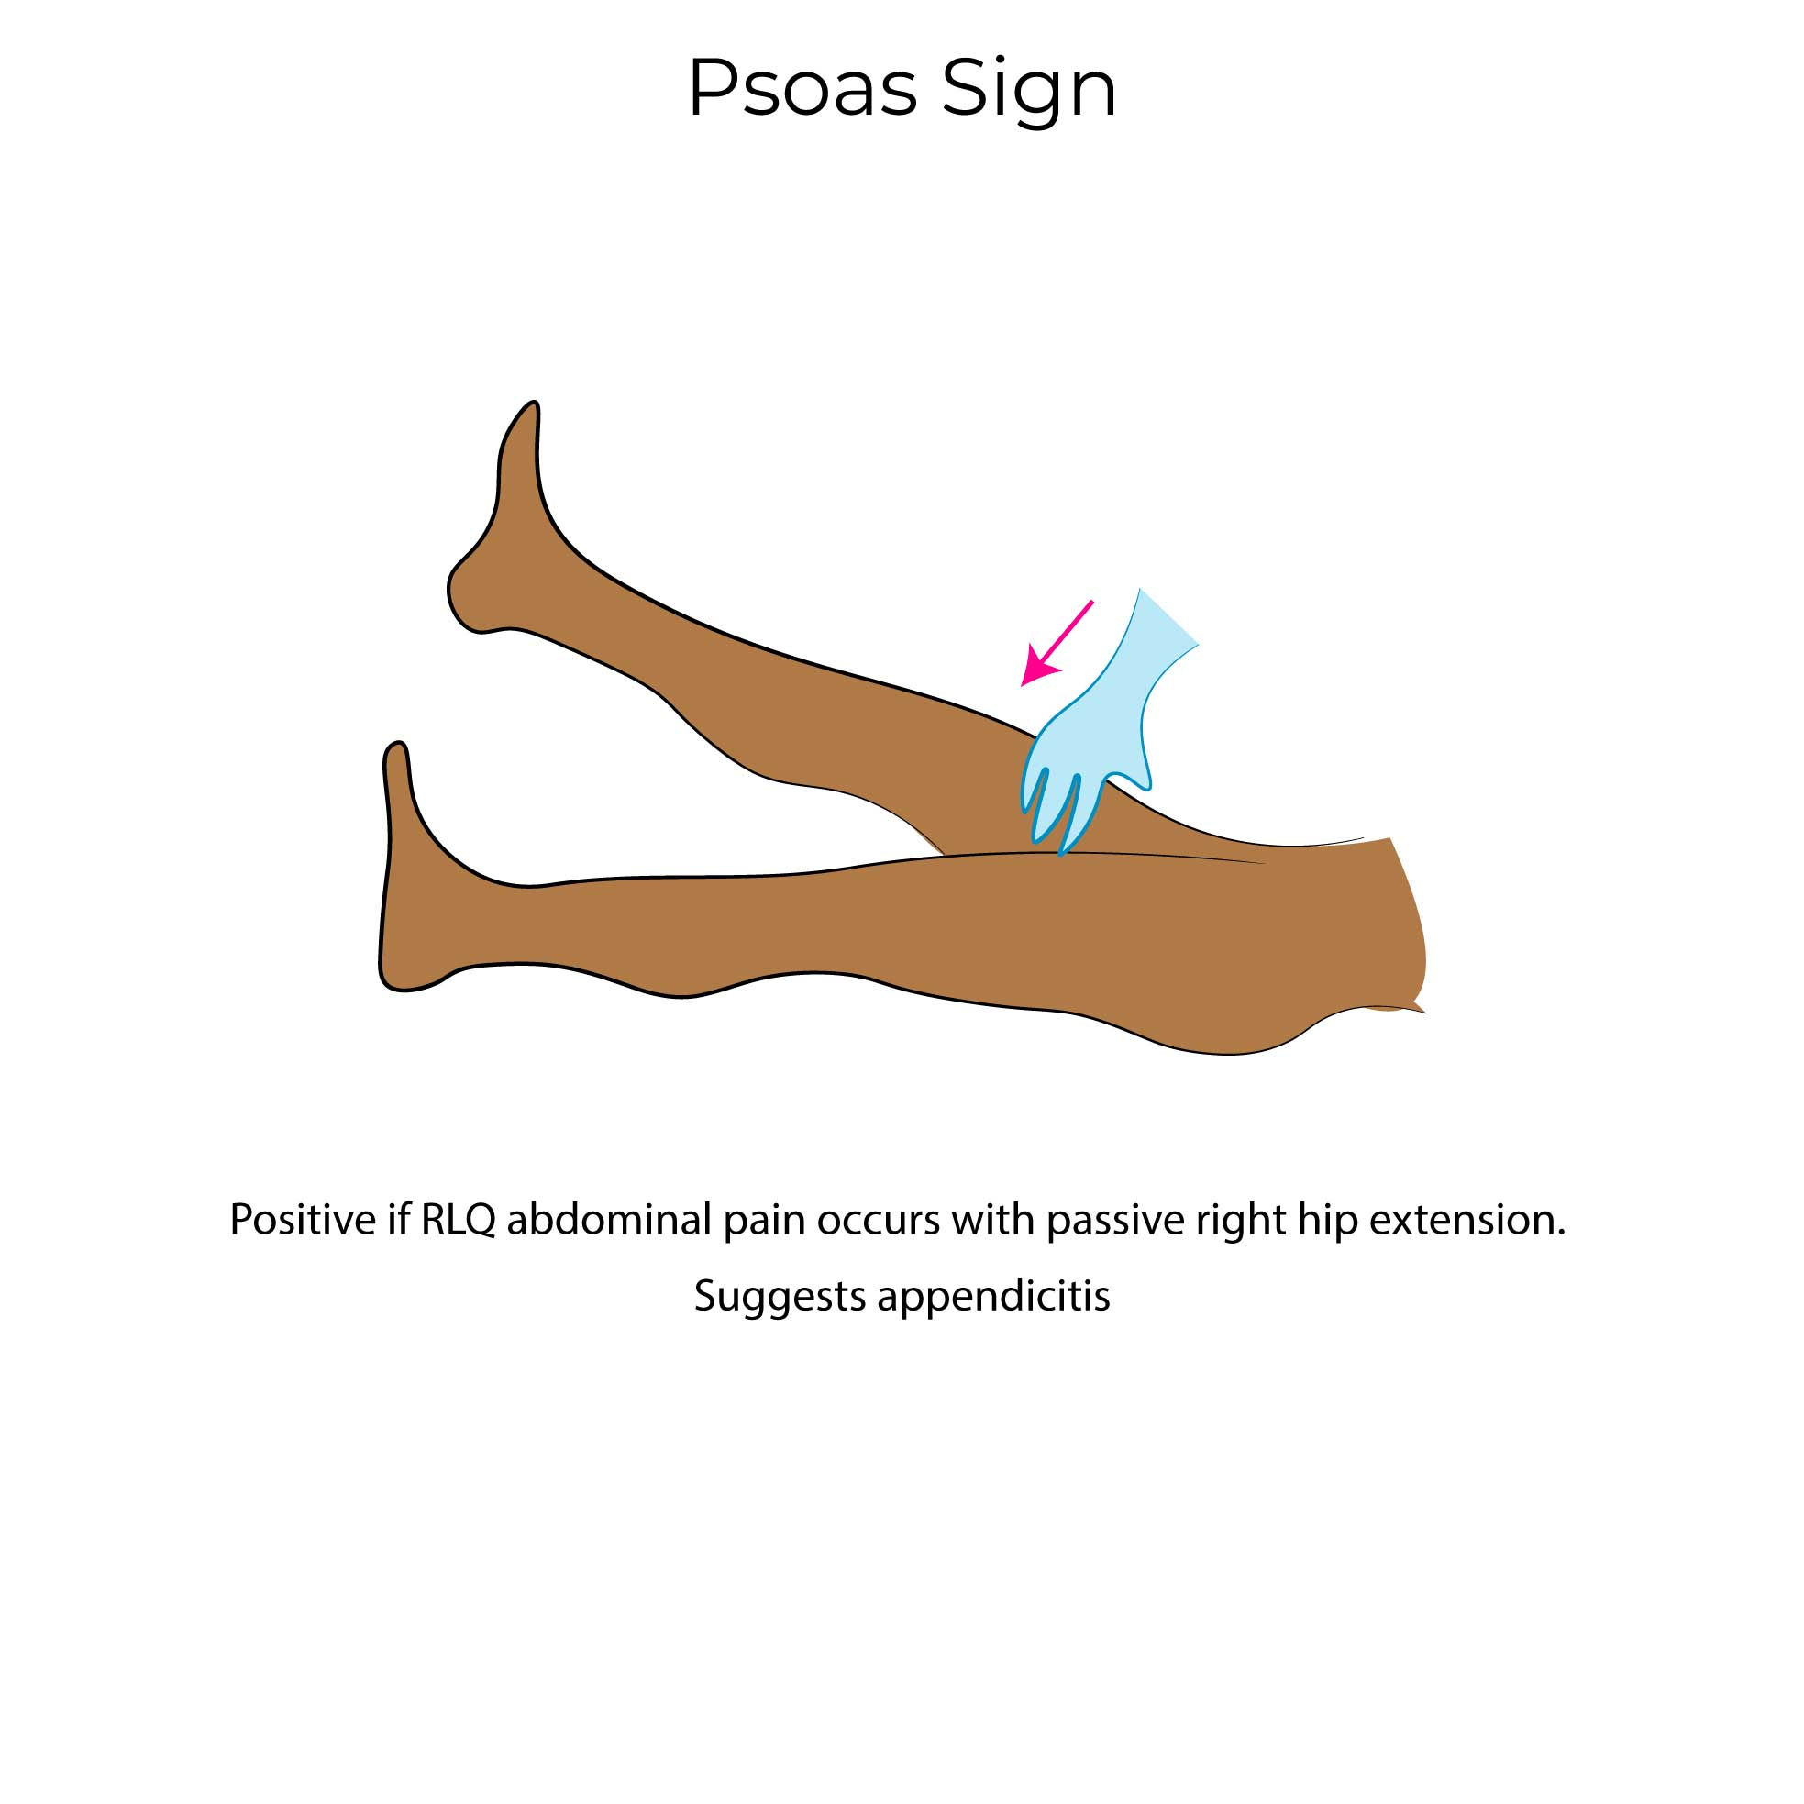 | Pain in the RLQ when the psoas muscle is moved  - Indicated appendicitis  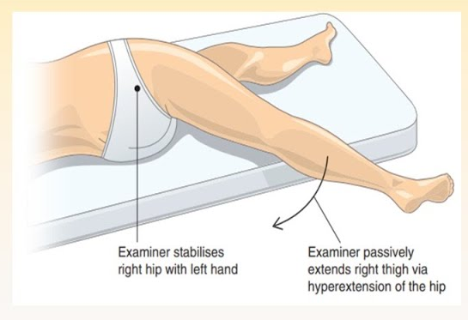
Obturator sign | Pain with right knee flexion and slight, slow internal rotation  - Indicates appendicitis, as the inflamed appendix is in contact with the obturator muscle  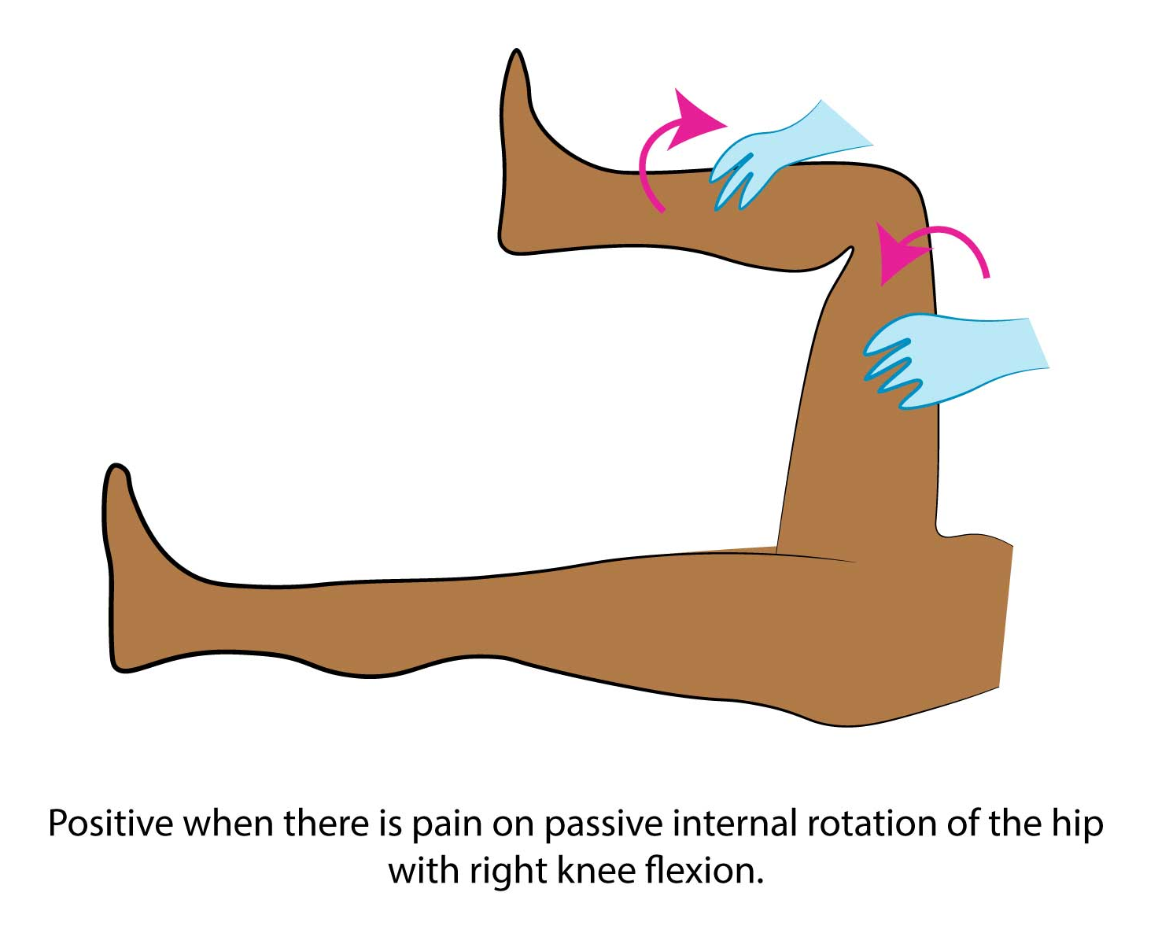
McBurney’s point tenderness | Located in the lower right abdomen, one-third of the way from the anterior superior iliac spine to the umbilicus  - Deep pressure here causes pain, indicating irritation near the appendix  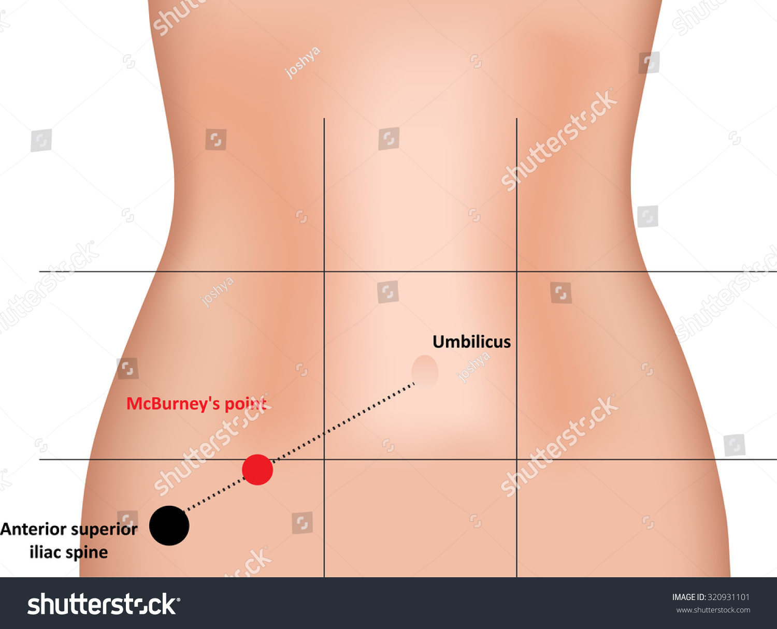
Murphy’s sign | Palpation of the RUQ of the abdomen while the patient inhales deeply  - Pain may indicate cholecystitis (gallbladder inflammation)  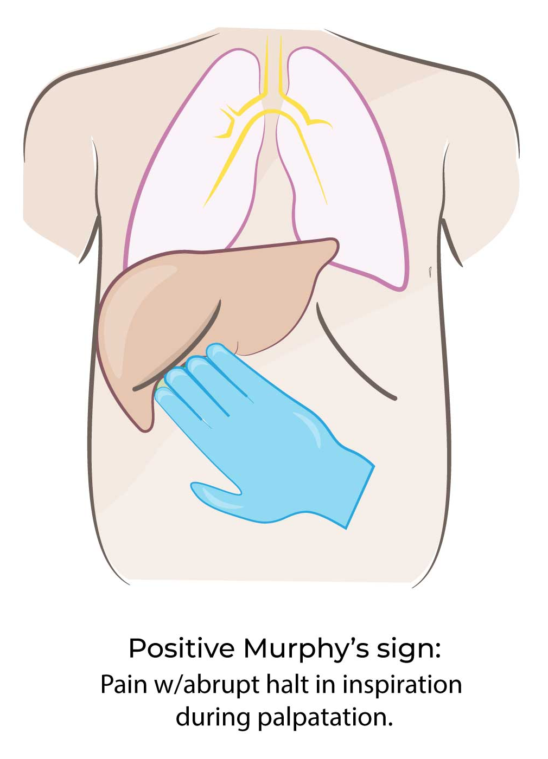
Rebound tenderness (Blumberg’s sign) | Applying steady pressure to the abdomen and then suddenly releasing it  - Indicates peritoneal irritation or inflammation  - More pain when the pressure is released  Indications: peritonitis, appendicitis, stomach ulcer (UQs), pancreatitis, diverticulitis (LLQ)
Rovsing’s sign | Pain referred to the RLQ when the LLQ is palpated  - Indicates appendicitis, and peritonitis (not very specific)  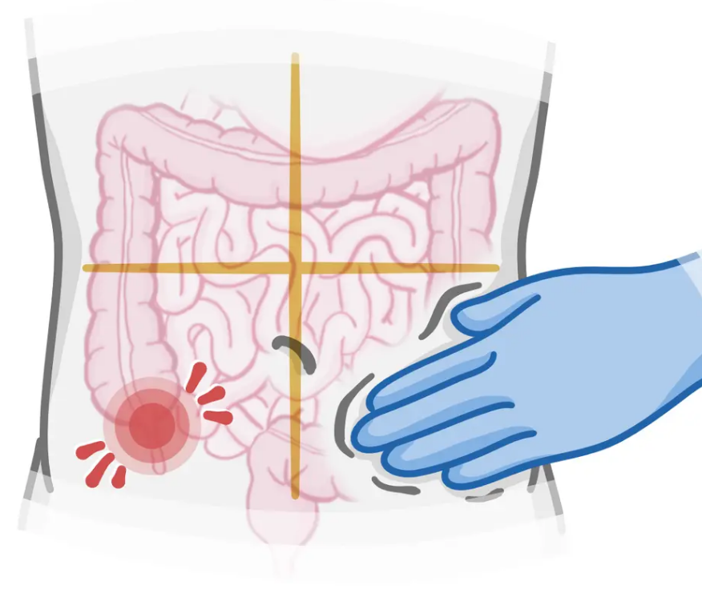
Shifting dullness and fluid wave tests | SHIFTING DULLNESS  Flank dullness to percussion that shifts when the patient changes position.  The idea that the abdominal bowel loops are filled with air, and floating on the peritoneal fluid. The bowel will move to the uppermost area of the abdominal cavity. The border between resonance and dullness will move away from the area of dependency. Typically remains horizontal  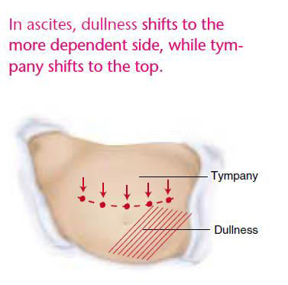  FLUID WAVE TESTS  Place one hand against the lateral wall of the abdomen and use the other hand to tap firmly on the opposite lateral wall. If +, tapping generates a wave transmitted through the abdomen and felt as a sudden shock by the other hand. False-positive response may result from waves traveling through the subcutaneous tissue of the anterior abdominal wall (clinician should always use the patient’s hand or that of an assistant to apply firm pressure against the anterior abdominal wall)  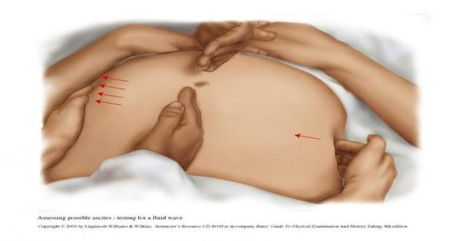

- Digital rectal exam
- Hernia assessment
- Stool for hemoccult testing

Diagnostic Imaging:
It is important to know what diagnostic imaging test can be ordered to confirm or refute a potential diagnosis. Please refer yourself to the readings and be familiar with the most appropriate diagnostic imaging and your scope of practice.
- 2021-2022 Diagnostic Imaging Referral Guideline
  - https://car.ca/patient-care/referral-guidelines/
- Particular attention to Section G https://car.ca/wp-content/uploads/Gastrointestinal-system.pdf
  - This is a summary of imaging recommendations for all GI related conditions

Case Study #1
Miranda (she/her), 26-years-old female, presents to the clinic with abdominal pain. She feels this discomfort in the upper part of the abdomen. This is the second episode of abdominal pain that Miranda has experienced in the last two weeks. Originally, she associated her symptoms with having the ‘flu. Her diet history today includes three large pieces of pizza and two glasses of wine for lunch. She also smokes one pack of cigarettes per day.

The health history reveals:
HPI – Pain
Severity: On a scale of 1 to 10, ”I would say 7 to 8”.
Quality: would describe it as sharp, colicky pain.
Deep respiration and coughing increases the pain. Has not eaten since.
Relieving factors: ”I have taken Tylenol to help me, but I vomited.”
No associated symptom. Has had a normal bowel movement today.
No previous history of similar pain.

HPI – N & V
Vomited (green bile, no blood) once two hours following onset of pain.
No relieving or aggravating factors.
The rest of the health history is unremarkable.

The physical exam reveals:
Fever of 38.1°C (tympanic)
Decreased bowel sounds
Generalized abdominal tenderness, no guarding
Positive Murphy’s sign

Question #1: At this stage, what differential diagnoses can you make based on Miranda’s symptoms? Provide rationale.
- Cholecystitis
- Pancreatitis
- PUD
- Gastritis

Question #2: Based on your list of differential diagnoses, what questions should be asked in the health history that would rule in/rule out the differential diagnoses?
- Recent food intake
- Radiation of pain?

Question #3: What are the key components of the physical exam that should be assessed in Miranda’s case?

Question #4: Are there any screening or diagnostic investigations that would be appropriate in this case? Provide rationale.
- Abdominal ultrasound
- LFTs (ALT, AST, GGT, albumin)
- Bilirubin, amylase and lipase
- CBCD

Question #5: When requesting an abdominal ultrasound, what would you include in the Clinical Indications/History section of the requisition?

Case Study #2
Jo (they/them), 25-years-old non-binary person, presents with “two weeks of diarrhea”. They spent five days on a canoe trip with friends in South America, two weeks ago. Since returning from the trip, they have had four to six loose, foul-smelling stools per day with malaise, abdominal cramps, and flatulence. No vomiting and denies any blood in the stools. When discussing the canoe trip, they makes the comment that they may have drank contaminated water on the trip. They expresses some concern because they also ate in some less than reliable restaurants in South America.

The health history reveals:
Immunizations
Td booster two months ago. Received full series of hepatitis A/B and typhoid fever immunizations before departure.
The rest of the history is unremarkable.

The physical exam reveals:
Vital signs: BP 122/74 R arm (sitting), 120/70 R arm (standing), P 88, R 18, T 36.8 °C (tympanic)
Weight: 3 kg loss in the past week
Abdomen: Bowel sounds hyperactive; no rebound tenderness or point tenderness; no organomegaly.
The rest of the exam is unremarkable.

Question #1: List the most likely differential diagnoses. Explain how you would rule these in or out.
- Giardia
- Cryptosporidium
- Traveller’s diarrhea (E. coli)

Question #2: What other key questions should the NP-PHC ask during health history?
- Did you swim on the trip? Anyone with similar symptoms?
- Are the symptoms associated with eating?

Question #3: What screening or diagnostic investigations are appropriate in this case?
- Stool culture, PCR, CBC/lytes

Case Study #3
Barbara (she/he) is a thin 71-year-old female who presents to the community health clinic reporting constipation. She normally has a bowel movement every two days. In the last few weeks, she has become irregular and has not had a bowel movement for seven days. She reports a sensation of fullness in her abdomen. She lives alone in her own home. She doesn’t get out much anymore because she is afraid of falling and injuring herself. When the NP-PHC inquires about Barbara’s diet, she states that she isn’t often hungry and doesn’t enjoy cooking for herself. She tends to eat toast and jam on a regular basis and drink a lot of tea. She thinks there may have been blood in her stool.

PMH
Hypothyroidism; mild hypertension (well controlled); osteoarthritis of right knee; insomnia
Medications
Levothyroxine 0.05 mg PO daily
Hydrochlorothiazide 25 mg PO daily
Calcium carbonate 500 mg PO bid
Amitriptyline 25 mg PO QHS (insomnia)
Tylenol #2 prn

The physical exam reveals:
BP 132/84
HR 84 & regular
Abdomen: Non-tender with decreased bowel sounds; no palpable masses
Remainder of physical examination is unremarkable

Questions:
Question #1: What factors could be contributing to her constipation?
- Taking regular Tylenol-2 medication
- Calcium can contribute (antacids)
- Hypothyroidism can cause constipation as a condition
*Low fibre, sedentary, advanced age, diuretics, low oral fluid intake

Question #2: What approach does the advanced practice nurse bring that is unique to the assessment and diagnosis of this client’s situation?

Question #3: List specific physical examination techniques that the NP-PHC should focus on. Provide rationale.
- Vital signs
- Inspection of nutritional status, skin around the rectum, signs of dehydration, hernias
- Auscultation of the bowel sounds for hypoactivity. High pitched or absent may indicate obstruction
- Percussion and palpation

Question #4: What screening or diagnostic investigations, if any, are appropriate in this case?
- Thyroid function test
- CBC to rule out inflammation
- Electrolytes (potassium and calcium due to the supplement use and the diuretic)
- Barium enema

Case Study #4
Mark (he/him) is a 25-year-old male. For the past three years, he has had intermittent abdominal pain associated with bloating and irregular bowel habits, which he describes as alternating diarrhea and constipation. The pain is alleviated after a bowel movement. Over the past three months, he has had diarrhea more frequently and the pain has been more intense. The history does not reveal any alarming symptoms. He recently broke up with his long term boyfriend of five years.

Question #1: What is the most probable diagnosis based on the data presented to date? Provide rationale.
- IBS with mixed bowel habits
- Pain relieved with defecation
- A known psychosocial stressor as a trigger
*IBS is typically a diagnosis of exclusion

Question #2: Are there any red flags that need to be considered in relation to this diagnosis?
- Increased risk of colorectal malignancy
- Unintentional weight loss
- Blood in stool
- Family history of colorectal disease
- Anemia and signs of malnutrition
Question #3: How would you explore the psycho-social factors that may be impacting on this person’s health?
- Interview for stress and coping
- GAD-7 and PHQ-9 screening tools
- Lifestyle and social supports
- Impacts on daily life

Case Study #5
Marie (she/her), 24-years-old female, reports right lower abdominal pain which started two days ago. She can point with her finger to the exact location of her pain. She also reports a loss of appetite, a slight fever and no bowel movement for two days which is unusual for her.

Question #1: Based on the data currently presented, list the differential diagnoses. Explain how you would rule these in or out?

Question #2: List the key components of the physical exam.
GI Disease and Medication History:
- Big topics
  - Ulcerative colitis
  - Cholecystitis
  - Appendicitis
  - Constipation
- GI disease can manifest as the following complaints…
  - Changes in appetite
  - Weight gain or loss
  - Dysphagia
  - Food intolerance
  - Nausea and vomiting
  - Changes in bowel habits
  - Abdominal pain
- Abdominal pain; what will you ask?
  - VITAL SIGNS HEIGHT AND WEIGHT
  - OPQRST
  - Prolonged NSAID use (aspirin, ibuprofen)
    - Other medication side effects may cause nausea and vomiting
    - Have you tried any new medications recently/
    - Any new dietary supplements?
  - Social history, lifestyle changes?
    - Usually this section has about 8 things to ask about
    - You should hit some of these (it will say “total 2 marks, 0.5 marks for each”)
      - Dietary changes
      - Smoking
      - Exercise
      - Stress
      - Caffeine (reflux, ulcers)
      - Alcohol use (liver cirrhosis, esophageal varices)
  - Recent travel history
  - Does the pain occur with food ingestion?
  - Travel history
  - Any recent scopes, surgeries?
  - Colonoscopy screening?
  - Family history of colon disease?
  - Have you presented in the past with a similar complaint? What did they think it was?
  - History of ulcers, hepatitis, gallbladder disease, hernias?
  - Do you still have all your organs?
  - Have you been treated for anything?
  - What about past abdominal surgeries? Bariatric, C-section, liposuction, appendicitis? Any complications of surgery?
  - Any x-rays of GI-related tests? What were the results?
- For abdominal examination
  - Inspection
    - Expose but preserve patient privacy
    - If the SP isn’t cooperating, keep going and talk through what you would do
    - Document the location of physical exam findings (try in your head to be in your clinical placement mindset, and look at the SP and vocalize what you see; don’t pretend)
      - E.g., if the patient has a large scar, even if unrelated to the case make sure you make note of it
    - Looking for: colour, enlarged veins, symmetry, contour, bluish colour, masses, bulges
      - Should position patient supine
        - Patient may be unable to lie flat if there is severe pain
    - Distention of the abdomen
      - Bowel obstruction, constipation/impaction, ascites, cancer, pregnancy, organomegaly
      - Hernia if it is localized
        - Have the patient sit up and cough to elicit a bulge of a hernia
    - Ecchymosis of the abdomen (purplish bruising)
      - Grey turner→ flank
        - Hemorrhagic pancreatitis
      - Cullens→ periumbilical
        - Intra-abdominal bleeding
    - Scars, vein dilation, portal hypertension
  - Auscultation (clockwise from the right lower quadrant)
    - Listen for at least 2 minutes before determining absent bowel sounds
    - Bowel sounds occur every 5-10s (hypoactive is every 20-30)
    - Examiner will tell you what the situational abnormal findings are if they are relevant to the case and diagnostic purpose
    - Auscultate for bruits (abdominal, iliac, renal)
      - State that you will do the femoral arteries as well, but don’t have to do them.
  - Percussion
    - Tympany is normal percussive sounds
    - Flat or dull would be unexpected findings
    - Flat→ an organ, stool
    - Red flags→ pain with percussion
    - Assess for ascites; place the patient on the right side and repeat percussion over the same area
      - If you get dullness and then move then, it would go back to tympani after they change position
    - Liver= 6-12 cm
    - Spleen
  - Palpation (palpate the painful area last)
    - If you do palpation and the patient is guarding
      - Involuntary tension of the abdominal muscles
        - Movement away from the pain
    - Palpate for masses, hernias, tenderness, pulsatile masses
      - AAA
    - Palpate liver and spleen
    - This is your chance to get your special tests done
  - Palpate the aorta
    - Palpate deeply to asses palpitations, assess the width in patients over 50, with one hand on each side (not >3cm wide)
    - Risk factors for AAA
      - Family history (first degree relative)
      - Age 65+
      - Smoking
      - Male
The order of the special tests…
- McBurney’s point
  - Halfway between the umbilicus and the anterior iliac spine
  - Appendicitis
  - Bowel irritation (Crohn’s)
- Gastric area LUQ
  - Gastritis
- LLQ masses
  - Diverticulitis
  - Hernias
  - Tumors/cancer
  - Ovarian cyst
  - Stool impaction/constipation
  - Suprapubic tenderness, PID, UTI
- Gallbladder→ Murphy’s sign
  - Right costal margin, mid clavicular line, 9th rib
  - Palpate while the patient breathes in, it may feel round and hard
  - Cholecystitis, cholelithiasis
  - Distended, painless gallbladder= cancer
- Maneuvers to identify appendicitis
  - Obturator sign
  - Psoas sign
  - Rovsing→ deep palpation in the LLQ causes pain on the right side
    - Sign of irritated peritoneum
- Rebound tenderness

The most abundant liver enzymes→ ALT, AST
- ALT is highest in the liver, also found in the bone as well
- AST is in the heart and brain
- GGT is abundant in the liver, the kidney, the intestines, the pancreas
  - Liver and pancreas are both influenced by alcohol
Increased AST (prominent in the liver, muscles, heart)
- Hepatitis
- Rhabdomyolysis
- MI
Increased ALT
- Hepatitis
- Pancreatitis
Increased ALP (bone)
Increased GGT
- Pancreatitis
- Hepatitis
- Colitis
Increased bilirubin
- Obstructive disorder
- Hepatitis
- Malignancy
- Anemias
When screening for liver disease, consider alcohol use, diabetes
- If the SP identifies alcohol use, go down that road and ask about their drinking habits, ask how much, why, is it problematic?
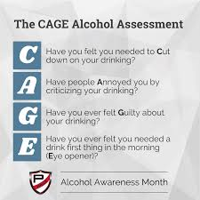

The quadrants of the abdomen…
Cholelithiasis  Cholecystitis  Hepatitis  Pancreatitis | Abdominal Aortic Aneurysm  GERD  Gastritis  PUD  Pancreatitis | Splenomegaly  Pancreatitis  Ulcerative colitis or Crohn’s  H. pylori and PUD
Gallstones  Pyelonephritis  Bowel obstruction | Hernias  AAA  Gastroenteritis | Gallstones  Pyelonephritis  Constipation
Appendicitis  Ovarian cyst/torsion  Ectopic pregnancy  Inguinal hernia | Ectopic pregnancy  PID, cystitis  Endometriosis  Pregnancy  STI | Constipation  Ovarian cyst/torsion  Ectopic pregnancy  Diverticulitis  Inguinal hernia

MSK

AHAD week 11

- Cervical radiculopathy Xray and EMG
- Hip (bursitis) none…can do U/S and CBC/ESR to r/u infec
- Rheumatoid arthritis xray, RF, ANA, CRP, ESR
- Systemic lupus erythematosus
- Septic arthritis send to ED…blod clture, xray, joint aspiration, cbc, esr, crp
- Gout
- Osteoarthritis xray
- Scoliosis
- Shin splints
- Ankle and foot sprains/strains none
- Ankle and foot sprains/strains: fractures xray
- Ankle and foot sprains/strains: plantar fasciitis
- Elbow pain: lateral/medial epicondylitis not needed but csn do U/S and xray to r/u stuff
- Elbow pain: nursemaid’s elbow
- Elbow pain: bursitis nothing
- Elbow pain: tendonitis not needed but can do U/S
- Fibromyalgia + Canadian Guidelines for the Diagnosis and Management of Fibromyalgia Syndrome in Adults
- Knee injury: strains/sprain none
- Knee injury: fracture xray
- Knee injury: ligament injuries u/s for faster results, mri gold standrdad. Xray if ottawa rules
- Knee injury: meniscus injury mri….u/s for faster result
- Knee injury: patellar subluxation /dislocation xray
- Knee injury: chondromalacia patellae xray
- Knee injury: bursitis n/a
- Knee injury: Patello-femoral syndrome + Evaluation of patients presenting with knee pain: Part 1. History, physical examination, radiographs, and laboratory tests xray
- Low back pain acute and chronic: lumbosacral strain
- Low back pain acute and chronic: herniated disk
- Low back pain acute and chronic: spondylolysis and spondylolisthesis
- Low back pain acute and chronic: degenerative process
- Low back pain acute and chronic: spinal stenosis + Centre for Effective Practice. Low Back Pain
- Wrist and hand pain: carpal tunnel syndrome emg
- Wrist and hand pain: ganglion cysts not needed but can do u/s
- Wrist and hand pain: scaphoid fracture xray
- Wrist and hand pain: tendonitis NOTHING unless want to r/u OA then xray or r/u tissue concern then U/S..if concerned about fracture then XRAY
- Shoulder pain: fractures dislocations Xray
- Shoulder pain:acromioclavicular joint sprain/separation
- Shoulder pain: shoulder strain, impingement 2 view xray of both shoulders to compare. Can also do U/S if concnerned
- Shoulder pain: rotator cuff injury/dysfunction MRI but can take time so do U/S
- Shoulder pain: adhesive capsulitis none…can concern xray if concerned for OA. Can consider lidocaine test.
- Shoulder pain: osteoarthritis Xray
- Shoulder pain: bursitis Nothing
- Shoulder pain: tendonitis U/S
- MSK imaging: https://vimeo.com/npeducation/review/722700514/bf317a78b6
- Spine imaging: https://vimeo.com/npeducation/review/722696175/bfb550216a

TEMPLATE TO USE
Def’n
Pathology/Cause
Risk Factors/Epidemiology
Clinical Presentation

*Insert picture here*
Hx/Key Questions
Physical Exam
Diagnostics/Labs
Red flags
Differential Diagnoses
Treatment/Management | Treatment:  Counseling/Education:  Non-pharm therapies:
Referrals
Follow-up

What to order MSK
Wrist tendonitis Usually clinical, Xray to r/u differneitald. US if considering steroid ingjectios or surgury
Impingement Usually none but 2 view xray to r/u differneutals. If unreoslved after 6 weeks MRI
Rotator cuff True AP X ray to r/u differentials (OA), US to MRI is indicated when there is suspicion of significant rotator cuff pathology, such as PTT/FTT when conservative management fails or for surgery planning
Fozen shoulder Usully none but can do xray to r/u other pathologies and lidocane test to confirm it
OA nott needed if over 45, morning stiffness <30 mins, pain with activity and better at rest, bony joint enlargement, in common joint (shoulder, knee, hip). Xray can help confirm and understadn severit but not needed. Blood tests such as CBC, ESR, CRP, RF, are usually normal in osteoarthritis.
Shoulder bursitis No imaging required. Suspected infection or trauma: X-ray first, then ultrasound if needed and to r/u cellulitis. Deeper bursa involvement or unclear cause: MRI or ultrasound.
Cervical rediculopthy Usually none. Order MRI if red flags (motor deficit, suspected myelopathy, infection, or bilateral symptoms) or persistent symptoms after conservative management; add X-ray or CT for trauma and consider EMG for diagnostic confirmation if needed.
RA Rheumatoid Factor, Anti-Citrullinated Protein Antibody, ESR/CRP, CBC (anemia of chronic disease, thrombocytosis, or neutropenia), Xray, MRI

https://www.youtube.com/watch?v=SAN5vlfVaIg&ab_channel=DrJamesGill

Wrist and Hand Pain: Tendinitis
https://www.youtube.com/watch?v=7aMvQmWR96Q&t=3s&ab_channel=DrJamesGill
Def’n | - Tendinitis is inflammation of a tendon, often developing after degeneration (tendinopathy).  - Chronic deterioration or inflammation of the tendon or tendon sheath can cause scars that restrict motion.
Pathology/Cause | - The cause of tendinitis is often unknown.  - Tendinopathy usually results from repeated small tears or degenerative changes (sometimes with calcium deposits) that occur over years in the tendon. Tendinitis and tenosynovitis most commonly affect tendons associated with flexor carpi radialis or ulnaris.
Risk Factors/Epidemiology | - Middle aged or older (>35 years)  - Obesity  - Repetitive microtrauma  - Fluoroquinolone antibiotics may contribute (e.g. Ciprofloxacin)  - Statins, aromatase inhibitors  - Certain systemic disorders: RA, systemic sclerosis, gout, reactive arthritis, diabetes, amyloidosis, markedly elevated blood cholesterol levels  - Disseminated gonococcal infection may cause acute migratory tenosynovitis  - Improper training, poor movement patterns, poor ergonomics, poor equipment
Clinical Presentation | Main S/S is wrist pain with active motion or when natural motion is resisted.  - Swelling may be visible or only palpable  - Along the tendon, palpation elicits localized tenderness or varying severity
Hx/Key Questions | - What are the presenting symptoms? Note pain, numbness, weakness, or stiffness.  - Was there any type of injury, either recently or in the past?  - Is there any radiation noted?  - How do these symptoms limit the client’s activity?  - How long can the client sit, stand, walk, or do overhead work?  - Is the client able to lift? If so, how much weight is bearable? Compare with normal weight.  - How long has the client had these symptoms?  - How have the symptoms evolved, from the beginning of discomfort until now?  - If the client has a previous history of a similar or the same pain, what therapy was used in the past and what were the results?  - Does the client have marked upper extremity weakness?  - Does the client have pain that wakes them from sleep?  - Does the client have any fatigue, swollen joints, or fever?
Physical Exam | Inspection→swelling, warmth, or asymmetry compared to the contralateral wrist.  Palpate→ Palpate gently over the wrist and tendons to check for tenderness or warmth. Also palpate with sharp and dull tools to assess sensation. Palpate pulses (radial, brachial)  - First dorsal compartment (for De Quervain’s tenosynovitis).  - Flexor tendons (on the palm side).  - Extensor tendons (on the back of the wrist).  Assess for crepitus→Feel for any grating or clicking sensations during palpation.  ROM→ Active and passive ROM of flexion and extension, radial and ulnar deviation…assess for pain or restrictions during movement.  Strength→Grip strength, resisted movements with flexion, extension, radial and ulnar deviation  Tests:  - Finkelstein’s Test (for De Quervain's Tenosynovitis):  - Have them a fist with thiei thumb inside your fingers.  - Gently deviate the wrist toward the ulnar side (toward the pinky).  - Positive test: Sharp pain on the thumb side of the wrist suggests De Quervain’s tendonitis.  - Resisted Thumb Extension: Try to extend their thumb while NP resists it.  - Pain with this movement could suggest De Quervain’s tendonitis.  Volar flexor tenosynovitis (digital flexor tendinitis)  - is a common musculoskeletal disorder that is often overlooked. Pain occurs in the palm on the volar aspect of the thumb or other digits and may radiate distally. Palpation of the tendon and sheath elicits tenderness; swelling and sometimes a nodule are present. The affected digit may rest in a flexed position, and passive extension elicits pain. In later stages, the digit may lock when it is flexed, and forceful extension may cause a sudden release with a snap (trigger finger).
Diagnostics/Labs | Clinical evaluation  Sometimes imaging: MRI or US
Red flags | - Sudden hand or wrist weakness (Tendon rupture)  - Pain that worsens or does not resolve within 1-2 weeks
Differential Diagnoses | 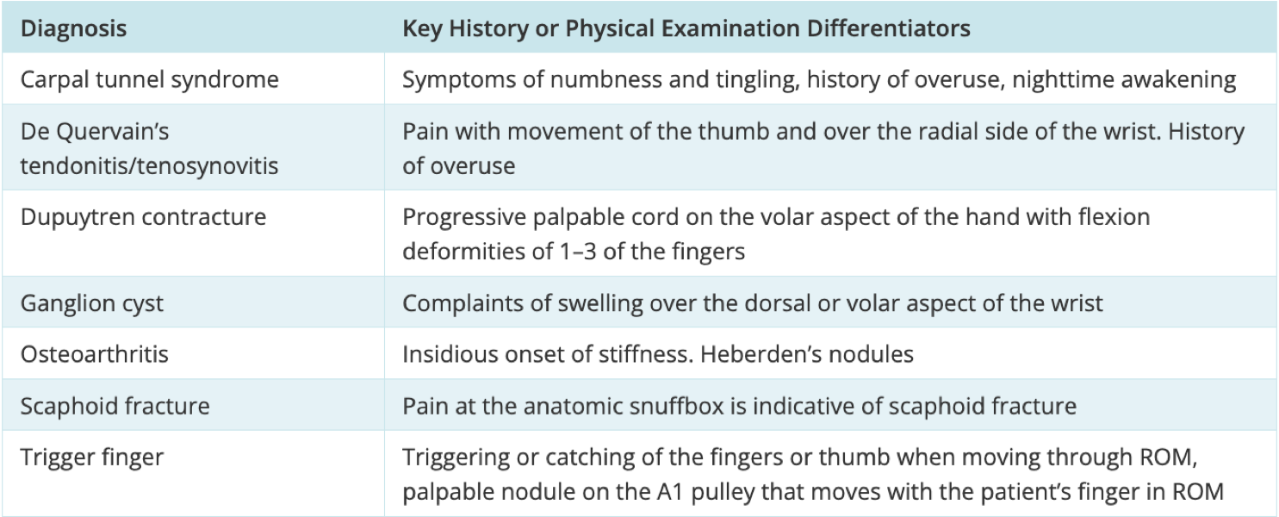
Treatment/Management | - Symptoms are relieved by rest or immobilization (eg, splint or sling) of the tendon, application of heat (usually for chronic inflammation) or cold (usually for acute inflammation)  - High-dose NSAIDs for 7 to 10 days.  - Indomethacin or colchicine may be helpful if gout is the cause.  - After inflammation is controlled, exercises that gradually increase range of motion should be done several times a day, especially for the shoulder, which can develop contractures rapidly.
Referrals | Physiotherapy, ortho if unresolved
Follow-up | Follow up in 3-6 months

Shoulder Pain: Impingement
Def’n | Stability of the shoulder depends on ligaments, capsules, tendons and muscular structures. Any dysfunction of these stabilizing structures can increase instability, allowing increased movement of the humeral head. This increased motion makes surrounding structures susceptible to impingement.  It is a common cause of shoulder pain, especially in individuals who engage in overhead activities. It occurs when the rotator cuff tendons or the bursa (a fluid-filled sac) become irritated or compressed as they pass through the subacromial space (the area between the humeral head and the acromion).
Pathology/Cause | Impingement is a spectrum of findings - NOT injury to a specific structure.  Stage 1: edema and haemorrhage (pt usually under 25 YO)  Stage 2: tendinopathy fibrosis and tendonitis (pt usually 25-40 YO) = see TENDINITIS table above  Stage 3: rotator cuff tear (RCT), biceps rupture or bony change (generally over 40 YO). Also look at ROTATOR CUFF table***
Risk Factors/Epidemiology | - See stage and associated ages above.  - Throwing athletes often suffer from impingement - due to extremes of rotation with throwing activities.  Risks:  - Participating in a lot of repetitive, overhead activities (swimming, painting, tennis, throwing sports)  - Bone and joint abnormalities
Clinical Presentation  *Insert picture here* | Hallmark: Common complaint is shoulder pain but don't get this confused with other differentials!!!  - Pain is typically felt in the anterior (front) and lateral (outside) of the shoulder, often radiating down the upper arm or into neck.  - Pain may also be referred to the deltoid region.  - Develops gradually, though it can sometimes be triggered by a specific injury or overuse ( repetitive overhead motions).  - Pain can become more severe if the condition progresses.  - Worsens with activity  - It may worsen at night, especially when sleeping on the affected shoulder.  - Scarf test***  - May experience difficulty raising the arm above shoulder level (painful arc: pain/difficulty at 60-120 degrees is a key sign!!).  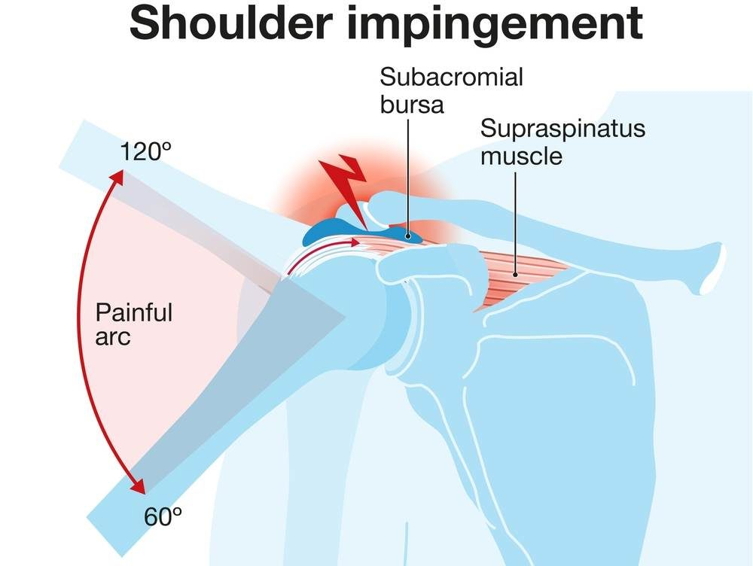
Hx/Key Questions | Screen for risk factors  Describe how the injury occured?  Did you hear any noise with the injury? Ripping, popping, cracking  Were you able to use the limb after the injury  Have you had previous injury to this joint?  Ask about fatigue, fever, neck, chest pain or swollen joints.  Rate the severity of the pain + PQRST  How is this injury affecting ADLs  What activities, movements, positions, make it worse  Do you have chronic diseases?  Have you had recent immunisation (Myalgia dt vax)  STI history (gonorrhea dissemination)  Have you had a cortisone treatment (increased pain after injection
Physical Exam | No single examination manoeuvre is diagnostic  VITALS  Inspect→ how the patient appears, walking, taking off jacket etc.  - Note any deformities  - Inspect for ss of inflammation  - Measure length of limbs  Palpate→ limbs and joint  TESTS:  Hawkins test: elevate shoulder to 90 degrees, flex elbow to 90 place forearm in neutral position. Support the arm, then internally rotate the humerus. Positive test is if there is pain with maximal internal rotation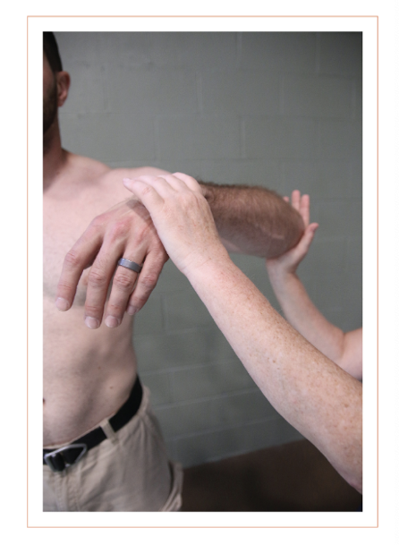  Neer impingement test: elevate arm in forward position, and depress the scapula. Positive test is when there is pain with full forward elevation  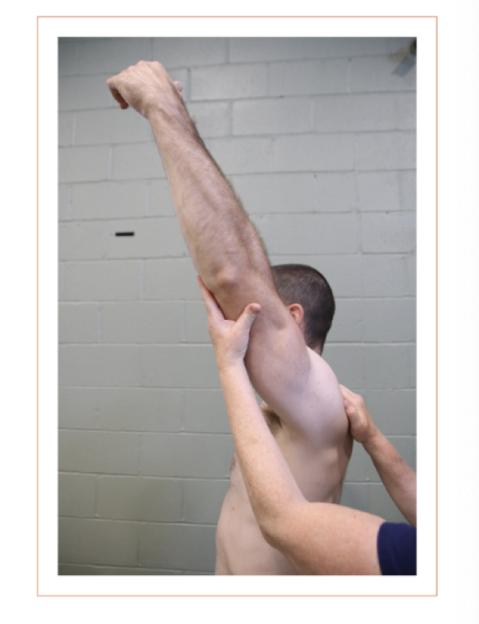  Painful Arc test: Is used to assess shoulder impingement. The patient actively raises their arm to the side, and if pain occurs between 60° and 120° of abduction, it suggests subacromial impingement (such as rotator cuff tendinitis). Pain above 120° may indicate AC joint pathology.  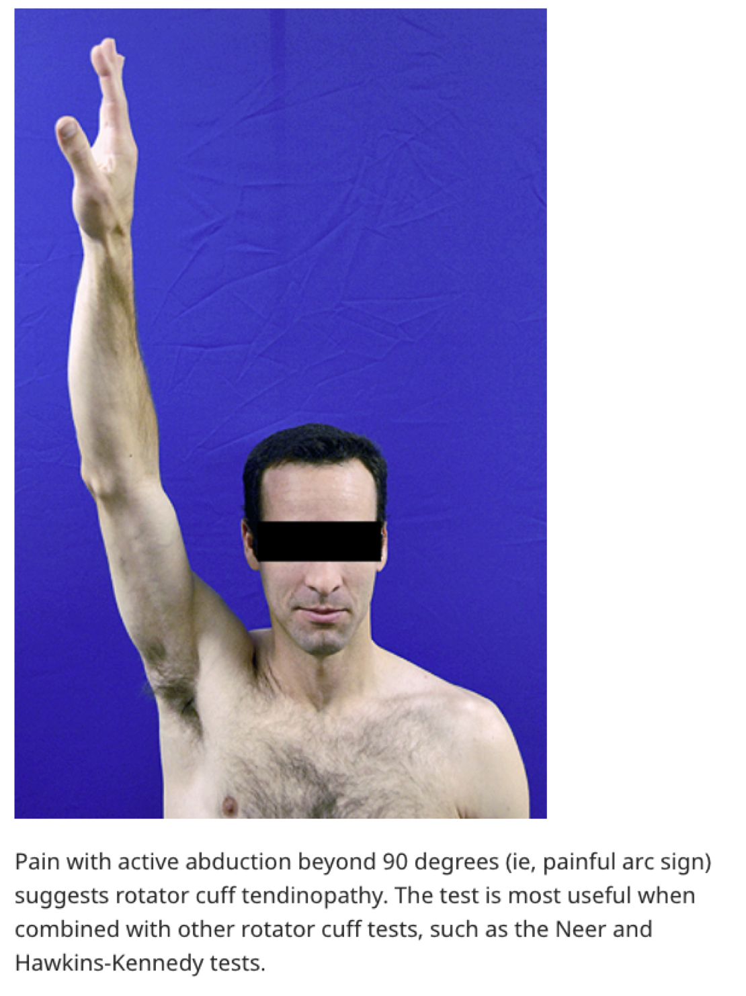  Push off test (Gerbers): used to assess the subscapularis muscle of the rotator cuff. Pt places their hand on their lower back with the elbow bent and is asked to lift the hand off the back. A positive test occurs if the patient cannot lift their hand or experiences weakness, indicating a subscapularis tear or dysfunction. *** helpful for diagnosing rotator cuff injuries, particularly involving the subscapularis tendon.  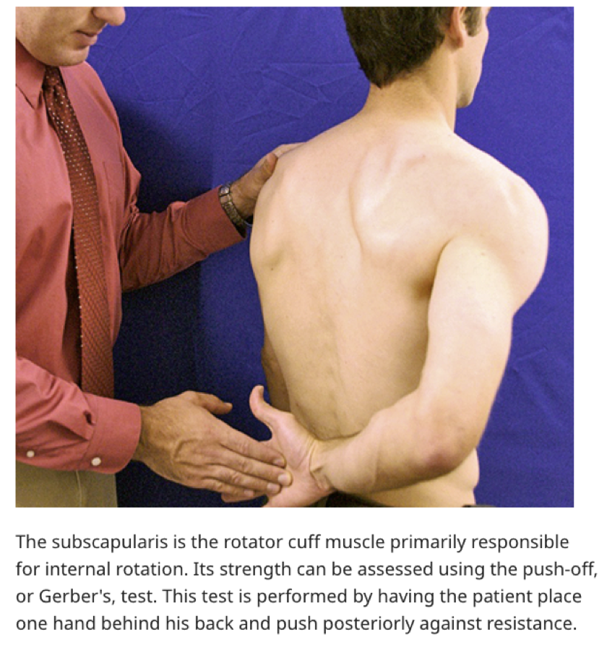
Diagnostics/Labs | - X ray 2 views (AP and lateral/scapular Y) to r/u other pathologies and do for both shoulders to compare. If after 6 treatment not improved over MRI  - Plain Xray can rule out other associated pathology, such as acromion joint abnormalities, evaluate the distance between acromion and humeral head, and visualize tendon calcification. DOES NOT diagnose impingement  - Ultrasound: can evaluate tendon and muscle lesions of the shoulder as well as bursitis. If very good technician, they can sometimes ID the site of impingement  - MRI: is only performed if symptoms do not improve, diagnosis remains unclear after evaluation, or a rotator cuff or labral tear is suspected
Red flags | Lost sensation, limb ischemia, dislocation (acute compartment syndrome), malignancy  Complications: capsulitis
Differential Diagnoses | 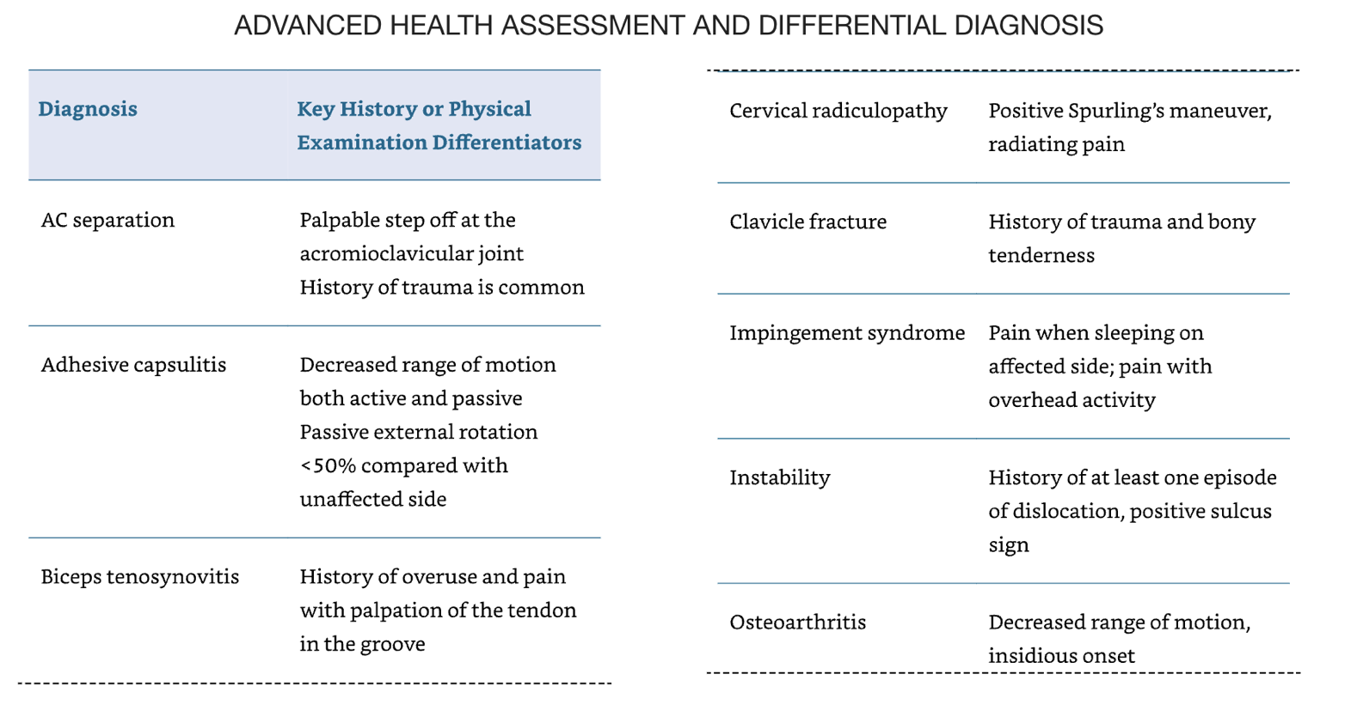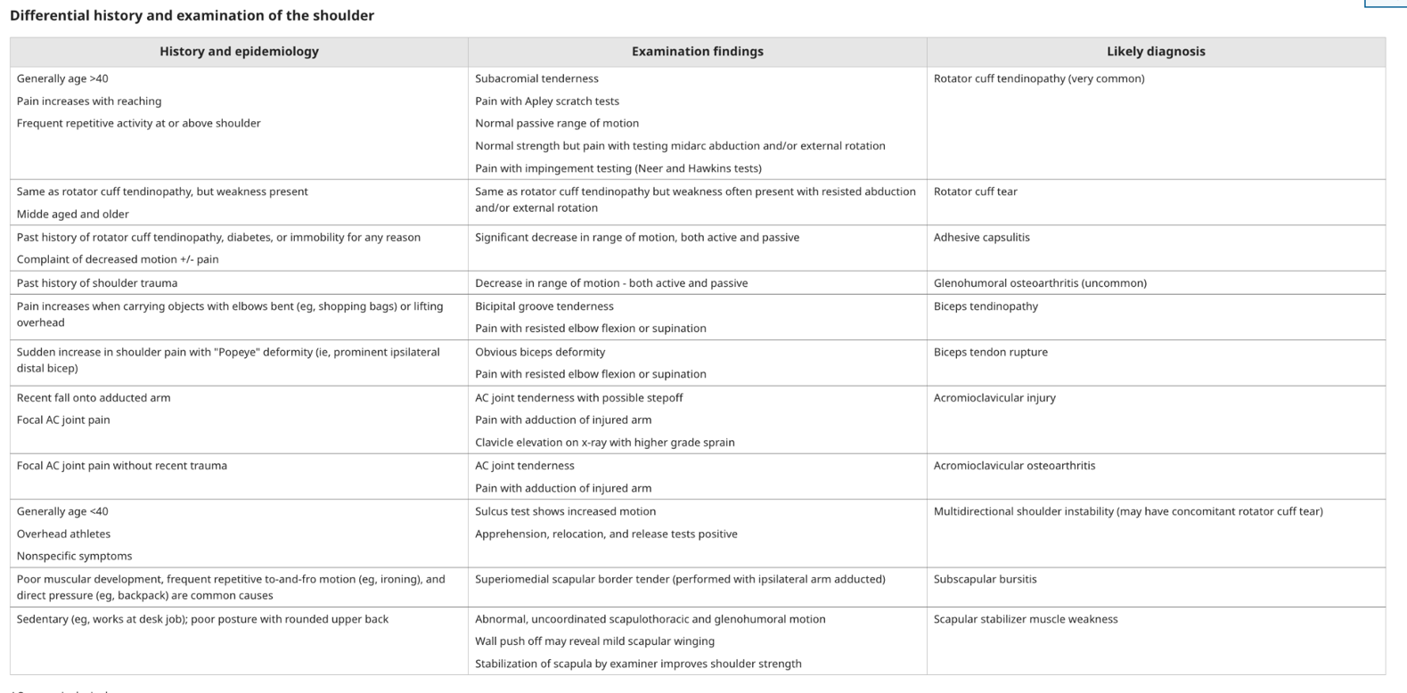
Treatment/Management | Acute treatment:  - Cryotherapy to decrease acute swelling and inflammation  - Rest - avoid activities that aggravate symptoms  - NSAIDs  General approach is conservative management with a physiotherapist. Steroid injection of the joint may improve ability to participate in physio (but refrain if ?rotator cuff injury)  Once symptoms improve, gradual return to all activities can  Kin tape - low level of evidence for efficacy
Referrals | Orthopedics is needed if three months of conservative treatment including appropriate PT fails to improve symptoms and function, or if diagnosis of capsulitis, rotator cuff tear or labral tear is suspected  Refer to ortho if surgical intervention
Follow-up | Follow up in the clinic within 2 weeks of the start of PT and NSAID schedule. Monthly follow up after

Shoulder Pain: Rotator Cuff Injury/dysfunction
Def’n | 4 muscles + some tendons make up the rotator cuff- the muscles are: supraspinatus, infraspinatus, teres minor and subscapularis. The tendons pass between the moving bones (acromion and humerus)
Pathology/Cause | Rotator cuff pathology is the most common cause of shoulder pain.  The cause of rotator cuff tears is likely multifactorial. Degeneration, impingement, and overload may all contribute in varying degrees to the development of rotator cuff tears.  Most often, rotator cuff dysfunction begins as partial tears of the undersurface or articular portion of the supraspinatus tendon, and overtime can progress to full thickness tears.
Risk Factors/Epidemiology | - Middle aged and older patients  - ***Sports and occupations that require overhead activity (these are younger patients, with labral pathology associated )  - Chronic diseases:  - Diabetes, Hypertension, High BMI and smoking are associated  - Familial predisposition:  - Anatomy that predisposes injury  - Trauma
Clinical Presentation | HALLMARK: Pain and weakness to lateral deltoid, exacerbated by overhead activities and at night.  - CREPPITITS IS KEY!!  - Pain during arc test is a key test to r/u out/in rotator cuff (see other tests below)  - Some studies say full thickness tears have less pain than partial thickness tears.
Hx/Key Questions | - Screen for risk factors  - Describe how the injury occured?  - Did you hear any noise with the injury? Ripping, popping, cracking  - Were you able to use the limb after the injury  - Have you had previous injury to this joint?  - Ask about fatigue, fever, neck, chest pain or swollen joints.  - Rate the severity of the pain + PQRST  - How is this injury affecting ADLs.  - What activities, movements, positions, make it worse  - Do you have chronic diseases?  - Have you had recent immunisation (Myalgia dt vax)  - STI history (gonorrhea dissemination)  - Have you had a cortisone treatment (increased pain after injection)
Physical Exam | - Inspect how the patient appears, walking, taking off their jacket etc.  - Note any deformities  - Inspect for ss of inflammation  - Measure length of limbs  - Inspect for symmetry of scapula (winging)  - Palpate limbs and joint  - Measure VS  - FYI: No single examination manoeuvre is diagnostic…BUT…  If active painful arc test, drop arm test and weakness in external rotation tests are all positive, a rotator cuff tear is likely.  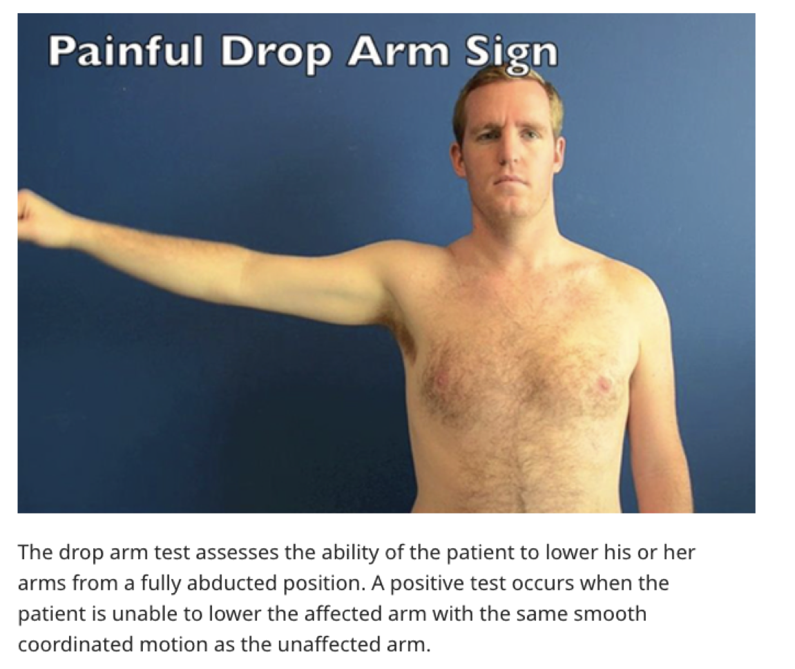  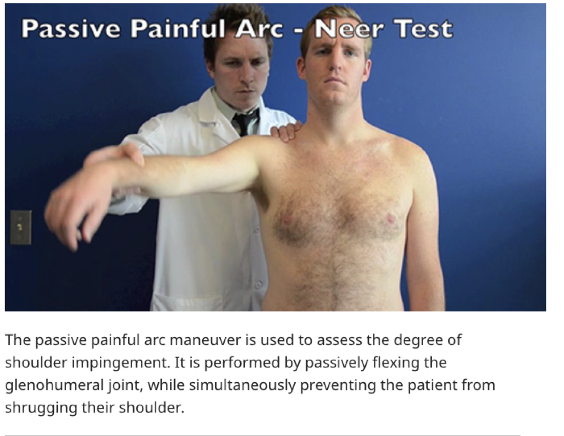  Weakness in external rotation  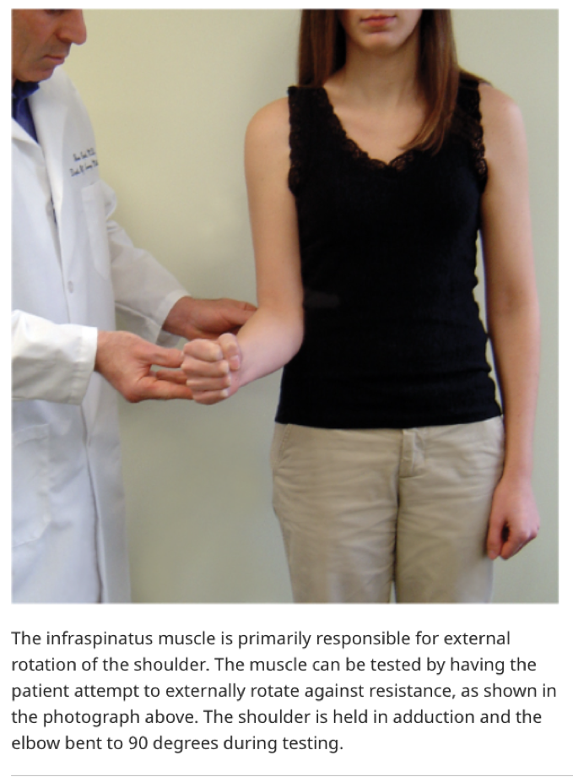  Winging of the Scapula  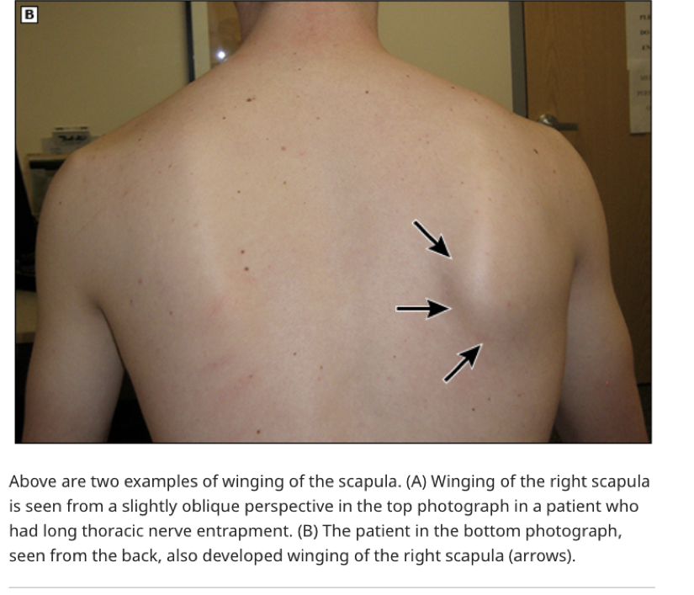
Diagnostics/Labs | - Acute traumatic tear: MRI within 2 weeks of injury  - MRI/s can take long to book so consider ultrasound in the time being  - Xray for structural assessment but will not see tear on it
Red flags | - Sudden loss of shoulder function after trauma  - Severe pain disrupting sleep  - Inability to lift or rotate the arm  - Neck or chest pain with shoulder pain  - Signs of infection (fever, redness, swelling)
Differential Diagnoses | See Shoulder Impingement differentials tables above
Treatment/Management | Mostly is non pharm:  - Keep elbows close to body.  - Avoid overhead movements and lifts  - Initial care of acute injury is Ice, rest and oral analgesics for pain control.  - Patients younger than 40 with acute traumatic tears do better with arthroscopic or open repair within 8 weeks of injury  - Elderly patients who are not optimized for surgery will best be managed conservatively
Referrals | Most rotator cuff tendon tears are treated initially with pt, and surgery is only considered when conservative measures fail,  Exceptions….  - Acute, full thickness traumatic tear in younger, otherwise healthy person should be treated with immediate surgery  - Sudden or severe weakness in person with preexisting partial thickness tear - these findings are consistent with new onset full thickness tear  - Failure to improve after 3 months of well-designed PT, or if symptoms worsen during the first 6 weeks of PT  - Heavy labourer with partial tear who relies on their should for livelihood  - Elite, professional overhead athletes
Follow-up | - Reevaluate partial and small full thickness tears that are not yet surgical at regular intervals to assess for increases in tear size.  - Initially, after 6 weeks and again after 3 months while pt is in rehabilitation.  - After than, can be 6-12 month intervals.  - At 12 months, if function is regained and painfree, may follow up as needed.  - Reimaging is not indicated unless deterioration suspected

Shoulder Pain: Adhesive Capsulitis/Frozen Shoulder
Def’n | Loss of both active and passive range of motion  There is severe pain
Pathology/Cause | - Can be idiopathic  - But often associated with other diseases (secondary to shoulder injuries)  - Thickening and contraction of glenohumeral joint capsule  - Uncertain whether it is primarily inflammatory or neuro related  - In cases of stroke, stiffness may be from muscle spasticity and joint dislocation  - More common in women  - Peak age is 50/60 YO  - Often affects non-dominant shoulder
Risk Factors/Epidemiology | -Diabetes (higher prevalence)****  -Thyroid disease  -Prolonged immobilisation, stroke, autoimmune disease,  -HIV  -Genetics  -Previous shoulder injury or surgery
Clinical Presentation | - 3 stages:  - Pain: Initial painful disabling shoulder pain that is worse at night, and increasing stiffness that lasts for two to nine months  - Forzen: Second stage, stiffness and severe loss of shoulder motion with pain becoming less pronounced for 4-12 months  - Recover: Finally, recovery, return to normal ROM that takes 5-24 months
Hx/Key Questions | -OPQRST  -Screen for above risk factors  -Questions about recent injury?  -Is there loss fo sensation, or numbness?  -How does this affect ADLs  -Pain worse at night? KEY FEATURE  -Stiffness?
Physical Exam | Measure VS  Assess for systemic symptoms  Inspect→ how the patient appears, walking, taking off their jacket etc.  - Note any deformities  - Inspect for ss of inflammation  - Measure length of limbs  - Inspect for symmetry of scapula (winging)  Palpate→ limbs and joint  Patients with frozen shoulders usually demonstrate significant reductions in active and passive range of motion in two or more planes compared with their unaffected shoulder  - Difficulty placing hand on back or buttock  - External rotation and abduction are most affected  - There is normally less pain with isometric testing of shoulder strength.  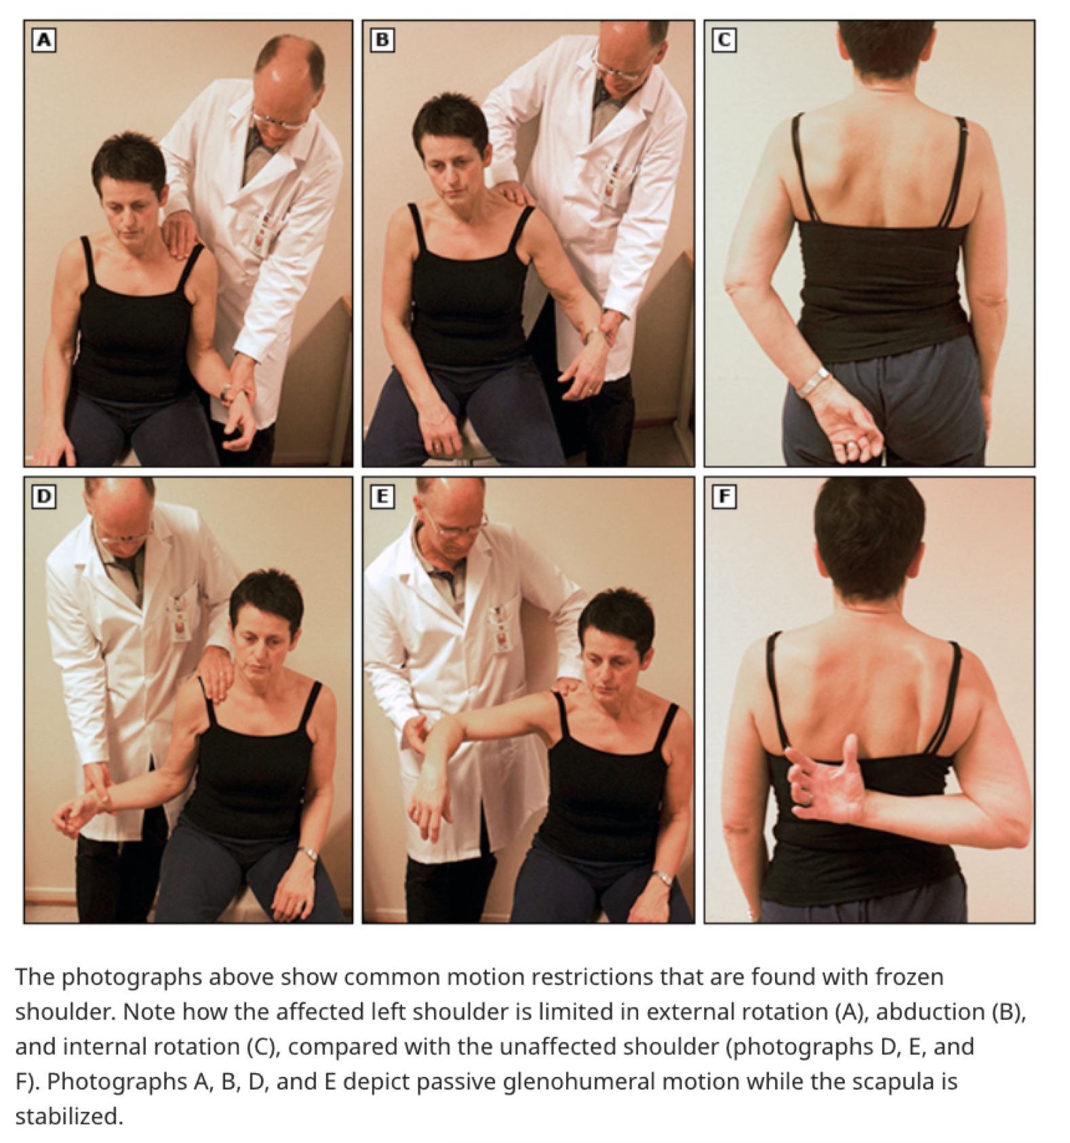
Diagnostics/Labs | Injection test using lidocaine:  If frozen shoulder, they will still have loss of mobility, whereas rotator cuff will have normal strength because of the pain relief  Xray: to rule out other deformity, and assess rotator cuff thinning  MRI!!!!!!  Ultrasound
Red flags | Malignancy  Cervical spine injury  Acute compartment syndrome
Differential Diagnoses | Referred pain from neck or diaphragm  Degenerative disc disease of cervical spine  MI  Polymyalgia rheumatica and malignancy  Apical lung cancers and metastasis
Treatment/Management | Be consistent with ROM exercises and PT, and stretching  Surgery does not improve outcomes for majority of patients
Referrals | Phyisotherapy  Endocrine is diabetes uncontrolled and related to DM
Follow-up | Initial evaluation…  Obtain good history and confirm diagnosis  Xray to rule out other diagnosis  Lidocaine injection test if unsure of diagnosis  After initial 2-3 months, shoulder rest with gentle ROM  If this is not improved do glucocorticoid injection  Assess every 2-3 months, for improved pain and ROM  After 10-12 months, refer to ortho if there are no improvements  Intervention includes manipulating the joint under anaesthesia to release the joint capsule using intra articular dilation.

Shoulder Pain: Osteoarthritis
Def’n | Osteoarthritis of the glenohumeral joint represents wear and tear of the articular cartilage of the glenoid, labrum, and humeral head. It is an uncommon problem that is generally preceded by trauma, although the injury may have occurred years earlier. Injuries that are associated with the development of osteoarthritis include previous dislocation, humeral head or neck fracture, large rotator cuff tendon tears (loss of musculotendinous support), and rheumatoid arthritis
Pathology/Cause | Injuries associated with the development of osteoarthritis include previous dislocation, humeral head or neck fracture, large rotator cuff tendon tears (loss of musculotendinous support), and rheumatoid arthritis.
Risk Factors/Epidemiology | Previous direct injury or dislocation  Humeral head or neck fracture  Large rotator cuff tears obesity and low fitness  Female, morning stiffness,
Clinical Presentation | HALLMARK: gradual pain, develops over months or years, of anterior shoulder and upper arm pain, mild morning and inactivity stiffness, and restricted movement.  - predominantly usage-related, initially and most severely affecting abduction/elevation and external rotation, but eventually potentially affecting all movements.  - Night pain and persistent discomfort at rest may also occur.  - The site of maximum pain is usually referred to the outer aspect of the upper arm close to the deltoid insertion, but pain may be experienced over a wide area including the whole deltoid contour down the radial aspect of the forearm to the elbow  - The pain is often eased by rubbing or squeezing the site of maximum discomfort  Diagnosis is based on:  - Persistent usage related joint pain in one or more joints  - Age over 45 years  - Morning stiffness for under 30 minute  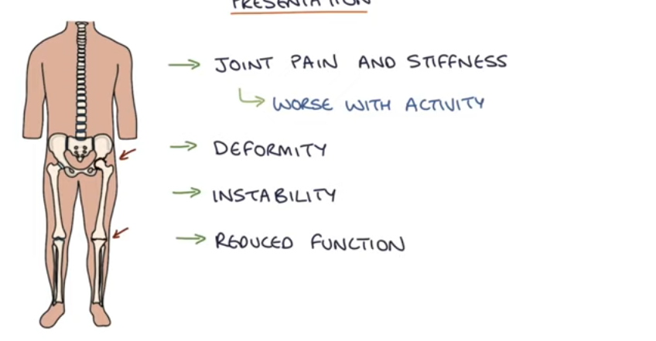
Hx/Key Questions | OPQRST  Screen for above risk factors  Questions about recent injury?  Is there loss fo sensation, or numbness?  How does this affect ADLs  Pain worse at night?  Stiffness?
Physical Exam | - INSPECT: Look for any visible deformity, muscle wasting (particularly the deltoid and supraspinatus areas), asymmetry, or swelling. Check for skin changes, such as redness or signs of trauma.  - PALPATE: Palpate the shoulder joint (AC joint, glenohumeral joint) for tenderness, crepitus, or warmth, which could suggest inflammation. Palpate the bony landmarks (clavicle, scapula, acromion) and muscles around the joint for tenderness.  - ROM: Assess active and passive ROM. Typical limitations in osteoarthritis include reduced abduction, external rotation, and internal rotation. Observe for pain or crepitus with movement. Measure ROM, comparing to the unaffected shoulder.  - Strength: Test shoulder muscle strength in flexion, extension, abduction, adduction, internal and external rotation. Look for weakness, which can be due to pain inhibition or muscle atrophy.  - TESTS:  - Hawkins-Kennedy Test: Checks for impingement, common in OA.  - Neer’s Impingement Test: Assess pain with shoulder impingement.  - Cross-Body Adduction Test: Checks for acromioclavicular (AC) joint osteoarthritis.  - Empty Can Test: Test supraspinatus tendon for rotator cuff integrity, which can be impacted by chronic OA.  Look for:  - Pain with OA is worse with joint use, and relieved by rest  - Pain is worse in the afternoon and early evening.  - Joint line tenderness  - Limitation of motion  - Bony swelling  - Joint deformity  - Instability
Diagnostics/Labs | ESR, CRP, RF, A1C is diabetic, xray
Red flags | S/s of infection…dont mistaken any joint pain/imbility for OA…could be septic arthritis, fracture, tumour!
Differential Diagnoses | - Frozen shoulder presents similarly  - Rheumatoid arthritis (Absense of rheumatoid factor, elevated CRP and ESR)  - Psoriatic arthritis  - Crystalline arthritis (crystal deposits on imaging  - Hemochromatosis (iron overload) RU with xray  - Infectious arthritis or other soft tissue abnormalities
Treatment/Management | - Address recreation, sleep disturbance, fall risk assessment, social supports,  - Pt expectations for the treatment  - Modifiable risk factors such as obesity and fitness  - RICE  - NSAIDs (oral and topical)  - Duloxetine if multiple joints are involved  - Tylenol  - Acupuncture, TCM, TENs machines
Referrals | If surgery indicated, ortho (very rare)
Follow-up

Shoulder Pain: Bursitis
Def’n | Scapulothoracic (subscapular) bursitis may result from mechanical pressure and friction  This causes inflammation of the bursae, which are the fluid filled sacs that cushion the join
Pathology/Cause | Injury or trauma to the shoulder, inflammatory arthritis such as RA, gout and infections.
Risk Factors/Epidemiology | -Older adults  -Age Obesity Occupation or hobbies History of RA, gout, diabetes
Clinical Presentation | HALLMARK: localized pain and tenderness over the affected bursa, often worsened by movement or pressure  ​​-Pain, swelling and tenderness near affected joint  -Affected patients complain of localised pain over the upper back or a popping sound whenever the shoulder is shrugged.
Hx/Key Questions | -What is your occupation?  -What type of sports and hobbies do you have?  -OPQRST  -Screen for above risk factors  -Questions about recent injury?  -Is there loss fo sensation, or numbness?  -How does this affect ADLs  -Is there any associated sounds with shoulder movement eg popping sounds
Physical Exam | Pain on palpation of the bursae  INSPECT: Look for signs of swelling or redness, though these are less commonly visible in shoulder bursitis.  PALPATE: Palpate over the subacromial bursa (located beneath the acromion) and around the deltoid for tenderness. Pain with palpation over the greater tuberosity of the humerus can suggest subacromial bursitis.  ROM: Assess active and passive ROM, particularly noting pain with abduction and forward flexion. Bursitis often limits ROM due to pain, especially in the "painful arc" (60–120 degrees of abduction).  STRENGTH: Perform strength testing for the rotator cuff muscles. In bursitis, muscle strength is often preserved but painful when moving the shoulder.  TESTS:  - Hawkins-Kennedy Impingement Test: Pain with this maneuver (forward flexion and internal rotation of the shoulder) can indicate subacromial bursitis.  - Neer’s Impingement Test: Pain with passive forward flexion of the shoulder also suggests impingement of the subacromial bursa.  - Painful Arc Test: Pain during abduction between 60-120 degrees is often associated with subacromial bursitis.
Diagnostics/Labs | Ultrasound can differentiate from cellultlis  Blood cell count, inflammatory markers  MRI
Red flags | Septic bursitis
Differential Diagnoses | - Osteoarthritis  - Cellulitis  - Shoulder subluxation or dislocation  - Labral tear  - Septic bursitis
Treatment/Management | Steroid injections, NSAIDS, physio, RICE, weight loss, exercise, taking breaks during repetitive tasks, rarely may need antimicrobial therapy or for draining of bursae if infection present
Referrals | Physio
Follow-up | 2 weeks if unresolved

Shoulder Pain: Tendonitis
Def’n | Symptomatic primary rotator cuff tendon disorders.
Pathology/Cause | Rotator cuff disease is the most common cause of shoulder pain. Any muscle may be involved but supraspinatus is most frequently injured.
Risk Factors/Epidemiology | Shoulder pain occurs more often in older adults and in working populations. Repetitive overhead work and sports.  Injury of one shoulder can put the contralateral shoulder at risk of overuse
Clinical Presentation | HALLMARK: localized pain and tenderness over the affected tendon, often worsened by movement, particularly activities involving overhead motion or lifting.  - Shoulder pain with overhead activity, eg putting on a shirt, brushing hair.  - Localised pain to lateral deltoid, increasing at night  - Pain while performing sport and weakness, fatigue, declined performance to that shoulder.
Hx/Key Questions | As per rest of the shoulder assessments, plus see algorithm below
Physical Exam | INSPECT→  - Muscle atrophy with long term tendinopathy  - Deviation of the scapula  - There may be referred neck pain  PALPATE→  - Tenderness over affected musculature, however often injury is very deep and not palpable.  - Night pain present  TESTS→  - Positive Hawkins-Kennedy, Neer and Jobe tests
Diagnostics/Labs | Lidocaine injection test: patient with tendinopathy will have normal strength after lido injection, whereas large tear in rotator cuff will still have weakness post lido.
Red flags | - Compartment syndrome  - Dislocation  - Lost sensation
Differential Diagnoses | 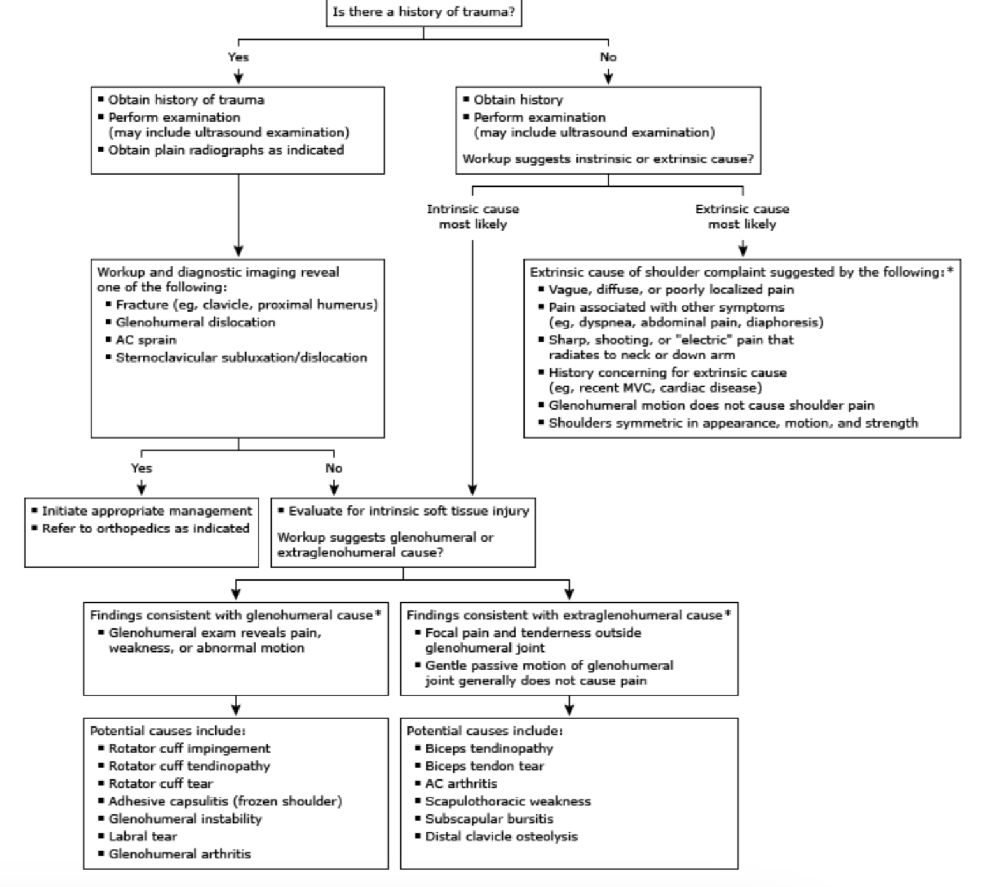
Treatment/Management | - Ice, rest  - Physiotherapy  - Topical NSAIDs  - Kin tape  - Platelet rich plasma (lack of evidence)  - Acupuncture  - TENS
Referrals | Indication for referral to ortho.  ● Functional deficits interfere with ADLS  ● Persistent pain  ● Worsening function  ● Persistent activity limitations that prevent participation in desired activities
Follow-up | Return to clinic within 2-3 weeks for re evaluation of symptoms and function

Shoulder Pain: Fractures, dislocations, acromioclavicular joint sprain/separation, shoulder strain
FYI THIS ONE WAS A CHALLENGE TO GET THROUGH I STRUGGLED TO ORGANIZE THE INFO AND FIND RELEVANT CONTENT IN THE TEXTBOOK…WITH STUDYING I WILL TRY AND UPDATE IT AND ORGANIZE BETTER AS I LEARN MORE BECAUSE IM CONFUSED ASF ATM LOL
Def’n | Shoulder pain is any pain in or around the shoulder joint.
Pathology/Cause | - Most shoulder problems fall into four major categories:  - Tendon inflammation (bursitis or tendinitis) or tendon tear  - Instability  - Arthritis  - Fracture (broken bone)  - Other much less common causes of shoulder pain are tumors, infection, and nerve-related problems.
Risk Factors/Epidemiology | Shoulder pain is responsible for approximately 16 percent of all musculoskeletal complaints.>40 years are more likely to have shoulder instability or rotator cuff disease, Sports
Clinical Presentation | - Fracture: swelling, bruising, tenderness, redness, pain to touch  - Dislocation: extreme pain, weakness, inability to move arm, visibly out of place, swelling, bruising, muscle spasm, numbness, or tingling  - Acromioclavicular joint sprain/separation: Shoulder pain,  - Shoulder that feels sore when touched, swelling, bruising, change in the shoulder's shape, bulge above the shoulder, shoulder that appears to droop, collarbone that moves upward.  - Shoulder strain: Pain at the front of the joint, tenderness when pressing on the area of the injury, swelling that develops rapidly, inability to move the shoulder, instability in the shoulder joint
Hx/Key Questions | -What is the primary problem?  -Pain extrinsic or intrinsic?  -Instability?  - Loss of motion, active or passive?  -Any history of trauma?  -Any unexplained sensory or motor deficits (rule out neurologic causes)?
Physical Exam | INSPECTION:  Observing the patient from the anterior view, evaluate for abnormal contours and bony prominences. Posteriorly, assess for symmetry and look for atrophy. Healthy patients who present for a screening examination without shoulder pathology should be free of abnormal contours, have symmetrical findings, and not exhibit atrophy.  PALPATION:  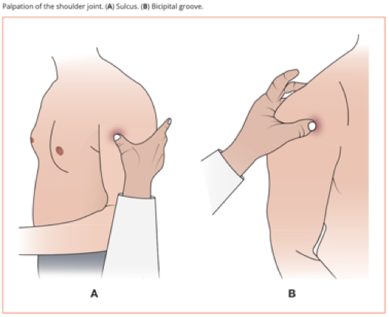Begin from a posterior approach and palpate the spine of the scapula from medial to lateral on your patient. Recall the bony landmarks of the anatomy, as the end of the scapula becomes the acromion. Palpate the anterolateral portion of the acromion moving toward the deltoid until you feel the sulcus. The subacromial bursa is in this sulcus. Palpate over the humeral head in the region of the bicipital groove, until your fingers fall into the groove, locating the long head of the biceps tendon.  MUSCLE STRENGTH TESTING:  Supraspinatus muscle strength testing. With the patient in a position of 90 degrees abduction, 30 degrees forward flexion, and internal rotation, elbow extended, and thumb down, ask the patient to resist your downward pressure.  Infraspinatus and teres minor strength testing. With arm at side and externally rotated to 30 degrees, with a flexed elbow, apply pressure to the forearm and resistance to external rotation.  Subscapularis muscle testing. Lift off test: Place the patient’s arm behind back, palm out. Ask the patient to lift away against resistance. A positive test is one in which a patient cannot perform the motion or it is painful.  RANGE OF MOTION: ACTIVE AND PASSIVE ROM:  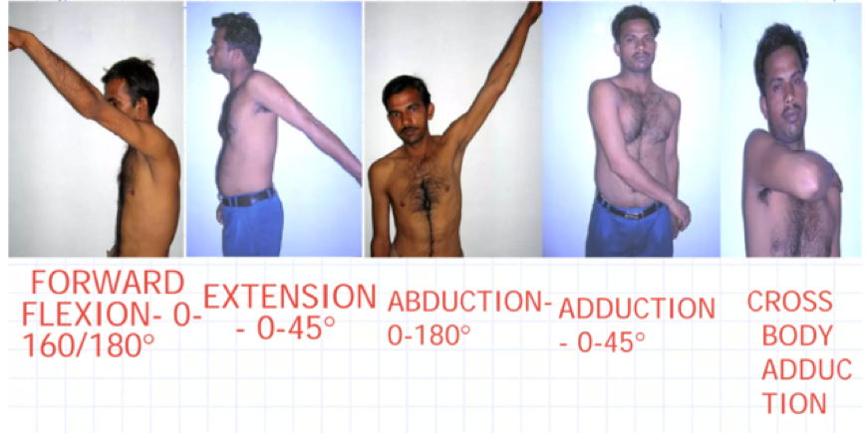  Shoulder Impingement Test (Neer test)  While stabilizing the scapula, pronate the arm and flex the shoulder to 180º (so that the upper arm is “neer the ear”). This test assesses for impingement of the supraspinatus tendon. Pain at the shoulder indicates a positive test.  Empty Can Test (Jobe test)  Checks for weakness or insufficiency of the supraspinatus muscle and rotator cuff impingement of the shoulder.  Scratch Test (Apley Test)  Instruct the patient to reach behind their head (palm facing their back) to attempt to touch the superior medial angle of the opposite scapula. This part of the test examines external rotation and abduction of the shoulder.  Next, instruct the patient to reach behind their back (dorsum of hand facing their back) to attempt to touch the inferior angle of the opposite scapula. This part of the test examines internal rotation and adduction of the shoulder.  Lastly, instruct the patient to reach across their torso to the opposite shoulder. This part of the test also examines internal rotation and adduction of the shoulder.  Apprehension Test  With the patient seated or standing, abduct and externally rotate the shoulder. Apply posterior-to-anterior pressure to the glenohumeral (GH) joint. If this causes significant discomfort and apprehension (fear of their shoulder dislocating), this is a positive test.  Then with the patient lying supine, again abduct and externally rotate the shoulder. Apply anterior-to-posterior pressure to the GH joint. If this relieves their discomfort and apprehension, this further confirms the positive test.  This test assesses for GH instability. Positive apprehension with the first maneuver followed by significant relief on the relocation (second maneuver) indicates a positive test.  Painful Arc test  This tests for subacromial impingement syndrome.  Active compression test (O’Brien test)  Used to test for labral injuries and SLAP lesions of the shoulder joint. The patient flexes the arm to 90 degrees with the elbow fully extended then adducts the arm 10-15 degrees medial to the sagittal plane. The arm is then maximally internally rotated and the pt resist the examiners downward force.  Cross arm test  Test for acromioclavicular joint separation/tear.
Diagnostics/Labs | 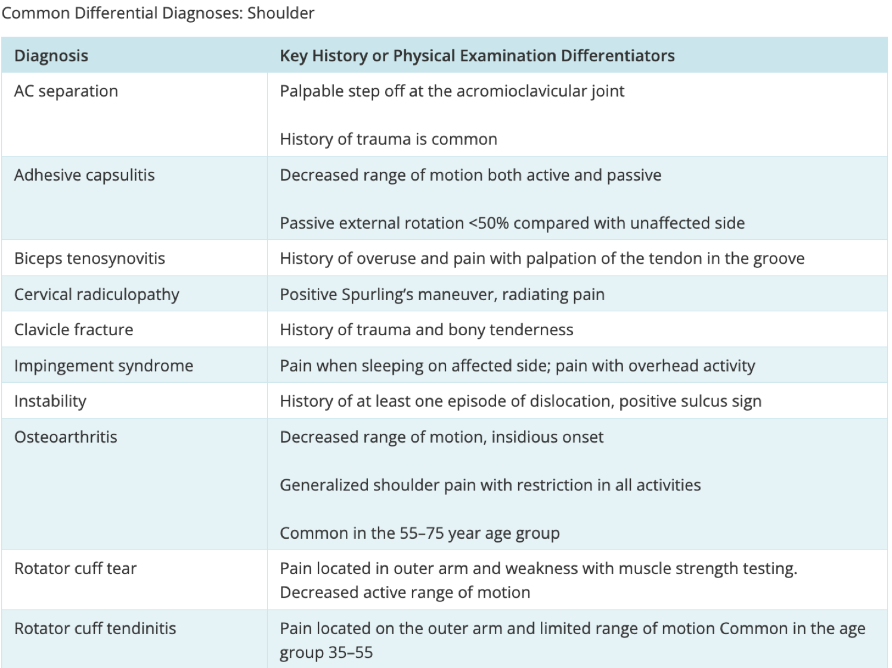  Fibromyalgia  Glenohumeral arthritis  Myofascial pain  AMC joint deformity
Red flags | - Sudden jerk, collapse or winging of the shoulder blade  - Intense stiffness  - Arm weakness  - Numbness in the arm/hand  - Limited or reduced motion  - Misshaped or swollen shoulder joint  - Unexplained mass or deformity  - Redness, heat, swelling  Acute disabling pain
Differential Diagnoses | - Xray  - Further imaging if unclear: MRI, CT, US  - EMG for nerve function  - Arthroscopy  - Arthrogram
Treatment/Management | Rest Altering activities, Physical therapy, Medications for inflammation or pain, Steroids, Numbing medication, Surgery
Referrals | Physiotherapy  Orthopedic Surgeon- Sx or cortisone injections
Follow-up | - Follow up if signs of infection  - Sudden worsening  - Need for surgical intervention

Spine Imaging Video
- Spine Imaging common conditions:
- Spinal Stenosis
- Disc herniation
- Cauda equine syndrome *not diagnosed by imaging
- Arthritic conditions- DISH and ankylosing spondylitis
- Infection
- Tumor
- Trauma (fracture)

Pediatric Red Flags: back pain under 10 years of age, persistent back pain, pain at nighttime, pain with fever or other generalized symptoms, prolonged greater than 4 weeks; radiculopathy or motor changes (pins, needles, numbness, weakness)
Imaging warranted for above and abnormal neurological exam, develop of curvature of spine

Low back pain shouldn't have imaging- ministry supports for low back pain management- Interprofessional spine assessment and education clinics (ISAEC) and rapid assessment clinics through LHIN

Red Flags for Imaging for Adults:
Cauda equina syndrome- saddle anesthesia, urinary retention and overflow incontinence, loss of anal sphincter tone/fecal incontinence, lower extremity symptoms (numbness, tingling, radicular pain, weakness)
Progressive neurological deficits
Back pain at night (malignancy)
Significant trauma

MRI:
- Gold standard for imaging of spine
- Soft tissue
- Neural elements- spinal cord, nerves
- Gadolinium- helps to identify infection, tumor
- Contraindications: metallic implants, foreign body in eyes (welders), claustrophobia, body habitus, pregnancy is okay but gadolinium avoided in pregnancy

CT Scan:
- Good to identify bony structure of spine
- If patient has pacemaker or other MRI contraindications
- Aids in surgical planning
- Contraindications: pregnancy, if using contrast then allergy and renal function

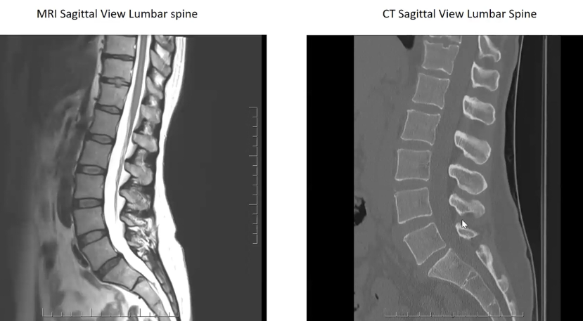

CT Myelogram
- Used when MRI contraindicated and more detailed information needed
- Contrast injection prior to CT scan
- Identifies: spinal cord, spinal canal, spinal nerve roots, blood vessels supplying spinal cord

What is needed on the requisition?
Information to help protocoling appropriately to determine urgency
- Area of spine to be imaged, cervical, thoracis, lumbar, entire
- contrast requirements, if tumor presumed
- clinical symptoms, back pain is not detailed enough, foot drop
- differential diagnosis, ie. Rule out disc herniation
- patient demographics
- ordering clinical contact info

Key words to identify in the report:
- Lesion/tumor
- Bony island
- Cord signal change
  - Myelomalacia
  - T2 hyperintensity
- Compression of causa equina
- Turbulence of nerve roots- sever spinal stenosis
**after imaging go back to patient, complete additional physical exam to ensure correlates clinically prior to referral as EVERYONE will have changes due to age/wear and tear; what are patient's symptoms? Does it correlate with pathology found on imaging? Additional tests that can be done are vascular studies, EMG/NC studies, imaging of other body parts; avoid medicalization of results

Making a referral:
Specific clinical symptoms, Don't just repeat MRI findings; include any treatments and results; radiological imaging reports included
Example: 56 y/o male with bilateral leg pain that occurs with standing and walking; conservative management has failed, MRI shows spinal stenosis at L4-5

Spinal Stenosis: white along column becomes interrupted,
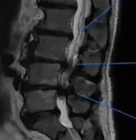

Disc Herniation: bulge of disc into white column
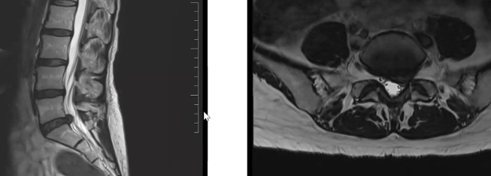

Tumor: more white opacities infringing on column
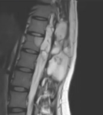

Infection: would have had Gadolinium and notice that signal along column is interrupted (beside mouse) and disc is white below base of mouse
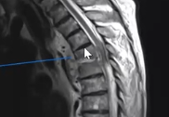
CT of same infection above: shows bony destruction
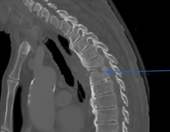
Trauma: MVA showing spinal compression of column/spinal cord
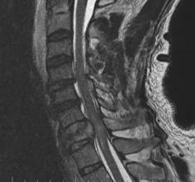
Ankylosing Spondylosis- x-ray sufficient: bamboo spine
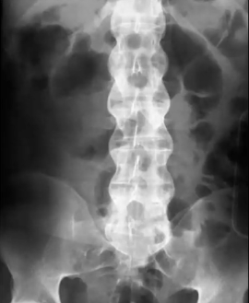

MSK Imagining
In orthopedics when a pt comes in wih a MSE complain, an xray is always first line since its easy and quick. However consider the context, if the pt is young and healthy it is unlujlet they have a bone related issue so an U/S to assess their muscles make make more sense.
What is a CT scan?
- Best choice for skeletal system
- Biases nmsicel and bons disorders
- Pinpoint laction of tumor, infection, clot
- More detailed then the xray
- If a pt has metal in the mody thy are safe to have a CT scan
- Contraindiactaions:I allergies to contrast/iodine, renal impairtents, pregnant
Contrast vs no contrast?
- Use NO contrast if: trauma, preoperative planning
- Use contrast sepsis or soft tissue cinjury
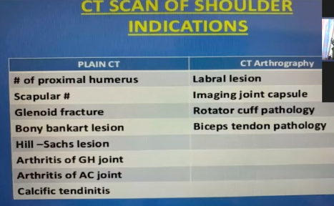
What is a MRI?
- No radiation
- Can use if pregnant
- CI: if they have metal in their body (includes piercings and hair clips…most ortho implants are fine though), severe CKD
- Helps ith earling findings of OA
- Best for soft tissue
- Helps see ligaments, ceritalge, rotaterm herniated disk, bone tumors
- MRI with contrast:
  - Inflmaiation, infection, tumor, pre and post op comparison, and blood supple to area/tumor/organ
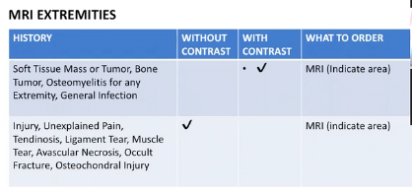

Clinical scenarios:
- CONSIDER: Age, type of injury, suspect bone (CT) or tissue issue (MRI)? Remember that if you order a CT and a MRI is needed they will tell you to consider an MRI so don’t worry if you get it wrong in practice!
- 47 year old male with pain in ankles bilateral, no redness, difficulty ambulating, previous hockey injury years ago and overweight.
  - Order a MRI because no know current injury so want to look at soft tissue not bones
- 50 year old with risk of osteromylitis?
  - Order a CT as this is a bond disorder not a soft tissue disorder
- 61 year old with septic artititis, has low Hbg and swelling to thigh/hip with pain, with a high WBC count. H x of osteoporosis.
  - First do a U/S to thigh/hip because low hemaglobin and swelling/pain could signal a bleed there!!!
  - Order an MRI as they can show swelling/edema and tissue concerns
- 34 year olf skatebordered with pain of the knee and has hypoflexion of knee.
  - A xray could be done but this is likely a soft tissue not a bone issue, do an MRI is needed as it could be a ACL tear.
- 48 year old fell and hurt right shoulder and can no longer flex her shoulder and has restricted ROM, otherwise healthy.
  - MRI because this is likely a tissue tear however for a quick and easy scan could order a U/S

Cervical Radiculopathy- “pinched nerve in neck”
Def’n | -nerve root in the spine is compressed or impeded, causing pain that spreads beyond neck into arm, chest, shoulders and upper back.  -Pathological process affecting the nerve root that may cause neck, shoulder, or arm pain, muscle weakness, sensory symptoms
Pathology/Cause | -usually C7 or C6  Radiculopathy affects the nerve root.  The causes are either compressive, or non-degenerative.  Two predominant compressive mechanisms are cervical spondylosis and disc herniation.  Spondylosis is caused by aging  Disc herniation is caused by intervertebral pressure in and degeneration of the ligamentous fibres, causing a tear.  Non-degenerative causes include infectious processes, (eg herpes zoster, lyme disease), nerve infarction, infiltration by tumour, demyelination, inflammatory and neurodegenerative conditions.
Risk Factors/Epidemiology | -herniation more common up to 50 years, then degeneration of disk likely cause  -poor posture, repetitive movement,
Clinical Presentation | -muscle weakness and impaired deep tendon reflexes  -may have radiating numbness  -pain described as sharp or burning  **USUALLY ALWAYS UNILATERAL (one side of body)  ● Neck, shoulder or arm pain,  ● Muscle weakness, sensory symptoms  ● Diminished reflexes  ● Atypical referred pain such as chest pain, breast pain, or facial pain.  Sensory loss is mild or absent, but this is due to the overlap of dermotomes in this area
Hx/Key Questions | Sometimes putting hands on head relieves pain.  PQRST  OPQRST  Characteristics of pain  Preceding events, and activities, head trauma, msk injury to upper limb  Medication review  ADL interruptions?  Efforts to treat?  Recent chiropractor or other neck manipulation?  Changes in sleeping (eg new pillow or mattress)  Psychological distress?
Physical Exam | Reflexes on affected arm- biceps and triceps  Spurling’s test- hand on shoulder and apply pressure on head while flexing neck towards other shoulder and/or while looking up  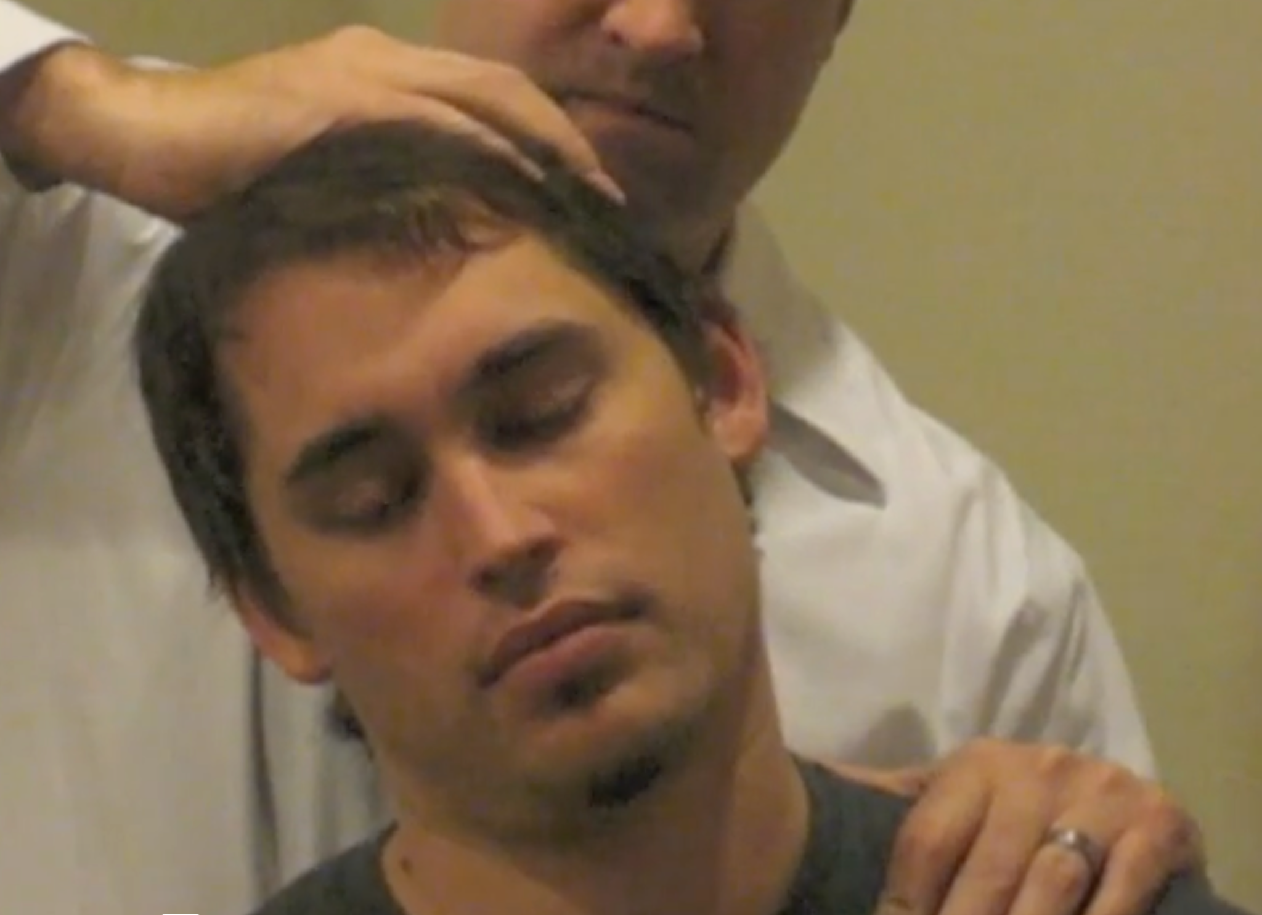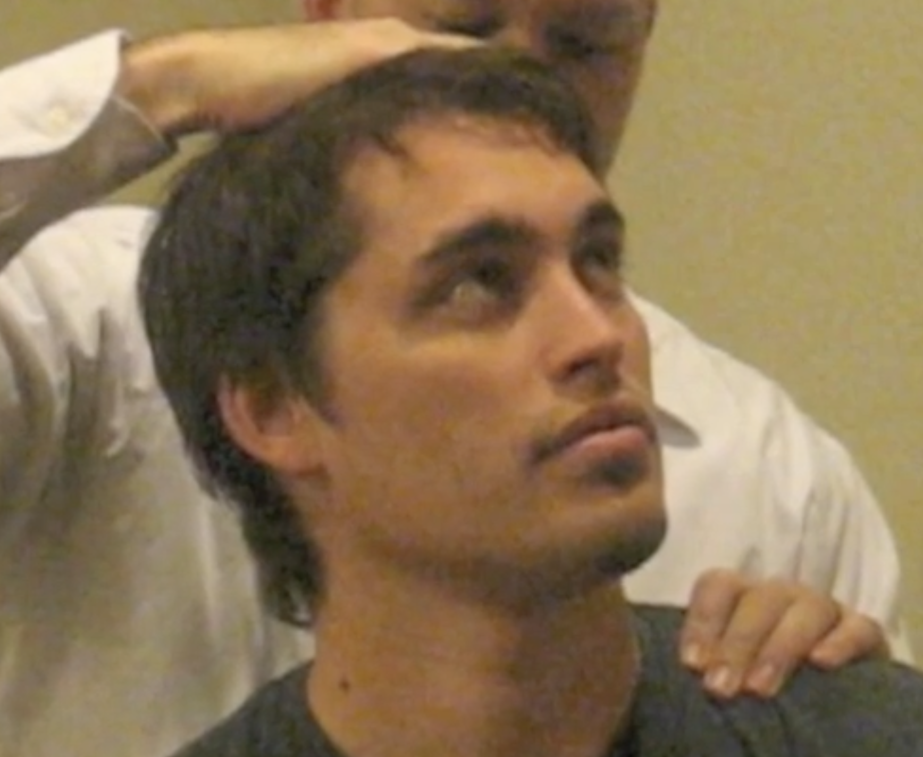  Non-degenerative radiculopathy may have more motor and sensory deficits than are found in compressive type.  Look for evidence of weakness and sensory disturbance = see table below  Do deep reflexes as this is a better indication when there is a lot of pain.  Spurling manoeuvre: extend and rotate neck to side of pain, apply downward pressure on the head. Negative result is neck pain.  Positive test is limb pain or paresthesia  ** caution, do not perform if unstable cervical spine.  Shoulder Abduction relief test: lift symptomatic arm above head, resting hand on top of head. Positive test if patient has a decrease or disappearance of radicular symptoms
Diagnostics/Labs | Spine Xray (nontraumatic), MRI (>6 weeks of symptoms)  EMG nerve testing
Red flags | Fever, night sweats, weight loss, excruciating pain, neck stiffness  Certain danger signs indicate cervical myelopathy  - Gait disturbances, sensory loss, weakness and atrophy in hands, neck and arm pain. Occasionally there is bladder and incontinence with cervical myelopathy.  Lhermitte phenomenon, is a shock like paresthesia occurring with neck flexion  - Indicates disc herniation, spondylosis  - Could also be a sign of MS.  History of chills, fever, unexplained weight loss,  - Tumour or infection for cause  -  Rapid progressive weakness warrants urgent imaging
Differential Diagnoses | -neuropathy, arthritis, strain, fracture  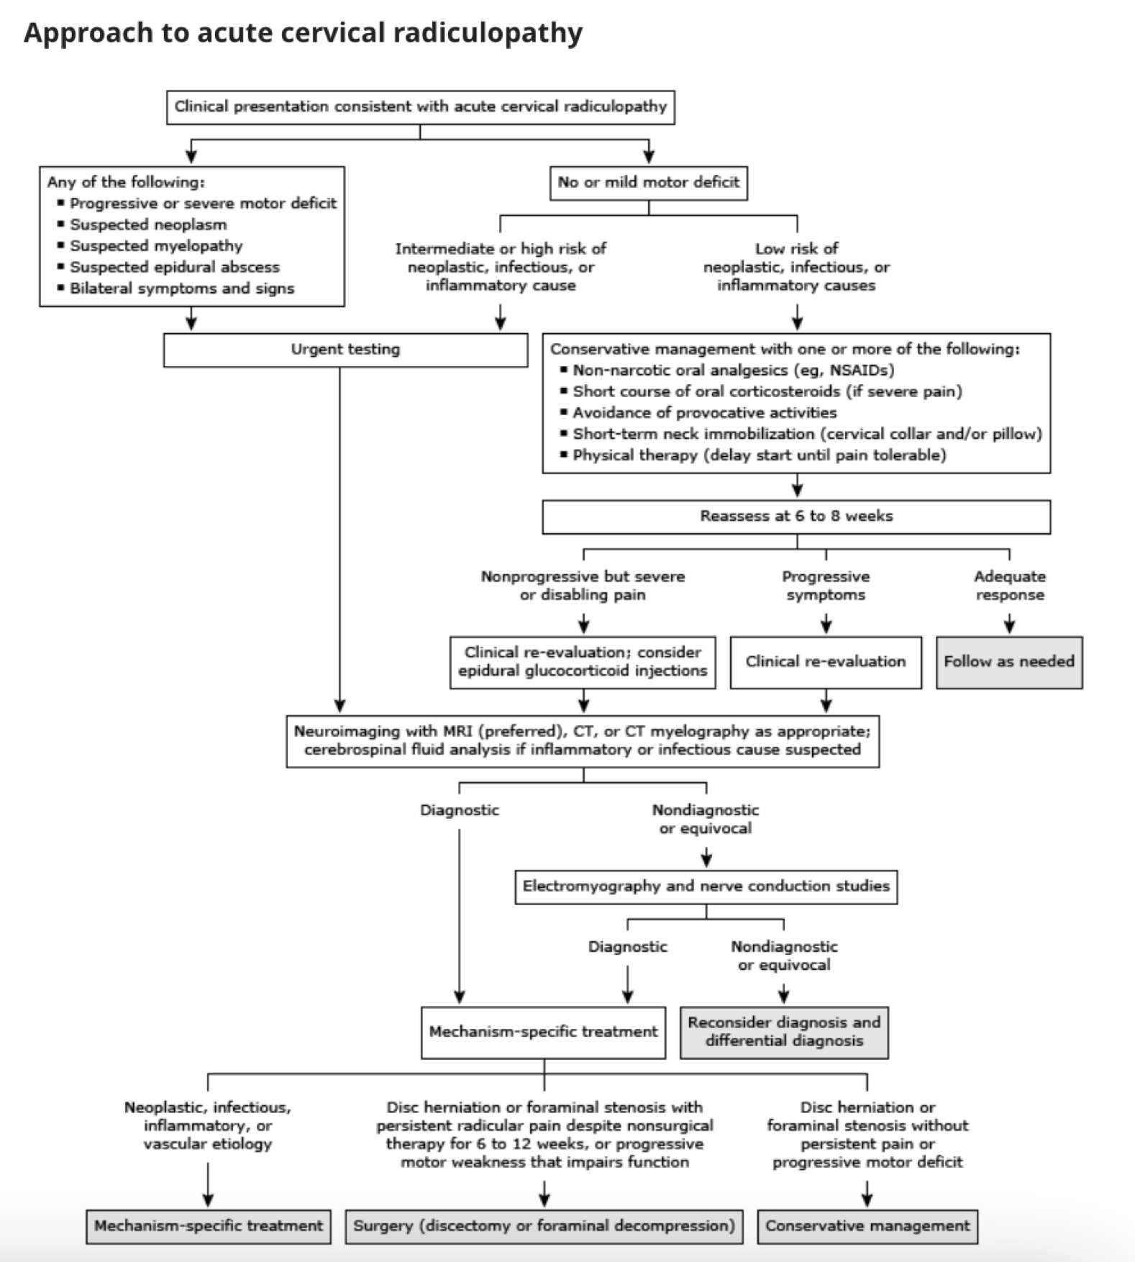
Treatment/Management | Treatment: resolve in 8-12 weeks, symptom management  Counseling/Education:  Non-pharm therapies: physical therapy, surgery

Hip Bursitis
Def’n | -bursae are fluid filled sacs in shoulder, elbow, hip, knee and heel to reduce friction; bursitis is inflammation of bursae
Pathology/Cause | -trochanteric bursitis-pain at point of hip or iliopsoas bursa- groin side pain
Risk Factors/Epidemiology | -female, age, repetitive stress. Hip injury, leg-length inequality  Inflammatory arthritis  Chronic overuse or pressure  Acute or chronic infection  Injury  Age: degenerative osteoarthritis and fractures considered first  Previous surgery  Leg length inequality  Rheumatoid arthritis  Scoliosis
Clinical Presentation | 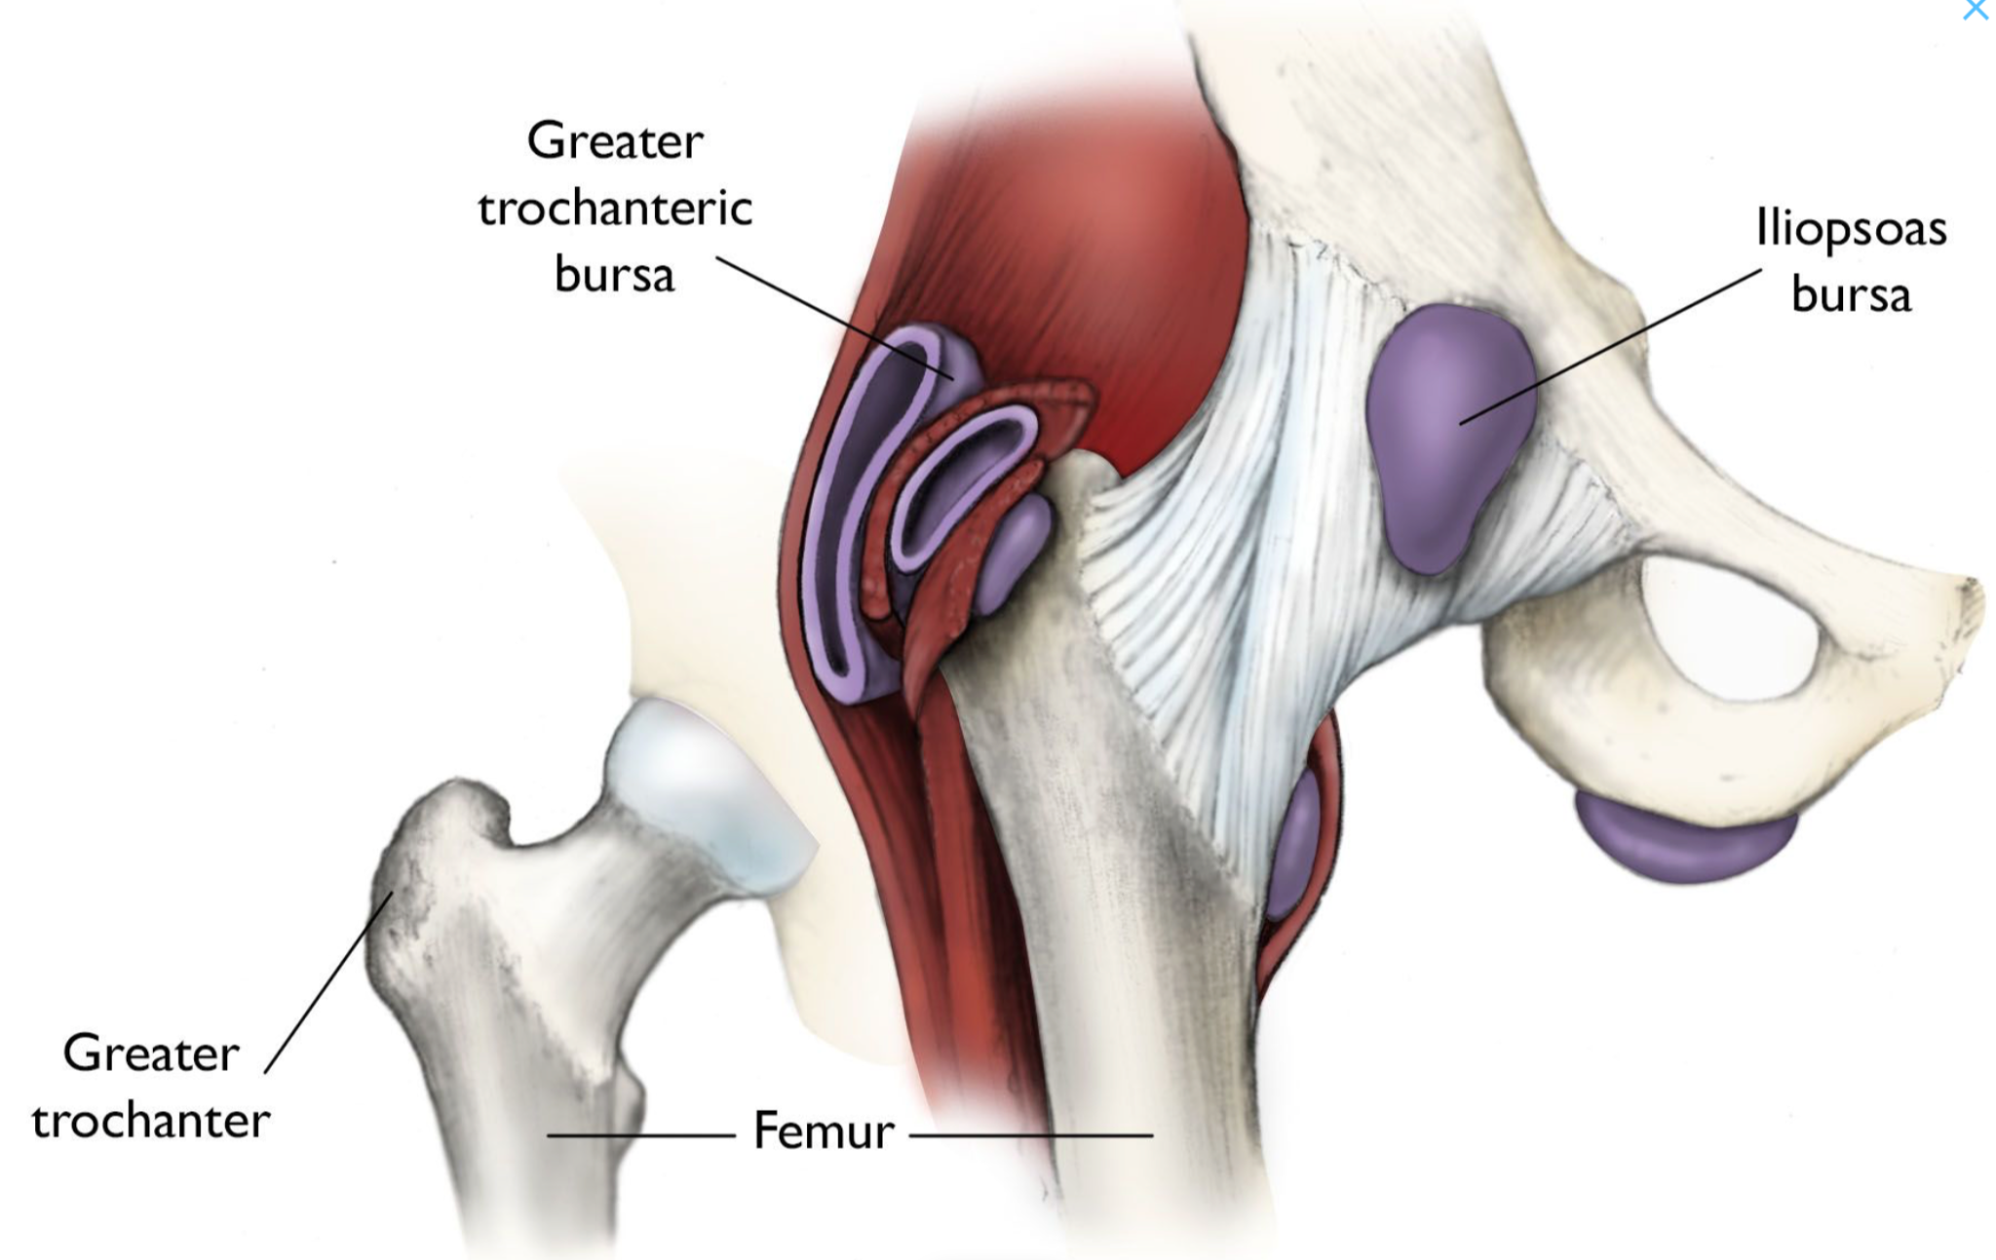  -pain at point of hip, extends to outside thigh; early pain is sharp and intense, later pain ache  -pain worse at night, when lying on affected hip, and when getting up from a chair after being seated for awhile; worse with prolonged walking, stair climbing or squatting  Symptoms include pain (particularly with motion or pressure), swelling, and tenderness.
Hx/Key Questions | . Recent trauma?  2. Inciting activity or factors that increase or decrease the pain?  3. Questions related to hip function, such as ease with ADLs?  4. Location of hip pain, anterior, groin, posterior hip and lateral hip?
Physical Exam | -tenderness over point of hip and palpate for edema in bursae;  -ROM  1. Inspection  Inspect for bony deformities and symmetry; assess gait. Waddling gait is caused by bilateral weakness of the hip abductor muscles.  2. Palpation  Assess for areas of tenderness, paying particular attention to bony landmarks. Assess leg length.  3. Trendelenburg Test: indicates inadequate pelvic stability. This sagging of the pelvis secondary to hip abductor weakness is known as Trendelenburg’s sign.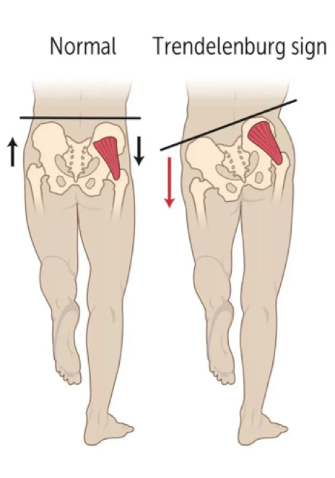  4. test: 1 is normal, 2 is a positive test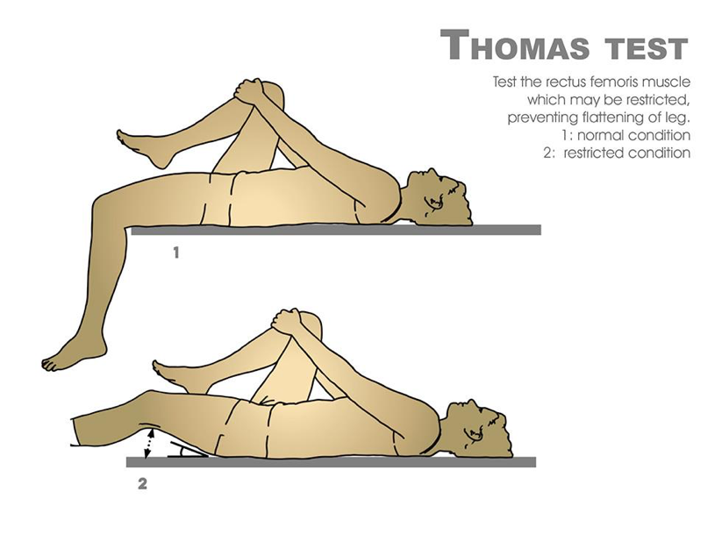  5. Muscle strength testing  -Test hip flexor muscles, ask the patient to bend knee against chest and hold it against resistance.  - Test hip extensor muscles: ask patient to lie prone, bend their knee and lift it toward the ceiling.  - Test hip abductor muscles: ask patient to lie supine and to move his or her leg away from the midline of the body.  - Test hip internal rotator muscles: internal and external obturators, quadratus femoris, superior and inferior gemelli. Ask the patient to lie supine, bend the knee and turn the leg out at the hip joint away from the midline of the body.  6. ROM active and passive  Iliopsoas bursitis (internal snapping hip): Patients with this condition have anterior hip pain when extending the hip from a flexed position, often associated with intermittent catching, snapping, or popping of the hip
Diagnostics/Labs | -x-ray- R/O fracture if impeding ROM
Red flags | -signs of hip fracture- shortening, rotation, CSM compromise  Disabling joint pain  Excessive swelling, redness, bruising or a rash in affected area
Differential Diagnoses | -arthritis, tendonitis
Treatment/Management | Treatment: lifestyle changes, supportive treatment, cortisol shot

Rheumatoid Arthritis
Def’n | -chronic systemic disease involving articular inflammation of the joints; (interphalangeal joints of fingers and thumbs #1)  s/s fpr at min 6 weeks  SYMETRIC/ BOTH SIDES  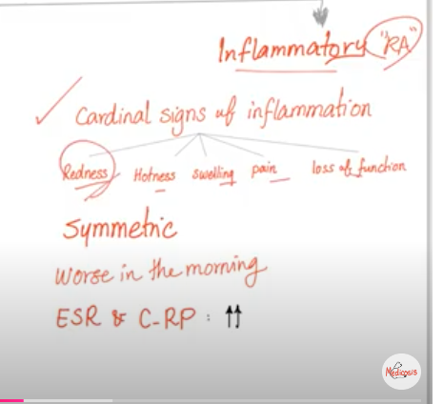
Pathology/Cause | -untreated = disability and deformity; goal is remission, prevention of functional decline and halting progression
Risk Factors/Epidemiology | -female, family hx, age (developes 40-60 y/o), recent systemic illness or trauma as infection can trigger, cigarette smoking increases risk and severity
Clinical Presentation | -insidious and symmetrical involvement of synovial joints **Characteristic feature  - joint pain, morning stiffness in joints for AT LEAST one hour and present for MORE THAN 6 weeks  -swelling and warmth in at least 3 joints for more than 6 weeks  - Other: fatigue, malaise, joint deformities, low grade fever, weight loss, anemia, carpal tunnel  Four stages of RA:  1. Stage 1: No symptoms or signs; normal activity; RF and/or CCP antibody is present.  2. Stage 2: Morning stiffness, warmth at joint, normal activities of daily living (ADL), minimal limitation in joint use; increased T-cells, B-cells, antibody production, and synovial cells are observed.  3. Stage 3: Morning stiffness, warmth at joint, and extra-articular manifestations; marked limitation in ADL. Increased T-cells, B-cells, antibody production, and synovial cells are observed.  4. Stage 4: Same as Stage 3 plus proliferating synovial membrane involved, causing injury to the bone, tendons, and cartilage. Client is now incapacitated or confined to a wheelchair.  Common findings:  · Joint pain  · Morning stiffness in joints for at least one hour that has been present for more than six weeks  · Swelling and warmth in at least three joints or more for at least six weeks. Common joints affected include the wrist and hands. The metacarpal phalangeal (MCP) joints and the proximal interphalangeal (PIP) joints.  S/S:  · Fatigue, malaise  · SC nodules  · Joint deformities: PIP joints (Boutonniere deformities)  · Fingers (swan-neck contractures, ulnar deviation)  · Wrists: loss of extension  · Hips: loss of internal rotation, followed by flexion contractures  · Knees: suprapatellar pouch distention  · Elbows: decreased extension, olecranon bursitis  · Shoulders: Limited ROM  · Cervical spine: subluxation rare  · TMJ: pain with biting  · Depression  · Low grade fever  · Weight loss  · Myalgia  · Anemia  · Carpal tunnel syndrome  Four stages of RA:  Stage 1: No symptoms or signs; normal activity; RF and/or CCP antibody is present.  Stage 2: Morning stiffness, warmth at joint, normal activities of daily living (ADL), minimal limitation in joint use; increased T-cells, B-cells, antibody production, and synovial cells are observed.  Stage 3: Morning stiffness, warmth at joint, and extra-articular manifestations; marked limitation in ADL. Increased T-cells, B-cells, antibody production, and synovial cells are observed.  Stage 4: Same as Stage 3 plus proliferating synovial membrane involved, causing injury to the bone, tendons, and cartilage. Client is now incapacitated or confined to a wheelchair.
Hx/Key Questions | Onset, time of day, impact on ADL, family history, previous injury to location of swelling, depressive symptoms  1. Review when joint pain began and identify the joints involved. Is pain and stiffness worse in the morning? How long does it last? Is it symmetrical?  2. Elicit the client’s description of pain and a description of how the pain interferes with ADL (walking, climbing stairs, using the toilet, getting up from a chair, opening a jar).  3. Review the family history of RA.  4. Has the client ever had any type of injury to the specific joint area? Rule out recent injuries.  5. Identify what makes the pain worse and alleviating factors. In clients with RA, activity typically alleviates symptoms, which is indicative of inflammation.  6. Review list of medications, including herbal and OTC medications. What therapies have specifically been used, and what were the results?  7. Review the client’s history for recent infections.  Does the client use any assistive devices, including cane, crutches, walker, wheelchair/power mobility device, kitchen devices/grips, and so forth?
Physical Exam | Temp, weight  Observe movements walking and changing position and handling things in hands  Inspect all joints for deformities, temp, *heat and redness are not RA  Inspect for subcutaneous rheumatoid nodules (Elbow most common)  Heart and lung Auscultation  Lymph nodes  Abdomen- splenomegaly???  Grip strength- parameter for measuring activity and progression, close hand to make a fist  A. Check temperature, if indicated, pulse, respirations, blood pressure (BP), and weight.  B. General observation:  1. Observe the client getting up and down in the chair.  2. Observe the client walking (may have a tendency to bear weight on heels and hyperextend toes secondary to tenderness to the metatarsophalangeal joints).  3. Observe the client handling objects in his or her hands.  4. Observe for signs of depression.  C. Inspect:  1. Inspect all joints, noting deformities, erythema, and temperature. (Heat and redness are not prominent features of RA.)  2. Evaluate for pitting oedema in the hand (may have a “boxing glove” appearance).  3. Inspect for subcutaneous rheumatoid nodules (elbow is the most common site).  4. Evaluate skin for ulcerative lesions (secondary from venous stasis and neutrophilic infiltration), skin atrophy and ecchymoses from glucocorticoids, and petechiae (side effect from medications causing thrombocytopaenia).  5. Eye examination:  a. Episcleritis: Acute redness and pain without discharge.  b. Scleritis: Deep ocular pain with dark red discolouration.  D. Auscultate.  1. Heart.  2. Lungs (at risk of infectious complications from immunosuppression and pulmonary toxicity from methotrexate [MTX] if currently being treated with medications).  E. Percuss:  1. Perform a patellar tap to evaluate synovial thickening/effusion of the knee.  F. Palpate:  1. Palpate the lymph nodes.  2. Perform oral examination to palpate the salivary glands (may have lymphocytic infiltration).  3. Palpate all joints to evaluate for tenderness with pressure, pain with movement of the joint, and “bogginess” of the joint (synovial thickening).  4. Palpate the popliteal fossa for evidence of a popliteal (Baker’s) cyst.  5. Examine abdomen for splenomegaly.  G. Musculoskeletal examination:  1. Assess grip (a reduced grip is a useful parameter in evaluating disease activity and progression). Is the client able to close fingers to make a fist?  2. Assess the strength of the extremities.  Assess the ROM (active and passive) and flexion.
Diagnostics/Labs | CBC  ESR  CRP  Ferratin  RF, quantitative  CCP antibody  Uric acid level  Synovial fluid (optional)  X-ray swollen joints for baseline
Red flags | -extra articular symptoms- anemia, pleuropericarditis, splenomegaly, etc.
Differential Diagnoses | -OA, gout, reactive arthritis, viral infections (lyme disease), Sjogren’s
Treatment/Management | Treatment: exercise and joint mobility; disease mondifying antirheumatic drugs  Counseling/Education:  Non-pharm therapies:
Referrals | -rheumatologist early
Follow-up | -based on disease progression

Systemic Lupus Erythematosus (SLE)
Def’n | -chronic, inflammatory autoimmune disorder; SLE attacks body organs and systems, joints, kidney, brain, heart, lungs
Pathology/Cause | -antibodies attack normal tissue and organs
Risk Factors/Epidemiology | -young women after menarche but before menopause  -african canadian, asian, hispanic, family hx; hydralazine, isoniazid and procainamide drug use
Clinical Presentation | -joint pain, fever, loss of appetite, fatigue, weight loss, oral/nasal ulcers, hair loss, sun sensitivity- rash/lesions,  -butterfly rash across face- round scaling papules 5-10 mm diameter
Hx/Key Questions | -medication history; family hx; systemic features*
Physical Exam | -all vitals and weight  -inspect rash, lesions, joints  -look for organ impacts- heart for lifts, heaves, thrills, thyroid enlargement, lymph swelling, abdomen of organomegaly  -listen all organs
Diagnostics/Labs | -CBC, ANA- positive with high titre, complement levels (decreased C3 and C4), RF can be positive, thyroid profile, anti-DNA antibodies, lupus specific antibodies, ESR, urinalysis, skin biopsy,
Red flags | *life threatening organ damage
Differential Diagnoses | Drug-induced lupus, vasculitis, RA (destruction of bone, not with SLE),
Treatment/Management | Treatment: NSAID, corticosteroid, immunosuppressives
Referrals | Rheumatologist immediately
Follow-up | frequent

Septic Arthritis
Def’n | -painful infection in a joint from germs circulating in body or placed there through trauma
Pathology/Cause | -staph aureus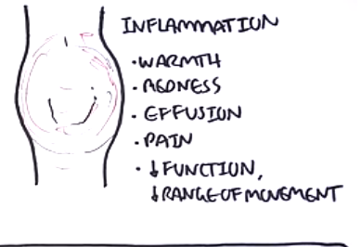
Risk Factors/Epidemiology | -infants or older adults, artificial joints,knees most common  -previous infection (ie. UTI, where bacteria traveled from)  -RA drugs increase susceptibility
Clinical Presentation | -extreme discomfort and difficulty using joint  -swollen, red, warm join  -fever  -typically pain goes away at rest
Hx/Key Questions | -fast onset, severe pain
Physical Exam | -decreased ROM due to pain and inflammation  -red and warm joint
Diagnostics/Labs | -synovial fluid assessment (culture, gram stain, crystal analysis, WBC)  -WBC, ESR and CRP, blood cultures  -Xray? Shows some changes, usually use US for aspiration and MRI best imaging  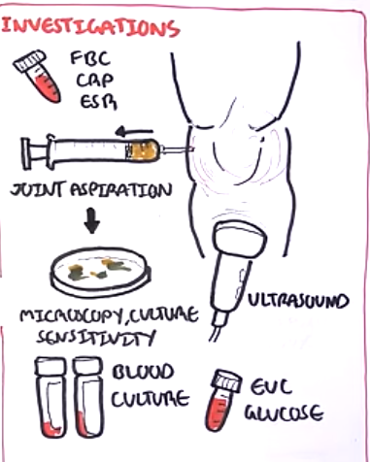
Red flags | Systemic infection
Differential Diagnoses | -RA, lupus, gout, systemic infection, lyme disease
Treatment/Management | Treatment: aspiration and antibiotics
Follow-up | Should improve 5-6 days, if not, aspirate and rule out lyme disease

Gout
Def’n | Acute, sudden inflammatory disease of joint caused by high uric acid
Pathology/Cause | Three stages of gout:  1. Acute gouty arthritis: Acute attack exhibiting severe pain, redness, and swelling of a joint, which may last from days to weeks, even if left untreated.  2. Intercritical gout: Period without flares.  3. Chronic/tophaceous gout: The progression of gout that has been inadequately treated, resulting in urate crystal deposits (tophaceous deposits) in the joints that can cause deformity and disability of the joint.
Risk Factors/Epidemiology | -high uric acid  -men 30-60, women after menopause  -secondary caused by: HTN, DM, obesity, ischemic cardiovascular disease; medications: diuretics, ASA, alcohol, nicotinic acid  -Diet- high intake beer, meat/fresh seafood
Clinical Presentation  *Insert picture here* | -redness, swelling, warmth/ pain in ONE JOINT ONLY (usually big toe), pain most severe first 12-24 hours  -Tophi can show if uncontrolled for years, fever in acute stage
Hx/Key Questions | History of gout, medications/diet
Physical Exam | Vitals  Inspect joints and for tophi; palpate for tenderness, pain, temp
Diagnostics/Labs | Oint FLuid Aspiration for urate crystals is gold standard- examine with polarized light microscopy  CBC (elevated)  ESR (elevated)  Serum uric acid level to r/u gout (can be normal during attacks, perform at least 2 weeks after attack/flare resolved)  RF titre  Xray or MRI if severe
Differential Diagnoses | -infectious arthritis, hyperparathyroidism, bursitis, cellulitis
Treatment/Management | Treatment: colchicine  Non-pharm therapies: rest, increase fluids, analgesics
Follow-up | w/i 24 hours, one month later; chronic gout = yearly labs

Osteoarthritis
Def’n | -chronic noninflammatory disease that affects moveable joints  -destruction of cartilage with reduction in joint spaces and bony overgrowth
Pathology/Cause | Secondary: trauma, septic arthritis, inflammatory arthritis, metabolic disorders
Risk Factors/Epidemiology | -increasing age, women more severe, trauma, genetic predisposition, obesity, secondary inflammation
Clinical Presentation  *Insert picture here* | -UNILATERAL joint pain involving joints of hands, neck, lower back, knees and hips  -morning stiffness lasting LESS than one hour  -early signs increase pain with use and improves with rest; pain at rest for severe/late disease
Hx/Key Questions | -age of onset of pain, gradual worsening from months to years? Morning pain? Deformity, warmth, redness, swelling? ROM? Family hx?
Physical Exam | Temp, pulse, BP  Inspect joints  Palpate joints, ROM
Diagnostics/Labs | ESR- OA does no increase this  Chemistry  CBC  RF  Xrays- severity and joint narrowing  CT/MRI if nerve involvement
Red flags | -systemic disease
Differential Diagnoses | RA, gout, septic arthritis, bursitis/tendonitis
Treatment/Management | Treatment: acetaminophen, NSAID  Non-pharm therapies: physical/occupational therapy
Follow-up | Based on severity

Scoliosis
Def’n | -side to side surve of spine
Pathology/Cause | -diagnosed in adolescence
Risk Factors/Epidemiology | -cerebral palsy, muscular dystrophy, genetic predisposition, spinal cord injury/surgeries
Clinical Presentation  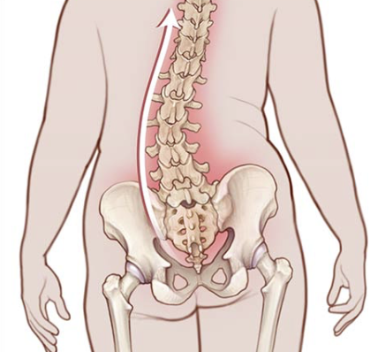 | -uneven shoulders, one shoulder blade that appears more prominent than the other  -uneven waist, one hip higher than the other, one side of rib cage jutting forward  -prominence on one side of the back when bending forward  -back pain, difficulty standing upright, core muscle weakness, leg pain/numbness
Hx/Key Questions | -pain
Physical Exam | Gait, standing straight, palpation of spinal column
Diagnostics/Labs | X-ray
Red flags | -severe and causing lung issues
Differential Diagnoses | -disk degeneration
Treatment/Management | Generally no treatment, some kids wear a brace

Shin Splints
Def’n | -pain along tibia/shin bone…usually by exercise  Shin splints refer to the pain and tenderness along or just behind the large bone in the lower leg.
Risk Factors/Epidemiology | -running, dancing, military  -intensified athletics overworking muscles, tendons and bone tissue  -female, obese, flat feet,  Athletes  Military personnel  Dancers  Flat feet, high arches  Unsupportive shoes  Vitamin D deficiency or eating disorders
Clinical Presentation | -tenderness, pain, along inner side of shinbone and mild swelling to lower leg  Pain felt on the front and outside of the shin. It's first felt when the heel touches the ground during running. In time, pain becomes constant and the shin is painful to the touch.  Pain that starts on the inside of the lower leg above the ankle. Pain gets worse when standing on the toes or rolling the ankle inward. As the shin splint progresses, the pain will increase.
Hx/Key Questions | -onset, aggravating features, rest resolve?  Have you tried anything to alleviate the pain?  3. Any redness, swelling, edema?  4. Any history of DVT or embolism in your family?  5. Any recent trauma?
Physical Exam | gait  ROM and pain doing jumps/walking  percussion/palpate shin  Fulcrum test for tibial fracture- supine, knee of examiner acts as fulcrum and grab below knee and above ankle and pull leg towards examiners knee; positive if pain  Homans to rule out DVT  Shin splints that do not resolve can lead to stress fractures  Palpate over the skin directly and look for a tender point  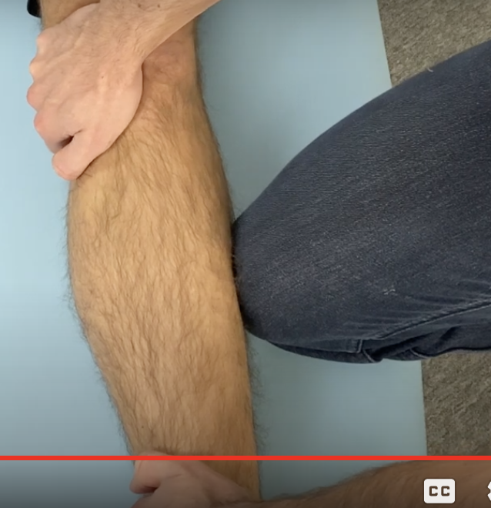
Red flag | Shin splints that do not resolve can lead to stress fractures
Diagnostics/Labs | Xray- R/O fracture
Differential Diagnoses | -tibia fracture, muscle sprain, DVT, stress facture, compartment syndome, tendonitis
Treatment/Management | Rest, ice, wear proper footwear, modify exercise routine  Can refer to physio

Ankle and foot strains/sprains/fractures (OTTAWA ANKLE)
https://www.youtube.com/watch?v=yKJ-UonKknw&ab_channel=Bob%26Brad
Def’n | -Sprain- ligament stretching or partial tears from forceful stress on joint  Grade 1: Microscopic tears without ligament tearing or joint instability.  Grade 2: Partial tearing of involved ligaments and laxity of joint with moderate function loss.  Grade 3: Ligament tearing with severe function loss and joint instability.
Risk Factors/Epidemiology | Falling, slipping,
Clinical Presentation  *Insert picture here* | First degree: Minimal pain; mild to moderate pain with stress, little swelling; minimal tenderness with palpation; little functional loss; unimpaired weight bearing or walking; internal microdamage with full continuity.  Second degree: Moderate pain with range of motion (ROM); swelling; marked tenderness on palpation; moderate loss of function; difficulty with weight bearing or walking; mechanical dissociation with partial loss of continuity.  Third degree: Severe pain, especially with passive inversion; severe swelling, marked tenderness; marked decrease in ROM; intolerant of weight bearing or walking; joint instability; discoloration of skin; complete rupture of a ligament.
Hx/Key Questions | Trauma, describe injury, popping/clicking?
Physical Exam | Ambulate  Inspect for swelling, discoloration and deformity  Palpate tenderness, and joints below and above  ROM, strength, CSM  Palpate for tender sulcus in anterolateral aspect on inversion of the ankle. Assess for pain aggravated by forced ankle inversion. Perform isometric test of plantar flexion and eversion. Crepitation = fracture  Talar tilt test: lateral ankle sprain- testing 4 different ligaments;, sitting with knee hanging off table, anterior- foot in plantar flexion and invert foot, then foot flat and invert () and evert (deltoid); posterior - dorsiflexion and then invert and evert; positive if pain  Assess ATFL, CFL, PTFL  Anterior Drawer Test: heel resting in palm, stabilize calcaneus, pull down and compare to other side for end laxity feel and distance can pull down  ATFL  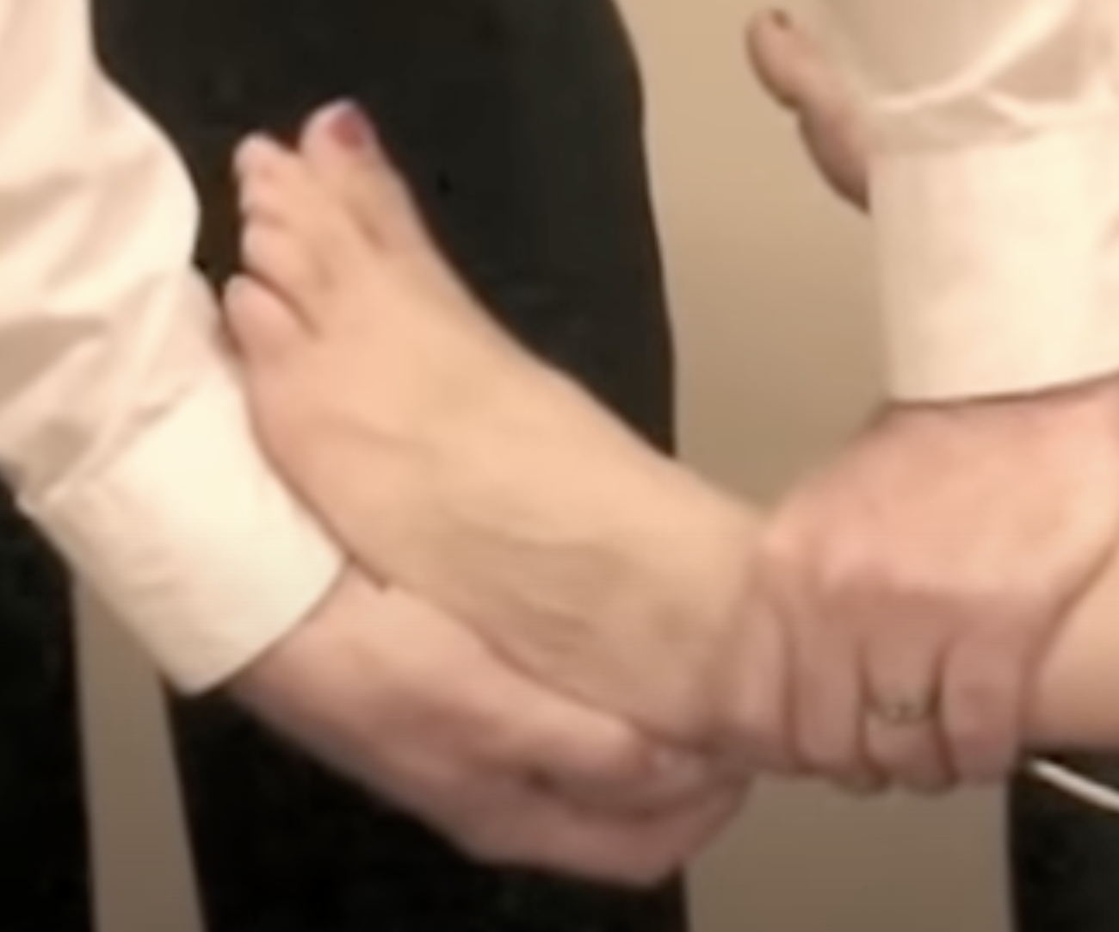
Diagnostics/Labs | Xray- Ottawa Rule  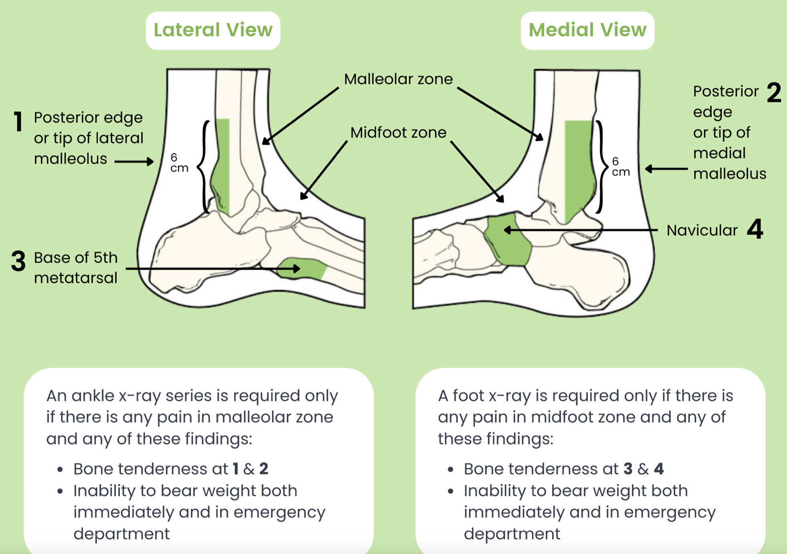
Red flags | CSM compromise
Differential Diagnoses | Fracture, dislocation, infection, strain
Treatment/Management | Rest, ice, compression, elevation; exercises; NSAIDs
Referrals | No resolution in 6 weeks then orthopedic surgeon for sprain
Follow-up | 2 weeks for sprain
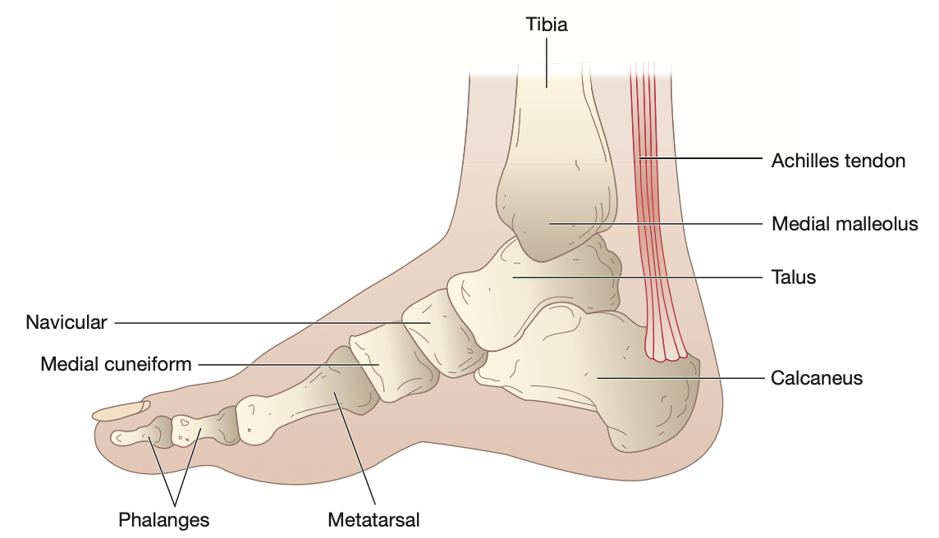
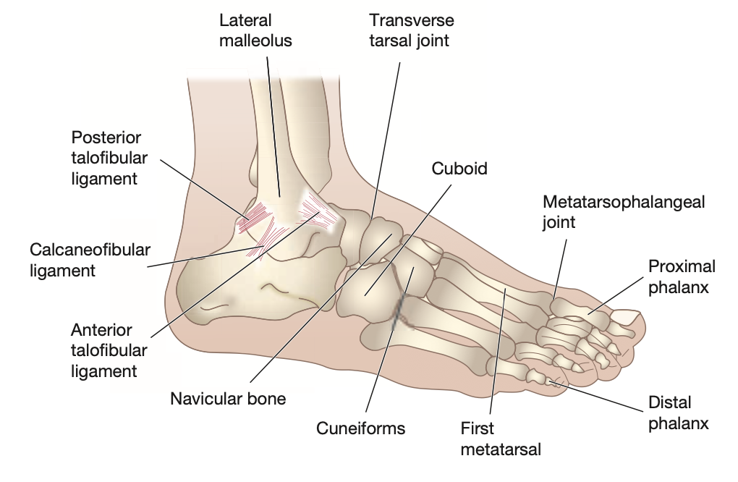

Knee Injury (chondromalacia patellae)
Def’n | Chondromalacia of the patella is a change in patellofemoral joint cartilage
Pathology/Cause | Caused by trauma, anatomic anomalies, misalignment of the patella  Softening of joint cartilage, tufts of patellar cartilage, fissures or ulcers occur
Risk Factors/Epidemiology | Most common in female adolescents  Risks: history of knee, trauma or misalignment, knee pain worse with activity
Clinical Presentation  *Insert picture here* | -Patients present with anterior knee pain that is worse while climbing stairs or biking
Hx/Key Questions | Where is the knee pain? When does your knee hurt? Does your knee hurt climbing stairs?
Physical Exam | -Tenderness to palpation over knee
Diagnostics/Labs | Radiographic studies of the knee including tangential and sunrise views show irregularities of the patellofemoral joint  -four-view radiographs of knee to rule out arthritis
Red flags
Differential Diagnoses | arthritis
Treatment/Management | Treatment:  Counseling/Education:  Non-pharm therapies:
Referrals
Follow-up

Knee Injury (Bursitis)
Def’n | -Prepatellar bursitis: swelling over patella  -Bursitis is inflammation of a sac lined with synovial fluid
Pathology/Cause | -caused by overuse and trauma
Risk Factors/Epidemiology | -most often secondary to traumatic tenosynovitis of the knee
Clinical Presentation  *Insert picture here* | -Inability to kneel due to swelling  -aching pain over knee that can radiate along the leg  -Muscle weakness may be present
Hx/Key Questions | Do you have a history of overuse or trauma of knee? Does it hurt when palpate directly over bursae?
Physical Exam | -palpation directly over bursae causes pain (vs pain over patellar tendon occurs with tendonitis)  -local tenderness and swelling without full ROM
Diagnostics/Labs | -no diagnostic studies for bursitis
Red flags
Differential Diagnoses | Knee tendonitis, knee sprain
Treatment/Management | Treatment:  Counseling/Education:  Non-pharm therapies:
Referrals
Follow-up
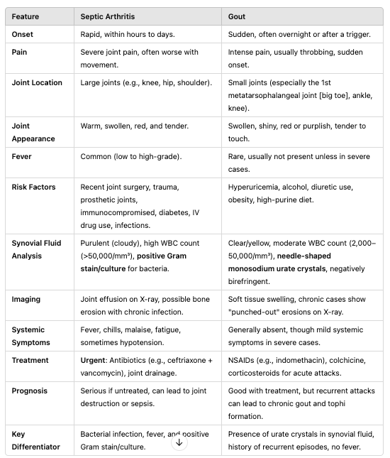

Knee Injury (Patello-Femoral Syndrome) (not in any of the readings)
Def’n | Shin splits  Back  fibro
Pathology/Cause
Risk Factors/Epidemiology
Clinical Presentation

*Insert picture here*
Hx/Key Questions
Physical Exam
Diagnostics/Labs
Red flags
Differential Diagnoses
Treatment/Management | Treatment:  Counseling/Education:  Non-pharm therapies:
Referrals
Follow-up

Evaluation of Patient Presenting With Knee Pain

https://www.aafp.org/pubs/afp/issues/2003/0901/p907.html
History |  | Characteristics of the patients pain:
-onset (rapid or insidious),
-location (anterior, medial, lateral, or posterior knee)
-duration, severity, and quality (e.g., dull, sharp, achy).
-aggravating and alleviating factors.
-if knee pain is caused by an acute injury, the physician needs to know whether the patient was able to continue activity or bear weight after the injury or was forced to cease activities immediately.
 |  | Mechanism of injury:
-ask about specific details of the injury
-did the patient have a direct blow to the knee?
- Ex. anterior force applied to proximal tibia with knee in flexion can cause injury to the posterior cruciate ligament.
- Ex. medial collateral ligament commonly injured as a result of lateral force
-was the foot planted during the time of injury?
-was the patient decelerating or stopping suddenly?
- Can cause a sprain or rupture to ACL
-did they land from a jump?
-was there a twisting component?
- Can cause injury to the meniscus
-did hyperextension occur?
- Can cause injury to ACL or posterior cruciate ligament

 |  | Mechanical symptoms
-Does your knee lock?
- Suggests meniscus tear
-Does your knee have any popping?
- Suggests a ligamentous injury
- Could be a complete rupture of a ligament
-Do you have any giving way of the knee?
- Indicates knee instability can indicate patellar subluxation or ligamentous rupture
 |  | Joint Effusion (timing, amount, recurrence)
-Rapid onset (within two hours) or a large tense effusion
- Suggests rupture of ACL or fracture of tibial plateau
-Slower onset (24 to 36 hours) of a mild effusion
- Suggests a meniscus injury or ligament sprain
-Recurrent knee effusion after activity
- Suggests meniscus injury

Physical Examination |  | Inspection of the knee  Palpation for point tenderness  Assess Joint Effusion  ROM  Evaluation of ligaments for: injury or laxity  Assess menisci
Radiographs |  | Obtain if:  -isolated patellar tenderness  -tenderness at the head of the fibula  -inability to bear weight or flex knee to 90 degrees  -55 years older
Anatomy of the knee |  | 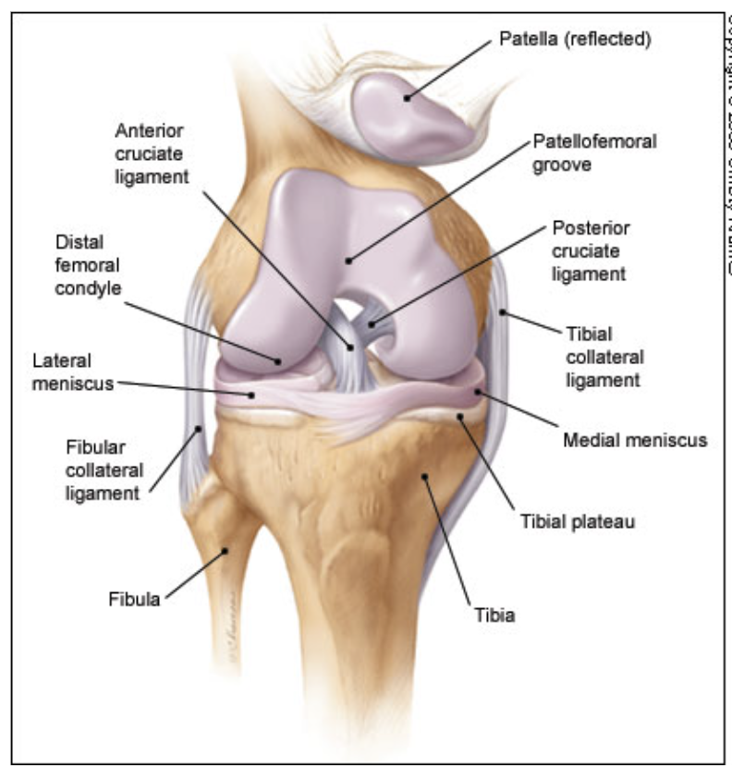

Low Back Pain acute and chronic (lumbosacral strain)
Def’n
Pathology/Cause
Risk Factors/Epidemiology
Clinical Presentation  *Insert picture here* | 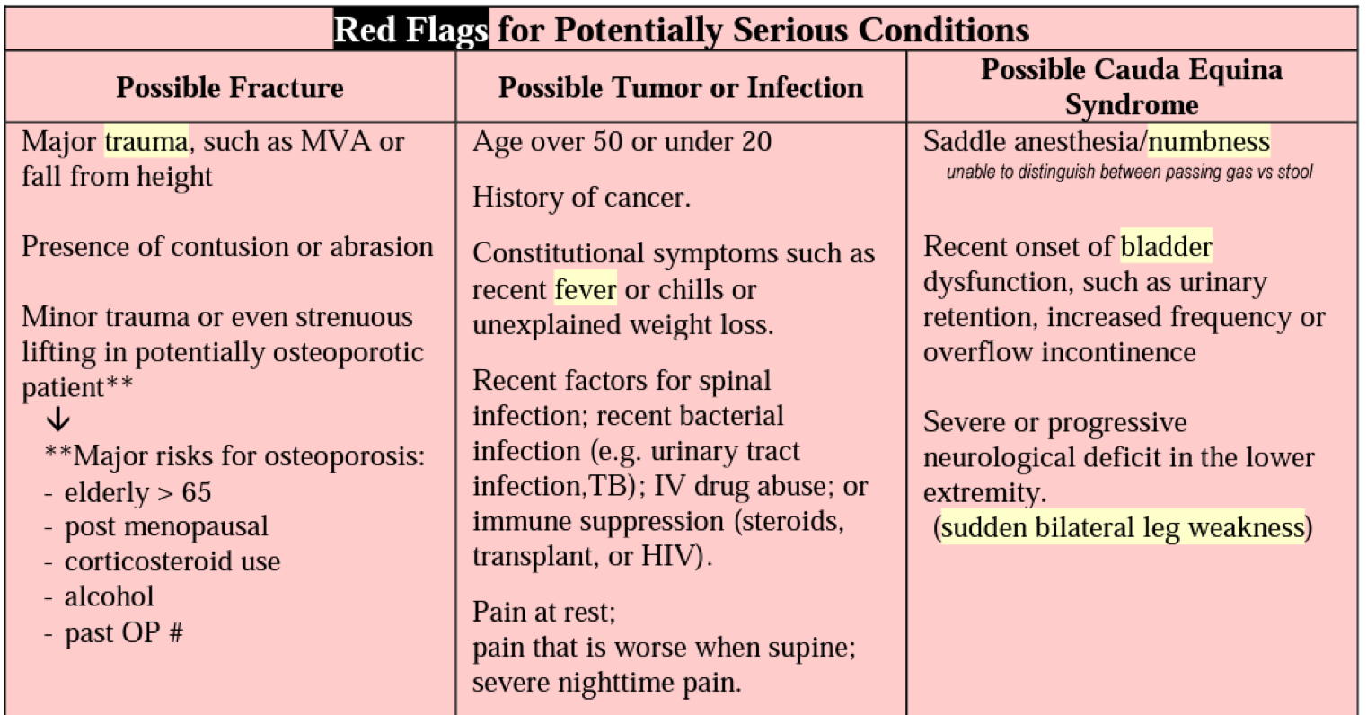  Red Flag Acronym:  N Neurologicak, I: Infection, F: Fracture, T: tumour, I: Inflammation  Clauda equina
Hx/Key Questions
Physical Exam
Diagnostics/Labs
Red flags
Differential Diagnoses | Mri shows shoft tissue (for herniated disc)
Treatment/Management | Treatment:  Counseling/Education:  Non-pharm therapies:
Referrals
Follow-up

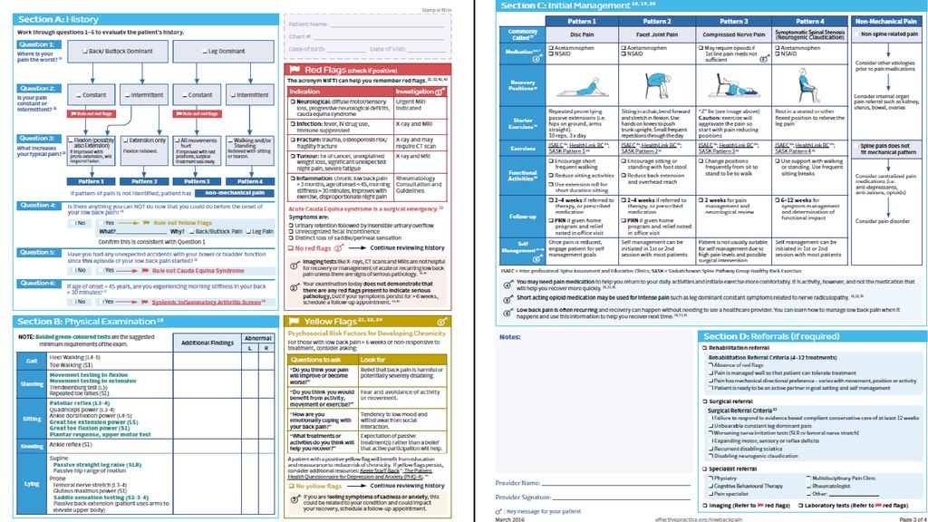

est | Medial Epicondylitis (Golfer's Elbow) | Lateral Epicondylitis (Tennis Elbow)
Description | Inflammation of the tendons on the inner side of the elbow, often due to repetitive wrist flexion and pronation. | Inflammation of the tendons on the outer side of the elbow, often due to repetitive wrist extension and supination.
Pain Location | Pain on the inner side of the elbow (medial epicondyle). | Pain on the outer side of the elbow (lateral epicondyle).
Active Test | Golfer's Elbow Test: Patient flexes the wrist against resistance while the examiner palpates the medial epicondyle. Positive test if pain is reproduced on the inner side of the elbow. | Cozen's Test: Patient makes a fist, extends the wrist, and resists examiner's pressure. Pain on the lateral epicondyle indicates a positive test.
Passive Test | Medial Epicondylitis Stretch Test: Examiner passively extends the wrist while the elbow is extended. Pain in the medial epicondyle suggests medial epicondylitis. | Mill's Test: Examiner extends the elbow and pronates the forearm while flexing the wrist. Pain on the lateral epicondyle is suggestive of lateral epicondylitis.
Special Test | Reverse Cozen's Test: Patient resists extension of the wrist against resistance with the forearm pronated. Positive if pain occurs on the medial epicondyle. | Tennis Elbow Test: Palpate the lateral epicondyle, then ask the patient to extend the wrist or pronate the forearm. Pain reproduction confirms lateral epicondylitis.
Palpation | Tenderness at the medial epicondyle (inner elbow). | Tenderness at the lateral epicondyle (outer elbow).
Diagnostic Imaging | X-ray and MRI can help rule out other conditions but are not typically required for diagnosis. | X-ray and MRI can help rule out other conditions but are not typically required for diagnosis.
Common Activities that Cause Pain | Repetitive gripping, wrist flexion, and pronation activities (e.g., golf, throwing). | Repetitive gripping, wrist extension, and supination activities (e.g., tennis, using hand tools).

PLANTAR FASCIITIS
Short definition/ description | An inflammatory condition of the plantar fascia in the foot causing pain in the arch of the foot, radiating to the heel  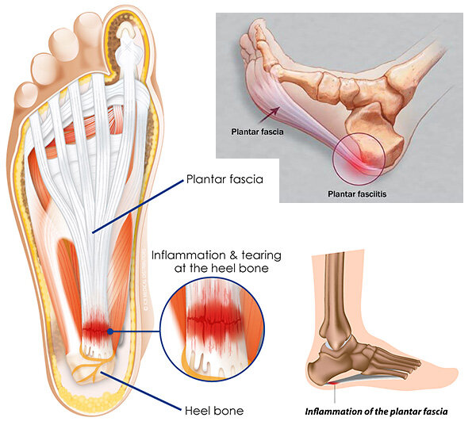
Pathology/cause | - Plantar fascia is connective tissue that runs across the bottom of the foot  - Connects the bottom of the tuberosity of the calcaneus (heel) bone to the heads of the metatarsal bones  Repetitive small tears in the fascia cause collagen breakdown at the medial tubercle of the calcaneus
Epidemiology | The most common cause of heel pain in Canada  - Seen in both men and women; common in middle-aged people
Risk Factors | - Athletes (overuse injury from running)  - Tight or weak muscles/tendons  - Achilles tendon, heel cord, gastrocnemius, soleus  - Poor arch support or improper footwear (poor support in shoes)  - Anatomic abnormalities like low arch support, a flat foot, high arch, tibial torsion, overpronated foot, leg-length discrepancies, forefoot varus, and thinning of the fat pad
Screening
Clinical Presentation  (Subjective Symptoms & Objective Signs) | HALLMARK: severe, stabbing foot pain in the bottom of the foot, especially first thing in the morning  Common findings:  - Burning pain with walking; stiffness in the foot and heel  - Worse in the morning, improves during the day, gets worse again at the end of the day  - Increased foot pain with walking after long periods of standing or sitting  Other signs and symptoms:  - Both heels can be affected; heel spurs may or may not be present  - Pain in the medial tubercle of the calcaneus, medial to the longitudinal arch  - Pain that worsens with prolonged standing
Hx/Key Questions | OPQRST of the pain  - Activities that aggravate pain  - Ask if the pain is radiating into the toes or the leg
Physical Exam | VITALS: pulse and blood pressure (pulse in the affected extremity)  INSPECT: feet bilaterally→ note swelling, discolouration, rash  - Observe gait  AUSCULTATE: heart and lungs  PALPATE: both feet  - Note pain, tenderness (pain will be noted over insertion on medial heel)  *Perform passive dorsiflexion of the toes and ankle; have the client stand on the tips of the toes to see if this elicits the pain
Red Flags
Differential Diagnosis | Generic heel pain; heel spurs; arthritis; stress fracture
Diagnostics:  Labs & Imaging | Diagnostic tests and/or Imaging  - X-ray may be done BUT it is often normal and not needed  - If there are suspected spurs, tumors, or stress fractures, then it would be appropriate  - MRI  - If there is thickening of the proximal plantar fascia or rupture is suspected
Treatment/ Management | Counseling/Education  - Avoid walking on hard surfaces; never go barefoot, even indoors  Complementary Therapies (non-pharmacological)  - Conservative treatment: avoiding long periods of standing for 6-8 weeks  - Proper foot care and support  - Shoe arches (custom orthotics)  - New shoes  - Ice therapy for pain and swelling  Exercises…  - Roll the foot arch over a tennis ball or frozen water bottle for 20-30 minutes each evening to help stretch the plantar fascia  - Calf stretches against a wall, leaning forwards
Medical management | In severe cases→ corticosteroid lidocaine injections to the most tender area  NSAIDs for pain relief
Advise clients when to RTC or call for help | Consider diagnostic workup with MRI if the pain worsens despite treatment
Referrals | Physiotherapy!  Podiatrist if conservative therapy fails after 6 weeks, or if nerve entrapment is suspected
Follow-up | In 4 weeks to evaluate efficacy of treatment; pain should slowly improve with aggressive treatment management  - Must ensure compliance with instructions (can take 6-12 months for full resolution)
Complications | Foot, knee, hip, and back if gait changes to compensate for pain when ambulating
1° and 2° Prevention | Primary prevention: supportive, well-fitting footwear
References | Cash & Glass

LATERAL AND MEDIAL EPICONDYLITIS (the same thing as elbow tendonitis)
Short definition/ description | Lateral Humeral epicondylitis= Tennis elbow (affects supinator muscles); an overuse injury  - The flexor muscles  Medial epicondylitis= golfer’s elbow or thrower’s elbow (affects pronator muscles)  - The flexor muscles  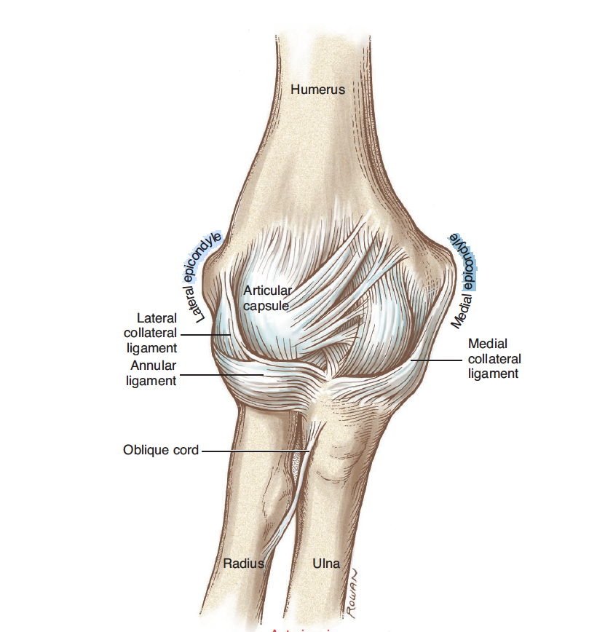  Aseptic inflammation of the bone-tendon junction, resulting from repetitive concentric contractions that transmit force via the muscles to the origin on the epicondyle  - A degenerative condition, not an inflammatory process
Pathology/cause | Medial epicondyle= involvement off the ulnar nerve, and ulnar collateral ligaments  Overall→ a chronic tendinosis, not acute inflammation  - Degenerative changes occur from overuse  4 stages→ generalized inflammation; angiofibroblastic degeneration; structural failure; fibrosis and calcification  - Repetitive microtearing of the tendon at the origin, followed by an unsuccessful healing process
Epidemiology | Lateral epicondylitis is the most common cause of elbow symptoms in patients  - Genders are affected equally  Medial epicondylitis is much less common than lateral epicondylitis (10%)  - Middle aged adults are more likely to be affected
Risk Factors | LATERAL  - Non-athletes with occupations that require repeated contractions of the affected muscle groups  - In lateral epicondylitis→ extensor and supinator muscles  - Athletes who play tennis, bowling, and hockey  - Often precipitated by por body mechanics and technique, improper equipment  MEDIAL  - Smoking, diabetes, obesity  - Repetitive wrist flexion and forearm pronation for 2+ hours per day
Screening
Clinical Presentation  (Subjective Symptoms & Objective Signs) | HALLMARK: pain with palpation to either epicondyle (about 1 cm from the epicondyle itself)  Common findings:  - Gradual onset of pain and tenderness that progresses in intensity  - Supination against resistance causes worsening of the pain  - Elbow movement is not limited with these conditions  - Symptoms that manifest in the patient’s dominant arm  Other signs and symptoms:  - Tenderness of the epicondyle with palpation  - Pain typically subsidies with rest  - Morning exacerbation of the pain is common
Hx/Key Questions | OPQRST of the pain  - Ask about history of repetitive movements  - Patients may report a sudden onset, but recall overuse history without a specific inciting event  - Ask about hobbies, occupations  - Ask about new equipment, or atypical workout circumstances  - Assess for any numbness
Physical Exam | *Common for the elbow to be unremarkable in appearance  VITALS: HR, BP, temp (if indicated)  Inspect: both elbows for redness, swelling, deformities  Palpate: bilateral elbow  - Tenderness with palpation to the affected side  - In lateral→ pain is aggravated by supination  - Resisted extension of the middle finger while elbow is extended is painful because it puts added pressure onto the tendon  - Typically there is an absence of numbness or tingling  - In medial→ pain is aggravated by pronation  - More common to have numbness and tingling due to positioning of the ulnar nerve  - Flex the elbow at 90 degrees to isolate the muscle groups  MEDIAL  - Tinel’s sign  - Milking maneuver  - Valgus stress test
Red Flags
Differential Diagnosis | LATERAL  - Elbow bursitis, cervical radiculopathy, posterolateral elbow plica, radial nerve entrapment, radial tunnel syndrome, fracture, triceps tendonitis, shingles  MEDIAL  - Ulnar neuropathy, cervical neuropathy, ulnar collateral ligament sprain or tear, valgus overload syndrome, synovial plica, synovitis, elbow bursitis, rheumatoid arthritis, shingles, occult fracture
Diagnostics:  Labs & Imaging | Diagnosis is usually made through history and physical alone  Diagnostic tests and/or Imaging  - X-ray if there is suspected calcification of the tendons, osteophytes, or acute or traumatic cause  - May be helpful for assessing growth plates in pediatric patients  MEDIAL  - MRI is the gold standard for diagnosis  - Thickened common flexor sheath  - Ultrasound can be used to detect thickening of the tendon sheath, partial or full thickness tears, and neovascularization
Treatment/ Management | Counseling/Education  - SHORT TERM→ stop offending activities and add pain relievers  - Modify previously offending activities long-term  - Early rehabilitation is KEY  Complementary Therapies (non-pharmacological)  - Ice after activities, use NSAIDs and acetaminophen for pain relief (oral and topical)  - Bracing with a counterforce elbow strap overnight may help some patients  - Kinesiology tape (more evidence for use in lateral epicondylitis)
Medical management | Most case of both types are self-limiting; non-operative management is common  Corticosteroid injections for short-term relief of pain for up to 6 weeks
Referrals | Physiotherapy→ active participation is crucial  Rehab or sports medicine for severe and refractory cases
Follow-up | After a few weeks to evaluate benefit of conservative therapy
Common Complications | With medial epicondylitis, ulnar neuritis can occur  With lateral, common to see recurrence of the injury when normal activity is resumed  - Tendons may rupture with repeated steroid injections
1° and 2° Prevention | Primary prevention: proper technique, and properly fitting equipment for sports activities
References | https://www.ncbi.nlm.nih.gov/books/NBK557869/  https://www.ncbi.nlm.nih.gov/books/NBK431092/

NURSE-MAID’S ELBOW
Short definition/ description | Also known as radial head subluxation  *REMINDER: with subluxation, the heads of the bones are still touching in the joint  - The radial head slips under the annular ligament, resulting in pain and an inability to supinate the forearm
Pathology/cause | Annular ligament holds the radial head against the ulna  - Applying axial traction to a pronated forearm and an extended elbow causes the ligament to slip over the head of the radius and become trapped in the radiohumeral joint
Epidemiology | Common in young children ages 1-4  - Less common in aged 5+ (annular ligament strengthens with age)  - Slightly more common in females, and more common in the left arm  - 20% recurrence rate
Risk Factors | - Being swung by the arms or lifted by the arms  - Falling onto the elbow  - Twisting the forearm  - Rolling over in bed onto the arm (ages <6 mos)
Clinical Presentation  (Subjective Symptoms & Objective Signs) | HALLMARK: children protect the arm by holding it in a complete extended, pronated position  Common findings:  - Typically no pain unless the arm is actively manipulated  - Tenderness at the radial head  - Resistance to pronation, supination, flexion, extension  Other signs and symptoms:  - Not common to see visual signs (redness, swelling, signs of trauma)  - Circulation and movement should be intact distal to the elbow despite potentially uncooperative patient
Hx/Key Questions | Expect to rely heavily on the caregiver  - What happened just prior to the event? Caregivers may not understand the association between seemingly harmless movements and the injury  - Ask about falls
Physical Exam | VITALS: all, as needed  INSPECT:  - Pay attention to how the child is holding the arm  - Don’t expect to see any outward signs of trauma or injury  - Assess the clavicle as well  PALPATION:  - Pain with radial head palpation and all movement of the affected arm  - Assess that cap refill, sensation, and motor function remains intact  - Palpate the entire arm for pain and tenderness
Red Flags
Differential Diagnosis | Elbow fracture, fractured wrist, hand injury, soft tissue damage, greenstick fracture  - Monteggia fracture  - Proximal ⅓ ulna fracture, often associated with radial dislocation  - Supracondylar fracture
Diagnostics:  Labs & Imaging | Diagnosis is typically made on history and physical exam  Laboratory tests  Diagnostic tests and/or Imaging  - May x-ray if fracture, elbow dislocation is suspected OR if there is edema or deformity  - Consider imaging if the injury did not occur with the typically expected traction, or if non-accidental trauma is suspected  - If it a true nursemaid elbow, the radiograph should be normal
Treatment/ Management | Counseling/Education  - Reduction itself is painful, but pain should resolve within a few minutes  Complementary Therapies (non-pharmacological)  - Have the child sit in the parent’s lap for the procedure, with the examiner facing the child
Medical management | Closed reduction in the clinical setting; may spontaneously reduce before being seen
Advise clients when to RTC or call for help | Should come to clinic for reduction as soon as possible. If it spontaneously reduces, child should still be brought in for assessment  - Spontaneous reduction is fine; the joint does not need to be manipulated or corrected in any way if this occurs
Referrals | None required
Follow-up | Monitor for recurrence; can occur in 20% of children
Common Complications | Potential for associated ulnar fracture (Monteggia fracture)
1° and 2° Prevention | Primary prevention: avoid significant pressure, traction, or pulling on the elbow joint in young children
References | https://www.ncbi.nlm.nih.gov/books/NBK430777/

BURSITIS (OF THE ELBOW; OLECRANON)
Short definition/ description | Inflammation of the sac (synovial membrane) lined with synovial fluid; usually secondary to traumatic tenosynovitis of the shoulder or elbow.  - Caused by overuse and trauma  Can be associated with rheumatoid arthritis
Pathology/cause | - Bursae lie over bony prominences to reduce friction from motion of fascial planes  - They are superficial, and have limited vascularity, meaning they are susceptible to trauma and infection
Epidemiology | Most often secondary to trauma; bleeding in the bursa causes inflammatory mediators to be released  - Not associated with mortality; no sex or race predisposition; occurs in children and adults
Risk Factors | - Common in people who engage in contact sports  - Repetitive motion  - Rubbing or placing pressure on the elbow  - Overuse  Associated with inflammatory conditions  - Rheumatoid arthritis  - Psoriatic arthritis  - Gout  Associated with chronic conditions→ diabetes, alcoholism, HIV  *usually transcutaneous route of infection, not hematogenous
Clinical Presentation  (Subjective Symptoms & Objective Signs) | HALLMARK: an aching pain that radiates to the points of tendon insertion or further along the limb, and swelling over the olecranon process  Common findings:  - Muscle weakness  - Tenderness with palpation  - Swelling leading to limited range of motion in the joint (typically normal ROM)  - A round or golf-ball shape due to fluid confinement within the bursa  Other signs and symptoms:  - Erythema, edema  - Septic bursitis may be associated with fever and systemic features
Hx/Key Questions | OPQRST of symptoms  - Ask about occupational habits like leaning on the elbows  - Ask about recurrence  - Ask about systemic symptoms to rule out septic bursitis  - Ask about recent trauma to the area
Physical Exam | VITALS: all, as needed (HR, BP)  INSPECT:  - Examine the skin for intactness  - Penetrating injury can cause septic bursitis  - Patients may stop movements of the elbow due to pain  PALPATE  - Warmth, tenderness
Red Flags
Differential Diagnosis | Gout, rheumatoid arthritis, elbow fracture, tendonitis, acute trauma to the elbow  Cutaneous abscess, hematoma, cellulitis, tendon rupture, neoplasm, ligament rupture
Diagnostics:  Labs & Imaging | Diagnosis is typically made by history and physical alone  Labs  - Consider the risk for septic bursitis, and weight the potential need for aspiration of the bursa (bursal aspiration is the gold standard)  - Fluid could be sent for culture and sensitivity testing  Diagnostic tests and/or Imaging (important in risk for alternative ddx or infection)  - X-ray if there is suspected bone infection
Treatment/ Management | - Counseling/Education  Complementary Therapies (non-pharmacological)  - Conservative management: ice, rest, and NSAIDs  - Elastic bandage application can help reduce swelling  - Corticosteroid injection can help with early reduction in symptoms
Medical management | Aspiration→ 10% risk of persistent symptoms at 6 months  Bursectomy can be considered with repeat symptoms (higher risk with underlying bone spurs)
Referrals | - Refer to orthopedic surgeon for surgical excision or if there is an underlying bone spur
Follow-up | Assess for resolution of symptoms as needed for each patient
Common Complications | Infection and persistence of symptoms if aspiration is performed
References | https://www.ncbi.nlm.nih.gov/books/NBK470291/

FIBROMYALGIA (and associated link)
Short definition/ description | A syndrome of diffuse body pain associated with several secondary symptoms  - Can wax and wane over time
Pathology/cause | Unknown, no associated abnormalities to joints or soft tissue despite pain and tenderness  - Neurophysiological changes are present  - Abnormalities in pain processing at nervous system level  - Altered HPA axis stress response  - Abnormalities of peripheral sensitization
Epidemiology | 2-3% prevalence in Canada, 6-9x more likely to occur in females than males  - Common in middle-aged women (age 30-50), but also seen in children, teenagers, and elderly  In the elderly, can be associated with more significant pain due to osteoarthritis and other concurrent conditions
Risk Factors | - Female  - Middle age  - Previous infectious illness (viral), trauma, or psychological stressful event can lead to a vulnerable health status, triggering FM  - Genetics (offspring of FM women)  - Early life psychosocial stress  - Depression
Clinical Presentation  (Subjective Symptoms & Objective Signs) | HALLMARK: fatigue, nonrestorative sleep, cognitive dysfunction, mood disorder, and variable somatic symptoms  Common findings:  - Symptoms occur for years prior to diagnosis  - Morning stiffness, pain that worsens with stress, sensitivity to touch, light, sound  - Numbness, swelling, hyperemia of skin, Reynauld’s phenomenon, IBS, bladder symptoms, headaches, restless leg syndrome  The symptom complex  - Pain- the primary complaint; present for at least 3 months  - Usually an insidious onset, beginning in a localized area, initially intermittent, and then becoming progressively more persistent  - Felt in muscle or joint areas in the absence of actual abnormality  - May have a burning quality  - Symptoms may increase with cold and humid weather  - Pressure induced pain  - Fatigue→ may be more disabling than pain  - Nonrestorative sleep→ disturbances, fragmented, sleep apnea, restless leg  - Cognitive dysfunction→ poor memory, free recall, and verbal fluency  - Mood disorder→ depression, anxiety (75%)  - Somatic symptoms  - Sexual dysfunction, symptom severity linked to cigarette smoking
Hx/Key Questions | OPQRST of symptoms  - Ask about length of symptoms experienced (3 months for diagnosis)  - Ask about impact on quality of life  - Ask about family history of FM or rheumatoid disease  - Ask about sleep quality, history of stressors, depression  - Ask about previous diagnoses of chronic fatigue, Lyme disease, thyroid disease
Physical Exam | Typically, the physical exam is within normal limits  VITALS  INSPECT  - Overall appearance  - Assess nails, skin, mucous membranes, eyes, joints, spine  - If there is clubbing and limited tenderness, consider hypertrophic osteoarthropathy  Auscultate heart and lungs  PALPATION  - General tenderness of the soft tissues is reported  - A specific tender point is not required for a diagnosis  - Sensitivity to light touch can occur without other neurological findings  MSK  - Palpate the muscles with sufficient pressure  - Focus on back, neck, jaw, shoulders, chest, abdomen, arms, hips, and legs  - Look for a positive pain reaction; client telling you that palpation causes pain (tenderness is different!)  NEUROLOGICAL  The tender point examination…  - Previously required 11 of 18 tender points to be present in designated areas  - Indicated a reduction in pain threshold without underlying pathology  - Most commonly done by digital examination  - Eliminated in the new criteria for diagnosis of FM  *Do manual palpation of the soft tissues for general tenderness, but there is no required specific tender point examination for diagnosis
Red Flags
Differential Diagnosis | Hypothyroidism, arthritis, polymyalgia rheumatica, myopathy, MS, systemic lupus erythematosus, depression, Lyme disease, hepatitis C, HIV, medication use (statins, aromatase inhibitors, bisphosphonates)
Diagnostics:  Labs & Imaging | Diagnose based on clinical evaluation including history of complaints, past health status, and physical exam. (FM IS NOT A DIAGNOSIS OF EXCLUSION)  - Diffuse body pain present over at least 3 months, with other associated symptoms that cannot be explained by another illness  Laboratory tests  - There is no confirmatory lab test  - Limit lab testing to CBC, ESR, CRP, TSH, and creatine kinase  - This should effectively rule out the other common disorders that may present similarly to FM  - Vitamin D and ANA testing is not indicative of pain levels or future connective disease  - Screening should be driven by clinical findings only
Treatment/ Management | Counseling/Education  - There is no gold standard of treatment  - Self-efficacy and adherence to treatment will influence a favourable outcome  Complementary Therapies (non-pharmacological)  - Exercise, education, CBT (at least one educational or psychological therapy and at least one exercise therapy)  - Good social supports to promote healthy lifestyle practices
Medical management | There is no cure for FM; treat to reduce symptoms  Ideal management→ pain and symptom control  Alternative medicines→ acupuncture, Chinese herbal medicine for pain relief, chiropractic care, hydrotherapy  Pharmacological→ optimal treatment is likely a combination  - Analgesics (acetaminophen) and TCAs  - If there is moderate to severe pain, can consider a trial of a weak opioid like tramadol if the patient is unresponsive to other treatments  - If there is sleep disturbance, consider a trial of a cannabinoid product  - Consider antidepressants, gabapentinoids, dopaminergic agents, sleep modifiers  WSIB FORMS***
Referrals | Encouraging more diagnosis and management in primary care, less referral to specialists  - Specialist referral is not required for a diagnosis  Consider involving a psychiatrist for depression in patients
Follow-up | Any treatment regimen requires follow-up for repeated re-evaluation and assessment of side effects (more frequent visits with treatment initiation)  - Consider every 2-4 weeks
References | https://fmguidelines.ca/?page_id=21  Cash & Glass

KNEE STRAINS AND SPRAINS
Short definition/ description | Strain= tendon or muscle involvement  Sprain= ligament stretch or partial tear from forceful stress on the joint  Grade 1→microscopic tears without ligament tearing or joint instability  Grade 2→ partial tearing of the involved ligaments and laxity of the joint with moderate function loss  Grade 3→ ligament tearing with severe function loss and joint instability
Pathology/  cause | A sudden stress to a supporting ligament causes stretching or tearing; usually from a jumping, falling, or rotating of the joint  - Knee sprains most commonly affect the patellofemoral joint
Epidemiology | SPRAINS= Among the 10 most common causes of occupational injury and worker compensation claims
Risk Factors | Previous injury to the joint  Athletic activities  Patellofemoral instability  Gait and falls
Screening | Knee ligament tears usually do not tear in prepubertal or peripubertal clients. The growth plate may open on one side (should always check for fracture of the growth plate in this population with a radiograph)
Clinical Presentation  (Subjective Symptoms & Objective Signs) | HALLMARK: patient reports a twisting of the knee  Common findings:  - Swelling, pain, weakness of the joint from a specific event  Other:  - First degree sprain= minimal pain, occurs with stress, minimal swelling and tenderness, unimpaired weight bearing or walking, internal microdamage  - Second degree sprain= moderate pain with rOM, swelling, tenderness, trouble walking or weight bearing  - Third degree sprain= severe pain especially with passive movements, severe swelling and tenderness, decreased ROM, intolerant to weight bear, joint instability, discoloured skin, complete rupture may occur
Hx/Key Questions | OPQRST of the pain  - History of trauma  - Ask the client to describe the injurious event in detail  - Are the symptoms acute or chronic?  - Ask about any popping, clicking, locking, recurrent swelling, or giving way of the joint  - Ask if there is pain in other associated areas  - Determine history of the injury and previous assessments or treatments  - Assess ability to weight bear and ROM tolerated
Physical Exam | VITALS: temp, pulse, respirations, BP  INSPECT:  - Observe ambulation, inspect for swelling and overall appearance (compare to other side)  PALPATE:  - For tenderness, ROM, assess above and below the joint  - Do both active and passive ROM and against resistance  - Check for catching or locking of the knee with extension  - Assess neurovascular status of the knee and distal to the affected joint  Palpate for tenderness on the medial and lateral joint line  anterior/posterior drawer  Varus and vulgaris  - McMurray’s Test→ detects a torn meniscus  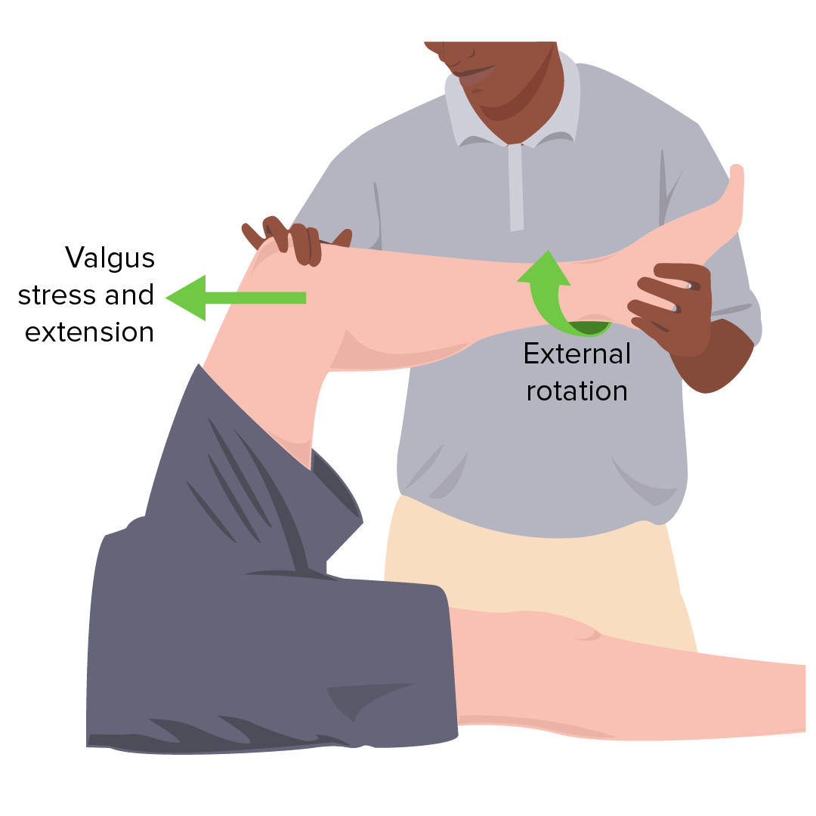
Red Flags | Meniscus tear= locking of the knee with flexion and knee gives way  Collateral ligament tear= pain at the lateral and medial sites  Anterior cruciate tear= popping sound at the injury site and immediate swelling  Posterior cruciate ligament= pain in interior knee  Patellofemoral syndrome= popping or snapping, pain under the patella with motion, and pain with using stairs and hills  Tendinitis= pain over the patellar tendon  Prepatellar bursitis= swelling over the patella with an inability to kneel due to swelling  Nonspecific effusions= effusion worse with exercise
Differential Diagnosis | Fracture, dislocation, septic arthritis, infected bursitis, inflammation, tumor, meniscus tear (and any of the above red flag conditions described), nonspecific knee pain
Diagnostics:  Labs & Imaging | Diagnostic tests and/or Imaging  - Radiograph if fracture is suspected (use Ottawa knee rule)  - MRI if there is effusion and mechanical symptoms  - Bone scans, CT scans as needed if clients fail to respond to treatment after 6-12 weeks of therapy
Treatment/ Management | Counseling/Education  Complementary Therapies (non-pharmacological)  - Follow RICE (rest, ice, compression, elevation) for grade 1-2  - Exercise program to prevent stiffness, restore function, improve ROM, and restore normal flexibility and strength
Medical management | NSAIDs for pain and inflammation (ibuprofen, ASA, indomethacin)  MEthylprednisolone acetate injections for symptoms that persist after 6-8 weeks
Referrals | When to refer…  - If fracture is suspected  - For physiotherapy as needed  - To orthopedic surgeon if therapy is unproductive and symptoms do not regress in 6 weeks
Follow-up | Initial f/u after 2 weeks to evaluate efficacy of current therapy (sooner is better too!)
Common Complications
References | Cash & Glass

KNEE FRACTURES
Short definition/ description | A break in the patella bone  Diffuse swelling around the injured bone soon after the injury occurred. Deformity may or may not be present.
Pathology  /cause | Almost always caused by a direct blow to the knee (e.g., falling, car accident)  Sudden contractions of the quadriceps that cause the tendon to pull on the kneecap and break it apart
Epidemiology | Accounts for about 1% of fractures
Risk Factors | - Falling on a hard surface  - Contact sports with balls, bats, and sticks  - Car accidents  - Gunshot wounds
Screening | In children→ patellar sleeve fracture: ages 8-12; the bony part of the patella is pulled out of its cartilage sleeve (not a broken bone, not actually a fracture, but treated similarly)
Clinical Presentation  (Subjective Symptoms & Objective Signs) | HALLMARK:  Common findings:  - Rapid onset of effusion that is large and tense within 2 hours  - Pain, bruising, swelling that is severe  Other signs and symptoms:  - Unable to hold the knee straight or bend it  - Inability to weight bear
Hx/Key Questions | OPQRST of the pain  - History of trauma  - Ask the client to describe the injurious event in detail  - Are the symptoms acute or chronic?  - Ask about any popping, clicking, locking, recurrent swelling, or giving way of the joint  - Ask if there is pain in other associated areas  - Determine history of the injury and previous assessments or treatments  - Assess ability to weight bear and ROM tolerated
Physical Exam | INSPECT AND PALPATE  - Compare the painful knee to the asymptomatic knee  - Look for pain, swelling,redness, discoloration and bruising, deformity  - Musculature should be symmetrical bilaterally  - Evaluate the vastus medialis obliquus muscle of the quadriceps for atrophy  - Palpate the knee  - Check for tenderness at the patella, the tibial tubercle, the patellar tendon, the quadriceps tendon, the anterolateral and anteromedial joining, medial joint line, and lateral joint line  - Assess ROM  - Extend and flex the knee as far as possible  *Normal range of motion is extension to 0 degrees, and flexion to about 135 degrees
Diagnostic/  Special Tests | Evaluate for effusion:  - Milk to suprapatellar pouch when the patient is lying flat  Patellofemoral tracking:  - Assess for smooth motion while the patient contracts the quadriceps muscle  - Note any crepitus  Assess the Q-angle:  - Draw one line from the anterior superior iliac spine through the centre of the patella, through the tibial tuberosity  - >15 degrees is a predisposing factor for subluxation  Patellar apprehension test:  - Attempting to sublux the patella laterally  - If there is pain, it is indicative of patellar subluxation
Red Flags
Differential Diagnosis | Fracture, dislocation, septic arthritis, infected bursitis, inflammation, tumor, nonspecific knee pain
Diagnostics:  Labs & Imaging | Labs  - If there is warmth, exquisite tenderness, painful effusion, and marked pain with even slight ROM, consider septic arthritis or acute inflammatory arthropathy  - CBCD, ESR  - Arthrocentesis→ measure glucose, protein, bacterial culture, crystals  Diagnostic tests and/or Imaging  - If doing an x-ray, 3 views are sufficient  - Anteroposterior view, lateral view, and Merchant’s view (assesses the patellofemoral joint)  - Add notch or tunnel view in teenage patients with chronic knee pain or recurrent effusion  - Do the posterolateral view with the knee 40-50 degrees flexed to detect radiolucencies of the femoral condyles that would indicate osteochondritis dessicans
Treatment/ Management | Counseling/Education  - Rehab can be months long  Complementary Therapies (non-pharmacological)  - Rehab to improve ROM, build muscle strength, decrease stiffness
Medical management | Cast or splint, reduce or prevent weight bearing, pain medication, walking aids  Surgery if needed for severe fractures
Referrals | To surgeon if required for complex fractures  To physio for rehab
Follow-up | After 1-2 weeks with initial therapy, and as needed based on patient condition
Common Complications | Often also associated with tendon and ligament injuries  Continued pain and reduced ROM; post-traumatic arthritis, muscle atrophy,
References | Dains et al  https://www.hopkinsmedicine.org/health/conditions-and-diseases/kneecap-fractures

KNEE LIGAMENT INJURIES
Short definition/ description | 4 main ligaments  - ACL  - Centre of the knee  - Controls rotation and forward movement of the tibia  - PCL  - Back of the knee  - Controls backward movement of the tibia  - MCL  - Gives the inner knee stability  - LCL  - Gives the outer knee stability
Pathology/ cause
Epidemiology | ACL is one of the most common ligaments to be injured  - Can be stretched or torn with twisting, contact sports
Risk Factors | Anterior force applied to the proximal tibia with the knee in flexion can cause injury to the posterior cruciate ligament (e.g., car accident)  Direct lateral force to the knee causes injury to the medial collateral ligament  - Creates a valgus load on the knee joint and results in rupture  Medial force would injure the lateral collateral ligament  Quick stops and sharp turns, hyperextension→ sprain or rupture of the anterior cruciate ligament
Red Flags | Hemarthrosis with joint arthrocentesis may indicate a tear of the ACL, a fracture or an acute tear of the meniscus. Osteochondral fracture will also have fat globules present
Clinical Presentation  (Subjective Symptoms & Objective Signs) | HALLMARK: a popping sound, followed by the leg bucking with attempt to stand (maybe no pain)  Common findings:  - Slower onset of effusion over 24-36 hours  - Other signs and symptoms:
Hx/Key Questions | A popping sensation at the time of the injury suggests this type of injury  OPQRST of the pain  - History of trauma  - Ask the client to describe the injurious event in detail  - Are the symptoms acute or chronic?  - Ask about any popping, clicking, locking, recurrent swelling, or giving way of the joint  - Ask if there is pain in other associated areas  - Determine history of the injury and previous assessments or treatments  - Assess ability to weight bear and ROM tolerated
Physical Exam | INSPECT AND PALPATE  - Compare the painful knee to the asymptomatic knee  - Look for pain, swelling,redness, discoloration and bruising, deformity  - Musculature should be symmetrical bilaterally  - Evaluate the vastus medialis obliquus muscle of the quadriceps for atrophy  - Palpate the knee  - Check for tenderness at the patella, the tibial tubercle, the patellar tendon, the quadriceps tendon, the anterolateral and anteromedial joining, medial joint line, and lateral joint line  - Assess ROM  - Extend and flex the knee as far as possible  *Normal range of motion is extension to 0 degrees, and flexion to about 135 degrees
Diagnostic/  Special Tests | Evaluate for effusion:  - Milk to suprapatellar pouch when the patient is lying flat  Patellofemoral tracking:  - Assess for smooth motion while the patient contracts the quadriceps muscle  - Note any crepitus  Assess the Q-angle:  - Draw one line from the anterior superior iliac spine through the centre of the patella, through the tibial tuberosity  - >15 degrees is a predisposing factor for subluxation  Patellar apprehension test:  - Attempting to sublux the patella laterally  - If there is pain, it is indicative of patellar subluxation
Cruciate Ligament Tests | ACL/Anterior Cruciate Ligament→ the anterior drawer test  - Patient is supine, knee is flexed to 90 degrees  - Assessing for anterior displlacement of the tibia  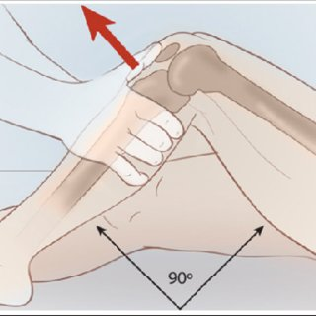  ACL/Anterior Cruciate Ligament→Lachman’s Test  - Patient is supine, knee is flexed 30 degrees  - Assessing for a lack of a clear end point  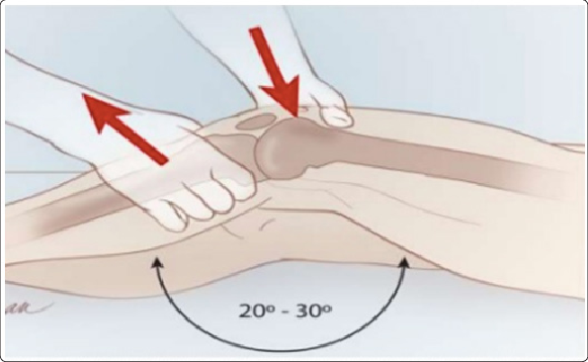  PCL/Posterior Cruciate Ligament→ Posterior drawer test  - Patient is supine with the knee flexed to 90 degrees  - Assessing for posterior displacement of the tibia  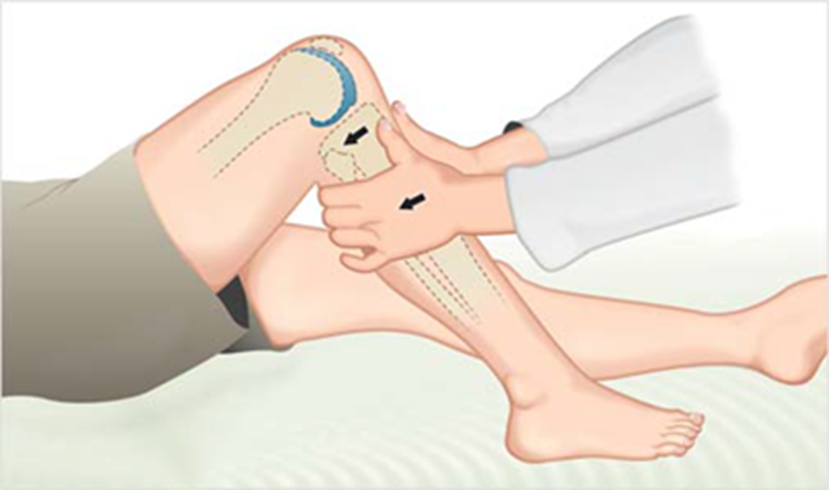
Collateral Ligaments | Medial collateral ligament→ Valgus stress test  - Apply at both 0 and 30 degrees  - Assesses laxity of the MCL  Lateral collateral ligament→ varus stress test  - Apply at 0 and 30 degrees  - A firm endpoint indicates that the LCL is intact, but an absent endpoint indicates complete rupture of the ligament  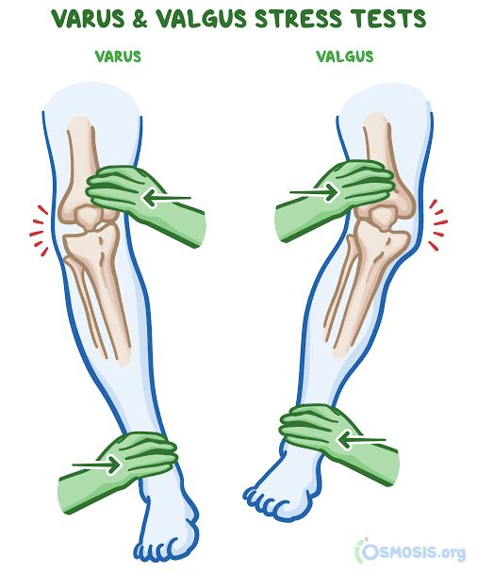
Differential Diagnosis | Fracture, dislocation, septic arthritis, infected bursitis, inflammation, tumor, nonspecific knee pain
Diagnostics:  Labs & Imaging | Labs  - If there is warmth, exquisite tenderness, painful effusion, and marked pain with even slight ROM, consider septic arthritis or acute inflammatory arthropathy  - CBCD, ESR  - Arthrocentesis→ measure glucose, protein, bacterial culture, crystals  Diagnostic tests and/or Imaging  - If doing an x-ray, 3 views are sufficient  - Anteroposterior view, lateral view, and Merchant’s view (assesses the patellofemoral joint)  - Add notch or tunnel view in teenage patients with chronic knee pain or recurrent effusion  - Do the posterolateral view with the knee 40-50 degrees flexed to detect radiolucencies of the femoral condyles that would indicate osteochondritis dessicans
Treatment/ Management | - Counseling/Education  - Complementary Therapies (non-pharmacological)
Medical management
Advise clients when to RTC or call for help
Referrals
Follow-up
Common Complications
1° and 2° Prevention | Primary prevention
References | Dains et al  https://www.hopkinsmedicine.org/health/conditions-and-diseases/ligament-injuries-to-the-knee

KNEE MENISCUS INJURIES
Short definition/ description | Meniscus= two rubbery discs that help to cushion the knee  - Wedge-shaped pieces of fibrocartilage located between the femur and the tibia
Pathology/cause | 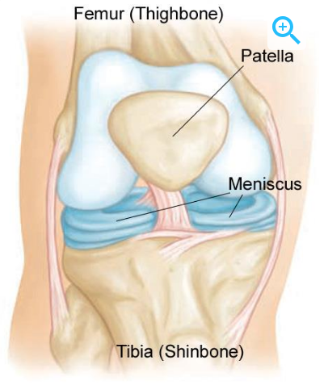  Patient experiences a sudden twisting  A chronic, unstable meniscal tear may present as frequent locking of the knee, and manipulating that induces the unlocking  Tearing can be acute or from degenerative changes over time
Epidemiology
Risk Factors | Athletes who play contact sports  Age
Screening | Perform the McMurray test  - A positive test causes a click or thud, pain in a reproducible portion of the ROM
Clinical Presentation  (Subjective Symptoms & Objective Signs) | HALLMARK: tenderness at the joint line  Common findings:  - Slower onset of effusion over 24-36 hours  - Recurrent knee effusion after activity  Other signs and symptoms:  - An inability to straighten or bend the knee  - Most people are still able to walk
Hx/Key Questions | A history of locking episodes suggests a meniscus tear; a tearing sound, a sudden twisting  OPQRST of the pain  - History of trauma  - Ask the client to describe the injurious event in detail  - Are the symptoms acute or chronic?  - Ask about any popping, clicking, locking, recurrent swelling, or giving way of the joint  - Ask if there is pain in other associated areas  - Determine history of the injury and previous assessments or treatments  - Assess ability to weight bear and ROM tolerated
Physical Exam | INSPECT AND PALPATE  - Compare the painful knee to the asymptomatic knee  - Look for pain, swelling,redness, discoloration and bruising, deformity  - Musculature should be symmetrical bilaterally  - Evaluate the vastus medialis obliquus muscle of the quadriceps for atrophy  - Palpate the knee  - Check for tenderness at the patella, the tibial tubercle, the patellar tendon, the quadriceps tendon, the anterolateral and anteromedial joining, medial joint line, and lateral joint line  - Assess ROM  - Extend and flex the knee as far as possible  *Normal range of motion is extension to 0 degrees, and flexion to about 135 degrees
Diagnostic/  Special Tests | Evaluate for effusion:  - Milk to suprapatellar pouch when the patient is lying flat  Patellofemoral tracking:  - Assess for smooth motion while the patient contracts the quadriceps muscle  - Note any crepitus  Assess the Q-angle:  - Draw one line from the anterior superior iliac spine through the centre of the patella, through the tibial tuberosity  - >15 degrees is a predisposing factor for subluxation  Patellar apprehension test:  - Attempting to sublux the patella laterally  - If there is pain, it is indicative of patellar subluxation
Red Flags | Hemarthrosis with joint arthrocentesis may indicate a tear of the ACL, a fracture or an acute tear of the meniscus. Osteochondral fracture will also have fat globules present
Differential Diagnosis | Fracture, dislocation, septic arthritis, infected bursitis, inflammation, tumor, nonspecific knee pain
Diagnostics:  Labs & Imaging | Labs  - If there is warmth, exquisite tenderness, painful effusion, and marked pain with even slight ROM, consider septic arthritis or acute inflammatory arthropathy  - CBCD, ESR  - Arthrocentesis→ measure glucose, protein, bacterial culture, crystals  Diagnostic tests and/or Imaging  - If doing an x-ray, 3 views are sufficient  - Anteroposterior view, lateral view, and Merchant’s view (assesses the patellofemoral joint)  - Add notch or tunnel view in teenage patients with chronic knee pain or recurrent effusion  - Do the posterolateral view with the knee 40-50 degrees flexed to detect radiolucencies of the femoral condyles that would indicate osteochondritis dessicans
Treatment/ Management | Counseling/Education  Complementary Therapies (non-pharmacological)  - RICE (rest, ice, compression, elevation)
Medical management | Tears to the red zone (the outer ⅓) may heal on their own due to a rich blood supply  - E.g., a longitudinal tear  Inner ⅔ is harder to heal, less blood supply  NSAIDs for pain and inflammation (ibuprofen, ASA, indomethacin)  Methylprednisolone acetate injections for symptoms that persist after 6-8 weeks
Referrals | To orthopedic surgeon for knee arthroscopy if needed
Follow-up
Common Complications | Most patients with knee pain have soft tissue injuries (generally radiographs are not indicted)
1° and 2° Prevention | Primary prevention
References | Dains et al  https://orthoinfo.aaos.org/en/diseases--conditions/meniscus-tears/

PATELLAR SUBLUXATION/DISLOCATION
Short definition/ description | Also called patellar instability  The patella moves outside the groove at the end of the femur  Types…  - Traumatic patellar dislocation  - This is most often the result of an injury to the knee.  - The patella gets pushed completely out of the groove.  - Chronic patellar instability (subluxation)  - Kneecap usually only slides partly out of the groove.  - Acute= the first time dislocation  - Recurrent
Pathology/cause | Caused by rapid deceleration and twisting, traumatic events like falling
Epidemiology | Represents about 3% of knee injuries; leading cause of knee hemarthrosis
Risk Factors | Dislocation is more common in 20-30s  - Obesity  - Female  - Athletes  - Under 16 (risk for recurrence)
Screening
Clinical Presentation  (Subjective Symptoms & Objective Signs) | HALLMARK: pain, swelling, stiffness, difficulty walking, buckling or catching of the knee  Common findings:  - Inability to stretch or bend the knee  - Notable deformity of the knee  - Patient reports a sensation of the kneecap having shifted  Other signs and symptoms:  - If it is chronic, pain will be less severe  - Pain complaints under the kneecap, especially during activities that involve deep knee bending
Hx/Key Questions | A history of the knee giving way or being unstable overall  OPQRST of the pain  - History of trauma  - Ask the client to describe the injurious event in detail  - Are the symptoms acute or chronic?  - Ask about any popping, clicking, locking, recurrent swelling, or giving way of the joint  - Ask if there is pain in other associated areas  - Determine history of the injury and previous assessments or treatments  - Assess ability to weight bear and ROM tolerated  Was the foot planted at the time, was there a direct blow to the knee, was there a rapid deceleration, a jump, or a twisting component?
Physical Exam | INSPECT AND PALPATE  - Compare the painful knee to the asymptomatic knee  - Look for pain, swelling,redness, discoloration and bruising, deformity  - Musculature should be symmetrical bilaterally  - Evaluate the vastus medialis obliquus muscle of the quadriceps for atrophy  - Palpate the knee  - Check for tenderness at the patella, the tibial tubercle, the patellar tendon, the quadriceps tendon, the anterolateral and anteromedial joining, medial joint line, and lateral joint line  - Assess ROM  - Extend and flex the knee as far as possible  *Normal range of motion is extension to 0 degrees, and flexion to about 135 degrees
Diagnostic/  Special Tests | Evaluate for effusion:  - Milk to suprapatellar pouch when the patient is lying flat  Patellofemoral tracking:  - Assess for smooth motion while the patient contracts the quadriceps muscle  - Note any crepitus  Assess the Q-angle:  - Draw one line from the anterior superior iliac spine through the centre of the patella, through the tibial tuberosity  - >15 degrees is a predisposing factor for subluxation  Patellar apprehension test:  - Attempting to sublux the patella laterally  - If there is pain, it is indicative of patellar subluxation
Red Flags | Direct blow= serious injury  Hemarthrosis with joint arthrocentesis may indicate a tear of the ACL, a fracture or an acute tear of the meniscus. Osteochondral fracture will also have fat globules present
Ddx | Fracture, dislocation, septic arthritis, infected bursitis, inflammation, tumor, nonspecific knee pain
Diagnostics:  Labs & Imaging | Labs  - If there is warmth, exquisite tenderness, painful effusion, and marked pain with even slight ROM, consider septic arthritis or acute inflammatory arthropathy  - CBCD, ESR  - Arthrocentesis→ measure glucose, protein, bacterial culture, crystals  Diagnostic tests and/or Imaging  - If doing an x-ray, 3 views are sufficient  - Anteroposterior view, lateral view, and Merchant’s view (assesses the patellofemoral joint)  - Add notch or tunnel view in teenage patients with chronic knee pain or recurrent effusion  - Do the posterolateral view with the knee 40-50 degrees flexed to detect radiolucencies of the femoral condyles that would indicate osteochondritis dessicans
Treatment/ Management | Counseling/Education  Complementary Therapies (non-pharmacological)  - If it is the first time  - RICE  - Physical therapy to strengthen the muscles
Medical management | Reduction in the ED; it may reduce spontaneously  Surgery if the cartilage is knocked loose and sits in the knee (loose body)  - More likely to require surgery with repeated dislocations or chronic instability  - Would require removal or repair  - May also be associated with ruptured ligaments that require repair
Referrals | Physio; surgeon
Follow-up
Common Complications | Arthritis, arthrofibrosis, osteonecrosis, infection, recurrence
1° and 2° Prevention | Primary prevention
References | Dains et al  https://www.hopkinsmedicine.org/health/conditions-and-diseases/patellar-instability  https://www.ncbi.nlm.nih.gov/books/NBK482427/#:~:text=The%20most%20common%20occurrences%20involve,to%20a%20partially%20flexed%20knee.

MSK Questions
- Where does it hurt? Can you point to the location with one finger? (This is a big clue if they can because it points towards a more focal point of injury, whereas, if the client indicates the source of pain with their whole hand it points to a more generalized source of pain such as inflammation).
- What are the aggravating and alleviating factors?
- How long has this been bothering you? (acute vs. chronic)
- Is there any radiation of the pain?
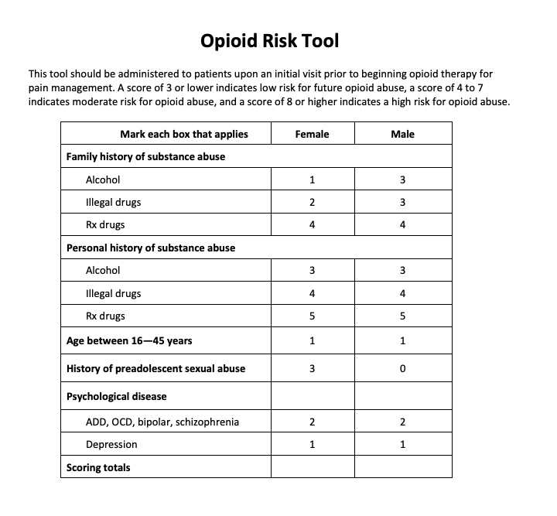
- Is there any past history of a similar injury? How was it treated? Did the treatment work?
- What was the mechanism of injury? (Going through exactly how the injury occurred will help pinpoint the possible diagnosis).
- Is there any weakness or loss of function?
- Is there any numbness or tingling (suggests nerve compression)?
- Is the pain worse with movement in the a.m. (suggesting an inflammatory condition)?
- Is the pain worse with activity (suggest an injury or degenerative condition)?
- Does the pain wake the client in the night or prevent sleep (this may suggest a neoplasm or severe arthritis).
- Is there a deformity? How long has it been there?
- What do you do for a living? Hobby? (are the symptoms interfering with normal activities)
- How distressful is this disorder for you on a daily basis?
- Is this a work related problem? Will insurance companies be involved in your care?
- Always assess opioid risk.

CT Indications
Order "With" OR "Without" Contrast, Not Both:
  - For most CT exams, you should either order contrast "with" or "without" …not both.
  - Combining both contrasts (referred to as a "with and without" protocol) increases radiation exposure and usually doesn't add diagnostic value unless there is a specific clinical indication.

When to Order "With and Without" Contrast:
- Hematuria to help evaluate the source of bleeding.
- Known masses/lesions in the liver, kidneys, or pancreas to better characterize tumors or other abnormalities.
- Acute jaundice with symptoms like abdominal pain, fever, or known gallstones to evaluate the cause of the jaundice.

When to Order "With Oral Contrast":
- CT of the abdomen and pelvis generally requires oral contrast (except for CT stone studies and CT angiography). Oral contrast helps outline the gastrointestinal tract for better visualization of structures in the abdomen and pelvis.

When to Order "With IV Contrast":
CT scans should usually be ordered with IV contrast for the following conditions:
- Abdominal pain — to help identify the cause (e.g., inflammation, infection).
- Pancreatitis — to assess pancreatic damage or complications.
- Painless jaundice — often indicative of biliary obstruction or cancer.
- Abdominal mass — to evaluate the nature of the mass (benign vs. malignant).
- Small bowel obstruction — IV contrast helps visualize the bowel and any obstructions.
- Staging of colorectal carcinoma — IV contrast helps assess spread or metastasis.
- Vascular pathology — to evaluate blood vessels for aneurysms, blockages, etc.
- Abscesses — to define the extent and location of infection.

When NOT to Order IV Contrast:
- Flank pain (e.g., possible kidney stones).
- Evaluation of urinary tract calculus (stones).
- Hernia — for identifying a hernia, IV contrast is typically unnecessary.
FYI:
- CT Chest for possible or follow-up nodules should be ordered WITHOUT contrast to better evaluate the nodule itself, as IV contrast may obscure small nodules or calcifications.
- Neoplasm (known or suspected): Always perform with IV contrast, if possible, as contrast helps to identify and characterize tumors.

General Logic for Deciding Whether to Use Contrast:

1. Soft Tissue vs. Bone / Calcifications
- With Contrast: like organs, blood vessels, or tumors
- Without Contrast: If you're mainly looking at bones, calcifications, or dense structures (like stones)

2. Vascular vs. Non-Vascular Pathologies
- With Contrast: If you're assessing anything to do with blood vessels (e.g., aneurysms, embolisms, vascular malformations),
- Without Contrast: If the primary concern is non-vascular issues (like kidney stones, hernias, or non-vascular masses), contrast is usually not necessary.

3. Inflammatory / Infectious vs. Structural Pathologies
- With Contrast: If you're looking for evidence of inflammation, infection, or tumors Without Contrast: If you're evaluating more structural issues like stones, hernias, or certain types of simple cysts, contrast usually doesn't add value.

4. Tumors / Neoplasm
- With Contrast: If you're trying to identify, stage, or evaluate a known or suspected tumor, contrast is almost always used.
- Without Contrast: If you're primarily concerned with calcified tumors or certain benign lesions, contrast may not be necessary.

5. Acute vs. Chronic
- With Contrast: Acute conditions often involve inflammation, infection, or changes in blood supply (e.g., acute appendicitis, pancreatitis, or bowel obstruction), which benefit from contrast to assess the extent of damage or complications.
- Without Contrast: Chronic conditions or stable states (like old healed fractures, simple cysts, or some benign conditions) often don't need contrast.

Simplified Decision Tree
- Is the primary concern related to blood vessels or tumors?
  - Yes → Use contrast (for vascular pathology, neoplasm, staging).
  - No → Go to the next step.
- Are you looking for soft tissue inflammation, infection, or a mass (e.g., abscess, pancreatitis, inflammation)?
  - Yes → Use contrast (contrast highlights soft tissue details and boundaries).
  - No → Go to the next step.
- Is the issue more structural (e.g., stones, bones, calcifications)?
  - Yes → Use no contrast (contrast can obscure stones or calcified structures).
  - No → Go to the next step.
- Is the patient experiencing acute symptoms (e.g., abdominal pain, fever)?
  - Yes → Use contrast to assess for complications or infections.
  - No → Use no contrast if it's a chronic or stable issue (e.g., follow-up of stable nodules).

Quick Rule of Thumb:
- With contrast: Soft tissue abnormalities (tumors, abscesses, inflammation, vascular issues, cancer staging, etc.).
- Without contrast: Stone detection, hernia evaluation, calcified masses, and lung nodule follow-up
Example Scenarios:
- Acute abdominal pain (e.g., appendicitis, pancreatitis):
  - With contrast → Helps assess soft tissues, inflammation, or masses.
- Flank pain (suspected kidney stone):
  - Without contrast → Stones show up clearly without contrast.
- Known liver tumor (for staging):
  - With contrast → Helps assess blood supply, size, and involvement of surrounding tissues.
- Follow-up of lung nodule:
  - Without contrast → Contrast may obscure small nodules.

MRI Indications

When to Use MRI with Contrast:
MRI contrast (gadolinium) helps improve the visualization of structures by enhancing certain tissues, particularly when assessing vascularity or detecting active inflammation, infection, or tumors. You generally want to use contrast in the following situations:
- Tumors (Brain, Spine, Abdominal Organs): Contrast highlights the borders, vascularity, and necrosis of tumors, making it easier to assess their extent and involvement with surrounding tissues.
  - Brain tumors (e.g., gliomas, metastases)
  - Spinal tumors
  - Liver, pancreas, or kidney tumors
- Neurological Conditions (MS, Infection): Contrast helps to identify areas of active inflammation or demyelination (e.g., in multiple sclerosis), and can show abscesses or tumor involvement in the brain and spinal cord.
- Vascular Pathologies: To visualize blood vessels and evaluate conditions such as aneurysms, arterial stenosis, or venous thrombosis, contrast is necessary.
  - MR angiography for vascular imaging
  - Cerebral vascular malformations, aneurysms
- Infections and Inflammation: Contrast can differentiate between active infection (which often enhances) vs. inactive tissue (which does not enhance as much).
  - Abscesses (brain, spinal cord, or abdominal)
  - Infected masses or inflammatory lesions
- Cardiac Imaging: Contrast enhances myocardial tissue and is essential for detecting heart attack damage, myocarditis, or cardiac tumors.
- Breast Imaging: MRI with contrast is frequently used for breast cancer detection, especially in patients with dense breast tissue or high cancer risk.
When NOT to Use MRI with Contrast:
- Simple Soft Tissue Injuries: For basic musculoskeletal conditions (e.g., ligament sprains, muscle tears), MRI without contrast is usually sufficient.
  - Knee or shoulder injuries (e.g., ACL tear, rotator cuff tear)
  - Hip labral tears
- Degenerative Spine Disease: In cases of spinal degeneration, spondylosis, or degenerative disk disease, contrast is generally not required.
  - Chronic back pain from degeneration
  - Herniated disks (unless there's concern for infection or tumor)
- Simple Structural Abnormalities: If you're looking for structural changes, such as bone fractures or chronic issues, contrast is not usually necessary.
  - Fractures (MRI is used mainly for soft tissues)
  - Osteoarthritis or other chronic degenerative diseases
- Routine Follow-Up: For stable conditions or follow-up of known lesions (e.g., benign cysts), contrast may not be needed unless you're specifically looking for changes or complications.
- Non-Vascular Conditions: If the focus is on musculoskeletal or soft tissue abnormalities without evidence of active inflammation, contrast is not needed.
  - Muscle tears
  - Simple joint effusion or non-inflammatory soft tissue injury
General MRI Contrast Guidelines:
- With contrast: When you're concerned about tumors, infections, inflammation, or anything that may change the vascularity or enhancement of tissues (active pathology).
- Without contrast: When you're looking at stable, chronic conditions or structural evaluations that don’t require tissue enhancement.

MRI Contrast Decision Logic
- Tumors / Masses → With contrast to enhance visualization and assess size, borders, and involvement of surrounding tissues.
- Infection / Inflammation → With contrast to detect active areas of infection or inflammation.
- Vascular Pathology → With contrast to visualize blood vessels (e.g., aneurysms, malformations).
- Soft Tissue Injuries (e.g., muscle, ligaments) → Without contrast, unless there's concern for infection or tumor.
- Chronic or Stable Conditions (e.g., degenerative spine disease) → Without contrast unless additional complications are suspected.

Core Back Tool
The CORE Back Tool is a clinical tool used to assess chronic low back pain (CLBP)...its SOOO helpful we use in placement all the time! It is part of a comprehensive approach to help clinicians assess the severity of symptoms, identify potential underlying causes, and track changes over time. Definitely know red and yellow flags from the tool: https://cep.health/media/uploaded/CEP_CORE_Back_2016.pdf

Tests Table:

Body Part | Test Name | How to Perform | What It Tests For
Wrist  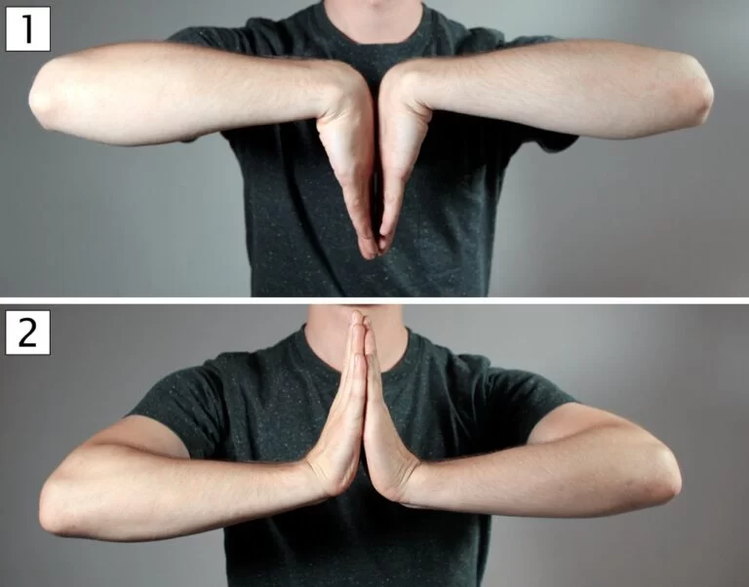 | Phalen’s Test | The patient places the backs of their hands together, pushing the wrists into maximum flexion for 60 seconds. | Tests for carpal tunnel syndrome. Pain, tingling, or numbness in the distribution of the median nerve suggests CTS.
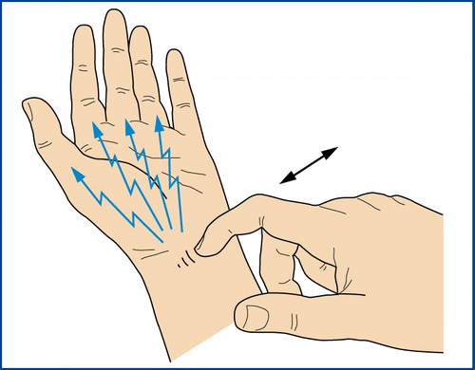 | Tinel’s Sign | Tap the median nerve at the wrist (or along the nerve’s path). | Tests for carpal tunnel syndrome. Tingling or a "pins and needles" sensation indicates median nerve irritation.
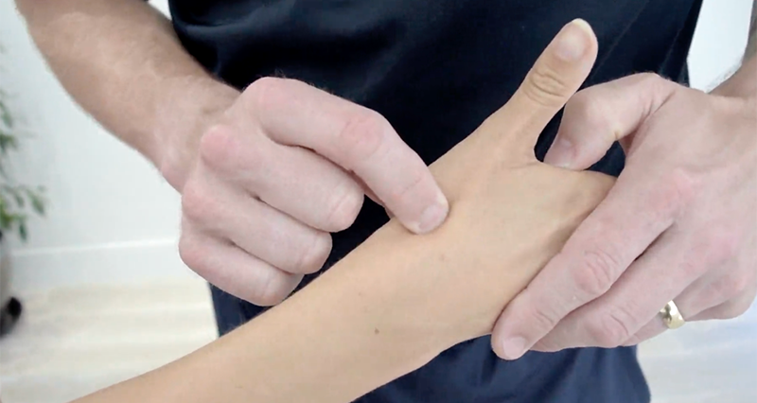 | “Snuff Box” Assessment | Ask the patient to extend the thumb while palpating the anatomical snuff box (the depression at the base of the thumb, between the tendons of the extensor pollicis longus and brevis). | Tests for scaphoid fractures. Tenderness over the snuff box suggests a possible scaphoid fracture.
Knee  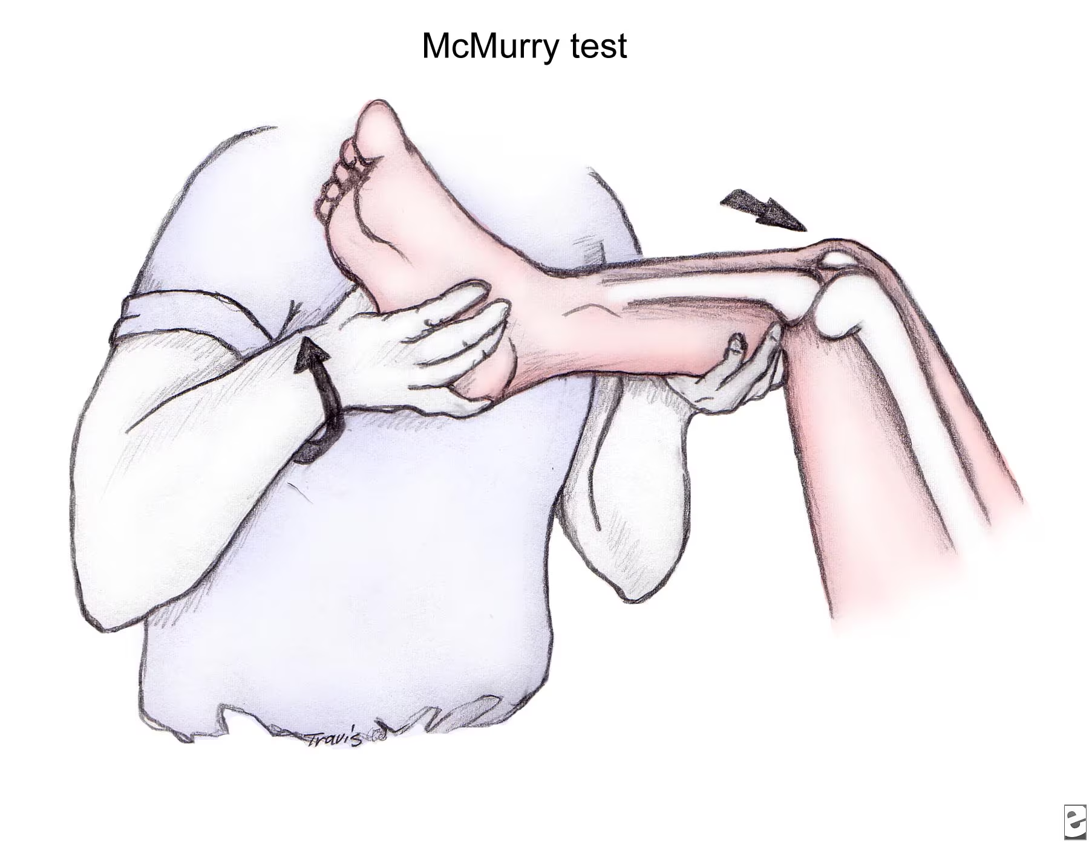 | McMurray Maneuver | With the patient supine, flex the knee and hip, then rotate the tibia internally and externally while extending the knee. | Tests for meniscal tears. A popping, clicking, or pain suggests a meniscal injury.
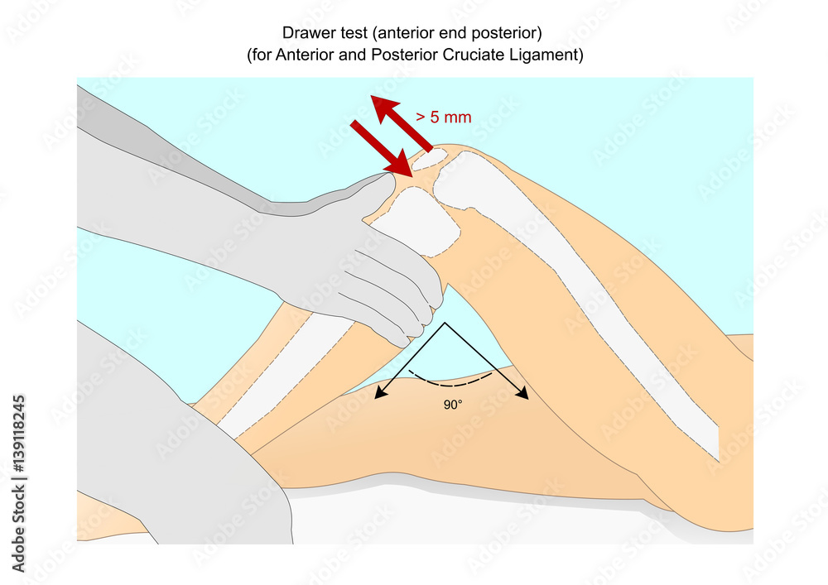 | Drawer Sign | The patient is supine with the knee flexed at 90° and the foot flat. The examiner pulls the tibia anteriorly (for ACL) or pushes it posteriorly (for PCL). | Tests for ACL (anterior cruciate ligament) or PCL (posterior cruciate ligament) instability. Forward (anterior) or backward (posterior) movement of the tibia indicates ligament damage.
 | Lachman’s Test | The patient lies supine, with the knee slightly flexed (20-30°). The examiner stabilizes the femur with one hand and pulls the tibia anteriorly with the other. | Tests for ACL integrity. Excessive anterior translation of the tibia indicates ACL injury.
 | Varus/Valgus Stress Tests | The knee is flexed at 20-30°. Apply a varus force (inward) or valgus force (outward) to the knee joint to test for ligament stability. | Tests for collateral ligament integrity (LCL for varus, MCL for valgus). Laxity or pain indicates ligament damage.
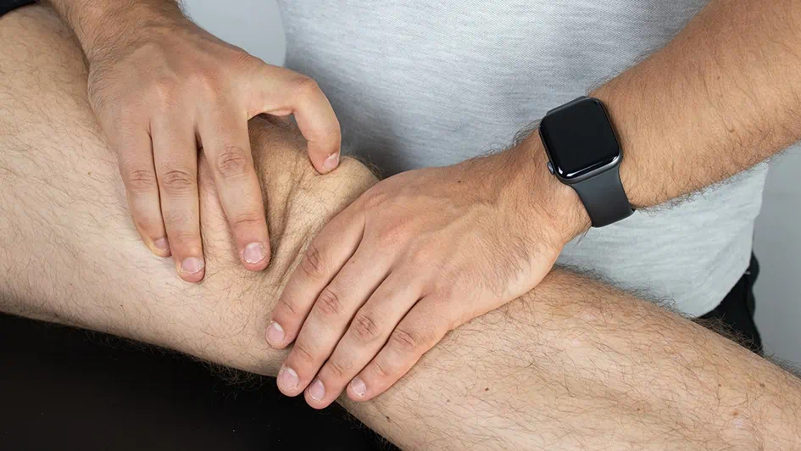 | Patellar Tap | With the knee extended, gently tap the patella while observing for any floating sensation or visible movement. | Tests for joint effusion (fluid in the knee). A floating or tapping sensation suggests effusion.
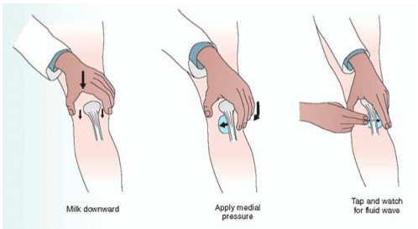 | Bulge Sign | With the knee extended, press on the medial side of the knee to push fluid laterally. Then press on the lateral side to observe for a bulge. | Tests for mild effusion in the knee. A bulge on the medial side indicates fluid accumulation.
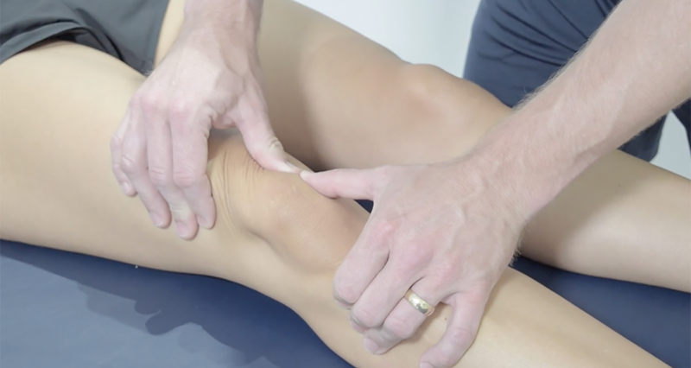 | Apprehension Test | The patient is supine, and the examiner applies a lateral force to the patella to attempt to displace it laterally. | Tests for patellar instability or subluxation. Pain or a look of apprehension from the patient suggests instability.
Ankle  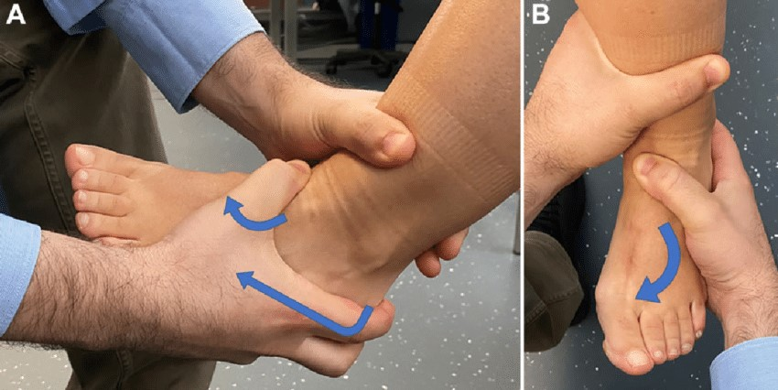 | Anterior Drawer Sign | With the patient sitting or supine, the examiner stabilizes the tibia and fibula and pulls the heel anteriorly. | Tests for anterior talofibular ligament (ATFL) instability. Excessive anterior movement suggests ATFL injury.
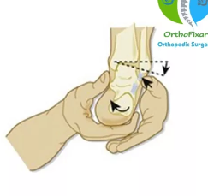 | Talar Tilt Test | With the patient’s ankle in neutral position, the examiner tilts the foot inward (inversion) and outward (eversion) to assess ligament integrity. | Tests for lateral ankle ligament injuries (especially ATFL and CFL). Excessive tilt suggests ligament damage.
Shoulder  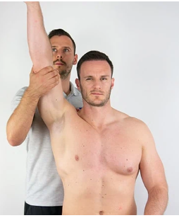 | Impingement Test (Neer’s Test) | The examiner elevates the patient's arm in forward flexion while stabilizing the scapula to compress the rotator cuff tendons. | Tests for shoulder impingement (e.g., rotator cuff tendinitis). Pain or discomfort in the shoulder suggests impingement.
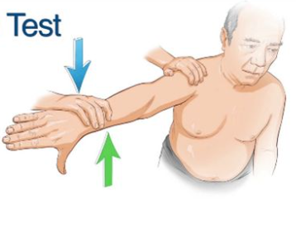 | Empty Can Test | The patient abducts their arms to 90° with the thumb pointing downward. The examiner applies downward pressure while the patient resists. | Tests for supraspinatus tendon or rotator cuff pathology. Weakness or pain indicates supraspinatus involvement.
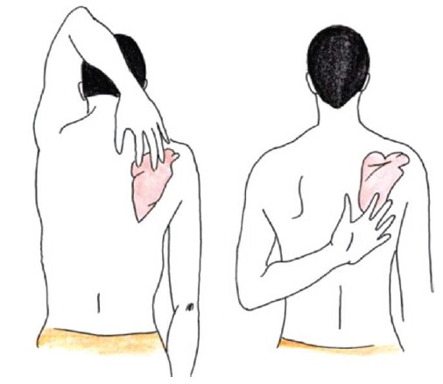 | Apley Test | The patient touches the opposite scapula behind the back (internal rotation) and over the shoulder (external rotation). | Tests for shoulder range of motion and rotator cuff or glenohumeral joint problems. Pain or limited range of motion suggests pathology.
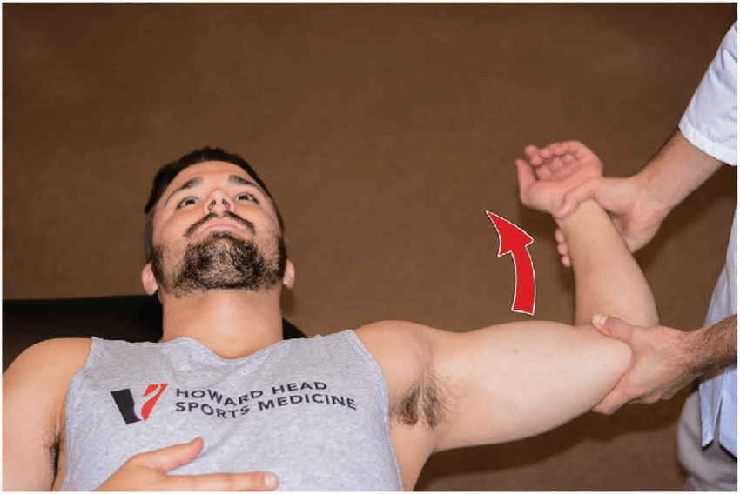 | Apprehension Test | The patient is supine, and the examiner externally rotates the shoulder while the arm is abducted to 90°. | Tests for shoulder instability or labral tears. A look of apprehension or pain indicates a possible dislocation or instability.
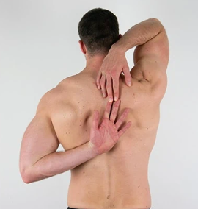 | Scratch Test | The patient attempts to scratch the opposite shoulder or between the scapulae. | Tests for range of motion in the shoulder. Difficulty performing the test suggests limited mobility or stiffness.
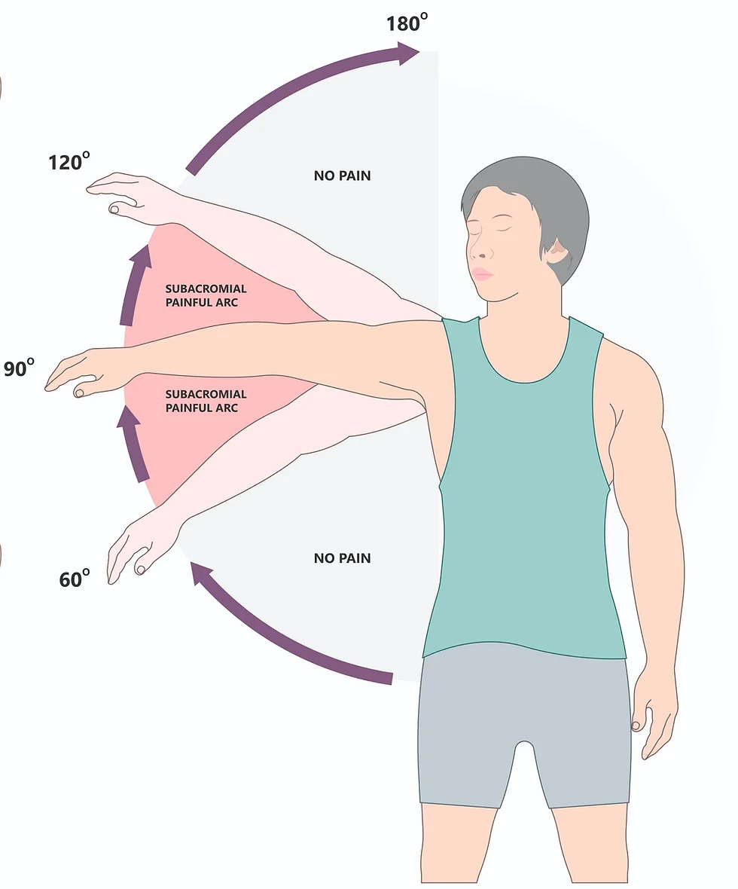 | Painful Arc Test | The patient actively raises their arm from 0° to 180°. | Tests for rotator cuff pathology or impingement. Pain between 60° and 120° indicates impingement, while pain above 120° suggests rotator cuff issues.
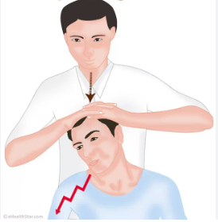 | Head Compression Test | The patient sits or stands, and the examiner compresses the head gently to assess for neck or shoulder pain. | Tests for cervical spine issues (e.g., disc herniation, nerve root compression). Pain in the neck, arms, or shoulders suggests compression.
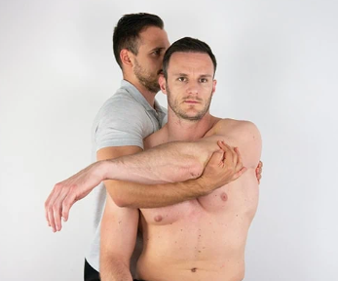 | Cross-Arm Test | The patient actively adducts their arm across the chest. | Tests for acromioclavicular (AC) joint pathology. Pain or discomfort in the AC joint suggests pathology.
Hip  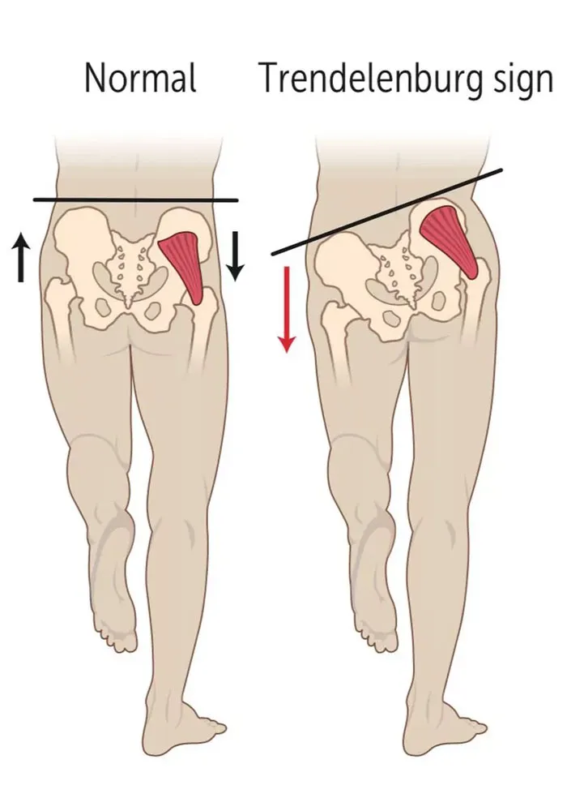 | Trendelenberg Test | The patient stands on one leg while the examiner observes the pelvis. If the pelvis drops on the unsupported side, the test is positive. | Tests for gluteus medius weakness or hip abductor weakness. A positive test indicates weak hip abductors (e.g., from hip arthritis).
Back | Neurological (Sensory/Motor) Components | Assess sensory (light touch, pinprick, vibration) and motor function (muscle strength) in the lower extremities. | Tests for nerve root involvement or neurological deficits (e.g., radiculopathy, herniated disc). Abnormalities suggest nerve damage.
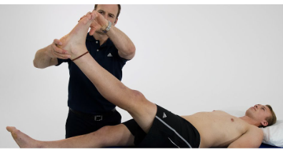 | Straight Leg Raise (Lasegue’s Sign) | With the patient lying supine, passively raise the extended leg while keeping the knee straight. | Tests for lumbar disc herniation or nerve root irritation (e.g., sciatic nerve). Pain or reproduction of symptoms suggests nerve root irritation.
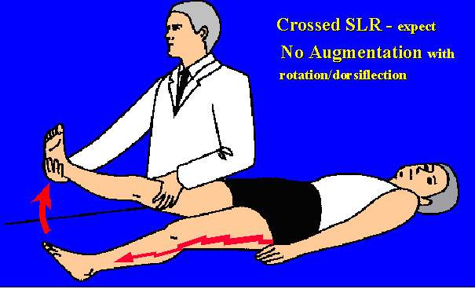 | Crossed Straight Leg Test | Perform the same test as the straight leg raise on the opposite leg. | Tests for lumbar disc herniation or nerve root involvement. Pain in the raised leg suggests a more serious herniated disc.
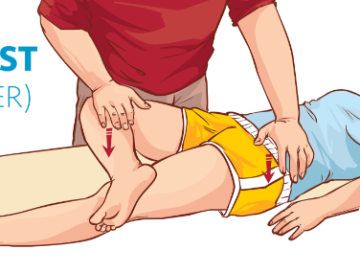 | Patrick’s Test (FABER Test) | Flex, abduct, and externally rotate the hip (figure-4 position), applying downward pressure on the knee. | Tests for hip joint pathology (e.g., arthritis) or sacroiliac joint dysfunction. Pain in the hip or groin suggests hip pathology, while pain in the sacrum suggests sacroiliac joint dysfunction.

Overview:
- Wrist tests often assess for nerve compression (carpal tunnel) or bone fractures (scaphoid).
- Knee tests mainly evaluate ligament integrity, meniscal tears, and joint effusion.
- Ankle tests focus on ligamentous instability (ex. ATFL) and lateral ankle ligaments.
- Shoulder tests assess for rotator cuff issues, instability, and impingement.
- Hip tests identify hip weakness or joint pathology.
- Back tests evaluate for nerve root involvement, lumbar disc herniation, and sacroiliac joint problems.
Quick Reference:

Condition | Relevant Tests
Ankle & Foot
Ankle Sprain | Anterior Drawer Sign, Talar Tilt Test
Cervical Radiculopathy | Neurological (Sensory/Motor) Components
Hip (Bursitis) | Trendelenberg Test
Knee Injury
Meniscus Injury | McMurray Maneuver
Patellar Subluxation/Dislocation | Apprehension Test
Low Back Pain (Acute/Chronic)
Herniated Disk | Straight Leg Raise (Lasegue’s Sign)
Spinal Stenosis | Straight Leg Raise (Lasegue’s Sign)
Shoulder Pain
Rotator Cuff Injury/Dysfunction | Empty Can Test, Neer’s Test, Apley’s Test
Impingement | Neer’s Test
Adhesive Capsulitis (Frozen Shoulder) | Painful Arc Test
Wrist & Hand Pain
Carpal Tunnel Syndrome | Phalen’s Test, Tinel’s Sign
Scaphoid Fracture | Snuff Box Assessment

Ottawa Rules

Ottawa Ankle Rules: help determine when to order an X-ray for an ankle injury.
- For Ankle X-ray:
  - Pain in the malleolar area (ankle area) + one of the following:
    - Bone tenderness at the posterior edge or tip of the lateral malleolus.
    - Bone tenderness at the posterior edge or tip of the medial malleolus.
    - Inability to bear weight immediately after the injury and for 4 steps in the emergency department (or clinic).
- For Foot X-ray (in addition to ankle X-ray):
  - Pain in the midfoot + one of the following:
    - Bone tenderness at the base of the fifth metatarsal.
    - Bone tenderness at the navicular bone.
    - Inability to bear weight immediately after the injury and for 4 steps in the emergency department (or clinic).

Ottawa Knee Rules: to decide when a knee injury needs an X-ray.
- Knee X-ray is required if the patient has:
  - Age 55 years or older.
  - Isolated patellar tenderness (no other bone tenderness).
  - Tenderness at the fibular head.
  - Inability to flex the knee to 90 degrees.
  - Inability to bear weight both immediately and in the emergency department (4 steps).
Condition | Ottawa Ankle Rules | Ottawa Knee Rules
Ankle X-ray | - Pain in the malleolar area (ankle region) + one of the following: | - Age 55 years or older.
 | - Bone tenderness at the posterior edge or tip of the lateral malleolus. | - Isolated patellar tenderness (no other bone tenderness).
 | - Bone tenderness at the posterior edge or tip of the medial malleolus. | - Tenderness at the fibular head.
 | - Inability to bear weight immediately after injury and for 4 steps in the ED or clinic. | - Inability to flex the knee to 90 degrees.
Foot X-ray | - Pain in the midfoot + one of the following: | - Inability to bear weight immediately after injury and for 4 steps in the ED or clinic.
 | - Bone tenderness at the base of the 5th metatarsal.
 | - Bone tenderness at the navicular bone.
 | - Inability to bear weight immediately after injury and for 4 steps in the ED or clinic.

Summary of the Ottawa Ankle and Knee Rules
- Ottawa Ankle Rules are used to identify patients with ankle or foot injuries who are at risk for fractures and should have an X-ray. The key points are:
  - Bone tenderness in specific areas (lateral or medial malleolus, navicular, base of 5th metatarsal).
  - Inability to bear weight for 4 steps after the injury.
- Ottawa Knee Rules are used to determine if a knee injury requires an X-ray. The key points are:
  - Age over 55.
  - Tenderness at the fibular head or patella.
  - Inability to flex the knee to 90 degrees or inability to bear weight after injury.
These rules help reduce unnecessary X-rays, improving clinical efficiency while ensuring important injuries are not missed.

MSK Assessment Overview:

ALWAYS COMPARE LEFT TO RIGTH
Vitals, BMI, H+W
Inspect→ SEAD (sweeling, ecchymosis (burising), atrophy, deformity), posture, gait, MSE, appearance, active ROM(first do unaffected side, then do affected side to compare)
Palpate→ crepitis, warmth, bulk and mass, laxity (loose/tightness of ligaments), pain, strength (5/5), sensation, cap refil, pulses, point tenderness (fracture), reflexes

Shoulder:

AC JOINT:
- Point tenderness at acromiam clavicular joint (2 options: fracture or bursitis that feels spongy)
- Pain with raising arm, scarf test numbness and tingling? (impingement)
Glenohumeral joint
- Sulkus sign to assess if joining intact (pull down on on arm…finger on acromiam process and pull down on arm…some laxity but if injuries will see increased laxity and pain)
Biceps tendon comes into shoulder joint, injury…to test impigement
- Speed’s test (roll shoulder in and feel biceps into bicepital groove and have them to the elevate arm over head and down put resistance)
SITS (supraspinatous, intraspinatous, terres major and minor, subscapularis)-->rotator cuff or impingement from swelling at that site
- Impingement
  - Neers or hawkings kennedy
  - Hawkins: bring arm out then turn to 90 degree at elbow then resistance at arm downwards and elbow up. Pain or paresthesia means impingement
ONE TEST THAT CAPTURS ALL OF SITS IS PAINFUL ARC→ shows rotator cuff tendonitis. Needs U/S to identify tendons but can do assessment to isolate tendon
- Empty can test
- Painful arc: if can do then rotator cuff is intact!!! Just need RICE. if cant do then do passive ROM and feel for crepiitis. With painful arc cant get it up but once up can hold it okay. DO ONCE ACTIVE AND ONCE PASSIVE WITH PAINFUL ARC!!
For shoulder consider cervical spine to r/u cervical rediculopathy so assess ROM of neck! And assess traumatic injury (face, head, neck trauma)

If neck pain and fine motor effecteded/dec sensation then refer to neuro
If shoulder pain rule out cardio!!!!!!! ALWAYS!!!!!!!!!
IF RIGHT SHOULDER R/U GALLBALLDER

Knee:
Patella:
- Patellar tap is useless lol, press down on patella with 2 fingers to see if effusion/fluid. Instead stabalize the patella and should be some laxity. If cant move it its probably a dislocation. If more fluid its probably a bursitis, need an U/S if you want to confirm. RICE for effusion.
- Ottaw knee rules: feel over and identify point tenderness ontop of knee and laterial head of fibula about 2 fingers from patella on lateral side. Also if over 55, cant weigh bear for more than 4 steps (or need equiptment), cant flex knee to 90 degrees…need an xray***
Tendons
- MCL PCLAnterior and poster drawer: Flex knee to 90 degress then sit on foot to impalize it then pull forward and back. Any movemevtn from 2-3 cm of patella to tibia and pain is positive and increased laxity
- MCL, sam eposition as before but palpate on two sides on ligament laterla and medial of knee and may be painful with movemeing knee back and forth like 90 degrees then 45…rocking leg back and forth
Valgus and varus tests if tenderness with MCL test
Valgus tests for mcl, pull leg and ally countra pessure on thigh pain or increased laxity is bad. Push at top and pull at bottom
Varus is possosite to pull at top and push at bottom
German pig armer, pig goes through leg and says ver is za pig lol is verus …pressure in
Meniscus→ mcmurrys test: knee to 90 degree, feel at knee joint with 2 singers on either side, turn leg inwards, then move up, around and brig heel externall, then switch hands and bring down, knee out and heed in…basically a figure 8. Feel for any locking or crepitisus. U/S but prefer MRI if meniscus pain because want to rule out tear and consult ortho for sugruyr not needed anymore for meniscus tear…physio!! Istead

CT: cancer, fracture

Knee and shoulder usually need MRI but consider time!

GU
Week 8: Genitourinary Part 1
Learning Objectives:
- Evaluate the clinical findings associated with breast and genitourinary conditions
- Examine the relationship between psycho-social factors and selected GU conditions
- Integrate the knowledge and skill required for the appropriate collection of cultures and cytology samples
- Distinguish the need for, and determine the most appropriate diagnostic imaging modality for specific clinical presentations within the NP-PHC scope of practice.
- Integrate the knowledge and skill required to conduct GU assessments on members of the 2SLGBTQ population, specifically those identifying as transgender.

Required Readings:
CONDITIONS
- Abnormal uterine bleeding
- Bacterial vaginosis
- Breast/chest mass, including breast/chest cancer
- Dysmenorrhea
- Endometriosis
- Herpes simplex virus (HSV)
- Human papillomavirus (HPV)
- Menopause
- Pelvic inflammatory disease (PID)
- Urethritis/cervicitis (gonococcal/nongonococcal)
- Urinary tract infections: cystitis, interstitial cystitis & pyelonephritis
- Vaginal atrophy
- Vulvovaginal candidiasis

Reference Links/Texts
- Alexander, I. et al (2023)
- Glass & Cash (2020)
- Myrick & Karosas (2022)
- Daines, Baumann & Scheibel (2024)
- Bournes and Kucharski (2022)
- SOGCLinks to an external site.
- MUMS Anti-infective (2019)
- Cancer Care Ontario (Cervical and Breast).
- Sherbourne’s Guidelines for gender-affirming primary care with trans and non-binary patients- Introduction to gender-affirming primary care; Hormone initiation; Part II: Feminizing hormone therapy (focusing on monitoring, follow-up); Table 6; Appendix D/E/J
- Transgender men and cervical screening
- Paps in Transgender menLinks to an external site.
- An Approach to the Diagnosis and Management of Benign Uterine Conditions in Primary Care

- Abnormal-Uterine-Bleeding.pdf
- Approach-to-Breast-Mass.pdf
- Female-Periodic-Health-Examination.pdf
- Sexually transmitted and blood-borne infections: Guides for health professionals
- Gynecological Assessment (2022)
- Please click here to access Bate

UTI: Culture, CBC, urinalysis, gonnorhea/clamidya

MENOPAUSE
Description | Physiologic or natural menopause= cessation of menses for 12 consecutive months due to the loss of ovarian follicular activity  - Generally experienced between ages 45 and 55  - Unrelated to age of menarche, pregnancies and contraceptive use  - Premature if before age 40  Premature ovarian failure= full or intermittent loss of varian function before age 40  - Caused by genetics, autoimmune disorders, or surgical/chemical intervention  Induced menopause= related to chemical or surgical interventions  Perimenopause= fluctuations in ovarian function in the years preceding menopause  - Average onset in 40s; Pregnancy may still occur  - Symptoms may last several years (average duration is 5 years, can last 10)
Pathology | Ovarian hormone depletion; decreased negative feedback from the HPA axis  - FSH and LH increase when the ovary is unable to produce estrogen and is unable to respond to the increased FSH levels
Screening | Retrospective diagnosis; only diagnose 12 months AFTER the last menses
Clinical Presentation  (Subjective Symptoms & Objective Signs) | HALLMARK: absence of menses for 12 months  Common findings:  - Insomnia (reduced total sleep time, prolonged time to sleep, reduced REM sleep), urogenital atrophy, vaginal dryness, dyspareunia, dysuria/urinary frequency  - Hot flashes, night sweats, mood changes, flushing  - Many women report increased palpitations  - 90% of women will gain some weight due to hormonal changes between ages 35 and 55
Hx/Key Questions | Determine onset, duration, and course of presenting symptoms  - Complete medical history, medications, risk for osteoporosis, cardiovascular disease, and breast/endometrial cancers  - Complete gynecological history with menarche patterns (interval, duration, dysmenorrhea history, pregnancy history)  - Sexual history, contraceptive use, frequency of method used  - What is the current menstrual pattern? Do you think you are pregnant?  - Review associated symptoms  - Hot flashes, insomnia, GU symptoms  - Assess for mood swings and dysphoria  - Ask what age mother and grandmother went through menopause
Physical Exam | VITALS: BP, temp, pulse, respirations  INSPECT: general wellness, weight and height, BMI  AUSCULTATE: heart, lungs, abdomen  PALPATE: thyroid gland, breast examination, groin lymph nodes, abdomen for masses  PERCUSS: for organomegaly  PELVIC EXAM  - Inspect Bartholin’s glands for enlargement, fissures, condyloma, herpes, pelvic relaxation, and atrophy  - Palpate the urethra for discharge  - Speculum examination for discharge, bleeding (culture and Pap as indicated)  - Bimanual exam to check for cervical motion tenderness, enlarged uterus would require further evaluation  - Postmenopausal uterus will decrease in size over time  - Palpate adnexa for tenderness  - Ovaries should not be palpable in postmenopausal women (would be concerning for masses, requiring further evaluation)  - If over age 50, also evaluate for occult blood in stool
Red Flags | Palpable ovaries i postmenopausal women, enlarged uterus, vaginal bleeding after menopause
Differential Diagnosis | Anemia, cardiac abnormalities, leukemia or other cancers, menstrual irregularity due to secondary amenorrhea of any cause, pregnancy, psychosomatic illness, thyroid disorders
Diagnostics:  Labs & Imaging | 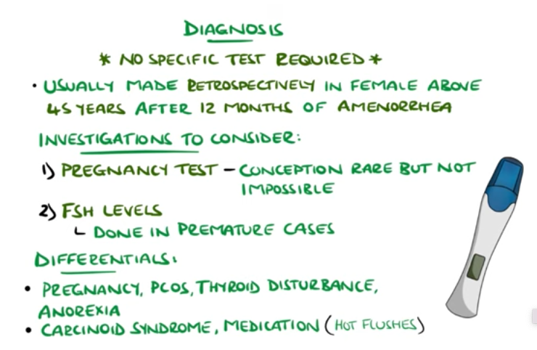Laboratory tests  - TSH, beta HCG, CBC if excess bleeding is present  - Menopause= FSH >40 IU/L, estradiol <15 IU/L, but this is not recommended for diagnosis because of fluctuations that occur  Diagnostic tests and/or Imaging  - Pap if indicated  - Endometrial biopsy for intermenstrual spotting or vaginal bleeding after menopause  - Transvaginal ultrasound for enlarged or irregular uterus  - Maammogram, hemoccult, cholesterol, and bone mineral density
Treatment/ Management | Counseling/Education  - Provide reassurance as to the cause of cessation of menses  - Discuss symptoms, provide healthy lifestyle education  - Encourage diet rich in vitamin D and calcium  - Need to assess and manage for risk of osteoporosis, cardiac risk factors like hypertension and hyperlipidemia  Complementary Therapies (non-pharmacological)  - PRN water soluble vaginal lubricants  - Avoid warm environments, caffeine, alcohol, spicy foods, and emotional upset  - These are known triggers of hot flashes  - Encourage sleep hygiene and adequate rest
Medical management | Can discuss risks and benefits of HRT with the patient  Transdermal estrogen
Follow-up | In 3-6 months if patients opt for pharmacological therapy  Provide yearly pap smears and lipid panels as needed
Common Complications | Vaginal skin atrophies and becomes more fragile and susceptible to injury and infection
1° and 2° Prevention | Primary prevention
References | Cash & Glass, Dains et al (no info in Myrick and Karosas)

PELVIC INFLAMMATORY DISEASE
Description | Inflammation from infection of the upper genital tract  - Can affect the endometrium, the fallopian tubes, the ovaries, the ligaments or uterine serosa, or the pelvic vascular system/connective tissue
Pathology | Pathogens ascend the vagina and cervix into the uterus, and menses facilitates invasion into the upper genital tract as the luteal phase stimulates growth (the cervical mucus barrier is removed)  - Infection and inflammation can spread to the endometrium, the fallopian tubes, and into the peritoneal cavity  Common organisms= chlamydia and gonorrhea (30-40%), mycoplasma hominis, ureaplasma ureallyctium, bacteroides, E. coli, ad some endogenous pathogens
Epidemiology | The leading cause of infertility worldwide; 10-15% of canadian women of reproductive age have had at least one episode of PID  The most common cause of lower abdominal pain in females
Risk Factors | - Age (higher rates in younger women)  - Highest in the <30 group  - Teens are susceptible due to immature immune systems, larger zones of ectopy in the cervix, and thinner cervical mucus  - Sexual activity: women with multiple sex partners have 3x higher risk  - IUD: leads to iatrogenic development of PID  - History of PID  - Menstruation supports the development and spread  - History of invasive procedures  - IUD insertion, dilation and curettage, hysterosalpingectomy, vacuum curettage  - Increased in african american women, ethnic minority groups, and women of low SES  - Cigarette smoking  - Vaginal douching  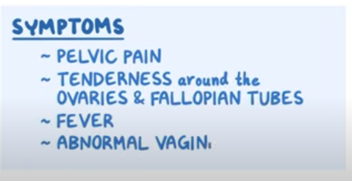
DIAGNOSTIC CRITERIA* | Minimal criteria…  - Empiric treatment should be initiated in sexually active women at risk for STDs if they have any of the following with no other identified cause  - Lower abdominal tenderness  - Adnexal tenderness  - Cervical motion tenderness, aka CMT (the chandelier sign)  Additional routine criteria…  - Oral temperature >38.3  - Abnormal discharge  - Elevated ESR 20+  - Elevated CRP  - LLab documentation of chlamydia or gonorrhea infection  Elaborate/definitive criteria for diagnosing PID…  - Histopathologic evidence of endometritis  - Tubo-ovarian abscess on ultrasound or radiologic tests  - Laparoscopic abnormalities consistent with PID
Clinical Presentation  (Subjective Symptoms & Objective Signs) | HALLMARK: lower abdominal pain, fever, chills  Common findings:  - Increased vaginal discharge, nausea, vomiting, lower back pain  - Typical onset of illness is shortly after menses  - Gonococcal PID tends to be more severe than chlamydial PID  Other signs and symptoms  - May be asymptomatic, vague symptoms  - Minimal to severe pelvic pain  - Right upper quadrant pain in 25% of cases  - Abnormal vaginal bleeding, heavy menstrual bleeding, intermenstrual or post-coital bleeding  - Deep vaginal dyspareunia
Hx/Key Questions | OPQRST of symptoms and pain  *Pain is usually bilateral, discomfort is exacerbated by the valsalva maneuver, intercourse or movement  - Character of discharge, history of dysmenorrhea, dyspareunia, intestinal or bladder symptoms  - Sexual history, sexual partners, most recent activity, contraceptive use  - Symptoms of current sexual partners  - Menstrual pattern, pregnancy chance, pain in relation to the menstrual cycle  - Pelvic or abdominal surgical history and procedures
Physical Exam | VITALS: temp, pulse, resps, BP  INSPECT: general wellness, discomfort level  AUSCULTATE: bowel in all quadrants  PERCUSS: for organomegaly  PALPATE:  - Groin for lymphadenopathy  - Abdomen for masses  - Levator ani muscle left and right, urethra, and trigone of the bladder  - Tests to do: rebound, involuntary guarding, and jar tests  - Jar test= hit the exam table and see if there is a pain response  PELVIC EXAM  - Vulva, bartholin's glands  - Look for fissures, condyloma, herpes, pelvic relaxation  - Palpate the urethra for discharge  - Speculum examination  BIMANUAL EXAM  - Cervical motion tenderness  - Adnexal tenderness  RECTOVAGINAL EXAM  - Assess for adnexal thickening and masses
Red Flags | Extreme risk of ectopic pregnancy; always test beta HCG even if clients have regular menses and reliable contraceptive use.
Differential Diagnosis | Gyne  - Ectopic pregnancy, pelvic endometriosis, dysmenorrhea, adenomyosis, functional ovarian cysts, pelvic relaxation, anatomic abnormalities  GI  - Acute appendicitis, IBS, ulcerative colitis/Crohn’s disease, diverticulitis, hernia  GU  - Cystitis/urethritis/interstitial cystitis, ureteral obstruction, carcinoma of the bladder  MSK  - Myofascial pain, pelvic floor myalgia, spinal injuries or degenerative disease  Neuro: nerve entrapment syndrome
Diagnostics:  Labs & Imaging | Laboratory tests  - CBC and WBC count  - CRP and ESR  - Beta HCG, hepatitis surface antigen levels, HIV if indicated  - Gonorrhea and chlamydial cultures (endocervical swabs, vaginal swabs, or first-void urine)  Diagnostic tests and/or Imaging  - Endometrial biopsy  - Transvaginal ultrasound  - Laparoscopy by referral  Have a LOW threshold for diagnosis because of the risk of damage to reproductive health
Treatment/ Management | Counseling/Education  - Risk of ectopic pregnancy is 10x higher with PID  - IUD does not need to be removed ; may consider if no improvement after 48-72h of therapy  - All sexual partners need to be examined and cultured when possible  - Treat for gonorrhea and chlamydia  - Greatest risk for women who do not use any contraception  Complementary Therapies (non-pharmacological)
Medical management | Early treatment with antibiotics
Advise clients when to RTC or call for help | Hospital admission if…  - Uncertain diagnosis  - Pelvic or tubo-ovarian abscess  - IUD in situ  - Pregnancy (required parenteral antibiotics)  - Adolescent client or someone incapable of adhering to outpatient regimen  - Client unable to be re-evaluated in 48-72 hours  - HIV positive  - General peritonitis or severe illness  - Unable to tolerate oral medications  - Where a surgical emergency cannot be ruled out
Referrals | To a Gynecologist if there is an atypical presentation, evidence for presumptive diagnosis, or if hospitalization is required.  *REPORT ALL CASES OF GONOCOCCAL PID TO PUBLIC HEALTH
Follow-up | Initial follow-up in 2-3 days to assess for clinical improvement  Re-evaluate in 4-6 weeks due to the high risk of re-infection  Re-culture chlamydia and gonorrhea +ve patients in 7-10 days after completing therapy  - REQUIRES A TEST OF CURE
Common Complications | Ectopic pregnancy risk, subsequent PID risk, and tubal infertility risk increases 8 to 10-fold  Long-term: infertility, ectopic pregnancy, chronic pelvic pain (increased risk with more episodes of pID)
1° and 2° Prevention | Primary prevention: contraceptive use (barriers, spermicides, and oral contraceptive pills all have benefits to them)
References | Cash & Glass  Dains et al  STI & Bloodborne infections Guide link (Government of Canada)  MUMS Anti-Infective

URETHRITIS/CERVICITIS
Short definition/ description | Cervicitis= acute or chronic inflammation of the cervix that is visible to the examiner
Pathology | CERVICITIS  83%= unknown cause, 25%= chlamydia and gonorrhea  - Other causes→ mycoplasma genitalium, trichomonas vaginalis, HSV 1 and 2  Acute cervicitis= due to bacterial or virus infection  Chronic cervicitis= trauma from childbirth or instrumentation, infection, or foreign bodies like IUDs  URETHRITIS  - 30% caused by gonorrhea  - Other common causes= chlamydia and Mycoplasma genitalium
Epidemiology | Incidence unknown; too many possible etiologies
Risk Factors | Vaginal delivery, cervical procedures, IUD, and STIs
Screening | Cervical inflammation is common in pregnancy  Cervicitis does not occur in pre-pubertal girls
Clinical Presentation  (Subjective Symptoms & Objective Signs) | 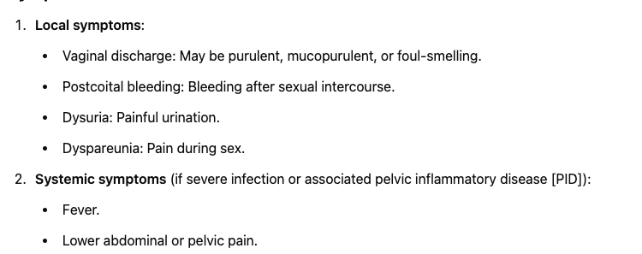  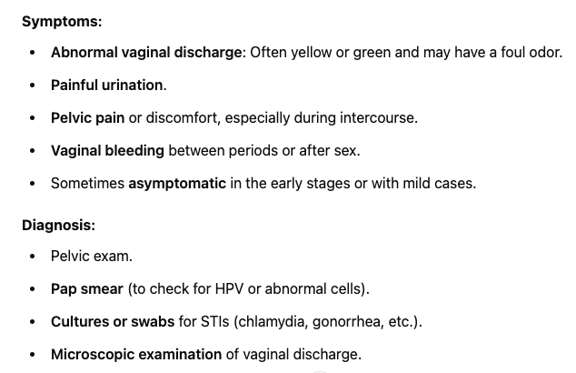  CERVICITIS  HALLMARK: copious mucopurulent vaginal discharge, postcoital bleeding  Common findings:  - Unusual vaginal discharge that is thick and yellow  - Vaginal bleeding during or after intercourse  - Purulent or mucopurulent endocervical exudate  - Glandular ectopy with friability  Other signs and symptoms:  - May be asymptomatic  URETHRITIS  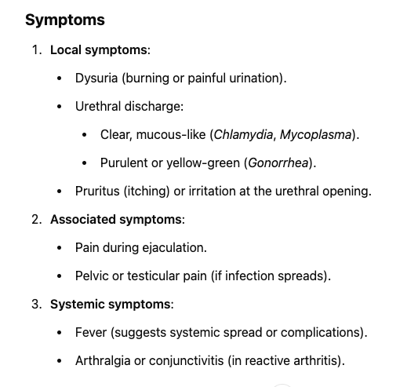  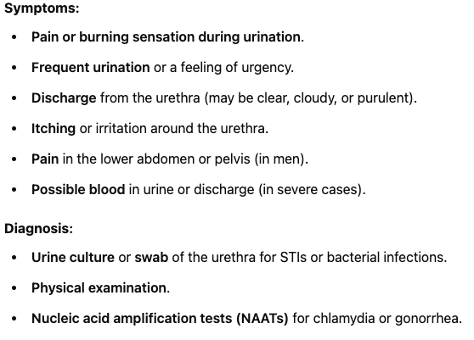  HALLMARK: initial blood in the urine that then turns clear  Common findings:  - mucoid/mucopurulent or purulent urethral discharge  - Dysuria, urethral itching or irritation  - Meatal burning and discharge  - Meatal erythema and edema  - Gonococcal symptoms usually begin 2-6 days after acquiring the infection  - If non-gonococcal, not until 1-5 weeks later
Hx/Key Questions | Determine OPQRST of the symptoms  - Is there any pelvic pain, fever, or urinary symptoms?  - Review characteristics of vaginal discharge  - History of STIs, sexual history and number of partners (do they have symptoms?)  - Review last Pap test date and results; history of abnormal pap and treatment  - LMP and contraceptive use  - Pregnancy history, records for cervical cerclage, vaginal deliveries, cervical lacerations, and other complications
Physical Exam | VITALS: temperature, pulse, respirations  INSPECT: for discomfort before, during, and after the examination  - Bartholin’s glands, examine for cysts, lesions, irritations, fissures, condyloma  - Colour, amount, and odor of discharge  PALPATE: CVA tenderness  - Abdomen for enlarged or tender inguinal lymph nodes  PELVIC EXAM  - SPECULUM  - Inspect for inflammation  - Cervical ectropion is found in 15-20% of healthy women (columnar epithelium that is farther out than the ectocervix, causing the cervix to appear granular and red)  - Different; cervical erosion; advanced pathology. Strawberry cervix suggests T. vaginalis infection  - Check for friability, bleeding when touched, polyps, lesions, discharge  - Assess for rugae on the vaginal wall  - BIMANUAL EXAM  - CMT, adnexal masses, uterine size, consistency, and tenderness  - Palpate for discharge from the urethra  - Palpate Bartholin’s glands
Red Flags
Differential Diagnosis | Chlamydia, gonorrhea, Bartholin’s gland abscess, cervical neoplasm, cervical polyps, HSV-2 infection, UTI, cervical ulceration/erosion from trauma (e.g., fingernail, cervical biopsy, postpartum, or sex toys), PID
Diagnostics:  Labs & Imaging | Laboratory tests  Urine dip and culture  Std  Cbc  Women can do speculum/pap  - Endocervical swabs for chlamydia and gonorrhea  - Consider HSV testing when ulcerations or vesicles are present  - If recurrent, consider Mycoplasma genitalium  - WBC count if indicated, urine C&S if indicated  - Consider syphilis, VDRL, and herpes testing  - In men, positive leukocyte esterase or nitrite test indicates urethritis  - For urethritis→ urine dipstick  Diagnostic tests and/or Imaging  - Speculum exam to evaluate cervix and vaginal wall  - Pap smear
Treatment/ Management | Counseling/Education  - Women should receive routine care for Pap smears following guideline recommendations  - Avoid sexual intercourse for one week to avoid reinfection  - Avoid tampons and douching until antibiotics are done
Medical management | Doxycycline therapy for non-chlamydial and non-gonococcal cervicitis
Transgender Considerations | - The use of testosterone increases risk of vaginitis and cervicitis  - Creates atrophic tissue subject to traumatic irritation from sexual contact that can result in dyspareunia  - Genita or pelvic surgery can also cause adhesions, scarring, bladder dysfunction and nerve injury, contributing to pain  Paps starting at age 25 and every 3 years are still required for patients taking testosterone therapy, patients not sexually active, up until age 70 if 3 negative tests in the last 10 years.
Referrals | Do if there is suspected neoplasm or if it is unresponsive to treatment  - Refer for colposcopy if there is a suspicious lesion
Follow-up | If recurrent cases: asses for poor adherence, use of alternate choice meds, reinfection, presence of other pathogens  - May require a test of cure if there is chlamydia or gonococcal involvement (repeat after 3 months post treatment due to high reinfection rates according to Cash & Glass)  - MUMS Anti-Infective says→ test with NAAT no earlier than 3 weeks post-treatment AND repeat screening for gonococcal infection after 6 months post-treatment  Test of cure is not required for non-gonococcal urethritis.
Common Complications | If left untreated, can progress to PID, chronic pelvic pain, ectopic pregnancy, and infertility  Increased risk of HIV-acquisition, increased HIV shedding at the cervical canal (increased transmission in HIV-infected patients)
1° and 2° Prevention | Primary prevention
References | STI & Bloodborne infections Guide link (Government of Canada)  Cash & Glass  Dains et al  Myrick & Karosas  MUMS anti-infective

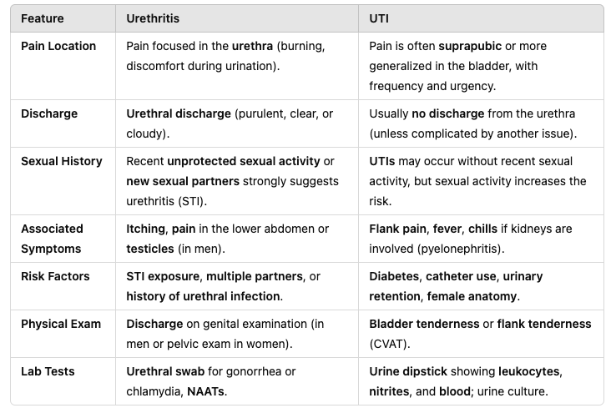

UTIS; CYSTITIS, INTERSTITIAL CYSTITIS & PYELONEPHRITIS
Description | 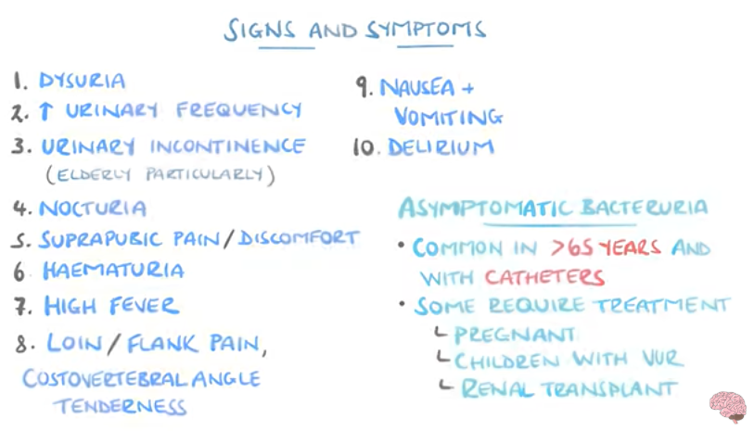UTI/CYSTITIS  Recurrent UTI= 2 uncomplicated UTIs within 6 months OR 3+ positive urine cultures in the prior 12 months  Reinfection= occurring after 2 weeks of completing antimicrobial therapy, caused by a different organism. Is most common; follows the ascension of microorganisms from the periurethral area into the bladder.  Relapse= occurring within 2 weeks of completing antimicrobial treatment. Caused by the original organism, bacteriuria persistence during therapy or re-occuring after 1-2 weeks of finishing therapy. Occurs in 5-10% of women  ACUTE CYSTITIS  - Normal genitourinary tract, limited morbidity, consistent microbiological spectrum  INTERSTITIAL CYSTITIS  A chronic condition resulting in recurring discomfort or suprapubic pain, pressure in the bladder and pelvic region related to bladder filling. Aka painful bladder syndrome. Includes all cases of urinary pain with persistent urge to void that cannot be attributed to other causes. Symptoms lasting for >6 weeks  PYELONEPHRITIS  - Acute infection and inflammation of the upper urinary tract of one or both kidneys  - An ascending UTI that has progressed from the lower urinary tract  - Less common and more serious than lower UTIs
Pathology/cause | Pyelonephritis→ ascending infection from the bladder, usually caused by E. coli or other gram-negative bacteria. May also reach kidneys from the bloodstream from IV drug use or endocarditis.  - Colonization in women is due to a short urethra  - In children, vesicoureteral reflex causes it  - In men, BPPH causes bladder obstruction leads to the infection
Epidemiology | Interstitial cystitis→ 10:1 ratio of females to males, can occur in children  About 30% of the female population have at least one UTI in their lifetime  For UTIs, incidence is increased in females after puberty, and then evens out again between the sexes after age 65
Risk Factors | UTI/CYSTITIS  In children→ previous history of UTI, non-circumcision  INTERSTITIAL CYSTITIS  - Female, age 42-45, UTI, prostatitis, chronic yeast infections, post-hysterectomy or pelvic surgery, medications (CCBs, cardiac glycosides), other hypersensitivity conditions (fibromyalgia, IBS, chronic headaches, vulvodynia, Sjogren’s syndrome)  PYELONEPHRITIS  - Previous UTI/cystitis/pyelonephritis  - Sickle cell disease, diabetes, urinary catheterization, obstruction, neurogenic bladder disease (stroke, MS, spinal cord injuries)  - Urinary reflux, HIV, trauma, chronic constipation in children  - Incomplete bladder emptying related to medications like anticholinergics  - In females: increased sexual activity, failure to void after sex, diaphragm and spermicide use  - Inn males: homsexuality, sexual partner with colonization, obstruction like BPH, age 50+, acute or chronic bacterial prostatitis
Screening
Clinical Presentation  (Subjective Symptoms & Objective Signs) | CYSTITIS  HALLMARK: dysuria, frequency, urgency, plus pyuria  Common findings:  - In older children→ classic symptoms  - In Infants→ nonspecific symptoms (poor feeding, irritability, fever, emesis, abdominal pain)  - In older infants/toddlers→ vomiting, abdominal pain, urinary retention, back pain, dysuria, frequency, new-onset incontinence, suprapubic tenderness  - Other signs and symptoms:  Minimum criteria to initiate antibiotics for UTI in lTC/nursing home residents without indwelling catheters→ acute dysuria alone OR fever and one of the following  - New or worsening urgency, frequency, suprapubic pain, gross hematuria, CVA tenderness, or urinary incontinence  PYELONEPHRITIS  HALLMARK: fever is strongly associated, also chills, shaking, flank pain, tenderness  - MILD= low-grade fever, normal/slight elevations in WBCs, no nausea and vomiting  - Urinary frequency or urgency, CVA tenderness, guarding  - Nocturia, hematuria, dysuria (not always)  - Blood in urine is unusual in males  - May be asymptomatic  - If pregnant, may experience uterine contractions  - In children  - Fever may be the only presenting symptom  - Nausea, vomiting, irritability, diarrhea, abdo pain, feeding trouble, failure to thrive  - In elderly  - Mental status changes  - Generalized deterioration  INTERSTITIAL CYSTITIS  HALLMARK: persistent urge to void; voiding is done to relieve pain  Common findings:  - Mild discomfort up to intense pain with bladder filling or emptying  - Urgency, nocturia, frequency, pressure, increased symptoms during menstruation, pain during intercourse, lower back pain with bladder filling
Hx/Key Questions | INTERSTITIAL CYSTITIS  - OPQRST of symptoms  - Is pain partially or completely relieved by voiding  - Are there any triggers? Any other chronic pain syndromes?  - Recent GU trauma or falls on the coccyx  - UTI, urinary retention, and kidney stone history  - Sexual hx.  PYELONEPHRITIS  - History of fever and treatments used  - Voiding-related symptoms  - Backache, unilateral or bilateral  - Rule out pregnancy in women  - Also rule out sickle cell disease, diabetes and MS  - In older men, review characteristics of urinary stream
Physical Exam | VITALS: temperature to rule out infection, BP (HR, resps with pyelonephritis as well)  - Interstitial cystitis is not associated with fever  - In pyelonephritis, rule out orthostatic hypotension, tachycardia  INSPECT: general appearance for depression and signs of discomfort  - Genitalia for redness, edema, lesions, discharge, fissures, cervicitis  - If suspecting pyelonephritis, inspect for signs of dehydration and respiratory distress  PALPATE: CVA tenderness, abdomen for suprapubic tenderness, rebound masses or pain  AUSCULTATE: heart and lungs, bowel sounds  PERCUSS: bladder and back  Brief: neurologic exam to rule out occult problem  In pregnancy…  - Assess fetal HR and evaluate for tachycardia  - Palpate for uterine contractions and tenderness  PELVIC
Red Flags | For pyelonephritis patients who have no clinical improvement or worsening status after 72 hours of treatment, investigate for complications and urinary obstruction
Differential Diagnosis | IN INTERSTITIAL CYSTITIS→ UTI, IBS, endometriosis, vulvodynia, chronic prostatitis, BPH, pregnancy, STIs  FOR PYELONEPHRITIS→ appendicitis, acute abdomen, cholecystitis, diverticulitis, pancreatitis, prostatitis, epididymitis, PID, nephrolithiasis
Diagnostics:  Labs & Imaging | 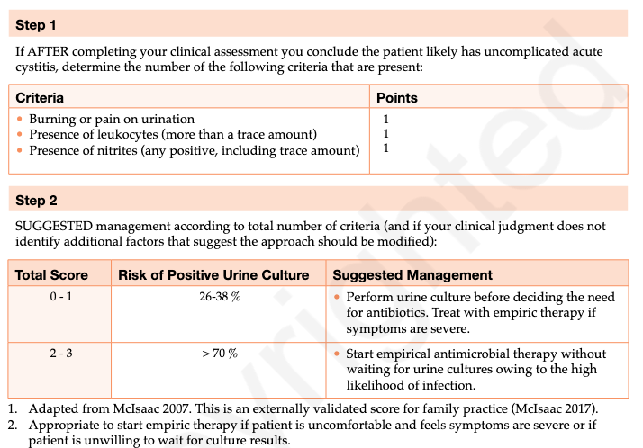  Laboratory tests  - IN ACUTE UNCOMPLICATED CYSTITIS: Urine culture is usually not recommended unless failure to respond to empiric therapy or early recurrence <1 month later  - IN NURSING HOMES/LTC: obtain urine specimen before initiation antimicrobial therapy  - Routine screening is not recommended  - IN PYELONEPHRITIS: initial urine C&S should always be performed before starting treatment  - Pyuria is almost always present in women (>2-5 leukocytes per high power microscopic field)  - pre-treatment culture is required; no repeat cultures required for asymptomatic patients  - Culture for chlamydia and gonorrhea  - IN INTERSTITIAL CYSTITIS: urinalysis to rule out hematuria, urine C&S to evaluate bacteria levels  Diagnostic tests and/or Imaging  - Imaging studies may be indicated in first UTI for boys of any age, girls under 3, and second UTI for girls over 3, anyone with family history of UTI, hypertension, poor growth, abnormal voiding patterns  - IN INTERSTITIAL CYSTITIS: may consider cystoscopy, ultrasound, or bladder biopsy to rule out other conditions  - FOR PYELONEPHRITIS: not routinely required but can be helpful to rule out masses or obstruction
Treatment/ Management | Counseling/Education  FOR INTERSTITIAL CYSTITIS  - Bladder irritants= foods rich in potassium- try eliminating them methodically  - Alcohol, tomatoes, spicy foods, chocolate, coffee, artificial sweeteners, citrus, cranberries  Complementary Therapies (non-pharmacological)  FOR CYSTITIS  - Fewer UTIs associated with women drinking an additional 1.5L of water per day  - Cochrane review for cranberry products…  - Decrease the risk of symptomatic UTIs in women with recurrent UTIs, children, and people susceptible to UTIs following interventions  - Not supported in the elderly, patients with bladder emptying problems, or pregnant women  - Always order a urine culture if UTI is suspected in a pediatric patient  FOR INTERSTITIAL CYSTITIS  - Limit fluid intake to 64 ounces per day (16 per meal, 8 between meals)  - Time voiding on a 2-3 hour schedule  - Kegel exercises should be avoided  FOR PYELONEPHRITIS  - Increase fluid intake, drink cranberry juice to help fight and prevent UTI  - No dietary restrictions
Advise clients when to RTC or call for help | Require hospitalization if dehydrated or unable to take oral fluids/medications
Referrals | FOR INTERSTITIAL CYSTITIS  - Physiotherapy for pelvic floor exercises  - Massage, acupuncture, trigger point injections  - Urologist for a thorough workup and testing  - Pain management as indicated  FOR PYELONEPHRITIS:  - For women with recurrence of this, further urologic investigation is required
Follow-up | RECURRENT CYSTITIS→ Reassess after 6 months of therapy if prophylaxis is being used  If pregnant→ monthly follow-up cultures if they are susceptible to recurrence  FOR PYELONEPHRITIS→ within 24-48 hours depending on initial symptom severity  - If symptoms and fever remains after 48-72h, should add another class of meds  - Follow up cultures not required if symptoms resolve with antibiotics
Common Complications | Pyelonephritis can cause kidney scarring and lead to significant damage  - Kidney failure, abscess formation, sepsis
1° and 2° Prevention | Primary prevention
References | Cash & Glass

VAGINAL ATROPHY (ATROPHIC VAGINITIS)
Short definition/ description | Inflammation of the vaginal epithelium due to a lack of estrogen support
Pathology/cause | Anything that lowers estrogen levels after puberty can result in a loss of vaginal thickness and rugosity, decreasing the elasticity of the vaginal tissues  - Estrogen maintains the vagina lpH in an acidic rage  - Lack of estrogen promotes and increase in pH that supports the development of bacterial infectious, a decrease in vaginal glycogen, and thin-walled epithelium  - Promotes friability and inflammation
Epidemiology | Very common. May occur during preadolescence, while breastfeeding, and post-menopause
Risk Factors | Preadolescence, breastfeeding, post menopause, ovarian failure  - May consider this a desired side effect of masculinizing hormone therapy
Screening | 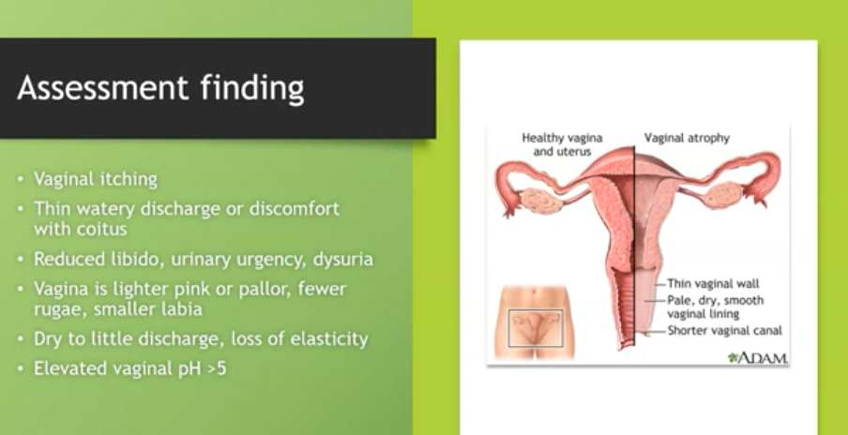
Clinical Presentation  (Subjective Symptoms & Objective Signs) | HALLMARK: pale vaginal mucosa with splotchy red patches  Common findings:  - A common finding after 1-6 months of starting masculinizing hormone therapy  - Peak effect is seen at 1-2 years after starting therapy  Other signs and symptoms:  - Vaginal dryness, dyspareunia, dysuria  - Post-coital bleeding, thin vaginal discharge, vaginal itching
Hx/Key Questions | OPQRST of symptoms  - Is it a new problem, and are there new uses of products recently?  - Determine color, amount, and odor of discharge  - Determine any vasomotor symptoms such as hot flashes  - Urinary symptoms?  - Breastfeeding? How long?  - Last date of menses, irregularity of cycles, reproductive surgery  - Sexual partners and practices, current medications  - HRT use, pap test history
Physical Exam | VITALS: temperature, pulse, respirations  INSPECT: for general discomfort before, during and after examination  PALPATE: CVA tenderness, and abdomen for suprapubic tenderness  PELVIC EXAMINATION  - Inspect for common menopausal signs  - Sparse, brittle pubic hair  - Shrinking of the labia minora  - Inflammation of the vulva  - Other inspection includes signs of erythematous vulva, labial edema, excoriation if pruritus is present  - Palpate for discharge in the urethra to rule out infection  - Perform a speculum and bimanual examination
Red Flags
Differential Diagnosis | Trauma, foreign body in the vagina, UTI, vaginitis from an infective cause, contact irritation, menopause, side effect of masculinizing hormonal therapy
Diagnostics:  Labs & Imaging | 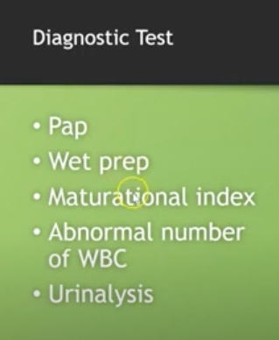Laboratory tests  - Routine hormonal measurements are not indicated for menopause screening  - Culture for urine if applicable  - Assess vaginal pH level, pap smear  - Wet prep, chlamydia/gonorrhea cultures, and endometrial biopsy if applicable  Diagnostic tests and/or Imaging  - Need to thoroughly rule out endometrial cancer if there is post-menopausal bleeding
Treatment/ Management | Counseling/Education  - Symptoms in preadolescent girls will resolve with puberty and increase of estrogen levels  - A physical, not an emotional problem (WTF does this mean)  Complementary Therapies (non-pharmacological)  - Regular sexual activity can decrease the problems associated with atrophic vaginitis  - Masturbation can facilitate the natural production of lubricating secretions by the body  - A decline in sexuality may be influenced by culture and attitudes as well as physical problems  - Use of water-soluble lubricants during sexual activity  - Pregnancy prevention needs to be included (perimenopausal symptoms do not ensure lack of fertility)
Medical management | Can be treated with topical vaginal estrogen, calamine lotion, or even oral therapy
Advise clients when to RTC or call for help
Referrals | Consult for endometrial biopsy if there is doubt about the origin of any postmenopausal bleeding
Follow-up | Follow-up with breastfeeding women after weaning to see if symptoms are persisting  Return to clinic 1-2 months after beginning oral or vaginal therapy, and then in 3-6 months to check for side effects, monitor BP, and response to therapy
1° and 2° Prevention | Primary prevention
References | Cash & Glass

VULVOVAGINAL CANDIDIASIS
Description | A yeast-like fungus infection of the vulva and vagina (90% caused by candida albicans)
Pathology | Candida is part of the normal flora of the mouth, GI tract, and vagina. Can become pathogenic if there are pH changes that encourage overgrowth.
Epidemiology | 75% of women will have at least one episode of candidiasis, and 50% of these women will have recurrences  In men, symptomatic complaints are more common if uncircumcised
Risk Factors | Diabetes, systemic antibiotic use, pregnancy, oral contraceptive pill use, obesity, warm climates, immunocompromised, HIV, wearing tight/restrictive clothing, corticosteroid use, tub bathing, and frequent use of hot tubs or whirlpools
Screening
Clinical Presentation  (Subjective Symptoms & Objective Signs) | 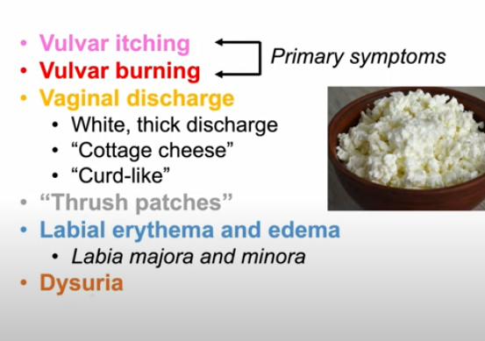HALLMARK: thick, white, “cheesy” vaginal discharge that is adherent to the vaginal wall, and mild to intense vulvar itching  Common findings:  - Discomfort after sexual intercourse, redness/irritation/swelling of the vagina or vulva  Other signs and symptoms:  - Vulvar excoriation, vaginal swelling or inflammation, burning with urination or intercourse, increase in symptoms near menses
Hx/Key Questions | OPQRST of symptoms, whether it is a first occurrence, recurrence or persistence, vs chronic  - Medication history (antibiotics, steroids, birth control pills)  - Past medical history, evidence of diabetes, HIV, immunity level  - Review use of hot tubs, whirlpools, tight exercise clothing  - Polyester underwear use, underwear to bed, tight jean wearing  - Previous treatment, self-treatment, and compliance  - Determine pregnancy status, sexual activity, partners  - Use of vaginal products like deodorants or sprays, scented toilet paper, tampon use, pads ad douching  - Changes in laundry soaps, softeners, or detergents  - Review diet for high-sugar content
Physical Exam | VITALS: temp, pulse, BP  INSPECT: vulva for inflammation, fissures, lesions, excoriations, rashes, condyloma  - Examine hairline and skin folds for inflammation, irritation, or skin breakdown  - Ote any erythema or drainage from potential secondary bacterial infection  PALPATE:  - External exam for enlarged or tender lymph nodes, vulvar masses, or lesions  - CVA tenderness  PELVIC EXAM:  - Inspect side walls of the vagina for erythema  - Note amount, odor, and colour of any discharge  - Inspect cervix for discharge and friability; bimanual exam for CMT, uterine size and adnexal masses/tenderness
Red Flags
Differential Diagnosis | Vulvar dystrophy, bacterial vaginosis, chlamydia, gonorrhea, trichomonas, HSV-2, chemical vaginitis, normal physiological discharge
Diagnostics:  Labs & Imaging | Laboratory tests  - Wet prep with 10% KOH and normal saline prep  - Yeast hyphae and spores: use these preps under microscope examination of vaginal discharge  - Test discharge with nitrazine paper  - pH with candidiasis remains in the normal range of <4.5  - Consider chlamydia and gonorrhea testing, herpes culture if lesions present, or urine C&S if symptoms present  Diagnostic tests and/or Imaging  - Consider 2-hour glucose testing
Treatment/ Management | Counseling/Education  - Upon initial symptoms, encourage evaluation for other etiology before using OTC treatment  - Consider treating partners as well  - Continue treatments even during menstruation
Advise clients when to RTC or call for help | Come in for re-evaluation if symptoms persist despite treatment
Referrals | To specialist if there is no response to treatments or concurrent systemic disease
Follow-up | Strongly consider diabetes and HIV testing if clients are presenting with recurrent yeast infections
Common Complications | Risk of transmission from mother to baby during delivery
1° and 2° Prevention | Primary prevention
References | Cash & Glass

Abnormal Uterine Bleeding
Def’n | Abnormal duration, frequency and amount of blood loss  Menorrhagia-heavy bleeding overal several consecultive cycles (more than 80mL blood loss lasting >7 days)  Metrorrhagia-irregular bleeding or between periods  Menometrorrhagia- prolonged or excessive bleeding that is irregular  Polymenorrhea: Frequent cycles (<21 days apart).  Oligomenorrhea: Infrequent cycles (>35 days apart).  Postmenopausal bleeding: Requires immediate investigation for malignancy!!!  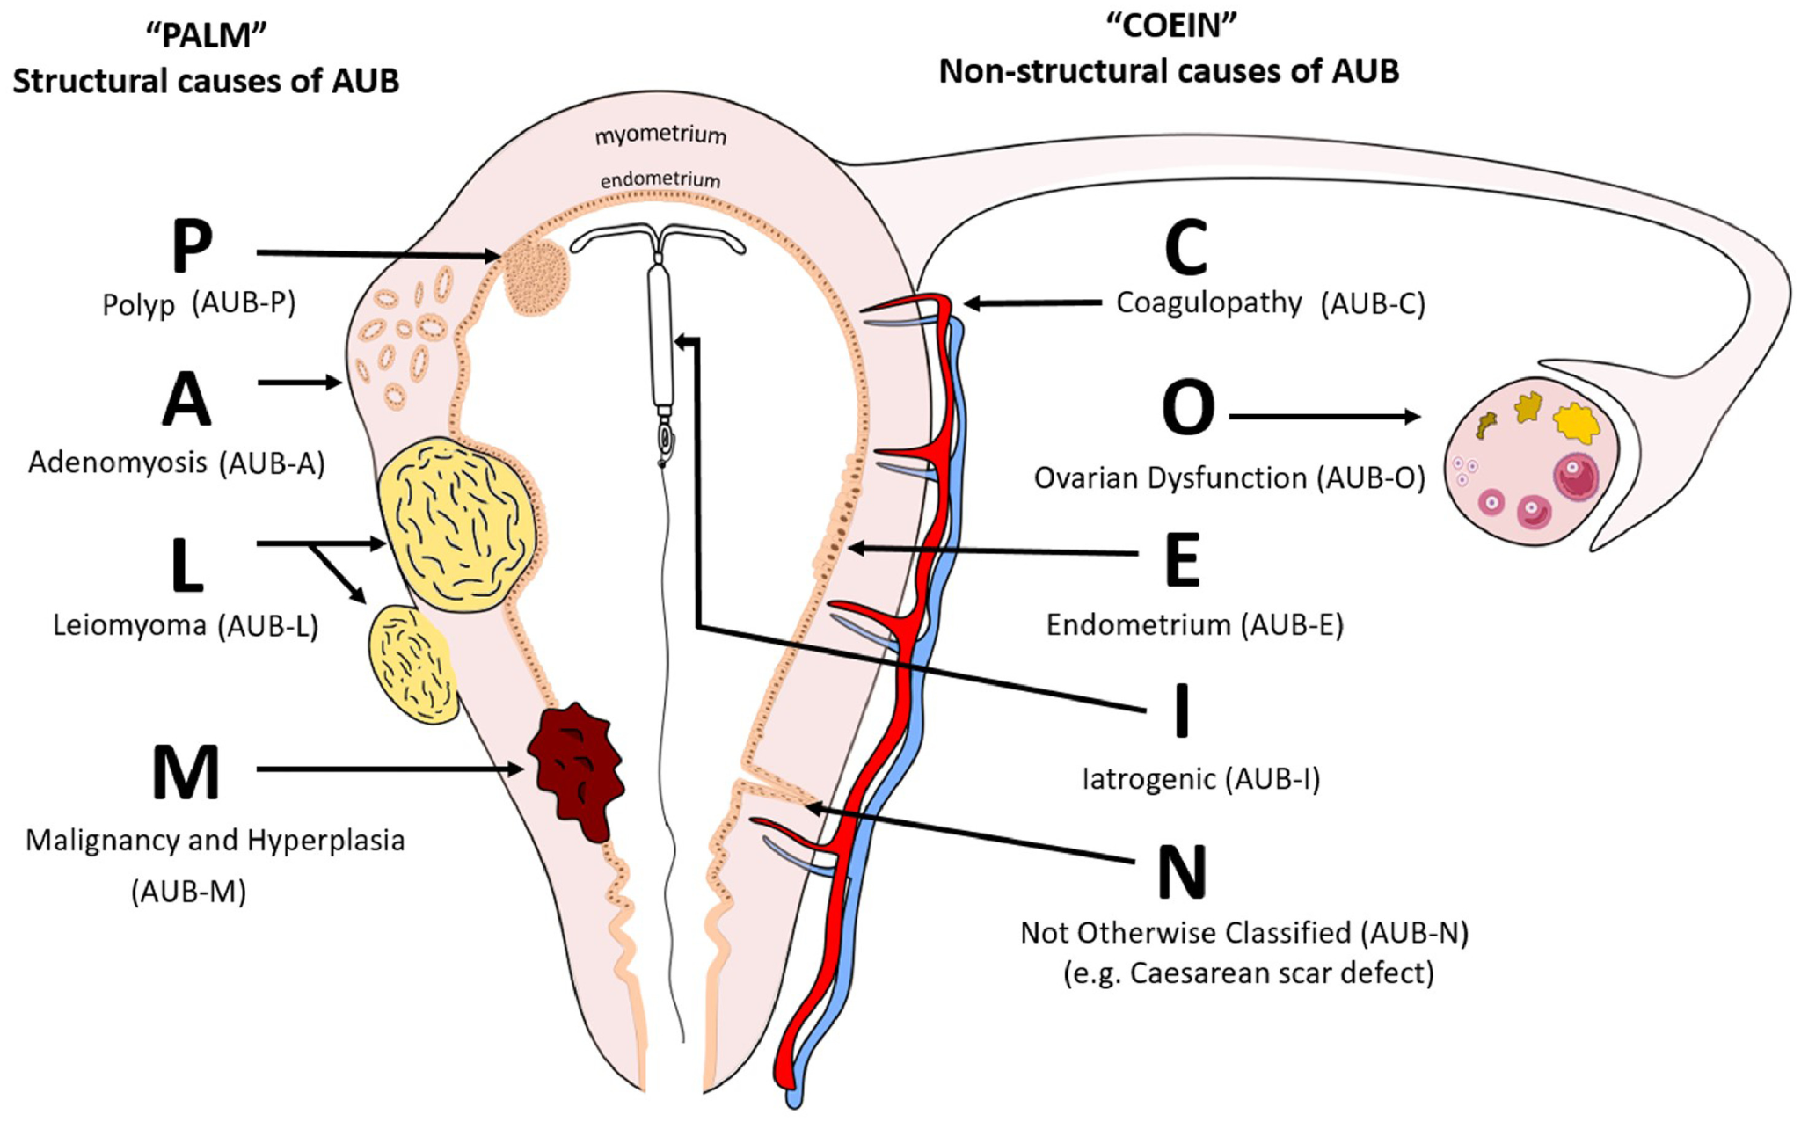  Dysfunctional AUB (Abnormal Uterine Bleeding) and structural AUB refer to two different causes of abnormal uterine bleeding in women.  - Dysfunctional AUB (formerly known as "Dysfunctional Uterine Bleeding" or DUB) is related to hormonal imbalances without any identifiable structural abnormalities in the reproductive organs. It's common during anovulatory cycles, such as during puberty or approaching menopause.  - Structural AUB refers to bleeding caused by identifiable physical abnormalities in the uterus or surrounding structures. These can include conditions such as fibroids, polyps, adenomyosis, or malignancies.  1. Dysfunctional AUB  -diagnosis of exclusion when there no pelvic pathology or underlying medical cause  Normal:  Frequency of cycle: 28 days  Duration: four days  Amount: bleeding 80ml or 40ml (contradicting from resources)  Abnormal:  -bleeding occurs before the age of 8 (caused by injury or sexual abuse)  - if cycle occurs more often than every 21 days (polymenorrhea)  - less often than every 35 days (oligomenorrhea)  -bleeding irregularly (intermenstrual bleeding, metrorrhagia)  -bleeding over seven days or bleeding more than 80ml (menorrhagia)  (saturating more than one pad/tampon hourly for several consecutive hours)  -regular bleeding but with decreased flow (hypomenorrhea)  -disorder of the hypothalamic-pituitary-ovarian axis leads to:  Menorrhagia, polymenorrhea, menometrorrhagia (too heavy and irregular)  2. Structural AUB:  Caused by structual issues .  Normal:  - Frequency of cycle: 28 days  - Duration: ~4 days  - Amount: Around 40–80ml (varying sources)  Abnormal Patterns:  - Polyps: Benign growths that can cause irregular or heavy bleeding.  - Adenomyosis: Endometrial tissue growing into the uterine muscle, leading to heavy, painful periods.  - Leiomyomas (Fibroids): Non-cancerous growths that can cause heavy bleeding, prolonged periods, or bleeding between periods.  - Malignancy: Cancerous growths can cause irregular or excessive bleeding, especially postmenopausal bleeding.
Pathology/Cause | -PID- heavy period, often caused by chlamydia and gonorrhea  -endometritis- heavy period  -Cervical polyps- bleed after intercourse  -Cervical cancer- bleeding due to disruption of cervical cells (perimenopausal and postmenopausal bleeding)  -Cervicitis-bleeding due to inflammation and irritation of mucosa  -Atrophic vaginitis-dry friable vagina can bleed  -Uterine fibroids- heavy irregular bleeding,  -STI (genital warts/syphilis)- abnormal bleeding due to inflammation and irritation of mucosa  -PCOS- chronic irregular menstrual cycle  -anovulation - more estrogen and less progesterone- menstrual pattern that is longer than 28 days with heavy flow up to 14 days (caused by thicker more vascular endometrium), often occurs during first year of menses  -hypothyroid- menorrhagia  -hyperprolactinemia- menometrorrhagia. loigomenorrhea  -perimenopause: irregular bleeding, spotting, missed period, period can become heavier and longer or shorter and lighter in other months  -Ectopic pregnancy- irregular spotting  -pregnancy- bleeding during implantation and first trimester  -spontaneous abortion-  -placenta previa- painless bleeding  -bleeding after child birth- caused by retained placenta  Systemic causes:  -Blood dyscrasia (leukemia), clotting disorder Ivon willebrand disease),liver and kidney disease, medications (NSAIDS, anticoagulants, hormones)  -birthcontrol-IUD-menorrhagia  -estrogen pills with no progesterone will cause bleeding  -drugs such as tamoxifen, phenobarbital, rifampin, aspirin  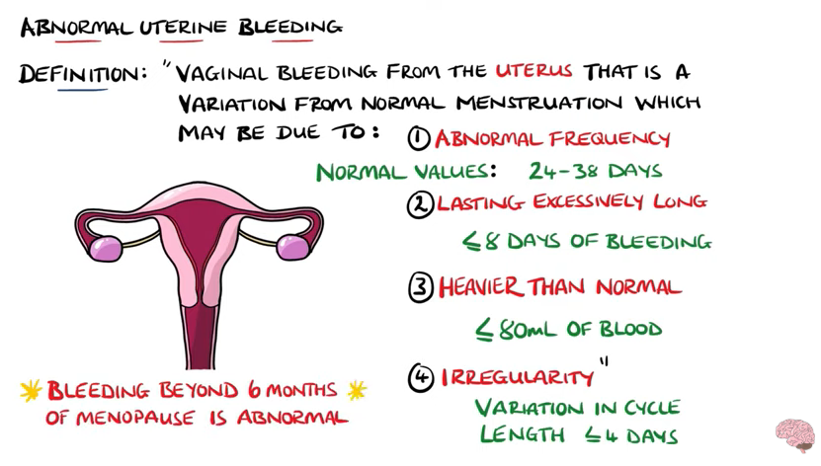
Risk Factors/Epidemiology | Clotting disorder (von willebrand disease)
Clinical Presentation  *Insert picture here* | 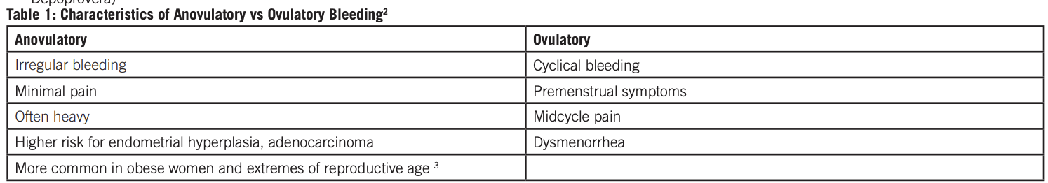  General assessment:  -assess for hirsutism, skin or hair changes can indicate HPO axis imbalance, bleeding  -weight- anorexia can cause amenorrhea, overweight can be linked to anovulatory cycle  -BMI  -abdominal exam  -check lymph nodes- enlargements can be due to STI or cancer  -thyroid exam  -Pelvic exam (mass, tendernessm cervical changes)  Vital signs:  -hemodynamically stable with bleeding (tachy, tachypnea, hypotensive)  Bleeding after intercourse can be caused by cervical polyps
Hx/Key Questions | - When did the bleeding begin? How long have you been bleeding? What is the flow like? How many pads do you use? Are there any accompanying problems?  - Do you have bleeding anywhere else?  - What does it look like? Colour?  - Med hx: Steroids, homrone repleacemnt, sprilocation, herbal, tamoxifen, ASA, antidepressants?  - Stress?  - Contraception?  - Family hx AUB/cancer/fibroids  - Sexually active? Pregnant?  - How heavy is bleeding? Do you have a bleeding disorder? Are you taking anticoagulants/ NSAID/ hormones?  - Do you have symptoms of pregnancy (missed period, breast tenderness, NV)  - Do you have symptoms of menopause? (vaginal dryness, hot flashes, night sweats?)  - Have you noticed any sores, lumps, rashes or lump in vagina? Do you have any vaginal discharge or burning or itching?
Physical Exam | 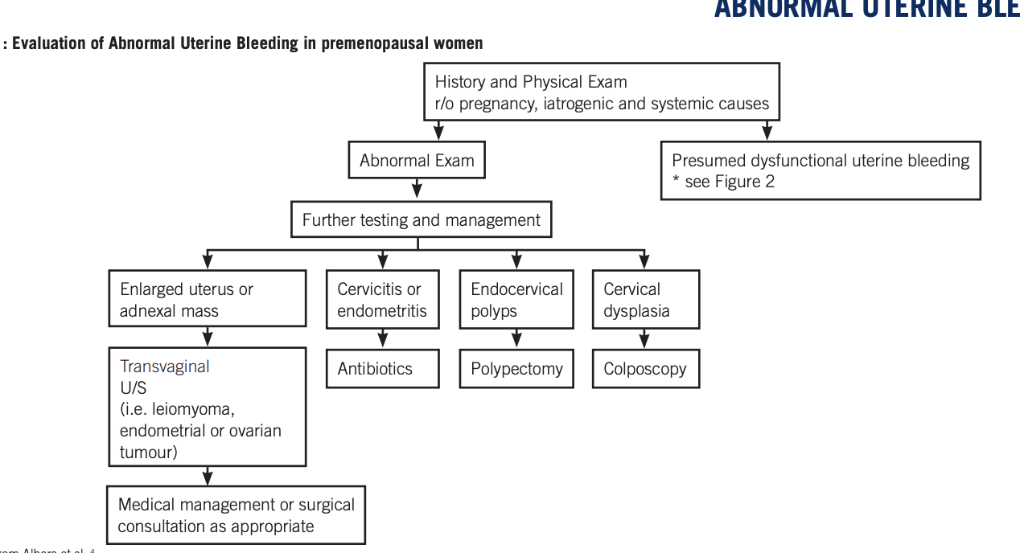  Weight, BMI  Thyroid exam  Inspect for bleeding disorders (petechiae, bruising present on skin)  -feel lumps or masses  -Abdominal exam to look for stigmata of liver disease  -Dermatologic exam (acne, hirsutism, jaundice acanthosis nigricans)  Pelvic exam:  -Uterine enlargement, adnexal mass, cervical changes, cervical motion tenderness  -external genitalia  -labia lesion, signs of bruising or lacerations could be caused by sexual abuse, check for atrophic vaginitis  -look for cervical changes
Diagnostics/Labs | - Transvaginal and lower abdominal US (day 4-5 of cycle)  - ** First line for young women with no risk factors  - Endometrial biopsy: Recommended for women over 40 with irregular bleeding and at risk of endometrial cancer. A histological evaluation helps rule out hyperplasia and malignancy.  - **First line if older/has risk factors  - Pelvic ultrasound- diagnose cause (PID, uterine fibroids)  - CBC, ferritin – r/o anemia  - Endometrial biopsy should be considered if patient has risk factors for developing endometrial carcinoma  - Dilation and currettage (not an ideal investigation as there can be sampling errors, reserved if office biopsy of hysteroscopic biopsy not available))  - STI testing/ Pap test- cervical dysplasia  - Check platelets, clotting studies (PTT, INR), Hct, Hgb  - CBC/ ferritin (r/o anemia)  - Check estrogen and progesterone levels  - Check FSH and LH levels  - Prolactin levels (elevated in PCOS)  - Pregnancy Test- positive human chorionic gonadtropin (hCG) test and US  - Saline sonohysterography: may improve the diagnosis of an intrauterine mass or endometrial abnormality during TVUS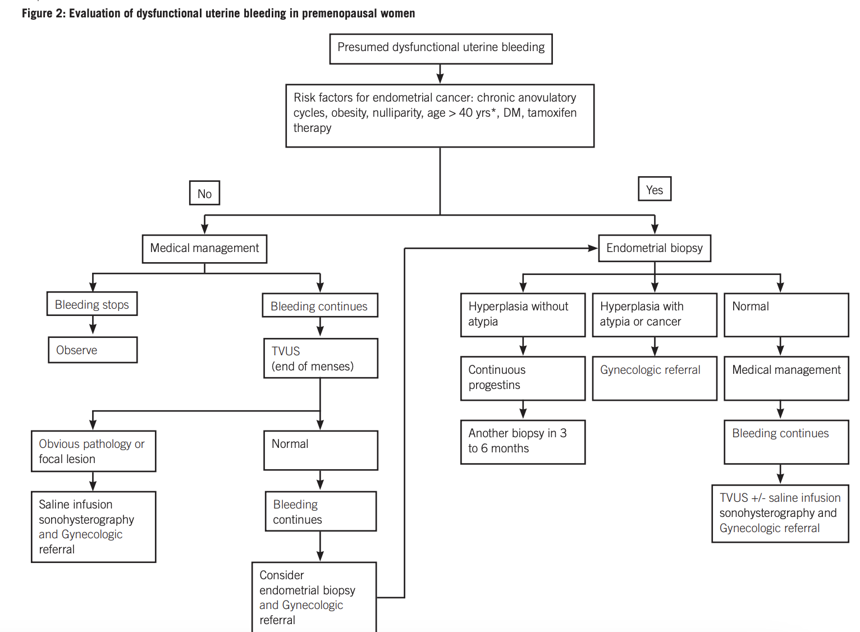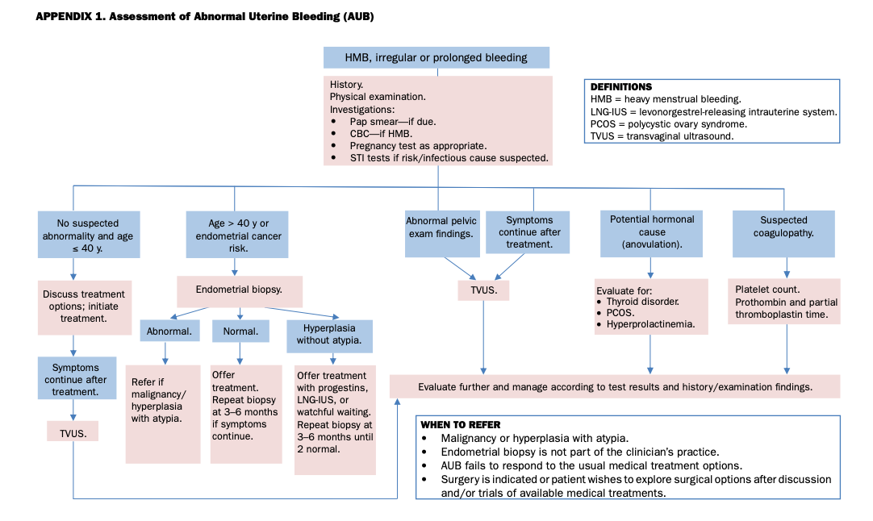
Red flags | Excessive blood loss making them hemodynamically unstable  Bleeding after hysterectomy or menopause- cancer suspicion
Differential Diagnoses | Abnormal bleeding is a diagnosis of exclusion and must find out the cause of underlying disease, condition or infection.
Treatment/Management | Treatment:  Counseling/Education:  Non-pharm therapies:
Referrals | Refer if:  -atypical biopsy/US refer to gyne  - no improvement in bleeding despite medical management  -can't do endometrial biopsy when indicated  -obvious pathological or focal lesion  -abnormal biopsy results
Follow-up

Abnormal Uterine Bleeding in Family Practice
Abnormal Uterine Bleeding (AUB) refers to changes in the frequency, duration, or amount of menstrual bleeding. Pregnancy must always be ruled out in women of childbearing age.
Diagnostic Considerations:
- Definitions:
  - Dysfunctional Uterine Bleeding (DUB): Diagnosis of exclusion when no pelvic pathology or underlying medical cause is found.
  - Menorrhagia: Heavy bleeding (>80ml/cycle) over several consecutive cycles during reproductive years.
  - Metrorrhagia: Bleeding at irregular intervals, between periods.
  - Menometrorrhagia: Prolonged or excessive bleeding occurring irregularly and more frequently.
- Normal Menses:
  - Frequency: 28 days ± 7 days
  - Duration: 4 days ± 2 days
  - Blood Loss: 40ml ± 20ml
History:
- Bleeding History: Pattern, timing, frequency, amount.
- Ovulatory vs Anovulatory Bleeding (refer to Table 1).
- If postcoital or intermenstrual bleeding occurs, rule out local causes like cervical infection, polyps, dysplasia, or cancer.
- Medication History: Anticoagulants, aspirin, antipsychotics (phenothiazines), antidepressants (SSRIs/TCAs), tamoxifen, herbal supplements (ginseng/ginkgo/soy), corticosteroids, hormone replacement therapy, and contraceptives (OCP, IUD, Norplant) can cause bleeding.
Physical Examination:
- General Exam: Weight, BMI, thyroid, and abdominal exam for signs of liver disease.
- Dermatologic Exam: Look for acne, hirsutism, jaundice, and acanthosis nigricans.
- Pelvic Exam: Assess for uterine enlargement, adnexal masses, cervical changes, or cervical motion tenderness.
Investigations:
- CBC, Ferritin: Rule out anemia.
- Pap Test +/- STI Swabs: Rule out infection and cervical dysplasia.
- Transvaginal Ultrasound (TVUS): Done on day 4-5 of the cycle to assess for abnormalities or ongoing bleeding.
- Endometrial Biopsy: Considered if risk factors for endometrial carcinoma are present. Endometrial sampling is more reliable than D&C.
- Saline Sonohysterography: May help diagnose intrauterine masses or endometrial abnormalities.
- Further Tests: Consider systemic causes based on clinical suspicion (see Table 2).
When to Refer:
- No improvement despite medical management.
- Inability to perform endometrial biopsy when indicated.
- Obvious pathology or abnormal biopsy results.
Bottom Line: DUB is a diagnosis of exclusion. Pregnancy, systemic, anatomic, and iatrogenic causes must be ruled out. A thorough history, physical exam, and appropriate investigations are crucial. Endometrial biopsy should be considered in patients at risk for endometrial carcinoma. Several medical and surgical treatments are available for DUB management.

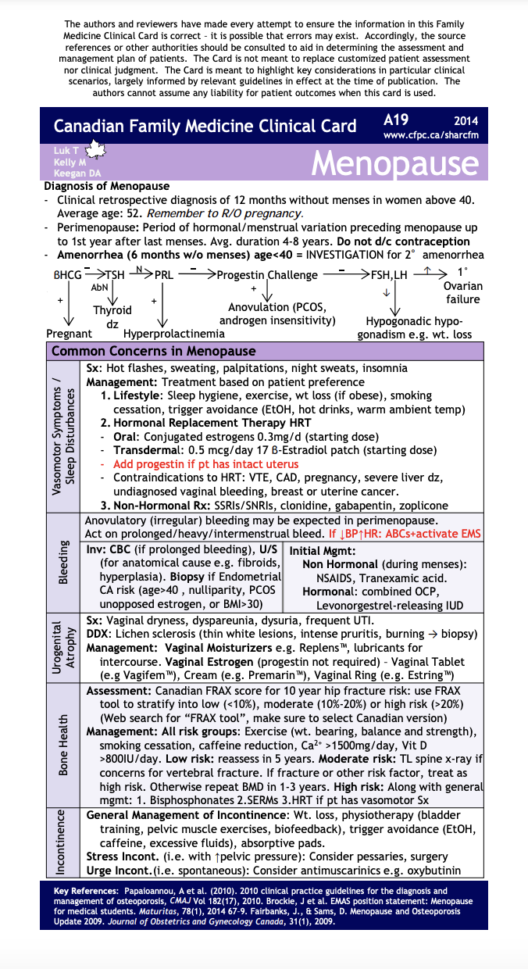

Endometriosis
Definition | Implantation and growth of endometrial tissue (tissue that normally lines the uterus) outside of the uterine cavity, often in the pelvic cavity, that responds to hormonal fluctuations. This ectopic tissue undergoes bleeding during menstruation, leading to inflammation, pelvic pain, and scarring.
Pathology/Cause | - Endometrial tissue responds to estrogen and progesterone levels, which cause the tissue to thicken, break down, and bleed, similar to the normal endometrium. The excess bleeding causes inflammation, scarring, and adhesions (fibrous bands of tissue that cause organs to stick together).  - The retrograde menstruation theory is the most accepted cause, where menstrual blood containing endometrial cells flows backward through the fallopian tubes and implants in the pelvis.  - Immune system dysfunction may also play a role, as the body may not recognize and destroy ectopic endometrial tissue.
Risk Factors/Epidemiology | - Affects women of reproductive age (typically 20-40 years old).  - More common in nulliparous women (those who have never been pregnant).  - Increased risk with a family history of endometriosis.  - Higher risk in women with short menstrual cycles, heavy menstrual flow, and long periods of menstruation.  - Women with a first-degree relative (mother, sister) who has endometriosis are at greater risk.  - Women with immunological disorders (autoimmune conditions) may have a higher incidence.
Clinical Presentation | Hallmark: severe pelvic pain often before and during menstruation, which worsens over time and dyspareunia (painful intercourse) particularly with deep penetration, may occur due to adhesions or endometriotic lesions in the pelvic region.  Other S/S:  Pain location→ Pelvis, lower abdomen, inguinal region, lower back.  Abdominal pain during exercise (due to muscular strain and endometriotic adhesions).  Menstrual symptoms→ Dysmenorrhea (painful periods), menorrhagia (heavy periods), irregular menstrual bleeding, spotting.  GI symptoms→Bloating, nausea, vomiting, dyschezia (painful or difficult bowel movements), rectal bleeding.  Urinary symptoms→Painful urination, urinary frequency, dysuria (painful urination), and hematuria (blood in urine).  Associated infertility (about 30-50% of women with endometriosis experience difficulty conceiving).  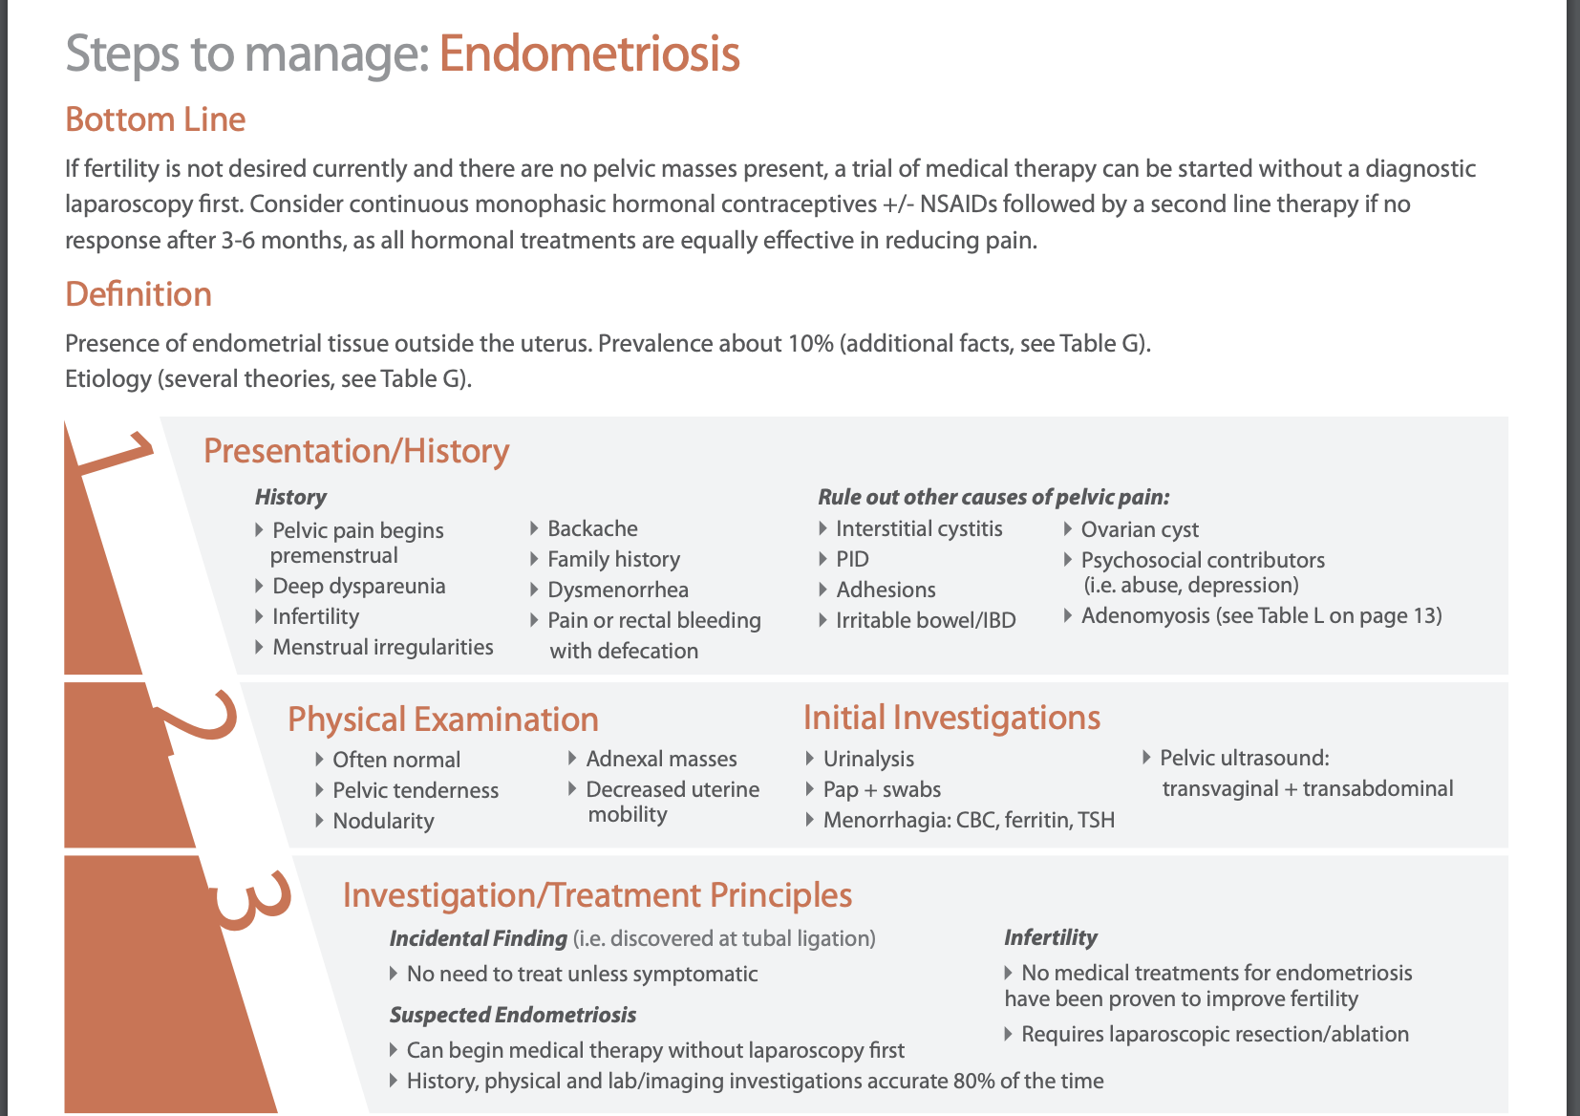
Hx/Key Questions | - Menstrual history frequency, duration, and flow characteristics.  - Use of oral contraceptives or other hormonal therapies for pain relief.  - Changes in bowel habits (constipation, diarrhea, bloating).  - Dyspareunia (painful intercourse) – location and severity.  - Fertility issues or history of miscarriage.  - History of pelvic infections (PID, STIs) or previous surgeries (C-sections, ovarian cysts).  - Family history
Physical Exam | Vitals (Typically normal, unless there is acute pain or associated infection)  Abdominal exam→Tenderness in the lower abdomen or pelvis, with possible rebound tenderness (especially if there is an infection or acute flare). The uterus may feel fixed (due to adhesions) and non-mobile on palpation.  Bimanual exam may show tenderness or masses (such as ovarian cysts or endometriotic nodules). CMT may be present.  Pelvic exam→ Cervical discharge, odour, colour changes may suggest infection.  Pelvic organ mobility may be restricted due to adhesions or scar tissue.
Diagnostics/Labs | - b-HCG to rule out pregnancy  - CBC to rule out infection (pelvic inflammatory disease, appendicitis).  - STI testing  - Urine dip/cultur to rule out UTIs  - Transvaginal ultrasound …not always diagnostic for endometriosis but first line to r/u obarioan cysts  - Also a retroverted uterus on an U/S is a key indicator of endo  - Laparoscopy→The gold standard for diagnosis (requires surgical procedure). During laparoscopy, endometrial implants can be visualized and biopsied/burned away….but now theres blood work you can do instead called EndomiR which is less invasive and give you the same results!!! It costs $300 though.  - Often gyne will treat empirically if you have pain with sex and menustartion without a laparoscopy as it is invasive.
Red Flags | Severe acute pain or fever with a rapid onset may suggest acute pelvic infection or ruptured ovarian cyst. Heavy menstrual bleeding or severe dysmenorrhea not improving with treatment may indicate ovarian cancer.
Differential Diagnoses | primary dysmenorrhea, ovarian cysts, PID, IBD, UTI, fibroids (leiomyomas) bladder infections (especially if urinary symptoms are prominent), pelvic tumors or ovarian cancer.
Treatment/Management | Non-surgical management:  NSAIDs, hormonal therapy (visanne), IUD  Surgical treatment (for severe or refractory cases):  Laparoscopic surgery to remove or ablate endometriotic implants, adhesiolysis (removal of adhesions), or ovarian cystectomy for endometriomas.  Hysterectomy especially in women who have completed their family planning.
Counseling/Education | It is achronic condition that can cause fertility issues, but many women with endometriosis can still conceive with treatment.  Discuss importance of early diagnosis to prevent disease progression and improve symptom management.  Encourage women to track symptoms, menstrual cycles to help with diagnosis
Referrals | Gynecology referral for initial management and potential surgical consultation for laparoscopy if diagnosis is uncertain. Consider fertility specialist referral if the patient has trouble conceiving.
Follow up | Once referred to gyne then follow up PRN

Endometriosis
Def’n | -Implantation and growth of endometrial tissue outside of the uterine cavity that exhibits a hormonal response and this tissue exhibits bleeding. Bleeding from the ectopic endometrial tissue causes pelvic inflammation and scarring.
Pathology/Cause | -Endometrial thickness varies depending on the amount of estrogen and progesterone levels  -Retrograde menstruation is the most popular theory where menses flow backward through fallopian tubes causing tissue to grow outside of the uterus  -The tissue can attach to intestine and cause scar tissue and pelvic adhesions, pelvic pain, obstruction of fallopian tube, decreased ovarian function.
Risk Factors/Epidemiology | -Affects women at reproductive age  Risks:  -Family history  -
Clinical Presentation | -severe pain before and during menses that gets worse over time  -dyspareunia (painful intercourse) may occur because of adhesion  Pain found in:  -pelvis  -lower abdomen  -inguinal  -back  -dyspareunia  -abdominal pain occurring during exercise  Menstrual symptoms: dysmenorrhea, menorrhagia, irregular menstrual bleeding, spotting  GI symptoms: Bloating, nausea, vomiting, dyschezia (difficulty having a BM), painful BM, rectal bleeding  Urinary symptoms: pain on micturition, urinary frequency
Hx/Key Questions | Ask about:  Menstrual frequency, duration,  Use oral contraceptives  Change in BM  Dyspareunia?  Fertility issues?
Physical Exam | Vitals  -the uterus may feel fixed and abdominal pain can be noticed  -may not palpate any nodular masses  -auscultate abdomen  -palpate abdomen for masses  -inspect cervix for: discharge, colour, odour  -bimanual exam: check for cervical motion, tenderness, uterine size position and mobility  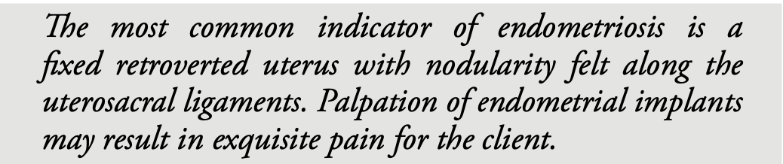
Diagnostics/Labs | HCG rule out pregnancy  WBC rule out infection  Cervical culture for chlamydia and gonorrhea to rule out STI and PID  Urine culture  Transvaginal US to rule out cysts and masses
Red flags
Differential Diagnoses | Dysmenorrhea, ovarian cysts, PID
Treatment/Management | Treatment:  Counseling/Education:  Non-pharm therapies:
Referrals | Gynae for initial management, surgical consultation if need definitive diagnosis
Follow-up

Dysmenorrhea
Definition | Lower abdominal pain or cramping that occurs with menstruation. Pain can radiate to the lower back or upper thighs.
Primary Dysmenorrhea | No pathological cause. Onset is usually soon after menarche, gradually diminishes with age. Associated with ovulatory cycles, worse on the first day of the period. Caused by prostaglandin-induced myometrial contractions (leading to pain).
Secondary Dysmenorrhea | Due to underlying pathology such as endometriosis, PID, adenomyosis, fibroids, IUDs, polyps, or cervical stenosis.  Onset is usually 20–40 years. May worsen over time and require additional evaluation.
Risk Factors | - Age (teens and early 20s for primary; 20–40 for secondary).  - Family history.  - Early menarche.  - Heavy or irregular periods.  - Smoking.  - Nulliparity.
Clinical Presentation | Primary dysmenorrhea: Cyclic pain during menstruation, often associated with nausea, vomiting, diarrhea, and headache due to prostaglandins.  Secondary dysmenorrhea: Progressively worsening pain, may occur outside of menstruation.
History/Key Questions | Age of menarche.  Period characteristics  - frequency, duration, regularity, flow amount, number of pads/tampons used.  Pain onset, location, radiation.  Associated symptoms such as nausea, bowel/bladder changes, dyspareunia.  Questions to rule out STDs (chlamydia)  Rule out hx of gyne concerns (ex. endometriosis)  R/u pregnancy
Physical Exam | Vitals (fever to r/u infection).  Inspect→ Abdo for distention, palpate for tenderness/masses.  Complete special tests to rule out appendicitis, or other causes of pain if indicated  Pelvic exam→Palpate for uterine/adnexal tenderness, cervical motion tenderness.  Consider Pap smear if needed.  If considering rectal vs vaginal bleeding consider DRE
Diagnostics/Labs | First line: Pelvic ultrasound (preferred for secondary causes).  Also consider: CBC (rule out anemia), WBC, STD tests(Chlamydia and gonorrhea), Pregnancy test.
Red Flags | - Severe pain or progressively worsening pain, intermenstrual bleeding, or postmenopausal bleeding!!!! (could mean cancer). Fever or systemic symptoms, infertility or dyspareunia.
Differential Diagnoses | Primary dysmenorrhea, Endometriosis, PID, Ovarian cysts, Adenomyosis, Fibroids, IUD-related pain, Ectopic pregnancy, IBS, Interstitial cystitis.
Treatment/Management | Primary Dysmenorrhea: NSAIDs (ibuprofen), hormonal contraceptives (Progesterine only pill), heat therapy, exercise.  Secondary Dysmenorrhea: Treat underlying cause ( antibiotics for PID, surgery for fibroids, etc.).  Reassure about the nature of primary dysmenorrhea. Discuss non-pharmacological options: heat packs, yoga, acupuncture. Educate on medication adherence.
Referrals | Gynecology consult and pelvic ultrasound for secondary dysmenorrhea, abnormal pelvic exam, or increasing severity/disability.
Follow-Up | Reassess in 3 months. Monitor response to treatment.

Bacterial Vaginosis
Def’n / Pathology/Cause | -bacterial alteration in vagina, less lactobacillus and more anaerobes and gram-negative bacilli; increased pH
Risk Factors/Epidemiology | -history of STIs, multiple sexual partners, IUD, hormonal changes, medications (abx, oral contraceptives), foreign bodies in vagina (douching, tampons, IUD)
Clinical Presentation | Halmark: fishy odour and vaginal discharge (thin, white, gray or milky)  -postcoital odour  -can be asymptomatic; odor increases after menses; occasional itching/burning  3 or more = diagnose*** Think, think, white grey d/c high pH >4.5, whiff test is fishy, clue cells (PCR test)
Hx/Key Questions | Onset, duration, course? Vaginal discharge characteristics and changes? Partner have symptoms? Review medication and medical history? Pregnant? History of STIs, vaginal infections? Last intercourse date? Foreign body? Tight clothing? Hx of seizures and anticoagulation therapy?
Physical Exam | VS: temp, pulse, respirations  Inspect: external vulva and introitus for discharge, irritation, fissures, lesions, rashes, condyloma  Palpate: abdomen for masses/tenderness; note lymph node swelling; external perineal area for vulvar masses; Milk urethra for discharge; check for CVA tenderness  Pelvic Examination: Inspect discharge (colour, amount, odour); inspect cervix (little to no inflammation normal, pink and healthy cervix)  Check cervical motion tenderness and adnexal masses  BV may be risk factor for PID
Diagnostics/Labs | -Gram stain is gold standard  -Clinical Diagnosis requires 3 of 4 signs: 1) homogeneous, white, adherent vaginal discharge; 2) vaginal fluid pH >4.5; 3) fishy, amine-like odour; 4) presence of clue cells on microscope examination (squamous vaginal epithelial cells covered in bacteria causing a stippled or granular appearance and ragged, moth eaten borders  -herpes culture and urinalysis and culture, if indicated
Differential Diagnoses | Vulvovaginal candidiasis  Trichomoniasis  Gonorrhea  Chlamydia  Foreign Body  Normal Discharge
Treatment/Management | Treatment: Metronidazole  Counseling/Education: Not an STI  Non-pharm therapies:
Special Considerations | Pregnancy- treat even if asymptomatic  Partners- treat if recurrence high
Follow-up | Only required for recurrence

Breast/chest mass, including breast/chest cancer

(includes info from https://www.cancercareontario.ca/en/types-of-cancer/breast-cancer as well)
Definition | Breast cancer originates in the cells lining the ducts or lobules of the breast. It can be invasive (cancer spreads beyond the duct wall into surrounding tissues) or non-invasive (cancer remains confined within the duct).
Pathology/Cause | Caused by genetic mutations in breast cells, leading to uncontrolled cell growth; mutations can be inherited (e.g., BRCA1, BRCA2 mutations) or acquired over time.
Risk Factors/Epidemiology | - Age: 9 out of 10 breast cancers occur in people over age 40.  - Family history: 5-10% have a hereditary link (BRCA1, BRCA2 mutations).  - Lifestyle: Increased alcohol consumption raises risk; maintaining a healthy weight and being physically active reduce risk.  - Hormones: Use of birth control pills and hormone replacement therapy (HRT) may raise risk, especially long-term use. Risk decreases after stopping HRT or birth control pills.  ->55 years old
Clinical Presentation | HALMARK: Breast lump, changes in breast shape, skin dimpling, nipple retraction, or discharge.  Other symptoms:  Localized pain, swelling, or redness. Advanced cases may present with systemic symptoms like bone pain or weight loss.
History/Key Questions | - Any family history of breast or ovarian cancer?  - Use of birth control or hormone replacement therapy?  - Any previous breast biopsies or abnormal mammograms?  - Current symptoms such as lumps, pain, or nipple changes?  - Lifestyle factors (e.g., alcohol consumption, physical activity)?
Physical Exam | Inspection: for visual changes (dimpling, asymmetry, nipple changes). Palpation: breast exam to detect lumps in breast tissue and lymph nodes (axillary or supraclavicular).  Assessment of nipple discharge or skin changes.  Brest exam steps:  - Patient supine with one arm raised – palpate tissue in superficial, intermediate, and deep tissue planes o Include examination of axilla, supraclavicular area, neck, and chest wall o Inspect nipple for discharge  - Search for a suspicious lesion  - General “lumpiness” is normal  - If no dominant mass on exam, consider ultrasound or mammogram based on patient’s age (see below), or referral to breast clinic if unsure  - If suspicious lesions is found (single lesion, hard, immobile, irregular borders), cannot definitively be diagnosed as cancer; requires further work up with Fine Needle Aspiration (FNA), ultrasonography, mammography
Diagnostics/Labs | - Mammogram: Primary screening tool for breast cancer.  - Ultrasound: For evaluating abnormalities seen on mammograms.  - Biopsy: For confirming the diagnosis by examining tissue.  - MRI: Recommended for high-risk cases or for better visualization in dense breast tissue.  - Genetic Testing: Offered for patients with family history or known mutations (BRCA1/2).
Red Flags | Rapidly growing lump, skin dimpling, nipple retraction, nipple discharge (especially if bloody), new changes in the breast shape, or persistent localized pain.  Fixed, hard, non tender=probably BC!!!
Differential Diagnoses | - Benign breast conditions→Fibroadenoma, cysts.  - Mastitis (Inflammation of breast tissue, usually in breastfeeding women)  - Lipoma (A benign fatty tumor)  - Fat necrosis (Lump resulting from trauma or surgery)  - Metastasis (Spread of cancer from another primary site to the breast)
Treatment | Depends on cancer type, stage, and patient preference:  Options include surgery (lumpectomy, mastectomy), drug therapy (chemotherapy), radiation therapy, hormone therapy, and targeted therapies.
Counseling/Education | Discuss lifestyle modifications, such as reducing alcohol consumption, maintaining a healthy weight, and regular physical activity. Counsel on the risks and benefits of treatments (e.g., surgery, chemotherapy) and the importance of early screening. Genetic counseling for those with family history or genetic mutations.
Non-pharm Therapies | Encourage physical activity and weight management, as well as limiting alcohol consumption. Stress management techniques for coping with diagnosis and treatment-related stress.
Referrals | Referral to oncology for treatment, genetic counseling for those at high risk, and consideration for breast reconstruction after surgery. Palliative care may be involved in advanced cases.
Follow-up | ***Regular mammograms (now in ON can self request if over 40 years!)  -clinical breast exams, and monitoring for recurrence.  -Patients may also require follow-up for managing long-term or late side effects after treatment.

An Approach to the Diagnosis and Management of Benign Uterine Conditions in Primary Care
Breast lumps are common in primary care, with 16% of women aged 40-69 presenting with a breast lesion over a 10-year period. Most lumps (90%) are benign, but breast cancer must be ruled out as approximately 1 in 10 new lumps are malignant.

Diagnostic Considerations:
- Benign:
  - Fibroadenoma: Most common, smooth, round, rubbery, mobile; often found in young women, identified on ultrasound or mammogram. Can be affected by menstrual cycle.
  - Breast cyst: Mobile, often tender, fluctuates with menstrual cycle; common in premenopausal women. Ultrasound differentiates cysts (fluid-filled) from solid tumors. Complex cysts (septations or solid parts) require biopsy.
  - Other causes: Fat necrosis, intraductal papilloma, phyllodes tumor, breast abscess.
- Premalignant:
  - Atypical Ductal/Lobular Hyperplasia: Premalignant lesions found incidentally on biopsy, 4-6x increased risk of breast cancer, requiring full excision.
  - Carcinoma in Situ:
    - Ductal Carcinoma In Situ (DCIS): Confined to the duct, 85% of in-situ cancers. High-grade or comedo-type DCIS has a higher risk of becoming invasive. Often asymptomatic, detected on screening, but 10% present as a mass or rarely as bloody nipple discharge. Requires surgery with or without adjuvant therapy.
    - Lobular Carcinoma In Situ (LCIS): Less common (15%) than DCIS, a marker of increased risk for invasive cancer in either breast.
- Invasive Cancer:
  - Most commonly ductal carcinoma, followed by lobular carcinoma.
  - Rare presentations:
    - Inflammatory Breast Cancer: Affects lymphatics, causing erythema, pain, skin changes (peau d’orange). Aggressive, 1-3% of cases.
    - Paget’s Disease: Nipple-areolar dermatitis/eczema, affects <5%.

Diagnostic Approach:
- History:
  - Mass characteristics (location, duration, changes, pain, nipple discharge/inversion).
  - Medical/surgical history (previous cancers, breast biopsies/surgeries, radiation).
  - Family history (breast/ovarian cancer), hormone use, reproductive history.
- Physical Exam:
  - Comepleted twice with pt sitting and supine with arm raised!!
  - Visual and palpation with the patient seated and supine, checking axilla, supraclavicular area, neck, chest wall, and nipple.
  - If a suspicious lesion (hard, immobile, irregular), further workup required.
  - 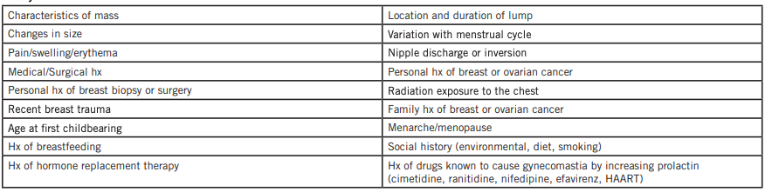
- Imaging:
  - <30 years:
    - Return 3-10 days after menses to see if lump regresses. Ultrasound first (due to high breast density), possibly followed by mammogram.
  - >30 years:
    - Mammography (2 views per breast). Normal mammograms do not fully exclude cancer—10-20% of cancers can be missed.
  - Persistent or suspicious mass: Requires biopsy.
  - If no mass palpable on exam F/U 2-3 months or order mamo for women >40 if no mamo in last year
SCREENING UPDATES 2024
  - Mamo screening is now self refer if 40 to 49 then every every 2 years.
  - 50 to 74→ get screened every 2 years with mammography.
  - 30 to 69 and meet any high risk criteria (known gene mutation, 1 first-degree relative who has a gene mutation, or a family history of breast or ovarian cancer.
  - Self exam is technically not reccomended lol

Biopsy:
- Fine Needle Aspiration (FNA):
  - First-line in low-risk patients (young, low cancer probability). If the fluid is non-bloody and the lump disappears, the cyst is benign; if the lump recurs, re-image. If bloody, send for cytology and consult a specialist.
  - If the lump remains after aspiration, refer for re-imaging and biopsy.
- Core biopsy:
  - Preferred for suspicious solid masses; requires specialist consultation. Sensitivity and specificity are close to excisional biopsy.

When to Refer:
- Any suspicious features on imaging or exam, persistent masses despite normal imaging, bloody aspirates, complex cysts, or discordant biopsy results.

Physical breast exam tequnique:

DO WHEN SITTING AND LAYIN DOWN WITH ARM ABOVE HEAD, offer a chaperon for pt comfort
Inspect:
Colour, nipple shape/colour/texture/DIMPLING***, symmetry on both sides (left may be a bit bigger due to heart), skin texture (orange peel dimpling), discharge (if bloody may need MRI!), skin contour, visible mass
Palpate:
“Lawn mower” up and down motion across the breast and auxilla
- Cycts/lipoma: firm, rounded, mobile, usually not painful except if palpated can irritate surrounding tissue when moving it
- Fibroademona: non cancerous tumor, made of connective/glad tissue, rubbery, easy to move/slippery, often in young women, 1-2 cm
- Intraductal ademona: benign wart-like tumour near the nipple in men and women. In older people it can indicate pre-cancer espeically if nipple d/c, pain, cancer. MRI or referal for abnoraml exam is needed.
- Phylloides tumour: connective tissue in gald, non cancerous, grow fast so may think its cancer but its not, may need lumectomy (possible due to estrogen/progest levels)
- Abcess: fluctuant, painful on palpation
- Fibrocyctic: multiple fibrous tissues growing in a clump, oblong growth, oblong shape, some movement, benign, usually bilaterally and at the bottom the breast
- Tumous: irregular shape, usually not painful but can be especially with touch, growing
  - IDC: most common, starts in milk ducts and speads to nearby tissue, most common BC, feels like a cluster of peas, fixed and non movable
  - Lobual BC: secdon most common starts in milk glads and speads to nearby tissue
  - Tripple negative (very hard to treat), pagets disease, inflamatory BC
Treatment
If young and abnormal test but low risk→ U/S
If risk factors, never had a mammo, older→ mamo and if concerning also consider U/S
Bleeding, cancer suspecious→ MRI or refer to breast clinic

Herpes Simplex Virus (HSV)
Def’n | -HSV-1 causes vesicular lesions on mucous membranes and skin, usually oral (mouth and lips)  -HSV-2 associated with genital warts
Pathology/Cause | *lesions+fluid infectious; incubation period 2-14 days; trigeminal ganglia where it hides until recurrence
Risk Factors/Epidemiology | -immunocompromised  -prior HSV infection  -exposure to virus
Clinical Presentation | 3 Stages: primary, latent and recurrent infection.  -painful lips, gums and oral mucosa  -Primary lesion- fever, blisters on lip, malaise, tender gums  -Recurrent episode fever blisters with prodrome itching, burning and tingling sensation at site before vesicle appears
Hx/Key Questions | Location, onset and duration of lesions? Prodromal symptoms? Systemic symptoms with outbreak? Exposed? Inquire if stress, skin trauma or sun exposure stimulates outbreak?
Physical Exam | Inspect skin and note location, appearance and stage of vesicles  Palpate lymph nodes for lymphadenopathy
Diagnostics/Labs | Viral culture
Red flags | -on eye/eye lid
Differential Diagnoses | Impetigo (amber-coloured vesicles with crusting)  Stomatitis (erythemic or erosion lesions in mouth and lips)  Herpes zoster (shingles; vesicles that run along a single dermatome)  Stevens-Johnson syndrome (SJS)
Treatment/Management | Treatment: acetaminophen; antiviral valacyclovir if severe/frequent recurrence (begin w/i 12 hrs of prodromal)  Counseling/Education: lip sunscreen; wash hands frequently, prevent drying of lips; transmission and recurrence education  Non-pharm therapies: comfort measures (ice to reduce swelling)
Referrals/F/U | Not required

Human Papillomavirus (HPV; Condyloma acuminata, genital warts and venereal warts other names)
Def’n | -STI; 6/11 are genital warts; 16,18, 31, 33, 35 high risk and cervical neoplasia
Risk Factors/Epidemiology | -early first coitus; multiple sexual partners; history transmitted infections
Clinical Presentation | HALMARK: Can be asymptomatic, or can have warts that may appear as early as one-two months after exposure but most infections remain subclinical  -painless genital bumps or warts (elevated and rough or flat and smooth; occurring singly or in clusters or cauliflower-like aggregates; or papillomas that are pale pink)  -pruritus  -bleeding during or after sex  -malodorous vaginal discharge  -dysuria
Hx/Key Questions | STIs in general: Genital and systemic symptoms? Risk factors: condom use, partners, vaccinations (HPV, hep B)? Known exposure? Drugs? Sex worker? Sexual abuse? Contraceptive? Pap? Menstruation?
Physical Exam | Inspect: external genitalia, perineum, anus for lesions; speculum examination for lesions on vaginal wall and cervix; application of 3% acetic acid whitems lesions
Diagnostics/Labs | Visual is adequate  Cytology- pap smears screen
Differential Diagnoses | Condylomata  Molluscum contagiosum  Carcinoma
Treatment/Management | Treatment: Trichloroacetic acid by clinical weekly; cryotherapy  Counseling/Education: UNABLE TO ELIMINATE VIRUS  Non-pharm therapies:
Follow-up | Cervical screening as usual

Various STIs and Blood Borne Infections
https://www.canada.ca/en/public-health/services/infectious-diseases/sexual-health-sexually-transmitted-infections/canadian-guidelines.html
Anogenital Warts  *don’t have to report or notify partner | -caused by HPV 6/11 (covered by vaccination)  -can spontaneously regress, recurrence is common (especially in pregnancy)  -Diagnosed by visual inspection (biopsy if recurrence/atypical)  -treatment with cryotherapy  -partner notification not required  -screening not recommended
Chlamydia  *report and test/treat all partners (had sex w/i 60 days) | -can spread from local site to pelvic inflammatory disease, ectopic pregnancy, infertility, chronic pelvic pain, reactive arthritis  -LGV variants more invasive and affect lymph tissue  -screening recommended, NAAT (vaginal/cervical swabs or first void urine), done during pregnancy twice (first and third trimester)  -treatment: nonpregnant- doxycycline or azithromycin  -F/U: test of cure 3 weeks after treatment if treatment compliance questionable; repeat screening 3 months post-treatment
Genital Herpes  *reportable some provinces, partner notification not required | -chronic infection with clinical and subclinical recurrences; asymptomatic shedding is frequent  -HSV 1 or 2  -can have systemic disease in neonates (neurological and developmental issues) and immunocompromised  -having HSV increases risk of HIV acquisition  -diagnosed with NAAT or viral culture; HSV type-specific serology  -treatment oral acyclovir, famciclovir or valacyclovir; started within 3-7 days of symptom onset
Gonorrhea  *report and test partners | -screening recommended in asymptomatic sexually active, pregnant; use NAAT from first void urine or vaginal, urethral or cervical swabs; and culture for abx sensitivity since so resistant  -treat with combination therapy- ceftriaxone 250mg IM + azithromycin 1 gram single dose  -test of cure 3-7 days following treatment; repeat screening 6 months post treatment
M. genitalium | -consider when chlamydia and gonorrhea have been ruled out as cause of persistent or recurrent urethritis, cervicitis or PID  -NAAT on urine, cervical, vaginal, urethral or meatal swab and endometrial biopsies  -treat azithromycin or moxifloxacin 400mg x7D  -test of cure 3 weeks after treatment if remain symptomatic
Syphilis  *reportable and partner testing | -screening recommended for sexually active and pregnant  -diagnosed through serology  -treatment depends on stage of disease but generally long acting Benzathine Penicillin G 2.4 million units IM
HIV  *reportable | soooo long, will come back to it lol
Hepatitis B  *reportable | Will come back to it too lol

The Female Periodic Health Exam:
- Women of average breast cancer risk
  - Age 40-74
  - Without personal or family history of breast cancer, BRCA1/2 mutations, or prior chest wall radiation
- When is mammography acceptable
  - Age 50-74
    - Routine screening every 2-3 years
    - Preserves the benefits of annual screening while limiting adverse events, inconvenience and cost
  - Age 40-49
    - Routine screening is not recommended, but can discuss risks/benefits with patients
    - Lower likelihood of cancer and greater risk of false positives on mammography in younger women
  - Limited data for under 40 and above 74
- Clinical breast exams are not recommended alone or combined with mammogram for breast cancer screening
- Breast self-exams are not recommended, neither are MRIs

Paps (in Transgender Men):
- Anyone with a cervix should have cervical cancer screening
  - Should be done in anyone who has ever had sexual contact
- Start regular testing by age 25, complete every 3 years or as recommended by the HCP
- Should get a pap regardless of testosterone HRT
  - Important to tell HCP due to changes that can occur with cervical tissue
  - Testosterone is NOT a form of birth control
- Paps should continue even if individuals are no longer sexually active
  - Only time you wouldn’t need it is if you have never had any sexual intercourse, genital skin to skin contact, or oral sex
- Screening is from age 25-70
  - After 70, if 3 negative tests in the last 10 years, screening can stop
- Exceptions
  - Total hysterectomy (unless personal hx of cervical dysplasia)
  - Vaginectomy (cervix will not be accessible)
- Continue if a partial hysterectomy was done

Sherbourne’s Guidelines for Gender-Affirming Care
Hormone Initiation: p. 16
- The informed consent model
  - Obtain informed consent as the threshold for initiating HRT
  - Does not require an in-depth mental assessment or referral unless significant mental health concerns are identified
  - The PCP is in a position to facilitate a decision-making process that supports patients
- Gender non-conformity vs gender dysphoria
  - GNC: the person’s gender identity, role or expression differs from cultural norms prescribed for people of a particular sex
  - GD: discomfort or distress that is caused by a discrepancy between the person’s gender identity and their sex assigned at birth as well as associated gender role or secondary sex characteristics
    - Requires incongruence for at least 6 months, and clinically significant distress of impaired social/occupational functioning, and requires 2+ criteria…
      - Incongruence; desire to rid of primary/secondary sex characteristics; desire to have the other gender’s primary/secondary sex characteristics; desire to be the other gender; desire to be treated of the other gender; strong conviction that they have feelings/reactions of the other gender
    - Re-named by the WHO in 2019 as “gender incongruence”
    - Removed from the category of mental health disorders
- Gender Incongruence
  - Persistent, marked incongruence between experienced gender and assigned sex
  - Leads to a desire to transition in order to live and be accepted as a person of the experienced gender
  - Diagnosis cannot be made prior to the onset of puberty
  - Gender variant behaviour and preferences is not a basis for assigning this diagnosis
Feminizing Hormone Therapy: Monitoring and Follow-Up p. 48 & 62
- Reversible feminizing therapy features
  - Reduction in muscle mass, reduction in body and facial hair, changes in skin, sweat, and odor patterns
  - Changes to facial and body subcutaneous fat
  - Changes to libido, reduction in erectile function
- Irreversible features
  - Changes to facial and body subcutaneous fat
  - Reduction in testicular and prostatic size, sperm count reduction and fertility effects
  - Breast development
  - In adolescents, if estrogen therapy is started before skeletal growth is complete, it may lead to early cessation of long-bone growth, and shorter adult height
- Monitoring anti-androgen therapy (different than estrogen therapy)
  - If on spironolactone
    - Drug interactions, breast inspection, Creatinine, lytes, total testosterone
  - If on cyproterone
    - Weight, BP, breast inspection
    - CBC, AST/ALT, creatinine, lytes, total testosterone
- Expected effects of feminizing hormones (estrogen)
  - Body fat redistribution
  - Decreased muscle mass and strength
  - Softening of the skin with decreased oiliness
  - Decreased libido and erections
  - Erectile dysfunction breast growth, decreased testicular volume and sperm production
  - Thinned or slowed growth of body and facial hair
  - Scalp hair loss stops but there is no regrowth
- Monitor at baseline, 3 months, 6 months, and 1 year
  - Some providers see patients monthly
  - Assess effect on mental health
  - Physical changes are considered complete after 2-3 years
  - Continuous, periodic monitoring for VTE
    - Reminder of importance of vitamin D and calcium intake
- At minimum, exam should include weight and BP
- Suggested blood work when following up with feminizing HRT patients
  - CBC, ALT/AST, creatinine/lytes, HBA1C, lipid profile, total testosterone, estradiol, prolactin, and hepatitis B/C, HIV, syphilis, and other STI screening as indicated
- What will feminizing therapy not affect
  - Pitch of voice
  - Complete elimination of hair on the face and neck
  - Bone structure of the face
  - Breast size is not related to dose amount of estrogen
- Risks to consider/contraindicated in
  - Unstable ischemic CVD
  - Estrogen-dependent cancer
  - End-stage liver disease
  - Psychiatric conditions that limit ability to provide consent
  - Hypersensitivity to formulation
- Precautions
  - Family history of clotting disorders, metabolic syndrome, migraine, seizure disorders, hyperprolactinemia, benign intracranial hypertension, hepatic dysfunction, strong family history of breast cancer, prior history of estrogen-sensitive cancer, persona or family history of porphyria, stable ischemic CVD, cerebrovascular disease, DVT/PE, hypertriglyceridemiia, uncontrolled diabetes or high blood pressure, and history of smoking

Common Presenting Symptoms:
- Increased bleeding during the menstrual cycle
- Pain during the menstrual cycle
- Fatigue
- Abnormal vaginal discharge
- Bloating sensation
- Pain during intercourse
- Breast pain or lump
- Pain during urination or frequency

History Taking
Remember that the health history is paramount to making an accurate diagnosis.
Always explore the OPQRST of the presenting chief complaint. This should assist in developing your list of differential diagnoses to guide the health history.
- Consider all the key questions which would either rule in/rule out these differential diagnoses.
E.g., when a client presents with burning while urinating, specific questions will assist the NP-PHC in supporting or eliminating specific differential diagnoses.
- Timing of the burning? Occurs during urination or after urine comes in contact with irritated labia, such as in Herpes Simplex.
- Associated symptoms of urgency, frequency, nocturia and suprapubic discomfort? These symptoms would suggest cystitis.
- Associated flank pain? The presence of this symptom would suggest pyelonephritis or nephrolithiasis.
- Associated fever and chills? Their presence would suggest an upper urinary tract infectious process (pyelonephritis).
- Associated abnormal vaginal discharge? More like to suggest a gynecological etiology (e.g., vaginitis, vaginosis, trichomoniasis).
- Sexually-active versus non-sexually active? Be aware of different sexual identities and orientations. Do not make assumptions about someone's sexual orientation. Ask about their sexual partners. Ask their sexual orientation. Do they have sex with men, women or both? Do you have sex with a partner that produces sperm or eggs? A non-sexually active woman would be less likely to have an STI.
- Use of new soap, laundry detergent or other products? This may suggest a chemical dermatitis as a cause of burning.
- Recent hospitalization and the use of urinary instrumentation and catheterization? More likely suggests an infectious process (e.g., cystitis, pyelonephritis).
The answers to the health history questions will now lead you to focus your physical examination to further rule in/rule out the differentials that still exist for the presenting chief complaint.

Investigations
- CA125, CBC, ß-hCG, LH, FSH, TSH, Prolactin, Progesterone, Estradiol
- Ultrasound (breast, transvaginal, transabdominal)
- Hysterosalpingography (x-ray of contrast-injected uterus and tubes)
- Genital tract biopsy (vulvar, vaginal, cervical, endometrial)
- Chlamydia, GC, Viral cultures, HPV
- Mammogram
- Urinary dipstick, Urinalysis, Urine culture, Creatinine, Urine cytology

GU Investigations Module…
*A lot of info!

Advanced Skills:
- Pelvic exam
- Sample collection
  - Endocervical curettage, punch biopsy, etc.
- PAP testing
  - Anyone with a cervix who is age 21-25, and every 3 years from then on
  - There is a chance of bleeding, but there should not be anny gushing/significant bleeding with the swab
  - It needs to go inside the cervix and scrape
- Examination of the genitals

Clinical Pearls:
- Obtain the Pap smear before obtaining the specimens for gonococcus and chlamydia.
- In the very obese client, it may be challenging to visualize the cervix due to the laxity of the vaginal walls. It may be helpful to cut the end of a condom and slide the condom over the speculum before insertion. This will assist in providing an unobstructed view. Make sure the client does not have a latex allergy.
- The best time in the patient’s menstrual cycle to do a Pap test is mid-cycle.
- Cells should be collected before the bimanual examination.
- Remove excessive vaginal discharge carefully before obtaining the cervical cytology.
- An adequate Pap smear should represent the entire transformation zone (squamous abnormalities arise in the transformation zone). The transformation zone, however, does not have to be visualized to ensure a sample adequate for examination.
Cytology_PAP_Specimen_Handling___Collection_Instructions.pdf

Choosing the Right Modality:
http://www.car.ca/en/standards-guidelines/guidelines.aspxLinks to an external site.
- This website is excellent to help the primary health care provider to decide which imaging is the most appropriate. It is from the Canadian Association of Radiologist. Use it in your bookmarks!
- Section H and I are particularly of interest for this module.

Case Study #1
Nancy (she/her), 41-years-old female, presents with heavy, irregular periods for the last two months. She reports that her last menstrual period was 19 days ago. Her last normal menstrual period was three months ago. Her cycle is usually every 26 days. Her periods have been light until these last two months when she has had ”a lot more bleeding”. She tells the NP-PHC that she is worried about this change as her mother had “cancer of the uterus”.

Questions:
Question #1: What is abnormal uterine bleeding?
- Any change in menses that includes abnormal frequency, duration, amount of blood flow, or bleeding that occurs between cycles
Question #2: What further health history questions should the NP-PHC ask Nancy?
- Is she sexually active? How many sexual partners?
  - Is she having post-coitall bleeding?
- Is she saturating pads hourly?
- Has this happened before, and if so how was it treated?
- Has she started any new medication (prescription, OTC, or herbals) in the past months?
- Any pain with the bleeding?
- Complete list of medications and history of anticoagulant use
- Any risk of STI exposure?
- Recent surgeries or implantations? (e.g., IUD)
- Any recent childbirth? Any chance she may be pregnant?
Question #3: List the essential components to include in the physical exam. Explain their significance in developing your diagnosis. How are they related to the health history?
- Vital signs to screen for infection
  - Weight, height, and BMI to assess risk for metabolic syndrome and related etiologies, significant weight gain or loss
- Dermatologic exam to assess for visual signs of hormone imbalances
  - Hirsutism, acne, jaundice
- Abdominal exam to assess for organomegaly in the spleen and liver, palpate for tenderness, rebound tenderness
- Pelvic exam to assess for cervical changes, signs of infection (chlamydia, gonorrhea), assess discharge if present, signs of trauma
- Bimanual exam to assess for cervical motion tenderness, adnexal tenderness
- CVA tenderness
Question #4: What screening or diagnostic investigations need to be ordered? Provide rationale and how they can affect each differential diagnosis.
- Thyroid hormone levels to screen for hyper/hypothyroidism
- Cultures for gonorrhea, chlamydia to assess for PID
- Potentially a transvaginal ultrasound to rule out an abnormal pelvic exam
  - May consider endometrial biopsy
Question #5: What are the most reliable diagnostic tools for abnormal uterine bleeding?
- Trasvaginal ultrasound is considered the first-linen diagnostic screening to assess for structural abnormalities
  - Indicated for tumors, cysts, ectopic pregnancy
    - Provides clearer pictures of the internal organs than trans-abdominal
  - Can be used in pregnancy as well
- Endometrial biopsy in women over age 40 at high risk for endometrial cancer would be recommended if the TVUS rules out structural abnormalities
- Coagulation studies would also be helpful
Question #6: If Nancy was 59-years-old, post-menopausal and had some vaginal bleeding, what would be the concern?
- Significant concern for endometrial cancer
- Bleeding/spotting may be normal immediately post-menopausal for up to one year

Case Study #2
Sarah (she/her) is a 19-year-old female who presents to the Street Health walk-in clinic reporting “having to run to the bathroom” and burning on urination for the last three days. She denies any fever or pain in her back, flank or abdomen. Her last menstrual period was normal, one week ago. She reports a whitish vaginal discharge.

She denies any perineal itching or other irritation. She is sexually active with one male partner for the past two months and using condoms sporadically for protection (that she gets from the street nurses). She states her partner has no symptoms.

The health history reveals:
- No previous history of urinary tract infections (UTI) or STIs.
Medications: Tricyclen daily x 21 days/month – “ran out” of pills two months ago
Living on the street for the past two months panhandling. Does not want to talk about her life before “hitting the streets.”

Questions:
Question #1: List the differential diagnoses for Sarah. Provide the rationale according to the history. What clinical information is important to make a proper diagnosis?
- Acute cystitis; symptoms of urgency and burning with urination.
  - Would not require urine culture necessarily, but may be helpful to rule out other diagnostic possibilities
- Cervicitis; symptoms of dysuria are present
- Chlamydia or gonorrhea infection; white vaginal discharge, urgency and burning with urination, infrequent contraceptive use during intercourse
Question #2: Compare the usefulness of individual symptoms in diagnosing a UTI?
- Symptoms may be enough to warrant empiric treatment regardless of dip U results (nitrates and leukocytes presence) if the patient reports them being severe enough
- Some symptoms are more specific for UTI than others
  - E.g., dysuria, frequency and urgency are most specific
Question #3: What is the accuracy of the urine dipstick for diagnosing a urinary tract infection (UTI)?
- Dipstick urine samples are useful for screening but do not provide definitive diagnoses
- False positives with leukocyte esterase
  - Bacterial vaginosis, contamination
  - False negatives early in infection
- Positive nitrites is more helpful than positive leukocyte esterase
- False negatives are common; dip-u needs to be combined with official urine testing
https://www.aafp.org/pubs/afp/issues/2013/0515/od2.html

Case Study #3
Ultrasound report of the abdomen and pelvis:
The right ovary appears considerably enlarged measuring approximately 6.3 x 3.7 cm with a volume of 76 mL. It demonstrates an inhomogeneous solid texture. It appears vascular. The left ovary appears unremarkable. There is free fluid in the cul-de-sac with internal echoes. The uterus demonstrates a 5 mm endometrial stripe.
- Inhomogeneous solid texture= varying densities, suggests abnormal growth

7 mm cyst left lobe of the liver. Small amount of perihepatic fluid also with internal echoes. No gallstones in gallbladder, no bile duct dilatation. The spleen, pancreas and kidneys are unremarkable. The aorta is not aneurysmal.

Impression: Enlarged inhomogeneous vascular right ovary: Associated complex fluid. Major consideration is ovarian malignancy.

Questions:
- What is your understanding of this ultrasound report?
  - The right ovary is concerning for malignancy.
  - A 5 mm endometrial stripe is within normal limits for a postmenopausal woman
  - The fluid around the liver and the presence of a cyst may indicate an infectious process
- How would you discuss this result with the patient?
  - The findings of the scan suggest that there may be possible ovarian malignancy present due to the enlargement, the increased volume, and the solid nature.
  - There is also the possibility of an infectious process evidenced by the abnormalities in and around the liver
  - Emphasize that while the findings are not diagnostic or conclusive, it would be important to set up further follow up and consultation with a specialist to examine further
- What are the next interventions as an NP-PHC you need to do at this point?
  - Consult a gynecologist and/r oncologist to see this patient and complete further diagnostic work-up
  - Biopsy (ovarian)
  - Order a more specific form of imaging such as a CT of the abdomen and pelvis
  - Order blood work
    - CBC/CRP, liver enzymes, liver function tests, coagulation panel
    - Estrogen/estradiol levels, tumor markers (CA-125)
  - If not done already, complete a pelvic, bimanual, and speculum exam to correlate physical exam findings with the ultrasound findings

Case Study #4
Starr (she/her), 19-years-old transgender female comes to see the NP-PHC for gender-affirming primary care. She socially transitioned 2 years ago and would like to start hormone therapy.

Questions:
Question #1: What further health history questions should the NP-PHC ask Starr?
- What her desired objectives or outcomes of HRT would be
- What medications she is currently taking
- Any personal history of DVT, ischemic CVD, estrogen-dependent cancers
- Any family history of estrogen-dependent cancers
Question #1: What questions should the NP-PHC ask as part of a gender history to support a diagnosis of Gender Incongruence?
- Does she feel a persistent, marked incongruence between experienced gender and assigned sex
- Does she feel that transitioning would make her be accepted as her desired gender by society
- Does she feel significant distress or functional limitations from these feelings?
  - This answer would be needed to rule out gender dysphoria
Question #3: List the essential components to include in the physical exam. Explain their significance in developing your diagnosis. How are they related to the health history?
Question #4: What screening or diagnostic investigations need to be ordered? Provide rationale.

Additional Questions:
Karen (she/her), the 20-year-old female, comes to the clinic worried about her breast health since her mother, 42 years old, was recently diagnosed with breast cancer. What should the NP-PHC recommend to Karen for screening? Provide rationale.

Monica (she/her), 40-year-old female, comes to the clinic requesting a mammography. She has no personal or familial history of breast lumps or cancer. How will the NP-PHC address Monica’s request? Provide rationale.
- Discuss the negative/adverse outcomes of mammography in younger ages, the risk of false positives, harm from exposure to radiation, reduced accuracy

Alex (him/him), 36-year old transgender male, comes to the clinic worried about the new onset of vaginal bleeding. Alex has been on testosterone for 12 years and has not had any regular menstrual bleeding since being on testosterone. How should the NP-PHC address Alex's concern?

Rosemary (she/her), 55-year-old female, comes to the clinic reporting the presence of a new painless lump in her right breast. On examination, the NP-PHC confirms her finding. What investigation will the NP-PHC order next? Provide rationale.
- Breast tissue ultrasound
Breast Cancer Screening
Incidence: 1 in 9 women; highest survival rates of cancers in women
- Not exclusive to females
- Can be invasive or noninvasive
- Birth control has risk and benefit
  - HRT increases risk of breast cancer due to estrogen
- Screening: not for diagnosis, but for finding who is more likely to have it in the future
  - May be associated with lower chance of dying
- Age 40-49- talk to family doctor
- Age 50-74- q 2 years
- Age 30-69 and you meet high-risk criteria= annual screening

AHAD Week 9: GU Part 2
Learning Objectives:
- Evaluate the clinical findings associated genitourinary conditions and renal function
- Appraise the clinical guidelines use for screening of prostate cancer

Required Readings by Condition:
- Hematuria
- Nephrolithiasis
- Pyelonephritis
- Renal Failure (acute and chronic)
- Assigned-Male-at-Birth Specific
  - Balanitis
  - Epididymitis/orchitis
Prostate issues:
  - Benign Prostatic Hypertrophy ✅
  - Prostate cancer ✅
  - Prostatitis acute and chronic ✅
  - Testicular cancer ✅
  - Testicular torsion ✅
  - Varicocele ✅, spermatocele, hydrocele ✅
  - Urethritis (gonococcal/nongonococcal) ✅
Textbooks to use…
- Glass & Cash (2020)
- Myrick & Karosas (2022)
- Daines, Baumann & Scheibel (2024)
Other websites for supplementation…
- Sherbourne’s Guidelines for gender-affirming primary care with trans and non-binary patients- Hormone initiation; Part III: Masculinizing hormone therapy (focusing on monitoring, follow-up); Table 6; Appendix F/G/M
- Acute Kidney Injury Clinical Presentation
- Chronic Kidney Disease-Identification, evaluation and management of adult patients
- The kidney failure risk equation
- Ontario Prostate Specific Antigen (PSA) Clinical Guidelines ✅
  - (in the prostate cancer table)
- The Prostate Specific Antigen (PSA) Test Video ✅
  - In the prostate cancer section
- Prostate cancer in the LGBTQ2SIA community. ✅
  - The only takeaway from this link; increased risk of dying than non-trans and heterosexual counterparts due to decreased likelihood to seek screening care
- Benign-Prostatic-Hyperplasia.pdf ✅
  - In the BPH table
- Male-Periodic-Health-Examination.pdf

Week 9: GU 2

Hematuria
Def’n | -blood in urine
Risk Factors/Epidemiology | Trauma, medications (blood thinners, rifampin), strenuous exercise  Malignancy: age >35, smoking (current or past history), chemical exposure, pelvic irradiation, urological disease treatment, chronic UTIs
Clinical Presentation  *Insert picture here* | Pink or red urine  Pain may or may not be present  Frequency, dysuria, urgency, suprapubic pain
Hx/Key Questions | Colour and amount? Systemic symptoms? Trauma, strenuous exercise? Pregnancy/menstruation? KIdney disease, stones, hx/family hx?
Physical Exam | Vitals, including weight  Full abdominal assessment, including CVA tenderness  Lymph nodes, specifically groin  Inspect and palpate genitalia, including DRE
Diagnostics/Labs | Urinalysis + culture and sensitivity  CBC with differential, urea/creatinine, PTT  CT urography (CTU)  U/S
Red flags | Unstable (blood loss)
Differential Diagnoses | Prerenal pathology (coagulopathy issues)  Renal Pathology (Nonglomerular: pyelonephritis, malignant neoplasm; Glomerular: glomerulonepharitis)  Postrenal pathology (renal calculi, cystitis, prostatitis, BPH, urethritis, malignant neoplasm)  Cystoscopy
Treatment/Management | Must solve the root cause so its dependandt on the main root issue
Referrals | Urologist/Nephrologist if benign/infectious causes ruled out

Hematuria (from Dains 2020)
No hematuria specific readings in Myrick & Karosis
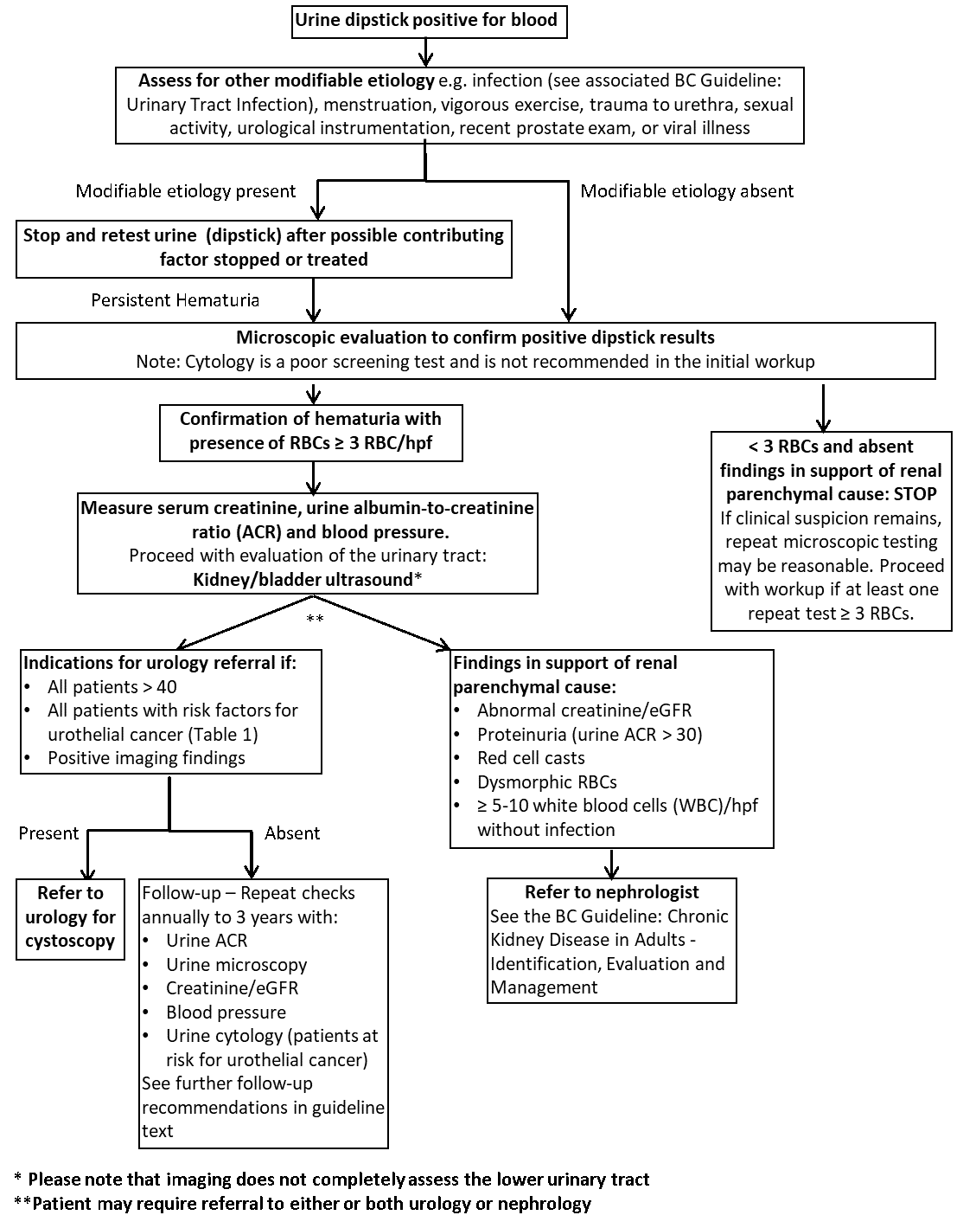
https://www.cua.org/sites/default/files/CanUUC/CanUUC-Hematuria-2020.pdf

Microscopic Hematuria on U/A:
- Suggests UTI (pyelo) or stone (urolithiasis) or neoplasm or BPH??

MALES
Blood can enter the urinary tract at any site.
- Most common source of isolated hematuria is extrarenal (lesions of the bladder or lower urinary tract in more than 60% of pts)
- Renal sources of bleeding are usually d/t nephropathy or polycystic kidney disease.
- 10-15% of hematuria is idiopathic (no cause)
Timing:
- Initial hematuria (bloody then becomes clear during voiding): indicative of anterior urethral lesions such as urethritis, stricture, or meatal stenosis
- Terminal hematuria (beginning with clear urine and then becoming bloody) - suggests prostatic lesions or lesions in the prostatic urethra
- Total Hematuria: characteristic of lesions in the kidneys and ureters
- Bleeding outside of micturition: bladder lesions
- Other causes: trauma to kidneys can also produce hematuria

Pain
- Hematuria with pain: indicates passage of stone or infection
- Painless hematuria: d/t upper or lower tract tumor (e.g. bladder tumor), systemic coagulopathy, excessive anticoagulants, or renal cancer

FEMALES
Common causes of hematuria:
- infection, trauma, stones, parenchymal renal diseases, systemic disease, medications, coagulopathies, bladder cancer (occurs in 60-90% of bladder tumors), some meds, trauma, cystitis
Timing:
- Initial hematuria: suggests urethra is the source
- Terminal hematuria: suggests posterior urethra or bladder base involvement
- Total hematuria: RBCs are dispersed throughout the urinary stream -suggests origin in kidney, ureter, or bladder

Pain:
- Painless hematuria: renal disease, bladder cancer, kidney cancer, stones, polycystic kidney disease, renal cysts, sickle cell disease, hydronephrosis
- Painful hematuria: ureteral stone
- Hematuria with Dysuria: bladder infx or lithiasis

Nephrolithiasis (Kidney Stones)
Def’n | -Renal calculi caused by formation of crystals (calcium oxalate) in urinary system from kidneys to the bladder  -Nephrolithiasis = renal stone disease  -Urolithiasis = presence of stones in the urinary system  -Most stones pass spontaneously but ½ symptomatic patients require intervention for stone removal
Pathology/Cause | Uric acid stones d/t oversaturation of urine with stone-forming constituents (uric acid, calcium, oxalate)
Risk Factors/Epidemiology | Incidence/prevalence: very common  - Initial cases typically occur between 30-40 and prevalence increases with age  - Stones because of infection more common in women  Risk factors:  - Male  - Dehydration  - Chronic obstruction with stasis of urine  - Hypercalcemia caused by hyperparathyroid, renal tubular acidosis, multiple myeloma, or excessive intake of Vit D, milk, and alkali  - Conditions: pregnancy (most common cause of non-obstetrical abdo pain requiring hospitalization), Chronic infections, Obesity, diabetes, gastric bypass  - Previous stones  - Fam hx of nephrolithiasis  - Meds: Vitamin A,C, D; loop diuretics, calcium containing meds, sulfa, acyclovir, topiramate and more  - 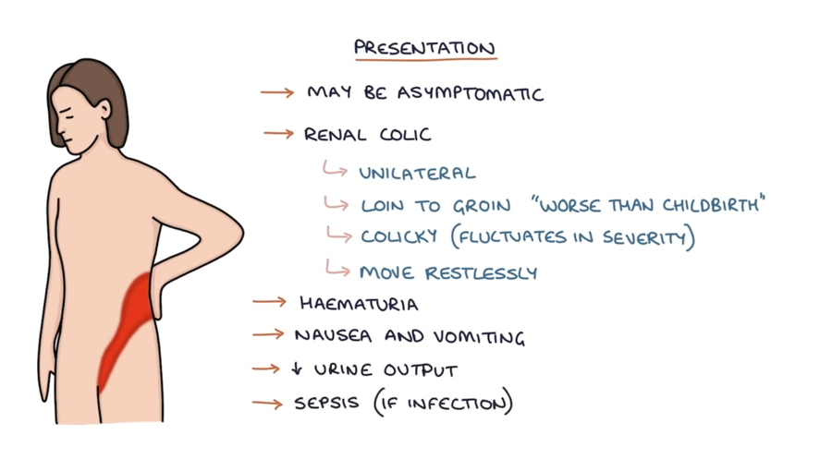  - 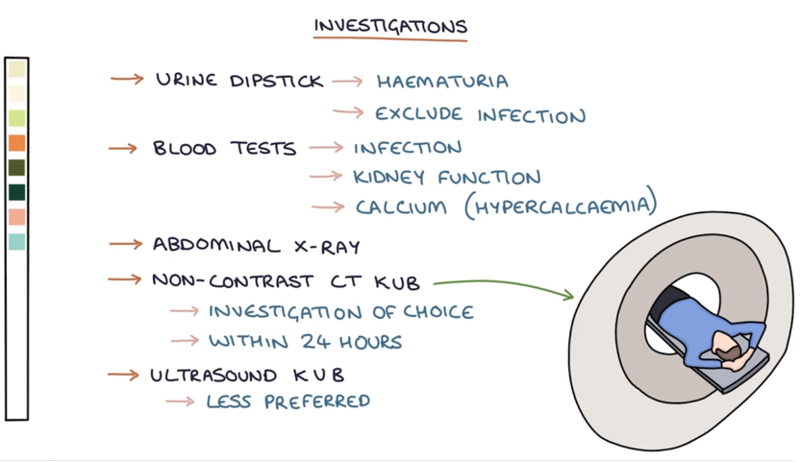  - 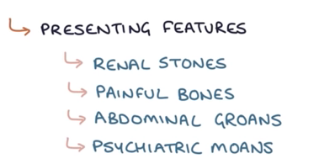
Clinical Presentation  *Insert picture here* | Common: severe flank/groin pain, hematuria, asymptomatic (depending on size of stone)  Other: unilateral flank pain radiating to groin, sudden onset of colicky pain, hematuria, N/V, restlessness, symptoms of cystitis are usually absent (so no frequency, dysuria, urgency, or suprapubic pain)
Hx/Key Questions | - OPQRST  - Other S/S of UTI or pyelonephritis: frequency/dysuria/fever  - Describe the pain (colicky); note intensity (1-10 scale), characteristics of pain  - Any hx of stones? How was it treated? What tests were performed? Have they ever seen a urologist?  - Review dietary intake of high animal protein in the diet, milk, and other calcium containing products for excessive intake  - Review med hx: excessive Vit C, Vit D, or calcium supplements?  - Any hematuria or clots?  - Any recent trauma to back or abdo?  - Fam hx of stone formation?  - Pregnancy?
Physical Exam | - VS (BP, elevated HR)  - Inspect: signs of discomfort, guarding of abdo, any lesions on genitalia, assess for edema  - Auscultate: abdo, note bruits, bowel sounds  - Palpate: “Milk” urethra for discharge, palpate abdo for masses and tenderness/organomegaly/suprapubic tenderness, check for CVA tenderness  - Pelvic or bimanual exam if indicated to R/O pelvic inflamm. disease
Diagnostics/Labs | Labs:  - Blood: urea, cr, calcium, uric acid, lytes (consider fasting calcium, phosphorus, and parathyroid hormone)  - Preg test  - Urinalysis:  - Gross screen  - pH >7.5 compatible with infection lithiasis and pH <5.5 favours uric acid lithiasis  - strongly suggest glomerulonephritis  - Evaluate urine sediment for crystalluria  - Urine culture if indicated  - 24h urine for Cr, Ca, uric acid, oxalate, pH, Na, K, citrate, and cystine  Imaging:  - Non-contrast CT is the standard imaging to assess for acute renal colic  - Renal U/S is the procedure of choice for pregnancy  - Xray of kidney, ureter, and bladder (KUB) often ordered with pelvic CT or US  - Nuclear renal scan  - Intravenous pyelography
Red flags | 10-30% of stones don’t pass and can cause continued pain, infection, or obstruction- monitor pt closely and refer to ER PRN
Differential Diagnoses | Kidney stones, UTI, acute abdomen/appendicitis, cholecystitis, pyelonephritis, pelvic inflamm. disease, IBD, urinary tract obstruction
Treatment/Management | - Increase fluids to allow passage of stone, strain urine to recover stone for analysis  - Reduce recurrence through dietary modifications  - Can be managed as an outpatient if stone is small (<6mm)  - Education: force fluids to maintain a daily output of 2-3L of urine; this increases flow rate and lowers urine solute concentration
Referrals | ER: if severe pain/nausea/vomiting for IV hydration and pain control  Urology:  - Severe symptoms and persistent obstruction beyond 3-4 days should get urology referral  - Also refer if pt needs surgical interventions
Follow-up | - F/U in 24h by phone or in clinic or sooner if pain increases d/t potential to progress to complete obstruction

Renal Failure (acute and chronic)
Def’n | AKI:  an abrupt and usually reversible decline in the glomerular filtration rate (GFR). This results in an elevation of serum blood urea nitrogen (BUN), creatinine, and other metabolic waste products that are normally excreted by the kidney. In addition, if urine output is also diminished, fluid retention and volume overload may result.
Def’n | CKD:  Chronic kidney disease (CKD) is a disorder that leads to progressive kidney damage from a variety of causes, including diabetes, hypertension (HTN), cardiovascular (CV) disease, urinary obstructions, prolonged use of nephrotoxic medications, and inherited diseases such as polycystic kidney disease. Associated comorbidities of CKD include renal osteodystrophy, anaemia, metabolic acidosis, and malnutrition. Early recognition of CKD as well as treatment of complications can improve long-term outcomes.  CKD is specifically defined as follows:  - The persistent and usually progressive reduction in glomerular filtration rate (GFR) <60 mL/min/1.73 m²  - Albuminuria: More than 30 mg of urinary albumin per gram of urinary creatinine  Stages of CKD  - Stage 1 disease is defined by a normal GFR (>90 mL/min/1.73 m²) and persistent albuminuria.  - Stage 2 disease is a GFR between 60 and 89 mL/min/1.73 m² and persistent albuminuria.  - Stage 3 disease is a GFR between 30 and 59 mL/min/1.73 m².  - Stage 4 disease is a GFR between 15 and 29 mL/min/1.73 m².  - Stage 5 disease is a GFR of <15 mL/min/1.73 m² orend-stage renal disease (ESRD
Risk Factors/Epidemiology | CKD:  Epidemiology  - Vascular disorders of the kidneys may involve partial or complete occlusion of large, medium, or small renal vessels.  - Tubular and interstitial disease: As with vascular disease, chronic tubulointerstitial nephritis (CTIN) can be primary or secondary to glomerular damage and renovascular disease  - Approximately two million Canadians are affected by chronic kidney disease. CV disease and diabetes often coincide with chronic kidney disease.  - Management of CV risk factors are critical as many clients will succumb to CV events before ESRD development.  - By age group, CKD is more prevalent among persons older than 60 years than among persons aged 40 to 59 years or persons aged 20 to 39 years.  - CKD prevalence is greater among persons with diabetes than among those without diabetes and among persons with CV disease than among those without CV disease.  - CKD prevalence is higher among persons with HTN than among those without HTN.  Risks:  - Diabetes  - Hypertension (HTN)  - Cardiovascular (CV) disease  - Chronic use of analgesics (e.g., NSAIDs)  - Autoimmune disorder  - Polycystic kidney disease  - Urinary tract obstructions (e.g., benign prostatic hypertrophy or kidney stones)  - Recurrent urinary tract infections (UTIs)  - Older than 60 years  - African Canadian or Indigenous heritage  - Smoking  - Exposure to toxins  - Family history of kidney disease
Risk Factors/Epidemiology | AKI:  Risks  - Hypertension  - Chronic heart failure  - Diabetes  - Liver disease  - Obesity  - Multiple myeloma  - Chronic infection  - Myeloproliferative disorder  - Connective tissue disorders  - Autoimmune diseases
Clinical Presentation  *Insert picture here* | AKI:  - Urinating less  - Peripheral edema (PE) to ankles/feet  - Fatigue  - Shortness of breath (SOB)  - Confusion
Clinical Presentation  *Insert picture here* | CKD:  CKD Stages 1 and 2  - Usually no presenting complaints; hypertension (HTN) is typically present.  - CKD is often identified through routine screening of kidney function and urine tests for microalbumin.  CKD Stage 3  While the person may develop CKD complications, identifiable signs/symptoms are usually still absent. Common issues include:  - Hypertension (HTN)  - Decreased dietary calcium absorption  - Reduced renal phosphate excretion  - Elevation of parathyroid hormone  - Altered lipoprotein metabolism  - Reduced spontaneous protein intake  - Anemia  - Left ventricular hypertrophy  - Salt and water retention  - Decreased renal potassium excretion  CKD Stage 4  Symptoms may begin to manifest:  - Changes in bone density  - Fatigue and pallor related to anemia  - Edema  - Decrease in muscle mass  CKD Stage 5  More severe symptoms are present:  - Impaired sleep  - Nocturia  - Fatigue  - Anorexia, nausea, vomiting, and weight change  - Decreased mental acuity  - Pruritus  - Edema  - Respiratory symptoms (e.g., orthopnea and dyspnea)  - Muscle cramps, twitching, and restless legs  - Peripheral neuropathy
Hx/Key Questions | AKI:  - Volume restriction (e.g., low fluid intake, gastroenteritis)  - Nephrotoxic drug ingestion (e.g., nonsteroidal anti-inflammatory drugs [NSAIDs], aminoglycosides)  - Exposure to iodinated contrast agents within the past week  - Trauma or unaccustomed exertion  - Blood loss or transfusions  - Exposure to toxic substances (e.g., ethyl alcohol, ethylene glycol)  - Exposure to mercury vapors, lead, cadmium, or other heavy metals (common in welders and miners)
Hx/Key Questions | CKD:  - Review the client’s medical history to identify risk factors for CKD (previously noted in section).  - Elicit information about how well risk factors such as diabetes mellitus (DM) and hypertension (HTN) are controlled.  - Review the onset and duration of signs/symptoms of CKD complications and uremia.  - Review all medications—including all over-the-counter (OTC) medications, especially NSAIDs, and supplements. Obtain specific information about dosing and length of time the drug was used.  - Elicit smoking history.
Physical Exam | AKI:  ● Skin  ● Eyes  ● Ears  ● Cardiovascular system  ● Abdomen  ● Pulmonary system
Physical Exam | CKD:  ​​Observe general demeanor, attentiveness, and signs of fatigue.  Measure:  - Height, weight, and body mass index (BMI).  - Vital signs, including orthostatic blood pressure (BP) and pulse.  Inspect:  - Skin for colour, moisture, turgor, and signs of scratching because of chronic pruritus.  - Neck for jugular venous distension.  - Abdomen for distensio.  - Extremities for oedema, muscle mass, and signs of pain disorders such as arthritis.  Auscultate:  - Lungs for crackles.  - Heart for cardiac heave, gallop, or rub.  - Abdominal or femoral bruit.  Palpate:  - Abdomen for masses, distension.  - Bladder, and assess for flank tenderness.  - Neurologic examination:  - Assess for sensation and vibratory sense on both feet.
Diagnostics/Labs | AKI:  - Serum Cr: Measures kidney function; an increase indicates impaired kidney function.  - BUN: Elevated levels can indicate kidney dysfunction or dehydration.  - Urinalysis: Assesses for abnormalities such as proteinuria, hematuria, and casts that may indicate kidney injury.  - Urine Output Monitoring: Measurement of urine volume; significant decrease (oliguria or anuria) suggests AKI.  - Lytes: Evaluates levels of potassium, sodium, calcium, and phosphate, as imbalances can occur with AKI.  - eGFR: Estimated using serum creatinine, provides an overview of kidney function.  - Urine Osmolality: Helps differentiate between prerenal and intrinsic renal causes of AKI.  - Fractional Excretion of Sodium (FENa): Assists in determining the cause of AKI (prerenal vs. intrinsic).  Renal Imaging:  - Ultrasound: To assess kidney size, structure, and rule out obstruction.  - CT Scan: Can be used to evaluate for renal artery thrombosis or other structural issues.  - Renal Biopsy: Considered in certain cases to identify intrinsic causes of AKI (e.g., glomerulonephritis).
Diagnostics/Labs | CKD:  Routine Kidney Function Tests:  - Serum Creatinine  - Urea  - Urinalysis (UA)  - Glomerular Filtration Rate (GFR)  - Proteinuria Assessment:  - Albumin-specific dipstick  - Albumin-to-creatinine ratio (first morning specimens are preferred)  - Patients with a positive dipstick (>1) should have confirmation of proteinuria by a quantitative measurement within 3 months.  - Two or more positive quantitative tests spaced one to two weeks apart should be diagnosed as having persistent proteinuria and require further evaluation and management for CKD.  Other Tests:  - Complete Blood Count (CBC)  - Hemoglobin (Hgb): If Hgb level is <120 g/L in females and <130 g/L in adult males, also do:  - Blood cell indices  - Absolute reticulocyte count  - Serum iron  - Total iron-binding capacity  - Percent transferrin saturation  - Serum ferritin  - White blood cell (WBC) count and differential  - Platelet count  - Testing for blood in stool  - Lipid Profile and Triglycerides  - Comprehensive Metabolic Profile:  - Serum total protein  - Serum albumin  - Glucose  - Calcium  - Sodium  - Potassium  - Chloride  - Bicarbonate  - Urea  - Creatinine  - Alkaline phosphatase  - Alanine aminotransferase (ALT)  - Aspartate aminotransferase (AST)  - Bilirubin  - Prealbumin  - Phosphorus  - Parathyroid Hormone  - Urine Immunofixation Study  - Autoimmune Screening:  - Antinuclear antibody (ANA)  - Anti-neutrophil cytoplasmic autoantibody (ANCA)  - Complement 3 and complement 4 (C3 and C4)  - Test to rule out autoimmune disorders, lupus, vasculitis, and cancer.  - No fasting is needed.  - Hepatitis B Surface Antigen (HBsAg) and Hepatitis C Antibody  - Anti-GBM Antibody  - Renal Ultrasound: To rule out postobstructive uropathy.  - Renal Doppler: To rule out renal artery stenosis.  Screening Recommendations  - At-risk populations should be screened every 1-2 years depending on clinical circumstances (e.g., annually for diabetics): GFR, UA, urine ACR + review of risk factors.
AKI:
- Sudden decrease in urine output, rapid rise in creatinine, fluid overload symptoms, electrolyte imbalances, signs of uremia (Nausea, vomiting, confusion, fatigue, or pericarditis), nephrotoxic drug exposure (NSAIDs, certain antibiotics, or contrast agents), sepsis
Red flags | CKD:  - Progressive decline in renal function (Cr or eGFR), persistent proteinuria or hematuria, hypertension, signs of complications (nemia, bone disease, electrolyte imbalances) , changes in urine output, uremia (Fatigue, pruritus, anorexia, nausea, or confusion), FHx CKD, comorbidities.
Differential Diagnoses | Eval is meant to determine whether kidney disease is acute/chronic and to determine prerenal, intrarenal or postrenal causation
Treatment/Management | CKD:  Understanding Kidney Function and CKD Impact  - Instruct the client on how kidneys work and how chronic kidney disease (CKD) affects their body.  - Emphasize the importance of following instructions to prevent further kidney damage.  Key Management Instructions  - Medication Management: Follow medication management instructions as carefully as possible.  - OTC Medications: No over-the-counter (OTC) medications should be taken without provider approval.  - Control of Chronic Conditions: Keeping diabetes and hypertension (HTN) under control is crucial for maintaining kidney function.  - Cardiovascular Health: Prevent cardiovascular complications by lowering cholesterol and blood pressure, which is especially important for clients with CKD.  - Smoking Cessation: Quitting smoking is essential to prevent worsening kidney function.  - Routine Follow-ups: Regular follow-ups with the healthcare provider are necessary to monitor kidney function. Encourage clients to keep all appointments.  Dietary Instructions  - Protein Intake: Dietary intake of protein is usually restricted to 0.8 to 1.0 g/kg/day of high biological value protein.  - Sodium: Dietary sodium should be restricted to no more than 2 g daily.  - Potassium: Potassium should be restricted to 40 to 70 mEq/day.  - Calories: Calories should be restricted to 35 kcal/kg/day; a lower amount may be prescribed if body weight is >120% of normal or the client is older than 60 years.  - Fat Intake: Fat intake should comprise about 30% to 40% of total daily caloric intake.  - Phosphorus: Restrict phosphorus intake to 600 to 800 mg/day.  - Calcium: Limit calcium intake to 1,400 to 1,600 mg/day.  - Magnesium: Magnesium should be restricted to 200 to 300 mg/day.  When to Notify the Provider  Instruct the client to notify the provider if they experience any of the following urgent signs/symptoms or changes in kidney function:  - Changes in urine volume  - Anorexia, nausea, or vomiting  - Increased edema  - Shortness of breath (SOB)  - Increased fatigue  - Difficulty concentrating  - Muscle weakness, cramping, or twitching  - Fever  - Chest pain
Referrals | Regular, consistent follow-up appointments to monitor progression of CKD, management of complications of CKD, and management of comorbidities such as DM and HTN are recommended.  Urology Consult Indications  - Renal mass  - Enlarged prostate  - Obstruction  - Large symptomatic or obstructing kidney stone

Balanitis
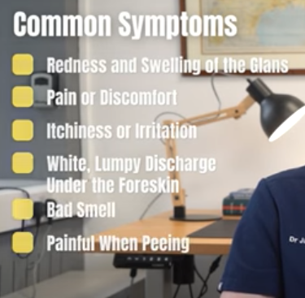
Def’n | - Inflammation of the glans penis  - When the prepuce (foreskin) also becomes involved, the condition is known as balanoposthitis.  - The terms are interchangeable; however, balanoposthitis occurs only in uncircumcised males.
Risk Factors/Epidemiology | - In the United States, balanitis accounts for approximately 11 percent of men seen in urology clinics. Approximately 3 percent of uncircumcised men are affected globally  - Most cases are related to inadequate hygiene in uncircumcised men.  - Lack of aeration and irritation from smegma and discharge surrounding the glans penis.  - Candidal infection is the most common cause.  May result from:  - Psoriasis  - Eczema  - Lichen planus  - Lichen sclerosus  - Plasma cell (Zoon’s) balanitis  - Contact dermatitis, etc.  Risks:  - Trauma (e.g., zipper injury)  - Obesity  - Edematous conditions (e.g., CHF, cirrhosis, nephrotic syndrome)  - Presence of foreskin  - Morbid obesity  - Poor hygiene  - Diabetes (particularly in males with uncontrolled diabetes), likely due to glucose on the skin encouraging bacterial and fungal growth  - Nursing home environment  - Condom catheters  - Sensitivity to chemical irritants (e.g., soaps and lubricants)  - Reactive arthritis  - Sexually transmitted infections (STIs)
Clinical Presentation | - Diagnosis confirmed by the presence of an inflamed and erythematous glans  - Tight, shiny skin on the glans  - Redness around the glans  - Inflammation, soreness, itchiness, or irritation of the glans  - A thick, cheesy white discharge under the foreskin (smegma)  - An unpleasant smell  - Tight foreskin that cannot retract  - Painful urination  - Swollen glands near the penis  - Sores on the glans
Hx/Key Questions | - Cleansing routine  - Pain  - Ulcerative lesions of the glans/foreskin  - Phimosis  - Paraphimosis  - Meatal/urethral stricture  - Malignant transformation of premalignant lesions
Physical Exam | All it says is “Assess the mobility of the foreskin to exclude phimosis and paraphimosis.”
Diagnostics/Labs | None. Made clinically based on hx and PE
Red flags | - Pain  - Ulcerative lesions of the glans/foreskin  - Phimosis  - Paraphimosis  - Meatal/urethral stricture  - Malignant transformation of premalignant lesions
Differential Diagnoses | Lichen Planus: A skin pathology characterized by small, itchy, pink, or purple spots on the arms or legs.  Psoriasis: A dry, scaly skin disorder.  Eczema: A chronic or long-term dermal condition that can result in itchy, reddened, cracked, and dry skin.  Dermatitis: An inflammatory skin condition due to direct contact with an irritant or allergen.
Treatment/Management | *hygiene practices are imperative
Referrals | No referral needed. Follow up in 1-2 weeks

Epididymis
Def’n | - Acute infection of the epididymis, the coiled segment of the spermatic duct that connects the efferent duct from the posterior aspect of the testicle to the vas deferens.  - Often develops during strenuous exertion in conjunction with a full bladder.  - Acute: Symptoms last less than 6 weeks.  - Chronic: Symptoms last more than 6 weeks.  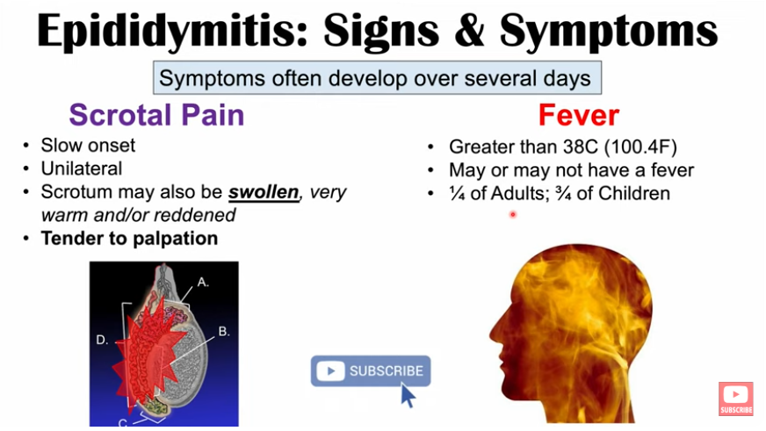  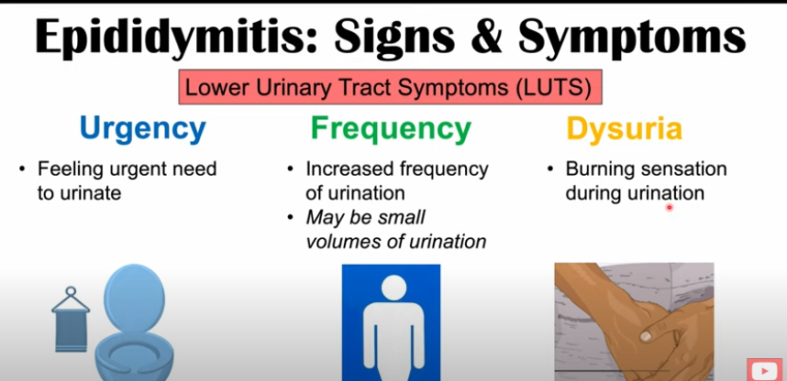
Risk Factors/Epidemiology | Risk:  - <35 yrs generally associated with urethritis with: C. trachomatis (chlamydia), N. gonorrhoeae (gonorrhea)  - BPH- more common for men >35 and common organism: E. coli, Pseudomonas species, Proteus species, Klebsiella species  - Older men usually have nonsexual epididymitis r/t urinary tract instrumentation, surgery and immunosuppression  - Men who have sex w men who are the insertive partner: E. coli, Pseudomonas, Coliform bacteria  - UTIs  - TB-should be considered if hx of TB exposure  - Vasectomy  - Indwelling catheter  - Urethral stricture  - Amiodarone- high drug concentrations (dose-dependent)  - Prolonged sitting (sedentary job, travel)  - Mumps  - 5th most common urologic dx in men aged 18-50  - STIs account for two-thirds of epididymis in men <35  Epidemiology:  The exact mechanism is unclear, but the cause may involve the retrograde passage of infected urine from the prostatic urethra to the epididymis via the ejaculatory duct and vas deferens.  Common Pathogens:  - Chlamydia trachomatis  - Neisseria gonorrhoeae  - Escherichia coli  - Proteus species  - Klebsiella species  - Pseudomonas species  - Mycoplasma species  - Treponema pallidum
Clinical Presentation  *Insert picture here* | Acute Epididymitis:  - Swelling and tenderness of the scrotum (usually located on one side)  - Fever  Chronic Epididymitis:  - Pain and inflammation lasting more than 6 weeks, with possible scrotal induration  Other Symptoms:  - Gradual onset of localized, unilateral testicular pain; client may experience relief with elevation of the scrotum (positive Prehn’s sign)  - Urethral discharge  - Dysuria, frequency, urgency (LUTS)  - Hematuria  - Fever and chills (noted in about 25% of adults with acute epididymitis, but up to 71% of children with the condition)
Hx/Key Questions | - Onset of duration, and course of symptoms  - Hx for vasectomy/trauma to the groin  - Other symptoms? (fever, dysuria, discharge?)  - What makes the pain better? (elevating the scrotum)  - Sexual partners w discharge?  - Pain: unilateral or bilateral  - Review meds hx for amiodarone  - Recent exposure to TB?
Physical Exam | - Examine general discomfort  - Check urethral meatus for discharge; retract foreskin and assess for hygiene and smegma; check shaft of the penis, glans, and prepuce for lesions.  - Check inguinal and femoral areas for bulges and hernias; bear down and cough, reexamine.  - Palpate testes for inflammation, tenderness, and masses. Chronic: feels firm and lumpy, may be beaded.  - Prehn's signs (releif of pain with elevation of the testicles/scrotum…if it causes more pain its torsion)
Diagnostics/Labs | - Urinalysis, urine culture, STD swab if risk, U/S to r/u torsion but usually pain is more abrupt  - Urethral swab for gram stain  - Specimens for identification of N. gonorrhoeae and C. trachomatis (intraurethral exudate or urine)  - Microscopy and culture for mid-stream urine  - Doppler US: useful to help differentiate epididymitis and testicular torsion if done without delay  - No role for epididymal aspiration in routine clinical practice. Recurrent infection that fails to respond to therapy or in clients with suspected abscess formation may require aspiration  - Not routinely recommended: IVP, Doppler US, scrotal US, radionuclide scrotal imaging
Red flags | *Testicular torsion should be considered in all cases- SURGICAL EMERGENCY*
Differential Diagnoses | - Bacterial vs viral  - Testicular torsion (surgical emergency)  - Testicular tumour  - Prostatitis  - Incarcerated inguinal hernia  - Orchitis (occurs with parotitis)  - Trauma  - Vasectomy side effects  - Folliculitis  - Herpes outbreak
Treatment/Management | Encourage/stress importance of adequate fluid intake  Stress the importance of taking all abx as directed  Offer supportive therapy
Referrals | Obtain immediate consultation with a urologist if testicular torsion, scrotal abscess or failed medical tx is suspected  Refer peds client for eval of an underlying congenital anomaly
Follow Up | - See client in 2-7 days depending on severity of infection:  - Pain typically improves within 1-3 days but may take up to 2-4 weeks.  - Inadequate treatment can result in abscess formation and decreased fertility.  - Culture urine at the end of treatment (test for cure).  - Failure to recognize and treat both partners for STIs has potential legal ramifications; test for all STIs and do not just focus on chlamydia and gonorrhea.  - Consider testing for HIV.  - Tuberculosis epididymitis should be suspected if clinical signs worsen despite appropriate antibiotic therapy.  - Men >50 years should be evaluated for urethral obstruction secondary to prostatic enlargement.

BENIGN PROSTATIC HYPERTROPHY
Description | Enlargement of the prostate gland that constricts the urethra, causing urinary symptoms. NOT believed to be a risk factor for prostate cancer (cancer begins in the periphery, BPH begins in the central or transitional zone)  - LUTS (lower urinary tract symptoms) occurs as a result of the voiding dysfunction
Pathology/cause | May be a response to androgen hormones; with aging, the amount of circulating androgens leads to hyperplasia of the normally thin and fibrous outer capsule of the prostate  - As it becomes thick and spongy, muscle fibers contraction compresses the urethra, requiring the bladder musculature to work harder to empty the urine
Epidemiology | Occurs in more than 90% of men age 80+  - 50% of men 50 years of age
Risk Factors | - Increases with age  - Genetic predisposition (increases with + family history of BPH)  - Obesity  - Diabetes  - High levels of alcohol consumption  - Physical inactivity
Screening | Prostate specific antigen: recommended in men with at least a 10-year life expectancy and if prostate cancer knowledge will change medical management  - Recommended at age 50 for most men, at age 45 if high risk, and discontinue at age 70 (consider 60 for those with level sunder 1 ng/mL, or earlier if life expectancy is less than 10 year)
Clinical Presentation  (Subjective Symptoms & Objective Signs) | HALLMARK: LUTS that appears slowly and progresses gradually over a period of years  Common findings:  - Difficulty starting urine flow  - Dribbling, bladder not feeling fully empty  - Frequency of urination  Other signs and symptoms:  - Obstructive symptoms: hesitancy, diminishing size and force of urinary stream, stream interruption/double voiding, urinary retention, straining or valsalva to fully empty bladder  - Irritative voiding symptoms: urgency, frequency, nocturia, painless hematuria (early symptom; be concerned with malignancy too)  - Severe, late signs of untreated BPH: acute urinary retention, recurrent UTIs, hydronephrosis, loss of renal concentration ability, systemic acidosis and renal failure
Hx/Key Questions | Use the International Prostate Symptom Score at each visit to track symptoms  - OPQRST  - Look for signs of a UTI  - Any blood in the urine?  - Any new symptoms of bone or back pain, loss of appetite, weight loss (signs of cancer)?  - History of diabetes and neurological problems  - Sexual history  - History of urethral trauma, urethritis, or instrumentation  - Medication review, family history, and fluid intake of caffeinated or carbonated beverages  - Evaluate impact on quality of life
Physical Exam | VITALS: temp, BP, and weight as indicated  INSPECT: general appearance for discomfort or acute discomfort of urinary retention  - Consider having the client void and assess how many mL per 12-15s (should be about 300mL)  - Examine urethral meatus for discharge, assess under foreskin if present  - Assess all structures for lesions, check inguinal and femoral areas for hernias before and after coughing  - Perform neurologic examination to evaluate for sensory and motor defects  PALPATE: abdomen for masses and bladder distention, lymph nodes for enlargement  - Assess for CVA tenderness  - Palpate testes and epididymides for inflammation, tenderness, and masses  - Palpate scrotum for hydrocele or varicocele  DIGITAL RECTAL EXAM; use the index finger of the dominant hand  *this is mandatory; note prostate size does not correlate with symptom severity  - Note the sphincter tone, nodules, masses and tenderness  - Decreased tone may indicate an underlying neurologic disorder  - Palpate the lateral lobes of the prostate gland and the median sulcus for irregularities  - Palpate the rectum and the adjacent peritoneal cavity for masses and tenderness if possible
Red Flags
Differential Diagnosis | BPH by class depending on the symptom score (mild= 0-7; moderate= 8-19, severe= 20-35)  Obstructive causes→ prostate cancer, urethral obstruction, urethral stricture, vesical neck obstruction  - Neurogenic bladder  - Cystitis  - Prostatitis  - Bladder calculi
Diagnostics:  Labs & Imaging | Laboratory and diagnostic tests  - Urinalysis for evaluating infection/UTI and hematuria***  - Urine culture due to increased susceptibility to UTIs (if symptoms present)  - Prostate specific antigen: recommended in men with at least a 10-year life expectancy and if prostate cancer knowledge will change medical management  - Recommended at age 50 for most men, at age 45 if high risk, and discontinue at age 70 (consider 60 for those with level sunder 1 ng/mL, or earlier if life expectancy is less than 10 year)  Repeating recommendations for PSA:  - <1 ng/mL→ repeat every 4 years  - 1-3 ng/mL→ repeat every 2 years  - >3 ng/mL→ repeat more frequently or consider adding additional test methods  - Optional… Creatinine, urine cytology, uroflowmetry, postvoid residual measurement  - Not routinely recommended…  - Cytology  - Cystoscopy  - Urodynamics  - Radiological evaluation  - Prostate ultrasound  - Prostate biopsy  - Imaging is not recommended unless there is hematuria, elevated creatinine, or a separate indication (BPH alone is not an indication for imaging)  - How to order….first order total PSA (includes unbinded PSA). If total PSA id in the grey zone (4-10 ng/mL) they should be assessed with additional tests like the free PSA test.  - When ordering free PSA if its also high then would need a biopsy as may be cancer. High is anything <10%.
Treatment/ Management | Counseling/Education  - Limit fluids at bedtime, avoid caffeinated beverages and spicy foods, avoid drugs like diuretics, decongestants, antihistamines, antidepressants  - Have planned voiding times, do pelvic floor exercises, and avoid or treat constipation  Complementary Therapies (non-pharmacological)  - Complete a 24-hour bladder voiding diary to assess frequency and volume
Medical management | KEY→ medication/treatments based on the patient-reported bother to their lives  After failed medication therapy surgery becomes an option…  - Minimally invasive therapy  - Transurethral microwave therapy (TUMT) or transurethral incision of the prostate (TUIP)  - Surgical therapies  - Transurethral resection of the prostate (TURP)  - The gold standard of the surgical treatment options for BPH  - Risk of sexual dysfunction, decreased libido, impotence, and ejaculatory difficulties  - Balloon dilation can be used, but relapse is common  - Open prostatectomy  - Laser procedures  - Vaporization of the prostate  - Enucleation of the prostate  - Transurethral needle ablation or photoselective vaporization
Referrals | With anything more than mild symptoms, should refer to a urologist to discuss options for treatment→ history off prostate cancer, elevated PSA, urethral stricture, spinal cord injury, stroke, recurrent or persistent UTI, microscopic hematuria
Follow-up | Monitor every 3-6 months for progression of symptoms
Complications | Elderly clients: can be difficult to diagnose due to poorly expressed or confusing symptoms
References | Cash & Glass; BPH PDF on required readings page

PROSTATE CANCER
Short definition/ description | Malignant tumor that starts in the cells of the prostate. In most cases, grows slowly and can be completed removed or managed successfully
Pathology/cause | Complex interplay between genetics, lifestyle factors, and hormones
Epidemiology | Rapidly spreading prostate cancer is only occurring in 2-3% of cases  - ⅓ of men in their 40s had prostate cancer on autopsies; this increases with age  - 15-year survival rate is 93%
Risk Factors | Increased risk for prostate cancer…  - Family history of prostate cancer (multiple generations, or 1+ first-degree relatives with it; e.g., father, brother)  - Black men  - Age***  - Occupational exposure to arsenic and cadmium, diets high in calcium (potential)
Screening | Recommended through shared decision-making with men ages 40+  - If re-screening is chosen, USA recommends every 2-4 years to reduce harms  - In Ontario, we don’t have an organized, population-based screening program
Clinical Presentation  (Subjective Symptoms & Objective Signs) | HALLMARK:  Common findings:  - Mass of varying size in the prostate  - May see similar symptoms of BPH but most likely asymptomatic  - Other signs and symptoms:
Hx/Key Questions | Use the International Prostate Symptom Score at each visit to track symptoms  - OPQRST  - Look for signs of a UTI; any blood in the urine?  - Any new symptoms of bone or back pain, loss of appetite, weight loss (signs of cancer)  - History of diabetes and neurological problems  - Sexual history; history of urethral trauma, urethritis, or instrumentation  - Medication review, family history, and fluid intake of caffeinated or carbonated beverages  - Evaluate impact on quality of life
Physical Exam | *Copied and pasted from BPH section; assuming if you are thinking cancer based on symptoms that you would also have BPH as a top differential  VITALS: temp, BP, and weight as indicated  INSPECT: general appearance for discomfort or acute discomfort of urinary retention  - Consider having the client void and assess how many mL per 12-15s (should be about 300mL)  - Examine urethral meatus for discharge, assess under foreskin if present  - Assess all structures for lesions, check inguinal and femoral areas for hernias before and after coughing  - Perform neurologic examination to evaluate for sensory and motor defects  PALPATE: abdomen for masses and bladder distention, lymph nodes for enlargement  - Assess for CVA tenderness  - Palpate testes and epididymides for inflammation, tenderness, and masses  - Palpate scrotum for hydrocele or varicocele  DIGITAL RECTAL EXAM; use the index finger of the dominant hand  *this is mandatory; note prostate size does not correlate with symptom severity  - Note the sphincter tone, nodules, masses and tenderness  - Decreased tone may indicate an underlying neurologic disorder  - Palpate the lateral lobes of the prostate gland and the median sulcus for irregularities  - Palpate the rectum and the adjacent peritoneal cavity for masses and tenderness if possible
Doc Mike Evans PSA Video | In Europe, 1/1000 men needed q 4 year PSA screening for 10 years in order for 1 man to be saved from prostate cancer  - Meta-analysis has failed to show that PSA screening makes a difference  - Half of men screened with PSA for prostate cancer have had no symptoms for their entire life
Red Flags
Differential Diagnosis | BPH by class depending on the symptom score (mild= 0-7; moderate= 8-19, severe= 20-35)  Obstructive causes→ prostate cancer, urethral obstruction, urethral stricture, vesical neck obstruction  - Neurogenic bladder  - Cystitis  - Prostatitis  - Bladder calculi  If you are having overt signs of cancer; consider other cancers
Diagnostics:  Labs & Imaging | Laboratory tests  PROSTATE SPECIFIC ANTIGEN  - Measures amount of PSA in the blood; produced by the prostate  - Normally present in small amounts  - May be high with BPH or cancer, or infections of the prostate  *Avoid in men age 70+ or with <10-15 year life expectancy  - If over 70, test is moore inaccurate  - Greatest benefit to screening is in men age 55-69  - Who would not need continued testing?  - PSA <1 and age 60  - PSA <3 and age 70  - Using routine PSA screening has minimal reduction in prostate cancer mortality  PSA test is covered by OHIP if…  - Receiving treatment for prostate cancer  - Being followed post-treatment for prostate cancer  - Suspected prostate cancer due to family history or results of a physical exam  Diagnostic tests and/or Imaging  - After an abnormal PSA level, a biopsy maybe indicated
Treatment/ Management | Counseling/Education  - Extremely slow-growing tumor  Complementary Therapies (non-pharmacological)  - Some studies suggest that lycopene-containing foods (tomatoes) may protect against prostate cancer
Medical management | Usually not required! Most urologists practice watchful waiting
Referrals | To oncologist if treatment is being sought
Follow-up | As needed by patient request; serial PSA testing is not recommended
Complications | Generally none; within 15 years of diagnosis, most men die from other causes than the cancer  - Cancer treatment is typically associated with more harm than leaving the cancer alone
1° and 2° Prevention | Primary prevention
References | Prostate-specific resources from the module required readings list

PROSTATITIS (ACUTE AND CHRONIC)
Description | Acute or chronic infection of the prostate gland. The most important cause of UTI in men  4 types…  - Acute bacterial prostatitis  - Chronic bacterial prostatitis  - Chronic prostatitis/chronic pelvic pain syndrome (common in men of any age)  - Inflammatory (WBCs)  - Non-inflammatory (no WBCs)  - Asymptomatic inflammatory prostatitis
Pathology/cause | *Nonbacterial prostatitis is an inflammatory condition with an unknown etiology  BACTERIAL PROSTATITIS  - Inflammatory condition caused by  - Ascending infection of the urethra  - Reflux of infected urine into the prostate through ejaculatory and prostatic ducts that empty into the prostatic urethra  - Hematogenous spread  - Invasion by rectal bacterial via direct extension in the lymph system  - Organisms→ e coli, klebsiella, pseudomonas, enterococcus, trichomonas vaginalis, ureaplasma, chlamydia, mycoplasma, neisseria gonorrhoeae, CMV, mycobacterium tuberculosis
Epidemiology | Approximately 1 in 10 men (acute and bacterial prostatitis)  - Non bacterial prostatitis is more common (6 in 10)
Risk Factors | More common in younger and middle aged men  - Sexual transmission  - Neuromuscular dysfunction  - Structural voiding dysfunction  - BPH  - History of allergies and asthma (non-bacterial)
Screening
Clinical Presentation  (Subjective Symptoms & Objective Signs) | HALLMARK: dysuria, perineal/rectal/suprapubic pain  Common findings:  - Less urine flow, spiking fever, back pain, sexual dysfunction  Other signs and symptoms:  - Acute bacterial prostatitis  - Fever, chills, malaise, hesitancy, acute onset of dysuria, urinary frequency and low back pain, pain with intercourse and defecation, initial or terminal hematuria with edema and acute urinary retention  - Arthralgia, myalgia, nocturia  - Chronic bacterial prostatitis  - Usually presents with recurrent UTl; may be asymptomatic between episodes  - Perineal, inguinal, suprapubic pain or irritation symptoms on voiding (frequency and urgency)  - Hematuria, hematospermia, painful ejaculations  - Prostatic calculi  *Both may cause suprapubic pain, frequency, urgency, hematuria, and pain with intercourse  - Nonbacterial prostatitis (most common)  - Vague discomfort or increasing pain; prostatic, lower back, perineum, groin, scrotum, or suprapubic pain location and ejaculatory pain  - Dysuria, frequency, urgency, hesitancy, decreased urine flow  - Penile discharge during the first BM of the day  - Sexual difficulty, low sperm count, blood or urine in ejaculate  - Asymptomatic inflammatory prostatitis  - Often found when looking for causes of infertility and testing for prostate cancer  - Causes prostatodynia (unknown cause)  - Pain and discomfort in the prostate, testicles, pennis, and urethra  - Difficulty urinating
Hx/Key Questions | OPQRST  - Any other symptoms like discharge, pain, hematuria, back pain, weight loss  - Has this ever happened before?  - Any sexual partners with similar symptoms or known STIs?  - Engagement in anal intercourse  - Impaired urinary flow  - Any recent instrumentation or surgery?
Physical Exam | VITALS: temperature and BP  INSPECT: examine for general discomfort  - Check urethral meatus or discharge  - Assess under foreskin for hygiene  - Check all structures for lesions  PALPATE: all structures for inflammation, tenderness, masses  - Check CVA tenderness; palpate for bladder enlargement  - Palpate abdomen for masses, organomegaly, suprapubic pain  - Palpate lymph nodes (inguinal and femoral areas); assess for hernias before and after coughing  RECTAL EXAM; first, obtain a clean-catch urine sample  - Assess prostate for swelling, symmetry, tenderness, and enlargement  - Prostate will be tender and boggy with acute prostatitis  - If fluctuant, indicates abscess that may require surgery  - Perform prostate massage for post-massage urine sample
Diagnostic/  Special Tests | The 2-glass Test (for post prostate massage void sample)  - A positive result would be a 10-fold or greater increase in bacteria counts in the post-massage specimen compared to the pre-massage urine. Cultures and colony counts need not be at least 100,000/mL to identify chronic bacterial prostatitis
Red Flags | Older men without evidence of infection with LUTS should have urine cytology done to rule out malignancy
Differential Diagnosis | - Acute vs chronic prostatitis  - Chronic pelvic pain syndrome  - Pyelonephritis  - Epididymitis  - Anal fistulas and fissures  - BPH  - Urethral stricture or stone
Diagnostics:  Labs & Imaging | Laboratory tests  If there is an acute infection→ CBC, urinalysis, urine culture, STI culture, gram stain of expressed prostate secretions  If there is a chronic infection→ urea, CBC, creatinine  If chronic bacterial prostatitis→ evaluate for structural or functional abnormalities with a CT scan  - Measure residual urine after voiding  - Diagnosis is likely if there are no urologic abnormalities, repeated cultures with the same bacterial strain  Diagnostic tests and/or Imaging  - Other pathologies can be ruled out with ultrasound, MRI, and biopsy as needed for the differentials in each situation
Treatment/ Management | - Counseling/Education  Complementary Therapies (non-pharmacological)  - Sitz baths 2-3 times per day  - Increase fluid intake and decrease caffeine and alcohol (irritants to the urethra)
Referrals | Urologist  - In acute bacterial recurrence or persistent infections  - For cystoscopy to rule out interstitial cystitis  *Urinary retention AND prostatitis may require hospitalization
Follow-up | Follow-up in 2-10 days to reassess symptoms and course  Urine should be cultured at the end of drug therapy (test of cure) to prevent chronic flares  - Cure may take a long time, even over 6-12 weeks  - IF there is a partial response, a second course of treatment can be given
References | Cash & Glass

TESTICULAR CANCER
Description & Pathology | Cancer of the testicle cells.  - Precancerous condition of the testicles= germ cell neoplasia in situ (GCNIS)  - Most common cancer of the testicles starts in the germ cells, where sperm is produced  - Seminomas and nonseminomas
Epidemiology | Most common cancer in men ages 15-35 (most are diagnosed between ages 20-35)
Risk Factors | - White men  - Germ cell neoplasia in situ  - Cryptorchidism (undescended testicle as a child)  - Orchidopexy (surgical repair of this) before puberty may decrease risk  - Family history of testicular cancer in a first-degree relative  - Personal history of testicular cancer (high likelihood of developing in the other one)  - Klinefelter syndrome  Potential risks…  - Tall height, calcium deposits (microlithiasis) of the testicles, firefighter occupation, HIV, fertility problems, smoking cannabis, pesticide exposure, earlier onset puberty  *There is no evidential link between testicular cancer and a vasectomy, injury to the testicles, diet, smoking tobacco, or alcohol intake
Screening | Tips for patients…  *Self-exam every month  - Encourage the patients to palpate their own testicles when they have just had a warm bath/shower  - Feel for lumps other than the epididymis at the back  - Remind patients it is normal for one testicle to be slightly larger than the other
Clinical Presentation  (Subjective Symptoms & Objective Signs) | HALLMARK: painless lump on the testicle that does not go away  Common findings: vague and mild symptoms  - Swelling of one testicle  - Painful, dull ache in the testicle or scrotum  - Heaviness in the scrotum or abdomen  - Buildup of fluid in the scrotum  Other signs and symptoms:  - Weight loss, infertility, signs of puberty in boys earlier than expected  - Enlarged lymph nodes in the abdomen or neck  Late signs→ back pain, ascites, cough/hemoptysis  Rare signs→ gynecomastia, excess hair growth in boys
Hx/Key Questions | Consider the questions from other sections…  - Ask about acute onset, pain description, UTI symptoms  - BPH, urinary passage  - Ask about fertility challenges  - Ask about puberty, history of testicular concerns (cryptorchidism), personal history of testicular cancer as well as family history  - Ask about sexual health and sexual behaviours  - Ask about general cancer red flags (weight loss)
Physical Exam | Abdominal exam: assess for pain, swelling, organomegaly  Palpate the testicles for lumps, tenderness  Auscultate the heart and lungs  Palpate lymph nodes in abdomen, groin, and upper chest  Assess for gynecomastia, size and tenderness
Red Flags
Differential Diagnosis | Hydrocele  Scrotal trauma (typically associated with more pain, and bruising)  Hernia (usually felt separate from the testis as opposed to a part of it)  Epididymitis (associated with pain)  Testicular torsion (sudden severe pain is not typical of testicular cancer)  Spermatocele
Diagnostics:  Labs & Imaging | Laboratory tests  - CBC  - LFTs  - eGFR, creatinine  - Tumor markers (alpha fetoprotein is higher with nonseminoma tumors)  - HCG levels may be higher  - Lactate dehydrogenase  Diagnostic tests and/or Imaging  - Ultrasound to confirm solid mamas in the testicle  - CT to assess regional lymph node spread
Treatment/ Management | Counseling/Education  - Refer patient to social support groups if self-esteem is a problem after removal of the testicle(s)  - Consider fertility goals before treatment; some treatments can cause permanent loss of fertility due to removal of both testes, or nerve damage causing retrograde ejaculation  - Testicular cancer is one of the most curable cancers  Complementary Therapies (non-pharmacological)
Medical management | Orchiectomy to remove the cancer if required  - Removal of the testicle and the spermatic cord  - Needle biopsy is avoided due to the high risk of spreading to the scrotum and nearby lymph nodes  Seminomas respond better to treatment, have a better prognosis
Advise clients when to RTC or call for help | Acute changes to testicular size, tenderness
Referrals | Typically, refer to a urologist for further work up and investigations in these patients
Follow-up | As needed
Common Complications | Infertility due to treatment side effects
1° and 2° Prevention | Primary prevention: monthly self-examinantions
References | https://cancer.ca/en/cancer-information/cancer-types/testicular  https://www.testicularcancer.ngo/your-health/signs-symptom

TESTICULAR TORSION
Short definition/ description | The twistin of a testicle around the vas deferens, compromising blood supply and causing possible necrosis of the testicle. A urologic emergency  - Most common cause of testicular loss in adolescent males
Pathology/cause | Abnormal fixation of the testicle to the scrotum, allowing for free rotation; spontaneous twist occurs in the spermatic cord  - Venous occlusion and engorgement causes arterial ischemia and infarction of the testicle
Epidemiology | Can occur with any age, but most common in adolescence  The “bell clapper congenital anomaly”--> present in 12% of males; 40% also have it in the contralateral testicle  - A predisposing factor in testicular torsion in which the tunica vaginalis has an abnormally high attachment to the spermatic cord.  Rare in neonates→ can be prenatal or postnatal cause  - Hardened, fixed, nontender scrotal mass with a discoloured scrotum
Risk Factors | Adolescence; trauma to the testicle; spontaneous occurrence; bell clapper anomaly; exercise; undescended testes; active cremasteric reflex
Clinical Presentation  (Subjective Symptoms & Objective Signs) | HALLMARK: sudden onset of acute scrotal pain, afebrile, history of prior episodes  Common findings:  - Swelling of the scrotal sac  - High position of the testicle; abnormal cremasteric reflex  Other signs and symptoms:  - Pain may radiate to the groin, there may be edema  - Abdominal pain in ⅓ of cases, N/V in 50% of cases, fever in 16% of cases  - Urinary frequency is an uncommon finding (4%)
Hx/Key Questions | OPQRST of symptoms  - History of prior episodes of intermittent testicular pain  - Abdominal symptoms  - Review for urethral discharge and possibility of STI and dysuria  - Review history for trauma to the area
Physical Exam | VITALS: temp, BP, pulse, respirations  INSPECT; observe for general pain before, during and after examination  - Visualize the scrotal sac for edema, symmetry, lesions, discharge, color  - Blue dot superior to the anterior lateral side of affected testicle! (this is cysnosis due to cutoff of blood)  - Assess inguinal and femoral areas for hernias  AUSCULTATE: abdominal quadrants; Scrotum for bowel sounds  PALPATE: abdomen for masses, rebound and tenderness or guarding  - Palpate groin lymph nodes, examine for hernia  GENITAL EXAMINATION  - Check for warmth, tenderness, swelling, nodularity, masses  - Testes should be sensitive to gentle compression but not tender  - Normal feel= smooth, rubbery, and free of nodules  - Elicit a cremasteric reflex (is absent in testicular torsion)  - Prehns sign: Elevate the scrotum; usually doesn't provide relief of pain with torsion  - May relieve pain of epididymitis
Red Flags
Differential Diagnosis | *If patient has a firm, tender mass with acute onset, is afebrile, and has a history of prior episodes, consider this testicular torsion until proven otherwise  - Epididymitis  - ORchitis  - Hydrocele, varicocele  - Testicular tumor  - Acute appendicitis  - Scrotal or testicular trauma
Diagnostics:  Labs & Imaging | Laboratory tests  - Urinalysis→ normal in 90% of cases  Diagnostic tests and/or Imaging  - Doppler ultrasound for blood flow and scrotal exam
Treatment/ Management | - Counseling/Education  - Complementary Therapies (non-pharmacological)
Medical management | Requires urgent surgery (will also stabilize the opposite testicle at this time
Advise clients when to RTC or call for help | Acute onset of pain, seek emergency department
Referrals | Immediately send clients to the emergency department
Follow-up | Refer to a urologist for post-op follow-up
Common Complications | Risk of necrosis if symptoms have been going on for 6+ hours
1° and 2° Prevention | Primary prevention
References | Cash & Glass

HYDROCELE
Short definition/ description | HYDROCELE (can co-exist with inguinal hernia)  - Collection of fluid between the layers of the processus vaginalis  - Produces swelling in the scrotum or inguinal area  - Risk of developing cystic masses spontaneously
Pathology/cause | - Congenital patent processus vaginalis  - Reactive inflammatory condition in the scrotum like trauma, torsion  - Idiopathic, arising over a long period of time (most common)  - Hydroceles arise from an imbalance of secretion and reabsorption of fluid from the tunica vaginalis
Epidemiology | HYDROCELE→ 6% of the male pediatric population at birth or in neonatal period (rare in adulthood)  - Can also be caused by Wucherreria bancrofti parasitic infection causing filariasis
Risk Factors | Males in childhood; W. bancrofti parasite; viral illness; chronic increase in intra-abdominal pressure; increased abdominal fluid production
Screening | Infant testicle= 1 cm in size  - Parents may notice a hydrocele that fluctuates slightly in size, and resolves on its own usually by 6 months
Clinical Presentation  (Subjective Symptoms & Objective Signs) | HALLMARK: a swollen scrotum  Common findings:  - Painless, swollen scrotum (pain increases with size)  Other signs and symptoms:  - Rarely becomes infected or causes pain
Hx/Key Questions | OPQRST of symptoms  - Is the sac full all day, or is it flat in the morning, and there is a gradual increase throughout the day  - Was it noted in the neonatal period?  - Has this occurred before?  - History of scrotal injury  - Any pain or symptoms related to a hernia with the swelling?  - Review risk of other causes; discharge, dysuria, fever, backaches  - Birth control method (recent vasectomy?)
Physical Exam | With a hydrocele, there will be a nontender, smooth, and firm mass. Palpation confirms confinement to the scrotum unless it has been present for a long time. It will transilluminate  VITALS: temperature and BP  INSPECT: careful examination to rule out masses or tumor  - Examine in both supine and standing positions  - Genital examination to note swelling, symmetry, lesions, discharge, hernias, varicess, and color of the scrotum  *Transillumination of the scrotum→ determine if the mass is cystic, solid, or a varicocele  - If it is serous fluid, the illumination will appear as a red glow  - If normal, blood and tissue will not transilluminate, but bowel can  AUSCULTATE: scrotum for bowel sounds to rule out hernia  PALPATE: check for warmth, tenderness, swelling, nodularities  - Palpate lymph nodes, assess for hernia  - Palpate abdomen for masses, rebound and tenderness
Red Flags | ACUTE ONSET PAIN IN THE SCROTUM AND AFEBRILE
Differential Diagnosis | - Varicocele→ feels like a big bag of worms (ew)  - Hernia→ bowel makes sounds when auscultating the scrotum  - Testicular tumors→ occur in young men (15-30), consider if acute onset, firm to touch, non-tender and fixed, but not transilluminating; may also see inguinal lymphadenopathy  - Clients may complain of heaviness  - Testicular torsion  - Orchitis→ rare unless client has mumps infection; usually unilateral and associated with fever, swelling, pain, and tenderness  - Epididymitis→ inflammation with concurrent UTI  - Tender scrotum and relief of pain with elevation  - Spermatocele→ cystic swelling of the epididymis, not as large as a hydrocele, but will also transilluminate
Diagnostics:  Labs & Imaging | Laboratory tests  - Not required  Diagnostic tests and/or Imaging  - Scrotal U/S
Treatment/ Management | Counseling/Education  - Most are painless; if not bothersome, can watch and see if they resolve  - Complementary Therapies (non-pharmacological)
Medical management | Surgical repair may be considered…  - Failure to resolve by age 2  - Continued discomfort reported  - Enlargement or waxing/waning of volume  - Unsightly appearance  - Secondary infections
When to RTC | In adults, seek help if it grows in size, causes pain/discomfort, or interfere with sexual function
Referrals | To a urologist as needed
Follow-up | Monitor every 3 months if watching and waiting
Complications | Ischemia, necrosis, and loss of a testicle if not treated in time
1° and 2° Prevention | Primary prevention: surgeons can stabilize the unaffected testicle while in surgery for treatment of torsion of the other.
References | Cash & Glass

VARICOCELE
Short definition/ description | Engorgement of the internal spermatic vein above the testes; causes decreased testicular function. Some can be easily identified and surgically corrected  - Varicocele alone is not indication for surgical repair  The leading cause of male infertility; may be associated with decreased sperm count, infertility and testicular atrophy  - No link between size of varicocele and degree of infertility
Pathology/cause | Exact cause is unknown→ may be due to valvular incompetence or elevated spermatic vein pressure  - Testicular temperature increase is also associated  - New varicocele in older males may be secondary to renal tumors
Epidemiology | Occurs in 15-20% of males (usually on the left side in 80-90% of cases), and 40% with a palpable left varicocele also have a right varicocele  - Right sided varicocele is uncommon; can indicate retroperitoneal malignancy
Risk Factors | Manifest usually at the onset of puberty
Screening | Classes of Varicocele:  - Grade 1= small  - Palpable only on valsalva  - Grade 2= medium  - Palpable when standing and bearing down (Valsalva)  - Grade 3= large  - Visible on inspection  - Subclinical  - Not palpable, but vein >3 mm on ultrasound showing doppler reflux with valsalva maneuver
Clinical Presentation  (Subjective Symptoms & Objective Signs) | HALLMARK: asymptomatic until assessed for fertility  Common findings:  - Some clients experience pain or discomfort in the scrotum  Other signs and symptoms:  - Pain or aching and heaviness in the scrotum  - Worms type feeling with bluish discolouration of the scrotum
Hx/Key Questions | OPQRST of symptoms  - When was it first noted?  - Has it enlarged/ if so, over what time frame? Does it collapse with sitting or lying down?  - Is there any pain or discomfort? Any history of infertility?
Physical Exam | Varicoceles will collapse in size slightly when supine or sitting compared to standing. They will not transilluminate. If they are large in size, you may be able to see them. Otherwise you can palpate or ask the client to perform the valsalva maneuver to accentuate them.  VITALS: temp and BP as indicated  INSPECT: done in a warm room to promote scrotal relaxation  - Examine appearance of structures  - Varicoceles tend to collapse when sitting or supine  - Transilluminate to visualize (varicoceles do not transilluminate)  - Large varicoceles can be seen with inspection alone  PALPATE: each side of the scrotum for testicular size  - Valsalva maneuver can help accentuate small varicoceles  - Moderate-size varicoceles can be palpated without this  - Palpate spermatic cord during valsalva maneuver  - Palpate the abdomen for masses, hernias, and tenderness  - Perform a rectal exam to palpate the prostate and seminal vesicles for tenderness and other signs of infection  AUSCULTATE: listen to the scrotum for bowel sounds to rule out hernia
Red Flags | Signs of malignancy→ Sudden onset varicocele, Single right-sided varicocele, Any varicocele that is not reducible in supine position  - New onset varicocele in older adults may indicate renal tumor
Differential Diagnosis | Hernia, epididymitis, hydrocele, testicular tumor
Diagnostics:  Labs & Imaging | Laboratory tests  - Semen analysis x2 , if indicated  Diagnostic tests and/or Imaging  - Scrotal ultrasound with high-resolution colour flow  - Doppler is the diagnostic method of choice when physical exam is inconclusive, but is not required for diagnosis or standard evaluation  - CT would rule out retroperitoneal pathology. Order if…  - Sudden onset varicocele  - Single right-sided varicocele  - Any varicocele that is not reducible in supine position
Treatment/ Management | Counseling/Education  - If surgery is not indicated, then no other interventions are needed  Complementary Therapies (non-pharmacological)  - Can try athletic supported if there is discomfort
Medical management | Consider surgery if…  - Palpable on physical examination  - Couples with known infertility  - Female with normal fertility or potential treatable cause of infertility  - Male partner with abnormal semen parameters or abnormal results from sperm function tests
Referrals | Consult urology for assessment and possible surgery
Follow-up | After surgery, teach scrotal self-exam, and then no routine follow-up is needed  - Instruct client to return if there is pain, or a change in the size/shape if surgery is not done  Follow adolescents with q6mos or annual objective measurements and semen analysis to detect earliest sign of injury
Common Complications | Infertility
1° and 2° Prevention | Primary prevention: self-screening and self-scrotal exam to follow for changes
References | Cash & Glass

SPERMATOCELE
Short definition/ description | A painless mass or cystic swelling at the head of the epididymis, containing fluid and sperm
Pathology/cause | Occurs when one of the tubules connecting the testis to the epididymis becomes blocked  - A benign finding; filled with clear fluid and sperm cells
Epidemiology | Typically affect middle-aged men, but can affect adolescents; peak incidence in age 65+  - Discovered in 30% of men undergoing imaging for other reasons
Risk Factors | No real link to anything; some studies suggest certain meds taken by mom during pregnancy  Idiopathic alterations in development of the vessels during growth/development?
Clinical Presentation  (Subjective Symptoms & Objective Signs) | HALLMARK: patient complains of feeling a scrotal mass “like a third testicle”  Common findings:  - A nontender mass that is palpable clearly separately from the testis  - No effect on sexual function, erectile function or fertility  - Larger than 2 cm  Other signs and symptoms:  - Smooth and spherical
Hx/Key Questions | OPQRST of symptoms  - When was it first noted?  - Has it enlarged/ if so, over what time frame?  - Is there any pain or discomfort?
Physical Exam | Light source shines through the mass (it is fluid-filled, so it should!). Testis is palpable separate from the spermatocele, connected to testis at superior aspect.  - Smaller than a hydrocele  VITALS: temperature and BP  INSPECT: careful examination to rule out masses or tumor  - Genital examination to note swelling, symmetry, lesions, discharge, hernias, varicess, and color of the scrotum  *Transillumination of the scrotum→ determine if the mass is cystic, solid, or a varicocele  - If it is serous fluid, the illumination will appear as a red glow  - If normal, blood and tissue will not transilluminate, but bowel can  AUSCULTATE: scrotum for bowel sounds to rule out hernia  PALPATE: check for warmth, tenderness, swelling, nodularities  - Palpate lymph nodes, assess for hernia
Red Flags | Cystadenocarcinoma→ feeling a ‘cluster of grapes’  May lead to torsion; presentation similar/same as testicular torsion
Differential Diagnosis | - Varicocele→ feels like a big bag of worms (ew)  - Hernia→ bowel makes sounds when auscultating the scrotum  - Testicular tumors→ occur in young men (15-30), consider if acute onset, firm to touch, non-tender and fixed, but not transilluminating; may also see inguinal lymphadenopathy  - Clients may complain of heaviness  - Testicular torsion  - Orchitis→ rare unless client has mumps infection; usually unilateral and associated with fever, swelling, pain, and tenderness  - Epididymitis→ inflammation with concurrent UTI  - Tender scrotum and relief of pain with elevation  - Hydrocele
Diagnostics:  Labs & Imaging | Laboratory tests  - None required  - If pain is reported, can do urinalysis to r/o epididymitis  Diagnostic tests and/or Imaging  - Scrotal ultrasound; can be done if transillumination is inconclusive or cancerous DDx is suspected
Treatment/ Management | Counseling/Education  - Typically are benign and should not cause symptoms  - Complementary Therapies (non-pharmacological)
Medical management | Not typically required; can be left for years and not change  Surgery indicated for larger cysts or ones that change over time, or if they cause symptoms of pain, heaviness, discomfort
Referrals | To urologist if changing inn size, or causing symptoms
Follow-up | As patient determines
References | Dains et al, Myrick & Karosas  https://www.urologygroupvirginia.com/urologic-care/testicular-scrotal-disorders/spermatocele  https://www.simplevas.net/wp-content/uploads/2022/09/Nonacute-scrotal-conditions-in-adults-UpToDate.pdf  https://emedicine.medscape.com/article/443432-overview?form=fpf#a5

URETHRITIS (GONOCOCCAL AND NON-GONOCOCCAL)
Short definition/ description | Urethritis in general is considered an STI (both gonococcal and non)  Gonorrhea= a STI that also thrives in the rectum and oropharynx  Most common non-gonococcal= chlamydia
Pathology/cause | 30% caused by gonorrhea; other causes include chlamydia and Mycoplasma genitalium  - Gonorrhea adheres to the mucosal membranes of the GU tract  - Incubates for 2-5 days; rectal and pharyngeal infections are usually asymptomatic  - Non-gonococcal pathogens tend to incubate for longer
Epidemiology | *Gonorrhea is a reportable infection to public health
Risk Factors | STIs; higher rates in males than females; multiple sex partners; early age at first coitus; sexual contact with someone with a confirmed infection; unprotected sex; sex workers and their partners; youth under age 25; street youth and homeless youth; MSM
Screening
Clinical Presentation  (Subjective Symptoms & Objective Signs) | HALLMARK: initial blood in the urine that then turns clear  Common findings:  - mucoid/mucopurulent or purulent urethral discharge  - Dysuria, urethral itching or irritation  - Meatal burning and discharge  - Meatal erythema and edema  - Gonococcal symptoms usually begin 2-6 days after acquiring the infection  - If non-gonococcal, not until 1-5 weeks later  - Gonococcal= yellow-green discharge  - Non-gonnococcal= thin, mucoid, clear discharge  Other signs and symptoms:  - Asymptomatic; polyarthralgia; necrotic skin lesions
Hx/Key Questions | Determine OPQRST of the symptoms  - Is there any pelvic pain, fever, or urinary symptoms?  - Review characteristics of vaginal discharge  - History of STIs, sexual history and number of partners (do they have symptoms?)  - Obtain a thorough sexual history
Physical Exam | VITALS: temperature, pulse, respirations  INSPECT: for discomfort before, during, and after the examination  - Colour, amount, and odor of discharge  PALPATE: Abdomen for enlarged or tender inguinal lymph nodes  - CVA tenderness  - Assess discharge  - Inspect all structures, palpate for tenderness
Red Flags
Differential Diagnosis | Chlamydia, arthritis, epididymitis, orchitis, HSV-2 infection, UTI
Diagnostics:  Labs & Imaging | Laboratory tests  - Urine dipstick (leukocyte esterase and nitrites)  - Urinalysis  - Joint aspiration for culture if septic joint  - Additional testing for chlamydia, syphilis, and HIV should be done  Diagnostic tests and/or Imaging  - NAATs are superior to a culture (more sensitive and specific)  - Culture should also be done as it allows for testing of antimicrobial susceptibility  - The preferred test of cure
Treatment/ Management | Counseling/Education  - Use protection when engaging in all forms of sexual activity  - Avoid sexual intercourse for one week to avoid reinfection  Complementary Therapies (non-pharmacological)
Medical management
Advise clients when to RTC or call for help
Referrals | Referral for suspected treatment resistance or complications arising
Follow-up | If recurrent cases: asses for poor adherence, use of alternate choice meds, reinfection, presence of other pathogens  - May require a test of cure if there is chlamydia or gonococcal involvement (repeat after 3 months post treatment due to high reinfection rates according to Cash & Glass)  - MUMS Anti-Infective says→ test with NAAT no earlier than 3 weeks post-treatment AND repeat screening for gonococcal infection after 6 months post-treatment  Test of cure is not required for non-gonococcal urethritis.
Common Complications | Can progress to urethral strictures in untreated cases; banding of the penile urethra in the shaft of the penis  Acute bacterial prostatitis, epididymitis, orchitis
1° and 2° Prevention | Primary prevention
References | Cash & Glass, Dains et al, Myrick & Karosas

MSK 2

- Cervical radiculopathy
- Hip (bursitis)
- Rheumatoid arthritis
- Systemic lupus erythematosus
- Septic arthritis
- Gout
- Osteoarthritis
- Scoliosis
- Shin splints
- Ankle and foot sprains/strains
- Ankle and foot sprains/strains: fractures
- Ankle and foot sprains/strains: plantar fasciitis)
- Elbow pain: lateral/medial epicondylitis
- Elbow pain: nursemaid’s elbow
- Elbow pain: bursitis
- Elbow pain: tendonitis
- Fibromyalgia + Canadian Guidelines for the Diagnosis and Management of Fibromyalgia Syndrome in Adults
- Knee injury: strains/sprain
- Knee injury: fracture
- Knee injury: ligament injuries
- Knee injury: meniscus injury
- Knee injury: patellar subluxation /dislocation
- Knee injury: chondromalacia patellae
- Knee injury: bursitis
- Knee injury: Patello-femoral syndrome + Evaluation of patients presenting with knee pain: Part 1. History, physical examination, radiographs, and laboratory tests
- Low back pain acute and chronic: lumbosacral strain
- Low back pain acute and chronic: herniated disk
- Low back pain acute and chronic: spondylolysis and spondylolisthesis
- Low back pain acute and chronic: degenerative process
- Low back pain acute and chronic: spinal stenosis + Centre for Effective Practice. Low Back Pain
- Wrist and hand pain: carpal tunnel syndrome
- Wrist and hand pain: ganglion cysts
- Wrist and hand pain: scaphoid fracture
- Wrist and hand pain: tendonitis
- Shoulder pain: fractures dislocations
- Shoulder pain:acromioclavicular joint sprain/separation
- Shoulder pain: shoulder strain, impingement
- Shoulder pain: rotator cuff injury/dysfunction
- Shoulder pain: adhesive capsulitis
- Shoulder pain: osteoarthritis
- Shoulder pain: bursitis
- Shoulder pain: tendonitis
- MSK imaging: https://vimeo.com/npeducation/review/722700514/bf317a78b6
- Spine imaging: https://vimeo.com/npeducation/review/722696175/bfb550216a

TEMPLATE TO USE
Def’n
Pathology/Cause
Risk Factors/Epidemiology
Clinical Presentation

*Insert picture here*
Hx/Key Questions
Physical Exam
Diagnostics/Labs
Red flags
Differential Diagnoses
Treatment/Management | Treatment:  Counseling/Education:  Non-pharm therapies:
Referrals
Follow-up

CNO's reporting: Made to protect the public by ensuring patient safety through collaboration with employers, facility operators, nurses, and others who work with nurses.

What Must Be Reported?

A report must be made if a nurse:

Poses a serious risk of harm to patients

Is suspected of sexually abusing a patient

Is incompetent (significant and repeated lack of knowledge, skill, or judgment)

Is incapacitated (physical or mental condition impairing safe care)

Has been terminated or resigned due to concerns about competence, conduct, or capacity

Has had privileges revoked, suspended, or restricted for concerns about competence, conduct, or capacity

Has a partnership/association dissolved because of professional misconduct, incompetence, or incapacity

Who Must Report?
Situation | Anyone who works with a nurse | Employers | Facility operators | Nurses
Serious risk of harm to patients | X | X | X | X
Suspected sexual abuse | X | X | X | X
Incompetence or incapacity | X | X | X | X
Termination or resignation (in lieu of termination) |  | X
Privilege revoked, suspended, or restricted |  | X
Dissolution of partnership/association due to misconduct/incompetence/incapacity | X

Reports must be sent as soon as possible, but no more than 30 days after the incident.

Sexual Abuse:

Any sexual or romantic relationship with a patient (even if consensual) is abuse.

A patient remains a "patient" for 1 year after the therapeutic relationship ends…aka dont sleep with them for a year pleaseee!!!

You must not include the patient's name without written consent.

Penalties for failing to report:

Up to $50,000 for individuals

Up to $200,000 for corporations

Employers must report if a nurse is terminated, resigns in lieu of termination, or if their privileges are revoked/suspended/restricted for professional misconduct, incompetence, or incapacity.

A nurse must self-report if they:

Are charged with or found guilty of an offence

Have a finding of professional negligence/malpractice

Have a finding of professional misconduct, incompetence, or incapacity in nursing or another profession

Are the subject of a current investigation or proceeding for misconduct, incompetence, or incapacity in Ontario or elsewhere

What Happens After a Report Is Submitted?

CNO conducts a preliminary investigation.

Most cases are resolved without a hearing.

All reporting is confidential.
AC joint sprain/seperation: https://www.youtube.com/watch?v=npHPXrV6_JI&ab_channel=Physiotutors

Wrist and Hand Pain: Tendinitis
Def’n | - Tendinitis is inflammation of a tendon, often developing after degeneration (tendinopathy).  - Chronic deterioration or inflammation of the tendon or tendon sheath can cause scars that restrict motion.
Pathology/Cause | - The cause of tendinitis is often unknown.  - Tendinopathy usually results from repeated small tears or degenerative changes (sometimes with calcium deposits) that occur over years in the tendon. Tendinitis and tenosynovitis most commonly affect tendons associated with flexor carpi radialis or ulnaris.
Risk Factors/Epidemiology | - Middle aged or older (>35 years)  - Obesity  - Repetitive microtrauma  - Fluoroquinolone antibiotics may contribute (e.g. Ciprofloxacin)  - Statins, aromatase inhibitors  - Certain systemic disorders: RA, systemic sclerosis, gout, reactive arthritis, diabetes, amyloidosis, markedly elevated blood cholesterol levels  - Disseminated gonococcal infection may cause acute migratory tenosynovitis  - Improper training, poor movement patterns, poor ergonomics, poor equipment
Clinical Presentation | Main S/S is wrist pain with active motion or when natural motion is resisted.  - Swelling may be visible or only palpable  - Along the tendon, palpation elicits localized tenderness or varying severity
Hx/Key Questions | - What are the presenting symptoms? Note pain, numbness, weakness, or stiffness.  - Was there any type of injury, either recently or in the past?  - Is there any radiation noted?  - How do these symptoms limit the client’s activity?  - How long can the client sit, stand, walk, or do overhead work?  - Is the client able to lift? If so, how much weight is bearable? Compare with normal weight.  - How long has the client had these symptoms?  - How have the symptoms evolved, from the beginning of discomfort until now?  - If the client has a previous history of a similar or the same pain, what therapy was used in the past and what were the results?  - Does the client have marked upper extremity weakness?  - Does the client have pain that wakes them from sleep?  - Does the client have any fatigue, swollen joints, or fever?
Physical Exam | Inspection→swelling, warmth, or asymmetry compared to the contralateral wrist.  Palpate→ Palpate gently over the wrist and tendons to check for tenderness or warmth. Also palpate with sharp and dull tools to assess sensation. Palpate pulses (radial, brachial)  - First dorsal compartment (for De Quervain’s tenosynovitis).  - Flexor tendons (on the palm side).  - Extensor tendons (on the back of the wrist).  Assess for crepitus→Feel for any grating or clicking sensations during palpation.  ROM→ Active and passive ROM of flexion and extension, radial and ulnar deviation…assess for pain or restrictions during movement.  Strength→Grip strength, resisted movements with flexion, extension, radial and ulnar deviation  Tests:  - Finkelstein’s Test (for De Quervain's Tenosynovitis):  - Have them a fist with thiei thumb inside your fingers.  - Gently deviate the wrist toward the ulnar side (toward the pinky).  - Positive test: Sharp pain on the thumb side of the wrist suggests De Quervain’s tendonitis.  - Resisted Thumb Extension: Try to extend their thumb while NP resists it.  - Pain with this movement could suggest De Quervain’s tendonitis.  Volar flexor tenosynovitis (digital flexor tendinitis)  - is a common musculoskeletal disorder that is often overlooked. Pain occurs in the palm on the volar aspect of the thumb or other digits and may radiate distally. Palpation of the tendon and sheath elicits tenderness; swelling and sometimes a nodule are present. The affected digit may rest in a flexed position, and passive extension elicits pain. In later stages, the digit may lock when it is flexed, and forceful extension may cause a sudden release with a snap (trigger finger).
Diagnostics/Labs | Clinical evaluation  Sometimes imaging: MRI or US
Red flags | - Sudden hand or wrist weakness (Tendon rupture)  - Pain that worsens or does not resolve within 1-2 weeks
Differential Diagnoses
Treatment/Management | - Symptoms are relieved by rest or immobilization (eg, splint or sling) of the tendon, application of heat (usually for chronic inflammation) or cold (usually for acute inflammation)  - High-dose NSAIDs for 7 to 10 days.  - Indomethacin or colchicine may be helpful if gout is the cause.  - After inflammation is controlled, exercises that gradually increase range of motion should be done several times a day, especially for the shoulder, which can develop contractures rapidly.
Referrals | Physiotherapy, ortho if unresolved
Follow-up | Follow up in 3-6 months

Shoulder Pain: Impingement
Def’n | Stability of the shoulder depends on ligaments, capsules, tendons and muscular structures. Any dysfunction of these stabilizing structures can increase instability, allowing increased movement of the humeral head. This increased motion makes surrounding structures susceptible to impingement.  It is a common cause of shoulder pain, especially in individuals who engage in overhead activities. It occurs when the rotator cuff tendons or the bursa (a fluid-filled sac) become irritated or compressed as they pass through the subacromial space (the area between the humeral head and the acromion).
Pathology/Cause | Impingement is a spectrum of findings - NOT injury to a specific structure.  Stage 1: edema and haemorrhage (pt usually under 25 YO)  Stage 2: tendinopathy fibrosis and tendonitis (pt usually 25-40 YO) = see TENDINITIS table below  Stage 3: rotator cuff tear (RCT), biceps rupture or bony change (generally over 40 YO). Also look at ROTATOR CUFF table***
Risk Factors/Epidemiology | - See stage and associated ages above.  - Throwing athletes often suffer from impingement - due to extremes of rotation with throwing activities.  Risks:  - Participating in a lot of repetitive, overhead activities (swimming, painting, tennis, throwing sports)  - Bone and joint abnormalities
Clinical Presentation  *Insert picture here* | Hallmark: Common complaint is shoulder pain but don't get this confused with other differentials!!!  - Pain is typically felt in the anterior (front) and lateral (outside) of the shoulder, often radiating down the upper arm.  - Pain may also be referred to the deltoid region.  - Develops gradually, though it can sometimes be triggered by a specific injury or overuse ( repetitive overhead motions).  - Pain can become more severe if the condition progresses.  - Worsens with activity  - It may worsen at night, especially when sleeping on the affected shoulder.  - May experience difficulty raising the arm above shoulder level (painful arc: pain/difficulty at 60-120 degrees is a key sign!!).
Hx/Key Questions | Screen for risk factors  Describe how the injury occured?  Did you hear any noise with the injury? Ripping, popping, cracking  Were you able to use the limb after the injury  Have you had previous injury to this joint?  Ask about fatigue, fever, neck, chest pain or swollen joints.  Rate the severity of the pain + PQRST  How is this injury affecting ADLs  What activities, movements, positions, make it worse  Do you have chronic diseases?  Have you had recent immunisation (Myalgia dt vax)  STI history (gonorrhea dissemination)  Have you had a cortisone treatment (increased pain after injection
Physical Exam | No single examination manoeuvre is diagnostic  VITALS  Inspect→ how the patient appears, walking, taking off jacket etc.  - Note any deformities  - Inspect for ss of inflammation  - Measure length of limbs  Palpate→ limbs and joint  TESTS:  Hawkins test: elevate shoulder to 90 degrees, flex elbow to 90 place forearm in neutral position. Support the arm, then internally rotate the humerus. Positive test is if there is pain with maximal internal rotation  Neer impingement test: elevate arm in forward position, and depress the scapula. Positive test is when there is pain with full forward elevation  Painful Arc test: Is used to assess shoulder impingement. The patient actively raises their arm to the side, and if pain occurs between 60° and 120° of abduction, it suggests subacromial impingement (such as rotator cuff tendinitis). Pain above 120° may indicate AC joint pathology.  Push off test (Gerbers): used to assess the subscapularis muscle of the rotator cuff. Pt places their hand on their lower back with the elbow bent and is asked to lift the hand off the back. A positive test occurs if the patient cannot lift their hand or experiences weakness, indicating a subscapularis tear or dysfunction. *** helpful for diagnosing rotator cuff injuries, particularly involving the subscapularis tendon.
Diagnostics/Labs | - Plain Xray can rule out other associated pathology, such as acromion joint abnormalities, evaluate the distance between acromion and humeral head, and visualize tendon calcification. DOES NOT diagnose impingement  - Ultrasound: can evaluate tendon and muscle lesions of the shoulder as well as bursitis. If very good technician, they can sometimes ID the site of impingement  - MRI: is only performed if symptoms do not improve, diagnosis remains unclear after evaluation, or a rotator cuff or labral tear is suspected
Red flags | Lost sensation, limb ischemia, dislocation (acute compartment syndrome), malignancy  Complications: capsulitis
Differential Diagnoses
Treatment/Management | Acute treatment:  - Cryotherapy to decrease acute swelling and inflammation  - Rest - avoid activities that aggravate symptoms  - NSAIDs  General approach is conservative management with a physiotherapist. Steroid injection of the joint may improve ability to participate in physio (but refrain if ?rotator cuff injury)  Once symptoms improve, gradual return to all activities can  Kin tape - low level of evidence for efficacy
Referrals | Orthopedics is needed if three months of conservative treatment including appropriate PT fails to improve symptoms and function, or if diagnosis of capsulitis, rotator cuff tear or labral tear is suspected  Refer to ortho if surgical intervention
Follow-up | Follow up in the clinic within 2 weeks of the start of PT and NSAID schedule. Monthly follow up after

Shoulder Pain: Rotator Cuff Injury/dysfunction
Def’n | 4 muscles + some tendons make up the rotator cuff- the muscles are: supraspinatus, infraspinatus, teres minor and subscapularis. The tendons pass between the moving bones (acromion and humerus)
Pathology/Cause | Rotator cuff pathology is the most common cause of shoulder pain.  - Rotator cuff muscles= SITS  - Supraspinatus, infraspinatus, teres minor, subscapularis  The cause of rotator cuff tears is likely multifactorial. Degeneration, impingement, and overload may all contribute in varying degrees to the development of rotator cuff tears.  Most often, rotator cuff dysfunction begins as partial tears of the undersurface or articular portion of the supraspinatus tendon, and overtime can progress to full thickness tears.
Risk Factors/Epidemiology | - Middle aged and older patients  - ***Sports and occupations that require overhead activity (these are younger patients, with labral pathology associated )  - Chronic diseases:  - Diabetes, Hypertension, High BMI and smoking are associated  - Familial predisposition:  - Anatomy that predisposes injury  - Trauma
Clinical Presentation | HALLMARK: Pain and weakness to lateral deltoid, exacerbated by overhead activities and at night.  - Pain during arc test is a key test to r/u out/in rotator cuff (see other tests below)  - Some studies say full thickness tears have less pain than partial thickness tears.
Hx/Key Questions | - Screen for risk factors  - Describe how the injury occured?  - Did you hear any noise with the injury? Ripping, popping, cracking  - Were you able to use the limb after the injury  - Have you had previous injury to this joint?  - Ask about fatigue, fever, neck, chest pain or swollen joints.  - Rate the severity of the pain + PQRST  - How is this injury affecting ADLs.  - What activities, movements, positions, make it worse  - Do you have chronic diseases?  - Have you had recent immunisation (Myalgia dt vax)  - STI history (gonorrhea dissemination)  - Have you had a cortisone treatment (increased pain after injection)
Physical Exam | - Inspect how the patient appears, walking, taking off their jacket etc.  - Note any deformities  - Inspect for ss of inflammation  - Measure length of limbs  - Inspect for symmetry of scapula (winging)  - Palpate limbs and joint  - Measure VS  - FYI: No single examination manoeuvre is diagnostic…BUT…  If active painful arc test, drop arm test and weakness in external rotation tests are all positive, a rotator cuff tear is likely.  Weakness in external rotation  Winging of the Scapula
Diagnostics/Labs | - Acute traumatic tear: MRI within 2 weeks of injury  - MRI/s can take long to book so consider ultrasound in the time being  - Xray for structural assessment but will not see tear on it
Red flags | - Sudden loss of shoulder function after trauma  - Severe pain disrupting sleep  - Inability to lift or rotate the arm  - Neck or chest pain with shoulder pain  - Signs of infection (fever, redness, swelling)
Differential Diagnoses | See Shoulder Impingement differentials tables above
Treatment/Management | Mostly is non pharm:  - Keep elbows close to body.  - Avoid overhead movements and lifts  - Initial care of acute injury is Ice, rest and oral analgesics for pain control.  - Patients younger than 40 with acute traumatic tears do better with arthroscopic or open repair within 8 weeks of injury  - Elderly patients who are not optimized for surgery will best be managed conservatively
Referrals | Most rotator cuff tendon tears are treated initially with pt, and surgery is only considered when conservative measures fail,  Exceptions….  - Acute, full thickness traumatic tear in younger, otherwise healthy person should be treated with immediate surgery  - Sudden or severe weakness in person with preexisting partial thickness tear - these findings are consistent with new onset full thickness tear  - Failure to improve after 3 months of well-designed PT, or if symptoms worsen during the first 6 weeks of PT  - Heavy labourer with partial tear who relies on their should for livelihood  - Elite, professional overhead athletes
Follow-up | - Reevaluate partial and small full thickness tears that are not yet surgical at regular intervals to assess for increases in tear size.  - Initially, after 6 weeks and again after 3 months while pt is in rehabilitation.  - After than, can be 6-12 month intervals.  - At 12 months, if function is regained and painfree, may follow up as needed.  - Reimaging is not indicated unless deterioration suspected

Shoulder Pain: Adhesive Capsulitis/Frozen Shoulder
Def’n | Loss of both active and passive range of motion  There is severe pain
Pathology/Cause | - Can be idiopathic  - But often associated with other diseases (secondary to shoulder injuries)  - Thickening and contraction of glenohumeral joint capsule  - Uncertain whether it is primarily inflammatory or neuro related  - In cases of stroke, stiffness may be from muscle spasticity and joint dislocation  - More common in women  - Peak age is 50/60 YO  - Often affects non-dominant shoulder
Risk Factors/Epidemiology | -Diabetes (higher prevalence)****  -Thyroid disease  -Prolonged immobilisation, stroke, autoimmune disease,  -HIV  -Genetics  -Previous shoulder injury or surgery
Clinical Presentation | - 3 stages:  Initial painful disabling shoulder pain that is worse at night, and increasing stiffness that lasts for two to nine months  - Second stage, stiffness and severe loss of shoulder motion with pain becoming less pronounced for 4-12 months  - Finally, recovery, return to normal ROM that takes 5-24 months
Hx/Key Questions | -OPQRST  -Screen for above risk factors  -Questions about recent injury?  -Is there loss fo sensation, or numbness?  -How does this affect ADLs  -Pain worse at night? KEY FEATURE  -Stiffness?
Physical Exam | Measure VS  Assess for systemic symptoms  Inspect→ how the patient appears, walking, taking off their jacket etc.  - Note any deformities  - Inspect for ss of inflammation  - Measure length of limbs  - Inspect for symmetry of scapula (winging)  Palpate→ limbs and joint  CREPPITITS IS KEY!!  Patients with frozen shoulders usually demonstrate significant reductions in active and passive range of motion in two or more planes compared with their unaffected shoulder  - Difficulty placing hand on back or buttock  - External rotation and abduction are most affected  - There is normally less pain with isometric testing of shoulder strength.
Diagnostics/Labs | Injection test using lidocaine:  If frozen shoulder, they will still have loss of mobility, whereas rotator cuff will have normal strength because of the pain relief  Xray: to rule out other deformity, and assess rotator cuff thinning  MRI  Ultrasound
Red flags | Malignancy  Cervical spine injury  Acute compartment syndrome
Differential Diagnoses | Referred pain from neck or diaphragm  Degenerative disc disease of cervical spine  MI  Polymyalgia rheumatica and malignancy  Apical lung cancers and metastasis
Treatment/Management | Be consistent with ROM exercises and PT, and stretching  Surgery does not improve outcomes for majority of patients
Referrals | Phyisotherapy  Endocrine is diabetes uncontrolled and related to DM
Follow-up | Initial evaluation…  Obtain good history and confirm diagnosis  Xray to rule out other diagnosis  Lidocaine injection test if unsure of diagnosis  After initial 2-3 months, shoulder rest with gentle ROM  If this is not improved do glucocorticoid injection  Assess every 2-3 months, for improved pain and ROM  After 10-12 months, refer to ortho if there are no improvements  Intervention includes manipulating the joint under anaesthesia to release the joint capsule using intra articular dilation.

Shoulder Pain: Osteoarthritis
Def’n | Osteoarthritis of the glenohumeral joint represents wear and tear of the articular cartilage of the glenoid, labrum, and humeral head. It is an uncommon problem that is generally preceded by trauma, although the injury may have occurred years earlier. Injuries that are associated with the development of osteoarthritis include previous dislocation, humeral head or neck fracture, large rotator cuff tendon tears (loss of musculotendinous support), and rheumatoid arthritis
Pathology/Cause | Injuries associated with the development of osteoarthritis include previous dislocation, humeral head or neck fracture, large rotator cuff tendon tears (loss of musculotendinous support), and rheumatoid arthritis.
Risk Factors/Epidemiology | Previous direct injury or dislocation  Humeral head or neck fracture  Large rotator cuff tears obesity and low fitness
Clinical Presentation | HALLMARK: gradual pain, develops over months or years, of anterior shoulder and upper arm pain, mild morning and inactivity stiffness, and restricted movement.  - predominantly usage-related, initially and most severely affecting abduction/elevation and external rotation, but eventually potentially affecting all movements.  - Night pain and persistent discomfort at rest may also occur.  - The site of maximum pain is usually referred to the outer aspect of the upper arm close to the deltoid insertion, but pain may be experienced over a wide area including the whole deltoid contour down the radial aspect of the forearm to the elbow  - The pain is often eased by rubbing or squeezing the site of maximum discomfort  Diagnosis is based on:  - Persistent usage related joint pain in one or more joints  - Age over 45 years  - Morning stiffness for under 30 minute
Hx/Key Questions | OPQRST  Screen for above risk factors  Questions about recent injury?  Is there loss fo sensation, or numbness?  How does this affect ADLs  Pain worse at night?  Stiffness?
Physical Exam | - INSPECT: Look for any visible deformity, muscle wasting (particularly the deltoid and supraspinatus areas), asymmetry, or swelling. Check for skin changes, such as redness or signs of trauma.  - PALPATE: Palpate the shoulder joint (AC joint, glenohumeral joint) for tenderness, crepitus, or warmth, which could suggest inflammation. Palpate the bony landmarks (clavicle, scapula, acromion) and muscles around the joint for tenderness.  - ROM: Assess active and passive ROM. Typical limitations in osteoarthritis include reduced abduction, external rotation, and internal rotation. Observe for pain or crepitus with movement. Measure ROM, comparing to the unaffected shoulder.  - Strength: Test shoulder muscle strength in flexion, extension, abduction, adduction, internal and external rotation. Look for weakness, which can be due to pain inhibition or muscle atrophy.  - TESTS:  - Hawkins-Kennedy Test: Checks for impingement, common in OA.  - Neer’s Impingement Test: Assess pain with shoulder impingement.  - Cross-Body Adduction Test: Checks for acromioclavicular (AC) joint osteoarthritis.  - Empty Can Test: Test supraspinatus tendon for rotator cuff integrity, which can be impacted by chronic OA.  Look for:  - Pain with OA is worse with joint use, and relieved by rest  - Pain is worse in the afternoon and early evening.  - Joint line tenderness  - Limitation of motion  - Bony swelling  - Joint deformity  - Instability
Diagnostics/Labs | ESR, CRP, RF, A1C is diabetic
Red flags | S/s of infection…dont mistaken any joint pain/imbility for OA…could be septic arthritis, fracture, tumour!
Differential Diagnoses | - Frozen shoulder presents similarly  - Rheumatoid arthritis (Absense of rheumatoid factor, elevated CRP and ESR)  - Psoriatic arthritis  - Crystalline arthritis (crystal deposits on imaging  - Hemochromatosis (iron overload) RU with xray  - Infectious arthritis or other soft tissue abnormalities
Treatment/Management | - Address recreation, sleep disturbance, fall risk assessment, social supports,  - Pt expectations for the treatment  - Modifiable risk factors such as obesity and fitness  - RICE  - NSAIDs (oral and topical)  - Duloxetine if multiple joints are involved  - Tylenol  - Acupuncture, TCM, TENs machines
Referrals | If surgery indicated, ortho (very rare)
Follow-up

Shoulder Pain: Bursitis
Def’n | Scapulothoracic (subscapular) bursitis may result from mechanical pressure and friction  This causes inflammation of the bursae, which are the fluid filled sacs that cushion the join
Pathology/Cause | Injury or trauma to the shoulder, inflammatory arthritis such as RA, gout and infections.
Risk Factors/Epidemiology | -Older adults  -Age Obesity Occupation or hobbies History of RA, gout, diabetes
Clinical Presentation | HALLMARK: localized pain and tenderness over the affected bursa, often worsened by movement or pressure  ​​-Pain, swelling and tenderness near affected joint  -Affected patients complain of localised pain over the upper back or a popping sound whenever the shoulder is shrugged.
Hx/Key Questions | -What is your occupation?  -What type of sports and hobbies do you have?  -OPQRST  -Screen for above risk factors  -Questions about recent injury?  -Is there loss fo sensation, or numbness?  -How does this affect ADLs  -Is there any associated sounds with shoulder movement eg popping sounds
Physical Exam | Pain on palpation of the bursae  INSPECT: Look for signs of swelling or redness, though these are less commonly visible in shoulder bursitis.  PALPATE: Palpate over the subacromial bursa (located beneath the acromion) and around the deltoid for tenderness. Pain with palpation over the greater tuberosity of the humerus can suggest subacromial bursitis.  ROM: Assess active and passive ROM, particularly noting pain with abduction and forward flexion. Bursitis often limits ROM due to pain, especially in the "painful arc" (60–120 degrees of abduction).  STRENGTH: Perform strength testing for the rotator cuff muscles. In bursitis, muscle strength is often preserved but painful when moving the shoulder.  TESTS:  - Hawkins-Kennedy Impingement Test: Pain with this maneuver (forward flexion and internal rotation of the shoulder) can indicate subacromial bursitis.  - Neer’s Impingement Test: Pain with passive forward flexion of the shoulder also suggests impingement of the subacromial bursa.  - Painful Arc Test: Pain during abduction between 60-120 degrees is often associated with subacromial bursitis.
Diagnostics/Labs | Ultrasound can differentiate from cellultlis  Blood cell count, inflammatory markers  MRI
Red flags | Septic bursitis
Differential Diagnoses | - Osteoarthritis  - Cellulitis  - Shoulder subluxation or dislocation  - Labral tear  - Septic bursitis
Treatment/Management | Steroid injections, NSAIDS, physio, RICE, weight loss, exercise, taking breaks during repetitive tasks, rarely may need antimicrobial therapy or for draining of bursae if infection present
Referrals | Physio
Follow-up | 2 weeks if unresolved

Shoulder Pain: Tendonitis
Def’n | Symptomatic primary rotator cuff tendon disorders.
Pathology/Cause | Rotator cuff disease is the most common cause of shoulder pain. Any muscle may be involved but supraspinatus is most frequently injured.
Risk Factors/Epidemiology | Shoulder pain occurs more often in older adults and in working populations. Repetitive overhead work and sports.  Injury of one shoulder can put the contralateral shoulder at risk of overuse
Clinical Presentation | HALLMARK: localized pain and tenderness over the affected tendon, often worsened by movement, particularly activities involving overhead motion or lifting.  - Shoulder pain with overhead activity, eg putting on a shirt, brushing hair.  - Localised pain to lateral deltoid, increasing at night  - Pain while performing sport and weakness, fatigue, declined performance to that shoulder.
Hx/Key Questions | As per rest of the shoulder assessments, plus see algorithm below
Physical Exam | INSPECT→  - Muscle atrophy with long term tendinopathy  - Deviation of the scapula  - There may be referred neck pain  PALPATE→  - Tenderness over affected musculature, however often injury is very deep and not palpable.  - Night pain present  TESTS→  - Positive Hawkins-Kennedy, Neer and Jobe tests
Diagnostics/Labs | Lidocaine injection test: patient with tendinopathy will have normal strength after lido injection, whereas large tear in rotator cuff will still have weakness post lido.
Red flags | - Compartment syndrome  - Dislocation  - Lost sensation
Differential Diagnoses
Treatment/Management | - Ice, rest  - Physiotherapy  - Topical NSAIDs  - Kin tape  - Platelet rich plasma (lack of evidence)  - Acupuncture  - TENS
Referrals | Indication for referral to ortho.  ● Functional deficits interfere with ADLS  ● Persistent pain  ● Worsening function  ● Persistent activity limitations that prevent participation in desired activities
Follow-up | Return to clinic within 2-3 weeks for re evaluation of symptoms and function

Shoulder Pain: Fractures, dislocations, acromioclavicular joint sprain/separation, shoulder strain
FYI THIS ONE WAS A CHALLENGE TO GET THROUGH I STRUGGLED TO ORGANIZE THE INFO AND FIND RELEVANT CONTENT IN THE TEXTBOOK…WITH STUDYING I WILL TRY AND UPDATE IT AND ORGANIZE BETTER AS I LEARN MORE BECAUSE IM CONFUSED ASF ATM LOL
Def’n | Shoulder pain is any pain in or around the shoulder joint.
Pathology/Cause | - Most shoulder problems fall into four major categories:  - Tendon inflammation (bursitis or tendinitis) or tendon tear  - Instability  - Arthritis  - Fracture (broken bone)  - Other much less common causes of shoulder pain are tumors, infection, and nerve-related problems.
Risk Factors/Epidemiology | Shoulder pain is responsible for approximately 16 percent of all musculoskeletal complaints.>40 years are more likely to have shoulder instability or rotator cuff disease, Sports
Clinical Presentation | - Fracture: swelling, bruising, tenderness, redness, pain to touch  - Dislocation: extreme pain, weakness, inability to move arm, visibly out of place, swelling, bruising, muscle spasm, numbness, or tingling  - Acromioclavicular joint sprain/separation: Shoulder pain,  - Shoulder that feels sore when touched, swelling, bruising, change in the shoulder's shape, bulge above the shoulder, shoulder that appears to droop, collarbone that moves upward.  - Shoulder strain: Pain at the front of the joint, tenderness when pressing on the area of the injury, swelling that develops rapidly, inability to move the shoulder, instability in the shoulder joint
Hx/Key Questions | -What is the primary problem?  -Pain extrinsic or intrinsic?  -Instability?  - Loss of motion, active or passive?  -Any history of trauma?  -Any unexplained sensory or motor deficits (rule out neurologic causes)?
Physical Exam | INSPECTION:  Observing the patient from the anterior view, evaluate for abnormal contours and bony prominences. Posteriorly, assess for symmetry and look for atrophy. Healthy patients who present for a screening examination without shoulder pathology should be free of abnormal contours, have symmetrical findings, and not exhibit atrophy.  PALPATION:  Begin from a posterior approach and palpate the spine of the scapula from medial to lateral on your patient. Recall the bony landmarks of the anatomy, as the end of the scapula becomes the acromion. Palpate the anterolateral portion of the acromion moving toward the deltoid until you feel the sulcus. The subacromial bursa is in this sulcus. Palpate over the humeral head in the region of the bicipital groove, until your fingers fall into the groove, locating the long head of the biceps tendon.  MUSCLE STRENGTH TESTING:  Supraspinatus muscle strength testing. With the patient in a position of 90 degrees abduction, 30 degrees forward flexion, and internal rotation, elbow extended, and thumb down, ask the patient to resist your downward pressure.  Infraspinatus and teres minor strength testing. With arm at side and externally rotated to 30 degrees, with a flexed elbow, apply pressure to the forearm and resistance to external rotation.  Subscapularis muscle testing. Lift off test: Place the patient’s arm behind back, palm out. Ask the patient to lift away against resistance. A positive test is one in which a patient cannot perform the motion or it is painful.  RANGE OF MOTION: ACTIVE AND PASSIVE ROM:  Shoulder Impingement Test (Neer test)  While stabilizing the scapula, pronate the arm and flex the shoulder to 180º (so that the upper arm is “neer the ear”). This test assesses for impingement of the supraspinatus tendon. Pain at the shoulder indicates a positive test.  Empty Can Test (Jobe test)  Checks for weakness or insufficiency of the supraspinatus muscle and rotator cuff impingement of the shoulder.  Scratch Test (Apley Test)  Instruct the patient to reach behind their head (palm facing their back) to attempt to touch the superior medial angle of the opposite scapula. This part of the test examines external rotation and abduction of the shoulder.  Next, instruct the patient to reach behind their back (dorsum of hand facing their back) to attempt to touch the inferior angle of the opposite scapula. This part of the test examines internal rotation and adduction of the shoulder.  Lastly, instruct the patient to reach across their torso to the opposite shoulder. This part of the test also examines internal rotation and adduction of the shoulder.  Apprehension Test  With the patient seated or standing, abduct and externally rotate the shoulder. Apply posterior-to-anterior pressure to the glenohumeral (GH) joint. If this causes significant discomfort and apprehension (fear of their shoulder dislocating), this is a positive test.  Then with the patient lying supine, again abduct and externally rotate the shoulder. Apply anterior-to-posterior pressure to the GH joint. If this relieves their discomfort and apprehension, this further confirms the positive test.  This test assesses for GH instability. Positive apprehension with the first maneuver followed by significant relief on the relocation (second maneuver) indicates a positive test.  Painful Arc test  This tests for subacromial impingement syndrome.  Active compression test (O’Brien test)  Used to test for labral injuries and SLAP lesions of the shoulder joint. The patient flexes the arm to 90 degrees with the elbow fully extended then adducts the arm 10-15 degrees medial to the sagittal plane. The arm is then maximally internally rotated and the pt resist the examiners downward force.  Cross arm test  Test for acromioclavicular joint separation/tear.
Diagnostics/Labs | Fibromyalgia  Glenohumeral arthritis  Myofascial pain  AMC joint deformity
Red flags | - Sudden jerk, collapse or winging of the shoulder blade  - Intense stiffness  - Arm weakness  - Numbness in the arm/hand  - Limited or reduced motion  - Misshaped or swollen shoulder joint  - Unexplained mass or deformity  - Redness, heat, swelling  Acute disabling pain
Differential Diagnoses | - Xray  - Further imaging if unclear: MRI, CT, US  - EMG for nerve function  - Arthroscopy  - Arthrogram
Treatment/Management | Rest Altering activities, Physical therapy, Medications for inflammation or pain, Steroids, Numbing medication, Surgery
Referrals | Physiotherapy  Orthopedic Surgeon- Sx or cortisone injections
Follow-up | - Follow up if signs of infection  - Sudden worsening  - Need for surgical intervention

Spine Imaging Video
- Spine Imaging common conditions:
- Spinal Stenosis
- Disc herniation
- Cauda equine syndrome *not diagnosed by imaging
- Arthritic conditions- DISH and ankylosing spondylitis
- Infection
- Tumor
- Trauma (fracture)

Pediatric Red Flags: back pain under 10 years of age, persistent back pain, pain at nighttime, pain with fever or other generalized symptoms, prolonged greater than 4 weeks; radiculopathy or motor changes (pins, needles, numbness, weakness)
Imaging warranted for above and abnormal neurological exam, develop of curvature of spine

Low back pain shouldn't have imaging- ministry supports for low back pain management- Interprofessional spine assessment and education clinics (ISAEC) and rapid assessment clinics through LHIN

Red Flags for Imaging for Adults:
Cauda equina syndrome- saddle anesthesia, urinary retention and overflow incontinence, loss of anal sphincter tone/fecal incontinence, lower extremity symptoms (numbness, tingling, radicular pain, weakness)
Progressive neurological deficits
Back pain at night (malignancy)
Significant trauma

MRI:
- Gold standard for imaging of spine
- Soft tissue
- Neural elements- spinal cord, nerves
- Gadolinium- helps to identify infection, tumor
- Contraindications: metallic implants, foreign body in eyes (welders), claustrophobia, body habitus, pregnancy is okay but gadolinium avoided in pregnancy

CT Scan:
- Good to identify bony structure of spine
- If patient has pacemaker or other MRI contraindications
- Aids in surgical planning
- Contraindications: pregnancy, if using contrast then allergy and renal function

CT Myelogram
- Used when MRI contraindicated and more detailed information needed
- Contrast injection prior to CT scan
- Identifies: spinal cord, spinal canal, spinal nerve roots, blood vessels supplying spinal cord

What is needed on the requisition?
Information to help protocoling appropriately to determine urgency
- Area of spine to be imaged, cervical, thoracis, lumbar, entire
- contrast requirements, if tumor presumed
- clinical symptoms, back pain is not detailed enough, foot drop
- differential diagnosis, ie. Rule out disc herniation
- patient demographics
- ordering clinical contact info

Key words to identify in the report:
- Lesion/tumor
- Bony island
- Cord signal change
  - Myelomalacia
  - T2 hyperintensity
- Compression of causa equina
- Turbulence of nerve roots- sever spinal stenosis
**after imaging go back to patient, complete additional physical exam to ensure correlates clinically prior to referral as EVERYONE will have changes due to age/wear and tear; what are patient's symptoms? Does it correlate with pathology found on imaging? Additional tests that can be done are vascular studies, EMG/NC studies, imaging of other body parts; avoid medicalization of results

Making a referral:
Specific clinical symptoms, Don't just repeat MRI findings; include any treatments and results; radiological imaging reports included
Example: 56 y/o male with bilateral leg pain that occurs with standing and walking; conservative management has failed, MRI shows spinal stenosis at L4-5

Spinal Stenosis: white along column becomes interrupted,

Disc Herniation: bulge of disc into white column

Tumor: more white opacities infringing on column

Infection: would have had Gadolinium and notice that signal along column is interrupted (beside mouse) and disc is white below base of mouse
CT of same infection above: shows bony destruction
Trauma: MVA showing spinal compression of column/spinal cord
Ankylosing Spondylosis- x-ray sufficient: bamboo spine

MSK Imagining
In orthopedics when a pt comes in wih a MSE complain, an xray is always first line since its easy and quick. However consider the context, if the pt is young and healthy it is unlujlet they have a bone related issue so an U/S to assess their muscles make make more sense.
What is a CT scan?
- Best choice for skeletal system
- Biases nmsicel and bons disorders
- Pinpoint laction of tumor, infection, clot
- More detailed then the xray
- If a pt has metal in the mody thy are safe to have a CT scan
- Contraindiactaions:I allergies to contrast/iodine, renal impairtents, pregnant
Contrast vs no contrast?
- Use NO contrast if: trauma, preoperative planning
- Use contrast sepsis or soft tissue cinjury
What is a MRI?
- No radiation
- Can use if pregnant
- CI: if they have metal in their body (includes piercings and hair clips…most ortho implants are fine though), severe CKD
- Helps ith earling findings of OA
- Best for soft tissue
- Helps see ligaments, ceritalge, rotaterm herniated disk, bone tumors
- MRI with contrast:
  - Inflmaiation, infection, tumor, pre and post op comparison, and blood supple to area/tumor/organ

Clinical scenarios:
- CONSIDER: Age, type of injury, suspect bone (CT) or tissue issue (MRI)? Remember that if you order a CT and a MRI is needed they will tell you to consider an MRI so don’t worry if you get it wrong in practice!
- 47 year old male with pain in ankles bilateral, no redness, difficulty ambulating, previous hockey injury years ago and overweight.
  - Order a MRI because no know current injury so want to look at soft tissue not bones
- 50 year old with risk of osteromylitis?
  - Order a CT as this is a bond disorder not a soft tissue disorder
- 61 year old with septic artititis, has low Hbg and swelling to thigh/hip with pain, with a high WBC count. H x of osteoporosis.
  - First do a U/S to thigh/hip because low hemaglobin and swelling/pain could signal a bleed there!!!
  - Order an MRI as they can show swelling/edema and tissue concerns
- 34 year olf skatebordered with pain of the knee and has hypoflexion of knee.
  - A xray could be done but this is likely a soft tissue not a bone issue, do an MRI is needed as it could be a ACL tear.
- 48 year old fell and hurt right shoulder and can no longer flex her shoulder and has restricted ROM, otherwise healthy.
  - MRI because this is likely a tissue tear however for a quick and easy scan could order a U/S

Cervical Radiculopathy- “pinched nerve in neck”
Def’n | -nerve root in the spine is compressed or impeded, causing pain that spreads beyond neck into arm, chest, shoulders and upper back.
Pathology/Cause | -usually C7 or C6
Risk Factors/Epidemiology | -herniation more common up to 50 years, then degeneration of disk likely cause  -poor posture, repetitive movement,
Clinical Presentation | -muscle weakness and impaired deep tendon reflexes  -may have radiating numbness  -pain described as sharp or burning  **USUALLY ALWAYS UNILATERAL (one side of body)
Hx/Key Questions | Sometimes putting hands on head relieves pain.  PQRST
Physical Exam | Reflexes on affected arm- biceps and triceps  Spurling’s test- hand on shoulder and apply pressure on head while flexing neck towards other shoulder and/or while looking up
Diagnostics/Labs | Spine Xray (nontraumatic), MRI (>6 weeks of symptoms)  EMG nerve testing
Red flags | Fever, night sweats, weight loss, excruciating pain, neck stiffness
Differential Diagnoses | -neuropathy, arthritis, strain, fracture
Treatment/Management | Treatment: resolve in 8-12 weeks, symptom management  Counseling/Education:  Non-pharm therapies: physical therapy, surgery

Hip Bursitis
Def’n | -bursae are fluid filled sacs in shoulder, elbow, hip, knee and heel to reduce friction; bursitis is inflammation of bursae
Pathology/Cause | -trochanteric bursitis-pain at point of hip or iliopsoas bursa- groin side pain
Risk Factors/Epidemiology | -female, age, repetitive stress. Hip injury, leg-length inequality
Clinical Presentation | -pain at point of hip, extends to outside thigh; early pain is sharp and intense, later pain ache  -pain worse at night, when lying on affected hip, and when getting up from a chair after being seated for awhile; worse with prolonged walking, stair climbing or squatting
Hx/Key Questions | -see above for presentation
Physical Exam | -tenderness over point of hip and palpate for edema in bursae;  -ROM
Diagnostics/Labs | -x-ray- R/O fracture if impeding ROM
Red flags | -signs of hip fracture- shortening, rotation, CSM compromise
Differential Diagnoses | -arthritis, tendonitis
Treatment/Management | Treatment: lifestyle changes, supportive treatment, cortisol shot

Rheumatoid Arthritis
Def’n | -chronic systemic disease involving articular inflammation of the joints; (interphalangeal joints of fingers and thumbs #1)
Pathology/Cause | -untreated = disability and deformity; goal is remission, prevention of functional decline and halting progression
Risk Factors/Epidemiology | -female, family hx, age (developes 40-60 y/o), recent systemic illness or trauma as infection can trigger, cigarette smoking increases risk and severity
Clinical Presentation | -insidious and symmetrical involvement of synovial joints **Characteristic feature  - joint pain, morning stiffness in joints for AT LEAST one hour and present for MORE THAN 6 weeks  -swelling and warmth in at least 3 joints for more than 6 weeks  - Other: fatigue, malaise, joint deformities, low grade fever, weight loss, anemia, carpal tunnel  Four stages of RA:  1. Stage 1: No symptoms or signs; normal activity; RF and/or CCP antibody is present.  2. Stage 2: Morning stiffness, warmth at joint, normal activities of daily living (ADL), minimal limitation in joint use; increased T-cells, B-cells, antibody production, and synovial cells are observed.  3. Stage 3: Morning stiffness, warmth at joint, and extra-articular manifestations; marked limitation in ADL. Increased T-cells, B-cells, antibody production, and synovial cells are observed.  4. Stage 4: Same as Stage 3 plus proliferating synovial membrane involved, causing injury to the bone, tendons, and cartilage. Client is now incapacitated or confined to a wheelchair.
Hx/Key Questions | Onset, time of day, impact on ADL, family history, previous injury to location of swelling, depressive symptoms
Physical Exam | Temp, weight  Observe movements walking and changing position and handling things in hands  Inspect all joints for deformities, temp, *heat and redness are not RA  Inspect for subcutaneous rheumatoid nodules (Elbow most common)  Heart and lung Auscultation  Lymph nodes  Abdomen- splenomegaly  Grip strength- parameter for measuring activity and progression, close hand to make a fist
Diagnostics/Labs | CBC  ESR  CRP  RF, quantitative  CCP antibody  Uric acid level  Synovial fluid (optional)  X-ray swollen joints for baseline
Red flags | -extra articular symptoms- anemia, pleuropericarditis, splenomegaly, etc.
Differential Diagnoses | -OA, gout, reactive arthritis, viral infections (lyme disease), Sjogren’s
Treatment/Management | Treatment: exercise and joint mobility; disease mondifying antirheumatic drugs  Counseling/Education:  Non-pharm therapies:
Referrals | -rheumatologist early
Follow-up | -based on disease progression

Systemic Lupus Erythematosus (SLE)
Def’n | -chronic, inflammatory autoimmune disorder; SLE attacks body organs and systems, joints, kidney, brain, heart, lungs
Pathology/Cause | -antibodies attack normal tissue and organs
Risk Factors/Epidemiology | -young women after menarche but before menopause  -african canadian, asian, hispanic, family hx; hydralazine, isoniazid and procainamide drug use
Clinical Presentation | -joint pain, fever, loss of appetite, fatigue, weight loss, oral/nasal ulcers, hair loss, sun sensitivity- rash/lesions,  -butterfly rash across face- round scaling papules 5-10 mm diameter
Hx/Key Questions | -medication history; family hx; systemic features*
Physical Exam | -all vitals and weight  -inspect rash, lesions, joints  -look for organ impacts- heart for lifts, heaves, thrills, thyroid enlargement, lymph swelling, abdomen of organomegaly  -listen all organs
Diagnostics/Labs | -CBC, ANA- positive with high titre, complement levels (decreased C3 and C4), RF can be positive, thyroid profile, anti-DNA antibodies, lupus specific antibodies, ESR, urinalysis, skin biopsy,
Red flags | *life threatening organ damage
Differential Diagnoses | Drug-induced lupus, vasculitis, RA (destruction of bone, not with SLE),
Treatment/Management | Treatment: NSAID, corticosteroid, immunosuppressives
Referrals | Rheumatologist immediately
Follow-up | frequent

Septic Arthritis
Def’n | -painful infection in a joint from germs circulating in body or placed there through trauma
Pathology/Cause | -staph aureus
Risk Factors/Epidemiology | -infants or older adults, artificial joints,knees most common  -previous infection (ie. UTI, where bacteria traveled from)  -RA drugs increase susceptibility
Clinical Presentation | -extreme discomfort and difficulty using joint  -swollen, red, warm join  -fever  -typically pain goes away at rest
Hx/Key Questions | -fast onset, severe pain
Physical Exam | -decreased ROM due to pain and inflammation  -red and warm joint
Diagnostics/Labs | -synovial fluid assessment (culture, gram stain, crystal analysis, WBC)  -WBC, ESR and CRP, blood cultures  -Xray? Shows some changes, usually use US for aspiration and MRI best imaging
Red flags | Systemic infection
Differential Diagnoses | -RA, lupus, gout, systemic infection, lyme disease
Treatment/Management | Treatment: aspiration and antibiotics
Follow-up | Should improve 5-6 days, if not, aspirate and rule out lyme disease

Gout
Def’n | Acute, sudden inflammatory disease of joint caused by high uric acid
Pathology/Cause | Three stages of gout:  1. Acute gouty arthritis: Acute attack exhibiting severe pain, redness, and swelling of a joint, which may last from days to weeks, even if left untreated.  2. Intercritical gout: Period without flares.  3. Chronic/tophaceous gout: The progression of gout that has been inadequately treated, resulting in urate crystal deposits (tophaceous deposits) in the joints that can cause deformity and disability of the joint.
Risk Factors/Epidemiology | -high uric acid  -men 30-60, women after menopause  -secondary caused by: HTN, DM, obesity, ischemic cardiovascular disease; medications: diuretics, ASA, alcohol, nicotinic acid  -Diet- high intake beer, meat/fresh seafood
Clinical Presentation  *Insert picture here* | -redness, swelling, warmth/ pain in ONE JOINT ONLY (usually big toe), pain most severe first 12-24 hours  -Tophi can show if uncontrolled for years, fever in acute stage
Hx/Key Questions | History of gout, medications/diet
Physical Exam | Vitals  Inspect joints and for tophi; palpate for tenderness, pain, temp
Diagnostics/Labs | Oint FLuid Aspiration for urate crystals is gold standard- examine with polarized light microscopy  CBC (elevated)  ESR (elevated)  Serum uric acid level (can be normal during attacks, perform at least 2 weeks after attack/flare resolved)  RF titre  Xray or MRI if severe
Differential Diagnoses | -infectious arthritis, hyperparathyroidism, bursitis, cellulitis
Treatment/Management | Treatment: colchicine  Non-pharm therapies: rest, increase fluids, analgesics
Follow-up | w/i 24 hours, one month later; chronic gout = yearly labs

Osteoarthritis
Def’n | -chronic noninflammatory disease that affects moveable joints  -destruction of cartilage with reduction in joint spaces and bony overgrowth
Pathology/Cause | Secondary: trauma, septic arthritis, inflammatory arthritis, metabolic disorders
Risk Factors/Epidemiology | -increasing age, women more severe, trauma, genetic predisposition, obesity, secondary inflammation
Clinical Presentation  *Insert picture here* | -UNILATERAL joint pain involving joints of hands, neck, lower back, knees and hips  -morning stiffness lasting LESS than one hour  -early signs increase pain with use and improves with rest; pain at rest for severe/late disease
Hx/Key Questions | -age of onset of pain, gradual worsening from months to years? Morning pain? Deformity, warmth, redness, swelling? ROM? Family hx?
Physical Exam | Temp, pulse, BP  Inspect joints  Palpate joints, ROM
Diagnostics/Labs | ESR- OA does no increase this  Chemistry  CBC  RF  Xrays- severity and joint narrowing  CT/MRI if nerve involvement
Red flags | -systemic disease
Differential Diagnoses | RA, gout, septic arthritis, bursitis/tendonitis
Treatment/Management | Treatment: acetaminophen, NSAID  Non-pharm therapies: physical/occupational therapy
Follow-up | Based on severity

Scoliosis
Def’n | -side to side surve of spine
Pathology/Cause | -diagnosed in adolescence
Risk Factors/Epidemiology | -cerebral palsy, muscular dystrophy, genetic predisposition, spinal cord injury/surgeries
Clinical Presentation | -uneven shoulders, one shoulder blade that appears more prominent than the other  -uneven waist, one hip higher than the other, one side of rib cage jutting forward  -prominence on one side of the back when bending forward  -back pain, difficulty standing upright, core muscle weakness, leg pain/numbness
Hx/Key Questions | -pain
Physical Exam | Gait, standing straight, palpation of spinal column
Diagnostics/Labs | X-ray
Red flags | -severe and causing lung issues
Differential Diagnoses | -disk degeneration
Treatment/Management | Generally no treatment, some kids wear a brace

Shin Splints
Def’n | -pain along tibia/shin bone
Risk Factors/Epidemiology | -running, dancing, military  -intensified athletics overworking muscles, tendons and bone tissue  -female, obese, flat feet,
Clinical Presentation | -tenderness, pain, along inner side of shinbone and mild swelling to lower leg
Hx/Key Questions | -onset, aggravating features, rest resolve?
Physical Exam | gait  ROM and pain doing jumps/walking  Fulcrum test for tibial fracture- supine, knee of examiner acts as fulcrum and grab below knee and above ankle and pull leg towards examiners knee; positive if pain
Diagnostics/Labs | Xray- R/O fracture
Differential Diagnoses | -tibia fracture, muscle sprain
Treatment/Management | Rest, ice, wear proper footwear, modify exercise routine

Ankle and foot strains/sprains/fractures (OTTAWA ANKLE)
Def’n | -Sprain- ligament stretching or partial tears from forceful stress on joint  Grade 1: Microscopic tears without ligament tearing or joint instability.  Grade 2: Partial tearing of involved ligaments and laxity of joint with moderate function loss.  Grade 3: Ligament tearing with severe function loss and joint instability.
Risk Factors/Epidemiology | Falling, slipping,
Clinical Presentation  *Insert picture here* | First degree: Minimal pain; mild to moderate pain with stress, little swelling; minimal tenderness with palpation; little functional loss; unimpaired weight bearing or walking; internal microdamage with full continuity.  Second degree: Moderate pain with range of motion (ROM); swelling; marked tenderness on palpation; moderate loss of function; difficulty with weight bearing or walking; mechanical dissociation with partial loss of continuity.  Third degree: Severe pain, especially with passive inversion; severe swelling, marked tenderness; marked decrease in ROM; intolerant of weight bearing or walking; joint instability; discoloration of skin; complete rupture of a ligament.
Hx/Key Questions | Trauma, describe injury, popping/clicking?
Physical Exam | Ambulate  Inspect for swelling, discoloration and deformity  Palpate tenderness, and joints below and above  ROM, strength, CSM  Palpate for tender sulcus in anterolateral aspect on inversion of the ankle. Assess for pain aggravated by forced ankle inversion. Perform isometric test of plantar flexion and eversion. Crepitation = fracture  Talar tilt test: lateral ankle sprain- testing 4 different ligaments;, sitting with knee hanging off table, anterior- foot in plantar flexion and invert foot, then foot flat and invert () and evert (deltoid); posterior - dorsiflexion and then invert and evert; positive if pain  Anterior Drawer Test: heel resting in palm, stabilize calcaneus, pull down and compare to other side for end laxity feel and distance can pull down
Diagnostics/Labs | Xray- Ottawa Rule
Red flags | CSM compromise
Differential Diagnoses | Fracture, dislocation, infection, strain
Treatment/Management | Rest, ice, compression, elevation; exercises; NSAIDs
Referrals | No resolution in 6 weeks then orthopedic surgeon for sprain
Follow-up | 2 weeks for sprain

Knee Injury (chondromalacia patellae)
*Aka Runner’s Knee
Def’n | Chondromalacia of the patella is a change in patellofemoral joint cartilage
Pathology/Cause | Caused by trauma, anatomic anomalies, misalignment of the patella  Softening of joint cartilage, tufts of patellar cartilage, fissures or ulcers occur
Risk Factors/Epidemiology | Most common in female adolescents  Risks: history of knee, trauma or misalignment, knee pain worse with activity
Clinical Presentation  *Insert picture here* | -Patients present with anterior knee pain that is worse while climbing stairs or biking
Hx/Key Questions | Where is the knee pain? When does your knee hurt? Does your knee hurt climbing stairs?
Physical Exam | -Tenderness to palpation over knee
Diagnostics/Labs | Radiographic studies of the knee including tangential and sunrise views show irregularities of the patellofemoral joint  -four-view radiographs of knee to rule out arthritis
Red flags
Differential Diagnoses | arthritis
Treatment/Management | Treatment:  Counseling/Education:  Non-pharm therapies:
Referrals
Follow-up

Knee Injury (Bursitis)
Def’n | -Prepatellar bursitis: swelling over patella  -Bursitis is inflammation of a sac lined with synovial fluid
Pathology/Cause | -caused by overuse and trauma
Risk Factors/Epidemiology | -most often secondary to traumatic tenosynovitis of the knee
Clinical Presentation  *Insert picture here* | -Inability to kneel due to swelling  -aching pain over knee that can radiate along the leg  -Muscle weakness may be present
Hx/Key Questions | Do you have a history of overuse or trauma of the knee? Does it hurt when palpate directly over bursae?
Physical Exam | -palpation directly over bursae causes pain (vs pain over patellar tendon occurs with tendonitis)  -local tenderness and swelling without full ROM
Diagnostics/Labs | -no diagnostic studies for bursitis
Red flags
Differential Diagnoses | Knee tendonitis, knee sprain
Treatment/Management | Treatment:  Counseling/Education:  Non-pharm therapies:
Referrals
Follow-up

Knee Injury (Patello-Femoral Syndrome) (not in any of the readings)
Def’n
Pathology/Cause
Risk Factors/Epidemiology
Clinical Presentation

*Insert picture here*
Hx/Key Questions
Physical Exam
Diagnostics/Labs
Red flags
Differential Diagnoses
Treatment/Management | Treatment:  Counseling/Education:  Non-pharm therapies:
Referrals
Follow-up

Evaluation of Patient Presenting With Knee Pain (good chart for studying)

https://www.aafp.org/pubs/afp/issues/2003/0901/p907.html
History |  | Characteristics of the patients pain:
-onset (rapid or insidious),
-location (anterior, medial, lateral, or posterior knee)
-duration, severity, and quality (e.g., dull, sharp, achy).
-aggravating and alleviating factors.
-if knee pain is caused by an acute injury, the physician needs to know whether the patient was able to continue activity or bear weight after the injury or was forced to cease activities immediately.
 |  | Mechanism of injury:
-ask about specific details of the injury
-did the patient have a direct blow to the knee?
- Ex. anterior force applied to proximal tibia with knee in flexion can cause injury to the posterior cruciate ligament.
- Ex. medial collateral ligament commonly injured as a result of lateral force
-was the foot planted during the time of injury?
-was the patient decelerating or stopping suddenly?
- Can cause a sprain or rupture to ACL
-did they land from a jump?
-was there a twisting component?
- Can cause injury to the meniscus
-did hyperextension occur?
- Can cause injury to ACL or posterior cruciate ligament

 |  | Mechanical symptoms
-Does your knee lock?
- Suggests meniscus tear
-Does your knee have any popping?
- Suggests a ligamentous injury
- Could be a complete rupture of a ligament
-Do you have any giving way of the knee?
- Indicates knee instability can indicate patellar subluxation or ligamentous rupture
 |  | Joint Effusion (timing, amount, recurrence)
-Rapid onset (within two hours) or a large tense effusion
- Suggests rupture of ACL or fracture of tibial plateau
-Slower onset (24 to 36 hours) of a mild effusion
- Suggests a meniscus injury or ligament sprain
-Recurrent knee effusion after activity
- Suggests meniscus injury

 |  | Additional Information to Ask During Medical History
-hx of knee injury or surgery?
-previous attempts to treat the knee pain: medications, supporting devices, physical therapy?
-hx of gout, pseudogout, RA, degenerative joint disease?
Physical Examination |  | Inspection of the knee  Palpation for point tenderness  Assess Joint Effusion  ROM  Evaluation of ligaments for: injury or laxity  Assess menisci
 |  | Inspection and Palpation of Knee
-compare painful knee with asymptomatic knee for:
- erythema, swelling, bruising, discoloration, bilateral knee symmetry
- Look at the quadriceps to see if there is any atrophy
-palpate the knee for:
- Pain, warmth, effusion
- Assess for point tenderness in areas such as:
  - Patella, tibial tubercle, patellar tendon, anterolateral and anteromedial joint line, medial joint line, lateral joint line
- Move the patient's knee through a short arc of motion to assess joint lines.
- ROM: assess by extending and flexing the knee as far as possible

 |  | Patellofemoral Assessment
-patient should be supine and the injured knee extended to assess the knee for effusion
-suprapatellar pouch should be milked to determine whether an effusion is present
-patellofemoral tracking is assessed by observing the patella for smooth motion while the patient contracts the quadriceps muscle
-crepitus should be noted during palpation of the patella
-quadricep angle is determined by drawing one line from anterior superior iliac spine through the center of the patella and a second line from center of the patella through the tibial tuberosity
-Q angle greater than 15 degrees is a predisposing factor for patellar subluxation
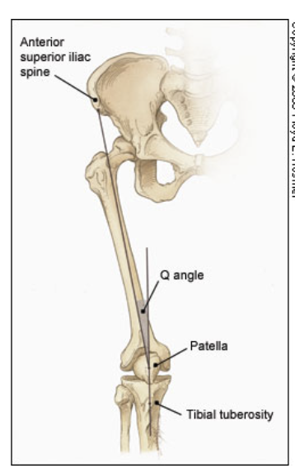
-patellar apprehension test:
- place fingers at the medial aspect of the patella
- attempting to sublux the patella laterally
- Positive sign for patella sublux if : patient has pain or giving-way sensation
- Both superior and inferior patellar facets should be palpated with patella subluxed medially and laterally

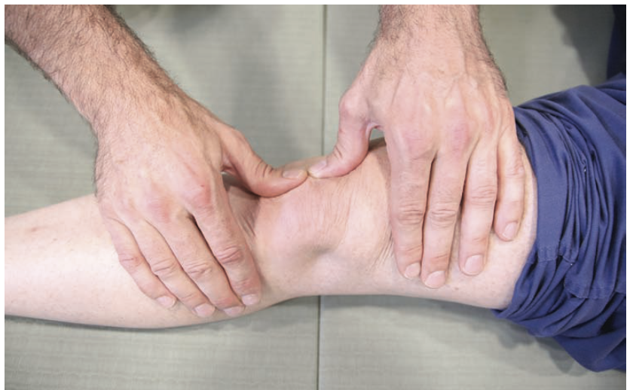

 |  | Cruciate Ligaments
Anterior Cruciate Ligament (ACL):

-Anterior Drawer Test:
-patient is supine with injured knee flexed to 90 degrees attempt to displace tibia forward
-fix the patient foot in slight external rotation (by sitting on the foot)
-place thumbs at the tibial tubercle and fingers at the posterior calf
-the patients hamstring muscles must be relaxed, pull anteriorly and assess anterior displacement of the tibia (anterior drawer sign)
-positive sign: anterior displacement of tibia

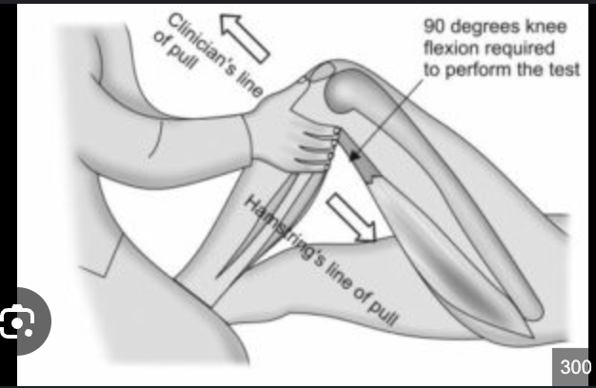

Lachman Test:
-assessing the integrity of the ACL
-patient is supine, the injured knee is flexed to 30 degrees
-stabilize the distal femur with one hand, the proximal tibia in other hand
-attempt to sublux the tibia anteriorly, displace tibia forward on the femur
-positive test: lack of clear end point, increased translation of tibia on femur
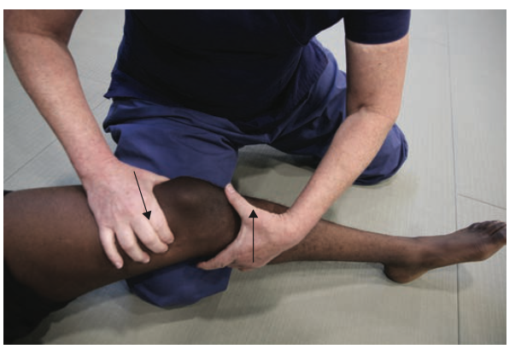
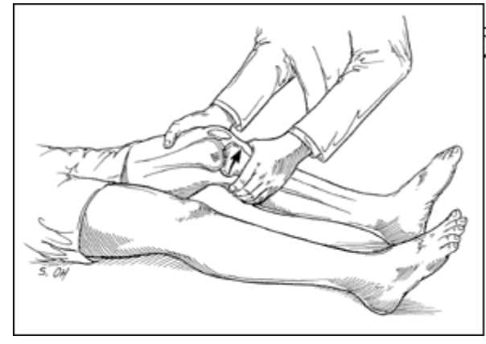

Posterior Cruciate Ligament (PCL):

-patient is supine with knee flexed 90 degrees
Inspection:
-stand at the side of the examination table
-look for posterior displacement of the tibia (posterior sag sign)

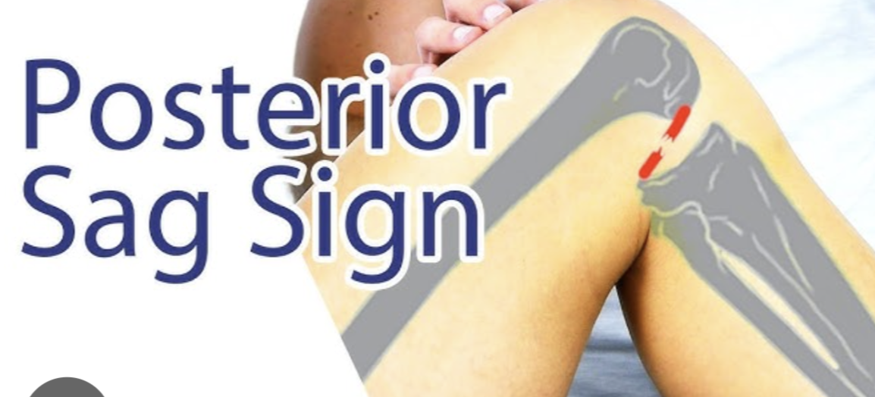

Posterior Drawer Test:

-bend patients knee 90 degrees push backwards on tibia
-fix the patient’s foot in neutral rotation (sit on the foot)
-position thumbs at the tibial tubercle and place fingers at the posterior calf
-place fingers at posterior calf
-push posteriorly
-positive sign if posterior displacement of tibia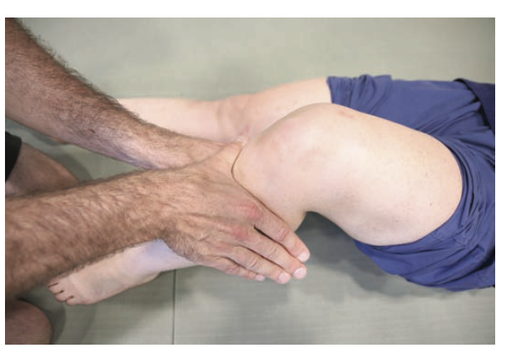

Collateral Ligaments:

Medial Collateral Ligament:
-Valgus Stress Test:
-assessing for MCL laxity
-patient leg slightly abducted, place one hand at lateral aspect of knee joint and other hand at medial aspect of distal tibia
-valgus stress is applied to the knee ad full extension and 30 degrees of flexion
-zero degree full extension: PCL and the atrculation of femoral condyle with tibial plateau should stabilize the knee
-knee at 30 degrees of flexion: application of valgus stress assess the laxity or integrity of medial collateral ligament
-positive test: opening of joint when performing valgus stress
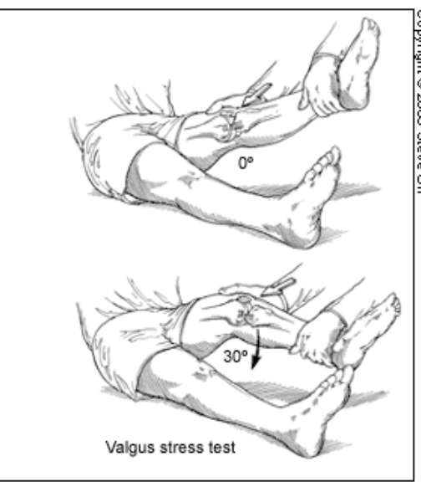

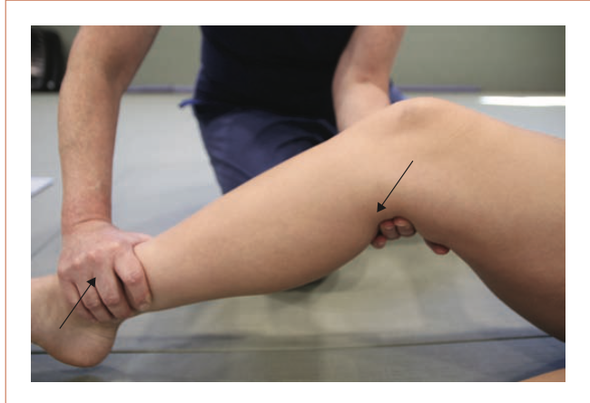

Lateral Collateral Ligament:
Varus Stress Test:
-assessing LCL laxity
-place one hand at medial aspect of patients knee and other hand lateral aspect of distal fibula
-varus test is applied to the knee at full extension and 30 degree knee flexion
-firm end point means collateral ligament is intact
-positive sign: soft or absent end point indicating rupture of ligament (3rd degree tear), opening of joint

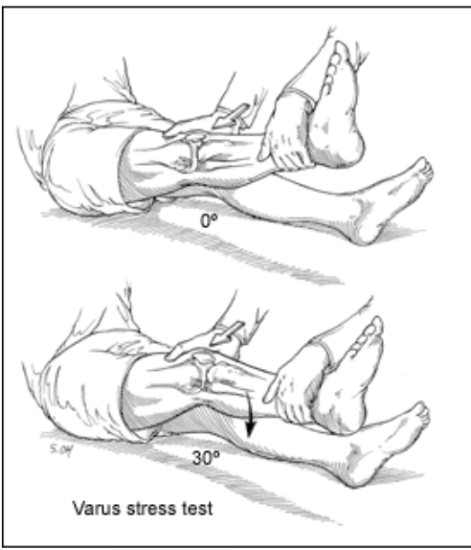

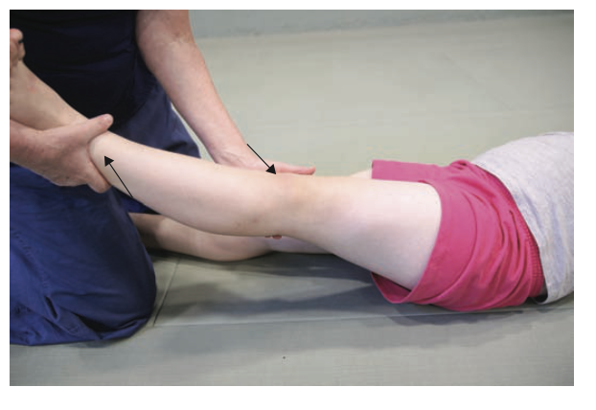
Menisci:

-injury to menisci demonstrates tenderness at joint line
-McMurray test:
-performed with patient lying supine
-grasp patients heel with one hand and the knee with other hand
-have thumb at lateral joint line and fingers at medial joint line
-flex the knee maximally

-to test lateral meniscus: rotate tibia internally and knee extended from maximal flexion to 90 degrees
-added compression to the lateral meniscus is produced by applying valgus stress across knee joint while knee is extended.

-to test medial meniscus:
-tibia is rotated externally
-knee is extended from maximal flexion to 90 degrees
-add compression to medial meniscus by varus stress across knee joint while knee is extended
-positive test: thud or click, pain in ROM

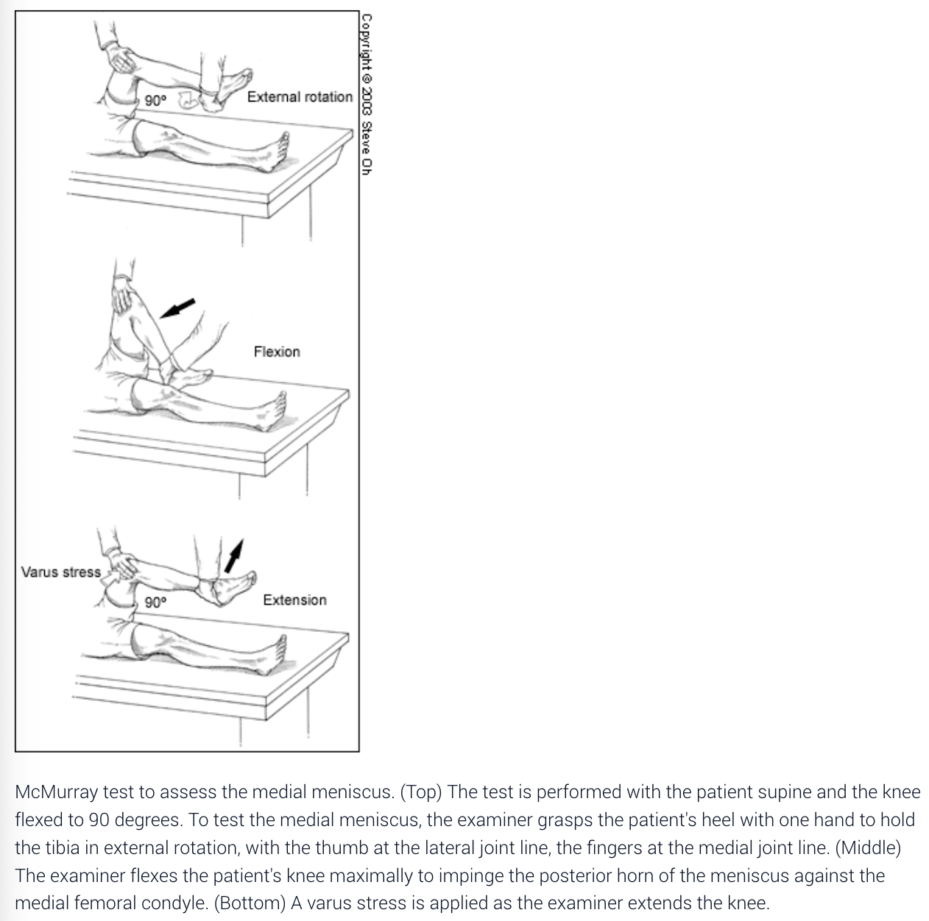
Radiographs |  | **Most knee pain is soft tissue injury and does not require x-ray***  -if require radiograph need 3 views:  -anteroposterior view, lateral view, Merchant view (patellofemoral joint)  -assess for fractures  Obtain if:  -isolated patellar tenderness  -tenderness at the head of the fibula  -inability to bear weight or flex knee to 90 degrees  -55 years older  Ottawa Knee Rul (if any of the below criteria are met patient qualifies for xray)  :  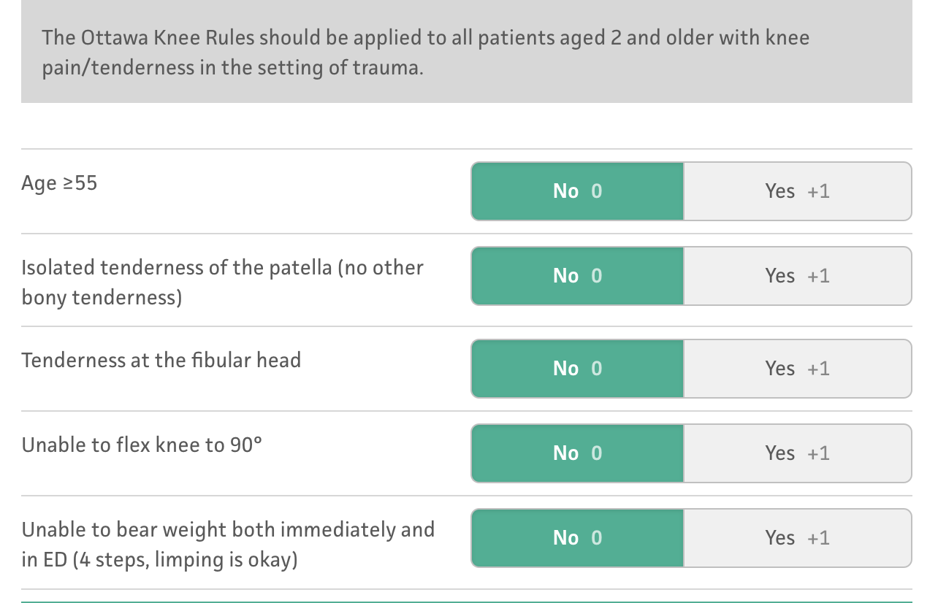  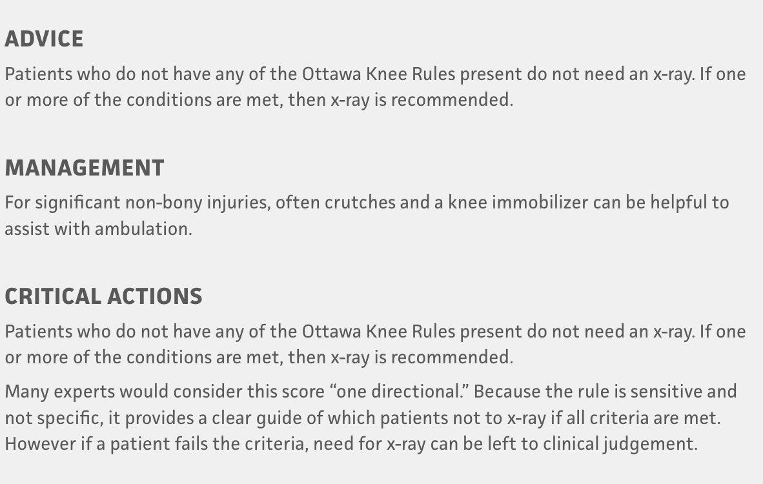
Labs |  | -if presence of warm, tenderness, painful effusion, pain with even slight ROM of knee: could be septic arthritis or acute inflammatory arthropathy  -CBC with differentials, ESR, arthrocentesis  -joint fluid: send to lab for cell count with differentials, glucose and protein measurements, bacterial culture and sensitivity, polarized light microscopy  RA: check ESR and rheumatoid factor
Anatomy of the knee

General Low Back Pain
Def’n | Acute lower back pain: activity intolerance producing lower back or back related leg symptoms of less than 3 months
Pathology/Cause | Pain can arise from:  -fracture  -tumour  -nerve root compression  -degenerative disc  -OA  -strain of ligament or musculature in lumbosacral area
Risk Factors/Epidemiology | -commonly seen in patients aged 20-40  Predisposing factors:  -trauma causing ligament tearing  -trauma causing stretching of vertebrae muscles, tendons, ligaments, fascia  -repetitive mechanical stress  -tumour  -lordosis  -pelvis forward tilted  -uneven leg length  -poor posture
Clinical Presentation  *Insert picture here* | Pain in lower back range from discomfort to severe back pain  Pain may or may not radiate
Hx/Key Questions | What is origin of pain?  Has the pain progressed?  Point to area where pain is  Describe the pain is it dull? Sharp? Shooting down to lower legs and feet?  What makes pain worse? Better?  Pain 1-10?  What current medications using?  What therapies are you doing?  History of back pain or trauma? Arthritis? Osteoporosis? Cancer?  R/O malignancy: unexplained weight loss  R/O infection: do you have a fever  R/O Cauda Equina: Bowel or bladder dysfunction? Bilateral Sciatica? Saddle compression? – urgent referral and workup
Physical Exam | Temperature, pulse, BP, RR  Inspect:  -General appearance, evidence of trauma (bruising, cut, fractures), posture and gait  -bony deformities, curvature of spine  Palpate:  -palpate spine and paravertebral structures note any tenderness or muscle spasm  -palpate peripheral pulses  Neuro: assess sensation, assess pain distribution, test motor and muscle strength if symmetrical  -reflexes  -check sensation of cauda equina **  -if patient has fallen on coccyx a rectal examination is needed to check for stability  Tests:  straight leg raise:  -patient lies supine and the HCP moves the leg passively from zero to 80 degrees with flexion at the hip and extension of the knee.  -Elevate each leg passively -Positive straight leg when patient has pain down the leg as the leg is elevated between 30 and 70 degrees  **pain that is felt felt on opposite leg that is being raised can mean herniated disc  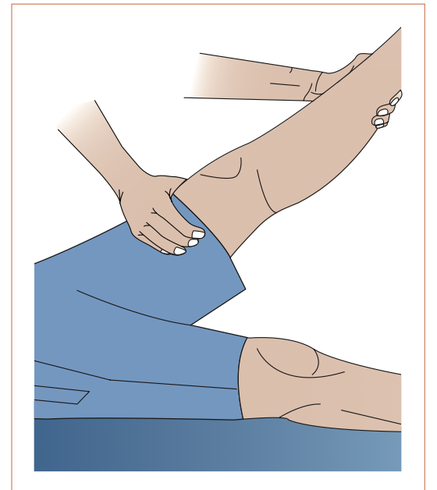  - Crossed leg raises:  -Test is positive when pain occurs in the leg not being raised.  -Yeoman Guying:  -positive: unilateral hyperextension in a prone position identifies lumbosacral mechanical disorder.  - Patrick’s test:  -Place heel on opposite knee and apply lateral force; check for hip or sacroiliac disease.  -Range of motion:  ROM:  -Spinal flexion, extension, lateral left bending, lateral right bending, rotation  -Increased pain with extension often indicates osteoarthritis. Increased pain with flexion often indicates strain or injured disc
Diagnostics/Labs | -CBC, ECR  -calcium, alkaline phosphate, urinalysis  -serum immunoelectrophoresis  -Radiograph of spine  -MRI to rule out disease or tumour  -Bone Scan to rule out cancer
Red flags | Severe compression of cauda equina: Bowel/ bladder dysfunction, bilateral sciatica, saddle compression  Urgent workup and referral  Fracture, tumor, infection, sciatica or leg pain and numbness.  Night back pain- tumour, infection, inflammation,
Differential Diagnoses | -Back pain secondary to MSK  -Herniated intervertebral disease  -Sciatica  -Fracture  -Ankylosing spondylitis  -OA  -osteoporosis
Treatment/Management | Treatment:  Counseling/Education:  Non-pharm therapies: May require rehabilitative services: acupuncture, massage, CBT, yoga
Referrals | -Physiotherapy  -Neurologist: if cauda equina syndrome, herniated disc, neurological widespread involvement, cancer, significant trauma  -Rheumatologist: if noticing morning stiffness, peripheral joint involvement, iritis
Follow-up | If pain is severe and unimproved follow up in 24 hours  If pain is moderate, reevaluate the client in 7-10 days  See client in 2-4 weeks to reevaluate their condition
Refer to the above charts for general back assessments and below I wrote down specific points related to the condition

Low Back Pain acute and chronic (lumbosacral strain)
Def’n
Pathology/Cause | Pain arises from lumbosacral strain of ligament and musculature in lumbosacral area  Caused by: trauma, repetitive mechanical stress, lifting techniques causing excessive strain
Risk Factors/Epidemiology | LBP commonly seen ages: 20-40
Clinical Presentation  *Insert picture here* | Increased pain with flexion  Low back pain without radiculopathy
Hx/Key Questions | Origin of pain? Pain progressed or changed? Point to area where pain is felt  Does activity make pain better or worse?  What medications do you use?  History of trauma? Over use?  Heavy lifting?  Pain 1-10? Dull or sharp?  R/O malignancy/ infection: :unexplained weight loss or fever
Physical Exam
Diagnostics/Labs
Red flags | Severe compression of cauda equina: Bowel/ bladder dysfunction, bilateral sciatica, saddle compression  Urgent workup and referral
Differential Diagnoses
Treatment/Management | Treatment:  Counseling/Education:  Non-pharm therapies:
Referrals
Follow-up

Low Back Pain acute and chronic (herniated disc)
Def’n
Pathology/Cause | Disk herniation causes nerve root irritation and produces lower back pain
Risk Factors/Epidemiology | -immobility of lumbosacral junction increases mechanical stress at L5 and S1 increases the likelihood of disc herniation or spondylolisthesis of L5 and S1
Clinical Presentation  *Insert picture here* | -increased pain with flexion  -the pain radiates down buttock to below knee  -most common cause of sciatica is a herniated disc presenting as pain or numbness traveling down the lateral or posterior leg unilateral
Hx/Key Questions
Physical Exam | Tests:  straight leg raise:  -patient lies supine and the HCP moves the leg passively from zero to 80 degrees with flexion at the hip and extension of the knee.  -Elevate each leg passively -Positive when patient has pain on opposite leg
Diagnostics/Labs | MRI: diagnose herniated disc if pain is longer than 1 month
Red flags | Cauda equina syndrome medical emergency bowel and bladder dysfunction, reduced sensation in saddle area
Differential Diagnoses
Treatment/Management | Treatment:  Counseling/Education:  Non-pharm therapies: yoga
Referrals | Consult with a neurologist for herniated disc
Follow-up

Low Back Pain acute and chronic (spondylolysis and spondylolisthesis)
Def’n | Spondylosis: general degenerative changes in spine such as disc and facet joint degeneration  Spondylolisthesis: when a vertebra slips forward out of its normal position and onto the vertebra below
Pathology/Cause | -spondylolysis has 40% familial occurrence in native alaskans
Risk Factors/Epidemiology | -immobility of lumbosacral junction increases mechanical stress at L5 and S1 increases the likelihood of disc herniation or spondylolisthesis of L5 and S1  Spondylolisthesis: pain that can result from disruption of vertebral spinous process, where disruption causes subluxation of vertebral body into adjacent structures usually between L5 and S1
Clinical Presentation  *Insert picture here* | Early adulthood (20-45) and chronic back pain that improves with activity  Can have affected gait with severe spondylosis  Spondylosis: history of overuse and pain, localized pain  Spondylolisthesis: pain that is intermittently worse with movement, pain is usually chronic, forward flexion is limited
Hx/Key Questions | Spondylolisthesis: young person in a sport that demands rapid movement between hyperflexion and hyperextension or requires excess loading in hyperextension.
Physical Exam | Spondylolisthesis: palpable spinous process; no neurological signs; pain localized to low back just below level of iliac crest; tight hamstrings, forward flexion is limited
Diagnostics/Labs | radiograph
Red flags
Differential Diagnoses
Treatment/Management | Treatment:  Counseling/Education:  Non-pharm therapies: yoga
Referrals
Follow-up

Low Back Pain acute and chronic (Degenerative Process)
Def’n
Pathology/Cause
Risk Factors/Epidemiology | -caused by aging  -repetitive use  -degenerative disease  -OA
Clinical Presentation  *Insert picture here* | -occurs at older age  -progressive worsening of back pain and symptoms
Hx/Key Questions
Physical Exam
Diagnostics/Labs
Red flags
Differential Diagnoses
Treatment/Management | Treatment:  Counseling/Education:  Non-pharm therapies:
Referrals
Follow-up

Low Back Pain acute and chronic (Spinal Stenosis)
Def’n | Spinal stenosis is a bony encroachment on the nerve roots of lumbar spine
Pathology/Cause
Risk Factors/Epidemiology | Occurs over age of 50 years
Clinical Presentation  *Insert picture here* | Pain that hurts more with extension  Pain associated with lumbosacral radiculopathy  Pain with walking or standing, sneezing, coughing  Relief with sitting or forward flexion (if pain is not relieved with lying down might be cancer/infection).  Pain is worse throughout the day; aggravated by standing; relieved by rest; pseudoclaudication  Neurogenic (pseudo) claudication pain:  Pain of lower extremities is made worse with prolonged standing, walking, bending, hyperextending the back
Hx/Key Questions
Physical Exam | Signs of OA of joints, may have neurological sings
Diagnostics/Labs | MRI
Red flags
Differential Diagnoses
Treatment/Management | Treatment:  Counseling/Education:  Non-pharm therapies:
Referrals
Follow-up

Low Back Pain Tool
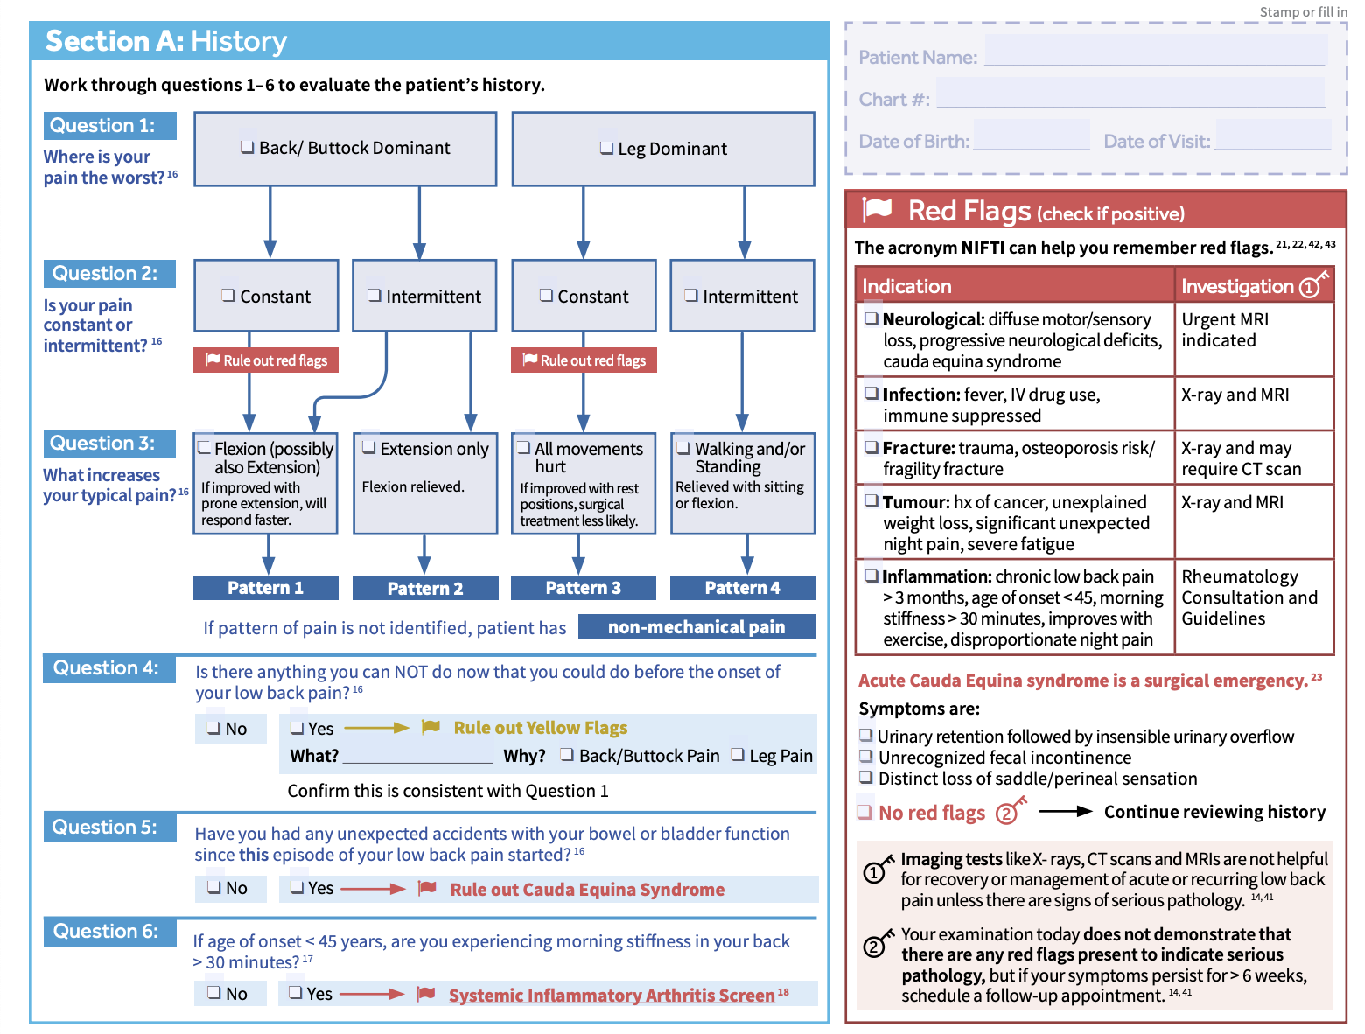
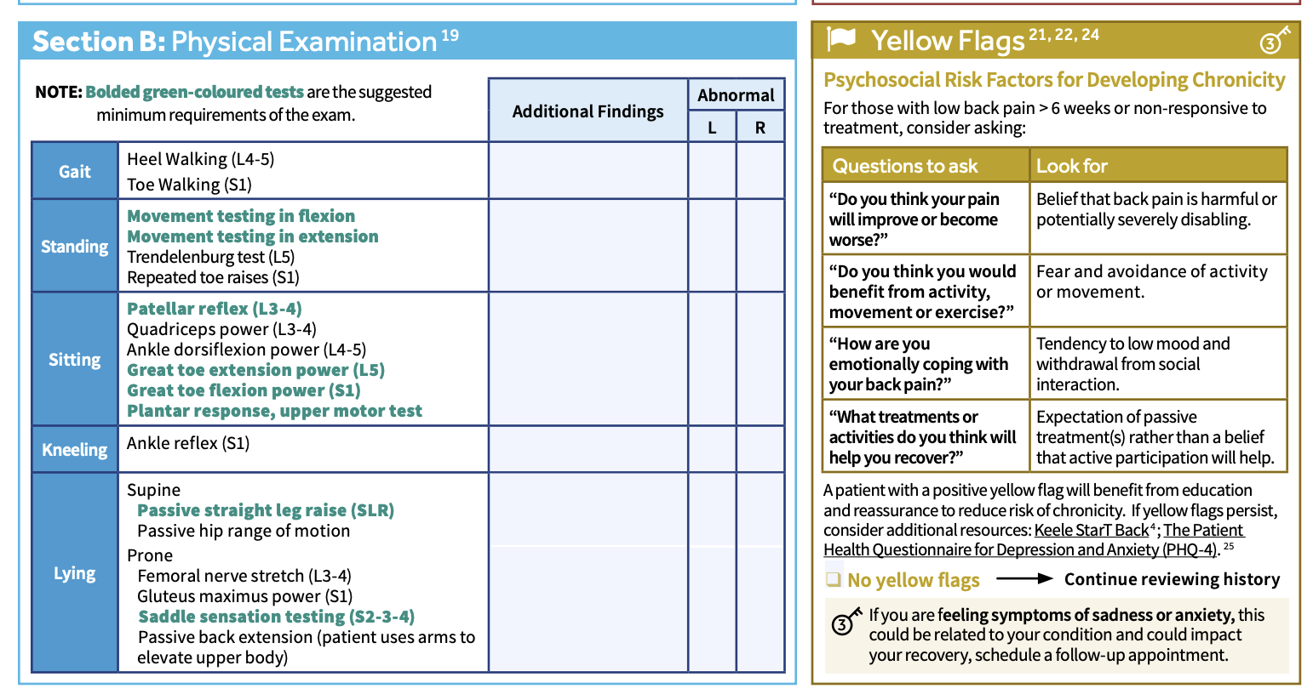
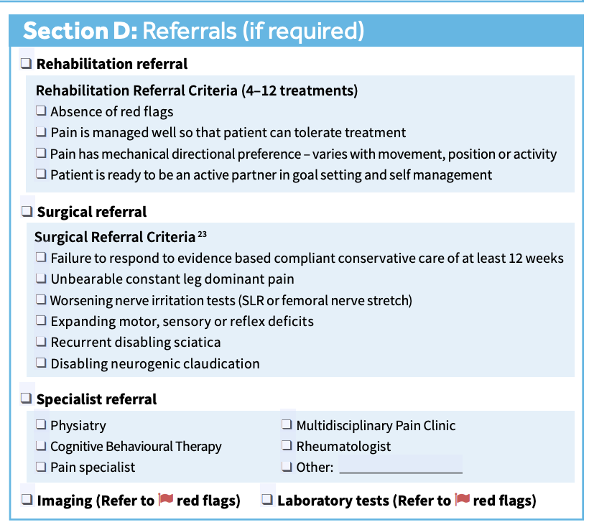

Wrist and Hand pain (Scaphoid Fracture)
Def’n | Scaphoid fracture usually
Pathology/Cause | Results from falling on outstretched hand
Risk Factors/Epidemiology
Clinical Presentation  *Insert picture here* | Present with painful, swollen distal forearm and wrist
Hx/Key Questions
Physical Exam | Assess pulse, pain, sensation, motor function ROM.  Palpate anatomical snuffbox for tenderness  (snuff box is located between the extensor pollicis longus and extensor pollicis brevis tendons)  Positive sign for scaphoid fracture if there is tenderness in snuffbox area  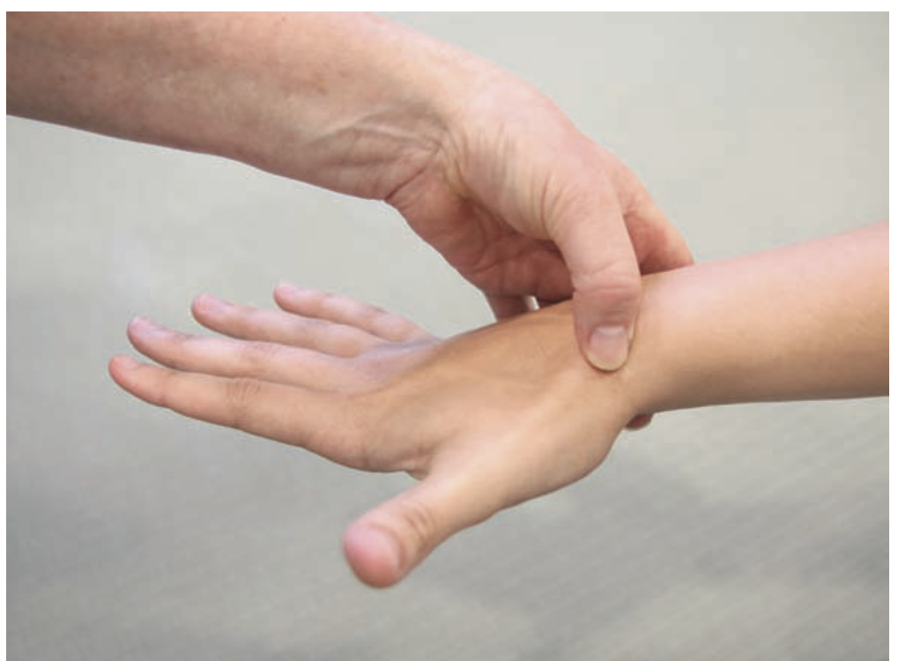
Diagnostics/Labs | Radiograph view (posteroanterior, lateral, oblique)
Red flags
Differential Diagnoses
Treatment/Management | Treatment:  Counseling/Education:  Non-pharm therapies:
Referrals
Follow-up

Wrist and Hand Pain (Carpal Tunnel)
Def’n | Carpal Tunnel is area in which forearm muscles and medial nerve pass  Carpal tunnel syndrome involves entrapment of the median nerve  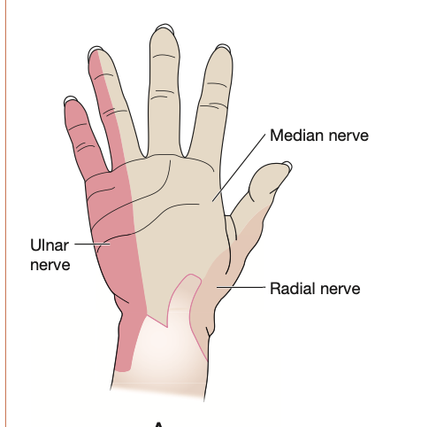
Pathology/Cause | More common in women and people over 30 years of age  Compression of median nerve occurs due to repeated strain that causes thickening of the flexor tendon sheath causing pressure that blocks the nerve fibers
Risk Factors/Epidemiology | Overuse caused by repetitive microtrauma which often affects fingers and wrists  Working on keyboards  Can also be caused by: trauma, rheumatoid disorder, DM,
Clinical Presentation  *Insert picture here* | Median nerve neuropathy causing sensory loss (thumb, index, half of middle finger).  Symptoms of numbness and tingling  Feel a dull achy pain is felt across the wrist and forearm with paresthesia, weakness, clumsiness of hand, atrophy, symptoms are often worse at night
Hx/Key Questions | History of repetitive motion? Do the symptoms get worse with activity? DO you waken at night due to symptoms?
Physical Exam | Notice dry skin on the thumb, index finger, middle finger  Tinel’s Test:  -percuss the carpal tunnel for paresthesias into the hand  Positive sign: if there is paresthesia in the median nerve distribution with percussion  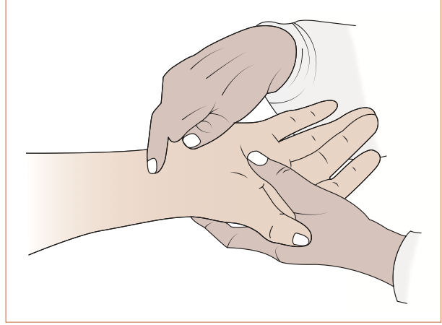  Phalens Test:  Ask patient to hold their flexed wrists pressed together for at least 60 seconds or until symptoms arise.  Positive test if reproduction of patient symptoms at or before 60 seconds  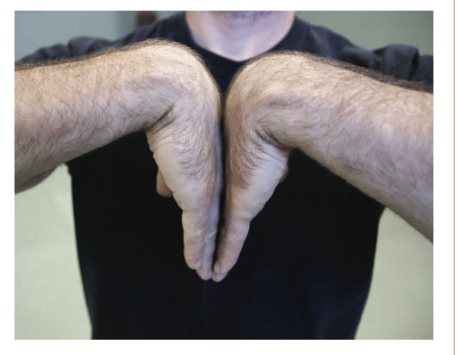
Diagnostics/Labs | EMG: is gold standard diagnostic test.  Two other tests have a low sensitivity: tinels test and phalanges test
Red flags
Differential Diagnoses
Treatment/Management | Treatment:  Counseling/Education:  Non-pharm therapies:
Referrals | Refer to surgery if severe symptoms, occupational therapy
Follow-up | Month to evaluate status

Wrist Pain (Ganglion Cyst)
Def’n | Cyst
Pathology/Cause | Ganglion is a cyst that contains gelatinous fluid
Risk Factors/Epidemiology
Clinical Presentation  *Insert picture here* | Complains of swelling over dorsal or volar aspect of wrist  Presents as an outpouching of a joint capsule or tendon sheath  Usually presents on dorsum wrist  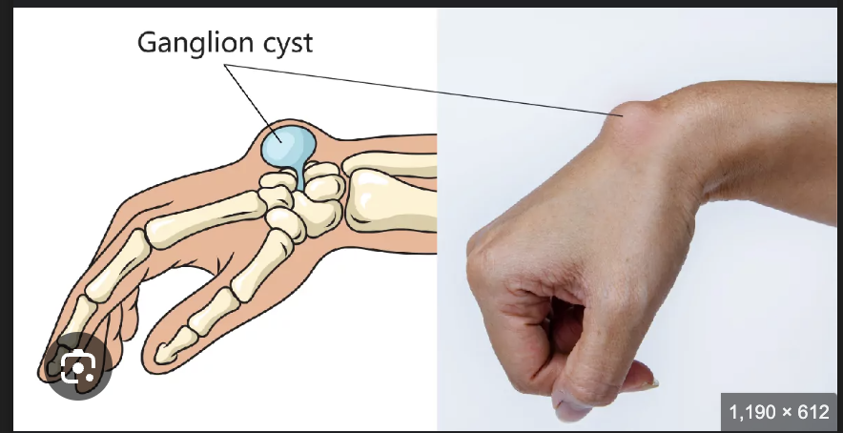
Hx/Key Questions
Physical Exam | Inspect for swelling over dorsal and volar surface of wrist joint looking for ganglion cyst  Evaluate for flexion deformities of metacarpal phalangeal joints  **differentiates from a tumour by being soft and transilluminating**
Diagnostics/Labs
Red flags
Differential Diagnoses
Treatment/Management | Treatment:  Counseling/Education:  Non-pharm therapies:
Referrals
Follow-up

PLANTAR FASCIITIS
Short definition/ description | An inflammatory condition of the plantar fascia in the foot causing pain in the arch of the foot, radiating to the heel
Pathology/cause | - Plantar fascia is connective tissue that runs across the bottom of the foot  - Connects the bottom of the tuberosity of the calcaneus (heel) bone to the heads of the metatarsal bones  Repetitive small tears in the fascia cause collagen breakdown at the medial tubercle of the calcaneus
Epidemiology | The most common cause of heel pain in Canada  - Seen in both men and women; common in middle-aged people
Risk Factors | - Athletes (overuse injury from running)  - Tight or weak muscles/tendons  - Achilles tendon, heel cord, gastrocnemius, soleus  - Poor arch support or improper footwear (poor support in shoes)  - Anatomic abnormalities like low arch support, a flat foot, high arch, tibial torsion, overpronated foot, leg-length discrepancies, forefoot varus, and thinning of the fat pad
Screening
Clinical Presentation  (Subjective Symptoms & Objective Signs) | HALLMARK: severe, stabbing foot pain in the bottom of the foot, especially first thing in the morning  Common findings:  - Burning pain with walking; stiffness in the foot and heel  - Worse in the morning, improves during the day, gets worse again at the end of the day  - Increased foot pain with walking after long periods of standing or sitting  Other signs and symptoms:  - Both heels can be affected; heel spurs may or may not be present  - Pain in the medial tubercle of the calcaneus, medial to the longitudinal arch  - Pain that worsens with prolonged standing
Hx/Key Questions | OPQRST of the pain  - Activities that aggravate pain  - Ask if the pain is radiating into the toes or the leg
Physical Exam | VITALS: pulse and blood pressure (pulse in the affected extremity)  INSPECT: feet bilaterally→ note swelling, discolouration, rash  - Observe gait  AUSCULTATE: heart and lungs  PALPATE: both feet  - Note pain, tenderness (pain will be noted over insertion on medial heel)  *Perform passive dorsiflexion of the toes and ankle; have the client stand on the tips of the toes to see if this elicits the pain
Red Flags
Differential Diagnosis | Generic heel pain; heel spurs; arthritis; stress fracture
Diagnostics:  Labs & Imaging | Diagnostic tests and/or Imaging  - X-ray may be done BUT it is often normal and not needed  - If there are suspected spurs, tumors, or stress fractures, then it would be appropriate  - MRI  - If there is thickening of the proximal plantar fascia or rupture is suspected
Treatment/ Management | Counseling/Education  - Avoid walking on hard surfaces; never go barefoot, even indoors  Complementary Therapies (non-pharmacological)  - Conservative treatment: avoiding long periods of standing for 6-8 weeks  - Proper foot care and support  - Shoe arches (custom orthotics)  - New shoes  - Ice therapy for pain and swelling  Exercises…  - Roll the foot arch over a tennis ball or frozen water bottle for 20-30 minutes each evening to help stretch the plantar fascia  - Calf stretches against a wall, leaning forwards
Medical management | In severe cases→ corticosteroid lidocaine injections to the most tender area  NSAIDs for pain relief
Advise clients when to RTC or call for help | Consider diagnostic workup with MRI if the pain worsens despite treatment
Referrals | Physiotherapy!  Podiatrist if conservative therapy fails after 6 weeks, or if nerve entrapment is suspected
Follow-up | In 4 weeks to evaluate efficacy of treatment; pain should slowly improve with aggressive treatment management  - Must ensure compliance with instructions (can take 6-12 months for full resolution)
Complications | Foot, knee, hip, and back if gait changes to compensate for pain when ambulating
1° and 2° Prevention | Primary prevention: supportive, well-fitting footwear
References | Cash & Glass

LATERAL AND MEDIAL EPICONDYLITIS (the same thing as elbow tendonitis)
Short definition/ description | Lateral Humeral epicondylitis= Tennis elbow (affects supinator muscles); an overuse injury  - The flexor muscles  Medial epicondylitis= golfer’s elbow or thrower’s elbow (affects pronator muscles)  - The flexor muscles  Aseptic inflammation of the bone-tendon junction, resulting from repetitive concentric contractions that transmit force via the muscles to the origin on the epicondyle  - A degenerative condition, not an inflammatory process
Pathology/cause | Medial epicondyle= involvement off the ulnar nerve, and ulnar collateral ligaments  Overall→ a chronic tendinosis, not acute inflammation  - Degenerative changes occur from overuse  4 stages→ generalized inflammation; angiofibroblastic degeneration; structural failure; fibrosis and calcification  - Repetitive microtearing of the tendon at the origin, followed by an unsuccessful healing process
Epidemiology | Lateral epicondylitis is the most common cause of elbow symptoms in patients  - Genders are affected equally  Medial epicondylitis is much less common than lateral epicondylitis (10%)  - Middle aged adults are more likely to be affected
Risk Factors | LATERAL  - Non-athletes with occupations that require repeated contractions of the affected muscle groups  - In lateral epicondylitis→ extensor and supinator muscles  - Athletes who play tennis, bowling, and hockey  - Often precipitated by por body mechanics and technique, improper equipment  MEDIAL  - Smoking, diabetes, obesity  - Repetitive wrist flexion and forearm pronation for 2+ hours per day
Screening
Clinical Presentation  (Subjective Symptoms & Objective Signs) | HALLMARK: pain with palpation to either epicondyle (about 1 cm from the epicondyle itself)  Common findings:  - Gradual onset of pain and tenderness that progresses in intensity  - Supination against resistance causes worsening of the pain  - Elbow movement is not limited with these conditions  - Symptoms that manifest in the patient’s dominant arm  Other signs and symptoms:  - Tenderness of the epicondyle with palpation  - Pain typically subsidies with rest  - Morning exacerbation of the pain is common
Hx/Key Questions | OPQRST of the pain  - Ask about history of repetitive movements  - Patients may report a sudden onset, but recall overuse history without a specific inciting event  - Ask about hobbies, occupations  - Ask about new equipment, or atypical workout circumstances  - Assess for any numbness
Physical Exam | *Common for the elbow to be unremarkable in appearance  VITALS: HR, BP, temp (if indicated)  Inspect: both elbows for redness, swelling, deformities  Palpate: bilateral elbow  - Tenderness with palpation to the affected side  - In lateral→ pain is aggravated by supination  - Resisted extension of the middle finger while elbow is extended is painful because it puts added pressure onto the tendon  - Typically there is an absence of numbness or tingling  - In medial→ pain is aggravated by pronation  - More common to have numbness and tingling due to positioning of the ulnar nerve  - Flex the elbow at 90 degrees to isolate the muscle groups  MEDIAL  - Tinel’s sign  - Milking maneuver  - Valgus stress test
Red Flags
Differential Diagnosis | LATERAL  - Elbow bursitis, cervical radiculopathy, posterolateral elbow plica, radial nerve entrapment, radial tunnel syndrome, fracture, triceps tendonitis, shingles  MEDIAL  - Ulnar neuropathy, cervical neuropathy, ulnar collateral ligament sprain or tear, valgus overload syndrome, synovial plica, synovitis, elbow bursitis, rheumatoid arthritis, shingles, occult fracture
Diagnostics:  Labs & Imaging | Diagnosis is usually made through history and physical alone  Diagnostic tests and/or Imaging  - X-ray if there is suspected calcification of the tendons, osteophytes, or acute or traumatic cause  - May be helpful for assessing growth plates in pediatric patients  MEDIAL  - MRI is the gold standard for diagnosis  - Thickened common flexor sheath  - Ultrasound can be used to detect thickening of the tendon sheath, partial or full thickness tears, and neovascularization
Treatment/ Management | Counseling/Education  - SHORT TERM→ stop offending activities and add pain relievers  - Modify previously offending activities long-term  - Early rehabilitation is KEY  Complementary Therapies (non-pharmacological)  - Ice after activities, use NSAIDs and acetaminophen for pain relief (oral and topical)  - Bracing with a counterforce elbow strap overnight may help some patients  - Kinesiology tape (more evidence for use in lateral epicondylitis)
Medical management | Most case of both types are self-limiting; non-operative management is common  Corticosteroid injections for short-term relief of pain for up to 6 weeks
Referrals | Physiotherapy→ active participation is crucial  Rehab or sports medicine for severe and refractory cases
Follow-up | After a few weeks to evaluate benefit of conservative therapy
Common Complications | With medial epicondylitis, ulnar neuritis can occur  With lateral, common to see recurrence of the injury when normal activity is resumed  - Tendons may rupture with repeated steroid injections
1° and 2° Prevention | Primary prevention: proper technique, and properly fitting equipment for sports activities
References | https://www.ncbi.nlm.nih.gov/books/NBK557869/  https://www.ncbi.nlm.nih.gov/books/NBK431092/

NURSE-MAID’S ELBOW
Short definition/ description | Also known as radial head subluxation  *REMINDER: with subluxation, the heads of the bones are still touching in the joint  - The radial head slips under the annular ligament, resulting in pain and an inability to supinate the forearm
Pathology/cause | Annular ligament holds the radial head against the ulna  - Applying axial traction to a pronated forearm and an extended elbow causes the ligament to slip over the head of the radius and become trapped in the radiohumeral joint
Epidemiology | Common in young children ages 1-4  - Less common in aged 5+ (annular ligament strengthens with age)  - Slightly more common in females, and more common in the left arm  - 20% recurrence rate
Risk Factors | - Being swung by the arms or lifted by the arms  - Falling onto the elbow  - Twisting the forearm  - Rolling over in bed onto the arm (ages <6 mos)
Clinical Presentation  (Subjective Symptoms & Objective Signs) | HALLMARK: children protect the arm by holding it in a complete extended, pronated position  Common findings:  - Typically no pain unless the arm is actively manipulated  - Tenderness at the radial head  - Resistance to pronation, supination, flexion, extension  Other signs and symptoms:  - Not common to see visual signs (redness, swelling, signs of trauma)  - Circulation and movement should be intact distal to the elbow despite potentially uncooperative patient
Hx/Key Questions | Expect to rely heavily on the caregiver  - What happened just prior to the event? Caregivers may not understand the association between seemingly harmless movements and the injury  - Ask about falls
Physical Exam | VITALS: all, as needed  INSPECT:  - Pay attention to how the child is holding the arm  - Don’t expect to see any outward signs of trauma or injury  - Assess the clavicle as well  PALPATION:  - Pain with radial head palpation and all movement of the affected arm  - Assess that cap refill, sensation, and motor function remains intact  - Palpate the entire arm for pain and tenderness
Red Flags
Differential Diagnosis | Elbow fracture, fractured wrist, hand injury, soft tissue damage, greenstick fracture  - Monteggia fracture  - Proximal ⅓ ulna fracture, often associated with radial dislocation  - Supracondylar fracture
Diagnostics:  Labs & Imaging | Diagnosis is typically made on history and physical exam  Laboratory tests  Diagnostic tests and/or Imaging  - May x-ray if fracture, elbow dislocation is suspected OR if there is edema or deformity  - Consider imaging if the injury did not occur with the typically expected traction, or if non-accidental trauma is suspected  - If it a true nursemaid elbow, the radiograph should be normal
Treatment/ Management | Counseling/Education  - Reduction itself is painful, but pain should resolve within a few minutes  Complementary Therapies (non-pharmacological)  - Have the child sit in the parent’s lap for the procedure, with the examiner facing the child
Medical management | Closed reduction in the clinical setting; may spontaneously reduce before being seen
Advise clients when to RTC or call for help | Should come to clinic for reduction as soon as possible. If it spontaneously reduces, child should still be brought in for assessment  - Spontaneous reduction is fine; the joint does not need to be manipulated or corrected in any way if this occurs
Referrals | None required
Follow-up | Monitor for recurrence; can occur in 20% of children
Common Complications | Potential for associated ulnar fracture (Monteggia fracture)
1° and 2° Prevention | Primary prevention: avoid significant pressure, traction, or pulling on the elbow joint in young children
References | https://www.ncbi.nlm.nih.gov/books/NBK430777/

BURSITIS (OF THE ELBOW; OLECRANON)
Short definition/ description | Inflammation of the sac (synovial membrane) lined with synovial fluid; usually secondary to traumatic tenosynovitis of the shoulder or elbow.  - Caused by overuse and trauma  Can be associated with rheumatoid arthritis
Pathology/cause | - Bursae lie over bony prominences to reduce friction from motion of fascial planes  - They are superficial, and have limited vascularity, meaning they are susceptible to trauma and infection
Epidemiology | Most often secondary to trauma; bleeding in the bursa causes inflammatory mediators to be released  - Not associated with mortality; no sex or race predisposition; occurs in children and adults
Risk Factors | - Common in people who engage in contact sports  - Repetitive motion  - Rubbing or placing pressure on the elbow  - Overuse  Associated with inflammatory conditions  - Rheumatoid arthritis  - Psoriatic arthritis  - Gout  Associated with chronic conditions→ diabetes, alcoholism, HIV  *usually transcutaneous route of infection, not hematogenous
Clinical Presentation  (Subjective Symptoms & Objective Signs) | HALLMARK: an aching pain that radiates to the points of tendon insertion or further along the limb, and swelling over the olecranon process  Common findings:  - Muscle weakness  - Tenderness with palpation  - Swelling leading to limited range of motion in the joint (typically normal ROM)  - A round or golf-ball shape due to fluid confinement within the bursa  Other signs and symptoms:  - Erythema, edema  - Septic bursitis may be associated with fever and systemic features
Hx/Key Questions | OPQRST of symptoms  - Ask about occupational habits like leaning on the elbows  - Ask about recurrence  - Ask about systemic symptoms to rule out septic bursitis  - Ask about recent trauma to the area
Physical Exam | VITALS: all, as needed (HR, BP)  INSPECT:  - Examine the skin for intactness  - Penetrating injury can cause septic bursitis  - Patients may stop movements of the elbow due to pain  PALPATE  - Warmth, tenderness
Red Flags
Differential Diagnosis | Gout, rheumatoid arthritis, elbow fracture, tendonitis, acute trauma to the elbow  Cutaneous abscess, hematoma, cellulitis, tendon rupture, neoplasm, ligament rupture
Diagnostics:  Labs & Imaging | Diagnosis is typically made by history and physical alone  Labs  - Consider the risk for septic bursitis, and weight the potential need for aspiration of the bursa (bursal aspiration is the gold standard)  - Fluid could be sent for culture and sensitivity testing  Diagnostic tests and/or Imaging (important in risk for alternative ddx or infection)  - X-ray if there is suspected bone infection
Treatment/ Management | - Counseling/Education  Complementary Therapies (non-pharmacological)  - Conservative management: ice, rest, and NSAIDs  - Elastic bandage application can help reduce swelling  - Corticosteroid injection can help with early reduction in symptoms
Medical management | Aspiration→ 10% risk of persistent symptoms at 6 months  Bursectomy can be considered with repeat symptoms (higher risk with underlying bone spurs)
Referrals | - Refer to orthopedic surgeon for surgical excision or if there is an underlying bone spur
Follow-up | Assess for resolution of symptoms as needed for each patient
Common Complications | Infection and persistence of symptoms if aspiration is performed
References | https://www.ncbi.nlm.nih.gov/books/NBK470291/

FIBROMYALGIA (and associated link)
Short definition/ description | A syndrome of diffuse body pain associated with several secondary symptoms  - Can wax and wane over time
Pathology/cause | Unknown, no associated abnormalities to joints or soft tissue despite pain and tenderness  - Neurophysiological changes are present  - Abnormalities in pain processing at nervous system level  - Altered HPA axis stress response  - Abnormalities of peripheral sensitization
Epidemiology | 2-3% prevalence in Canada, 6-9x more likely to occur in females than males  - Common in middle-aged women (age 30-50), but also seen in children, teenagers, and elderly  In the elderly, can be associated with more significant pain due to osteoarthritis and other concurrent conditions
Risk Factors | - Female  - Middle age  - Previous infectious illness (viral), trauma, or psychological stressful event can lead to a vulnerable health status, triggering FM  - Genetics (offspring of FM women)  - Early life psychosocial stress  - Depression
Clinical Presentation  (Subjective Symptoms & Objective Signs) | HALLMARK: fatigue, nonrestorative sleep, cognitive dysfunction, mood disorder, and variable somatic symptoms  Common findings:  - Symptoms occur for years prior to diagnosis  - Morning stiffness, pain that worsens with stress, sensitivity to touch, light, sound  - Numbness, swelling, hyperemia of skin, Reynauld’s phenomenon, IBS, bladder symptoms, headaches, restless leg syndrome  The symptom complex  - Pain- the primary complaint; present for at least 3 months  - Usually an insidious onset, beginning in a localized area, initially intermittent, and then becoming progressively more persistent  - Felt in muscle or joint areas in the absence of actual abnormality  - May have a burning quality  - Symptoms may increase with cold and humid weather  - Pressure induced pain  - Fatigue→ may be more disabling than pain  - Nonrestorative sleep→ disturbances, fragmented, sleep apnea, restless leg  - Cognitive dysfunction→ poor memory, free recall, and verbal fluency  - Mood disorder→ depression, anxiety (75%)  - Somatic symptoms  - Sexual dysfunction, symptom severity linked to cigarette smoking
Hx/Key Questions | OPQRST of symptoms  - Ask about length of symptoms experienced (3 months for diagnosis)  - Ask about impact on quality of life  - Ask about family history of FM or rheumatoid disease  - Ask about sleep quality, history of stressors, depression  - Ask about previous diagnoses of chronic fatigue, Lyme disease, thyroid disease
Physical Exam | Typically, the physical exam is within normal limits  VITALS  INSPECT  - Overall appearance  - Assess nails, skin, mucous membranes, eyes, joints, spine  - If there is clubbing and limited tenderness, consider hypertrophic osteoarthropathy  Auscultate heart and lungs  PALPATION  - General tenderness of the soft tissues is reported  - A specific tender point is not required for a diagnosis  - Sensitivity to light touch can occur without other neurological findings  MSK  - Palpate the muscles with sufficient pressure  - Focus on back, neck, jaw, shoulders, chest, abdomen, arms, hips, and legs  - Look for a positive pain reaction; client telling you that palpation causes pain (tenderness is different!)  NEUROLOGICAL  The tender point examination…  - Previously required 11 of 18 tender points to be present in designated areas  - Indicated a reduction in pain threshold without underlying pathology  - Most commonly done by digital examination  - Eliminated in the new criteria for diagnosis of FM  *Do manual palpation of the soft tissues for general tenderness, but there is no required specific tender point examination for diagnosis
Red Flags
Differential Diagnosis | Hypothyroidism, arthritis, polymyalgia rheumatica, myopathy, MS, systemic lupus erythematosus, depression, Lyme disease, hepatitis C, HIV, medication use (statins, aromatase inhibitors, bisphosphonates)
Diagnostics:  Labs & Imaging | Diagnose based on clinical evaluation including history of complaints, past health status, and physical exam. (FM IS NOT A DIAGNOSIS OF EXCLUSION)  - Diffuse body pain present over at least 3 months, with other associated symptoms that cannot be explained by another illness  Laboratory tests  - There is no confirmatory lab test  - Limit lab testing to CBC, ESR, CRP, TSH, and creatine kinase  - This should effectively rule out the other common disorders that may present similarly to FM  - Vitamin D and ANA testing is not indicative of pain levels or future connective disease  - Screening should be driven by clinical findings only
Treatment/ Management | Counseling/Education  - There is no gold standard of treatment  - Self-efficacy and adherence to treatment will influence a favourable outcome  Complementary Therapies (non-pharmacological)  - Exercise, education, CBT (at least one educational or psychological therapy and at least one exercise therapy)  - Good social supports to promote healthy lifestyle practices
Medical management | There is no cure for FM; treat to reduce symptoms  Ideal management→ pain and symptom control  Alternative medicines→ acupuncture, Chinese herbal medicine for pain relief, chiropractic care, hydrotherapy  Pharmacological→ optimal treatment is likely a combination  - Analgesics (acetaminophen) and TCAs  - If there is moderate to severe pain, can consider a trial of a weak opioid like tramadol if the patient is unresponsive to other treatments  - If there is sleep disturbance, consider a trial of a cannabinoid product  - Consider antidepressants, gabapentinoids, dopaminergic agents, sleep modifiers  WSIB Forms should be completed if needed
Referrals | Encouraging more diagnosis and management in primary care, less referral to specialists  - Specialist referral is not required for a diagnosis  Consider involving a psychiatrist for depression in patients
Follow-up | Any treatment regimen requires follow-up for repeated re-evaluation and assessment of side effects (more frequent visits with treatment initiation)  - Consider every 2-4 weeks
References | https://fmguidelines.ca/?page_id=21  Cash & Glass

KNEE STRAINS AND SPRAINS
Short definition/ description | Strain= tendon or muscle involvement  Sprain= ligament stretch or partial tear from forceful stress on the joint  Grade 1→microscopic tears without ligament tearing or joint instability  Grade 2→ partial tearing of the involved ligaments and laxity of the joint with moderate function loss  Grade 3→ ligament tearing with severe function loss and joint instability (rupture)  *some sites have grade 4, which is an associated fracture at the site of the ligament connection
Pathology/  cause | A sudden stress to a supporting ligament causes stretching or tearing; usually from a jumping, falling, or rotating of the joint  - Knee sprains most commonly affect the patellofemoral joint
Epidemiology | SPRAINS= Among the 10 most common causes of occupational injury and worker compensation claims
Risk Factors | Previous injury to the joint  Athletic activities  Patellofemoral instability  Gait and falls
Screening | Knee ligament tears usually do not tear in prepubertal or peripubertal clients. The growth plate may open on one side (should always check for fracture of the growth plate in this population with a radiograph)
Clinical Presentation  (Subjective Symptoms & Objective Signs) | HALLMARK: patient reports a twisting of the knee  Common findings:  - Swelling, pain, weakness of the joint from a specific event  Other:  - First degree sprain= minimal pain, occurs with stress, minimal swelling and tenderness, unimpaired weight bearing or walking, internal microdamage  - Second degree sprain= moderate pain with rOM, swelling, tenderness, trouble walking or weight bearing  - Third degree sprain= severe pain especially with passive movements, severe swelling and tenderness, decreased ROM, intolerant to weight bear, joint instability, discoloured skin, complete rupture may occur
Hx/Key Questions | OPQRST of the pain  - History of trauma  - Ask the client to describe the injurious event in detail  - Are the symptoms acute or chronic?  - Ask about any popping, clicking, locking, recurrent swelling, or giving way of the joint  - Ask if there is pain in other associated areas  - Determine history of the injury and previous assessments or treatments  - Assess ability to weight bear and ROM tolerated
Physical Exam | VITALS: temp, pulse, respirations, BP  INSPECT:  - Observe ambulation, inspect for swelling and overall appearance (compare to other side)  PALPATE:  - For tenderness, ROM, assess above and below the joint  - Do both active and passive ROM and against resistance  - Check for catching or locking of the knee with extension  - Assess neurovascular status of the knee and distal to the affected joint  Palpate for tenderness on the medial and lateral joint line  - McMurray’s Test→ detects a torn meniscus
Red Flags | Meniscus tear= locking of the knee with flexion and knee gives way  Collateral ligament tear= pain at the lateral and medial sites  Anterior cruciate tear= popping sound at the injury site and immediate swelling  Posterior cruciate ligament= pain in interior knee  Patellofemoral syndrome= popping or snapping, pain under the patella with motion, and pain with using stairs and hills  Tendinitis= pain over the patellar tendon  Prepatellar bursitis= swelling over the patella with an inability to kneel due to swelling  Nonspecific effusions= effusion worse with exercise
Differential Diagnosis | Fracture, dislocation, septic arthritis, infected bursitis, inflammation, tumor, meniscus tear (and any of the above red flag conditions described), nonspecific knee pain
Diagnostics:  Labs & Imaging | Diagnostic tests and/or Imaging  - Radiograph if fracture is suspected (use Ottawa knee rule)  - MRI if there is effusion and mechanical symptoms  - Bone scans, CT scans as needed if clients fail to respond to treatment after 6-12 weeks of therapy
Treatment/ Management | Counseling/Education  Complementary Therapies (non-pharmacological)  - Follow RICE (rest, ice, compression, elevation) for grade 1-2  - Exercise program to prevent stiffness, restore function, improve ROM, and restore normal flexibility and strength
Medical management | NSAIDs for pain and inflammation (ibuprofen, ASA, indomethacin)  MEthylprednisolone acetate injections for symptoms that persist after 6-8 weeks
Referrals | When to refer…  - If fracture is suspected  - For physiotherapy as needed  - To orthopedic surgeon if therapy is unproductive and symptoms do not regress in 6 weeks
Follow-up | Initial f/u after 2 weeks to evaluate efficacy of current therapy (sooner is better too!)
Common Complications
References | Cash & Glass

KNEE FRACTURES
Short definition/ description | A break in the patella bone  Diffuse swelling around the injured bone soon after the injury occurred. Deformity may or may not be present.
Pathology  /cause | Almost always caused by a direct blow to the knee (e.g., falling, car accident)  Sudden contractions of the quadriceps that cause the tendon to pull on the kneecap and break it apart
Epidemiology | Accounts for about 1% of fractures
Risk Factors | - Falling on a hard surface  - Contact sports with balls, bats, and sticks  - Car accidents  - Gunshot wounds
Screening | In children→ patellar sleeve fracture: ages 8-12; the bony part of the patella is pulled out of its cartilage sleeve (not a broken bone, not actually a fracture, but treated similarly)
Clinical Presentation  (Subjective Symptoms & Objective Signs) | HALLMARK:  Common findings:  - Rapid onset of effusion that is large and tense within 2 hours  - Pain, bruising, swelling that is severe  Other signs and symptoms:  - Unable to hold the knee straight or bend it  - Inability to weight bear
Hx/Key Questions | OPQRST of the pain  - History of trauma  - Ask the client to describe the injurious event in detail  - Are the symptoms acute or chronic?  - Ask about any popping, clicking, locking, recurrent swelling, or giving way of the joint  - Ask if there is pain in other associated areas  - Determine history of the injury and previous assessments or treatments  - Assess ability to weight bear and ROM tolerated
Physical Exam | INSPECT AND PALPATE  - Compare the painful knee to the asymptomatic knee  - Look for pain, swelling,redness, discoloration and bruising, deformity  - Musculature should be symmetrical bilaterally  - Evaluate the vastus medialis obliquus muscle of the quadriceps for atrophy  - Palpate the knee  - Check for tenderness at the patella, the tibial tubercle, the patellar tendon, the quadriceps tendon, the anterolateral and anteromedial joining, medial joint line, and lateral joint line  - Assess ROM  - Extend and flex the knee as far as possible  *Normal range of motion is extension to 0 degrees, and flexion to about 135 degrees
Diagnostic/  Special Tests | Evaluate for effusion:  - Milk to suprapatellar pouch when the patient is lying flat  Patellofemoral tracking:  - Assess for smooth motion while the patient contracts the quadriceps muscle  - Note any crepitus  Assess the Q-angle:  - Draw one line from the anterior superior iliac spine through the centre of the patella, through the tibial tuberosity  - >15 degrees is a predisposing factor for subluxation  - Looking at the intersection of the two lines  Patellar apprehension test: essentially just trying to move the patella  - Attempting to sublux the patella laterally  - If there is pain, it is indicative of patellar subluxation
Red Flags
Differential Diagnosis | Fracture, dislocation, septic arthritis, infected bursitis, inflammation, tumor, nonspecific knee pain
Diagnostics:  Labs & Imaging | Labs  - If there is warmth, exquisite tenderness, painful effusion, and marked pain with even slight ROM, consider septic arthritis or acute inflammatory arthropathy  - CBCD, ESR  - Arthrocentesis→ measure glucose, protein, bacterial culture, crystals  Diagnostic tests and/or Imaging  - If doing an x-ray, 3 views are sufficient  - Anteroposterior view, lateral view, and Merchant’s view (assesses the patellofemoral joint)  - Add notch or tunnel view in teenage patients with chronic knee pain or recurrent effusion  - Do the posterolateral view with the knee 40-50 degrees flexed to detect radiolucencies of the femoral condyles that would indicate osteochondritis dessicans
Treatment/ Management | Counseling/Education  - Rehab can be months long  Complementary Therapies (non-pharmacological)  - Rehab to improve ROM, build muscle strength, decrease stiffness
Medical management | Cast or splint, reduce or prevent weight bearing, pain medication, walking aids  Surgery if needed for severe fractures
Referrals | To surgeon if required for complex fractures  To physio for rehab
Follow-up | After 1-2 weeks with initial therapy, and as needed based on patient condition
Common Complications | Often also associated with tendon and ligament injuries  Continued pain and reduced ROM; post-traumatic arthritis, muscle atrophy,
References | Dains et al  https://www.hopkinsmedicine.org/health/conditions-and-diseases/kneecap-fractures

KNEE LIGAMENT INJURIES
Short definition/ description | 4 main ligaments  - ACL  - Centre of the knee  - Controls rotation and forward movement of the tibia  - PCL  - Back of the knee  - Controls backward movement of the tibia  - MCL  - Gives the inner knee stability  - LCL  - Gives the outer knee stability
Pathology/ cause
Epidemiology | ACL is one of the most common ligaments to be injured  - Can be stretched or torn with twisting, contact sports
Risk Factors | Anterior force applied to the proximal tibia with the knee in flexion can cause injury to the posterior cruciate ligament (e.g., car accident)  Direct lateral force to the knee causes injury to the medial collateral ligament  - Creates a valgus load on the knee joint and results in rupture  Medial force would injure the lateral collateral ligament  Quick stops and sharp turns, hyperextension→ sprain or rupture of the anterior cruciate ligament
Red Flags | Hemarthrosis with joint arthrocentesis may indicate a tear of the ACL, a fracture or an acute tear of the meniscus. Osteochondral fracture will also have fat globules present
Clinical Presentation  (Subjective Symptoms & Objective Signs) | HALLMARK: a popping sound, followed by the leg bucking with attempt to stand (maybe no pain)  Common findings:  - Slower onset of effusion over 24-36 hours  - Other signs and symptoms:
Hx/Key Questions | A popping sensation at the time of the injury suggests this type of injury  OPQRST of the pain  - History of trauma  - Ask the client to describe the injurious event in detail  - Are the symptoms acute or chronic?  - Ask about any popping, clicking, locking, recurrent swelling, or giving way of the joint  - Ask if there is pain in other associated areas  - Determine history of the injury and previous assessments or treatments  - Assess ability to weight bear and ROM tolerated
Physical Exam | INSPECT AND PALPATE  - Compare the painful knee to the asymptomatic knee  - Look for pain, swelling,redness, discoloration and bruising, deformity  - Musculature should be symmetrical bilaterally  - Evaluate the vastus medialis obliquus muscle of the quadriceps for atrophy  - Palpate the knee  - Check for tenderness at the patella, the tibial tubercle, the patellar tendon, the quadriceps tendon, the anterolateral and anteromedial joining, medial joint line, and lateral joint line  - Assess ROM  - Extend and flex the knee as far as possible  *Normal range of motion is extension to 0 degrees, and flexion to about 135 degrees
Diagnostic/  Special Tests | Evaluate for effusion: The Patellar Tap Test  - Milk to suprapatellar pouch when the patient is lying flat  Patellofemoral tracking:  - Assess for smooth motion while the patient contracts the quadriceps muscle  - Note any crepitus  - Is there any medial or lateral tracking?  Assess the Q-angle:  - Draw one line from the anterior superior iliac spine through the centre of the patella, through the tibial tuberosity  - >15 degrees is a predisposing factor for subluxation  Patellar apprehension test:  - Attempting to sublux the patella laterally  - If there is pain, it is indicative of patellar subluxation
Cruciate Ligament Tests | ACL/Anterior Cruciate Ligament→ the anterior drawer test  - Patient is supine, knee is flexed to 90 degrees  - Assessing for anterior displlacement of the tibia  ACL/Anterior Cruciate Ligament→Lachman’s Test  - Patient is supine, knee is flexed 30 degrees  - Assessing for a lack of a clear end point  PCL/Posterior Cruciate Ligament→ Posterior drawer test  - Patient is supine with the knee flexed to 90 degrees  - Assessing for posterior displacement of the tibia
Collateral Ligaments | Medial collateral ligament→ Valgus stress test  - Apply at both 0 and 30 degrees  - Assesses laxity of the MCL  Lateral collateral ligament→ varus stress test  - Apply at 0 and 30 degrees  - A firm endpoint indicates that the LCL is intact, but an absent endpoint indicates complete rupture of the ligament
Differential Diagnosis | Fracture, dislocation, septic arthritis, infected bursitis, inflammation, tumor, nonspecific knee pain
Diagnostics:  Labs & Imaging | Labs  - If there is warmth, exquisite tenderness, painful effusion, and marked pain with even slight ROM, consider septic arthritis or acute inflammatory arthropathy  - CBCD, ESR  - Arthrocentesis→ measure glucose, protein, bacterial culture, crystals  Diagnostic tests and/or Imaging  - If doing an x-ray, 3 views are sufficient  - Anteroposterior view, lateral view, and Merchant’s view (assesses the patellofemoral joint)  - Add notch or tunnel view in teenage patients with chronic knee pain or recurrent effusion  - Do the posterolateral view with the knee 40-50 degrees flexed to detect radiolucencies of the femoral condyles that would indicate osteochondritis dessicans
Treatment/ Management | - Counseling/Education  - Complementary Therapies (non-pharmacological)
Medical management
Advise clients when to RTC or call for help
Referrals
Follow-up
Common Complications
1° and 2° Prevention | Primary prevention
References | Dains et al  https://www.hopkinsmedicine.org/health/conditions-and-diseases/ligament-injuries-to-the-knee

KNEE MENISCUS INJURIES
Short definition/ description | Meniscus= two rubbery discs that help to cushion the knee  - Wedge-shaped pieces of fibrocartilage located between the femur and the tibia
Pathology/cause | Patient experiences a sudden twisting  A chronic, unstable meniscal tear may present as frequent locking of the knee, and manipulating that induces the unlocking  Tearing can be acute or from degenerative changes over time
Epidemiology
Risk Factors | Athletes who play contact sports  Age
Screening | Perform the McMurray test  - A positive test causes a click or thud, pain in a reproducible portion of the ROM
Clinical Presentation  (Subjective Symptoms & Objective Signs) | HALLMARK: tenderness at the joint line  Common findings:  - Slower onset of effusion over 24-36 hours  - Recurrent knee effusion after activity  Other signs and symptoms:  - An inability to straighten or bend the knee  - Most people are still able to walk
Hx/Key Questions | A history of locking episodes suggests a meniscus tear; a tearing sound, a sudden twisting  OPQRST of the pain  - History of trauma  - Ask the client to describe the injurious event in detail  - Are the symptoms acute or chronic?  - Ask about any popping, clicking, locking, recurrent swelling, or giving way of the joint  - Ask if there is pain in other associated areas  - Determine history of the injury and previous assessments or treatments  - Assess ability to weight bear and ROM tolerated
Physical Exam | INSPECT AND PALPATE  - Compare the painful knee to the asymptomatic knee  - Look for pain, swelling,redness, discoloration and bruising, deformity  - Musculature should be symmetrical bilaterally  - Evaluate the vastus medialis obliquus muscle of the quadriceps for atrophy  - Palpate the knee  - Check for tenderness at the patella, the tibial tubercle, the patellar tendon, the quadriceps tendon, the anterolateral and anteromedial joining, medial joint line, and lateral joint line  - Assess ROM  - Extend and flex the knee as far as possible  *Normal range of motion is extension to 0 degrees, and flexion to about 135 degrees
Diagnostic/  Special Tests | Evaluate for effusion:  - Milk to suprapatellar pouch when the patient is lying flat  Patellofemoral tracking:  - Assess for smooth motion while the patient contracts the quadriceps muscle  - Note any crepitus  Assess the Q-angle:  - Draw one line from the anterior superior iliac spine through the centre of the patella, through the tibial tuberosity  - >15 degrees is a predisposing factor for subluxation  Patellar apprehension test:  - Attempting to sublux the patella laterally  - If there is pain, it is indicative of patellar subluxation
Red Flags | Hemarthrosis with joint arthrocentesis may indicate a tear of the ACL, a fracture or an acute tear of the meniscus. Osteochondral fracture will also have fat globules present
Differential Diagnosis | Fracture, dislocation, septic arthritis, infected bursitis, inflammation, tumor, nonspecific knee pain
Diagnostics:  Labs & Imaging | Labs  - If there is warmth, exquisite tenderness, painful effusion, and marked pain with even slight ROM, consider septic arthritis or acute inflammatory arthropathy  - CBCD, ESR  - Arthrocentesis→ measure glucose, protein, bacterial culture, crystals  Diagnostic tests and/or Imaging  - If doing an x-ray, 3 views are sufficient  - Anteroposterior view, lateral view, and Merchant’s view (assesses the patellofemoral joint)  - Add notch or tunnel view in teenage patients with chronic knee pain or recurrent effusion  - Do the posterolateral view with the knee 40-50 degrees flexed to detect radiolucencies of the femoral condyles that would indicate osteochondritis dessicans
Treatment/ Management | Counseling/Education  Complementary Therapies (non-pharmacological)  - RICE (rest, ice, compression, elevation)
Medical management | Tears to the red zone (the outer ⅓) may heal on their own due to a rich blood supply  - E.g., a longitudinal tear  Inner ⅔ is harder to heal, less blood supply  NSAIDs for pain and inflammation (ibuprofen, ASA, indomethacin)  Methylprednisolone acetate injections for symptoms that persist after 6-8 weeks
Referrals | To orthopedic surgeon for knee arthroscopy if needed
Follow-up
Common Complications | Most patients with knee pain have soft tissue injuries (generally radiographs are not indicted)
1° and 2° Prevention | Primary prevention
References | Dains et al  https://orthoinfo.aaos.org/en/diseases--conditions/meniscus-tears/

PATELLAR SUBLUXATION/DISLOCATION
Short definition/ description | Also called patellar instability  The patella moves outside the groove at the end of the femur  Types…  - Traumatic patellar dislocation  - This is most often the result of an injury to the knee.  - The patella gets pushed completely out of the groove.  - Chronic patellar instability (subluxation)  - Kneecap usually only slides partly out of the groove.  - Acute= the first time dislocation  - Recurrent
Pathology/cause | Caused by rapid deceleration and twisting, traumatic events like falling
Epidemiology | Represents about 3% of knee injuries; leading cause of knee hemarthrosis
Risk Factors | Dislocation is more common in 20-30s  - Obesity  - Female  - Athletes  - Under 16 (risk for recurrence)
Screening
Clinical Presentation  (Subjective Symptoms & Objective Signs) | HALLMARK: pain, swelling, stiffness, difficulty walking, buckling or catching of the knee  Common findings:  - Inability to stretch or bend the knee  - Notable deformity of the knee  - Patient reports a sensation of the kneecap having shifted  Other signs and symptoms:  - If it is chronic, pain will be less severe  - Pain complaints under the kneecap, especially during activities that involve deep knee bending
Hx/Key Questions | A history of the knee giving way or being unstable overall  OPQRST of the pain  - History of trauma  - Ask the client to describe the injurious event in detail  - Are the symptoms acute or chronic?  - Ask about any popping, clicking, locking, recurrent swelling, or giving way of the joint  - Ask if there is pain in other associated areas  - Determine history of the injury and previous assessments or treatments  - Assess ability to weight bear and ROM tolerated  Was the foot planted at the time, was there a direct blow to the knee, was there a rapid deceleration, a jump, or a twisting component?
Physical Exam | INSPECT AND PALPATE  - Compare the painful knee to the asymptomatic knee  - Look for pain, swelling,redness, discoloration and bruising, deformity  - Musculature should be symmetrical bilaterally  - Evaluate the vastus medialis obliquus muscle of the quadriceps for atrophy  - Palpate the knee  - Check for tenderness at the patella, the tibial tubercle, the patellar tendon, the quadriceps tendon, the anterolateral and anteromedial joining, medial joint line, and lateral joint line  - Assess ROM  - Extend and flex the knee as far as possible  *Normal range of motion is extension to 0 degrees, and flexion to about 135 degrees
Diagnostic/  Special Tests | Evaluate for effusion:  - Milk to suprapatellar pouch when the patient is lying flat  Patellofemoral tracking:  - Assess for smooth motion while the patient contracts the quadriceps muscle  - Note any crepitus  Assess the Q-angle:  - Draw one line from the anterior superior iliac spine through the centre of the patella, through the tibial tuberosity  - >15 degrees is a predisposing factor for subluxation  Patellar apprehension test:  - Attempting to sublux the patella laterally  - If there is pain, it is indicative of patellar subluxation
Red Flags | Direct blow= serious injury  Hemarthrosis with joint arthrocentesis may indicate a tear of the ACL, a fracture or an acute tear of the meniscus. Osteochondral fracture will also have fat globules present
Ddx | Fracture, dislocation, septic arthritis, infected bursitis, inflammation, tumor, nonspecific knee pain
Diagnostics:  Labs & Imaging | Labs  - If there is warmth, exquisite tenderness, painful effusion, and marked pain with even slight ROM, consider septic arthritis or acute inflammatory arthropathy  - CBCD, ESR  - Arthrocentesis→ measure glucose, protein, bacterial culture, crystals  Diagnostic tests and/or Imaging  - If doing an x-ray, 3 views are sufficient  - Anteroposterior view, lateral view, and Merchant’s view (assesses the patellofemoral joint)  - Add notch or tunnel view in teenage patients with chronic knee pain or recurrent effusion  - Do the posterolateral view with the knee 40-50 degrees flexed to detect radiolucencies of the femoral condyles that would indicate osteochondritis dessicans
Treatment/ Management | Counseling/Education  Complementary Therapies (non-pharmacological)  - If it is the first time  - RICE  - Physical therapy to strengthen the muscles
Medical management | Reduction in the ED; it may reduce spontaneously  Surgery if the cartilage is knocked loose and sits in the knee (loose body)  - More likely to require surgery with repeated dislocations or chronic instability  - Would require removal or repair  - May also be associated with ruptured ligaments that require repair
Referrals | Physio; surgeon
Follow-up
Common Complications | Arthritis, arthrofibrosis, osteonecrosis, infection, recurrence
1° and 2° Prevention | Primary prevention
References | Dains et al  https://www.hopkinsmedicine.org/health/conditions-and-diseases/patellar-instability  https://www.ncbi.nlm.nih.gov/books/NBK482427/#:~:text=The%20most%20common%20occurrences%20involve,to%20a%20partially%20flexed%20knee.

Readings Sign Up

Kirstie
Nicole
Rianne
Linda
Julia
Pick 3 conditions each, preferably 1-2 conditions and 1-2 links. FYI for the RNAO guidelines do not lose sleep over them, just do what you can and summarize the big ideas. Like could just read the summary table and the appendices lol
Common conditions:
- Age-related changes in the Older Adult
- Cognitive impairment ( Recommendations on screening for cognitive impairment in older adults)
- Constipation in older adults
- Falls/Risk assessment ( Prevention of falls and injuries in the older adult) fulltext
- Caregiver burden
- Elder abuse and/or neglect (Spotting the signs of Elder Abuse) learn-the-facts
- Urinary incontinence
- Short report: functional mobility assessment at home. Timed up and go test using three different chairs
- Elderly and sun-affected skin: Distinguishing between changes caused by aging and those caused by habitual exposure to sun
- Medical reporting requirement of unsafe drivers

RNAO. Nursing best practice guidelines:
- A Proactive Approach to Bladder and Bowel Management in Adults
- Promoting continence using prompted voiding
- Best Practices in Long-Term Care Working together towards excellence in resident care
- Aging with Pride
- Choosing wisely: long term care recommendations
- Profile of ”hidden world” wins acclaim. Canadian Family Physician [Note: Should you not be able to access the link, search for House Calls on National Film Board of Canada site.]

Long Term Care Recommendations- Choosing Wisely
https://choosingwiselycanada.org/recommendation/long-term-care/
- Don’t send the frail resident of a nursing home to the hospital, unless their urgent comfort and medical needs cannot be met in their care home.
-47% of hospitalizations considered avoidable; delirium, hospital-acquired infections, lack of sleep, loss of muscle strength
- Don’t use antipsychotics as first choice to treat behavioural and psychological symptoms of dementia
-high risk, low reward; frequent reviews, attempt reduction/discontinuation
- Don’t do a urine dip or urine culture unless there are clear signs and symptoms of a urinary tract infection (UTI).
-bacteria are present in all urine, increased risk of diarrhea and infection with C. diff with unnecessary abx treatment
- Don’t insert a feeding tube in individuals with advanced dementia. Instead, assist the resident to eat.
-feeding tubes do not make patients more comfortable or reduce suffering; tube can increase risk of aspiration and pneumonia
- Don’t continue or add long-term medications unless there is an appropriate indication and a reasonable expectation of benefit in the individual patient.
-reduce meds that have little value for a frail elder as side effects impact QoL; can impact mobility, function, mortality
- Don’t order screening or routine chronic disease testing just because a blood draw is being done.
-unless certain treatment can be given that would add to quality of life, don’t order
- Don’t hesitate to use virtual care to complement in-person visits in order to meet the needs of residents in long-term care during the COVID-19 pandemic.
-use telemedicine to prevent transfer to ER/hospitalizations
- Don't target stringent A1c values in older adults living with frailty in LTC homes, instead use individualized glycemic goals that focus on avoiding hypoglycemia and symptomatic hyperglycemia.
-adherence to rigorous glycemic targets is poorly tolerated and associated with adverse events and higher mortality; hypoglycemia is worse- falls, behavioural symptoms, cardiovascular complications and mortality; prevention of acute complications more important than prevention of long-term complications
- Don’t use sliding scale insulin for older adults living with frailty in LTC homes.
-pooer glycemic control, increased risk of hypoglycemia and needlestick burden

Promoting Continence using prompted voiding
https://rnao.ca/bpg/guidelines/proactive-approach-bladder-and-bowel-management-adults
-approach person at prescribed time, greet by name and state purpose, provide information- identify ways for them to indicate need to urinate (call bell), and provide visual cues in environment (photo of toilet on bathroom door, leave bathroom door open when not in use, use clocks with large numbers, post schedules for toileting), provide privacy during change, ask for permission before performing continence check, determine person’s awareness of continence status, ask if there is need to void, prompt patient to use toilet, repeating prompt up to 3 times, use constant/familiar language, offer assistance, give positive feedback, refrain from negative feedback or treating like a child- say you are dry, good job with this new plan, thank you for reminding me to help you with the bathroom, etc; provide frequent reminders of desired behaviors, inform of next scheduled prompt

Caregiver Burden
Prevalence: 8 million canadians provided unpaid care to family members, expected to rise
Physical, emotional and financial toll: strain of all 3, injuries from lifting/assisting with mobility, increased isolation and leaves of absence
High Risk mental health issues- depression, anxiety and burnout
Funding: ontario caregiver tax credit, home and community care program (respite care, home care services funding), Ontario Caregiver Organization
Respite Care and Long-Term Care- long wait times

AVOID Frailty
-medical condition of reduced function and health in older individuals; body doesn’t have the ability to cope with minor illnesses- leading to quick decline/deterioration; more common with increasing age, however not an inevitable part of aging
-common features: unintentional weight loss, muscle loss and weakness, a feeling of fatigue, slow walking speed and low levels of physical activity

-AVOID frailty
A: Activity- stay mobile to strengthen muscle, get heart beating, challenge your balance; also let your body recharge and repair with sleep (7-8 hours)
V: Vaccinate- resist infectious disease and avoid illness; flu shot 65+, shingles/pneumonia 50+
O: Optimize Medications- review periodically including OTC/herbals
I: Interact- loneliness and social isolation increases risk of death
D: Diet and Nutrition- protein, vit D, calcium

Mental Capacity
-Ontario law assumes that adults are capable of making decisions until it is proven they are not capable. A person is incapable of making a decision if they do not understand the information relevant to the decision or don’t understand the consequences of making or not making it, or both. People can be capable of making one kind of decision, but not another, and their ability to make decisions can change over time. Power of Attorney designates wishes- if none set up then ask court to appoint a guardian or Public Guardian and Trustee
-finances and property, personal care, health care
-can request capacity assessment of someone else and can challenge an incapacity decision

MSK continued

Shoulder Conditions
Condition | Physical Exam Tests | Key Features | Diagnostics
Clavicle/Proximal Humerus/Scapula Fracture | - Inspection: Look for deformity, swelling, and bruising.  - Palpation: Tenderness over fracture site.  - ROM: Limited due to pain. | - Trauma history.  - Pain, swelling, bruising.  - Limited movement, deformity, grinding with movement. | - X-ray: AP and lateral views to confirm fracture.
Shoulder Dislocation | - Inspection: Loss of shoulder contour.  - ROM: Limited external rotation and abduction.  - Apprehension Test: Pain/apprehension with external rotation and abduction. | - Trauma history.  - Pain, deformity, inability to abduct arm. | - X-ray: To confirm dislocation and assess associated fractures.
AC Joint Injury (Sprain/Separation) | - Inspection: Visible deformity ("step-off") over AC joint.  - Palpation: Tenderness over AC joint.  - Cross-Body Adduction Test: Pain when arm is horizontally adducted across the chest.  Resisted abduction with below at 90 degrees | - Trauma history.  - Pain over AC joint.  - Visible deformity or tenderness. | - X-ray: Bilateral shoulder views (with weight-bearing if needed).
Shoulder Strain | - Palpation: Tenderness over strained muscles.  - ROM Testing: Full but mildly painful movement in all directions. | - Overuse/repetitive motion.  - Localized pain and tenderness. | - Clinical Diagnosis: Imaging not required unless persistent symptoms.
Impingement Syndrome | - Neer’s Test: Pain with passive forward elevation while stabilizing the scapula.  - Hawkins-Kennedy Test: Pain with internal rotation in 90° forward flexion.  Painful Arc  Scarf | - Repetitive overhead activity.  - Pain radiating to side of arm, worse with raising arm to shoulder height. | - Clinical Diagnosis: Imaging (X-ray, MRI) only if refractory to treatment or atypical signs.
Rotator Cuff Tear | - Drop-Arm Test: Inability to slowly lower arm from abduction.  - Empty Can Test: Pain/weakness with resisted arm abduction in the scapular plane.  - External Rotation Weakness Test: Pain/weakness during external rotation against resistance.  Lag sign + is FTT  Crepitis | - Trauma (acute) or degeneration (chronic).  - Pain, weakness with overhead activity, sleep disturbance. | - X-ray: To rule out fractures.  - MRI: For definitive diagnosis (especially chronic cases).
Adhesive Capsulitis (Frozen Shoulder) | - Passive and Active ROM Testing: Both are restricted in all planes (external rotation often most limited).  Scratch test  Scarf test  Palpate for crepitits | - Gradual onset of stiffness and pain.  - Limited ROM in all directions. | - X-ray: To rule out arthritis.
Osteoarthritis | - Palpation: Joint line tenderness.  - ROM Testing: Limited with crepitus.  - Inspection: Bony deformity or muscle wasting in severe cases.  reduced abduction, external rotation, and internal rotation  Cross body Abduction  Crepitus  Pathognomonic feature of frozen shoulder (AC). Significant restriction in passive motion (e.g., external rotation and abduction) is a hallmark finding. | - Gradual onset of pain and stiffness, worse in the morning.  - Limited ROM, crepitus. | - X-ray: Shows joint space narrowing, osteophytes.
Bursitis | - Palpation: Localized tenderness over bursa.  - ROM Testing: Pain at the extremes of motion. | - Overuse.  - Localized pain, swelling, tenderness near bursae.  - Limited motion. | - Clinical Diagnosis
Tendonitis | - Palpation: Tenderness over the affected tendon.  - Painful Arc Test: Pain during active abduction between 60°–120°.  - Speed’s Test: Pain with resisted forward flexion (biceps tendon). | - Repetitive activities.  - Pain over tendon, worsened by movement.  - Swelling, crepitus over tendon. | - Clinical Diagnosis

Elbow Conditions
Condition | Physical Exam Tests | Key Features | Diagnostics
Epicondylitis (Tennis/Golfer’s Elbow) | - Palpation: Tenderness over lateral (tennis) or medial (golfer’s) epicondyle.  Medial: Resisted flexion and pronation causes pain, milking maneuver  Lateral: Resisted extension and supination causes pain, Mills and Cozen test | - Overuse/repetitive contraction.  - Pain at lateral/medial epicondyle, worsened by specific resisted motions. | - Clinical Diagnosis: Imaging not required unless atypical features or persistent symptoms.
Nursemaid’s Elbow (Radial Head Subluxation) | - Inspection: Child holds arm flexed at elbow, pronated, or close to the body.  - Reduction Test: Gentle supination/flexion maneuver relieves symptoms. | - Occurs in young children.  - History of arm tugging/pulling.  - Refusal to use affected arm. | - X-ray: Only if reduction fails or trauma is suspected.
Elbow Bursitis (Olecranon Bursitis) | - Inspection: Redness, swelling, warmth over olecranon.  - Palpation: Localized tenderness.  - ROM: Full or slightly limited motion without significant pain. | - Repetitive motion or pressure.  - Localized pain, swelling, warmth. Full ROM usually preserved. | - X-ray: To rule out fractures.  - Aspiration: If infection suspected.
Tendonitis | - Palpation: Tenderness over affected tendon (e.g., triceps or biceps insertion).  - Resisted Motion: Pain increases with resisted elbow flexion (biceps) or extension (triceps). | - Repetitive activity or trauma.  - Pain and swelling over tendon, worsened with resisted motion. | - Clinical Diagnosis: Imaging not routinely needed unless a tear is suspected (MRI)

Wrist and Hand Conditions
Condition | Physical Exam Tests | Key Features | Diagnostics
Carpal Tunnel Syndrome | - Tinel’s Sign: Tapping over the median nerve at the wrist elicits paresthesia.  - Phalen’s Test: Symptoms reproduced by flexing wrists for 60 seconds. | - Repetitive motion history.  - Paresthesia in median nerve distribution, worse at night.  - Weakness/clumsiness. | - Clinical Diagnosis: Nerve conduction studies only if atypical presentation or severe symptoms.
Ganglion Cysts | - Inspection: Visible lump on the dorsal wrist.  - Palpation: Soft, mobile, non-tender or minimally tender nodule. | - Noticeable lump, often dorsal wrist.  - Gelatinous, soft, mobile nodule. | - Clinical Diagnosis: Imaging (e.g., ultrasound) only if atypical or unclear diagnosis.
Scaphoid Fracture | - Palpation: Tenderness in the anatomical snuffbox.  - ROM Testing: Pain with wrist extension or radial deviation. | - Fall on outstretched hand.  - Pain/swelling in wrist and forearm.  - Tenderness in snuffbox. | - X-ray (3 views): May require repeat imaging or MRI if initial X-rays are negative.
Tendonitis | - Finkelstein Test: Pain with ulnar deviation of wrist while grasping thumb (De Quervain’s tendonitis).  Resisted thumb extension  - Palpation: Tenderness over affected tendon. | - Repetitive trauma activities.  - Localized pain and tenderness along tendon. | - Clinical Diagnosis: Imaging rarely required unless tear suspected.

Hip Conditions
Condition | Physical Exam Tests | Key Features | Diagnostics
Bursitis (Trochanteric Bursitis) | - Palpation: Localized tenderness over greater trochanter.  - Ober’s Test: Pain when stretching iliotibial band.  - ROM Testing: Pain with active abduction or rotation of the hip. | - Overuse/repetitive trauma history.  - Aching lateral hip pain radiating to thigh.  - Pain with lying on affected side. | - Clinical Diagnosis: Imaging (e.g., X-ray, MRI) only to rule out fractures, arthritis, or other causes.

Knee Conditions
Condition | Physical Exam Tests | Key Features | Diagnostics
Strains | - Inspection/Palpation: Tenderness over affected muscles or tendons.  - ROM Testing: Pain with active motion. | - History of overstretching or muscle trauma.  - Pain and swelling localized to muscle group. | - Clinical Diagnosis: Imaging not required unless severe or associated with trauma.
Sprains | - Inspection/Palpation: Swelling and tenderness over ligament.  - Stress Tests: Valgus/varus stress test for MCL/LCL. | - Trauma or twisting injury.  - Pain, swelling, instability of knee. | - X-ray: Rule out fractures.
Osgood-Schlatter Disease | - Palpation: Tenderness, swelling over tibial tubercle.  - ROM Testing: Pain with knee flexion/extension. | - Teen males, active in sports.  - Painful, swollen tibial tubercle, limp, worsens with activity. | - Clinical Diagnosis: Imaging rarely needed unless atypical.
Patellar Tendinitis | - Palpation: Tenderness at distal patella.  - Quadriceps Angle Measurement: Angles >10° in males or >15° in females.  - ROM Testing: Pain with extension. | - Athletes in jumping sports.  - Dull, achy pain, clicking or popping in knee. | - Clinical Diagnosis: Imaging not routinely needed.
Patellofemoral Pain Syndrome | - Observation: Patellar tracking during movement.  - ROM Testing: Pain increases with flexion/extension.  - Patellar Grind Test: Elicits anterior knee pain. | - Pain with sitting, stairs, or kneeling.  - Rubbing, grinding sounds during movement. | - X-ray: Rule out structural abnormalities if indicated.
MCL Sprain | - Valgus Stress Test: Pain or laxity indicates MCL injury.  - Palpation: Point tenderness over medial joint line. | - History of valgus stress to knee.  - Pain, swelling, effusion. | - X-ray (2-view): Rule out fractures.
ACL Tear | - Lachman Test: Positive if anterior translation of tibia.  - Anterior Drawer Test: Confirms instability. | - Twisting or hyperextension injury.  - "Pop" sound, swelling, instability of knee. | - MRI: Confirm ligament tear.  - X-ray: Rule out fractures.
Meniscus Injury | - McMurray Test: Pain or clicking during knee flexion/extension.  - Thessaly Test: Pain when standing and twisting on knee. | - Twisting injury to knee.  - Pain, swelling, clicking, or locking. | - MRI: Confirm tear.  - X-ray: Rule out fractures.
Patellar Subluxation/Dislocation | - Inspection: Observe deformity or malalignment.  - Palpation: Tenderness over patella.  - ROM Testing: Limited or painful movement. | - Cracking sound during injury.  - Pain, swelling, difficulty moving knee. | - X-ray: Rule out fractures.
Chondromalacia Patellae | - Patellar Grind Test: Pain when compressing and moving patella.  - ROM Testing: Pain with flexion. | - Adolescent females.  - Pain with activity, tenderness over patella. | - X-ray (4-view): Rule out arthritis or alignment issues.
Bursitis | - Palpation: Swelling and tenderness over bursa.  - ROM Testing: Full range but may be limited by pain. | - Overuse or repetitive trauma.  - Localized swelling, tenderness, and warmth. | - Clinical Diagnosis: Imaging not routinely needed unless infection suspected.
Shin Splints | - Palpation: Tenderness over medial tibia.  - ROM Testing: Pain worsens with dorsiflexion. | - Runners or repetitive activities.  - Pain along tibia, worsens with exercise. | - X-ray: May show stress fractures in chronic cases.

